Brewer Jayden

Technical report with drawings
Fundamentals of construction technology

1.
A. Offsite construction is when components of a building or structure are built or assembled at another location to where they will be used. Components are often made in factories and are then transported to a site where they are ready to be used. Offsite construction can allow for other activity to carry resume on site as material/components are typically delivered at a set time to align with the building works.
B. The four main categories of offsite construction are:
∙ Panelized systems
∙ Volumetric systems
∙ Sub-assemblies and components
∙ Hybrid systems
Panelized systems
The client has proposed to use a factory-made timber panel system with woodfibre blown insulation. This is a closed Panelized system as it includes insulation. Having the panel system made off site will speed up the construction time as we can use recourses on other elements of the construction, and it will be delivered when needed and assembled together on site.

Volumetric systems
If a volumetric system is used, most of the construction is done before it arrives. Volumetric systems can come as whole sections of a house. The use of these systems is beneficial as minimal assembly is needed when they arrive on site. These systems are lifted into place and then fixed. These systems have the highest level of prefabrication and often come with windows and doors cut out or even installed, again speeding up construction times.

Sub assemblies and components
Sub assemblies and components are specific components made off site to be fixed to built structures. These can be components such as doors, windows and joists that are pre-manufactured and are ready to be installed.

Hybrid systems
A hybrid system is a term used to cover a variety of construction methods and techniques. It is used when multiple systems are used in combination in order to achieve a specific function. For example the timber panelized system could be made offsite using a Panelized system and then all finishes can be completed on site such as fitting doors/windows and M&E works.

2
A.

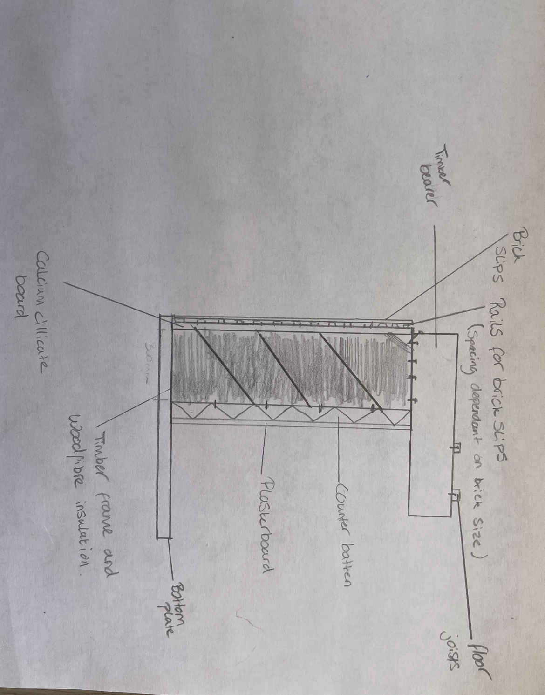
B.
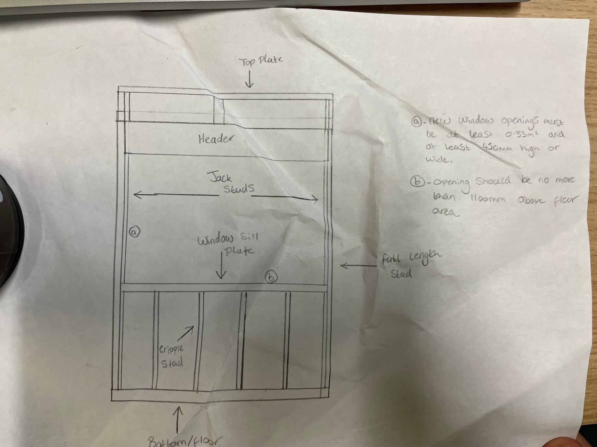

C.
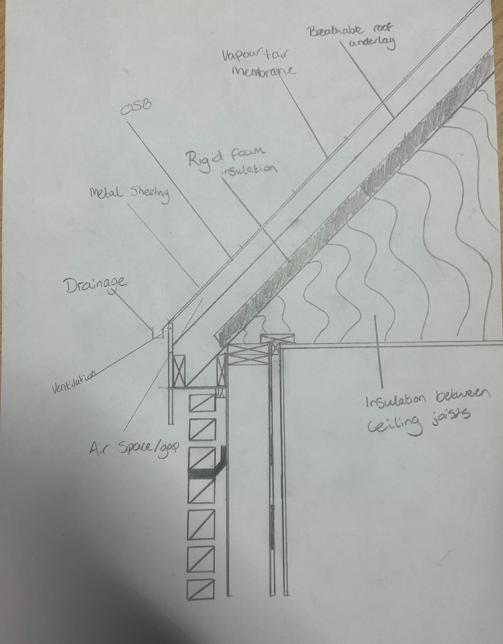

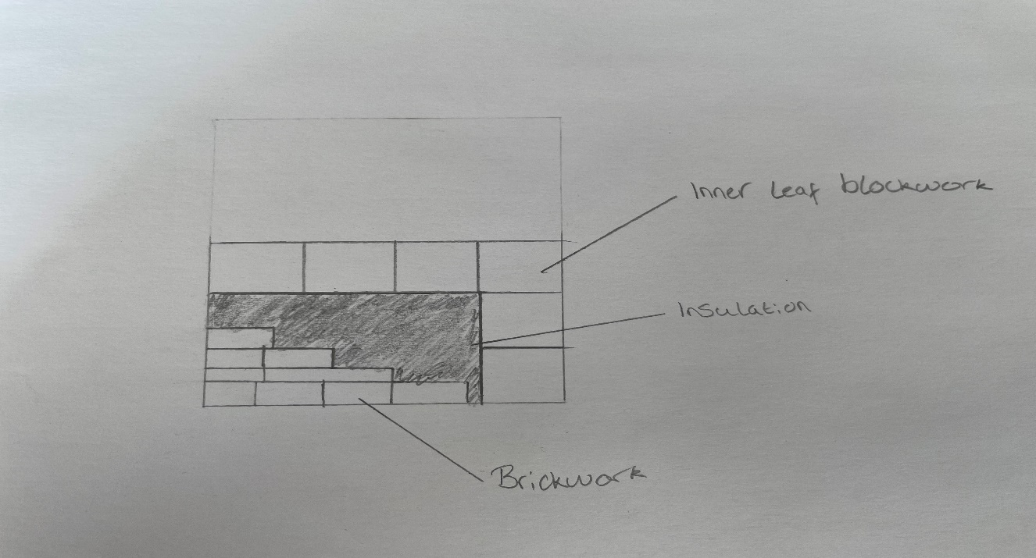
3.

Thermal performance
With the dense material that brick/block walls have, this will give good thermal properties to a building as heat is trapped.
With timber being naturally good insulator, it will provide a better thermal value than that of brick/block in general. However, it will all depend on the certain types of materials like what blocks, insulation etc.
A difference between brick/block and timber walls is how well they retain heat. Brick/block construction will take longer to heat up internally in comparison to a timber frame. Timber does not soak up heat in this way. Because of this a room that uses an insulated timber frame walls will heat up and cool down quicker. This can be a good thing or a bad thing depending on the homeowners’ preferences.
Thickness and structure
A timber frame wall will be less thick than that of a brick/block wall. This is due to the thickness of the blocks themselves. The layer of insulation also adds to the thickness of the wall due to there being no hollow area between blocks to fit insulation.
Insulation is easily fitted and fixed between studs of a timber frame wall, therefor saving a good thickness of the wall which will allow for more internal space.
Brick and block walls are a common method of building. They are used as they are typically highly durable. Materials take longer to produce than that of a timber frame and materials for brick and block walls are very heavy in comparison to those of a timber frame. They are also a better choice if sound proofing is a concern. Brick walls are also not flexible and are very rigid meaning workability is poor in comparison to a timber frame.
Building time will also be much faster due to the low weight of materials used in a timber frame.
Many workers involved in the construction of a building are unable to work in exposed weather conditions and therefore can’t start until the building is watertight. These trades can start much earlier in the build program of a timber frame building, which means that the project will be completed sooner. Houses with all brick/block walls require a longer period for mortar and plaster on the inside to dry out and this can extend the build time significantly.
If a prefabricated timber frame is used, then the quicker the time the project will be completed. This is because the timber frame is usually erected on site by the carpenters, in a matter of days rather than weeks.” (buckinghamschool, n.d)

Conclusion
A timber frame will be the best choice for this build due to many factors. The main few being:
Construction time – Offsite construction can be used to drastically increase build time and also assembly of parts. Brick/block can not be constructed offsite.
Thickness – In comparison to a brick/block wall, a timber framed wall will be thinner. This is due to the thickness of the blocks themselves and the layer of insulation that will need to be fitted.

Structure - With the building being built on land previously used for agricultural activity, I expect the land to be very soft, therefor if we can reduce the weight of the building then that may reduce the chances of any incidents with the ground.

References
buckinghamschool. (n.d). www.buckinghamschool.org. Retrieved from chrome-extension://efaidnbmnnnibpcajpcglclefindmkaj/https://www.buckinghamschool.org/_site/data/files/files/rt-tech/btec-con/unit1/Pros%20and%20cons%20timber%20framesdocx.pdf

.

