Evaluating the Impact of Artificial Intelligence on the Usability of Healthcare Appointment Booking Systems

Project Proposal
by
Evans Quartey-Tackie (2318850)

Course: BSc Cloud Computing
Module: ACCA6020 Independent Project

Supervisor: Osman Elgawi

Project submitted as part of the requirements for
the award of BSc Cloud Computing

29 th July 2026

Table of Contents

1.0 INTRODUCTION 3
1.1 Background 3
1.2 Aim and Objectives 3
1.3 Scope and Limitations 3
2.0 LITERATURE REVIEW 4
2.1 Review of Related Work 4
2.2 Rationale and Research Gap 4
3.0 METHODOLOGY 5
3.1 System Development Approach 5
3.2 Tools and Technologies 5
3.3 Requirements Analysis 6
3.4 System Architecture 6
3.5 Data Collection Method and Analysis 8
4.0 EXPECTED OUTCOMES AND IMPACT 9
5.0 PROJECT TIMELINE 10
REFERENCES 11

INTRODUCTION

1.1 Background

Digital appointment systems are increasingly used to improve healthcare access and reduce administrative workload. Artificial intelligence (AI) may strengthen these systems through conversational support, automation, prediction and personalised recommendations [1], [2]. In appointment booking, AI could help users identify suitable services, search availability, complete bookings and obtain immediate administrative guidance.
However, technical capability does not guarantee a positive user experience. Healthcare booking systems must accommodate different abilities, expectations and accessibility needs. Research into AI-supported outpatient appointment management highlights concerns involving login, navigation, accessibility, integration, trust and patient control [3]. AI should therefore not be assumed to improve usability automatically; its effect should be evaluated through a human-centred comparison with an equivalent conventional interface.

1.2 Aim and Objectives

The project aims to design and evaluate an AI-assisted healthcare appointment-booking prototype and determine whether it improves usability compared with a conventional interface.
The objectives are to:
- Review research on AI, usability and healthcare appointment management.
- Identify user requirements and common booking difficulties.
- Develop conventional and AI-assisted versions of a booking prototype.
- Compare both interfaces using task performance, System Usability Scale (SUS) scores and qualitative feedback.
- Produce recommendations for safe, accessible and human-centred AI booking systems.
The research questions are:
RQ1: What usability problems arise during common healthcare booking tasks?
RQ2: Does AI assistance improve effectiveness, efficiency and perceived usability?
RQ3: What trust, privacy and accessibility concerns affect acceptance?

1.3 Scope and Limitations
The project focuses on administrative booking rather than diagnosis, clinical triage or treatment advice. The prototype will support searching, filtering, booking, rescheduling, cancellation, confirmation, conversational assistance and preference-based recommendations. Synthetic appointment data will be used, with no connection to live healthcare systems. Limitations include a modest sample, prototype-based testing and limited generalisability. The study will evaluate usability and perceived acceptance rather than clinical effectiveness or organisation-wide deployment.

2.0 LITERATURE REVIEW

2.1 Review of Related Work

AI is increasingly applied in healthcare communication, service management, prediction and personalised support. AI-enabled transformation may improve responsiveness and performance [1], while reviews also identify concerns involving privacy, regulation, transparency and professional oversight [2]. Virtual assistants may improve engagement but can create security, bias and trust risks [4]. These studies establish AI’s potential, but do not demonstrate that adding AI to an appointment interface improves usability.
Existing booking systems may still require lengthy forms, unfamiliar terminology and inflexible searches, increasing time, errors, frustration and abandonment. Conversational assistance and recommendations may reduce this friction, yet evidence remains fragmented. Studies often examine healthcare chatbots, general digital-health usability, forecasting or acceptance separately, rather than comparing equivalent AI-assisted and non-AI booking interfaces [3]–[5].
Appointment-specific evidence is limited. Deep-learning forecasting can support operational planning [5], but predicting demand differs from improving the patient journey. Research on AI-supported outpatient booking found that acceptance depended on navigation, accessibility, interactivity, integration and trust [3], although the lack of a controlled comparison limits conclusions about effectiveness and efficiency.
Conversational AI may allow users to express needs in natural language. Nevertheless, healthcare conversations must be evaluated for trust, comprehension, robustness, ethics and interaction quality, not technical accuracy alone [6]. General-purpose chatbots are also unsuitable for unrestricted clinical use [7]. The proposed assistant will therefore be limited to administrative functions, approved information and explicit fallback responses.
Usability will follow ISO 9241-11, which defines it through effectiveness, efficiency and satisfaction in a specified context [14]. The standard SUS benchmark of 68 remains appropriate for digital-health applications [8], but SUS alone cannot explain failures. Completion rates, time, errors and think-aloud evidence can reveal problems hidden by satisfaction scores [9]–[11]. Digital literacy, age and accessibility also influence outcomes [12], [13].

2.2 Rationale and Research Gap

Existing research supports AI in healthcare operations and communication, but offers limited comparative evidence that AI improves appointment-booking usability over an equivalent conventional interface. Studies frequently measure broad acceptance, prediction or a single application rather than combining requirements analysis, prototype development and controlled comparison [3], [5], [8]. This project addresses the gap through a counterbalanced within-subject evaluation using quantitative performance measures and qualitative evidence concerning trust, accessibility, privacy and control.

3.0 METHODOLOGY

3.1 System Development Approach

An iterative human-centred process will include literature review, requirements elicitation, wireframing, implementation, pilot testing, refinement and comparative evaluation. This approach prioritises users’ goals, abilities and contexts rather than technical capability alone.
Alternative methods were considered. Surveys and interviews could capture perceptions but not observed performance. Heuristic evaluation would rely mainly on expert judgement. Studying a live platform or conducting a field trial would improve ecological validity, but access, privacy, governance and time requirements would exceed the project’s scope. A controlled mixed-method prototype study was therefore selected. Quantitative and qualitative data will be collected, analysed separately and integrated during interpretation [11]–[13].

3.2 Tools and Technologies
Project Technologies and Resources

Table summarises the technologies and resources used to design, implement and evaluate the proposed system.

Technology/Resource/Tool | Purpose
Figma | Wireframing, prototyping and interface iteration.
React | Development of the interactive front-end interface.
Python and Fast API | Application logic, constrained AI functions and API integration.
SQLite or PostgreSQL | Storage of synthetic services, appointment slots and test logs.
Git and GitHub | Version control and reproducibility.
Knowledge base and recommendation logic | Provides approved administrative responses and recommends suitable available appointments.
Safety layer and synthetic data | Rejects clinical requests, explains limitations and protects privacy by avoiding real patient data [2], [6], [7].

3.3 Requirements Analysis

Requirements will be derived from the literature and short pre-design interviews. Functional requirements (FRs) will include service search, booking, rescheduling, cancellation, confirmation, conversational assistance and a permanent option to return to standard navigation. Non-functional requirements (NFRs) will cover usability, accessibility, learnability, privacy, reliability, transparency, response time and error recovery.
Table summarises the intended participant group and recruitment approach for the usability evaluation.
Area | Description
Target users | Adults aged 18 or over who have previously used an online booking service.
Recruitment | Participants will be recruited through university and community channels.
User diversity | Recruitment will seek variation in age, digital confidence and accessibility needs.
Inclusion criteria | Participants must be aged 18 or over, have online-booking experience and provide informed consent.
Sample size | An a priori power analysis for a paired comparison will determine the minimum sample. Approximately 10 participants will be targeted, subject to the result and project feasibility.
Documentation | Recruitment materials, inclusion and exclusion criteria, and any compensation arrangements will be finalised before data collection.

3.4 System Architecture

The proposed architecture will contain four layers:
- Presentation layer: conventional interface controls and the AI conversational panel.
- Application layer: booking workflows, validation, appointment availability and scheduling rules.
- AI layer: intent recognition, approved-information retrieval and constrained appointment recommendations.
- Data layer: synthetic services, availability and anonymised interaction logs.
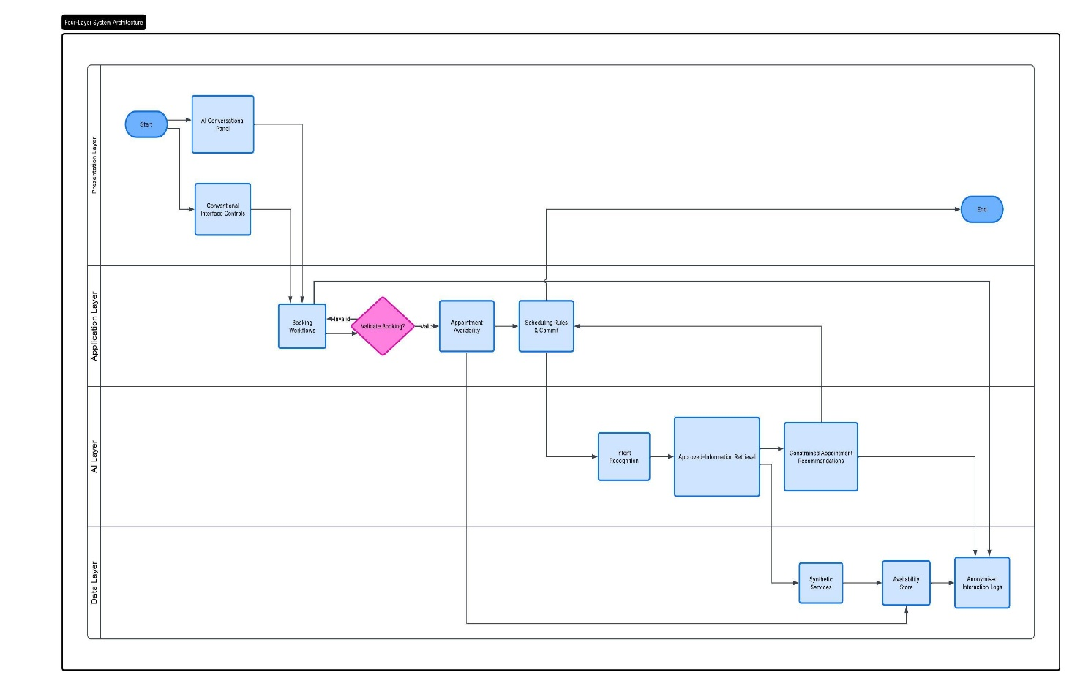
Figure 1 - Four Layer System Architecture

The principal information flow will be:
User interface → application logic → AI or booking service → synthetic database → validated response.
All bookings will require explicit user confirmation. Recommendations will be validated against stored availability, and unsupported requests will trigger a fallback message. Every AI-assisted task will remain achievable through conventional controls. This will preserve user autonomy and prevent the AI component from becoming a single point of failure.
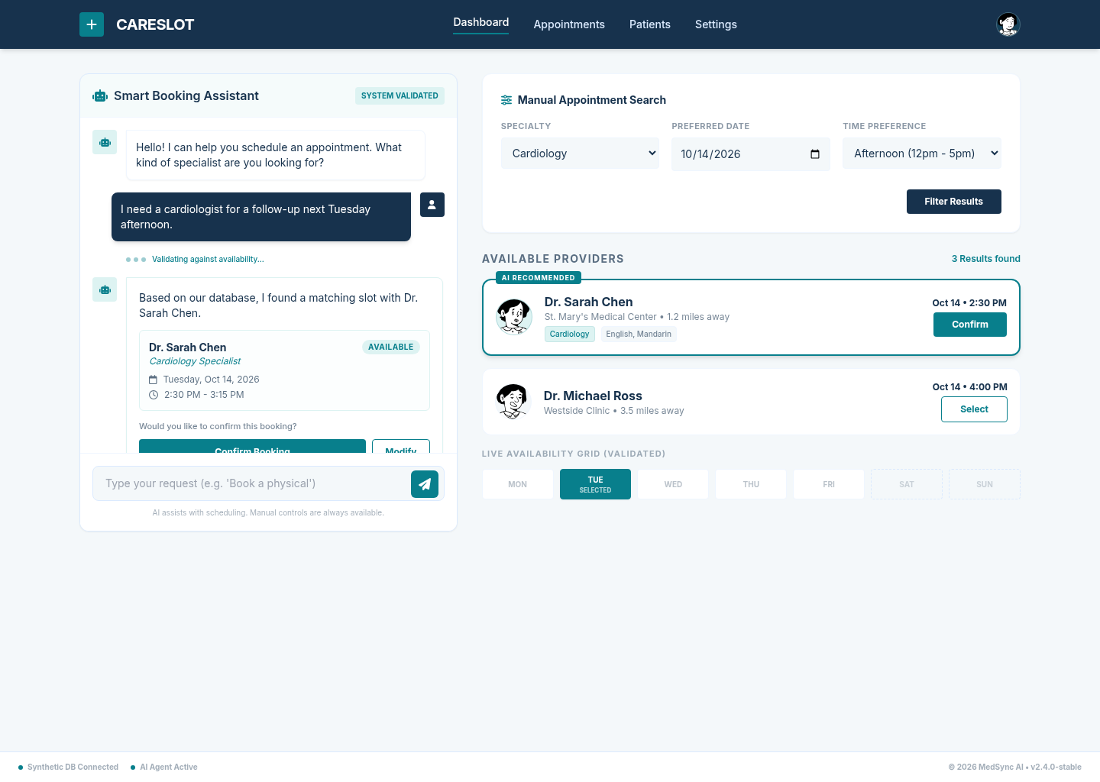
Figure 2 - Ai Assisted and conventional booking page

3.5 Data Collection Method and Analysis

Participants will complete standardised tasks involving service search, booking, rescheduling, cancellation and help-seeking on both interfaces. A counterbalanced within-subject design will be used: half will begin with the conventional version and half with the AI-assisted version. Equivalent task scenarios will reduce learning effects, and a pilot will test instructions, difficulty, timing and questionnaires.
The primary outcome is perceived usability measured by SUS after each interface. Secondary measures include task completion, time, assistance requests, error number and severity, trust, perceived control and willingness to use the system. Errors will be classified as minor, major or critical. Concurrent think-aloud sessions and short interviews will explore navigation, cognitive workload, accessibility, privacy and confidence in AI responses.
Means, medians, dispersion and confidence intervals will summarise quantitative data. Paired-samples t-tests will compare normally distributed continuous outcomes; otherwise, Wilcoxon signed-rank tests will be used. Paired categorical outcomes will use an appropriate test. Effect sizes will accompany p-values. Qualitative data will undergo reflexive thematic analysis through familiarisation, coding, theme development, review and naming. Findings will then be triangulated, including contradictory evidence.
The AI interface will be considered successful if it produces a higher SUS estimate and improved or equivalent task performance without reducing accessibility or perceived control. The SUS benchmark of 68 will provide context [8], while effect sizes, confidence intervals and qualitative findings will indicate practical significance.
Ethical approval will be obtained before recruitment. Participants will receive information, provide consent and retain the right to withdraw. Only necessary data will be anonymised and securely stored. Synthetic scenarios will prevent collection of real patient information, and identifiable data will not be sent to an external AI provider. Participants will be told that the prototype is not a clinical service. The ethics application will address accessibility, bias, data protection, misleading outputs and over-reliance on AI [2], [4], [6], [7].

4.0 EXPECTED OUTCOMES AND IMPACT

Outputs will include a literature review, requirements specification, two booking prototypes, architecture documentation, an anonymised usability dataset, a comparative evaluation report, design recommendations and the final dissertation. The study will not assume AI superiority; it will identify which functions improve or hinder effectiveness, efficiency, satisfaction, trust and accessibility.
Academically, the project links healthcare-AI research with controlled usability evaluation. Practically, it will provide guidance on constrained conversational support, fallback navigation, transparency, privacy and inclusive design. Findings may inform future patient-facing booking systems while remaining limited to prototype usability rather than clinical safety or organisation-wide effectiveness.

5.0 PROJECT TIMELINE
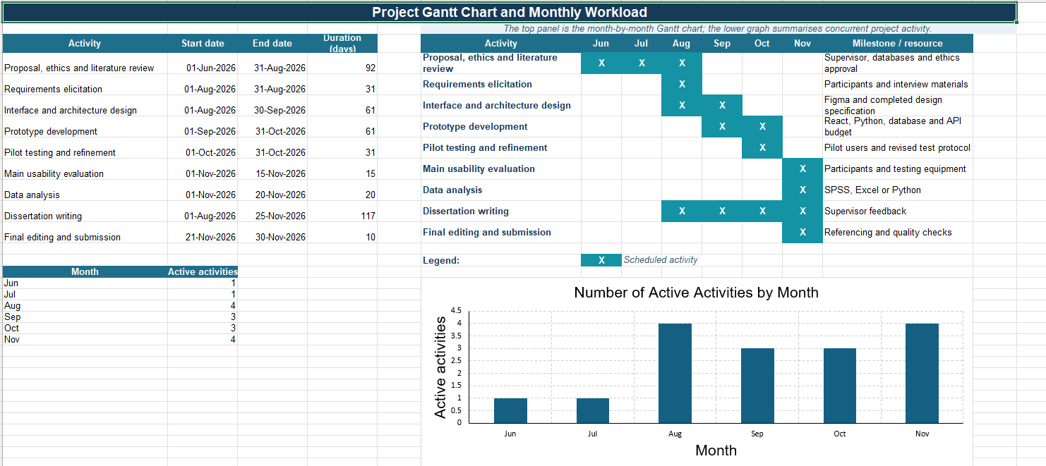
Figure 3 - Gantt Chart
The schedule ensures that ethics approval precedes participant research. It also provides a logical progression from evidence review and requirements analysis to implementation, evaluation and final reporting. Development and writing overlap to reduce end-stage workload, while time is retained for prototype refinement and recruitment delays.

REFERENCES
- Á. Periáñez et al., “The digital transformation in health: How AI can improve the performance of health systems,” Health Systems & Reform, vol. 10, no. 2, Art. no. 2387138, 2024, doi: 10.1080/23288604.2024.2387138.
- S. A. Alowais et al., “Revolutionizing healthcare: The role of artificial intelligence in clinical practice,” BMC Medical Education, vol. 23, Art. no. 689, 2023, doi: 10.1186/s12909-023-04698-z.
- K. V. Wood, D. Frings, C. Flood, and N. Thomas, “Artificial intelligence machine learning-driven outpatient appointment management: A qualitative study on acceptability,” Digital Health, vol. 11, Art. no. 20552076251321016, 2025, doi: 10.1177/20552076251321016.
- Y.-H. Li, Y.-L. Li, M.-Y. Wei, and G.-Y. Li, “Innovation and challenges of artificial intelligence technology in personalized healthcare,” Scientific Reports, vol. 14, Art. no. 18994, 2024, doi: 10.1038/s41598-024-70073-7.
- F. Piccialli, F. Giampaolo, E. Prezioso, D. Camacho, and G. Acampora, “Artificial intelligence and healthcare: Forecasting of medical bookings through multi-source time-series fusion,” Information Fusion, vol. 74, pp. 1–16, 2021, doi: 10.1016/j.inffus.2021.03.004.
- M. Abbasian et al., “Foundation metrics for evaluating effectiveness of healthcare conversations powered by generative AI,” npj Digital Medicine, vol. 7, Art. no. 82, 2024, doi: 10.1038/s41746-024-01074-z.
- J. Au Yeung et al., “AI chatbots not yet ready for clinical use,” Frontiers in Digital Health, vol. 5, Art. no. 1161098, 2023, doi: 10.3389/fdgth.2023.1161098.
- M. Hyzy, R. Bond, M. Mulvenna, L. Bai, A. Dix, S. Leigh, and S. Hunt, “System Usability Scale benchmarking for digital health apps: Meta-analysis,” JMIR mHealth and uHealth, vol. 10, no. 8, Art. no. e37290, 2022, doi: 10.2196/37290.
- P. Papadopoulos, M. Soflano, and T. Connolly, “A digital health intervention platform (Active and Independent Management System) to enhance the rehabilitation experience for orthopedic joint replacement patients: Usability evaluation study,” JMIR Human Factors, vol. 11, Art. no. e50430, 2024, doi: 10.2196/50430.
- S. Afrizal, R. Prihatni, and S. P. Hastono, “Evaluation of the quality of health applications using the System Usability Scale,” Jurnal Manajemen Informasi Kesehatan (Health Information Management), vol. 9, no. 1, pp. 1–9, 2024, doi: 10.51851/jmis.v9i1.492.
- Z. Meidani et al., “Evaluating the usability and quality of a clinical mobile app for assisting physicians in head computed tomography scan ordering: Mixed methods study,” JMIR Human Factors, vol. 11, Art. no. e55790, 2024, doi: 10.2196/55790.
- J. M. Murabito et al., “Smartphone app designed to collect health information in older adults: Usability study,” JMIR Human Factors, vol. 11, Art. no. e56653, 2024, doi: 10.2196/56653.
- M. Chatsatrian et al., “Usability evaluation of digital health applications for older people with depressive disorders: Prospective observational study in a mixed methods design,” JMIR Human Factors, vol. 12, Art. no. e66271, 2025, doi: 10.2196/66271.
- International Organization for Standardization, Ergonomics of Human-System Interaction—Part 11: Usability: Definitions and Concepts, ISO 9241-11:2018, Geneva, Switzerland, 2018.

