Student name: Dan Gheorghe Filimon

Student number: 1909419

Module teacher: Mushfiqur Rahman

Module name: Dissertation

Dissertation
A study to evaluate the effect of staff turnover on the service quality and business performance using the case study of Amazon

Executive Summary
The employee turnover is considered as a very serious concern for every organisation as it is associated to several consequences, such as business performance, service quality, business planning and strategies. There can be various reasons why employees leave their current job, which can vary from lower salary, work-life imbalance, stress, job satisfaction or even inability of the organisation to keep them engaged to their respective roles. Hiring new professionals is often very challenging for the organisations as it not only involves high cost to company but even consumes a lot of productive time of other employees in orienting or training them for their specific job role and make them aware of the organisational culture.
The purpose of this research is to find out the actual reasons for staff turnover and their damaging effect on the service quality and business performance of the organisations. This research also discusses regarding the positive outcome of staff turnover. For example, the organisations get an opportunity to hire more skilled and experienced employees to increase productivity. This research uses the case study of Amazon. For this, the survey is conducted on one of the Fulfilment Centres of Amazon in London. The qualitative research is used to explore the research topic in depth and collect all possible reasons and effect of staff turnover. The analysis of the survey result is done in relation to the literature review and accordingly certain recommendations are provided to Amazon to reduce its staff turnover.

Table of Contents
Executive Summary 3
Chapter 1 -Introduction 6
1.1 Research Background 6
1.2 Aims and Objectives 7
1.3 Rationale 7
1.4 Research Significance 8
1.5 Structure of dissertation 8
Chapter 2 – Literature Review 9
2.1 Causes of staff turnover in an organisation 9
2.2 The impact of staff turnover on service quality and business performance 11
Chapter 3 – Research Methodology 15
3.1 Introduction 15
3.2 Research onion 15
3.3 Research philosophy 16
3.4 Research approach 17
3.5 Research strategies 17
3.6 Research choices 18
3.7 Time horizon 18
3.8 Data collection and analysis 19
3.9 Research ethics 19
Chapter 4 – Research Findings and Discussion 21
4.1 Introduction 21
4.2 Data analysis 21
4.2 Discussions 26
Chapter 5 – Conclusion and Recommendation 27
5.1 Conclusion 27
5.2 Recommendation 27
5.3 Limitation 28
5.4 Future research 28
References 30

Chapter 1 -Introduction
Project Title: A study to evaluate the effect of staff turnover on the service quality and business performance using the case study of Amazon

Research Background
In the recent years, there has been significant growth in the service sector as compared to the manufacturing or agricultural sectors (Sarhadi, 2017). As a result, there has also been increase in the labour force of this sector. Since the service sector relies heavily on their employees to provide excellent customer service, hiring and retaining their workforce becomes very crucial for the organisations. However, due to highly demanding and competitive sector, there is a tendency of high employee turnover rates.
This employee turnover has bother negative and positive consequences on businesses. For example, the negative consequences may be linked to business costs and operations (Ogony, 2019). The positive consequences may be linked to innovation and company performance. These consequences may be associated with many factors, such as employee dissatisfaction, leadership skills and customer behaviour and expectations. As a result, it generates interests for researchers to explore about the causes and effects of employee turnover for any organisation.
For this research, the case study of Amazon’s Fulfilment Centre is used. Amazon is one of the largest retailers of the world that belong to the service sector. It is headquartered in Seattle, Washington, USA (aboutamazon.com, 2022). It is involved in the online business and deals with almost all types of products, such as books, apparels, electronics, toys and even beauty care, for all age group customers. In UK, the Fulfilment Centre is the largest department of Amazon. In this centre, the responsibilities of employees are to pick, pack and ship the orders to customers within the stipulated timeframe.
Amazon has adopted appropriate business strategies, such as cost leadership and product differentiation, to successfully expand its business all over the world. However, it experienced a very high turnover rate (i.e., around 150%) in the year 2021 (Dudovskiy, 2022). According to the New York Times, this high attrition was due to Amazon’s poor human resource management. The employees expressed their dissatisfaction towards company’s policies that resulted in work-life imbalance and poor management skills or behaviour.

Aims and Objectives
This research aims to evaluate the effect of staff turnover on the service quality and business performance at Amazon.
The main objectives of the research are:
- To identify the causes of staff turnover in an organisation
- To identify the impact of staff turnover on service quality and business performance
- To recommend strategies that can help to reduce staff turnover at Amazon
The research questions for this research are:
- What are the causes of staff turnover in an organisation?
- What is the impact of staff turnover on service quality and business performance of an organisation?
- What strategies can be used to reduce staff turnover at Amazon?
These research questions help the researchers to identify the cause an effect of staff turnover in organisations, especially in Amazon. These researchers are able to make a link on how high staff turnover rates have a negative impact on the service quality and business performance of Amazon.
This research has certain limitations due to limited budget and resources. Apart from this, another major limitation is that the research data is collected only from Amazon’s Fulfilment Centre. Even though this department of Amazon is the largest in UK with around 2500 employees, the data collected is indicative only for that department. As a result, the research is biased and the result of this data is applied to the whole company.

Rationale
The main purpose of this research is to investigate the effect of staff turnover on Amazon’s business performance and service quality offered. This will help the organisation to seriously consider the negative consequences of staff turnover and make strategies to overcome them or convert them to the positive ones (Hom, et al., 2019). It will also enable Amazon to gain employees trust and loyalty so that they remain associated with it for a long period. Such employees significantly contribute towards increasing organisation’s business performance and improving service quality.

Research Significance
This significance of the research is to achieve a holistic view on the effect of employee turnover on Amazon’s business performance and service quality. The focus-group for this research will be the Fulfilment Centre of Amazon. This research will help to identify the factors or reasons why employees tend to leave their jobs as employee retention is a very crucial ingredient in building brand image and increase customer base (Hom, et al., 2019). This research will help the researchers to identify the model that uses different dimensions of service quality and a framework to discusses how employee turnover affects these dimensions. It also identifies the challenges and opportunities employee turnover has towards service quality.

Structure of dissertation
The first chapter of this dissertation is ‘Introduction’, which states the topic i.e., a study to evaluate the effect of staff turnover on the service quality and business performance using the case study of Amazon. In this chapter, the research background is discussed, along with the project’s aims and objectives. This is followed by discussing the rationale and research and the significance of this research.
The next chapter is ‘Literature Review’, which elaborates the research topic by discussing how the staff turnover affects the service quality and business performance of an organisation, especially Amazon. After this, the ‘Research Methodology’ chapter is provided, which discusses about various methodologies adopted to conduct research. It includes research paradigm, philosophy, approach, data collection and analysis, sampling technique and the research ethics.
The chapter followed by ‘Research Methodology’ is ‘Data Analysis and Discussion’. In this chapter, the data collected from Amazon’s Fulfilment Centre is analysed using MS Excel statistical tools, such as pie chart, bar chart and tables. Once the data is analysed, it is interpreted appropriately to reach to specific results. Finally, the research is concluded, along with stating certain recommendations for the improvement strategies for Amazon to retain its employees for a long period in its ‘Conclusion and Recommendation’ chapter.

Chapter 2 – Literature Review

2.1 Causes of staff turnover in an organisation
The staff turnover is a serious concern for the management of any organisation due to stiff market competition (Allen & Vardaman, 2021). It affects the business profitability and performance of the organisations and possess risks of loosing skilled staff. In the recent past, many organisations all over the world has reported of high attrition rate of their employees. In the year 2015, around 49% of organisations faced this issue. There are various causes of staff turnover globally. Some of these reasons are:
Job dissatisfaction – It refers to what the employees feel about their jobs. It is negatively linked to staff turnover as it influences them to seek alternatives and switch their jobs. There are various theories related to staff turnover (Aikens, 2018). One such theory is that employees switch their jobs due to their perception of ease of movement. Another such theory is their desire to move out of their current organisation. The employees can get dissatisfied with their jobs due to various reasons, such as salary, leadership or management, work environment and even the nature of their job. The dissatisfied employees result in producing unproductive work, reduces the commitment level of the organisation towards the client and even negatively influences the work environment.
Group size – The size of group in any department also plays a critical role towards employee turnover. According to Al-Suraihi, et al. (2021), employees in large groups lack interests in their jobs, feel left out or less motivated, communicates less and feel pressurised in competing with fellow members, have low satisfaction and commitment levels and tend to participate or socialise less when in group. All these negative results in large groups in due to the employees being less cohesive with each other. Social ties are very important to increase the sense of community amongst the workers. This helps them to continuously exchange their ideas and views with each other so that each group member is at the same page and contributes positively (Aikens, 2018). On the other hand, staff turnover is less in small groups as the employees feel they are being valued and noticed. The management can minimise the staff turnover in this case by arranging formal and informal team activities, such as frequent team meetings, group games and get togethers, to provide icebreakers so that the employees get opportunity to understand each other.
Mental stress – It is the condition of mind that affects employees’ emotions, physical conditions and thoughts. The employees suffer from mental stress when they feel burnout at their workplace due to long working hours, low salary, work-life imbalance, unfit job role or even tight deadlines or schedules (Haque, 2022). In these conditions, the employees often get dissatisfied with their job or the work environment and tend to leave their jobs. The employees suffering from work-related mental stress often tend to lose their productivity and downgrades their performance. Such conditions of employees result in other chronic issues, such as insomnia and physical or mental issues.
Human Resource Management (HRM) practices – The HRM practices in an organisation is directly linked to employee turnover. If employees do not find the HRM practices as favourable for them, they prefer to consider switching their jobs. Some of such HRM practices includes, low salary, lack of recognition or reward system and appropriate career counselling or training programmes (Essien, 2019). With lack of such HRM practices, the employees consider their jobs to be insecure and are demotivated to give their best performance. The employees also become dissatisfied with their work if their job profile does not match with their skills or experiences. In such case, role discrepancy arise as there is a conflict in what the employees perceive regarding their job output and the expectations of their leaders. The lack of appropriate feedback system also contributes towards decreasing their satisfaction level towards their work. The HRM can improve staff turnover by conducting compensation reviews every year to ensure that the compensation benefits and rewards and recognitions provide to the employees are as per the industry standards. Such effective measures will keep the employees satisfied and provide them job security.
Leadership or management behaviour – The employees’ turnover is also linked with the attitudes or behaviour of their leaders or managers and their management style. When employees work with such leaders, their enthusiasm and focus towards work gets reduced, they suffer from mental stress and even are highly dissatisfied and demotivated (Rocha, 2018). Such employees chose to quit their jobs. The employees often complain that their leaders do not give them enough opportunity or challenges to show their true potential or excel in their work. The leaders are also blamed to discriminate their subordinates based on their gender or age. In order to reduce staff turnover, it is the responsibility of the HRM to provide appropriate training programmes for the mangers to improve their leadership skills and make them aware to treat all employees equally. There should be no employees who feel disgruntled, disrespected or even left out.
Customer satisfaction – The level of customer satisfaction plays is directly proportional to the satisfaction level of the employees. If the customers are dissatisfied with the quality of service provided by the employees, the employees are penalised by the organisation by degrading their performance through both monetary or non-monetary means (Amri & Pandey, 2019). This result in employees getting highly demotivated or dissatisfied. Such employees often suffer from stress and consider to quit their job. Organisations can reduce such instances by implementing appropriate feedback system or providing the required training to the employees to improve their skills and contribute positively towards increasing the satisfaction level of the customers. Sometimes, the customers’ attitude or behaviour towards employees are not acceptable as they use abusive language or provide unreasonable demands regarding work. In such cases, it is the responsibility of the leaders or the management to raise concerns to the customers. The management’s support for their employees also help to reduce staff turnover to a great extent.

2.2 The impact of staff turnover on service quality and business performance
The impact of employee turnover is often negative and serious for organisations and so they need to make continuously review their strategies to retain employees for a long period. Some of the negative impacts of staff turnover include costs of recruitment, training and development and operational disruption (Allen & Vardaman, 2021). These costs are more than the costs of maintaining employees in the company. Every time employees leave the company, the operation is disrupted, which results in the loss of working hours and thus the cost to company. Even when new employees join, the old employees have to invest their time to train the new employees, which again disrupts their operations too.
In order to recruit and on-board new employees, costs are incurred in their hiring process and then providing them adequate and appropriate training to make them fit and aware of the job positions they are hired for (Atar, 2022). The costs incurred in the hiring and training process depends upon the complexity of the job role. If the job role is complex, the recruitment cost is more than for the simple job roles. The delay in hiring new employees results in the delay in manufacturing products or providing services to the customers. In case the work of an employee leaving the work in interdependent on the work of other employees, the quality of service provided by these other employees also suffers. According to Atar (2022), the higher the job position of the employee, the higher is the disruption of operations as the higher rank employees have more responsibilities and ownerships than their responsibilities.
Another negative impact of staff turnover is the demoralising impact on other employees. For example, when any employee leaves the organisation, the other existing employees of the organisation get demotivated, dissatisfied or even demoralised assuming that the employee left due to organisational issue rather than personal reasons (Segalla, 2021). Such negative impact on the existing employees may also be the result due to the quitted employee’s high social status or the membership of cohesive group. With the impact of costs and quality of services offered, such negative impacts of staff turnover also disrupt or slow down the business performance.
The impact of staff turnover of business performance is shown in the following figure.
Turnover-Performance Curve
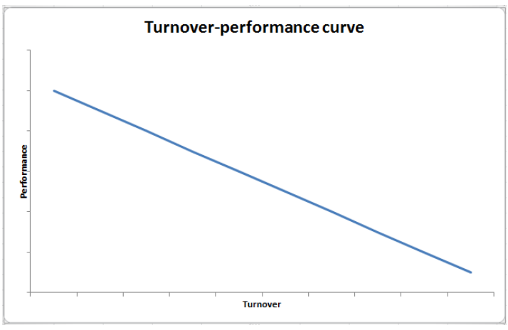
Figure 1. Source: (Kraiger, et al., 2020)

When the turnover rate goes up and business performance goes down and when the rate goes down the performance increases. This performance is also related to the tenure of the employee in the organisation and is referred in the J-shaped and U-shaped curve theories (Hom, et al., 2019). According to the J-shaped curve theory, when the employee is new to the organisation, the performance is low but it increases with time as the employee acquire skills, knowledge and experience. However, when the performance reaches its maximum, it stops improving. In the inverted U-shaped curve theory, the performance is at the lowest when the new employee joins the organisation and increases rapidly as he/she gains experience and skills. However, after reaching the maximum performance stage, the employee feels burnout and the performance start to drop rapidly.
Along with the decrease in business performance, the staff turnover also has negative impact on the service quality dimensions, such as availability, substance and courtesy (Bryson, et al., 2020). The availability dimension of the service quality refers to the staff shortage that organisations face either for a short term or long term due to staff turnover. This affects the quality of services offered to customers for that period, and thus decreases customer satisfaction.
The substance dimension of the service quality refers to the knowledge and skills required to perform certain job (Malik, 2022). When employees leave organisations and new employees replace them, it takes time for the organisations to train the new employees to acquire the same skills and knowledge so that they can maintain the quality of services offered. The new employees even tend to make mistakes as they are still in the learning phase. Thus, for this training and development period, the customers often receive a low quality of service.
The courtesy dimension of the service quality refers to the empathy and caring way in which the customers are handled. The turnover of staff may have a mixed impact (both positive and negative) on this dimension of service quality (Thaichon & Ratten, 2020). This is because the old employees tend to become tired and feel pressurised with the increase in expectations from their supervisors and customers or clients. As a result, they tend to become less customer-oriented. In contrast, the new and young employees tend to be more courteous and respectful to the customers as they are required to prove themselves in their new workplace. However, in the other case, the new employees can be over cautious and take more time to deliver the expected quality of service or tend to be less reliable due to their inexperience.
There is some other positive impact of staff turnover, such as increased effectiveness, reduced conflict and innovation, on the business and performance of organisations. According to Logue & Yates (2018), when a new and enthusiastic employee replaces the employee who left the job possess high skills and knowledge, has the potential to perform better and even excel in providing customer service to clients. So, it is the responsibility of the HRM to hire experienced and skilful staff who can use new technologies and can adopt to the new environment quickly.
An employee may leave his/her workplace due to conflict with the senior or colleagues. On hiring the new employee, this conflict would be over and the new workplace get a positive environment (Liddle, 2017). This will help to increase the effectiveness and productivity of the employee and thus improving the business performance.

Chapter 3 – Research Methodology

3.1 Introduction
Research methodology is referred as an approach that uses the knowledge of science to systemically conduct research (Thomas, 2021). In this approach, the researchers use different methods, techniques and processes to explore a research problem, formulate hypothesis, collect and analyse data, suggest possible recommendations and derive to certain conclusions.
The main purpose of using research methodology is to explore or unfold reality or unknown facts, which are yet to be exposed, to benefit the society. The research methodology can be exploratory or explanatory (Munot & Bairagi, 2019). When the researchers need to perform in-depth analysis to explore the unknown or unclear research problem, they use exploratory research. On the other hand, when the research problem is known to the researchers and they need to identify the cause and effect of the issue, they need to perform the explanatory research.
This research uses explanatory research methodology form as it helps to evaluate the effect of staff turnover on the service quality and business performance of Amazon.

3.2 Research onion
The complete research work is distributed in various stages, which is described as research onion, as shown in the following figure.
The Research Onion
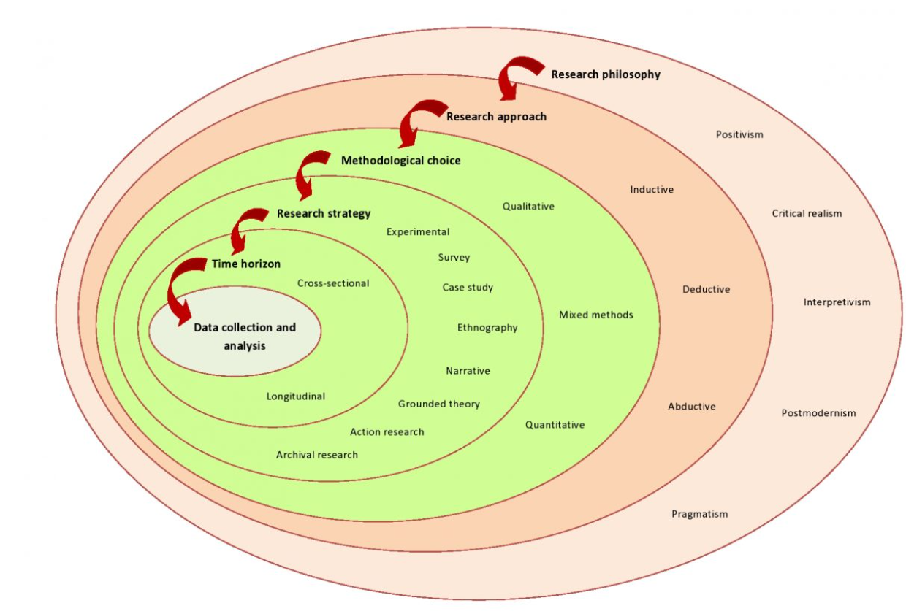
Figure 2. Source: (aesanetwork.org, 2020)
The research onion was introduced by Saunders et al in the year 2007 (Ngulube, 2021). Its main benefit is that it can be adapted for any type of research. The researchers need to start from the stages provided in the outer layer of the research onion and gradually move towards its innermost layer.

3.3 Research philosophy
The research philosophy refers to the belief with which the researcher conducts research to explore the reality of the research problem (Wilson, 2017). The researchers adopt a research philosophy based on the objective of the research and the type of the knowledge being studied. Basically, research philosophies are of three major types – positivism, interpretivism and critical realism.
Positivism is a type of research philosophy, which is based on scientific knowledge and universal laws and rules (Tshabangu, 2020). This knowledge is acquired by collecting facts and only those facts that can be proven is considered as to be true by the researchers. As a result, positivism uses research questions and hypothesis that can be tested and analysed.
According to the Interpretivism research philosophy, the knowledge and the truth is based on the researcher’s perception and experiences (Brinkmann, 2018). These researchers collect and analyse data in accordance with their own values and beliefs. As a result, the social realities are explored in a subjective manner. Finally, the critical realism is based on positivism theory. However, it rejects the evidences collected through experiments and observations. It believes that truth or reality is independent of the researchers’ mind.
This research uses the positivism research methodology as it explores research questions and derives to specific conclusion based on the data collected.

3.4 Research approach
The second layer of the research onion deals with the research approaches. There are two main types of research approaches – deductive and inductive. The deductive research approach uses existing theories and specific hypothesis, which has already been observed or recorded by the researchers (Stokes & Wall, 2017). These researchers test the hypotheses created for the research problem to identify whether they hold true or false in their relevant theories and then reach to specific conclusion. Thus, the deductive research approach starts from the generalised concept or theory and over the course of the process, narrows down to the specific observations. This approach insists on collecting data through interviews, questionnaire or survey. On the contrary, the inductive research approach starts from the specific observations that the researchers use to create generalised theories. This approach has no specific framework to collect data.
For this research, the deductive research approach is used as the researcher explores the existing theories regarding the effect of staff turnover on the service quality and business performance of organisations and with the help of the data collected through qualitative survey questions, specific observations are made.

3.5 Research strategies
This layer of research onion states various methods of data collection to carry forward the research process (Johanson & Williamson, 2017). Some of these methods are experiment, case study, archive, action research, grounded theory or even survey.
For this research, both the primary and secondary data is used. For the secondary data, the Government archives, databases, journals and books are used and for the primary data, the survey strategy to interview the employees of one of the Fulfilment Centre facilities of Amazon in London.

3.6 Research choices
This layer of research onion represents different choices, such as quantitative, qualitative and mixed methods, for conducting research. The quantitative research choice uses objective, structured, reliable and logical data in numeric form. Such data helps to confirm the hypothesis or generalised theories (Samoilenko & Osei-Bryson, 2021). The quantitative data can be collected by researchers through various methods, such as surveys, experiments or observations. It uses close-ended questionnaire for the data collection.
On the contrary, the qualitative research choice uses subjective, unstructured and generalised data for the research. Such choice helps researchers to express their thoughts, experiences or expressions (Leavy, 2017). They prefer this when there is a need to perform a detailed analysis of a research problem. The qualitative data can be collected by researchers through various methods, such as focus groups, surveys or interviews (semi-structured or unstructured). Apart from these two research choices, the researchers have the option to choose the mixed type, which includes both qualitative and quantitative data. Such choice is preferred by researchers when they need to synergistically use the data to perform a wide range of research. For this, they collect both descriptive as well as specific data for the research analysis.
For this research, the qualitative research choice is used to collect a detailed and subjective data regarding the effect of staff turnover on the service quality and business performance of a Fulfilment Centre facility of Amazon.

3.7 Time horizon
In this layer of research onion, it is revealed that the research data can be collected in two different time horizons - cross sectional or longitudinal (Machado & Davim, 2020). When the researchers collect data over a certain fixed period of time, it means they are using cross sectional time horizon for data collection. On the contrary, when the researchers continuously collect similar data over a period of time until any specific change is observed, it means they are using the longitudinal time horizon for data collection.
For this research, the researcher uses cross-sectional time horizon for data collection as there is a limited time to complete the research.

3.8 Data collection and analysis
This layer reveals what type of data is collected in research and how are they analysed. In order to collect data, two types of research are conducted – primary and secondary. In the primary research, the data is collected directly by the sources i.e., participants involved in the research process through interviews or surveys (Dubey & Kothari, 2022). The advantage of this type of data collection is that it helps the researchers to collect the up-to-date information. However, it is a time-consuming process and also collects personal information of the participants. Sometimes, the participants are very reluctant to share their private information. On the contrary, in the secondary type of research, the data is collected form secondary sources, such as databases, archives, books or journals. The advantage of this type of research is that the researchers are able to access a wide range of existing information to conduct their research effectively. However, the data collected is very subjective.
In order to collect primary and/or secondary data, the researchers need to use the sampling techniques to select the participants for the research. There are two types of sampling techniques – probability and non-probability (Wu & Thompson, 2021). The probability sampling technique is used to randomly select participants from a huge population. Its helps to provide equal opportunity to every member of the population to be selected for the survey. On the contrary, the non-probability sampling technique is used to non-randomly select some people from the huge population for the survey. The researchers can be biased while selecting this technique and use their preferences to select a sample for the research.
For this research, both the primary and secondary research is used to conduct research. The sampling technique used in probability or random method. The researcher randomly selects the employees i.e., 25 participants, from one of the Fulfilment Centres of Amazon in London to participate in the survey. These participants are required to answer six qualitative questions for the research purpose. However, due to limited time and resources, the research is conducted within a specific period.

3.9 Research ethics
The researchers can maintain research ethics by following the moral codes or values (Poth, 2020). The research ethics enable the researchers to maintain the data integrity and privacy of personal information of the participants. The researchers need to be honest and transparent in communicating the purpose of the research to the participants. They need to be accountable for ensuring all ethical standards are adopted. The participants cannot be harmed in any way by breaching their code of ethical conduct in any way.
For this research, the researcher has ensured all ethical standards are maintained in the entire research process.

Chapter 4 – Research Findings and Discussion

4.1 Introduction
This section analyses the data collected from primary sources i,e, survey questionnaire. This research involves around 25 employees of one of the Amazon’s Fulfilment Centre in London. They are given around six qualitative questions, which are analysed for the research purpose.

4.2 Data analysis
1. According to you, what are the causes of staff turnover in your workplace?
The response collected is shown through a bar graph.
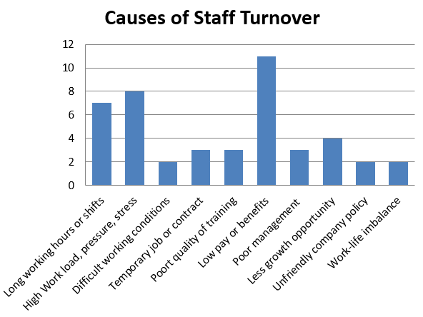
Figure 3
All the 25 participants responded to this question according to their own perception or experiences. They identified different causes of staff turnover in their workplace. Some of these causes are long working hours, poor communication skills, stress, difficult working conditions, lack of free time, rude colleagues, more work during festive seasons, low chance of promotions, big targets, poor pay, lack of training, poor management, discrimination, lack of job rotation, work-life imbalance, lack of resources, monotonous work, unpleasant working environment, unfriendly company policy, lack of appropriate work culture, inappropriate health and safety measures and lack of motivation. The maximum participants (around 11 out of 25 i.e. 44%) responded that pay or compensation is the major reason for staff turnover.
2. What do you think is the good quality of service at your workplace?
The response collected is shown through a pie chart.
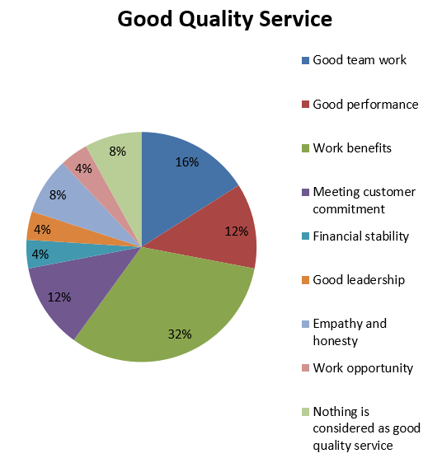
Figure 4
When the participants were questioned regarding good quality service at their workplace, they enthusiastically responded with various options that they can think of. Some of these good quality services include good communication, team work, empathy, coordination, excellent performance, transportation, benefits (paid transport or food and good facilities and work) or compensation, professionalism, work flexibility, work stability, paid leaves, financial security, health and safety measures, high productivity, appropriate skills, meeting customer expectations, honesty, career opportunities, good leadership, decent pay, balanced working hours and realistic targets. Around 8 out of 25 (32%) employees considered work benefits as the main good quality service at their workplace. The other main services were team work, performance and meeting customer expectations.

3. Do you consider staff turnover as a problem in your company and why?
The response collected is shown through a pie chart.
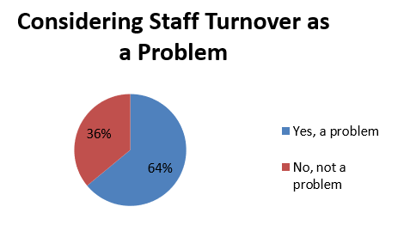
Figure 5
The respondents were quick to answer whether they consider employee turnover as an issue for their organisation. Around 16 out of 25 i.e. 64% respondents admitted that staff turnover causes problems for their workplace. The rest 36% do not find any problem in staff turnover for their company. The main reasons why they consider staff turnover as an issue are difficult to find new skilful employees, introduction of errors and mistakes by new employees, high recruitment costs, loss of institutional knowledge, lack of stability and reduced work flow. The reasons why they see staff turnover as a good opportunity for the company are to get new and skilful employees with temporary job, give opportunity to other people to acquire new skills and knowledge and being a financial stable company so can hire any number of employees anytime.
4. What are the negative and positive effects of staff turnover in your company?
The response collected is shown through a pie chart.
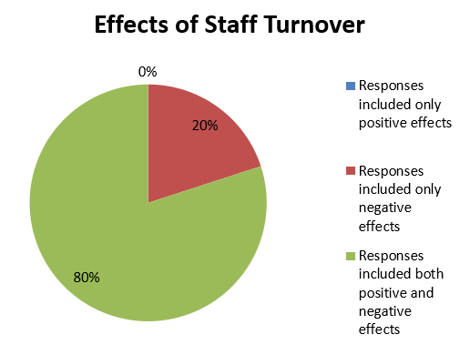
Figure 6
All the participants were asked regarding the positive and negative effects of staff turnover in their company. For this question, the response that they provided regarding the positive effects of staff turnover includes new enthusiastic and engaged staff who are willing to give their best performance, the company’s ability to pay more to fewer staff, new ideas and skill set from dynamic staff, creation of job opportunities and increase in training.
The response of the participants regarding the negative effect of staff turnover includes less experienced staff, increase of cost to company, loss of time due to training, more resources required for training, decrease in quality of service and productivity, lack of resources to meet customer deadlines, work stress as increase in work for remaining employees, toxic workplace culture, decrease in ownership or commitment by employees to take critical roles, knowledge gap, more mistakes or errors, slower work flow, instability amongst the employees and even loss of company’s image. Around 8 out of 25 employees responded that staff turnover results in loss of time for the company due to increase in training and hiring process. Around 4 out of 25 (i.e. 16%) employees responded that the staff turnover has negative impact on cost to company and another 16% responded that there is a negative effect on the quality of services and productivity of staff. There were even 12% of employees who felt the staff turnover has resulted in increase of employees’ stress.

5. How staff turnover affects the quality of customer service?
The response collected is shown through a pie chart.
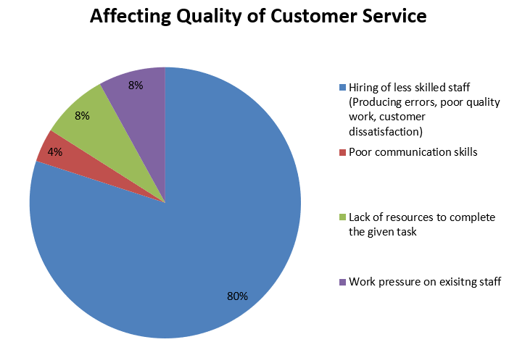
Figure 7
When the participants were questioned regarding how staff turnover affects the quality of customer service, they all accepted that quality of service is negatively impacted in some way or the other. According to 20 out of 25 (i.e. 80%) employees, staff turnover results in hiring of new and less skilled staff, which in turn result in introducing more errors, decreasing quality and generating customer dissatisfaction. Other respondents even mentioned that there due to staff turnover, there is increase in communication gap between staff and customers and lack of resources to complete the given task effectively and efficiently.
6. As per your opinion, what strategies Amazon can adopt to reduce its staff turnover?
The response collected is shown through a bar graph.

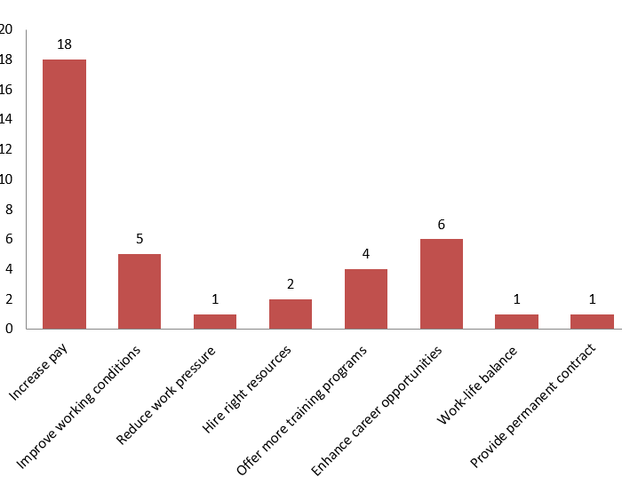
Figure 8
Towards the end of the survey, the participants were asked regarding their opinion on strategies that Amazon can adopt to reduce staff turnover. The maximum respondents i.e 18 out of 25 (72%) employees suggested that the company needs to hike the salary of the employees or provide them better compensation or benefits. The other respondents suggested to improve working conditions, reduce work pressure, normal working shifts, hiring right resources, offer more training programs and enhance career opportunities and work-life balance.

4.2 Discussions
The result of this primary research revealed that there are various factors or causes of staff turnover. Some of these factors were long working hours, stress, difficult working conditions, low chance of promotions, big targets, poor pay, lack of training, poor management, discrimination, work-life imbalance, lack of resources, unfriendly company policy and lack of appropriate work culture. This is in line with the “Causes of staff turnover in an organisation” section of the literature review, which states that mental stress, leadership, HRM practices, such as low salary, employee recognition or rewards mechanisms and lack of training programmes are the main causes of staff turnover.
Apart from this, the result also revealed that there are both positive and negative effects of staff turnover on service quality and business performance of Amazon. According to the survey, the participants have revealed that the negative effect of staff turnover includes less experienced staff, increase of cost to company, loss of time due to training, more resources required for training, decrease in quality of service and productivity, lack of resources to meet customer deadlines, work stress and more mistakes. This is in line with the “The impact of staff turnover on service quality and business performance” section of the literature review, which stated that some of the negative impacts of staff turnover include costs of recruitment, training and development, demotivation and operational disruption and mistakes from new employees. According to the result of the survey, the positive impacts of staff turnover were new enthusiastic and engaged staff and new ideas and skill set from dynamic staff. This is in line with the “The impact of staff turnover on service quality and business performance” section of the literature review, which stated that some of the positive impacts of staff turnover includes increased effectiveness due to skilful and energetic staff.

Chapter 5 – Conclusion and Recommendation

5.1 Conclusion
This research focused on the impact of staff turnover on the business performance and service quality of Amazon. It is concluded that it is very critical for organisations to identify the reasons, such as low remuneration, lack of training and career opportunities or poor leadership skills, for staff turnover. This helps these organisations to improve their corporate strategies and environment so that the employees feel comfortable to stay associated with them for a long period. Since employees are the backbone of any organisation, treating them well and making them motivated helps the organisations to remain competitive in the global market and provide excellent performance.
This research also helps the organisations to identify the positive and negative impacts of staff turnover on their performance and service quality. Organisations can relate these factors with their internal business environments and address the issues to lower the staff turnover rate. They can realise from the survey of the Amazon’s employees regarding how can their organisation can reduce staff turnover rate as per their opinion. Other organisations can relate those factors with their own employees and identify how much improvement is required for their HRM strategies and practices.

5.2 Recommendation
As per the empirical analysis of this research, some recommendations are provided to Amazon to lower their staff turnover rate and enhance their business performance and service quality. Firstly, the organisation needs to ensure that the pay of the employees is competitive and according to the industry standards (Bussin, 2018). It needs to recognise good efforts and performance of the employees and compensate them accordingly. The right career opportunities should be provided to each and every employee for their growth and competency. The goals set for them have to be realistic. It is important for Amazon to provide regular feedback to them regarding their performance and suggest them the ways they can become more competitive. At the same time, the leaders should also have regular meetings with their staff to share business information, experiences and their concerns.
The top management should ensure that adequate and appropriate training programmes are organised for the existing employees to help them to enhance their skills and knowledge (Abdullah, et al., 2019). Such measures help to motivate the employees and increase their confidence level regarding their abilities to accomplish their task successfully. There should also be orientation and training programmes for the new staff so that they clearly understand their work environment, culture and the job profile to give their best output. This also helps to reduce the wastage of resources.
The HRM needs to improve their hiring strategies to hire the right employees for the right job. This would help them to increase the work productivity of the employees and thus the business performance of the organisation (Wilton, 2019). Even there should be adequate staffing done so that work is evenly distributed amongst the employees. The employees should not be over-burdened to avoid them from getting stressed. It is important for Amazon to provide work-life balance to the employees and ensure that the working environment is conductive and hazard free.

5.3 Limitation
This research was conducted with limitations of resources, time and budget. Even the survey was limited to one of the Fulfilment Centre facilities of Amazon and not the organisation as a whole. Also, the research only collected qualitative data with open-ended questionnaire. The quantitative data analysis would have helped to interpret the results in a specific and accurate manner.

5.4 Future research
In order to improve the research, there should be mixed research conducted in future, involving both quantitative and qualitative research to provide the holistic view of the research and cover the objectives appropriately (Dubey & Kothari, 2022). This method also helps to ensure that the responses form the participants are specific and in right direction. The current research is only limited to the cause and impact on staff turnover. In the future research, it can focus more on the retention strategies to enable organisations to improve the productivity and cost to company by hiring new employees. Since this research was confined to only one department of Amazon, the future research can involve the organisation as a whole so that the collected data is relevant for the entire organisation.
The future research can also investigate on how staff turnover affects organisation’s financial stability and customer satisfaction, along with the service quality measure (Sarhadi, 2017). It can also investigate the relationship of seniority with the business performance i.e. if senior employees perform better than the junior employees.

References

Abdullah, A. G., Abdullah, C. U. & Widiaty, I., 2019. Global Competitiveness: Business Transformation in the Digital Era. Boca Raton: CRC Press.
aboutamazon.com, 2022. Our Workplace. [Online]
Available at: www.aboutamazon.com/workplace/facilities
[Accessed 2022].
aesanetwork.org, 2020. Research Onion: A Systematic Approach to Designing Research Methodology. [Online]
Available at: www.aesanetwork.org/research-onion-a-systematic-approach-to-designing-research-methodology/
[Accessed 2022].
Aikens, D., 2018. What are the Contributing Factors which Cause Employees in the Public-sector Hospitals to Leave Their Jobs. California: California State University, Northridge.
Allen, D. G. & Vardaman, J. M., 2021. Global Talent Retention: Understanding Employee Turnover Around the World. Bingley: Emerald Publishing Limited.
Amri, H. S. S. A. & Pandey, J., 2019. The perceived impact of employee turnoverand its outcome on the efficiency of theorganizational performance. Journal of Student Research.
Atar, E., 2022. The Impact of Employees' Behaviour in the Workplace. Cambridge: Cambridge Scholars Publishing.
Brinkmann, S., 2018. Philosophies of Qualitative Research. Oxford: Oxford University Press.
Bryson, J. R., Sundbo, J., Fuglsang, L. & Daniels, P., 2020. Service Management: Theory and Practice. Hamburg: Springer International Publishing.
Bussin, M., 2018. Retention Strategies: The Key to Attract and Retain Excellent Employees. Johannesburg: Knowledge Resources Pty Limited.
Dubey, U. K. B. & Kothari, D. P., 2022. Research Methodology: Techniques and Trends. Boca Raton: CRC Press.
Dudovskiy, J., 2022. Amazon Business Strategy: cost leadership & customer centricity. [Online]
Available at: research-methodology.net/amazon-business-strategy-benefiting-cost-leadership-diversification
[Accessed 2022].
Essien, W., 2019. Business Policy and Participative Decision-Making. Bloomington: AuthorHouse.
Haque, A. U., 2022. Handbook of Research on the Complexities and Strategies of Occupational Stress. Hershey: IGI Global.
Hom, P. W., Allen, D. G. & Griffeth, R. W., 2019. Employee Retention and Turnover: Why Employees Stay Or Leave. New Jersey: Taylor & Francis.
Johanson, G. & Williamson, K., 2017. Research Methods: Information, Systems, and Contexts. St. Louis: Elsevier Science.
Kraiger, K., Passmore, J., Santos, N. R. d. & Malvezzi, S., 2020. The Wiley Blackwell Handbook of the Psychology of Training, Development, and Performance Improvement. New Jersey: Wiley.
Leavy, P., 2017. Research Design: Quantitative, Qualitative, Mixed Methods, Arts-Based, and Community-Based Participatory Research Approaches. New York: Guilford Publications.
Liddle, D., 2017. Managing Conflict: A Practical Guide to Resolution in the Workplace. London: Kogan Page.
Logue, J. & Yates, J., 2018. The Real World of Employee Ownership. New York: Cornell University Press.
Machado, C. & Davim, J. P., 2020. Research Methodology in Management and Industrial Engineering. Hamburg: Springer International Publishing.
Malik, A., 2022. Strategic Human Resource Management and Employment Relations: An International Perspective. Hamburg: Springer International Publishing.
Munot, M. V. & Bairagi, V., 2019. Research Methodology: A Practical and Scientific Approach. Boca Raton: CRC Press.
Ngulube, P., 2021. Handbook of Research on Mixed Methods Research in Information Science. Hershey: IGI Global.
Ogony, S. M., 2019. The Effect of Employee Turnover on Performance. Pietermaritzburg: University of KwaZulu-Natal, Pietermaritzburg.
Poth, C. N., 2020. Research Ethics: Little Quick Fix. London: SAGE Publications.
Rocha, S., 2018. Leadership Styles and Employee Turnover. California: California State University, Northridge.
Samoilenko, S. & Osei-Bryson, K.-M., 2021. Quantitative Methodologies Using Multi-Methods: Models for Social Science and Information Technology Research. Boca Raton: CRC Press.
Sarhadi, S., 2017. The Effects of Employee High Turnover Within Organizations. California: California State University, Stanislaus.
Segalla, M., 2021. International Perspectives on Employee Engagement. New Jersey: Taylor & Francis.
Stokes, P. & Wall, T., 2017. Research Methods. London: Macmillan Education UK.
Thaichon, P. & Ratten, V., 2020. Transforming Relationship Marketing: Strategies and Business Models in the Digital Age. New Jersey: Taylor & Francis.
Thomas, C. G., 2021. Research Methodology and Scientific Writing. Hamburg: Springer International Publishing.
Tshabangu, I., 2020. Approaches and Processes of Social Science Research. Hershey: IGI Global.
Wilson, J., 2017. Essentials of Business Research: A Guide to Doing Your Research Project. London: SAGE Publications.
Wilton, N., 2019. An Introduction to Human Resource Management. London: SAGE Publications.
Wu, C. & Thompson, M. E., 2021. Sampling Theory and Practice. Hamburg: Springer International Publishing.

