Crina Iordache (2112903)
| ACCB4002_loN
Data Analysis and Visualization Assignment I
Infographic Analysis

Table of Contents

INTRODUCTION 1

Task 1 2

Understanding of the given Infographic 2

the points that need to be addressed in the evaluation: 2

Message Identification 3

Colour usage 3

text usage 3

graph suitability 3

Graphics Incorporation 4

cognition suitability 4

improvements 4

conclusion 4

REferences 5

appendix 5

INTRODUCTION

A definition of infographics according to M.J. Albers is: “An infographic is a web-based image that takes a large amount of information in text or numerical form and condenses it into a combination of images and text with a goal of making the information presentable and digestible to an audience.” [1]
This report aims to provide a clear understanding of infographics, their standards, meaning, criteria, and main characteristics in order to deliver a precise, broad and informative analysation and review of the “Physical activity for adults UK” infographic which can be accessed at : https://moodle.uwtsd.ac.uk/pluginfile.php/581525/mod_resource/content/1/physical-activity-infographic.jpg. The main points of the study will be characteristics such as scalability, structure, visual design, the clarity of information and so on.[1]

Task 1

The aim of task 1 is to create an engaging, analytical and creative discussion on multiple criteria and requirements of how effective, clear and understandable the above-mentioned infographic is based on research materials with an appropriate logical analysation. This task also entails the discussion of good points and bad points as well as new recommendations.[1]

Understanding of the given Infographic

The infographic presents information relevant to a specific target audience and is attempting to deliver relevant medical advice through the practice of physical activity, it is composed of symbols and visuals as well as text and numbers which will be thoroughly analysed and evaluated based on today’s standards.[1]

the points that need to be addressed in the evaluation:

- Message Identification
- Colour Usage
- Text Usage
- Graph Suitability
- Graphics Incorporation
- Cognition Suitability
- Improvements

Message Identification

At first glance, the point and message of the given infographic is identified by the headline itself, it provides a hint at what the infographic is trying to represent which is the “Physical activity for Adults and Older Adults”, it clearly focuses on adults and older adults, and it’s centered around the health and fitness domain. Although the headline is a good starting point for conveying the purpose of the infographic, it is not enough as the rest of the information is set in a disorganised manner and can be quite confusing, the infographic has little to no direction and it lacks visual simplicity.[2]

Colour usage

The colours of the infographic are unattractive and unsuitable for the subjects it represents, as the subject is fitness and health the colour palette should have focused more on energizing and fresher colours such as a brighter green and a faded-out orange to create contrast between ideas, give more direction to the information, be relevant to the subject and have a more attractive design.[3] [4]
See Figure 1.

text usage

Some areas of the infographic such as the “Minimise the sedentary time” section are clearer and written with the right size and amount of text and information, as well as the numbers but the rest of the infographic is written in a very hazy way, most of the information being too small and too much for adults to see or read, especially older adults that may have issues concerning their eyesight.
The text should have been sized appropriately for the target audience and for the scale and structure it has, as the text is currently it creates confusion and fails to present all the information.[3]

graph suitability

The usage of the graph is very lacking in this infographic as the information is not well organised, part of the text is written sideways and hard to understand, the percentages of the types of illnesses that physical activity can improve could have been much better understood through using a pie chart or histogram, which could better combine the information and visuals and more focus in the key points.[3]
See Figure 2.

Graphics Incorporation

The strengths of the given infographic are the usage of symbols and graphic design that clearly exhibit the activities, such as the cycling, swimming, and running symbols , they give a better understanding of the information and educates the audience though visuals, although these are strengths there are also weaknesses such as the lack of visual simplicity which makes the relationship between elements unclear and disorganised.[4]

cognition suitability

The given infographic could improve it’s cognition by minimizing the amount of information and summarizing only the key points since there is too much information and it fails to educate and share the knowledge of the subject without the aid of the visuals and symbols, the only strong points are the headline and physical activities yet the duration and benefits are easily overlooked with the current structure, by focusing only on the key factors the audience would be left with much more knowledge and information.[5]

improvements

The infographic could be improved by making more use of graphs, altering the text size for design and understanding, structuring and summarizing the information into key points as to convey more concise knowledge, adding arrow symbols to give the infographic a clearer direction and flow as for the audience to understand where to begin and end their read, it could also be made interactive with links to videos or a questions and answers section and it is also important to add citations to demonstrate the accuracy of the information provided.[5] [6]

conclusion

All in all the given infographic has been analysed based on the given requirements and criteria, as stated above it has both strengths and weaknesses and as demonstrated though the Figure 1 and Figure 2 it could be improved in certain areas in order to satisfy the standards of an up to date educational infographic that coveys an easily comprehensible message with precise knowledge.[6]

REferences

[1]M. J. Albers, “Infographics: Horrid chart junk or quality communication,” IEEE Xplore, Oct. 01, 2014, https://ieeexplore.ieee.org/abstract/document/7020344/references#references
[2]T. Bystrova, “Infographics as a Tool for Improving Effectiveness of Education,” KnE Social Sciences, vol. 4, no. 13, Sep. 2020, doi: 10.18502/kss.v4i13.7710.
[3]S. Yildirim, “Infographics for Educational Purposes: Their Structure, Properties and Reader Approaches,” Turkish Online Journal of Educational Technology - TOJET, vol. 15, no. 3, pp. 98–110, 2016, [Online]. Available: https://eric.ed.gov/?id=EJ1106376
[4]S. Ben, Information made beautiful : infographic design. Hong Kong: Sendpoints Publishing Co, 2015.
[5]R. Krum, Cool Infographics: Effective Communication with Data Visualization and Design. John Wiley & Sons, 2013. Accessed: Apr. 01, 2022. [Online]. Available: https://books.google.co.uk/books?hl=ro&lr=&id=7ZesAQAAQBAJ&oi=fnd&pg=PP2&dq=infographics+data+visualization&ots=L5PoGvnRU8&sig=vwed1EXBgCjz7NEsiaVWnwYf1dg&redir_esc=y#v=onepage&q=infographics%20data%20visualization&f=false
[6]M. J. Albers, “Infographics and Communicating Complex Information,” Design, User Experience, and Usability: Users and Interactions, pp. 267–276, 2015, doi: 10.1007/978-3-319-20898-5_26.

appendix

  - Appendix A

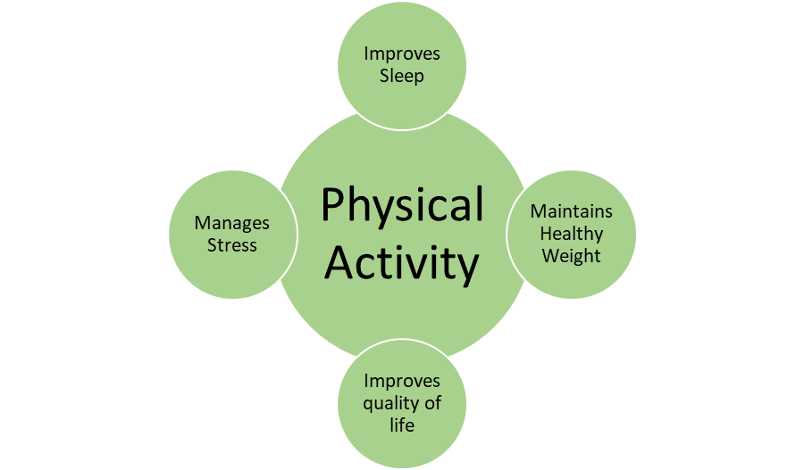Fig 1.
Fig 1. Represents an improvement to the reviewed infographic, this version gives it a better and easier understanding and more direction and flow as the viewer knows exactly what it means and what to connect the elements to.
  - Appendix B

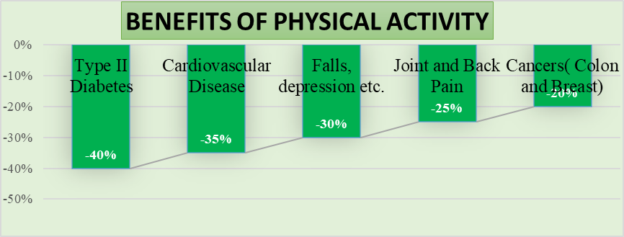Fig 2.

Fig 2. Is an example of how the usage of graphs can improve the infographic, the information is presented in a much more organised and logical manner, making it easier to educate and clearly transmit the information to the audience.

