2204938
Module code: BMOE6002

Curriculum Adventure



Assessment: Written Proposal
Module lead: Maria Trevino Gonzalez

Proposed plans to improve affordances of Cynefin

The New Curriculum for Wales states that within the Health and Wellbeing area of learning, learners will be supported to “understand and appreciate how the different components of health and well-being are interconnected, and it recognises that good health and well-being are important to enable successful learning” (Welsh Government, 2022). This proposal aims to highlights ways in which the learning environment at Cynefin (the outdoor facility used by the PE and Outdoor Ed departments) can be improved to improve physical literacy and health and wellbeing. Firstly, the problem will be contextualised within Wales and more information on exactly what sort of learnings the curriculum for Wales says students should be walking away with will be given. This will inform the solutions to the problem and then the paper will offer four changes that combat the issues and justification provided on how they propose to improve student physical literacy health and wellbeing. The first solution is creating loose parts section in one of the fields in cynefin, the next is building a small area of bouldering stones also in one of the fields. The third is making an outdoor kitchen that incorporates sustainability through water pumps and risk management through fire safety. Finally, the last solution is building a recycled path of plastic planks through the wetland area that leads to three bird hides.

Background
As a PE (Physical Education) and Outdoor education (Ed) department health and general wellbeing are large parts of what the subjects aim to do for students (Welsh Government, 2020). This means that as departments, appropriate environments that have suitable affordances which develop student’s physical literacy, should be readily available. There are a few underpinnings within this area of learning which curriculum for Wales guidance suggests should be prioritised. The first is that “Learners will be encouraged to develop the confidence, motivation, physical competence, knowledge and understanding that can help them lead healthy and active lifestyles which promote good physical health and well-being” (Welsh Government, 2020), in other words a good level of awareness of what health looks like and how they can adjust their lifestyles to feel healthy. The next one talks about how learners view and partake in healthy relationships, it highlights that learners should start to “value how feelings of belonging and connection that come from healthy relationships have a powerful effect on health (and) wellbeing” (Welsh Government, 2020). The last element that will be taken into consideration for this proposal helps learners “understand how their decisions and actions impact on themselves, others and on wider society” (Welsh Government, 2022). This incorporates all the factors that influence decision making and encourages learners to be conscious of their processes and therefore be able to make better more informed decisions. An important factor in decision-making, and something that needs to be prefaced in this proposal is the component of risk. As these environments are intended to be used by 12 –14-year-olds, it may be necessary to consider how they view risky environments and in what ways can PE and Outdoor Ed lessons foster this need to seek out risk but also facilitate it in a way that benefits decision making and is not causing harm.

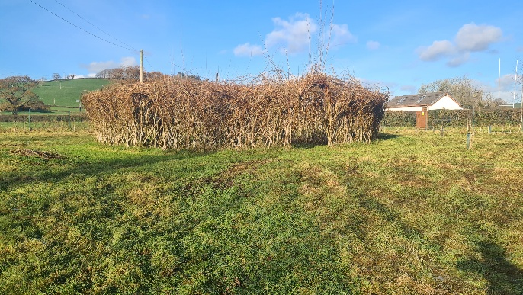
Loose Parts
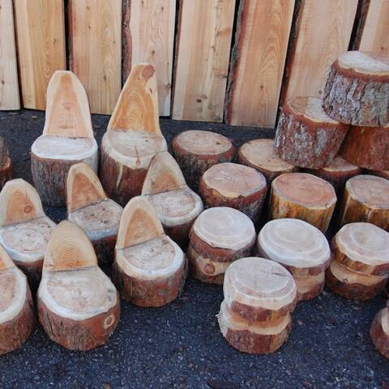
The first change I propose to the space is a loose parts area. This area will be located inside the existing willow structure. A weatherproof shed style structure will house the materials. The shed will be made out of wood to ensure the landscape remains visually as natural as possible. As seen in the images below it will house tires, wooden planks and crates, as well as natural materials like pinecones, acorns and nuts, and stones. This activity is intended to be done mostly independent to the facilitator. It can be used in organised activities for example, car or bridge building, or young people could be left to use the area as they want. Both uses encourage imagination and increase the use of fine and gross motor skills which have been shown to be an important factor for teenager’s physical activity levels (Weedon et al, 2018). This area is designed to be an inclusive and open environment to encourage students to see boundless opportunity within the area, this aims to combat disinterest which has been shown to lead to disengagement within Physical education (Mo et al, 2024). Because of the vastness of opportunity within this activity, it has the potential to significantly improve physical literacy among students, it’s inclusion of large, heavy objects which when used can improve; strength, balance and coordination, and smaller objects which when used can improve fine motor skills. This can increase self-confidence in Fundamental movement skills which in turn has been shown to higher confidence in physical activity therefore higher engagement (Dweck, 1991; Mcgrane, 2016). Overall, this area would create opportunities to develop; teamwork and communication skills between students, encourage creativity and imagination and improve fundamental movement skills.

Bouldering Stones
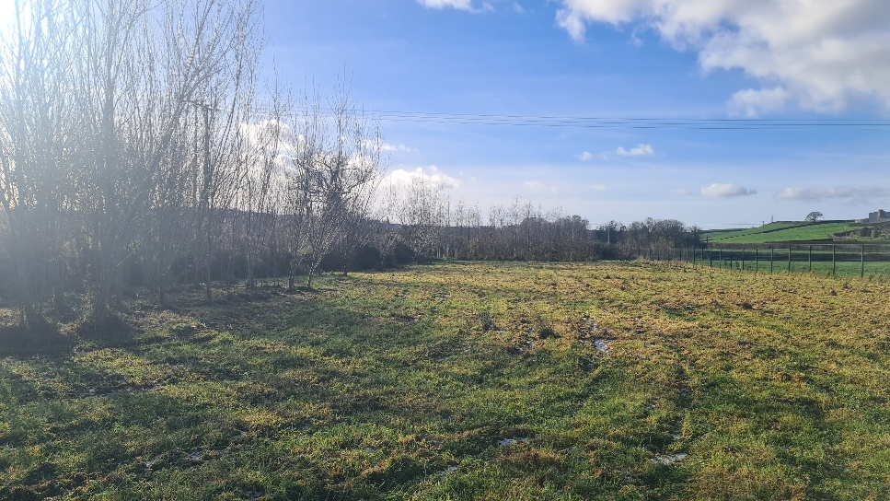
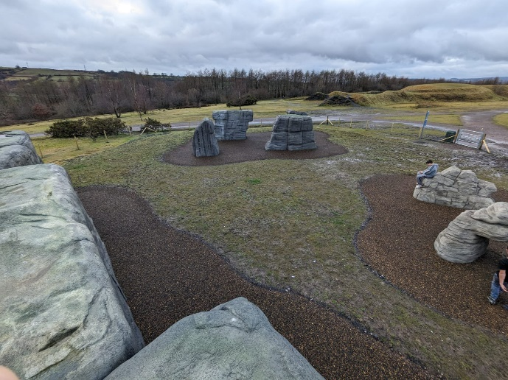
The second proposed change to the environment at Cynefin is a bouldering space. It would look very similar to what is pictured right, and would be located in the front field area. This is the flattest part of the site and would be suitable for putting in a soft ground such as wood chipping or rubber tarmac. The boulders will be purpose built to have different levels of difficulty, this allows them to be used by all learners and gives the opportunity to develop through the stages of progression. Having a range of difficulty means that students starting on different stages of progression or moving at a different speed still get just as rich of a learning experiences as the rest of the class. the curriculum for Wales highlights learners “will also be encouraged to develop their abilities to form, nurture and maintain relationships.”(Welsh government, 2020). Bouldering provides the opportunity to nurture peer relationships through supporting each other to route read and giving encouragement (Seigel and Fryer,2015; . Bouldering has the benefit of being a moderately intensive cardio activity while also requiring a lot of strength (Seigel and Fryer, 2015). Creating this space would mean students have an accessible and suitable level of challenge where they can develop their personal fitness and physical literacy, and also be learning how to communicate and participate in healthy, kind relationships with their peers. Having bouldering stones at Cynefin also provides an outlet for teenagers seeking adrenaline to partake in a risky situation safely and with supervision. Rock climbing as a hobby for adolescents has been linked with improved ability to take responsibility and accountability for actions as an individual. This was discussed by Hansen and Parker (2008), teenagers who joined a climbing club were taken through a programme that took them from an indoor wall to climbing a “75-to-80-foot mountain”. At the end of the programme the members had changed dramatically, “the need for greater support from others, the realization of the importance of caring for the equipment in a potentially threatening environment, and the boost in self-confidence from climbing mountains reinforced the respect and responsibility of club members”. This shows that these important lessons can be taught effectively through the medium of climbing.

Outdoor Kitchen
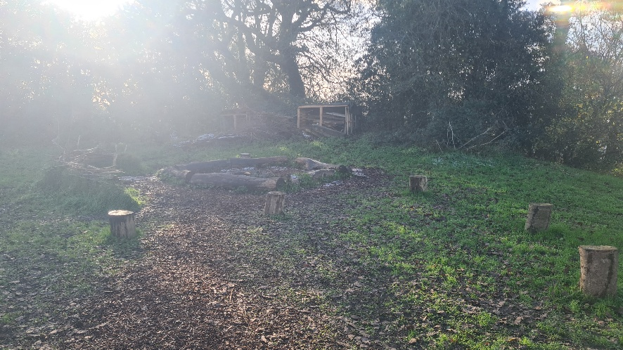
As mentioned earlier the Welsh government stated in its new curriculum that learners should be gaining understanding of “health promoting behaviours” this includes a “balanced diet” (Curriculum for Wales, 2022). A proposed method of teaching this is incorporating an outdoor sustainable kitchen to Cynefin’s grounds. The plan is to build a kitchen using recycled materials from various sources; online organisations like Enviromate (2024), the local community and local rubbish tips that allow the public to come and take materials. This would mean the building of the kitchen would have minimal impact through the sourcing of materials and also gives students the opportunity to have conversations about why this is a step in creating new projects.
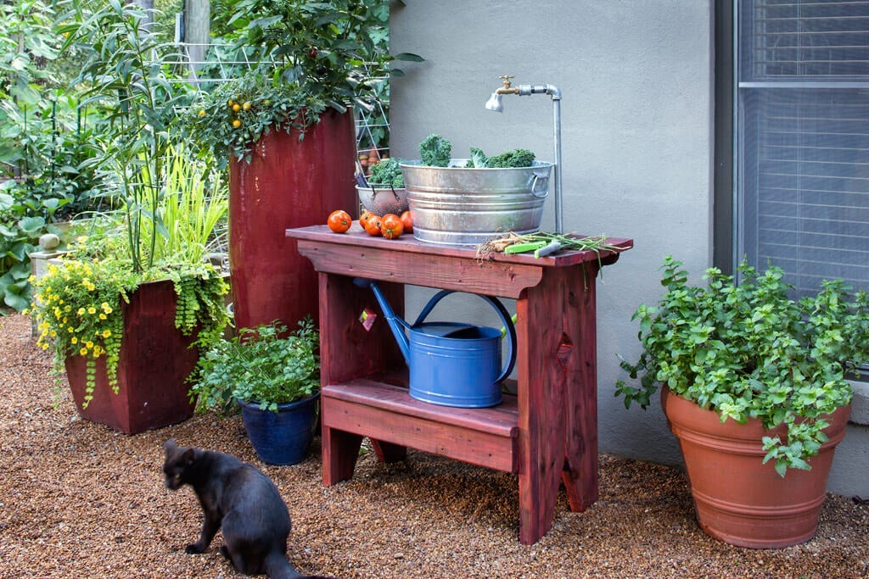
The kitchen would be located at the fire pit section of Cynefin and will include a recycled rainwater sink and counter space. The reason no heat source will be included is because there is already a firepit next to where the kitchen is proposed to be. This is a perfectly suitable place for cooking anything that needs heat and removes the need to fit an oven or hob, which would be a costly and long job, especially when there is a suitable alternative that already exists on the grounds.
Diet and Nutrition are integral parts of leading a physically active life (Amahmid et al, 2019; Comeau, 2023). This kitchen not only has the benefit of allowing the students to practically gain understanding of how to achieve a balanced diet, but it also incorporates, through the use of the firepit and being outdoors, an element of risk. Research seems to suggest that adolescents seek out risk in their daily live (Ciranka, 2021), in his book Tim Gill also describes how little we facilitate risk for children from a young age (Gill, 2007). Both of these factors contribute to create teenagers who are not capable of identifying reasonable risk so commonly will either take risks that are far too dangerous or become anxious. This is obviously not true for every teenager, but facilitating students to do something like working with fire can be something that feeds their need to take risks in a very managed way. It means that

Bird Hide
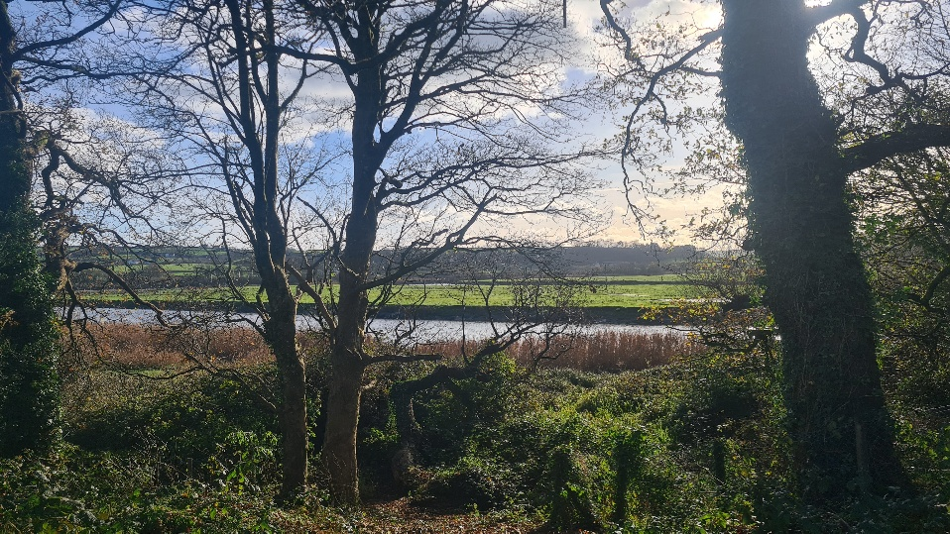
The fourth proposed change would be creating three bird hides in the wetland area located next to the river on the Cynefin site. As this area is next to the river it can be prone to flooding, to combat this it is proposed that a raised boardwalk is created using recycled plastic planks. The decision to build a boardwalk has multiple benefits, it means that access to the wetland is improved and will encourage usage of the area even in wetter conditions (Kusler, no date).
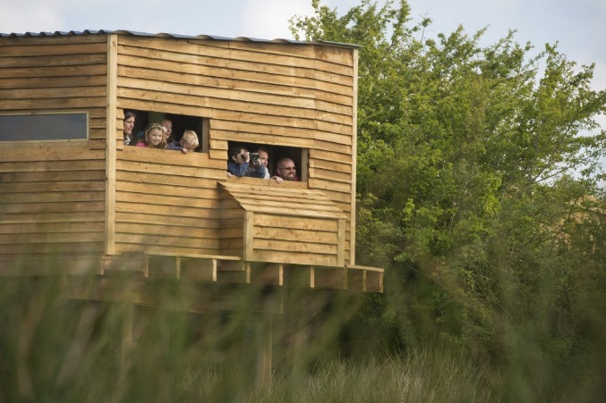
As identified by WWT, a Wetland restoration charity in UK, wetlands are dynamic rich areas that are either permanently or occasionally covered in water. They support many different species that have all evolved and adapted to the seasonal environment (WWT, no date). For birdwatching the provide the perfect environment, they are home to many different species that exist only in these specific environments. Birdwatchers are also able to access special benefits from being within the wetlands, the mental health foundation (no date) identified five ways birdwatching can encourage a nature connection; engaging all the senses, appreciating simple beauty in things we would not notice every day, feeling a sense of place and finding “hidden meanings” like “folklore” and “tradition” of a place, developing “moral and ethical concern for nature” which encourages deeper thought about compassion and empathy (Mental Health Foundation, 2021). Overall, building the boardwalk and bird-hides among the wetlands proposes to improve environmental understanding and consciousness, improving self -awareness in terms of empathy for animals and improving overall mental wellbeing (Mental health foundation, 2021; Reeves, 2021; Peterson et al, 2024).

Summary
In summary the proposal presented aims to hit three of the five “Statements of what matters” in the New Curriculum for Wales (2022), physical health and wellbeing, awareness of emotional health in self and others and develop an understanding of the impact of decision – making on self and others. To achieve these statements four changes were proposed to Cynefin, all targeting very different areas of development to come closer to achieving an area that is inclusive in catering for a range of interests and abilities among students. A loose parts area was proposed first, this aims to build peer connections through teamwork and enhance student’s creativity and problem-solving through physical activity. The second area was a patch of bouldering stones, this brings a different sort of challenge that is more physical and incorporates some development of risk management meaning students become more aware and intentional with their decision making as there are very real physical consequences that can affect their health. Next, a kitchen located next to the existing fire pit was introduced, this activity can allow students to put into practise theory they have learned about nutrition and a balanced diet. The novelty of this activity and the relaxed nature in which it would ideally be run should create an environment where students start to enjoy the food they create and as a result take the learnings into adulthood and be more mindful about their nutrition. The last proposed change was in the wetlands area, next to the river Towy, it was three bird-hides and raised path leading to them from Cynefin. This area is aimed at promoting a calm atmosphere, somewhere students can appreciate nature through spotting and identifying birds, an activity that will not work if students are too loud. It also aims at promoting those peer relationships again through communication and teamwork in getting to a common goal. Having a raised path also means that the area will become more inclusive for students.

References
Amahmid, O., El Guamri, Y., Rakibi, Y., Yazidi, M., Razoki, B., Kaid Rassou, K., … Belghyti, D. . (2019) ‘Nutrition education in school curriculum: impact on adolescents’ attitudes and dietary behaviours’, International Journal of Health Promotion and Education, 58(5), pp. 242–258.
Doi: 10.1080/14635240.2019.1685399

Ciranka, S., Bos.W.V.D. (2021), ‘Adolescent risk-taking in the context of exploration and social influence’, Developmental Review, 61.
https://doi.org/10.1016/j.dr.2021.100979

Comeau, A., Mertens, B., Bachwal, L., Utter, J., Herwerden, L. ‘Effectiveness of nutrition interventions in Australian secondary schools: a systematic review’, Health Promotion Journal Australia, 35(3), pp. 567-587.
https://doi.org/10.1002/hpja.787.

Dweck, C. S. (1991). Self-theories and goals: Their role in motivation, personality, and development. In Nebraska symposium on motivation. Lincoln, NE: Univeristy of Nebraska Press.

Enviromate , “buy, sell and discover leftover building materials”, 2024. [Online]
Available at: Enviromate | Free Leftover Building Materials Marketplace
Accessed on: 15/12/24

Gill, T. No Fear: Growing up in a risk averse society, London: Calouste Gulbenkian Foundation, 2007.

Hansen, K., & Parker, M. (2009). Rock Climbing: An Experience with Responsibility. Journal of Physical Education, Recreation & Dance, 80(2), 17–55. https://doi.org/10.1080/07303084.2009.10598278

Kusler, J. “Common questions: Constructing wetland boardwalks and trails”, no date. [Online].
Available at: Microsoft Word - 2_boardwalk_6_26_06.doc
Accessed on: 19/12/24

McGrane, B., Belton, S., Powell, D., & Issartel, J. (2016). ‘The relationship between fundamental movement skill proficiency and physical self-confidence among adolescents’, Journal of Sports Sciences, 35(17), pp. 1709–1714. https://doi.org/10.1080/02640414.2016.1235280

Mental Health Foundation, “Wetlands and Wellbeing: A guide for winter”, 2021. [Online].
Available at: Wetlands and wellbeing: A guide for winter | Mental Health Foundation
Accessed on: 19/12/24

Mo, W., Saibon, J.B., LI, Y. et al. (2024) ‘Effects of game-based physical education program on enjoyment in children and adolescents: a systematic review and meta-analysis’, BMC Public Health, 24 (517).
https://doi.org/10.1186/s12889-024-18043-6

Peterson, M. N., Larson, L.R., Hipp, A., Beall, J.M., Lerose, C., Desrochers, H., Lauder, S., Torres, S., Tarr, N. A., Stukes, K., Stevenson, K., Martin, K.L. (2024), ‘Birdwatching linked to psychological wellbeing on college campuses: A pilot-scale experimental study’, Journal of Environmental Psychology, 96.
https://doi.org/10.1016/j.jenvp.2024.102306

Reeves, J. P., John, C. H. D., Wood, K. A., Maund, P. R. (2021), ‘A Qualitative Analysis of UK Wetland Visitor Centres as a Health Resource’, International Journal of Environmental Research and Public Health, 18(16).
https://doi.org/10.3390/ijerph18168629

Siegel SR, Fryer SM. Rock Climbing for Promoting Physical Activity in Youth. American Journal of Lifestyle Medicine. 2017;11(3):243-251.
Doi:10.1177/1559827615592345

Weedon, B. D., Liu, F., Mahmoud, W., Metz, R., Beunder, K., Delextrat, A., Morris, M.G., Esser, P., Collett, J., Meaney, A., Howells, K., Dawes, H. (2018) ‘The relationship of gross upper and lower limb motor competence to measures of health and fitness in adolescents aged 13–14 years’, BMJ Open Sport & Exercise Medicine, 4(1).
https://doi.org/10.1136/bmjsem-2017-000288

Welsh Government, “Areas of Learning and Experience: Health and Wellbeing”, 2020. [Online].
Available at: Health and Well-being: Introduction - Hwb
Accessed on: 19/12/2024

WWT, “Wetland Wildlife”, no date. [Online].
Available at: Wetland wildlife | WWT
Accessed on: 19/12/24

