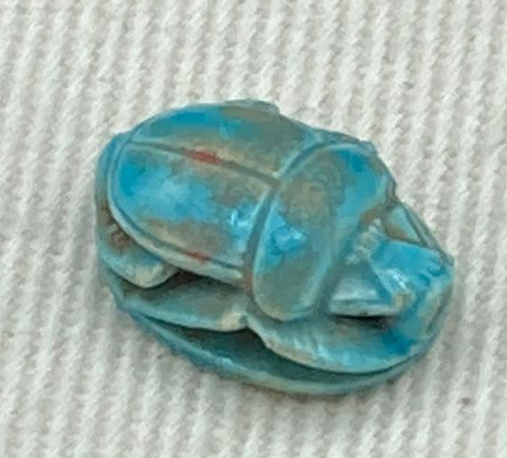
Scarab bearing the cartouche of Thutmose III
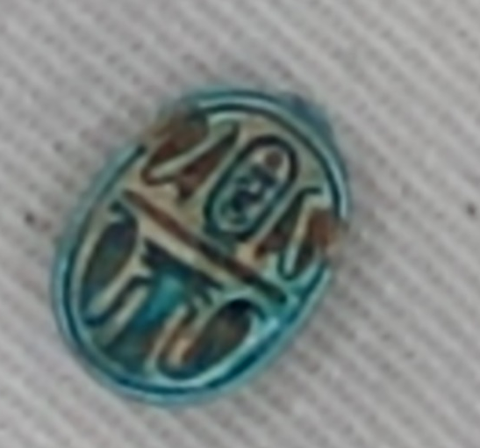
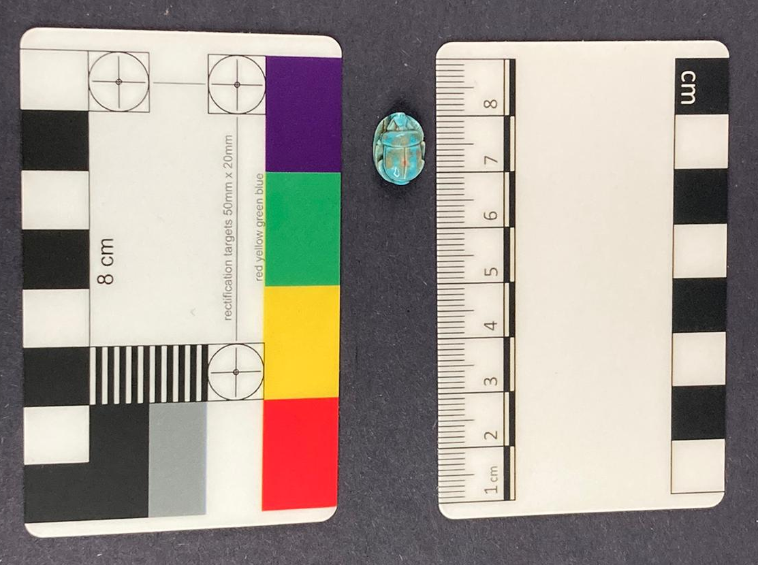
Images one two and three

Cyfarthfa Castle, Merthyr Tydfil (Assumed CCM 1725.004)

Object type: Scarab
Material: Faience
Period: After 1479 BCE
Provenance: unknown, most likely Egypt, or places with close relations to Egypt i.e. Nubia
Dimensions: 1.1 cm length, 0.7 cm width, and 0.3cm height.
Object analysis by Rachael (Aells) Bone

This object is a stylised Egyptian Scarab that is incredibly small,1.1 CM in length, 0.7 CM wide and 0.3 CM tall, and has a lot of fantastic detailing. The front legs of it have extra detailing carved in to give it a texture. There is not any noticeable humeral callosity, however, where the legs are joined with the rest of the body gives the illusion of these notches. The elytra and prothorax are given the similar stylised design to other scarabs, although the prothorax, when viewed from above, does seem to bulge out slightly. This prothorax seems to extend further than the elytra,

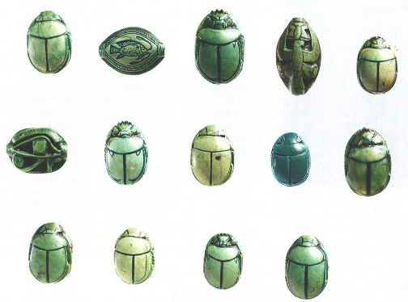
Image 4 - A collection of similar material culture – although all are made with soapstone rather than faience, they have the same overall design as our scarab – although some have the noticeable notches.
unlike other scarabs. The explanation for this could lie in one of its most distinct features, the fact that the scarab is not solidly attached to the base and instead there are gaps between its legs and body which stretch through the entirety of the piece, making it more impressive and delicate. There are no obvious joins between the scarab and the back plate, meaning they were most likely created joined together.

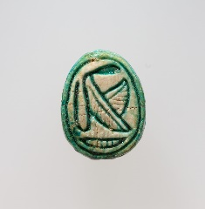
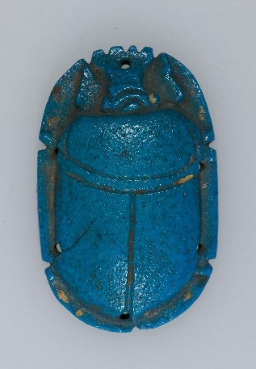
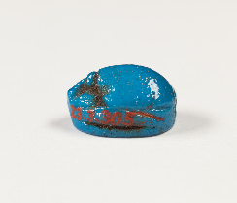
The scarab is made with Egyptian faience. While not the most common material we have for scarabs it is not unusual. Egyptian Faience is made from very common materials: quartz, alkaline salts, lime, and mineral-based colourants. It also holds some significant cultural value: objects created with Egyptian faience were considered magical, being linked with the sun and ‘imbued with the powers of rebirth’. As it has been made with this material, we can deduce it was either made with a mould or by hand, but due to the holes and intricate details the more likely option is by hand.
Image 5,6,7 – examples of Scarabs created with faience, The MET has around 753 scarabs made with this material

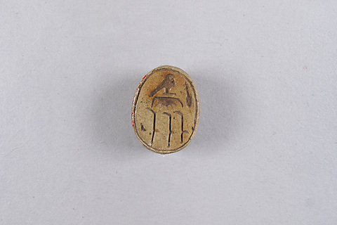
The material has then been glazed over, giving the scarab its beautiful blue colour. It is also possible to see the parts that are wearing away, showing the sandy colour underneath. The red colouration visible in some of it is most likely dirt which has gotten stuck when the glaze was applied and can be seen in other scarabs; some of which are unglazed. Another possibility is that it was done on purpose and the colours have worn away, but this seems unlikely as there are not any other examples of this. The glaze has worn away most noticeably around the lines that differentiate the elytra and prothorax, creating the possibility that these areas were glazed at a different time to the rest, or with fewer layers.
Image 8 - An unglazed scarab of Thutmose I

The scarab has some damage and not just the missing glaze. One of the front legs is chipped — and on the reverse side some of the edges have eroded away leaving some of the hieroglyphs less distinct. This does not look intentional and is likely due to either wear or transport to the UK.

The back of the scarab has a few hieroglyphs, the most notable of these being the cartouche of Thutmose III, with his throne name of Men-Keper-Re. This does allow us to give a lower-end date for this object, as it must come during or after the reign of Thutmose III. However, these scarabs were made well into the Late Period of Egypt, some were found for instance in the tomb of Tutankhamun.

The other hieroglyphs do not give us any other hints as to its exact purpose, they are readable but do not create a sentence or phrase. The cobra and ma ’at feathers could represent the god ma ‘at, the weighing of the heart or a great number of other things. It could also be representative of all of these things. The djed pillar, is also a symbol of strength lending credence to the idea that this was a scarab which was supposed to grant the wearer power.

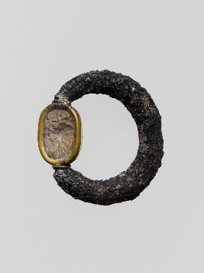
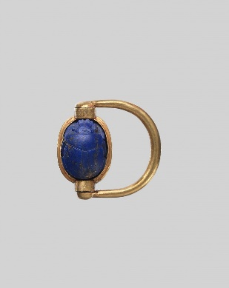
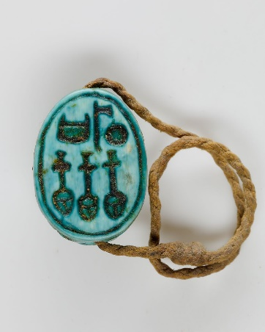
There are holes on either side of the Scarab: one near the clypeus and the other by the suture. These lend the idea at first glance that they were once an amulet or part of a necklace, with something running through. However, closer inspection lets us see that the hole does not fully go through and instead this could be used as some form of a ring instead. These were popular in Egypt from the Middle Kingdom onwards. This would give us an explanation of why it is so small if it was meant to sit on someone's finger. It seems unlikely that it would have been encased in gold, but it could have been attached to another material. There is evidence of silver and linen (Although the linen rings do look like they stretch all the way through)
Images 9, 10, 11 - Scarab rings, each with a different material, silver, gold, and linen.

Getting provenance on this scarab is incredibly difficult, while it was most likely made in Egypt it could have been traded to any country that Major Harry Hartley visited, while the vast majority of this collection was taken with the help of an antiques dealer in Cairo, we cannot be sure that if that was where this object was taken from. We also cannot be sure what the context around its discovery was, whether it was found in a tomb, or left as an offering, or discarded by the side of a path, leaving it to us to wonder.
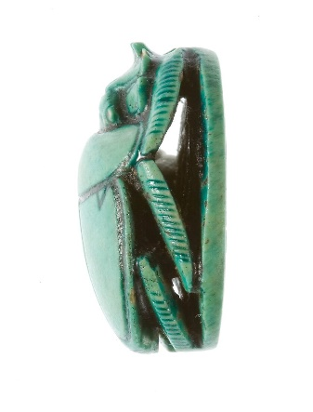
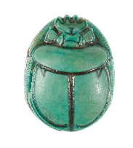
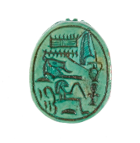
Image 12 - A Scarab with the same gaps as ours – in display at the Metropolitan museum – Hatshepsut united with Amun (27.3.164)
There is however one ray of light, in the discovery of a very similar scarab in The MET Museum which was in the Funerary temple of Hatshepsut in, it has the same ornate separations of the legs from the plate, which gives us a possible time frame for our object, the joint reign of Hatshepsut and Thutmose III or the years 1479–1458 B.C., it has also has similar dimensions to our scarab lending more credence to the fact they are from the same period.

Bibliography:
- Boddy K. Lotus. In Blooming Flowers: A Seasonal History of Plants and People (pp 71 – 82, 2020, Yale university press)
- Bryan B M. The eighteenth Dynasty before the Armana Period. in The Oxford history of Ancient Egypt (pp 218 – 269, 2000, Oxford University press)
- Drower, M.S, Dorman P.F Thutmose III –(https://www.britannica.com/biography/Thutmose-III, last accessed 15/2)
- El Mahdy, C. Mummies Myth and Magic (1998, first published 1991, Thames and Hudson Limited)
- Geddes & Grosset. Ancient Egypt: Myth and History (1997, Children’s leisure Products Limited)
- Hayward W, Fascinating Egyptian artefacts collected by a Merthyr explorer a century ago are set to go on display (https://www.walesonline.co.uk/news/local-news/fascinating-egyptian-artefacts-collected-merthyr-12630832 , Accessed 15/02/2023)
- Hart G .The Pharaohs. (2010, The Folio Society Ltd)
- Kessler D. The political history of the Eightieth to Twentieth Dynasty. In Egypt: The world of the Pharaoh (pp. 143 – 151, 1998, Könemann Verlagsgesellschaft mbH)
- Manley, B. Egyptian Hieroglyphs for Complete Beginners: The Revolutionary New Approach to Reading the Monuments. (2012, Thames & Hudson)
- Renfrew C. Loot, Legitimacy and Ownership: The Ethical Crisis in Archaeology (2000, Gerald Duckworth & Co. Ltd.)
- Riccardelli, C. “Egyptian Faience: Technology and Production.” In Heilbrunn Timeline of Art History. (New York: The Metropolitan Museum of Art, 2000–. http://www.metmuseum.org/toah/hd/egfc/hd_egfc.htm ,2017)
- Romer J. Valley of the Kings (1981, Book Club Associates)
- Taylor J H. Death & the afterlife in Ancient Egypt (2001, British Museum Press (British Museaum Company Ltd))
- Wilkinson, R. H. Egyptian Scarabs ( 2009 first published in 2008, Shire Publications Ltd.)
- Wilkinson, R.H. The Complete Gods and Goddesses of Anceint Egypt (2003, Thames an Hudson ltd)

Photos –
Image 1 – Courtesy of Sydney Padfield
Image 2 – Courtesy of Sydney Padfield
Image 3 – Courtesy of Sydney Padfield
Image 4 -Selected group of scarabs and seal amulets from the foundation deposits of Hatshepsut's temple at Deir el-Bahri - https://www.metmuseum.org/art/collection/search/545160 (Public domain)
Image 5 – Scarab https://www.metmuseum.org/art/collection/search/550533 (Public domain)
Image 6 – Scarab - https://www.metmuseum.org/art/collection/search/553736 (Public domain)
Image 7 – Scarab https://www.metmuseum.org/art/collection/search/550507 (Public domain)
Image 8 - Scarab Inscribed with the Name of Thutmose I https://www.metmuseum.org/art/collection/search/553354 (Public domain)
Image 9 - Silver swivel ring with agate scarab in gold setting - https://www.metmuseum.org/art/collection/search/243598 (Public domain)
Image 10 – Scarab Finger Ring with the Names of Thutmose III and Hatshepsut – https://www.metmuseum.org/art/collection/search/547602 (Public domain)
Image 11 – Scarab Ring https://www3.metmuseum.org/art/collection/search/548891 (Public domain)
Image 12 – Hatshepsut united with Amun - https://www.metmuseum.org/art/collection/search/545160 (Public domain)

See Image 4
See image 4
See image 5,6,7
Riccardelli, C. “Egyptian Faience: Technology and Production.” In Heilbrunn Timeline of Art History. (New York: The Metropolitan Museum of Art, 2000–. http://www.metmuseum.org/toah/hd/egfc/hd_egfc.htm ,2017)
Riccardelli. “Egyptian Faience: Technology and Production.”
See image 8
Translation courtesy of Julia Jones
Romer J. Valley of the Kings pp256 ((1981, Book Club Associates)
Own Translation
Drower, M.S, Dorman P.F – Britanica: Thutmose III
Scarab of Thutmose III - https://www.metmuseum.org/art/collection/search/557076
See Images 9,10, 11
Hayward W - Fascinating Egyptian artefacts collected by a Merthyr explorer a century ago are set to go on display

