I acknowledge the use of chat gpt on 17/02/2026 to create a logo for my work.
I used the prompt:

PROMPT 1- Generate me a logo for my business, the business idea is a business/charity would provide a support service for children who live with disabled or differently abled parents. The aim is to give children a safe, simple way to ask for help when they are worried about their parent, without immediately needing to call emergency services. The service would provide the child with a small, easy-to-use device. This device could stay in the home or be taken out with the child. When activated, it would alert a mobile support team who can attend the family and provide assistance or guidance.
PROPT 2- generate me a picture of what my device, cars and staff will look like

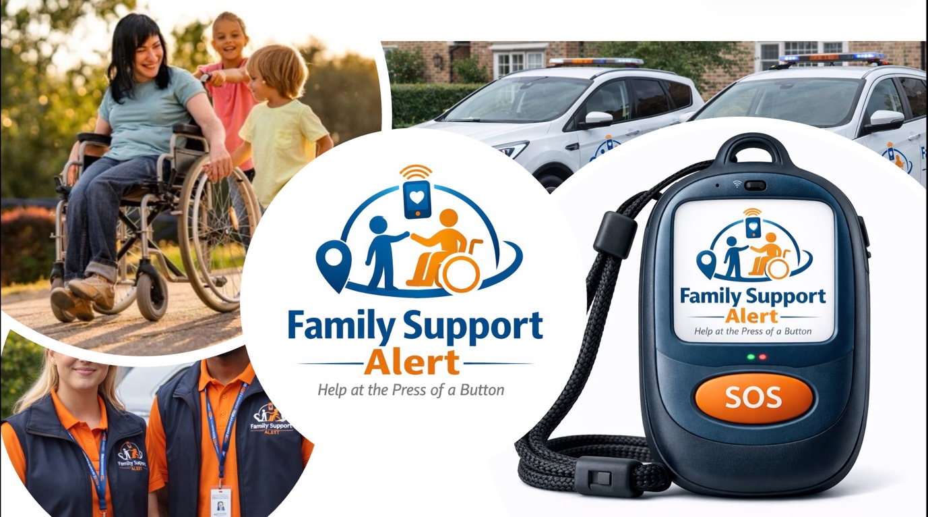
(Poster for pitch)
Business pitch script
Hello, good afternoon, my name is Anais Atkinson and I am here today to pitch my charity idea. The family support alert service.
I have always wondered how children cope and are affected with the stress of a parent or career that is disabled or differently abled. And this idea supports exactly that!
The family support alert service is a mobile service which is designed specifically for children who live with disabled or differently abled parents. The aim of this service is to provide children with a safe and straightforward way to reach out for help when they are worrying about their parent, without immediately needing to calling emergency services .
If the small device is activated, the device will alert a trained mobile support team member, who will attend the home or location that the device is registered to, or currently tracking, to provide prompt physical assistance, reassurance, or temporary supervision.
Family support alert service is all about reducing stress that may be placed on children, while still respecting the independence and capability of disabled parents.

Key features of the service will include:
- It is one button activated- the child can press it quickly if they are worried, without needing to make a phone call
- GPS tracking- the device will contain a gps tracker in it, so wherever the family travels with the device the team will be able to locate them and reach them quickly
- Child friendly design- the device is safe, durable and simple for children of different ages to use confidently
- Automatic alerts- once pressed, it will send an immediate notification to the Mobile response team also containing the medical history and diagnosis of the parent. As well as the information of the child or children in the care of the parent, alongside of emergency contacts.

This service will benefit children by reducing stress and anxiety relating to their disabled parent. It will give the children a safe way to ask for help, supporting their emotional wellbeing and allowing them to still focus on school, friendships and their personal development. By providing reassurance and prompt support, it will help children feel secure and confident, protecting their mental health and fostering healthy development.

So, where did the idea come from?
Approximately 1 out of 5 children under the age of 18 are young carers in the UK today evidently shown by (Barnardo's, 2023). Young carers are much more likely to experience anxiety, emotional stress, and disrupted education (Davies, 2022).
Whilst researching deeper into young carers, I noticed that most services available , focus on emotional support, peer groups or advocacy. These are very important and valuable aspects, however there is no real and practical emergency support designed specifically for children.
Through research I have come to an understanding that currently tele care equipment are provided through local councils or the NHS (NHS, 2023). Although, they are extremely useful and successful, they are often designed for older adults and are activated by the sails themselves. There it’s not much practical support aimed for children living with disabled parents.
My charity aims to fill the gap between coping alone and calling emergency services.

Benefits for the childrens wellbeing and development
This service will be highly beneficial for childrens emotional wellbeing and development. Living with a disabled parent can put children under constant stress and responsibility, which research has shown that it can negatively impact their mental health, confidence and educational engagement (Ronicle and Kendall, 2010).
By providing a safe and reliable way to ask for help, the family support alert service reduces chronic stress and anxiety. It will allow the space for the children to focus on more age appropriate activities. It will support the childrens healthy emotional growth, confidence and long term wellbeing (Ronicle and Kendall, 2010).
Another benefit that this service will provide is the relief that the parents will feel. Differently abled parents can tend to feel guilty, fearful, and or anxious about the amount of responsibility put upon their children. For parents to know that a trained response team is available, it will provide reassurance and a sense of relief. It will support the parents with their own independence whilst reducing pressure on the child (Centers for Disease Control and Prevention, 2024)

Why this charity will be successful
Although they are charities that provide wellbeing support and advocacy for young carers, there is currently extremely limited access to hands on support esspecially for immediate support and for children.
There is a clear gap in this area of support, which makes me confident that many families would benefit from this service as it provides a child focused intervention, which would also benefit emergency services. Due to the pressure and amount of callouts that my charity will decrease, my service will not only benefit families but also emergency services
The family support alert service would be able to benefit from already existing systems, services and charities to connect the appropriate people to my service.
Evidently, with the combination of a clear demand, an easy identifiable gap in services and alignment with afegaurding and wellbeing priorities, makes my charity both necessary and realistically sustainable.

Who am I and why am I the best person to advocate for off service?
So to begin I am deeply passionate about this idea because I want to help as many children and family's lives as possible. Also, this service has been creted from a place of care, understanding and a strong desire to improve childrens wellbeing.
As the person who developed this idea, I fully understand the purpose, values and future goals. I know exactly why the service is needed, how it would work and the positive difference it could make in childrens lives. So because of this, I am able to advocate for it with confidence, clarity and authenticity.
I am motivated, determined and genuinely invested in making this service successful. With my level of dedication would positively impact both the growth of the charity and the families it supports ensuring that the service remains child centred, responsive and effective.

Financial aspect
As a charity, the main cost would include
- staff recruitment
- manufacturing of the device
- Business car insurance
- Staff training
- Mileage compensation
The device its self will cost around £700-900 per unit, for a more advanced medical loacting/alert device, this would also incud the set up and searching of the device (Lancashire county council)
More of the financial factors would include:
- Business car insurance- around 500 pounds (Business, 2025)
- Staff trainig- £1,500
- Mileage compensation- 25p per mile
- Staff pay- £10.66- £16 an hour (Charity People, 2026)
- DBS- £50 and £13 a year to be on the update service (Gov.UK, 2017)
Prices can and will always change, so this will be something that will be looked into professionally by an accountant, which will ensure there are no areas being missed, and finances and being dealt with accordingly. An accountant can cost up t0 £200-400 a month.
Funding will be accessed through:
- Government charitable grants(GOV.UK, 2022)
- Donations
- Fundraisers
Thank you for listening, do you have any questions?
Part A-
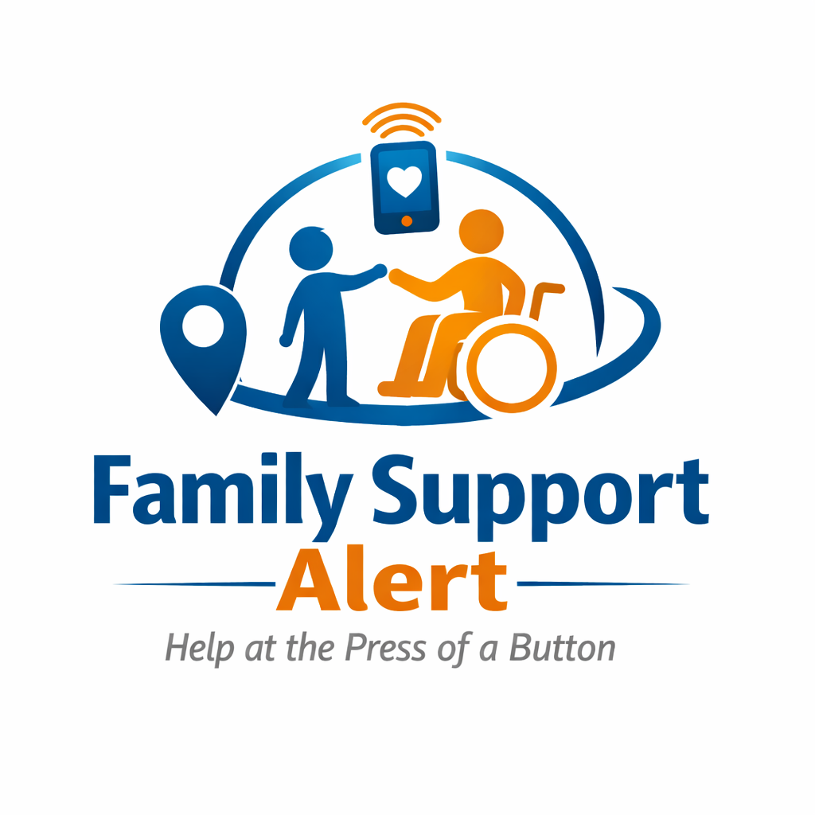
The family support alert service: Charity/Business plan

CONTENTS

SECTION 1-
- INTRODUCTION TO BUSINESS IDEA

SECTION 2-
- DESCRIPTION OF THE SERVICE

SECTION 3-
- INNOVATION AND LINKS TO EARLY YEARS

SECTION 4-
- BENEFITS FOR CHILDREN AND FAMILIES

SECTION 5-
- STAKEHOLDERS AND TARGET AUDIENCE

SECTION 6-
- CHALLENGES AND BARRIERS

SECTION 7-
- FINANCIAL OVERVIEW AND FUNDING CONSIDERATIONS

SECTION 8-
- PERSONAL SUITABILITY

Section 1- introduction to business idea
The family support alert service (FSAS) is a charity created to support children who live with disabled or differently abled parents or caregivers. This idea developed from myself questioning how children cope with the stress and responsibility that can occur within these family dynamics. Whilst many survices focus on emotional support and peer networks, it is clear that there is limited immediate and practical support specifically designed for child’s in situations where there may be worry or uncertainty (NHS, 2023).
In the United Kingdom, approximately 1 out of 5 children under the age of 18 are young carers, which can equate to roughly 700,00 children (Barnardo's, 2023). These children are much more inclined to to experience emotions of anxiety and disrupted education (Ronicle and Kendall, 2010)
Section 2- Description of the service
This service combines a small child friendly alert device with a trained mobile support team. Each family that meets the requirements for the service would receive free of charge device tha is instinctual, durable and suitable for all children of various ages (World Forgotten Children, 2024). The device will contains GPS tracker so the team will know where the family is located when the alert has been sent, this will ensure a a sufficient and quick response.
When the devise has been activated, the mobile support team will be notified straight away. The alert will then provide the families location, medical informations, and emerganc contacts. A trained member of the team will then attend he location in which the family are at and then provide support which could include assisting a a parent physically, reassuring the child, temporarily supervise an child, or contacting intervene services if necessary (HM Government, 2023).

Section 3- Innovation and links to early years
Moreover, the family support alert service is innovative as it begins to introduce child led emergency support, which is currently absent in young ccarer services (UNICEF, n.d.). From an early years perspective emotional security s vital to ensure healthy development, supported by (National Society for the Prevention of Cruelty to Children, 2021). Fraeworks such as the Early years foundation stage (Department for Education, 2024) highlight the importance of safe supportive environments, for buildings upon resilience, confidence and welling. Constant and fervour stress from homelife can negatively effect the child’s concentration, self esteem and attachment issues, evidently shown by (Steeger, Cook and Connell, 2016).
By proving a reliable, immediate safe mechanism, the device will only reduce anxiety and wil support the healthy emotional and social development of children whilst whilst supporting the child to obtain confidence, independence and resilience (NSPCC, 2021)

Section 4- Benefits for children and families
For chidren, this service gives them the opportunity to be children. It allows the child to become stress free and enables them to acts on age appropriate activities. Whilst there is some responsibility, it is reassuring for the child that there are people there to help them with their specific need. This will them promote the child’s emotional growth, confidence and long term wellbeing (Lacey, Xue and McMunn, 2022).
However, for parents it would be a completely different feeling. The service creates and offers reassurance that trained professionals are available when their child may feel concerned. This in turn should then eliminate the feelings of guilt, or worry and will strengthen their parental independence whilst still reducing the pressure from the child (McGlinchey et al., 2024).

Section 5- Stakeholders and target audience
One of the primary beneficiaries of the service would be children under the age of 18 that may care for their parents who are disabled or differently abled. The parents would then be the secondary beneficiaries, as much as the service is to benefit the children it is also to aid parents that may need a helping hand but it will also give the parents confidence that their child is safe.
Stakeholders could include:
- The mobile support staff
- Emergency services
- Potential partner charities
- Policy makers

Section 6- challenges and barriers
Potential challenges include:
- Financial constraints (manufacturing, staff recruitment/training) (Kear-Davies, 2024)
- Staff training and requirements (DBS check, capabilities for the role) (NSPCC, 2022)
- Technology understanding (samples may initially struggle with device)
- Awareness and uptake (families may be unaware or hesitant of the servic) (AMI, 2025)
- Legal challenges

Section 7- financial overview
Key costs include:
- Device manufacture- £700-900 per unit drains on spec (Lancashire county council)
- Staff wages- £10.66- £16 p/h depending on age (Indeed.com, 2024)
- Training and courses- about £30 course, safeguarding, first aid (NSPCC, n.d.)
- DBS and update service- £56 and £16 a year for update service (Government Digital Service, 2013)
- Mileage compensation- 25p per mile and if there is a passenger 5p per mile
- Business car insurance- around £500 for the year (Business,2025)
- Accountant- £200-£400 per month

The charity would be funded by government grants, charitable donations, fundraising events and partnerships with other organisations and charities (The Charity Commission, 2013).

Section 8- personal suitability
I am motivated and committed to supporting children’s wellbeing and improving a wait family's resilience. I saw personally developed this concept of the family support alert service, wih a clear understanding of its purpose, requirements and possible impact.

Part B-

The family support alert service has strong benefits and direct links between many different aspects of the early years development. This includes developing the child’s ability of awareness, they will gain such awareness of when there is something wrong, or when someone like their parent or carer is in need of support. whether that is physical or medical, the child will have a port of call for if it is something out of their own ability to help with.

Furthermore, this also works well with their development of decision making skills, which they can use such scenarios to determine whether they need to call upon the family support alert service to help, or decide and understand that they can help their parent or carer by themselves, and if it becomes too difficult they have the service as a safety net (Savoie, 2024) .

The service will help take away any extra emotional stress and anxiety the child may be dealing with when attending to their parent or carer, as they will always have someone to help from a click away. This can prevent any emotional development from being stunted caused by these situations where the child may feel afraid or upset.

The child may develop a better sense of pattern recognition when understanding their parent or carer is in danger or needs immediate support (Friedman, 1990). The service team members will be able to teach the child of signs of when they may need to alert the service to help as some scenarios maybe require a fast alter to receive help. This directly helps a child understand when something isn’t right and they will be able to spot the signs earlier, which can also provide a sense of achievement by following instructions correctly so their parent or carer can be aided promptly (Valiente et al., 2011).

Critical analysis on the challenges and barriers

To reflect on certain barriers and challenges that the family support alert service has to offer, Rosenbaum, Creedon and Drabman, (1981) makes it clear that some may include the strain on the service when a child may not have the full understanding for when the service needs to be alerted. For example the child may accidentally alert or use the service when it isn’t necessary, this puts strain on the service for when it maybe required for a more serious situation or for when it is genuinely required (Rosenbaum, Creedon and Drabman, 1981).

Another obstacle is the maintainance of the services alert device. For many children who already have similar devices in which they need recharging, developing the habit of keeping it charged, in a safe and accessible area and well looked after maybe difficult initially for the child(Pitch et al., 2023). This may become something for the parent or carer has to do to ensure the device can be used properly, however not all of these parents and carers will be able to do so. The services key workers will be able to provide guidance and training for the children to build this routine and ensuring they take good care of the device (Disabilityrightsuk.org, 2018). This may become challenging as children are prone to accidents and may unintentionally break or damage the device when not supervised.

Another challenge for the service is ensuring there is enough staff and having a quick response time for situations that are more serious (Civilsociety.co.uk, 2020). The child having the ability and accessibility to contact emergency services or other such services for when they are required, or for when the family support alert service cannot respond quickly, is a drawback that the services team can help a child understand, but not provide a phone to do so.
Having enough staff on standby for a variety of call-outs may prove difficult as the nature of each alert won’t be known until they have arrived at the family’s home (Civilsociety.co.uk, 2020).

Family support alert services links to current practice and legislative policies

The family support alert service is linked heavily with the practice of safeguarding, early intervention and the maintenance of a child’s welfare. Other similar services that currently operate have a main focus on peer groups, emotional support (Barnardo's, 2023), but having a service for young carers and children who have parents or carers with a disability or a medical condition who need and require immediate and practical support isn’t so accessible, which the family support alert service aims to fill that gap. (Carers Trust, 2024)

Some research shows that children and young carers are at an increased risk of disrupted education, stress and anxiety which in term affects these children with their own development and growth in areas such as emotional and social development, which the service aims to reduce. (Barnardo's, 2023)
The early years development frame work emphasises the importance of safe and supportive environments to ensure the child’s wellbeing and sense of safety is maintained for the best level of development (Pite, 2025).

The safeguarding of children is something the service will uphold and maintain its compliancy with. The service aims to provide care for both the parent and the child if required, by following the safeguarding guidelines. These guidelines are to be followed by the service as they have a duty of care for these affected children (Children in wales, N.D). The importance of safeguarding is further underlined Bernardo’s, 2023 where safeguarding is for the protection of any mistreatment, preventing any impairment of a child’s health and overall development and also taking the right action when it is right to to give the child the best outcome.

The Children’s act 1989 highlights some important key factors within a child’s care. These key factors include parental responsibility, the child’s welfare being the main consideration in terms of any legal action and that the child in best care with their family unless interjection is needed. (Foster, 2024) The family support alert service will use this act as guideline for best practice for both the children’s welfare and legal side of any required change in the child’s life.

By having the service integrate and implement these policies and legislations allows for a strong and supportive service that is in line with current legal standards and practises which will better both the service and lives of the young carers and children.

Conclusion

To conclude, there are many potential opportunities to further expand and grow the service. This includes the idea of making the service global and having it in other countries where this maybe a bigger issue and having it scaled into poorer areas where health care is harder to find and obtain.
It can also be partnered with other existing charities and companies that work within the same field, and can potentially help produce the device or provide more qualified and trained staff that can join the team to help counter understaffing issues to provide more care for more children.
The service maybe able to be expanded to even to younger children in the early years stage with a newer form of device which is equally as safe to use and easy to understand its use and purpose, potentially as a device installed directly into the home for quick and effective use.

Reference list
AMI (2025). Why Is Marketing Important for Nonprofit Organizations? | Anchor Marketing. [online] Anchormarketing.ca. Available at: https://anchormarketing.ca/blog/why-is-marketing-important-for-nonprofit-organizations/ [Accessed 28 Feb. 2026].
Barnardo's (2023a). Young Carers. [online] Barnardo’s. Available at: https://www.barnardos.org.uk/get-support/young-carers [Accessed 24 Feb. 2026].
Barnardo's (2023b). Young Carers. [online] Barnardo’s. Available at: https://www.barnardos.org.uk/get-support/young-carers [Accessed 28 Feb. 2026].
Carers Trust (2024). Getting support if you are a young carer or young adult carer. [online] carers.org. Available at: https://carers.org/getting-support-if-you-are-a-young-carer-or-young-adult-carer/getting-support-if-you-are-a-young-carer-or-young-adult-carer [Accessed 28 Feb. 2026].
Centers for Disease Control and Prevention (2024). About adverse childhood experiences. [online] U.S. Centers for Disease Control and Prevention. Available at: https://www.cdc.gov/aces/about/index.html [Accessed 24 Feb. 2026].
Charity People. (2026). Jobs - Charity People. [online] Available at: https://charitypeople.co.uk/jobs/ [Accessed 24 Feb. 2026].
Civilsociety.co.uk. (2020). Charity staff recruitment is a worldwide challenge, research finds. [online] Available at: https://www.civilsociety.co.uk/news/charity-staff-recruitment-is-a-worldwide-challenge-research-finds.html [Accessed 29 Feb. 2026].
Davies, S. (2022). The Big Ask Voices: Shining a light on young carers. [online] Children’s Commissioner for England. Available at: https://www.childrenscommissioner.gov.uk/blog/the-big-ask-voices-shining-a-light-on-young-carers/ [Accessed 24 Feb. 2026].
Department for Education (2024). Early Years Foundation Stage Statutory Framework (EYFS). [online] GOV.UK. Available at: https://www.gov.uk/government/publications/early-years-foundation-stage-framework--2 [Accessed 28 Feb. 2026].
Disabilityrightsuk.org. (2018). Disabled parents often seen as risk to their children rather than given support warns report | Disability Rights UK. [online] Available at: https://www.disabilityrightsuk.org/news/2018/september/disabled-parents-often-seen-risk-their-children-rather-given-support-warns?srsltid=AfmBOooZTuSt3jNBIkxAt-6dJ4Y9LKWkGZN5h8Br80IDsX2PfZJl44f9 [Accessed 29 Feb. 2026].
Foster, D. (2024). An Overview of Child Protection Legislation in England. commonslibrary.parliament.uk, [online] 1(6787). Available at: https://commonslibrary.parliament.uk/research-briefings/sn06787/ [Accessed 29 Feb. 2026].
Friedman, W.J. (1990). Children’s representations of the pattern of daily activities. Child development, [online] 61(5), pp.1399–412. Available at: https://pubmed.ncbi.nlm.nih.gov/2245733/ [Accessed 29 Feb. 2026].
GOV.UK (2022). Find government grants. [online] GOV.UK. Available at: https://www.gov.uk/guidance/find-government-grants [Accessed 24 Feb. 2026].
Gov.UK (2017). Request a basic DBS check. [online] GOV.UK. Available at: https://www.gov.uk/request-copy-criminal-record [Accessed 24 Feb. 2026].
Government Digital Service (2013). DBS Update Service. [online] GOV.UK. Available at: https://www.gov.uk/dbs-update-service [Accessed 28 Feb. 2026].
HM Government (2023). Working Together to Safeguard Children 2023. [online] Available at: https://assets.publishing.service.gov.uk/media/6849a7b67cba25f610c7db3f/Working_together_to_safeguard_children_2023_-_statutory_guidance.pdf [Accessed 28 Feb. 2026].
Indeed.com. (2024). Care worker salary in United Kingdom. [online] Available at: https://uk.indeed.com/career/care-worker/salaries [Accessed 28 Feb. 2026].
Kear-Davies, E. (2024). Unlocking Grant Funding for Charities: An Interview with Robert on the Challenges and Strategies - Community First. [online] Community First. Available at: https://www.cfirst.org.uk/funding/unlocking-grant-funding-for-charities-an-interview-with-robert-on-the-challenges-and-strategies/ [Accessed 28 Feb. 2026].
Lacey, R.E., Xue, B. and McMunn, A. (2022). The mental and physical health of young carers: a systematic review. The Lancet Public Health, [online] 7(9), pp.e787–e796. doi:https://doi.org/10.1016/s2468-2667(22)00161-x.
Limegreentangerine (n.d.). Safeguarding | Children in Wales. [online] www.childreninwales.org.uk. Available at: https://www.childreninwales.org.uk/safeguarding/ [Accessed 28 Feb. 2026].
McGlinchey, C., Harniess, P., Borek, A.J., Garrood, A., McDonald, A., Boyle, F., Logan, S. and Morris, C. (2024). What aspects of health and wellbeing are most important to parent carers of children with disabilities? Health Expectations, 27(3). doi:https://doi.org/10.1111/hex.14085.
National Society for the Prevention of Cruelty to Children (2021). Attachment and child development. [online] NSPCC Learning. Available at: https://learning.nspcc.org.uk/child-health-development/attachment-early-years [Accessed 28 Feb. 2026].
NHS (2023a). Help for Young Carers - Social Care and Support Guide. [online] nhs.uk. Available at: https://www.nhs.uk/social-care-and-support/support-and-benefits-for-carers/help-for-young-carers/ [Accessed 28 Feb. 2026].
NHS (2023b). Personal alarms, monitoring systems (telecare) and key safes - Social care and support guide. [online] nhs.uk. Available at: https://www.nhs.uk/social-care-and-support/care-services-equipment-and-care-homes/personal-alarms-security-systems-and-keysafes/ [Accessed 24 Feb. 2026].
NSPCC (2021). Promoting Mental Health and Wellbeing. [online] NSPCC Learning. Available at: https://learning.nspcc.org.uk/child-health-development/promoting-mental-health-wellbeing [Accessed 28 Feb. 2026].
NSPCC (2022). Safeguarding Deaf and Disabled Children. [online] NSPCC Learning. Available at: https://learning.nspcc.org.uk/safeguarding-child-protection/deaf-and-disabled-children [Accessed 28 Feb. 2026].
NSPCC (n.d.). Training. [online] NSPCC Learning. Available at: https://learning.nspcc.org.uk/training [Accessed 28 Feb. 2026].
Pitch, N., Anam Shahil, Mekhuri, S., Munazzah Ambreen, Chu, S., Keilty, K., Cohen, E., Orkin, J. and Amin, R. (2023). Caring for children with new medical technology at home: parental perspectives. BMJ paediatrics open, 7(1), pp.e002062–e002062. doi:https://doi.org/10.1136/bmjpo-2023-002062.
Pite, S. (2025). Enabling environments | www.eyalliance.org.uk. [online] Eyalliance.org.uk. Available at: https://www.eyalliance.org.uk/advice-and-information/early-years-practice/enabling-environments/ [Accessed 28 Feb. 2026].
Ronicle, J. and Kendall, S. (2010). Improving support for young carers - family focused approaches York Consulting LLP. [online] Available at: https://assets.publishing.service.gov.uk/media/5a7ac39ce5274a319e77a8f5/DFE-RR084.pdf [Accessed 24 Feb. 2026].
Rosenbaum, M.S., Creedon, D.L. and Drabman, R.S. (1981). Training preschool children to identify emergency situations and make emergency phone calls. Behavior Therapy, 12(3), pp.425–435. doi:https://doi.org/10.1016/s0005-7894(81)80129-3.
Savoie, L. (2024). Preschool Problem Solving: Real-Life Skills in Action. [online] Creative Montessori Learning Center. Available at: https://www.cmlcepa.org/preschool-problem-solving-real-life-skills-in-action [Accessed 28 Feb. 2026].
Steeger, C.M., Cook, E.C. and Connell, C.M. (2016). The Interactive Effects of Stressful Family Life Events and Cortisol Reactivity on Adolescent Externalizing and Internalizing Behaviors. Child Psychiatry & Human Development, 48(2), pp.225–234. doi:https://doi.org/10.1007/s10578-016-0635-6.
The Charity Commission (2013). Get funding to start a charity. [online] GOV.UK. Available at: https://www.gov.uk/guidance/get-funding-to-start-a-charity [Accessed 28 Feb. 2026].
UNICEF (n.d.). UN convention on the rights of the child (UNCRC). [online] unicef. Available at: https://www.unicef.org.uk/what-we-do/un-convention-child-rights/ [Accessed 28 Feb. 2026].
Valiente, C., Eisenberg, N., Haugen, R., Spinrad, T.L., Hofer, C., Liew, J. and Kupfer, A. (2011). Children’s Effortful Control and Academic Achievement: Mediation Through Social Functioning. Early Education & Development, [online] 22(3), pp.411–433. doi:https://doi.org/10.1080/10409289.2010.505259.
World Forgotten Children. (2024). The Importance of Digital Accessibility and Inclusive Design. [online] Available at: https://www.worldforgottenchildren.org/blog/the-importance-of-digital-accessibility-and-inclusive-design/196 [Accessed 28 Feb. 2026].

