Management Accounting

LCBB5002
Winifred Soribe

Elena Blagoeva
1913400
BA Business Management
Level 5 Term 1

Assessment 2

Table of Contents
Part A: 2
Original Budget: 2
Flexed budget: 3
Variances: 4
(ii) 5
(iii) 5
Recommendations to Amana’s CEO: 5
Engage with Customers on Social Media: 6
Package Travel Components into unique travel products: 6
Try Online booking software: 6
Extend your B2B network: 7
Enhance your offer by integrating with the GDS system: 7
Find a travel Niche Market: 7
Upsell products- Provide an experience: 8
Highlight the benefits of your product/service: 8
Offer more than your competitors: 8
Part B: 9
Option 1: 9
To setup the own Online shop: 9
Option 2: 11
To sell On Amazon: 11
Conclusion 12
Reference List 13

Part A:

Original Budget:

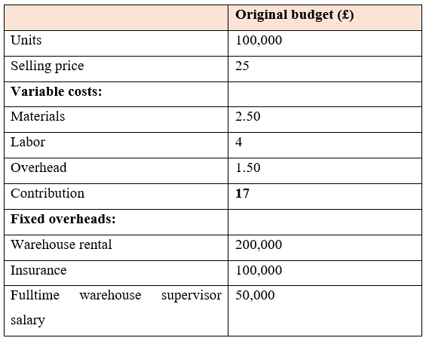

Flexed budget:

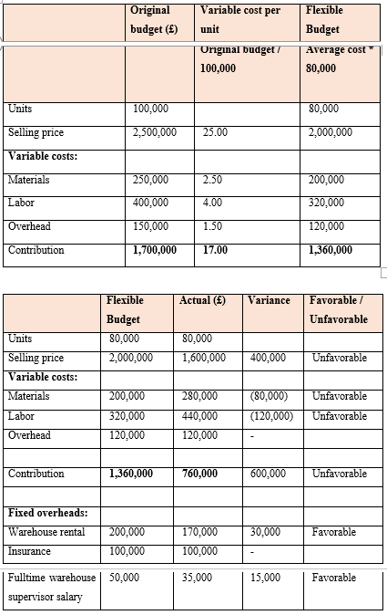

Variances:

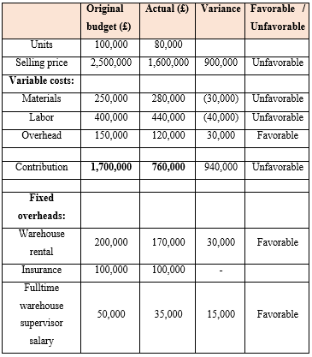

(ii)
The monitoring report in Part I shows very clearly that the company's performance is very low. On the one hand, as we transition from budget to budget, the sales price of each unit is reduced. However, the cost is often raised instead of decreasing. When we move from the budget to the actual, material costs are raised from 2.50 to 3.5. The same goes with labor expenses again, which raised by about 1.5 per unit. The overhead has not raised or decreased, however. The overhead per unit is the same as the budgeted amount. This reveals that all variable costs are much higher than the estimated costs (Rs and Atkinson, 2020).
When it comes to fixed costs, the fixed costs have been trying to stay lower than that of the budget. The location of the warehouse is 30,000, much less than the estimate. The pay of the warehouse manager is 15000 less than the budget once again. However, the premium costs were neither raised nor decreased, and the cost remained constant at $100,000, whether budgeted or actual (Rs and Atkinson, 2020).
These all indicate that the indirect costs are not controlled and, as such, the fixed price was controlled. However, overall productivity was not achieved.

(iii)

Recommendations to Amana’s CEO:
As the next slide reveals, a travel business based in England that offers souvenirs to visitors. Here you are our undiscovered talents. Since new businesses are springing to take on the travel business, the competition is fierce and ever-abundant. Each agency struggles for a piece of the pie, but every agency wants to sell more than it does now.
The sad truth is that many individuals lose interest in vying for an equal slice of the pie and forget why they started in the first place. Here are some standard tips that the CEO and the management of Amana Ltd has provided.

Engage with Customers on Social Media:
Travelers of all ages can talk about travel products, share opinions and express interests via social media platforms (Rs and Atkinson, 2020).
Using pictures, videos, questions, or updates to encourage dialogue and interest prospective clients in working with you Use the customers' feedback to develop trips and packages that are more specifically designed to meet their needs and tastes.

Package Travel Components into unique travel products:
To create an entirely new travel experience, try combining various types of brands. Attempt the operation, travel, and accommodation into a single bundle and price level to improve sales and market share. Providing travel, sightseeing, facilities, and souvenirs as one package deal will give travelers a more enhanced travel experience and give you a raised marketing opportunity (Horngren et al., 2020).
So much incoming work, though, necessitates an abbreviated package of requests. Using a tour and product package requires just a few procedures to assemble a personalized or packaged tour is a small assistance to have been taken.

Try Online booking software:
The Internet has made travel a need for everyone, which has forever changed how the travel industry does both its business and how people book their trips (Horngren et al., 2020). Providing the website customers with the possibility to reserve or book items online is a way of having more flexibility in booking their inventory.
When you do so, you will not have to worry about the people sitting at their tables. This online booking system gives online customers the option to use a 24-hour or 7-day calendar and to a week reservation, allowing your users to book reservations (Horngren et al., 2020). Providing consumers with an entirely easy and safe way to book online travel plans is the best way to expand their profits.

Extend your B2B network:
There is no question that effective talking with investors is crucial for business success. Alliances are used for many business purposes, including to expand the business, to gain future customers, and to generate fresh ideas in the form of new products (Ahrens and Chapman, 2020)
But remember that pursuing a new B2B business partner isn't your goal; instead, you've only personalized begun to earn their honesty. You must do your very best to keep an existing one and keep it. When it comes to B2B network-to-business expansion, expand how to communicate with others you already know as well as those you don't.

Enhance your offer by integrating with the GDS system:
It is a smart way of standing ahead of your competitors by providing the lowest available deals for a global set of interesting transfers, car rental, exhibition & amusement passes & adventure.
Thanks to XML connectivity for different hotel networks, this is easier for travel applications (third-party systems). By combining multiple channels to create a unique travel experience, the service will rise towards the next level (Ahrens and Chapman, 2020)

Find a travel Niche Market:
Building a business in a public niche is one way to become a sustainable travel company. There is no need to be hard or unusual in the travel niche, but the more particular, the better (Ahrens and Chapman, 2020). Niche travel indicates that you make goods that nobody else does and are unique to your deal.
You could specialize in that specific population, such as planning trips for foreign elderly couples or a specific type of travel, such as mountain rides, or simply traveling to a specific destination. With a raised degree of competition, this segmentation approach has become more popular.

Upsell products- Provide an experience:
Increasing your profits per customer by adding additional items to the box will be the most obvious method. For example, if your client takes a town tour in Barcelona, prepare for lunch and dinner. The visitors center tour operator will, on the other hand, offer a special astronomy observation experience, a coffee and tapas cup to make the trip more attractive to a couple who have booked the trip.
Find out what the clients want, test and use apps for the travel agency to monitor and manage sales offers and free items (Ahrens and Chapman, 2020)

Highlight the benefits of your product/service:
Be focused on emphasizing the distinct benefits of your offering rather than attempting to outperform your rivals. Ask your current, happy clients for a recommendation highlighting all the positive aspects of their partnership with your company (Ahrens and Chapman, 2020).
Most satisfied consumers would not hesitate to provide a testimonial-others would be happy to do so. Put it on the website of the firm prominently to see potential buyers coming.

Offer more than your competitors:
People are still sick and go to the same sites. The packets you sell to everyone have been loaded with all of them. Your clients deserve a unique experience they will recall for the remainder of their lives (Kaplan, 2020)
Ask clients what they need instead of pushing premade bundles. Maybe on a mountain crest they want to escape to a distant village. Maybe they want to dive rather than just lounge on the beach.
Become a travel expert to create offers focused on customers' needs and wants. See the travel agency tips and tricks to boost profits. Sixty% over thousands of years are prepared to pay extra for a travel agent's recommendation

Part B:
In the modern age, more people want to buy their products online and there is a current trend happening behind the scenes for the online goods that is currently occurring. As of today, Mr. Amana is shutting its branches throughout Brighton, Birmingham & Manchester to coordinate its operations and is now changing its 50% online revenue as its competitions now do. Mr. Amana has two choices for online sales, whether it can be sold by setting up his own online store or by selling the Amazon product (Kaplan, 2020)

Option 1:

To setup the own Online shop:
Begin by expanding the "You are about to setup your own online store."
In comparison to the above costs, additional costs have to be imposed if the company plans to market the commodity online by the establishment of its own online operation.
The first cost associated with this option was its cost to be incurred as the company establishes the delivery network (Kaplan, 2020). This is the calculation of the total estimated monetary cost of building the delivery system: $150,000. The company will then move from the retail side of the industry to the marketplace. This will make the company effective and efficient enough to deal with competitors in the online sector. The company wants to expand its website is an aim of this project. To further increase the overall number of purchases, the organisation should strive to make their website powerful enough to accommodate a significant percentage of those who purchase it. The cost is estimated at $50,000 for website maintenance and growth.
To resolve any issues and to tune up the application company so it can provide the same level of prompt response online, they need to employ an IT programmer to remain on the job round-the-the-clock (Bromwich and Bhimani, 2020). This not only looks at the programming of the online shop but also improves the effectiveness of the store. He will operate in such a way that the website will not be unavailable at any time. But on top of that, he'll be reviewing the company for us. The total cost of the IT programmer is estimated at 35,000 a year.
At the end of the day, after the detailed demand research as well as the online business of the company, the guaranteed revenue of 100,000 units will be estimated per year. As a result, we have the numerical analysis for the first alternative to select the best option (Bromwich and Bhimani, 2020).
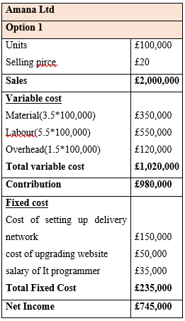
The above numerical assessment shows the firm will generate revenue of 100,000 units that contribute to a share of 49 percent if it sells its product in its own online store. Following the deduction of fixed costs associated with Option 1, the corporation is able to generate an operating revenue of 745,000.

Option 2:

To sell On Amazon:
The second option for Amana Ltd is that the firm should actually get rid of all of the costs and start selling products on Amazon rather than launch its own online store and pay the cost of website upgrades, IT programming salaries and the construction of the networks (Bromwich and Bhimani, 2020).
The corporation would face several other costs and problems when selling merchandise on Amazon. The Amazon fee of 50,000 to be paid here. The company needs to pay. However, there is no other cost for the business. However, if Amazon decides to market the product, the estimated sales for Amazon are 65000 units. The other sellers who have deepened their Amazon roots and a high degree of rivalry on this site are responsible (Bromwich and Bhimani, 2020).
Amazon is likely to raise the volume of revenue in line with the popularity of the product as well as the level of customer loyalty and feedback. However, one of Amazon's greatest disadvantages would be that the entrepreneur does not have leverage over the pricing and return policies. Although the seller uses the Amazon seller's and Amazon's account, the returns policy and pricing policy are not exclusively controlled by the seller. The seller needs to operate the company with a negative profit in order to maximize income at the outset (Burns and Vaivio, 2020). We here made a numerical analysis of Option 2 from the data given in the first section, whereby the company can sell its Amazon product and does not construct its own online shop.
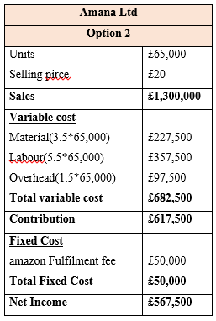
This estimate shows that the organization is able to realize a margin of $47,500 on Amazon sales of 65,000. The Company has only a fixed Amazon performance fee of 50,000 in this option. So, even after deducting the fixed profit, the company profits $567,500. This profit is smaller than that of 177,500 compared to Option 1. The other downside to this option is that the return and pricing strategy of the company is not regulated. To allow MR to obtain a fair return on their company, the company needs to start selling the product at the lowest price as advised by Amazon and keep profit margins to be sustainable (Burns and Vaivio, 2020).

Conclusion
The figure above shows that the company would benefit 567,500 if Option 1 resulted in a profit of approximately 745,000. As such, the company can go for option 1 as it is the better option. By building its own online store, the company is generating financial and competitive advantages, as well as additional profit. There is no need for any other forum to implement the company's policies.

Reference List
Ahrens, T. and Chapman, C.S., 2020. Management accounting as practice. Accounting, organizations and society, 32(1-2), pp.1-27.
Bromwich, M. and Bhimani, A., 2020. Management accounting: Pathways to progress. Cima publishing.
Burns, J. and Vaivio, J., 2020. Management accounting change. Available at SSRN 289124.
Horngren, C.T., Sundem, G.L., Stratton, W.O., Burgstahler, D. and Schatzberg, J., 2020. Introduction to management accounting. Upper Saddle River, NJ: Pearson Prentice Hall.
Kaplan, R.S., 2020. The evolution of management accounting. Readings in accounting for management control, pp.586-621.
RS, R.K. and Atkinson, A.A., 2020. Advanced management accounting. Prentice-Hall Inc.

