

Lab: IPv4, Subnetting, VLSM and IPv6 Addressing

- Understanding IPv4 and IPv6 addressing (word count 1000)

Features of IPV6 report
Some of the features of IPv6:
- Bytes/Bits – the IP address length
- Broadcast – Broadcast addresses- which they do not have
- Packets - efficiency
- Security – Not optional anymore
Introduction
IPv6 stands for internet protocol version 6. This protocol allows you to connect to the internet it is the most important protocol. It allows you to access websites such as Facebook, Twitter, Tumblr, and many more websites. An IPv4 has 32 bytes while IPV6 has more bytes with 128. It uses letters as well as binary. IPv4 is limited comparing to ipv6 it stores “unlimited number” of IP addresses while IPV4 is old, and only supported 4.3 billion devices.

More information

The develop of technology can continue because of ipv6. IOT (Internet of things) such as Alexa, smart devices are now able to be use without IP addresses running out because of ipv6. It is efficient because it is simple and efficient addressing structure. IPv6 is longer so that means more bits. Some protocols are not supported by ipv6 because they are not needed, and they have made it more efficient. An example of this protocol is DCHP.

The next feature of IPv6 is the broadcast. IPv4 has a broadcast built-in so it allows it to communicate but not as well as IPv6. While IPv6 has no broadcast, it is built into a multi cast which means it allows it to support multiple hosts. The security on ipv6 is required. Which means the security is built in. The security is called IPsec which stands for Internet Protocol Security it encrypts packets. IPV4 is optional for IPSEC. [3] [2]

The addressing method is different it is separated using a colon instead of a dot, it also is decimal notation while ipv6 is hexadecimal notation. It is a big difference because it is hexadecimal instead of decimal notation. The IP addresses are longer. Here is an example: 192.168.1.10 this is IPv4. This now IPv6: 0:0:0:0:0:ffff:c0a8:10a As you can tell this has extended massively it uses letters. You can see the colon is separating the numbers/letters. [3]

This is how ipv4 and IPV6 address is structured:
The IP address was short but now it is longer and can use letters as well as numbers. It is hexadecimal as well instead of decimal.
The images below shows the different address structures which as you can tell is big.
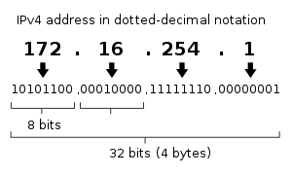
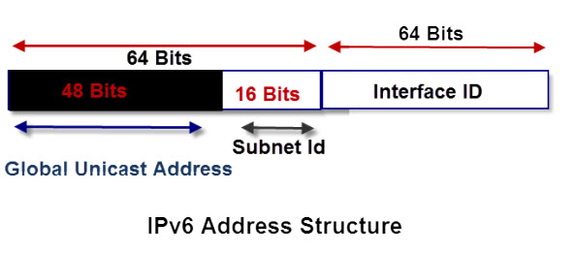
image from [4] 1
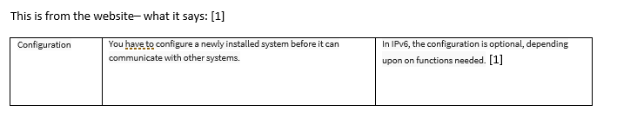
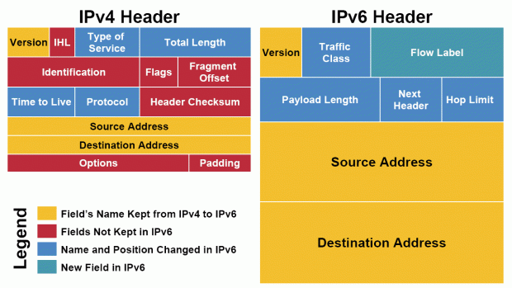
IPv6 has different addresses while IPv4 uses multiple broadcast addresses while IPV6 has multi-cast which allows them to communicate easily by using a multi cast addresses to send packets and does not use broadcast addresses. I have researched using a website called guru99.com. That IPv4 needs to be configured manually while IPv6 support auto configuration which automatically does it for you. The website also says “that IPv4 and IPv6 cannot communicate with other but can exist together on the same network. This is known as dual stack.” – it communicates and converts to be able to send packets to each other.
[2] Image from [2] 1

The features Dual stack, and automatic configuration. This feature benefits people because of ipv6 doing it automatically while on ipv4 you had to configure it which waste time. IPv6 is clearly supported if its automatically configured such as a mobile phone, laptop etc. Dual Stack allows packets to be sent from an ipv4 to now an ipv6 which allows communication. IPv6 is faster, and more efficient when it comes to processing. IPv4 obviously has some same features as IPv6. Ipv6 is more configurable and automatic. IPv6 is not optional for IPsec while on IPv4 it is which increases security. IPv4 has protocols which needs to be configured while IPv6 is built in also will auto configure while IPv4 is manual which spends less time which makes it more efficient to have.

The IP is a lot different, and much larger comparing to IPv4. The IPv6 is more supported for mobility. However, you have some features which is not supported on IPv6 which is on ipv4. The feature is DCHP. DCHP is not supported on IPv6, and broadcast addresses. It uses multicast which allows addresses. Which is more efficient. The auto- configurable feature saves time and does it for you. As you can tell by the image is that ipv6 is much smaller than IPv4 it has 12 fields while ipv6 has 8. It has extensions which not in the same headers.
The main thing about IPv6 is routing efficiency as you can tell in the header “Flow label”. This is not in IPv4. It is there to help with the packets sequence. As you can tell it can handle a lot more than ipv4. Ipv4 didn’t have a good “handle packet” it sent the packets and kept control of traffic control. While ipv6 has a packet flow which helps with the packet sequence which makes it more efficient and allows it to be controlled. IPV6 major thing is the fact it has better traffic routing and much better security than IPV4 because it is configurable. I have researched into different communication types for ipv6 from a website called tutorialsweb.com [3]. The three type of communications for IPV6 are
- UNICAST
- MULTICAST
- ANYCAST
UNICAST protocol is a one to one protocol – so for an example a phone call. It will specifically go to that data type and won’t collide with any other protocol. Its one to one so it could be doing something private.

Other protocols are more sharing with other devices, etc which allows you to communicate online without any struggle.

MULTICAST protocol is a one-to-many communication- a group chat on Facebook can use multicast protocol because you are messaging other people. It allows you to message people using different data types.
Anycast- used for one to one of many communication [2]
IPV4 has UNICAST, MULTICAST, ANYCAST, AND BROADCAST ADDRESS. IPV6 does not have broadcast address. IPV6 is efficient because the protocols, and the new features allow traffic/packets to get to the right destination without colliding or crashing. IPV4 offered extensions but ipv6 also have extensions as well as you see on the image. [4]

Bibliography

[3] | “Ipv6 (Internet Protocol Version 6):Ipv6 Features| Communication Types Of Ipv6,” [Online]. Available: https://www.tutorialsweb.com/ipv6/IPv6-Tut-3.htm.
[1] | “guru99.com,” 2019. [Online]. Available: https://www.guru99.com/difference-ipv4-vs-ipv6.html. [Accessed 4 December 2019].
[2] | J. Silverman, “What's wrong with IPv4 and Why we are moving to IPv6,” Tecmint.com, [Online]. Available: https://www.tecmint.com/ipv4-and-ipv6-comparison/. [Accessed 2019 12 4].
[4] | S. Cope, “IPv6 Explained for Beginner,” Steves-internet-guide.com, [Online]. Available: http://www.steves-internet-guide.com/ipv6-guide/. [Accessed 2019 12 4].

- Subnetting and VLSM

NOTE: To complete this part you would need full understanding of Lab 10 to 14.



Using the Network address 172.16.2.0/24, VLSM the network to support the following requirements:
Subnet A: 16 hosts
Subnet B: 2000 hosts
Subnet C: 6 hosts
Subnet D: 500 hosts
Subnet E: 60 hosts
Subnet F: 180 hosts and Serial links between routers

Subet B – 2000 - /21 32-11
Subnet D-500 - /23 32-9 0 bits – 0- 8 bits/255.0.0.0 16 bits 255.255.255 / 24 bits 255/255/255.0 32/ 255.255.255.255
It has to be continuous- So keep the flow going so you don’t miss any IP addresses.
Subnet F: 180 /24 32-8
Subnet E-60 / 26 32-6
Subnet A-16/ 27/ 27 32-5
Subnet C- 6/29/ 32-3

Table 1
Subnet | Network Address | Subnet mask | First Address | Last Address | Broadcast Address
Subnet b | 172.16.0.0 | 255.255.248.00 | 172.16.0.1 | 172.16.7.254 | 172.16.7.255
Subnet D | 172.16.8.0 | 255.255.254.0 | 182.16.8.1 | 172.16.9.254 | 172.16.9.255
Subnet F | 172.16.10.0 | 255.255.255.0 | 172.16.10.1 | 172.16.16.254 | 172.16.10.255
Subnet E | 172.16.11.0 | 255.255.255.192 | 172.16.11.1 | 172.16.11.63 | 172.16.11.64
Subnet A | 172.16.12.0 | 255.255.255.254 | 172.16.12.1 | 172.16.12.30 | 172.16.12.31
Subnet C | 172.16.13.0 | 255.255.255.248 | 172.16.13.1 | 172.16.12.7 | 172.16.13.8

