Marketing Plan – Hilton Hotel

Student Name:
Danut Gheorghe Muzicantu

Student ID number:
2233416

Word Count: 1558

Marketing Essentials BMIH4005 Rework C2

Lecturer

Chris Wilkin

Submission date: 26/05/2023

Table of contents

1. Marketing Plan – Hilton Hotel …………………………………...…………………………… 3
2. Component B – Powerpoint Presentation of the Marketing Plan ……...…………….……16
3. References ……………………………………………………………………………………....21

Marketing Plan – Hilton Hotel

1. Introduction

The Hilton Hotel Company is a multinational company which was founded in 1925 in United States of America. The purpose of this marketing plan is to evaluate the environment in which the company operates, by using different frameworks and tools, e.g. the SOSTAC plan, the Marketing mix or Bowmans strategy, etc. and it is addressed directly to the senior marketing management team with the purpose to provide the opportunity for the brand to increase its customers awareness and loyalty, by the end of 2023.

2. Situation analysis

The SOSTAC plan is a marketing planning framework, initially developed during the 1990s to assist in marketing plans by PR Smith (Chaffey and Smith, 2022).

Figure1: SOSTAC Marketing Planning Model

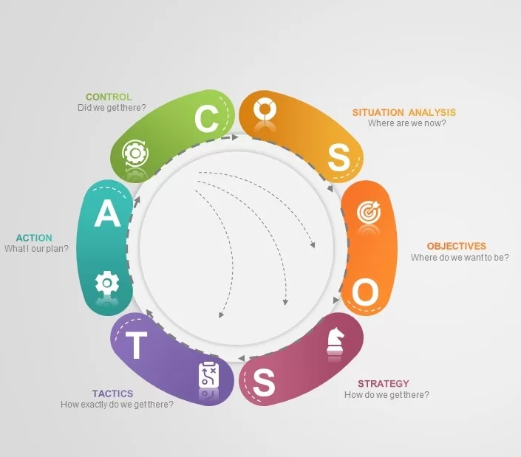

Source: SlideBazaar

One of the Hilton's business strategies is training its personnel in guest orientation, successfully developing a mindset in which their bartenders, front desk attendants and receptionists react naturally towards these unexpressed guest desires (Johnson and Chavala, 2017), so, furthermore, the following marketing plan is going through the SOSTAC model described stages.

The 5 'C's
Company
Various marketing approaches are used by the Hilton company, such as innovative features, pricing strategies, and promotions plans, etc. Based on their marketing strategies, it helps the company to be successful in the global market (Hague, 2019).
* SWOT analysis and further details, available in Appendix 1

Customer segmentation and targeting

The Hilton Hotel targeted market is represented by the premium segment and consists mainly of wealthy consumers and business travellers in search of a sophisticated and exclusive experience, those with a high budget, but also: corporate executives, corporations, leisure travellers, mid-age and seniors, and upper and middle class families (Sufi, 2019).
According to Comparably (2023), placed 1st in Customer Net Promoter Score in comparison with its rivals.
In the past 3 months Hilton’s website registered 35.8m visits in April, compared to 38.3m in March. Most of its guests come from USA, United Kingdom and Canada. The most Social Media platform used by visitors is Facebook – 38,71%, followed by Youtube and LinkedIn (Similarweb, 2023).

Competitors

Among other hospitality operators, Hilton Hotel main competitors are: Hyatt, Marriott, IHG, Loews Hotels and Holiday Inn (Comparably, 2023). The Hilton Hotel has successfully situated itself in the overall hospitality industry by approaching guests' tastes and desires. In Appendix 2, the graphic highlights the company's perceptual map among the direct competitors, in relation with price vs quality expected from their customers.
Regarding Bowman's Strategic Clock, the Hilton Hotel provides upscale services for a premium price. By analysing various combinations between price and the perceived value, it is possible to start choosing a strategic advantage position which is meaningful for the competencies within the organization (Thornton, 2022). The company maintains a strong pricing strategy, supported by a loyal and exclusive customer community, driven by an excellent quality of service and its capability to understand and follow its customers' interests (Chen and Petersen, 2022) and under this consideration, with the described involved factors, is strongly connected with the perceptual map presented in Appendix 2.

Collaborators and partnerships

Hilton Hotel started a collaboration with Brayford Hotels in 2016 (Hospitality & Catering News, 2016). Among his partnership we can include: Amazon (since 2019), with Live Nations (ticket events) or Lyft (Skift, 2019).

Climate: PESTLE analysis

According to Cook (2016), the PESTLE analysis focuses on the evaluation of the macro environmental factors. At the Hilton Hotel, there are three linked environments to consider in developing a successful strategy – geographic market, industry and socio-economic environment. Applying PESTLE analysis can help Hilton Hotel Hotel capture the major external factors that shape their strategy and competitiveness and assist their overall strategic planning process. While Hilton Hotel Hotel is looking to further extend and build upon its expertise and key capabilities, performing a PESTLE analysis is absolutely essential to effective strategy development and the achievement of long term growth goals (Helmold and Samara, 2019).
* PESTLE analysis and further details, available in Appendix 3

The Marketing Mix

All 4Ps components of the marketing mix are also recognized in the strategy adopted by the Hilton Hotel. These features are mainly utilised in the marketing of its activities and products, as well as in the development and brand strengthening operations. The marketing mix is a primary strategy that organisations can follow to address their target market (Kotler et al., 2015). This marketing method considers the characteristics of product, price, place and promotion. In making insights into the procedures embraced by Hilton Hotel, it can be noted that practices such as product and service innovation, consumer experience and marketing research investment have been helping the brand towards its successful growth model in an exponential manner.

3. Objectives

Aiming for a specific target involves establishing goals. A SMART objective serves to provide guidance in setting these goals (CFI Education Inc, 2023). The Hilton Hotel main objective is to expand its commitment to serving a wider range of customers through the integration of the culture for quality. In order to achieve these objectives, the company is expected to perform a comprehensive analysis of the market. It is recommended that the proposed objective should be achieved by the end of 2023, following the recommended guideline, which is in accordance with Hilton Hotel practices and policies.

Figure 2: SMART objective

Specific | - Achieving an increase of 5% market share of luxury and high quality services in the European accommodation and hospitality industry. This target will involve the senior management team as long with the dedicated teams in the company’s European division, which will have to take under consideration the specific social, cultural and economical factors.
Measurable | - In order to be achieved, it has to be at least 15% increased amount of current Hilton Hotel direct bookings from the official website, as long with the tour operators the company has a worldwide partnership with.
Achievable | - Advertising intensively on all online and traditional media channels  - Reviewing contracts with trustable and reputable tour operators and offering incentives for sales, when considered necessary  - Allocating a budget of £2m for sustainable achievements described above
Realistic | - As forecasted, it will generate a substantial revenue income for Hilton Hotel, of £12m to £15m per year, starting 2024, having a substantial impact on overall company efficiency, not to mention the increased marked share and the notoriety gained among the customers.
Timely | - To be successfully implemented by the end of 2023, in accordance to the marketing plan and the Hilton Hotel development strategies

4. Strategy

The cornerstone of Hilton Hotel's marketing strategy is represented by their unique brand, which is the main force behind the business. The guideline strategy is to deliver exceptional customer service and outstanding experience with the purpose to create lifetime customers (Bolton, 2016). Customers are rewarded with points through the loyalty program, when booking a visit, tours and events or through their travel partners. Another strategy we need to focus and concentrate on, is the employee engagement, whereby staff is passionate about the work environment, its overall success and its services, resulting in happier workers, which means more contented customers (Albrecht et al., 2015). Empowering the employees and training them how to forecast the unspoken desires of their visitors, will continue to deliver excellent services constantly and boost the customer experience. The Ansoff Matrix is a mapping marketing instrument that assists in the evaluation of different strategies for the development and growth of a company. As revealed in Appendix 4, it is accomplished by correlating existing and new markets and existing and new products or services.

5. Tactics
As revealed by the SWOT and PESTLE analysis, the weaknesses, strengths and opportunities for Hilton Hotel are representing actions and recommendation of the most importance for increasing brand awareness, profit margins and worldwide known reputation of the brand.

Figure 3: the 4 ‘P’s of current marketing strategy

Product | - Its purpose is to deliver the best professional hospitality expertise and personal service so that its guests can experience their stay in exquisite comfort and ambiance as one of the elements of its marketing mix, without noticeable changes for this campaign (Bardi, 2021). It strives to distinguish the Hilton Hotel brand from competitor in terms of hospitality services. The outcome is an increased focus on enhanced amenities in customers areas, dining and banquet halls, meeting rooms, luxury gourmet kitchens, spas and other complimentary conveniences such as car rental, travel guides, personalised rooms and suites etc.
Pricing | - On account of Hilton Hotel premium ranking, their particular target customer segment covers corporate directors, famous celebrities, international athletes, leisure and corporate guests, and mainly the upper middle class and high society. Because Hilton Hotel is renowned for its upscale service, the company has embraced a premium pricing policy. It caters to guests who never really seem to mind spending extra money in search of convenience and luxury (Holloway and Humpreys, 2022).  - For the proposed marketing strategy, with the fixed targets in question, is highly recommendable to input a 10% discount applicable to all Hilton Hotel membership possessors and 5% discount for the other guests.
Place | - By following the distribution strategy from the Hilton Hotel marketing mix, it is well known that the company seeks to have its hotels in the most attractive locations, worldwide. This considers, as well, the economic or political stability of each country it operates in. Given the fact that most European countries are considered to be a safe market, Hilton Hotel should pursue for the proposed marketing strategy
Promotion | - Hilton Hotel uses several media channels to promote its services. As an exceptionally upscale brand, the hotel chain relies extensively on word-of-mouth publicity to further advertise itself (Morrison, 2022). Beyond the official website, the Hilton Hotel is attempting to increase its brand awareness by running ads in travel magazines with attractive slogans.  - Strongly suggested is using more of the social media, especially collaborating with European influencers, as a powerful advertising tool, as it became nowadays  - The discounts proposed in pricing can be, as well, in the form of personalised gifts for premium customers. It also offers holiday bundles and other benefits through its app, such as reward points that imply a complimentary holiday stay or room upgrade to promote its services provided

6. Action

* Figure 4 – Gantt Chart for the proposed marketing plan

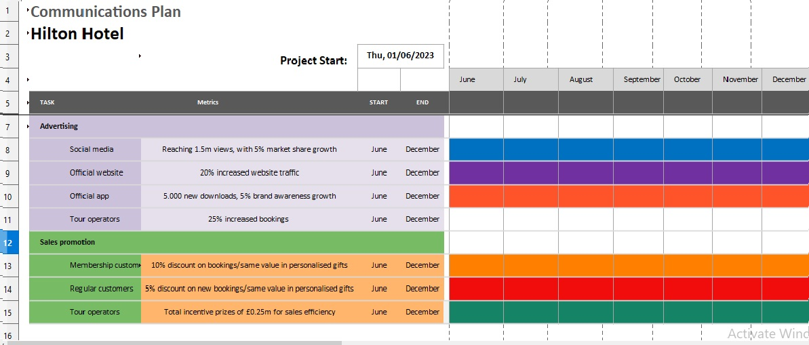
As the marketing plan is on medium term, is more than essential that all channels for advertising the campaign and all sales promotions should implement the strategy continuously from beginning of June to the end of December 2023, in order to reach the highlighted objectives described in previous paragraphs (Doyle, 2016). It is highly recommended that the proportion should be divided in implementing the strategy, in accordance with the above figure, as follows:
- 70% should be implemented in the industry season peak, between June and mid September
- 30% is to be focused on, from mid September to end of December

7. Control

The management team involved in implementing the marketing plan, has to have a clear weekly updated overview of the proposed strategy, by gathering information from the channels described above, as they were chosen by the impact importance for the strategy (Meredith et al., 2017). There is to consider that the ultimate achievement is to reach the targets described in the SMART objectives, utilising the detailed metrics from the strategy. After all, the reputation of Hilton Hotel is at stake and even it is a very competitive market in the luxury hospitality industry, the brand has to furthermore evolve, as it has the well known reputation to do so.

8. Conclusion

The marketing plan is developed in order to facilitate the achievement of the proposed objectives, as they are of major importance in Hilton Hotel business efficiency and performance in the premium European hospitality market. Being tangible and sustainable, the aimed goals are to be reached within following the specified analysis and recommendations.

Appendices:

Appendix 1: SWOT analysis for the Hilton Hotel

Strengths | Weaknesses
- Strong synergy amongst all stakeholders, having excellent partnership on all activity channels, such as suppliers, customers, travel agencies etc.  - Presence in the world's best locations with high potential for tourism and leisure industry  - High quality employees trained at the finest standards of Hilton Hotel.  - Confidence in their employees that they will deliver the expected customer experience by all means  - A high number of acquisitions and opening new Hilton Hotels  - Strong financial situation as reported on the official website of the company (Hilton, 2023) | - It can difficult to offer and sustain customised experiences on multiple owned locations, at high quality standards, as a result of so many different social, cultural and economical factors involved  - Maintaining and upgrading the brand identity by providing luxuries services to guests, as it is a high standard services provider for premium customers (Deng, 2023)  - Varying levels of demands from their customer, influenced by socio cultural factors, which can be hard to accomplish  - Gaps in customer service, as not all staff members are at the same level of training and brand awareness
Opportunities | Threats
- The increased tendency towards luxury, even with current economic recession  - By introducing health-related brands, they are able to target the customer's health-conscious market  - Widening its market to the countries in the process of development (e.g. Asia).  - Digital Marketing as an essential tool that has to be utilised when it comes to online advertising  - Maintain concentration on customer rewards and loyalty initiatives | - International Socio-Political Factors, such as the past worldwide pandemic or the current military conflicts around the globe  - Replacing products with healthier ones can lead to extra expenses which can reduce their profit (Park, 2020).  - Increased costs due to environmental legislation and climate change awareness  - Increased competition in an overcrowded industry can have a direct impact on Hilton Hotels identity and standards  - Increased costs for suppliers, generated by the economic global recession, fuel crisis and military conflicts

Appendix 2: Perceptual positioning Map for the Hilton

High price

Hyatt
Marriot

IHG
Holiday Inn

Low quality High quality

Loews Hotel
Hilton

Low price

The perceptual map displayed above reveals that Hilton has been successful in offering high quality services at a reasonably price. However, it also shows that there is an existing opportunity for the brand to enhance the perception of its target market by exploring the notion of quality. This approach will ultimately be instrumental in improving the resilience of the company in the changing hospitality industry. In addition, the first competitive advantage will improve substantially.

Appendix 3: PESTLE analysis for the Hilton

Political | - Political stability – Nowadays, Hilton Hotel is currently operating in various countries, each with their own specific political strains. Rising tensions and volatile developments in the global political climate have the potential to impact the growth of the luxury tourism industry and may limit the available expansion opportunities for Hilton Hotel.  - Protests organisations and governance system – The company is expected to consider carefully complaints from interest groups, social and environmental militants and trade unions, as such disputes have an influential role to play in the decision-making process. Working closely with these types of groups can improve the Hilton Hotel's capacity to be involved in the community and accomplish corporate objectives. In addition, a strong governance system with a democratic political climate makes the business environment more welcoming for international business organizations like The Hilton Hotel.  - Political modifications – Repeated changing government regulations have an impact on corporate efficiency by creating more uncertainties about the local political climate. Therefore, is significant for Hilton Hotel to examine the ongoing tendencies of the country's current and future political scenes, as the government changes may alter the development priorities of different industries.  - Corruption and administrative procedures – Doing business in high corruption countries with poor law implementation is making the operating environment more unpredictable for Hilton Hotel given the compromised public confidence in corporate organizations and the general political and economic climate. From licensing, contractual agreements, fraudulent business transactions to common lawsuits, corruption can influence a wide range of business operations. If Hilton Hotel makes the decision to enter in politically, economically corrupt markets, it will endanger the sustainable development of the organization by undermining public welfare, the justice system and the constitutional law order.
Economical | - Economic cycle stage – Expanding economies are providing significant growth potential for the Hilton Hotel. Equally, it is valuable to capture the life-cycle status of the industry. Entering mature economies can be more challenging as a result of market saturation than in growth phases. In addition, the Hilton Hotel's commercial success is also affected by the level of spending by the host government on basic infrastructure improvements. A highly improved infrastructure enhances the business climate and improves the growth potential of the country's luxury industry.  - Taxation, restrictions on trade and protecting intellectual property – By entering countries with a high level of taxation, Hilton Hotel profitability will be directly impacted and by entering low tax markets can leverage high profits for investment in research and development. Likewise, increased trade restrictions can complicate the business environment, undermining and deteriorating relationships with foreign business partners. In addition, if the government of the country concerned does not take the intellectual property rights of business organisations seriously, it will discourage investors from participating in the organisations because of the high risk of theft of ideas.  - Employment market conditions – The Hilton Hotel has to research and anticipate labour market circumstances to determine how it can attract skilled workforce and develop their skills to boost business efficiency. Where labour markets are more flexible, the company can take benefit from more productive employment. The Hilton Hotel would also need to examine availability of skilled human capital more carefully, as a shortage of qualified workforce can damage business profitability and will make it more difficult to attract and retain talented people.  - Inflation, interest and exchange rate – The rate of GDP will determine Hilton Hotel capability to proceed with its long-term strategies for positive trading. A low inflation rate also signals consumers' ability to increase spending on the products offered. The organisation also has to carefully analyse the borrowing rate and its incidence on capacity to borrow, as long with the attitude towards investment. The increased interest rate will enhance the willingness to invest and increase the opportunities for further growth for Hilton Hotel. Ultimately, exchange rate volatility can also shape profitability and international trade. High fluctuations in the local currency can be a serious concern for Hilton Hotel.  - Financial markets efficiency – The Hilton’s worldwide development policies are strongly impacted by the efficiency of the financial market, as functioning in highly effective financial markets results in an improvement of the liquidity balance and increases the possibility to enter other markets.
Social | - Societal norms and class distribution – All societies have particular values and standards that shape consumer behaviour. Hilton Hotel should establish locally based teams and build local partnerships to understand the attitudes and norms of society to adapt marketing tactics to the unique cultural context. Providing luxury services at premium prices in an environment where the upmarket market is notably small will also require Hilton Hotel to adopt niche marketing strategies.  - Demographic trends – By studying the demographics characteristics, Hilton Hotel can support in the selection of the right market segment with high revenue growth potential. Understanding the general attitude of the population towards migration is of importance for the company, as it can also influence the possibility to bring international managers and other skilled employees to the host country.  - Gender Roles – The Hilton Hotel should study the traditionally attributed gender roles to adjust its marketing and communication tactics appropriately. Marketing and HR policies in a traditional, patriarchal society with clearly distinct gender roles will differ than societies with reduced gender stereotypes.  - Equality and power distance – Power distance in all societies reveals the acceptance of hierarchy and unequal income. Hilton Hotel has to adapt its practices of business management when engaging in markets with high or low power differentials. Inequality increasing in many countries is modifying the power distribution structure, which has some serious issues for international business corporations like Hilton Hotel.
Technological | - Technological innovations and development level – The Hilton Hotel is expected to carefully evaluate technological innovations currently in progress to stay one step ahead of its competitors. Stepping into new markets where technological development has not yet reached its maturity means Hilton Hotel can improve its market share by targeting emerging technological innovations, for example a personalised online app for its premium customers.  - Social media marketing – The use of social media has become commonplace in the modern business climate, and the company can take the opportunities offered by social media marketing to improve overall business performance. The technological trends can be applied to start creative social media marketing campaigns to develop online brand communities for Hilton customers.  - Research and development on technology – Are extremely relevant in an environmentally creative disruptive context. In such an environment, Hilton Hotel would need to invest in innovative disruptive technologies to maximize profits and also reinvest profits for further technologies.
Legal | - Employment laws – The company must follow employee health and safety laws, as some countries are strict in their regulations to provide for workplace security. Maintaining a secure working environment for the employees is the ethical and moral obligation of Hilton Hotel. Equally, anti-discrimination laws (such as equality of opportunity in employment) must also be considered carefully when crafting HR policies, as discriminatory lawsuits against employers are detrimental to an organization's reputation and affect its ability to recruit and retain top quality talent.  - Consumer and data protection laws – Data security has emerged as an increasingly important topic due to consumer privacy and security concerns. Hilton Hotel has to implement all data protection legislation for its customers. In addition, laws are in place to set maximum pricing, ensure a specific quality standard and protect consumers from misleading marketing claims. Hilton Hotel must take these factors into consideration to ensure regulatory compliance with consumer protection laws.  - Intellectual property laws – The intellectual property framework is structured to safeguard valuable intellectual assets and ideas. Failure to protect the rights of ownership of intellectual property may lead to potential loss of competitive advantage, which may undermine Hilton Hotel position against other industry competitors.
Environmental | - Recycling and waste management – Increasing environmental degradation, together with advancing technology, has required business enterprises to implement new and innovative recycling and waste management methods. In many countries, recycling has almost attained the status of a business norm. In addition, embracing efficient waste management principles in organizational facilities that are situated in or near urban locations is extremely important to Hilton Hotel as the company has to comply with the regulations.  - Weather and climatic conditions – The extreme weather patterns can potentially raise the cost of operations and force Hilton Hotel to adjust its value chain. The changes can also affect consumer spending trends, causing the organization to reconsider its services and marketing strategies.  - Environmental regulations – The Hilton Hotel is required to study the specific environmental policies of the country they are operating in, under consideration to determine which resources (such as water, electricity, etc.) are believed to be limited which may result in problems for the organization.  - Attitude towards eco-friendly products – The company can take the opportunity and embrace green business principles to gain the trust of stakeholders. A focus by regulators on compliance with environmental norms is changing services innovation priorities. This requires Hilton Hotel to both prioritize and maintain a focus on marketing the green attributes of its services at the expense of mainstream value propositions.

Appendix 4 – Ansoff Matrix for Hilton Hotel

Market Penetration | Product/Service Development
- Rental accommodation at high quality provided services with reasonable price  - Organising social events at the highest standards  - Customising every dinning experience | - Customised service delivery from staff  - High standard benefits for customers with loyalty incentive  - Enhanced quality facilities for customers (rooms, spa, restaurants, gyms etc.)
Market Development | Diversification
- Taking responsibility having highly trained employees which are delivering the ultimate service regarding quality  - Considering factors from PESTLE analysis and applying the described recommendations | - Advertising intensely the difference upon services provided, from competitors  - Loyalty programmes which can bring unique experiences to costumers

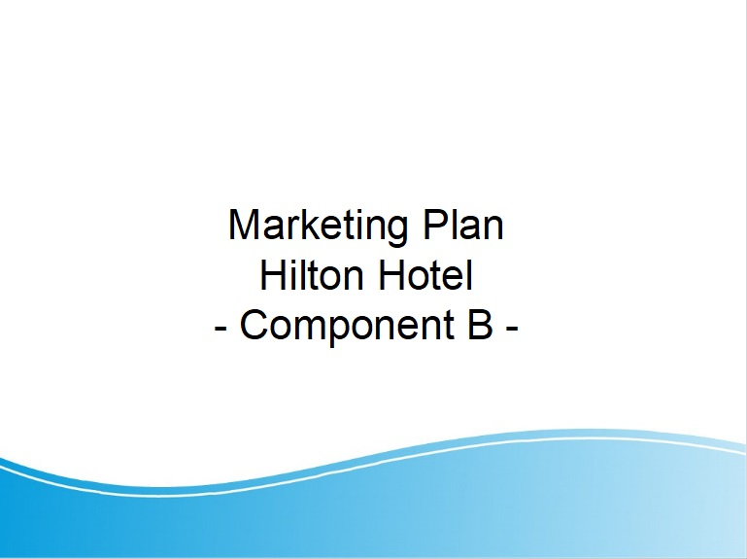

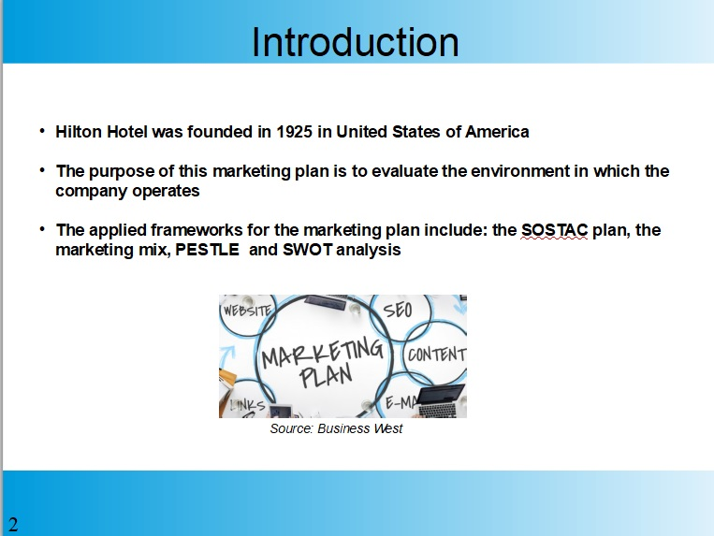

Organisation selected for the Marketing Plan is the Hilton Hotel. The company is focused on premium services and its target its to increase their customers awareness and loyalty.

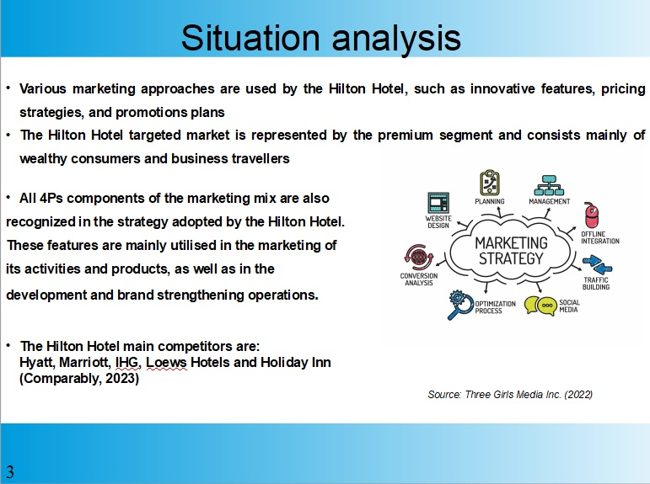

The situation analysis includes: SWOT and PESTLE analysis, Ansoff Matrix, the perceptual map for its main competitors and a detailed analysis on the Hilton Hotel.

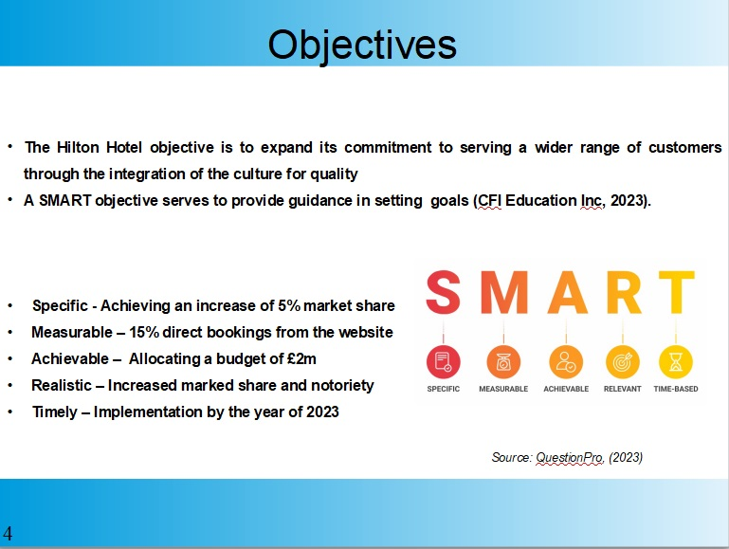

Hilton objective is to increase customers loyalty and to expand its services on new markets. Special offers for customers and tour operators will be applied.

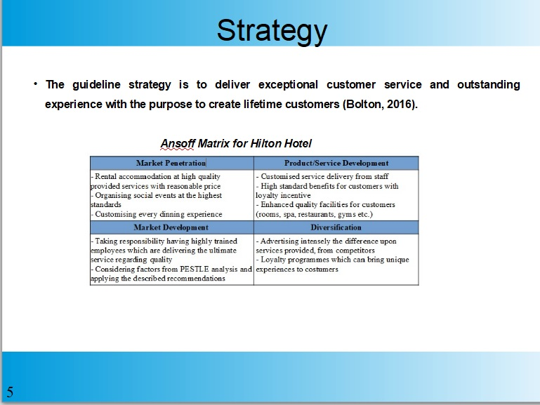
Their main strategy is to continue to deliver the same outstanding service to their guests, to assure trainings for their employees in order to retain their customer. Loyalty programs will be adapted accordingly with the marketing plan.

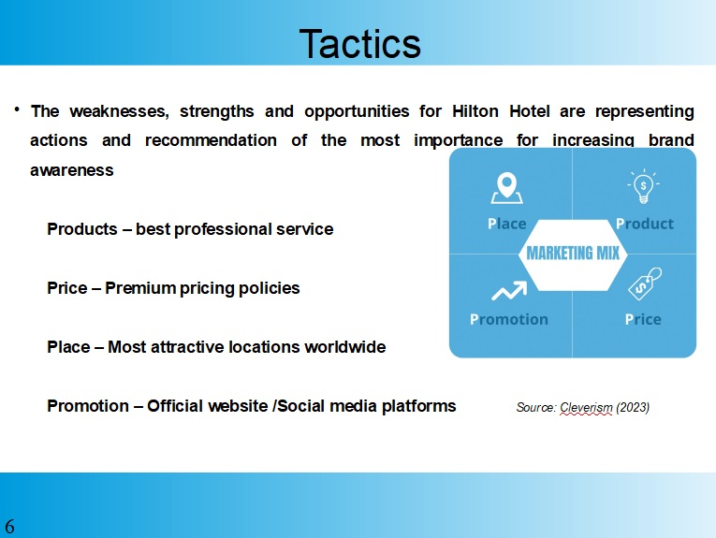

To increase its brand awareness, its revenues and to maintain its worldwide fame the company will maintain its focus on promoting itself on all media platforms and reward their customers for loyalty.

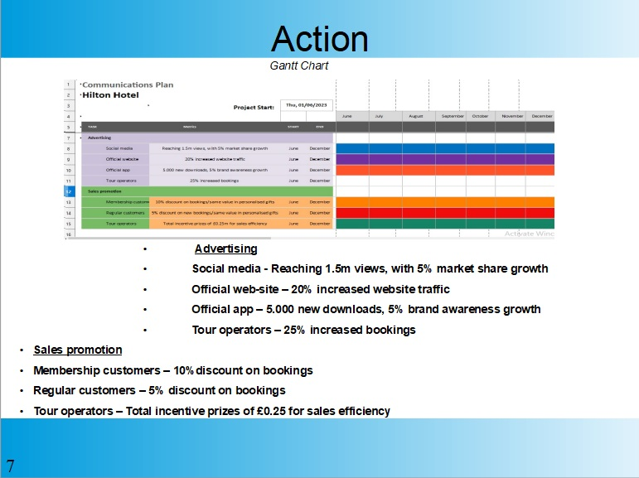

The marketing plan will be implemented starting with June 2023 and will end in December 2023.

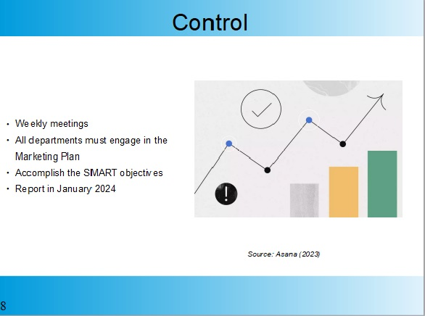

Weekly meetings will be scheduled in order to see the progress of the marketing plan. All departments have been informed of the new plan. Supervisors will complete weekly reports for the management team.
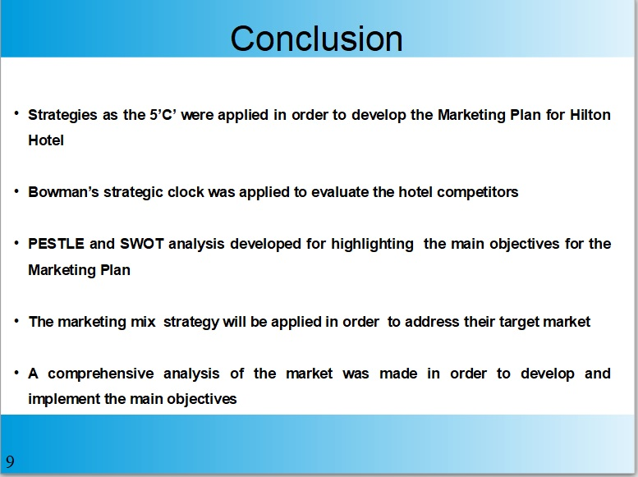

By following the marketing plan above all tasks should be complete and its goals achieved.

References:

Albrecht, S.L., Bakker, A.B., Gruman, J.A., Macey, W.H. and Saks, A.M., (2015). Employee engagement, human resource management practices and competitive advantage: An integrated approach. Journal of Organizational Effectiveness: People and Performance. Available at: https://www.emerald.com/insight/content/doi/10.1108/JOEPP-08-2014-0042/full/html [Accessed 17 May 2023]
Bardi, J.A., (2021). Hotel-Front-Office-Management. Available at: http://elibrary.gci.edu.np/bitstream/123456789/3237/1/Bt.447%28by-James-A.-Bardi%29-Hotel-Front-Office-Management-486525-.pdf [Accessed 17 May 2023]
Batinić, I., (2016). Hotel management and quality of hotel services. Journal of Process Management and New Technologies, 4(1), pp.25-29. Available at: https://scindeks-clanci.ceon.rs/data/pdf/2334-735X/2016/2334-735X1601025B.pdf [Accessed 14 May 2023]
Bolton, R.N., (2016). Service excellence: creating customer experiences that build relationships. Business Expert Press. Available at: https://pdfs.semanticscholar.org/7fbc/c73a362fe444e5ed0c7f089a53d97e003b37.pdf [Accessed 17 April 2023]
Chaffey, D. and Smith, P.R., (2022). Digital marketing excellence: planning, optimizing and integrating online marketing. Taylor & Francis.
Chen, N. and Petersen, F.E., (2022). Consumers’ Cooperation with Sustainability Programs: The Role of Luxury Branding and Profit Motive Attribution. Journal of Macromarketing, 42(4), pp.655-672. Available at: https://journals.sagepub.com/doi/pdf/10.1177/02761467221111987 [Accessed 14 May 2023]
CFI Education Inc, (2023). SMART Goals. Available at: https://corporatefinanceinstitute.com/resources/management/smart-goal/ [Accessed 14 May 2023]
Comparably, (2023) Hilton Competitors. Available at: https://www.comparably.com/companies/hilton/competitors [Accessed 14 May 2023]
Cook, S., (2016). Leading the customer experience: inspirational service leadership. Routledge.
Deng, J., (2022). Hotel Brands and the Impact of Brand Differentiation on the Success of the Global Hotel Brands. Highlights in Business, Economics and Management, 1, pp.265-276. Available at: https://drpress.org/ojs/index.php/HBEM/article/view/2582 [Accessed at 11 May 2023]
Doyle, C., (2016). A dictionary of marketing. Oxford University Press.
Ellis & Co. Chartered Accountants, (2022). Change in Hospitality VAT rate April 2022. Available at: https://www.ellis-uk.com/news/2022/03/change-in-hospitality-vat-rate-april-2022/ [Accessed 14 May 2023]
Hilton, (2023). Stories, Available at: https://stories.hilton.com/category/growth-development [Accessed 10 May 2023]

Hilton, (2023). Investors and relations. Available at: https://ir.hilton.com/ [Accessed 9 May 2023]
Helmold, M. and Samara, W., (2019). Progress in performance management. Springer International Publishing.
Hospitality & catering news, (2016). Hilton reveals collaboration with Brayford Hotels. Available at: https://www.hospitalityandcateringnews.com/2016/10/hilton-reveals-collaboration-with-brayford-hotels/ [Accessed 10 May 2023]
Holloway, J.C. and Humphreys, C., (2022). The business of tourism. Sage.
Honey, M. and Hogenson, S. eds., (2017). Coastal Tourism, Sustainability, and Climate Change in the Caribbean, Volume II: Supporting Activities. Business Expert Press.
Johnson, W.C. and Chvala, R.J., (2017). Adopting Quality Standards. In Total Quality in MARKETING (pp. 233-260). Routledge.
Keane, J., (2020). The new despotism. Harvard University Press.
Kotler, P., Burton, S., Deans, K., Brown, L. and Armstrong, G., (2015).Marketing. Pearson Higher Education AU.
Meredith, J.R., Shafer, S.M. and Mantel Jr, S.J., (2017).Project management: a strategic managerial approach. John Wiley & Sons.
Morrison, A.M., (2022). Tourism Marketing: In the Age of the Consumer. Routledge.
Park, S., (2020). Marketing management (Vol. 3). Seohee Academy.
SimilarWeb, (2023). Hilton. Available at: https://www.similarweb.com/website/hilton.com/#ranking [Accessed 10 May 2023]
Skift, (2019), Hilton Seeks More Partnerships to Entice Low-Tier Loyalty Members. Available at: https://skift.com/2019/08/01/hilton-seeks-more-partnerships-to-entice-low-tier-loyalty-members/ [Accessed 12 May 2023]
SlideBazaar, (2023). SOSTAC Marketing Model PowerPoint Template. Available at: https://slidebazaar.com/items/sostac-marketing-model-powerpoint-template/ [Accessed 10 May 2023]
Sufi, T., (2019). Principles of hotel star ratings. Notion Press.
ThinkInsights, (2023). Bowman’s Strategic Clock – How To Position Your Product?. Available at: https://thinkinsights.net/strategy/bowmans-strategic-clock/ [Accessed 14 May 2023]
Thornton, S.C., (2022). Differentiating the Indifferent: Dealing with Commoditization Paradox Through Innovation. In Commodity Marketing: Strategies, Concepts, and Cases (pp. 265-279). Cham: Springer International Publishing. Available at: https://link.springer.com/chapter/10.1007/978-3-030-90657-3_15 [Accessed 14 May 2023]

