11/1/2021
Raphael Phillip England (1650210)
UWTSD


University of Wales

Trinity Saint David
School of Engineering
Motorcycle Engineering BEng

Vehicle to Grid Technology
[Document subtitle]
Module: Automotive Materials and Sustainability
Module Code: ACHA6012
Lecturer: Abi Summerfield

Acknowledgements.

Abstract.

This report provides insight into the application of Vehicle to Grid technology (V2G). It aims to examine the contemporary environmental issues raised by the relevant automotive and motorsport industries. It will undertake a critical evaluation of the immediate and long-term applications which stem from the implementation of vehicle-to-grid (V2G) technologies. The purpose of this research is to examine the viability of V2G technology in Lithium-ion battery degradation by providing pragmatic solutions.
Literature research and practice to date has often resulted in highly polarising views being formed on the topic, often influenced by current politics. Therefore, this research aims to examine the practicality and of such a system for domestic, company, factory based automotive applications by reviewing the viability of vehicle-to-grid technology in reference to Lithium-ion battery degradation.

Contents.
Table of Contents
1 Acknowledgements. i
2 Introduction. 1
2.1 Summary. 1
2.2 Aims and objectives. 1
2.3 Background Research. 1
3 Grid capabilities in respect to electric vehicle demand. 2
3.1 Changes in demand. 2
3.2 Viable solutions to the rise in demand for electricity. 5
4 Environmental and ethical issues coinciding with current EV/automotive technology. 7
4.1 The effect of V2G and subsequently EV technology on the environment. 7
4.1.1 Energy sources. 7
4.1.2 Life Cycle Assessment. 8
4.1.3 Environmental risks of the extraction raw materials to produce EV batteries. 8
4.1.4 Recycling of batteries. 9
4.2 Ethics surrounding V2G. 9
5 The impact of V2G operations on the degradation of Lithium-ion batteries. 11
6 Conclusions. 12
7 References 14
9 Appendix. 17

List Of Figures.
Figure 1.Electric car models on the European market set to triple over the next three years.(Mathieu, 2019) 2
Figure 2. The shifting of Fossil fuel to Electric Vehicles (Morris, 2019) 2
Figure 3. Sources of Energy supply (ref) 3
Figure 4.Projected EV on the road. 4
Figure 5. (Wagner, 2021) 4
Figure 6. Total renewable capacity UK 4
Figure 7. Potential block diagram of V2G set-up. (MD. Shahrukh Adnan Khan, 2019) 5
Figure 8. (S&P Global Market Intelligence,, 2021) 5
Figure 9.Chart illustrates how charging at certain times eases the pressure off the Grid. 6
Figure 10.Percentage of Renewable Energy UK during first quarters of 2019-2020. (Deparment for Bussiness, Energy & Industrial Strategy, 2020) 7
Figure 11. (ElectricMotorengineering, 2021) 8
Figure 12. Optimized charging of 3 EVs showing V2G operation (Anderson Hoke, 2011) 11
Figure 13. Optimized charging of 3 EVs with multi-level cost of energy 18

List Of Equations.
$$C_{bd}=C_{bat×}\frac{∆L}{L}$$

Introduction.

Summary.
The following report outlines research into the utilisation and application of ‘Vehicle-to-Grid Technology’ (V2G). “V2G refers to the reciprocal flow of power between an electric vehicle (EV) and a recipient that could be, among other possibilities, the grid, a low voltage microgrid or a building.” (Kotub Uddin, 2018). The purpose of applying this technology could be a means of meeting the spike in demand for electricity that the rise in the popularity of electric vehicles has created specifically in the United Kingdom. This report consists of research into V2G as a plausible solution to meet the progressive rise in demand of electricity with reference to the current capacity that the National grid provides. While providing observations into future applications of this technology briefly; this report also dives into what developments in infrastructure would be needed to make V2G applicable and for which ordinance it would better suit.

Aims and objectives.
With the focus of this report on V2G; This paper’s objectives are as follows:
- To define V2G/Bidirectional charging
- To review multidirectional charging technology applications
- To assess current grid capabilities
- To scrutinize the practicality of V2G technology in real world applications
- To discuss the pros and cons of V2G with consideration to the environment
- To review the developments in infrastructure that would be required for V2G to operate successfully and if successful what noticeable changes would there be as a result for the energy sector

Background Research.
The transition from society’s co-dependency on fossil fuels to clean/renewable energy brings about various new and wonderful technologies such as V2G. Naturally studies have been undertaken and reports have been released providing contradictory opinions on the matter namely (Matthieu Dubarry, 2017)and (Kotub Uddin, 2017) of these two my research draws the facts around V2G technology revealing the pros and cons.

Grid capabilities in respect to electric vehicle demand.

Changes in demand.
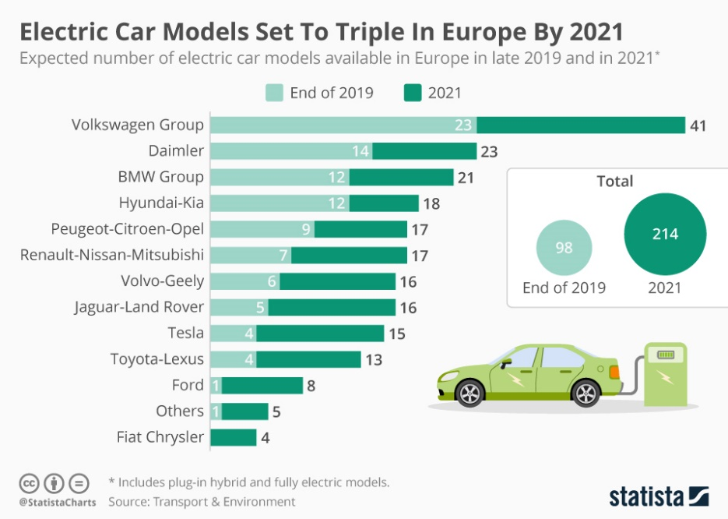
Statistics from (SMMT, 2021) state that Electric vehicle registrations continue to rise in absolute numbers, reflecting both the increase in demand for electric vehicles and the decline in demand for traditional, particularly diesel, vehicles (Lilly, 2021)
Figure 1.Electric car models on the European market set to triple over the next three years. (Mathieu, 2019)
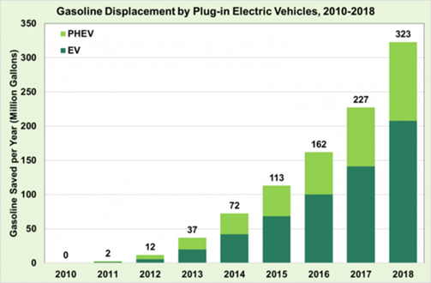
As we see a rise in popularity in vehicles whose powertrain is fully dependant on electricity (Figure 1); an increase in the demand for power from the transport sector can be witnessed accordingly. Approximately 5% of projected global electricity consumption in 2040 (Nuclearnews, 2019).
Figure 2. The shifting of Fossil fuel to Electric Vehicles (Morris, 2019)
“The growing use of electric vehicles could increase electricity peak demand by 3.5 gigawatts (GW) in Britain by 2030 according to the National Grid” (Reuters, 2017).
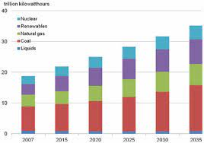
As displayed in figure 3, the progressive increase in the demand caused by the growing population’s dependence on electricity cannot be met solely by sustainable methods without current infrastructure in renewables developing further.
Figure 3. Sources of Energy supply
( (Gokten, 2012)
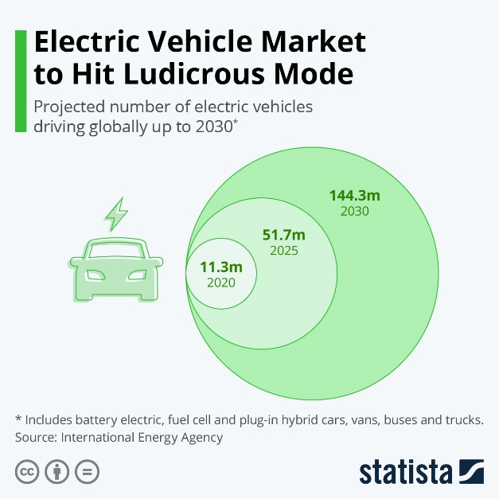
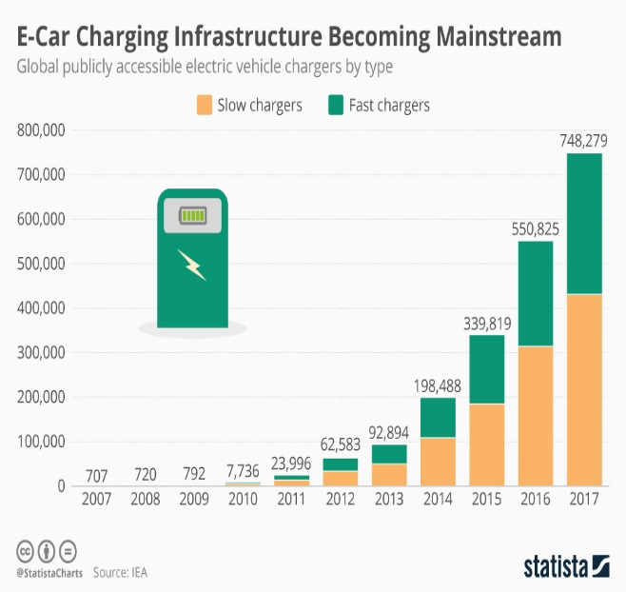
Despite environmental issues stated, electric vehicles are increasingly popular with the consumer and manufactures are set to meet demand by producing more models than in previous years combined.
Figure 4.Projected EV on the road.
Figure 5. (Wagner, 2021)
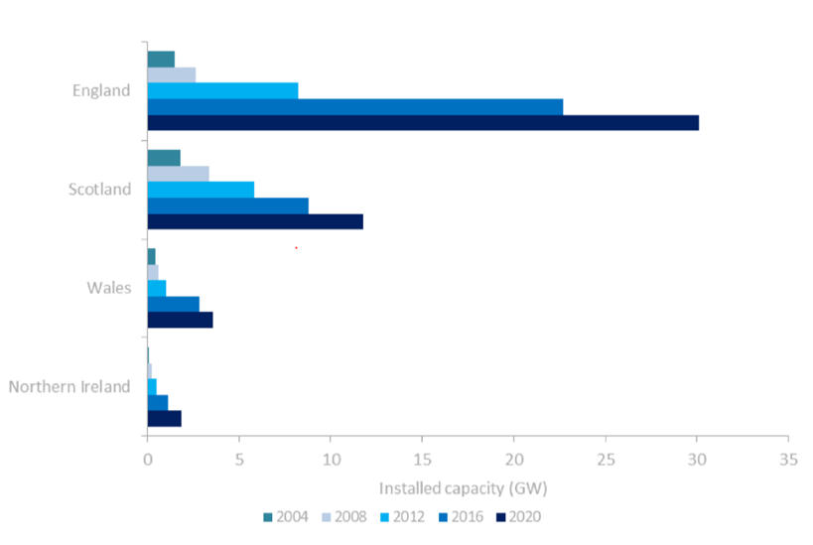
(Illustrated in figures 4 and 5.) Sales of electric cars rise in close coordination with the development of charging infrastructure. As a result, the level of demand on the grid is set to increase with an average global electricity consumption from EVs estimated to grow from around 8TWh in 2017 to 1,800TWh by 2040 (Nuclearnews, 2019). How this demand is met is crucial to making this supposedly ‘new clean technology’ part of our journey to becoming net-zero.
Figure 6. Total renewable capacity UK
“Political pressures, government policies, corporate influence, age-old infrastructure, lack of proper battery storage systems are just some of the challenges the renewable energy industry faces” (Regen Power, 2021)

Viable solutions to the rise in demand for electricity.
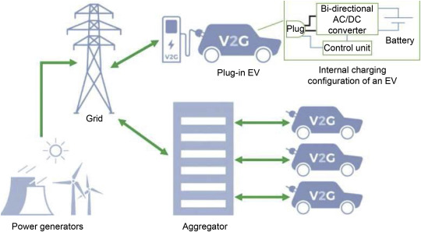
Bidirectional charging otherwise known as V2G offers the ability for electric vehicle owners to plug in to the Grid and sell remaining energy back during peak times. It also allows owners the opportunity to buy back at lower rates. (ESO, National Grid, 2021)V2G plays a key role in reducing energy demand as it helps to reduce the need for the active production of more energy at peak times. This has a direct impact on reducing emissions and decreases the adverse effect on the environment that producing more energy at peak times would create. The utilization of V2G from the estimated 8 million to 11 million hybrid or electric cars in the UK by 2030 according to (Local Government Association , 2021) would substantially subside the impact created by the transport sector on the Grid through the process displayed in figure 7.
Figure 7. Potential block diagram of V2G set-up. (MD. Shahrukh Adnan Khan, 2019)

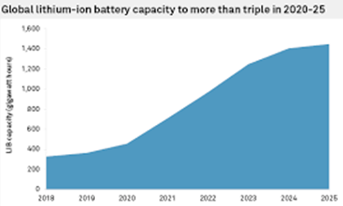
Even the most efficient Internal combustion engine’s efficiency is inferior (REF)as batteries are by far the most cost-efficient form of energy storage and continue to improve over time as displayed in figure 8.
Figure 8. (S&P Global Market Intelligence,, 2021)
Figure 9. (S&P Global Market Intelligence,, 2021)

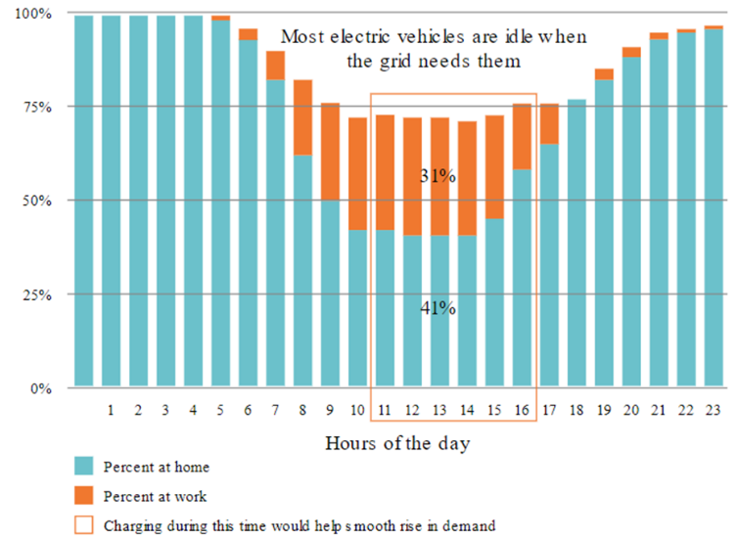
“V2G helps mitigate climate change by allowing our energy system to balance more and more renewable energy.” (VirtaGlobal, 2021)
As illustrated in Figure 9 vehicles are parked during the times where the grid is at peak demand. Utilizing the electric vehicles as energy storage systems when unused I.e., resupplying the Grid in the form of bidirectional charging or (V2G) tech could prove to be a viable solution providing sufficient infrastructure is available
Figure 10.Chart illustrates how charging at certain times eases the pressure off the Grid.

Environmental and ethical issues coinciding with current EV/automotive technology.

The effect of V2G and subsequently EV technology on the environment.

Energy sources.
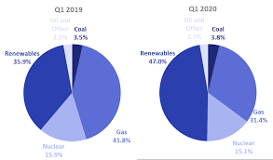
EVs are designed to “slow climate change, improve public health, and reduce ecological damage” (Xiong Shu, 2021).Such technology that is part of the global attempt to keep fossil fuels in the ground, curb methane emissions and tackle climate change. Critically analyzing the sources of the energy that are created to power EVs is vital.
Figure 11.Percentage of Renewable Energy UK during first quarters of 2019-2020. (Deparment for Bussiness, Energy & Industrial Strategy, 2020)
“Concerning CO₂ emissions, the energy provenience from fossil fuels or renewable sources is fundamental” (ElectricMotorengineering, 2021).“UK officials stated in 2020 that the energy produced from renewables had showed a 10% increase up to 45% from the previous year” (Deparment for Bussiness, Energy & Industrial Strategy, 2020). During the use phase, EV’s depend on energy production sources their carbon footprint can further decrease depending on the availability of renewable energies. (ElectricMotorengineering, 2021)

Life Cycle Assessment.
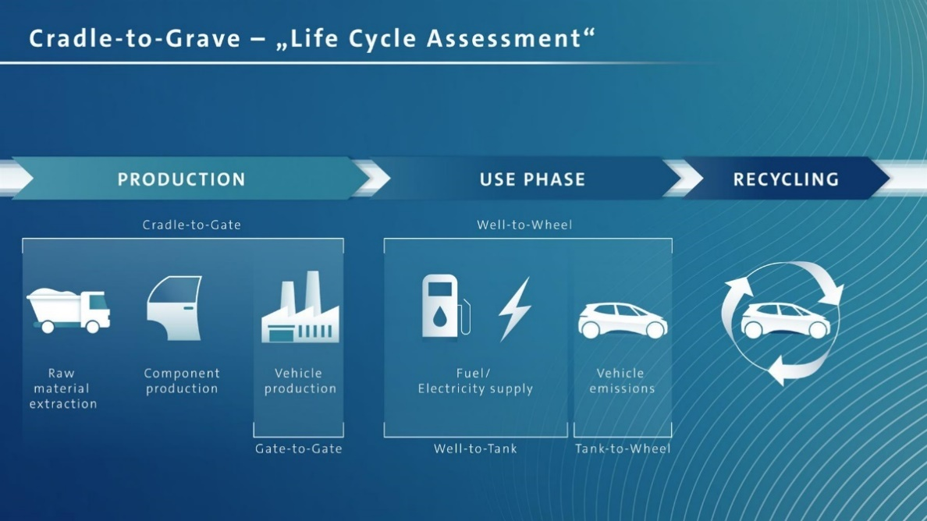
Life cycle assessment or ‘LCA’ of Electric vehicles must be critically assessed as part of the analysis of “whether energy and environmental impacts from batteries production, can exceed the benefits generated during the vehicle’s use phase” (Andrea Temporelli, 2020).
Figure 12. (ElectricMotorengineering, 2021)
“Most of the emissions for an electric car are generated during the production phase according to LCA studies” (ElectricMotorengineering, 2021).The large-scale production and application of EV batteries causes environmental pollution. The precious metal materials used in the batteries are both detrimental to human health and any nearby ecological systems. (Xiong Shu, 2021)
Battery production and the complex mining of raw materials account for almost half of CO₂ emissions for the entire lifecycle (ElectricMotorengineering, 2021)

Environmental risks of the extraction raw materials to produce EV batteries.
Lithium and Cobalt mines scar the landscape destroying neighbouring ecosystems, habitats and the biodiversity supported within these areas.
The extraction of these precious metals is undertaken in some of the driest climates on the planet where locals already face water shortages. Lithium mining processes involve excessive use of water with some statistics estimating that almost 2 million litres of water are required to produce one metric ton of lithium (UNCTAD, 2020).Cobalt mines cause pollution of nearby water sources through processes such as ‘acid mine drainage’ cobalt mines sites devastate rivers, streams, and aquatic life for hundreds of years. (UNCTAD, 2020)

Recycling of batteries.
Fortunately for the environment, recycling is at present the most common end-of-life (EoL) treatment for used EV batteries.
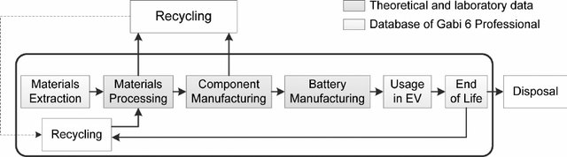
Figure 13.Battery recycling process. (Bingbing, 2014)
In addition to this alternate EoL methods such as battery reuse in other sectors outside of the automotive industry are being practiced and researched further worldwide. Due to EV’s demanding no less than approximately 70% of original capacity; batteries are rendered as ineffective for automotive applications. (Bingbing, 2014) The result is an enormous number of second-hand batteries left over from the automotive industry left with substantial battery life suitable for less demanding applications such household energy supply units.

Ethics surrounding V2G.
V2G technology does not create ethical issues directly as it manifests in the form of bidirectional charges designed to replace traditional one-way charges. However, issues that directly stem from EV technology which is in coordination with V2G technology must be bought to light.
As raw materials for lithium-ion battery production are concentrated in a few developing countries of which these countries are paying the environmental cost to fund ‘a greener future’ for more developed countries. (UNCTAD, 2020)
“In 2020, Tesla secured a deal with Swiss mining giant Glencore. Tesla has stipulated in its contract that suppliers use what it refers to as “conflict-free” minerals” (Franklin, 2021). This is left to scrutiny as Glencore sources most of its cobalt from the Dominican Republic of Congo. Within the Cobalt mining industry in the DRC children are made to work in inhumane and menacing work environments. Using nothing but hand tools to dig hundreds of feet below underground; this is where injury and death are just everyday occurrences. If this wasn’t bad enough mining extensively exposes local communities to toxic metals that often cause health related issues IE. Respiratory problems and birth defects. (Franklin, 2021)
Manufacturers such as Tesla stated it is not responsible for the working conditions of its suppliers.
This lack of responsibility from large corporations in a bid to earn profit should not be accepted in any corporation or country today especially one as large as Tesla that promotes itself as “the future of automotive technology”.

The impact of V2G operations on the degradation of Lithium-ion batteries.
“Lithium ion battery degradation governs the economic viability of V2G” (Kotub Uddin, 2018).
Well-publicised shortcoming in V2G technology is that of battery degradation according to numerous studies. (Matthieu Dubarry, 2017) “V2G is unlikely to be adopted if issues around Lithium ion battery degradation are not addressed, in application” (Kotub Uddin, 2018).
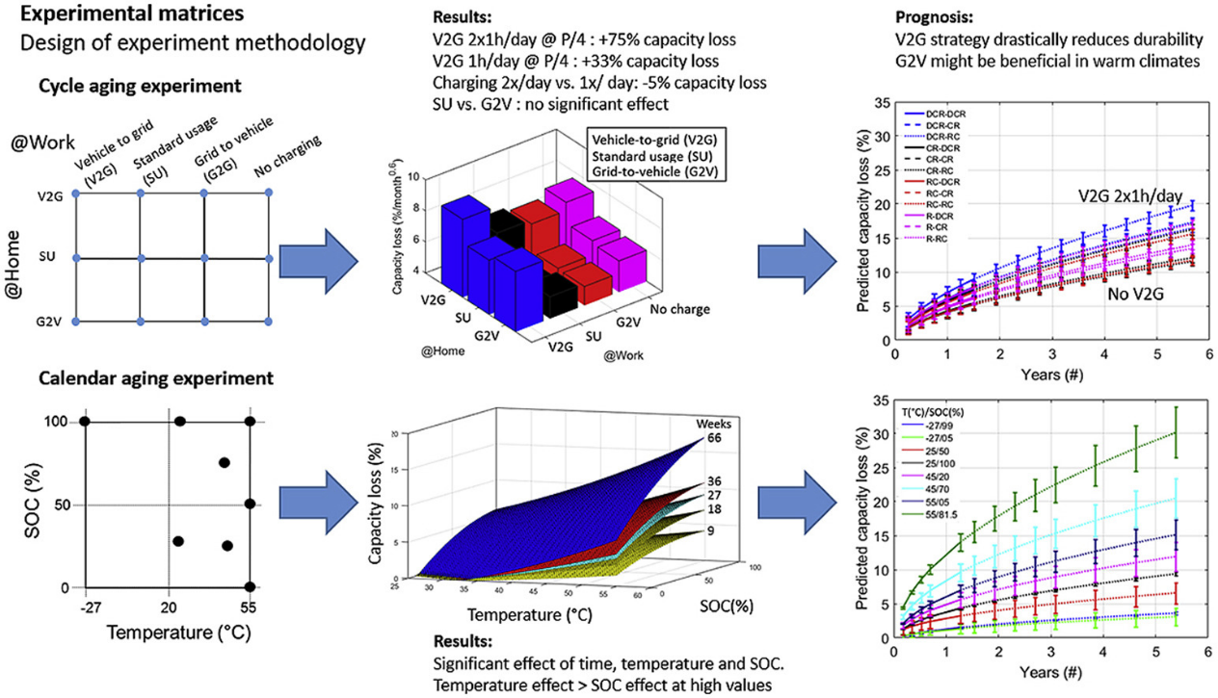
Figure 14.The effects of V2G on a battery (Matthieu Dubarry, 2017)
At first glance the works of (Kotub Uddin, 2017) and Matthieu (Dubarry 2017) may seem nothing less than contradictory. Results from these studies conclude that additional usage of the batteries through V2G is detrimental to cell performance and that it could shorten battery life to potentially less than five years. However, if further advancements on battery degradation were made in the effort to produce a smart-control algorithm with the objective of maximizing battery life. Which provides intelligently set limits on the amount of energy traded; and with these limits being based on accurate battery prognostic models, results conclude that V2G could both be viable and profitable in the near future. (Kotub Uddin, 2018)

Conclusions.
“New grid developments will be necessary to accommodate the significant electricity consumption stimulated by EV growth and maintain grid stability and reliability” (Kotub Uddin, 2018).
“Installing the grid improvements and platform is an essential first step but establishing the appropriate compensation model will be challenging and necessary for V2G to expand” (Kotub Uddin, 2018) Considering factors such as the geographical divide of charging infrastructure currently in the UK and thereby the lack of. It would be fair to conclude, that it is more applicable to fleet owners rather than the individual consumer as it proves unpractical for everyday drivers.
As this technology is only just starting to become readily available for EV owners this brings about more promise as technology improves in the future.
“V2X turns EV charging from electrical demand response to a battery solution. It enables the use of the battery 10x more efficiently compared to unidirectional smart charging.” (VirtaGlobal, 2021)
It is without doubt that this technology acts as a step further to meeting the net 0 emissions by 2050. Thereby making electric vehicles more of a ‘green’ option in today’s society and easing our dependence on fossil fuels and further benefiting the economy and relevant corporations by pressing and increasing the sale of new cars. V2G is beneficial to the planet by further reducing energy waste, pollution that would be a result of having to charge all electric vehicles without the support of bi-directional charging.
Electric vehicles promoting the removal tailpipe emissions altogether in Urban areas would result in a drop in the levels of harmful air pollutants such as carbon monoxide and nitrous oxide thereby, creating a much more sustainable and cleaner environment to live in. This would have an effect of surrounding environments also including bodies of water and all the biodiversity that is sustained and dependant on the connecting sources of water.
“The growth of renewables inevitably makes our energy system more volatile, requiring new ways to balance and store energy to be used” (VirtaGlobal, 2021).
Natural resources are being depleted at an ever-increasing rate due to a rise in fuel/energy demand. Oil, Gas, and ores that are mined for the production of batteries such as lithium or cobalt all have the common factor of being finite. *(in correlation to the demand of resources such as oil) stemmed from an ever-growing number of the global population.
“The pursuit of more environmentally friendly products should be one of the most important motivations. This is because the original intention of using EVs is to reduce carbon emissions and mitigate environmental pollution caused by transportation” (Xiong Shu, 2021).

References
Anderson Hoke, A. B. A. P. K. S., 2011. Electric vehicle charge optimization including effects of lithium-ion battery degradation, s.l.: IEEE Vehicle Power and Propulsion Conference.
Andrea Temporelli, M. L. C. G., 2020. Life Cycle Assessment of Electric Vehicle Batteries: An Overview of Recent Literature, Milan: Energies.
Bingbing, X. ,. Y., 2014. Life Cycle Environmental Impact of High-Capacity Lithium Ion Battery with Silicon Nanowires Anode for Electric Vehicles, Milwaukee: ACS Publications @ 2014 American Chemical Society.
Deparment for Bussiness, Energy & Industrial Strategy, 2020. UK Energy Statistics, Q1 2020. Press notice (June 2), p. 14.
ElectricMotorengineering, 2021. ElectricMotorengineering. [Online]
Available at: https://www.electricmotorengineering.com/life-cycle-assessment-electric-car-wins/
[Accessed 22 11 2021].
ESO, National Grid, 2021. National Grdi Capacity Report, Warrick: Copyright@2021 National Grid ESO.
Franklin, A., 2021. TESLA LOOKS FOR ALTERNATIVES TO COBALT MINING. Alternatives to Cobalt Mining.
Gokten, S., 2012. An overview of Financial Aspect for thermal Power Plants, Gazi: Researchgate.
HM Government, 2020. The Ten Point Plan for a Green Industrial Revolution, London: @CrownCopyright 2020.
Kotub Uddin, M. D. M. B. G., 2018. The viability of vehicle-to-grid operations from a battery technology andpolicy perspective, WMG, International Digital Laboratory, The University of Warwick, Coventry CV4 7AL, UKbHawaii Natural Energy Institute, SOEST, University of Hawaii at Manoa, 1680 East-West Road, POST 109, Honolulu, HI 96822, USA: Elsevier.
Kotub Uddin, T. W. D. W. G. C. P. A. J. J. M., 2017. On the possibility of extending the lifetime of lithium-ion batteries through optimal V2G facilitated by an integrated vehicle and smart-grid system, Warrick: © 2017 The Authors. Published by Elsevier Ltd..
Lilly, C., 2021. Electric car market statistics.
Local Government Association , 2021. Electric vehicles: What’s going on out there?. [Online]
Available at: https://www.local.gov.uk/electric-vehicles-whats-going-out-there
[Accessed 18 11 2021].
Mathieu, L., 2019. Electric car models to triple in Europe by 2021 – market data, s.l.: www.transportenvironment.org.
Matthieu Dubarry, A. D. K. M., 2017. Durability and reliability of electric vehicle batteries under electric utility grid operations: Bidirectional charging impact analysis, Manoa: Copyright © 2021 Elsevier B.V..
MD. Shahrukh Adnan Khan, K. M. K. K. S. M. M. I. I. A. A. K. M. M. B., 2019. Technical investigation on V2G, S2V, and V2I for next generation smart city planning, s.l.: © 2020 University of Electronic Science and Technology of China. Publishing Services provided by Elsevier B.V. on behalf of KeAi..
Morris, C., 2019. Cleantechnica. [Online]
Available at: https://cleantechnica.com/2019/06/13/chart-electric-cars-cutting-gasoline-use-by-hundreds-of-millions-of-gallons-a-year/
[Accessed 23 11 2021].
Nuclearnews, 2019. The impact of non-technoligical innovation on technological. s.l.:copyright@Nuclearnews.
Regen Power, 2021. What are the problems faced by renewable energy?, pp. 1-3.
Reuters, 2017. Reuters. [Online]
Available at: https://www.reuters.com/article/nationalgrid-energy-idUSL8N1K342P
[Accessed 14 11 2021].
S&P Global Market Intelligence,, 2021. Global Lithium Ion battery capacity set to triple, Global: S&P Global Sustainable1 .
SMMT, 2021. SMMT. [Online]
Available at: https://www.smmt.co.uk/vehicle-data/evs-and-afvs-registrations/
[Accessed 21 11 2021].
UNCTAD, 2020. United Nations Conference on Trade and Developement. [Online]
Available at: https://unctad.org/news/developing-countries-pay-environmental-cost-electric-car-batteries
[Accessed 5 11 2021].
Vella, H., 2020. Electric vehicles charging back with V2G technology, s.l.: E&T.
VirtaGlobal, 2021. VEHICLE-TO-GRID (V2G): EVERYTHING YOU NEED TO KNOW. [Online]
Available at: https://www.virta.global/vehicle-to-grid-v2g
[Accessed 21 11 2021].
Wagner, P., 2021. E-Car Charging Infrastructure Becoming Mainstream.
Xiong Shu, Y. G. W. Y. K. W. G. Z., 2021. Life-cycle assessment of the environmental impact of the batteries used in pure electric passenger cars, s.l.: Elsevier Ltd..

Appendix.
The cost of battery degradation, due to a charge cycle is defined as:
$C_{bd}=C_{bat×}\frac{∆L}{L}$
(insert citation “The cost of battery degradation”.)
In this equation, (C_{bat}) = is the cost to purchase the battery pack,
(ΔL) is the lifetime degradation due to the charge cycle being evaluated per unit time, and
(L) is the total battery lifetime if the charge cycle under evaluation were repeated until the battery’s end of life (EOL). By minimizing(c_{bd}), we are maximizing battery life. (Anderson Hoke, 2011)
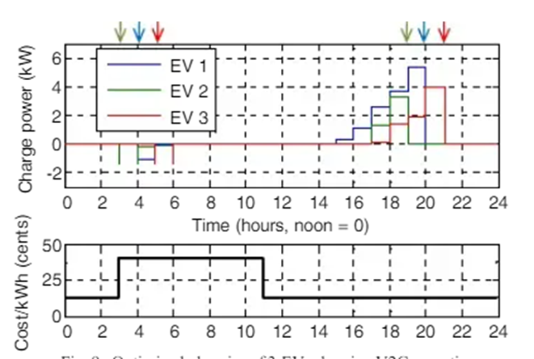
Figure 15. Optimized charging of 3 EVs showing V2G operation (Anderson Hoke, 2011)
By delaying charging, the batteries are stored at lower SOCs which is beneficial for most commercial Lithium-ion batteries.
The depth of battery discharge effects battery life. This can be aided by pre-installed built-in restrictions to aid preserving longevity of battery life as high rates of charge reduce battery life and cause further damage.
Temperature-related degradation can be solved by Installing a system in place to reduce the excess heat which is built up during charging I.e., cooling systems or active liquid thermal management systems have proven to be a successful method of tackling battery degradation on the Tesla model 3.
Cyclic degradation = degradation as a result of charging and the battery using that charge.
Calendar ageing = degradation over its lifetime.

This is partially because any energy exported must subsequently be imported back, leading to additional temperature-related degradation.
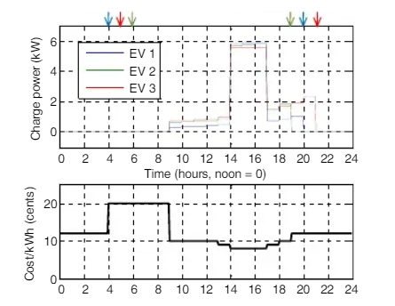
Figure 17. Optimized charging of 3 EVs with multi-level cost of energy
While the results from figure 8 indicate that a very high price differential is required to make V2G economical, it should be noted that low amplitude, high-frequency V2G associated with frequency regulation is not modelled here and may be economical at lower prices, especially if peak charge and discharge powers(and hence temperatures) are low. Because the cost of battery degradation due to V2G is dominated by the temperature-related costs, effective thermal management should make V2G economical at lower power prices. This is demonstrated in Fig. 16.

