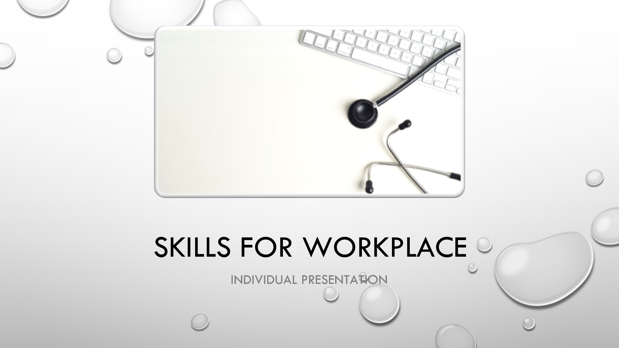
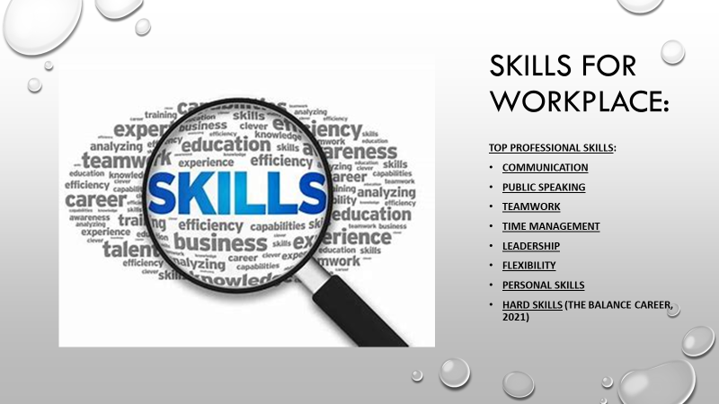
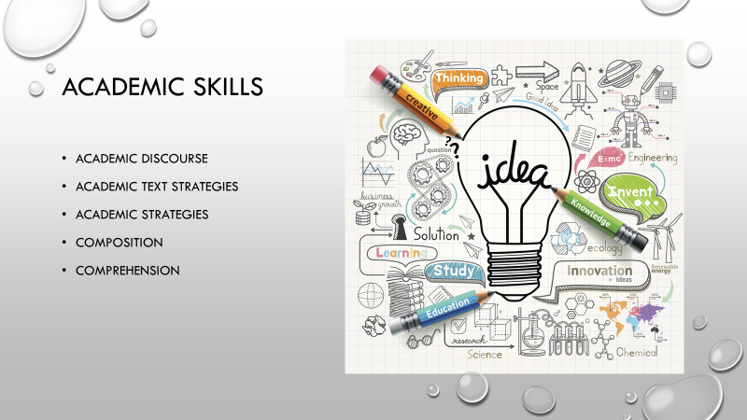

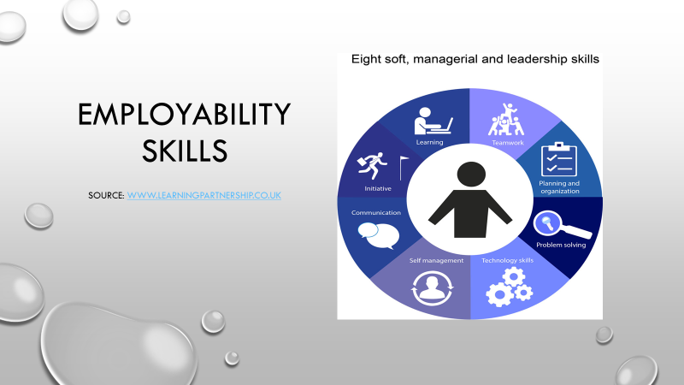

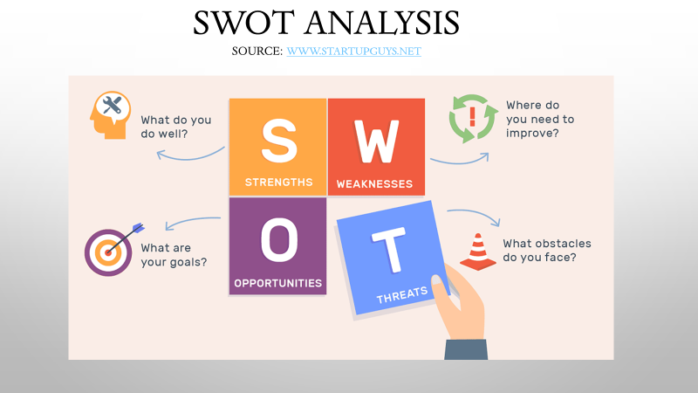
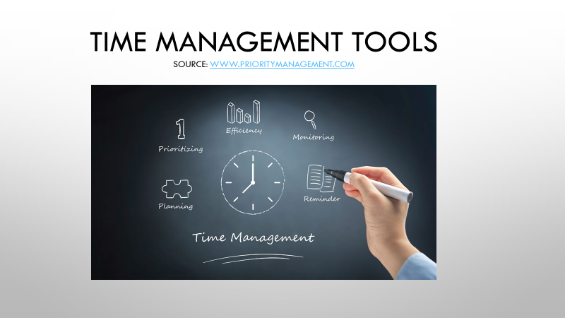
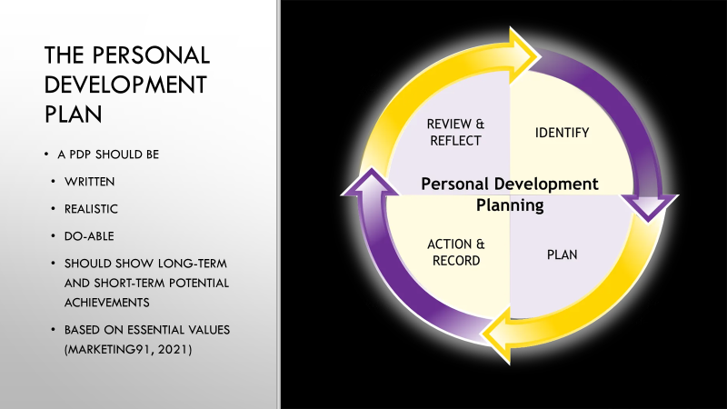

Skills for workplace
(Presentation notes)

Every professional need specific abilities, knowledge, qualities, and skills to do well at work. The skills required can be soft skills, hybrid skills or hard skills. Almost every job requires specific set of skills to achieve the best from a team member (The Balance Career, 2020).
Top professional skills:
- Communication: including verbal, written and nonverbal. The most written form of written communication nowadays is the email. This must be clear, concise and use adequate tone and vocabulary for the recipient.
- Public speaking: is the skills needed for team meetings, for sharing information verbally, must be clear and informative in an efficient way. This includes articulation, confidence, creativity, social skills, projection and able to receive feedback that is positive and negative.
- Teamwork: this assures that the business achieves is goals and targets. Delegating and sharing responsibility with the team, communicate effectively and have a common focus is a must. This includes having negotiation skills, team building skills, team management skills and relationship building skills.
- Time management: this entitles being organised, prioritising, target focused, attention to detail, motivation, punctuality, initiative.
- Leadership: take accountability, able to manage budgets, able to work under pressure, guiding the team, able to make decisions for the business, able to plan and prioritise, be positive and friendly.
- Flexibility: is important as sometimes adaptation to new working style is required, to be open to new ideas, able to analyse the situation, and have problem solving attitude.
- Personal skills: provides the individual with the ability to work with others, either colleagues or customers, partners, distributors, or any other people.
- Hard skills: this entitles being knowledgeable in the role (The Balance Career, 2020).
Academic skills:
Includes the learning, the research, report writing as well as presentations making. These skills are mainly for students and teachers but are ideal for professionals, depending on their work type. These are also important for students (Simplicable, 2020).
Academic skills bring confidence to students with their work, assignments, and their learning process. Skills such as learning, research and critical thinking will be transferable into the career post studies. Some academic skills: academic discourse, academic text strategies, academic strategies, composition, comprehension (English Blog, 2018).
Employability Skills:
Are some of the main skills required at workplace, also called the foundation skills or job-readiness skills. This will include skills that allows and individual to work well with others, the ability to solve problems that are happening within the company as well as skills that helps the professional succeed within the career (The Balance Career, 2020).
The SWOT Analysis:
The SWOT stands for the strengths, weaknesses, opportunities, and threats. The SWOT analysis is a tool used by managers to identify these aspects, analyse them, and put in place in plan that best suits the company’s activity and performance. This will include identifying what works best for the business, what are the challenges, what needs to improve, and what chances can be taken to perform well and achieve targets and goals. This analysis is also ideal when analysing the competitors of the business to identify what can be done better and perform better (Mind Tools, 2021).
Strengths include what the company does well, what is unique about the company, what competitors sees as strengths (Mind Tools, 2021).
Weaknesses include the areas that need improvement, identifying resources that are missing (Mind Tools, 2021).
Opportunities include the changes that the business can take to use as an advantage, strengths can be turned into opportunities (Mind Tools, 2021).
Threats include areas or things that can damage the business, its performance, reputation, the competition on the market (Mind Tools, 2021).
Time Management Tools:
Some of the time management tools are planning, prioritizing, efficiency, time management, monitoring and reminder Priority Management, 2021).
Planning is especially important at work as this is the plan that decides in the future what and how to be done and who is going to do it. The planning process and ability explains how goals can be achieved (Business Jargons, 2021).
Prioritizing involves identifying the tasks and work required and organise according to their importance, completion date and need (We Work, 2020).
Efficiency is the way of doing things right and in a productive way. Efficiency can be static (this means working with the resources already existent in a business) and dynamic (this means developing new items, services that improves the profitability of a business) (Effactory, 2013).
Time management is how a professional organises and plans his tasks and duties. A good time management at work can lead to business positive performance, efficiency, great reputation for the company, positive opportunities, less stress. Bad time management can lead to poor performance, lack of quality work, bad reputation, and high stress level (Mind Tools, 2021).
The personal development plan (PDP):
Is the action plan put in place by a person that has the aim to achieve the best self-improvement, development, and personal growth. The PDP has as a foundation the personal reflection of an individual, his values, personal achievements, performances, knowledge, studies, and career growth (Marketing91, 2021).
A PDP should be written, realistic and do-able, should show long term and short-term potential achievements, and based on essential values (Marketing91, 2021).

References:
“Academic skills for higher education”. Available at URL: https://www.english.com/blog/academic-skills-for-higher-education/. [Accessed on 28th March 2021].
“Academic skills”. Available at URL: https://simplicable.com/en/academic-skills. [Accessed on 28th March 2021]
“Employability skills”. Available at URL: https://www.thebalancecareers.com/employability-skills-list-and-examples-4143571. [Accessed on 28th March 2021]
“How to prioritize”. Available at URL: https://www.wework.com/ideas/worklife/how-to-prioritize-work. [Accessed on 29th March 2021]
“The personal development plan”. Available at URL: https://www.marketing91.com/personal-development-plan/. [Accessed on 29th March 2021]
“Top skills every professional should have”. Available at URL: https://www.thebalancecareers.com/top-skills-every-professional-needs-to-have-4150386. [Accessed on 27th March 2021].
“What is efficiency”. Available at URL: https://www.effectory.com/knowledge/what-is-employee-efficiency/#:~:text=Efficiency%20is%20the%20ability%20to%20act%20or%20produce,and%20speed%20with%20which%20organisational%20goals%20are%20achieved.. [Accessed on 29th March 2021]
“What is planning”. Available at URL: https://businessjargons.com/planning.html. [Accessed on 29th March 2021]
“What is SWOT Analysis”. Available at URL: https://www.mindtools.com/pages/article/newTMC_05.htm. [Accessed on 28th March 2021]
“What is time management”. Available at URL: https://www.mindtools.com/pages/article/newHTE_00.htm. [Accessed on 29th March 2021]

