
Student Name | Diana Kryemadhi
Student Number | 20202482
Module Number | BMSW4002
Module Title | Effective Team Working and Communication
Lecture Name | ZE ZOOK

Table of Contents
Introduction 2
Importance of communication in the workplace 2
Barriers to effective communication 2
Consequences due to poor communication 3
Models of communication 3
Linear models 3
Shannon-Weaver model of communication 4
Berlo’s model 5
Interactive model 6
Schramm Model 6
Transactional model 7
Theories of communication 7
Communication skills 8
The way of effective communication 9
Conclusion 9
References 10

Introduction
Communication has become a vital tool in today's world. If there is no communication, human activity will come to an end. Human interaction grows as much as is possible just via communication (Rosenthal, 2013). It is the Kingpin of personal development and a lucrative career. There are many obstacles to effective communication which can be minimized by improving or using some technique. Poor communication leads to hostile relationships, misunderstandings, and other disadvantages with people in our daily life and workplace. This report is aimed at describing various models and theories of communication which have taken place in the second section. In the third section, various methods of communication and a case study related to communication.

Importance of communication in the workplace
Competitive advantage: As communication becomes more sophisticated, employers will need individuals who can communicate properly with all aspects of the company.
Build trust: Effective communication may help with cooperation and system management since it encourages others to invest more resources in your happiness. If someone has gained respect from everyone you deal with, they will be able to more easily overcome unexpected conditions and difficult situations (Peterson, 2021).

Barriers to effective communication
Inability to listen to others
Effective communication and listening are interconnected. It is not possible to connect with someone or understand some if not the person listens carefully don’t have good listening skills (Nandi, 2021). In that case, the person will make an obscure assumption about the other person which will lead to poor communication.
Communication style
All of us have a different approach to communication. Some are straightforward while some are not. Some prefer verbal way of communication while some prefer non-verbal communication. Due to the variety of preference in communication a person have, the effectiveness of the style varies person to person (Turner et al., 2012).

Consequences due to poor communication
Communication gap: This will result in erroneous data and information which will bring disaster and will become a huge impediment to acquiring a common goal (Harris, 2011).
False impression: Misunderstandings may arise as a result of poor communication. Dissatisfaction may result if an employee thinks his/her effort or time has been wasted, or if he/she blames a partner for not delivering the right information in a well-coordinated manner (Turner et al., 2012).

Models of communication
Communication models are theoretical or conceptual structures that describe how people communicate. It also symbolizes the whole communication process between the communicating parties (Miller, 2015). Each model illustrates the growth and evolution of communication, on top of it, it focuses on various aspects of the process. The models depict complicated interactions as images or visual representations (Harris, 2011). They're helpful because they streamline communication's underlying basis and may help us comprehend it not only verbally, but also visually. They also act as a sort of blueprint to illustrate how different aspects of effective communication are interconnected.
Types of communication model
There are mainly three types of communication models, these are:
- Linear Models
- Interactive Models
- Transactional Models

Linear models
The linear communication model is a unilateral engagement in which there is no feedback. This model is the most common, and the transactional model is built on top of it (Cobley and Schulz, 2013). Despite getting feedback, the sender interacts with the recipient. It also symbolizes a one-way information exchange.
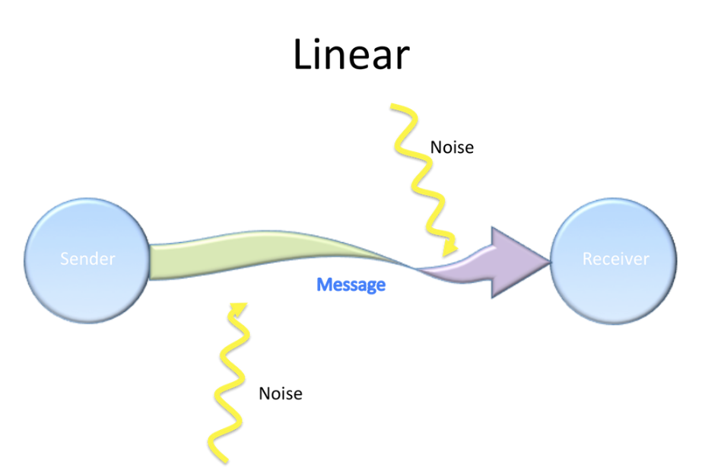
Figure 1 Linear Model / Source: (Miller, 2015)
Linear model example
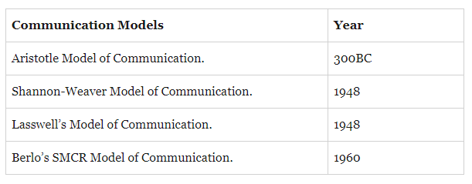

Shannon-Weaver model of communication
This model may be too simplistic. When a person considers the ideas about communication, stated in this model, the person can easily identify its limits. For starters, this model implies that communication is exclusively one-way (Cobley and Schulz, 2013). In practice, communication entails a two-way exchange between the sender and the recipient, with listeners serving as more than just passive receivers for the sender's message. This approach is further constrained by the fact that it only offers one route for a single message. Finally, it indicates that communications are different from one another, having an initial hypothesis and finish (Turner et al., 2012). Communication, on the other hand, is seldom, if ever, as clean as a linear model would imply.
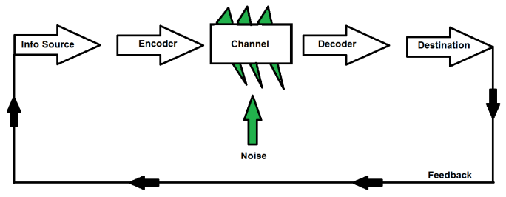
Figure 2 Shannon-Weaver model
Source: (Cobley and Schulz, 2013)

Berlo’s model
The SMCR model, which contains the concept of Source-Message-Channel-Receiver, is known as Berlo's Model of Communication (Miller, 2015).
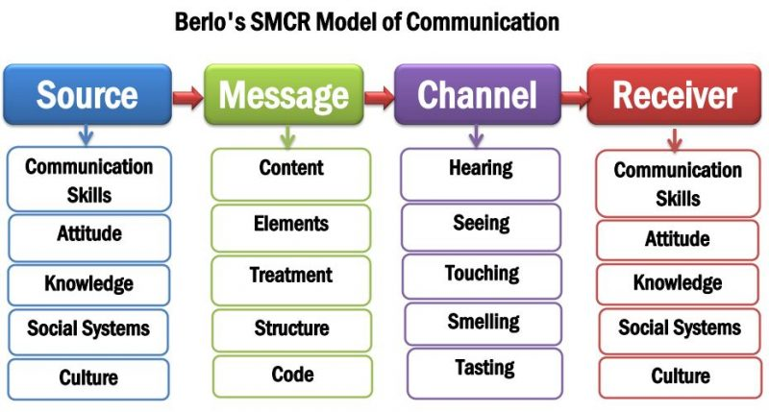
Figure 3 Berlo’s model / Source: (Peterson, 2021)
Source: The source is the very first component of Berlo's communication model. All communication must originate from somewhere (Cobley and Schulz, 2013). One individual, or a group of employees from a business, maybe the source. Numerous factors influence how a source behaves throughout the communication process, including:
- Thinking, writing, drawing, and speaking talents are examples of communication skills.
- Attitudes toward the listener, the topic, and so forth.
- The ability to understand the topic, the audience, and the circumstance.
- Socioeconomic status, education, friends, income, and culture are all factors to consider.
Message: The message is the information, opinions, or ideas that the source wishes to send (Harris, 2011). For sending the message, the source needs to choose the code or language.
Channel: The method by which the message will be transferred, such as telegraph, journal, radio, written statement, poster, or other media, is referred to as the channel (Cobley and Schulz, 2013).
Receiver: The receiver is the last component in the communication chain (Turner et al., 2012). The message's viewer is known as the receiver.

Interactive model
This model of communication pertains to a two-way communication system that includes feedback. Nevertheless, since feedback is not instantaneous, it is delayed and circuitous (WAGNER et al., 2011). When receivers do not respond to senders, communication may become linear. this model denotes both controlled and web-based communication.
Example
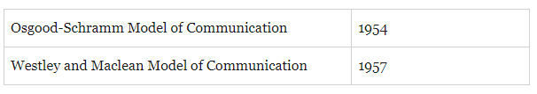

Schramm Model
This is a two-way model where a sender and receiver complete the successful communication. This model focus on encoder and decoder and they are the crucial component of a fruitful communication (Cobley and Schulz, 2013). Communication will not be effective until the sender gets a response from the receiver.

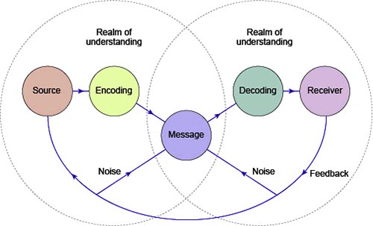
Figure 4 Schramm Model
Source: (Harris, 2011)

Transactional model
This model appears to be a bi-directional communication process with rapid feedback. Continuous feedback is a key element of transitional communication models (Miller, 2015). Furthermore, the response is immediate and direct. The recipient feels obliged to respond.

Theories of communication
Conflict theory: This theory enables people in a workplace environment to communicate with their colleagues and with everyone else to deal with all of the problems that arise (Turner et al., 2012). The managerial department of an office, which makes insights and plans, and the representatives who strive to turn those ideas into reality, are two elements in this hypothesis (Koski and Launonen, 2012). According to this theory, top management should consistently communicate with companies to awaken them and cut down on differences among everyone to get the greatest results.
Information theory: Occasionally, the information you have to convey to your client changes after it reaches the customer (Turner et al., 2012). As a result, this correspondence theory guarantees that no misunderstanding occurs and that the right message is sent to the recipient.
Post-positive theory: The tyranny method is used by a few organizations. The request is made by one person, and the others follow it. In any event, if the ideas are not properly addressed with the organizations, this may lead to conflicts (Harris, 2011). According to this idea, any plans established by top management are reviewed in a meeting or via other methods, and then a request is made for the job to be completed. This imparts in companies a sense of justice and motivates them to put up a strong effort.

Communication skills
Communication is the key element to make things work. Communication is the means through which an individual or organization communicates with the vision of attaining particular goals. Business communication is a unique kind of communication that aims to meet the needs of the company (Rosenthal, 2013). Collaboration, innovation, and engagement are all compelling criteria in cutting-edge management that revolve around communication.
Verbal communication: All communication utilizing audible words, or silent words in the case of sign language, is considered verbal communication (Koski and Launonen, 2012). To prevent misconceptions and increase attention when speaking, it's critical to know how to properly express thoughts orally. When communicating, it is important to be careful to use the proper vocabulary, talk clearly, know the audience, react appropriately, and use an acceptable tone.
Non-verbal communication: this way of communication involves physical gestures such as, eye contact, sign, hand movement and using other parts of the body to have a communication. this is one of the ancient ways of communication (Turner et al., 2012). It provides a positive impression to the person while communicating. It also creates a negative impression if the person is not good at nonverbal communication.
Written communication: While written communication is something of verbal communication, it is sufficiently distinct from spoken verbal communication to constitute its category. Written communication may take many forms, including emails, texts, and even a message written in the sky! Conference calls and speeches are examples of spoken one-to-many interactions, while e-mails may have a single or many recipients (Nandi, 2021).
Listening: listening is frequently included among the many forms of communication. Active listening, on the other hand, is arguably one of the most essential kinds of communication since we can't successfully interact with someone if we can't even listen to them (Ander, 2021). Consider a negotiation- it is important to listen carefully to the other person. It is hard to evaluate that without listening, making a win-win situation tough to accomplish.
Kinesics refers to the non-verbal form of communication using head movement, gestures, eye contact, and other physical activities which is an effective way of communication. On the other hand, In the Proxemics study, Distance and space affect communication (Miller, 2015). Space, communication, and relationships are all intertwined, as shown by how space appears in popular metaphors.

The way of effective communication
- We frequently concentrate on what we should say while interacting with people. But, to make communication effective, active listening is a must.
- Although consistency is essential, knowing the audience enables us to understand them.
- In communication, feedback is necessary to determine if the receiver has received the message. It is important to know whether he agrees or disagrees with the message.
According to Doyle (2017), “Listening effectively is comprehending not just the facts or information being conveyed, but also the feelings the presenter is attempting to express.” A few months back an incident happened with me while communicating with my friend. While taking preparation for my science exam, I was unable to understand a topic. So, I asked one of my friends to help. I briefed the topic with some questions to him which I was unable to understand. Once, he started to explain the topics and answering my questions, I got to realize he was discussing some other topics which I didn’t ask. Then, I stopped him. I realized he was not even listening to me the whole time. He did not engage with me. As a result, he did not understand what my questions were. The problem was my friend was just listening, he could not engage with me. That is why active listening is important to communicate effectively.

Conclusion
Communication is key to become productive and effective both in academics and the workplace. It is such a skill that helps the student become one step ahead of others and the person who acquires the skill will get prioritized in chasing a job. At every stage of life, this skill plays an important role to become more successful and achiever. Due to physical burdens, communication style, and other reasons a person might not be able to acquire this skill (Koski and Launonen, 2012). But with practice and technique, he/she can easily avoid having poor communication, because there are many ways to communicate. Different models are theories of communication portray the framework or structure of various communication that usually take place at the workplace and various stages of our day-to-day life.

References
Harris, R., 2011. Editorial: Communication about communication. Language & Communication, 1(1), pp.1-2.
Koski, K. and Launonen, K., (2012). Assessing the communication skills of carers working with multiple learning disabilities: a case study. International Journal of Language & Communication Disorders, 47(6), pp.685-695.
Doyle, A., (2017). Communication Skills for workplace success. The Balance Careers.
WAGNER, P., LENTZ, L. and HESLOP, S., 2011. Teaching Communication Skills. Academic Medicine, 77(11), p.1164.
Cobley, P. and Schulz, P.J. eds., 2013. Theories and models of communication (Vol. 1). Walter de Gruyter.
Miller, K., 2005. Communication theories. USA: Macgraw-Hill.
Training, M.T.D., 2012. Effective communication skills. Bookboon.
Turner, T., Qvarfordt, P., Biehl, J.T., Golovchinsky, G. and Back, M., 2010, April. Exploring the workplace communication ecology. In Proceedings of the SIGCHI conference on human factors in computing systems (pp. 841-850).
Ander, C., 2021. 9.1 Communication Strategies. [online] Open.lib.umn.edu. Available at: https://open.lib.umn.edu/humanresourcemanagement/chapter/9-1-communication-strategies/ [Accessed 27 July 2021].
Nandi, A., 2021. Communication Methods [Top ways of effective Communication]. [online] Knowledgehut.com. Available at: https://www.knowledgehut.com/tutorials/project-management/communication-methods [Accessed 27 July 2021].
Peterson, j., 2021. Different Effective Methods of Communication (Useful). [online] EDUCBA. Available at: https://www.educba.com/different-methods-of-communication/ [Accessed 27 July 2021].
Rosenthal, S., 2013. Measuring Differentials in Communication Research: Issues With Multicollinearity in Three Methods. Communication Methods and Measures, 7(2), pp.106-125.

