Module Code: ACCA4026

Software solutions for business
Edmund Charles Severn

Task 1.
In the past twenty years with the rise of the freedom of access to the internet, it was only natural that the fundamentals of capitalism (buying and selling goods and services) would grow and evolve alongside that. The past decade witnessed a surge in the availability of low-code tools, where software-based solutions can be developed with limited or no need for writing code as mentioned in [1]. Setting the bar lower for entrepreneurs to start or grow a business.
One of the world-renowned leaders in the e commerce space of website building is Shopify, founded in 2006, this platform offers many easy to use drag and drop personalisation tools for streamlined customization options to stand out from competitors, also giving newcomers to html coding a chance to enter the space with minimal understanding. One of the benefits of the popularity of Shopify is the ease of selling across many of the main social media networks with embedded links in “bios” and videos, often seen as a more trusted way to shop.
As shown in example 1 Shopify offers a wide range of easy options for adding products, within that option the ability to change product descriptions, availability, cost and product media in an easy drop-down menu design for a familiar multi choice layout.

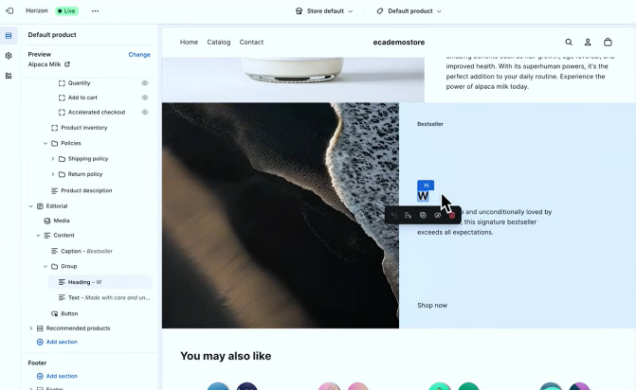
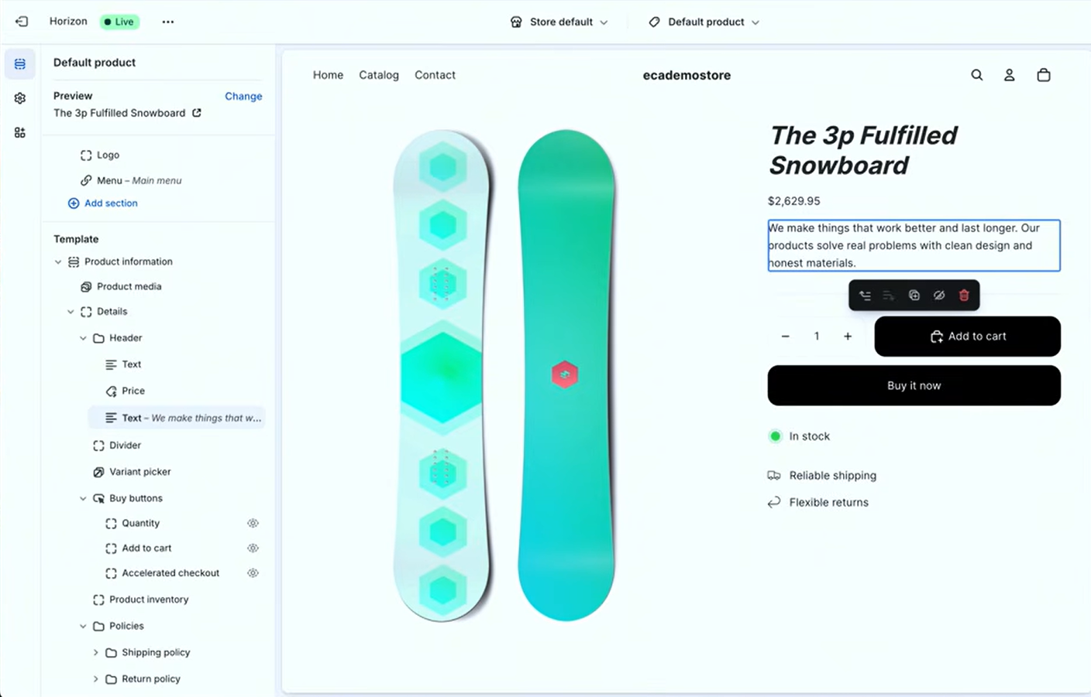
Figure 1example 1 Figure 2 Example 2

In example 2 we can see Shopify’s extensive offering of text editing options in the same consistent menu format, in conjunction with the ability to add media to the websites landing page, we are given a wide array of text and font options for different styles oif business.
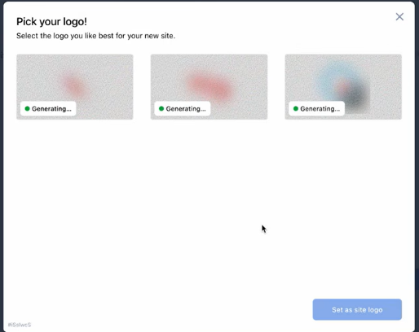
The second most predominate e commerce website builder is WooCommerce, founded in 2008 whilst the basis of E commerce website builders are all relative to each other, WooCommerce offers the ability to sell physical, digital and subscription-based products globally, a few stand out features are firstly the ability to use AI to generate your business logo as seen in example 3, also offering a wide range of payment options such as Amazon Pay, Apple Pay, Google Pay and more physical payment methods such as checks and cash on delivery for more offline payment methods. Setting up your new page can be completed through a checklist guiding you through the different features, rather than personal exploration of the user interface as seen in example 4. Giving beginners a foot in
(example 3)
the door of both graphic design and website building skills and techniques. Being open sourced there is an almost unlimited number of themes, extensions such as Shipment tracking, Smart coupons and fraud protection some offered for free and others do have to be paid for.

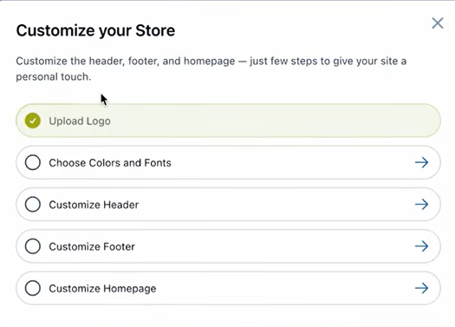
Example 4

Automation of your store is also offered with extensions giving store owners the chance to use shoppers personal data to send follow up emails to suggest other similar products, review rewards offering coupons based on multiple reviews on products and personalised coupons to raise purchase rates on different products, giving a sense of personalisation and connection between the store and consumer. (example 5)

(example 5)
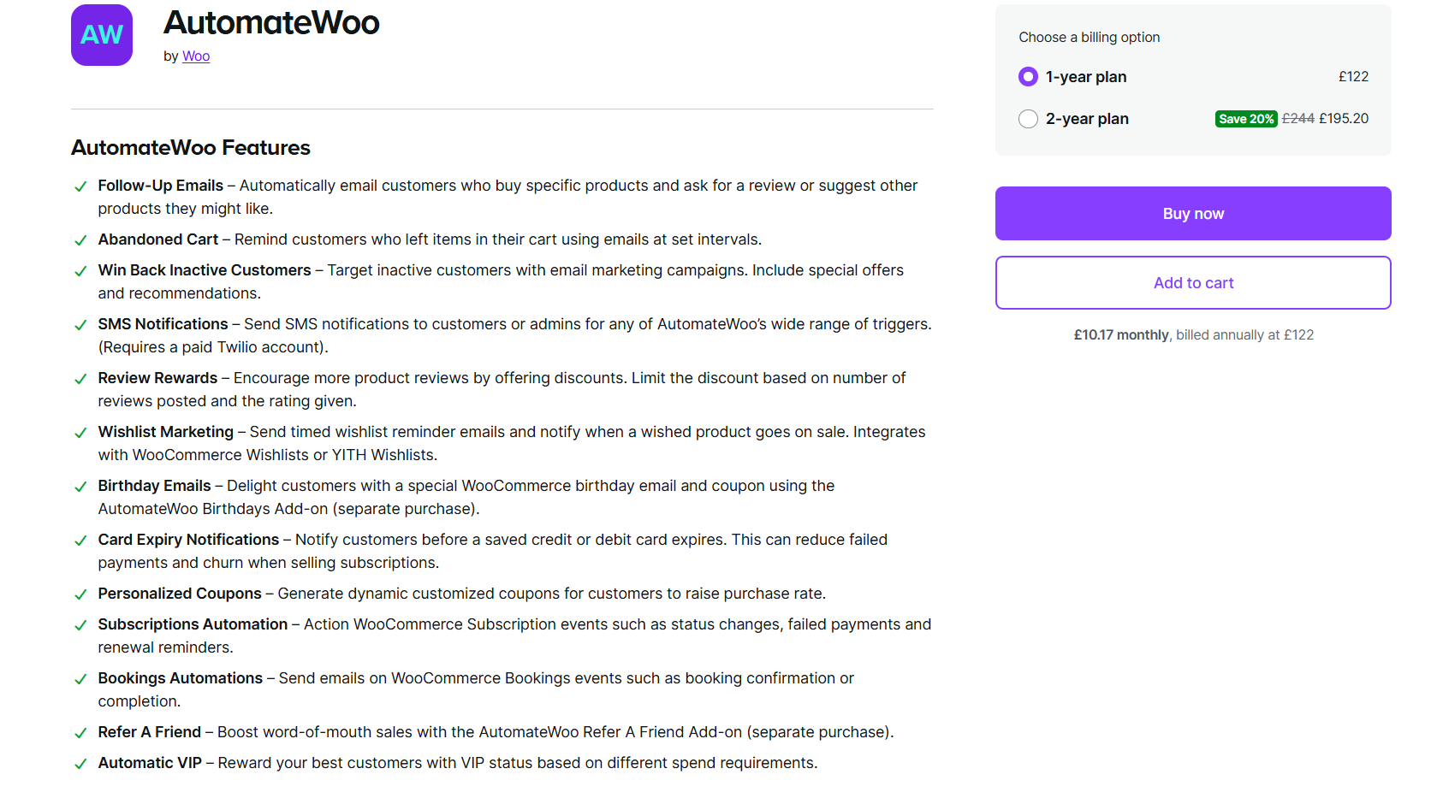

Task 2

The idea of a mind map is to help you process information, strengthen your memory with also helping improve the way you work {2]. Whilst keeping to the same format, the information presented in mind maps can vary from mapping phone calls, team planning events, meetings, organising ideas etc [3]
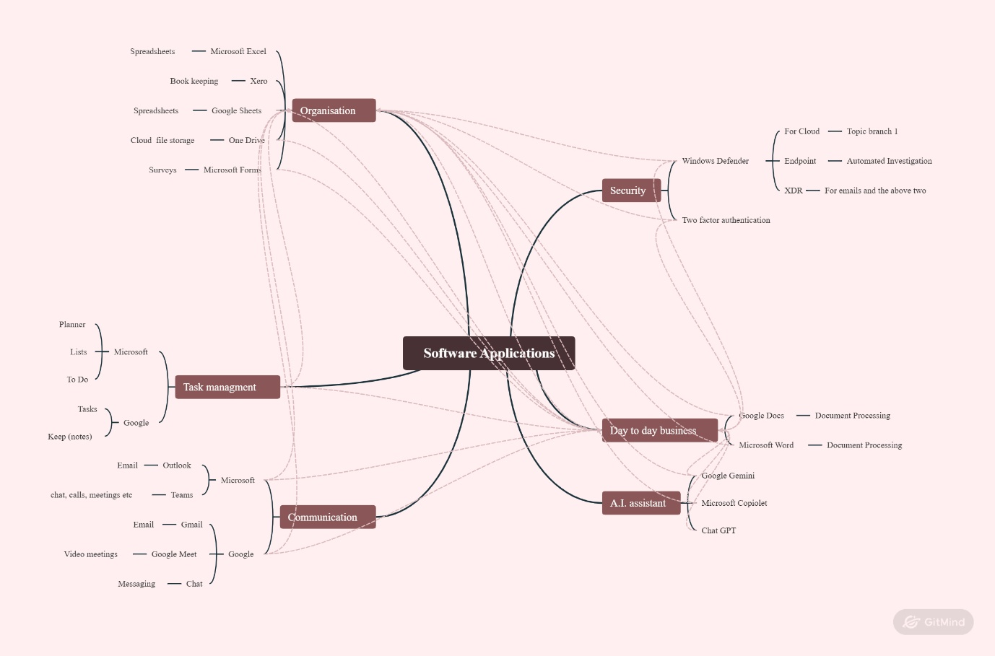
Task 3

Microsoft word is internationally used throughout education and business as it is known to encourage a fluid conceptualization of text whilst improving weaker writers’ ability to improve their writing [4]. Word can be used efficiently to create a wide range of both personal and business documents, from a complex report to a simple letter, as it is known for being one of the most sophisticated word processing apps available [5]. Some of the major features of MS Word are being able to change fonts, text formatting to give documents a more personal touch, inserting buttle points to give documents more structure and inserting data into tables with ease with the choice of table layout and designs as shown below.
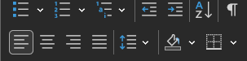
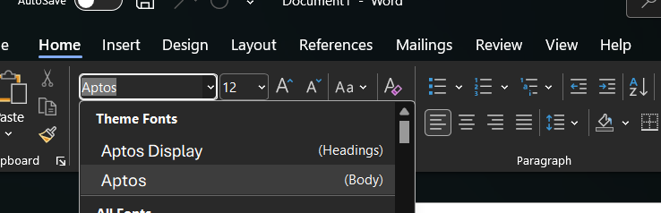
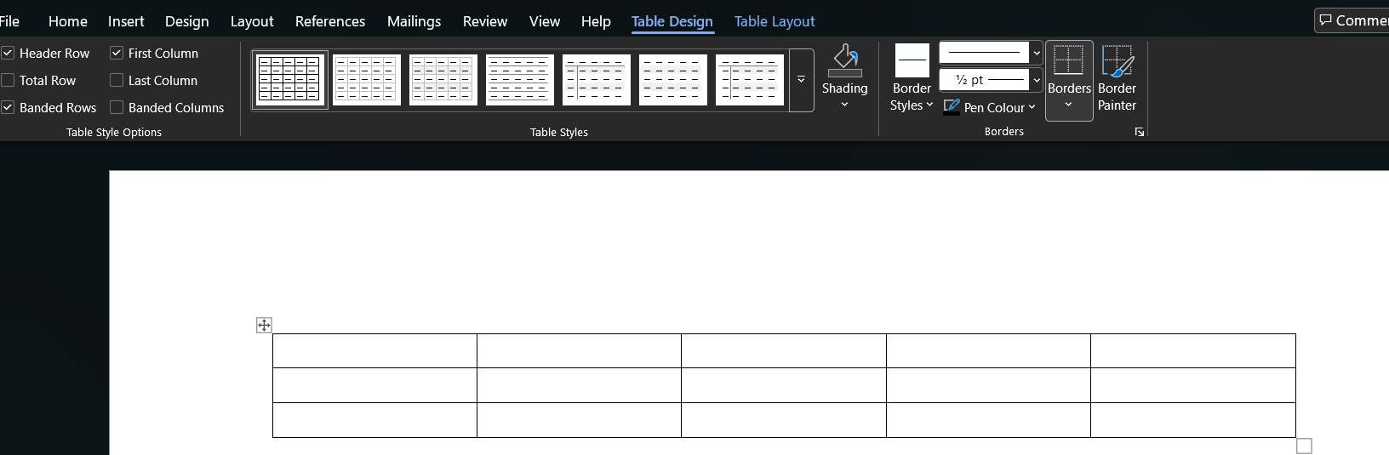
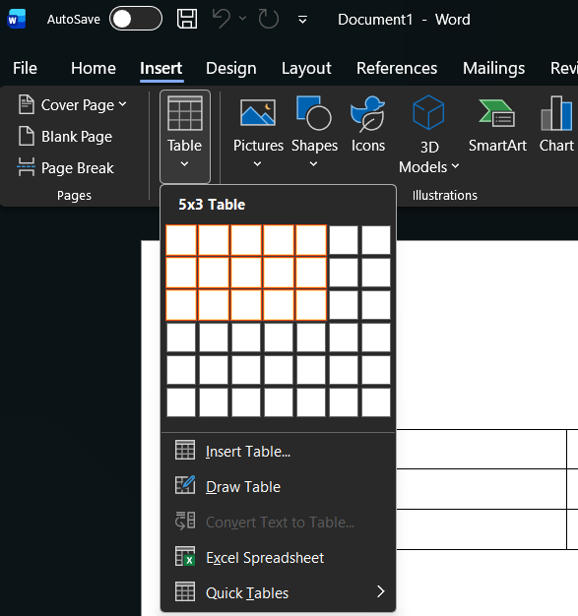
4

Part of Microsoft Office suite of programs, Microsoft PowerPoint is a presentation program that helps you efficiently and quickly develop presentations and then deliver them to an audience [6]. Because a presentation consists of several slides, there is a thumbnail view provided by PowerPoint to the left of the slides pane for each slide of the presentation [7]. PowerPoint offers many different templates for more custom presentations slides, also a new feature offered is when media is “drag and dropped” into a slide a side bar offers multiple layouts to include the placed media and the information in different arrangements. Finally, a newer feature is the ability to record a presentation within PowerPoint, giving the ability to read and create scripts and the use of the device’s camera for a more personal presentation. All the relevant screenshots below are examples of these features.
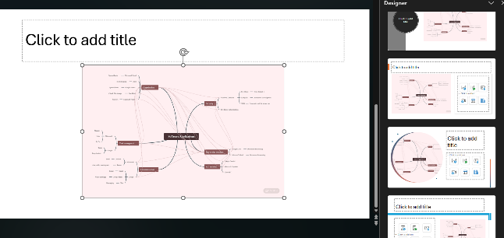
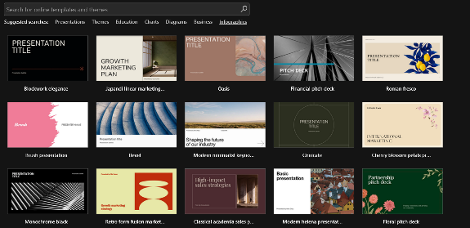

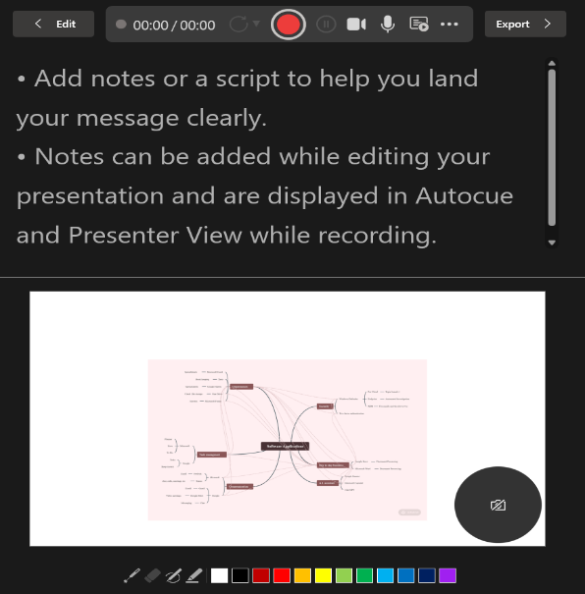


Microsoft Access provides facilities for creating reports, tables, forms etc, database apps csn be created with Microsoft Access Macro Language or Microsoft Visual Basic [8]. In Access to switch between the developer role and user role is very easy. Designing tables is typically the role of the developer, and the user role is used to enter data into them [9]. Shown below Access can be utilised within business like hotels, markets and so much more with features such as “Run Macro” gives the user the chance to run instructions and commands all grouped into one action, these may include generating a report, applying layout changes and importing data whilst cleaning up said data. Also vital within business is the idea of relationships which can connect one tables data to another to intwine data fluently, such as the first being a customer’s table connected to an orders table so staff can keep track of what is needed for reorder as well as understanding what products or services sell best.
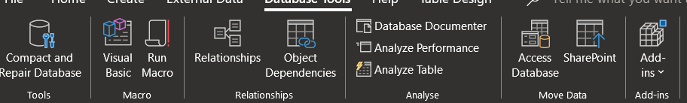

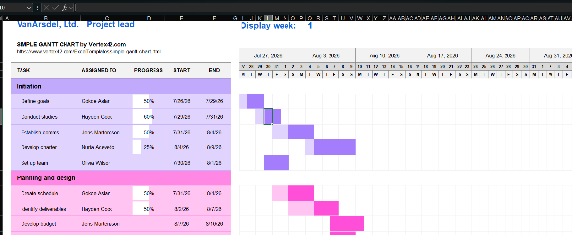
Microsoft Excel is often used for statistical analysis and data collection; a drawback of Excel is that unlike dedicated statistical programs it has a limited number of total cells whilst having fewer functions that can be used for analysis [10]. Excel can be used to input data into tables and graphs as shown to help deal with large amounts of data , underwear there is shown the input bar where equations can be inputted to either add, subtract, divide or multiply as well as divide etc,

Task 3b

VLOOKUP can be used to work out employee details as in income, bring prices up by code and to link data sheets. Using =VLOOKUP(1030, A2:H11, 8, FALSE) I can find out what employees need to be paid

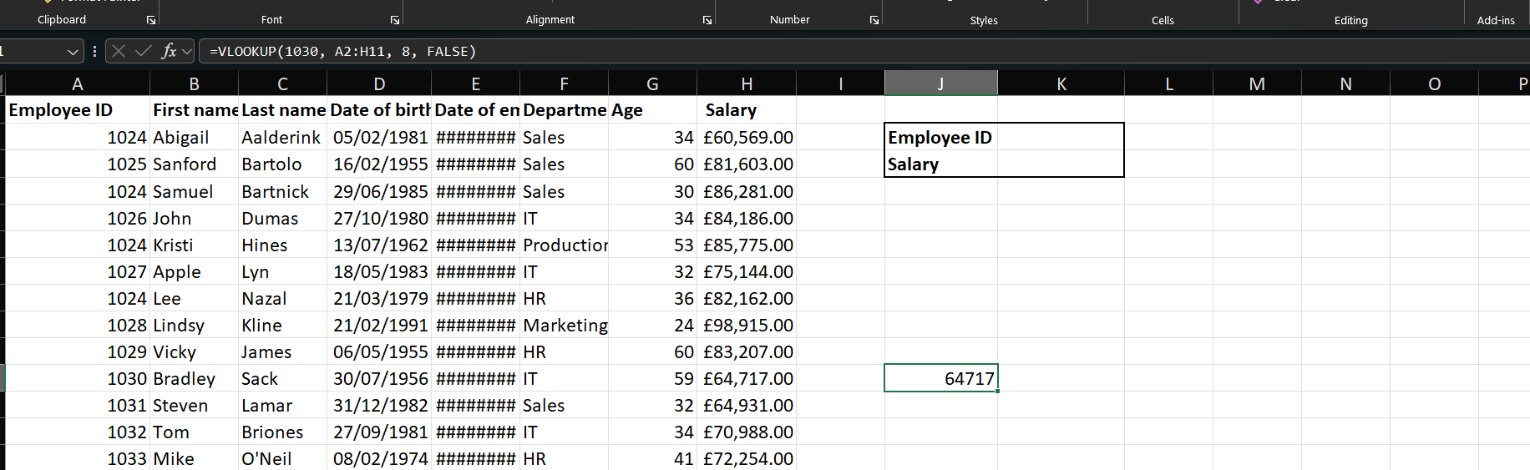
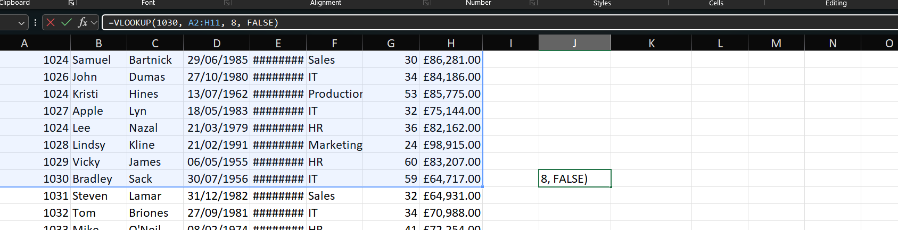
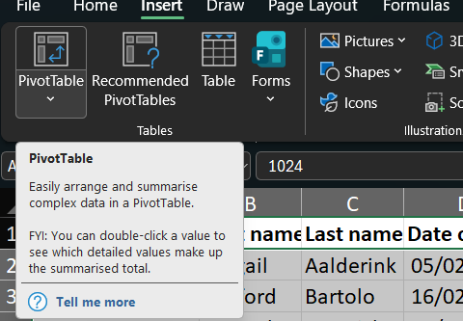
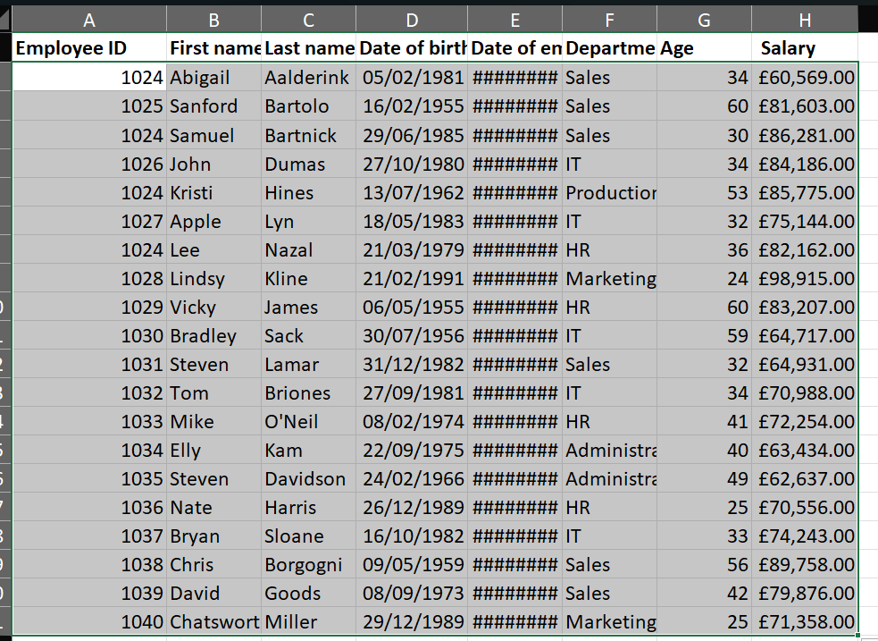
A Pivot Table in Excel can be used to create easy to read tables that have data such as employee names, ID data, salary and other data, it can be used by highlighting data within a spreadsheet.

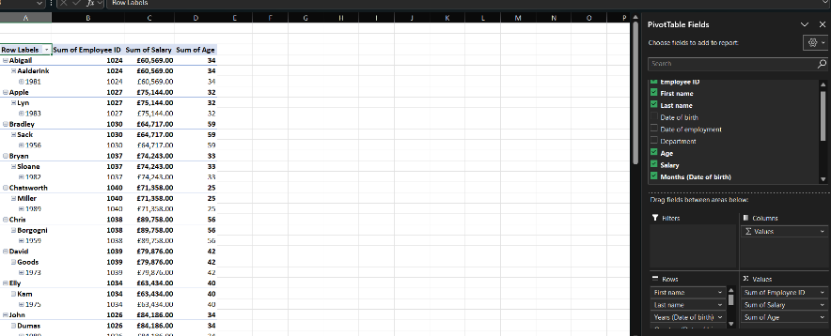
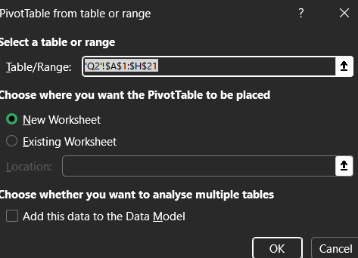
Once choosing the table option, select which fields you want to involve, following that you can change the column layout and what information you want to include such as age , names, salary etc.

Task 4
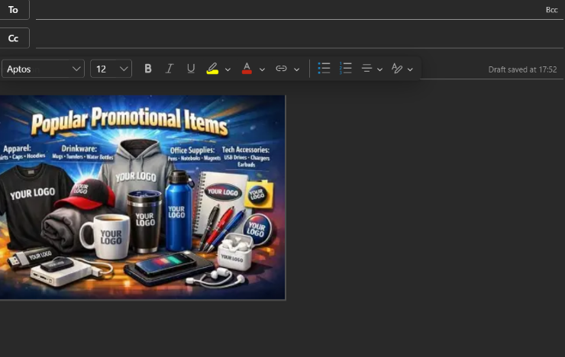
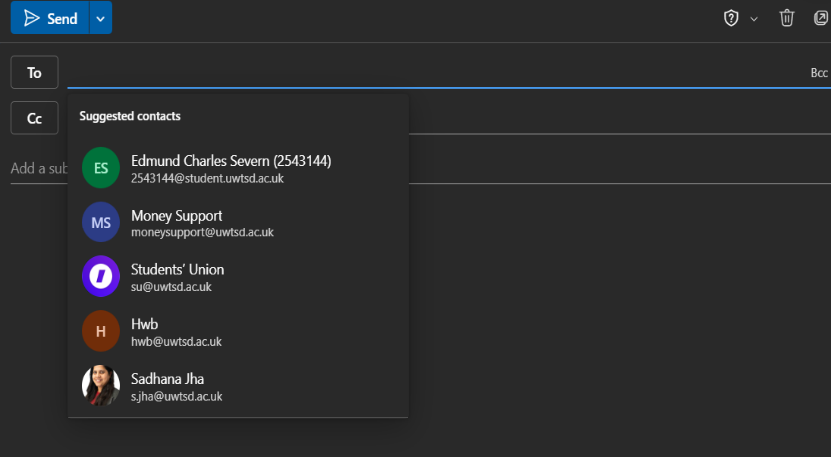
An example of contemporary communication is emails such as Microsoft outlook, it can be used to send email communications tons to certain groups on your contacts which you are interested in whilst leaving other contacts alone, whilst being able to personalize emails with content depending on what you need to convey, furthermore an email campaign for offers and newsletters can be created to help your business [11] as shown you can select multiple contacts at once to spread ideas within the workplace, another feature is to share images of promotional materials as well as links and videos.

An example of a online collaboration applications/tools is Microsoft Teams, as it is seen as the heart of communication and collaboration within Office 365 bringing together many collaboration applications and services into one platform to enable more fluent business practices [12]. Features include live communication with instant messages, group chats, instant sharing of links, images and videos giving people more connectivity. As seen below Temas is separated within channels which can be used to post content, whilst also being able to view content that was been shared within the channel
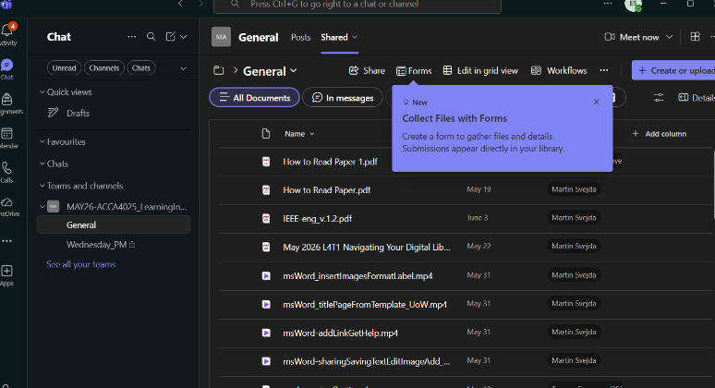
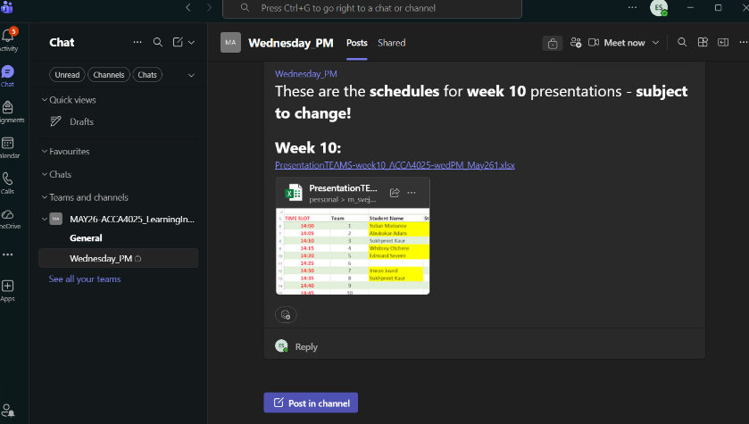

Refrences

[1] G. Dushnitsky and B. K. Stroube, “Low-code entrepreneurship: Shopify and the alternative path to growth,” Journal of Business Venturing Insights, vol. 16, 2021.
[2] T. Buzan, Mind Map Mastery: The Complete Guide to Learning and Using the Most Powerful Thinking Tool in the Universe. London, U.K.: Watkins Publishing, 2018.
[3] O. A. Osunsan, Mind Mapping for Business: Creativity, Problem Solving and Strategic Thinking. London, U.K.: Routledge, 2023.
[4] J. D. Novak and A. J. Cañas, “The theory underlying concept maps and how to construct and use them,” Review of Educational Research, vol. 76, no. 3, pp. 413–460, 2006.
[5] S. G. Powell and K. R. Baker, Business Analytics: The Art of Modeling with Spreadsheets. Hoboken, NJ, USA: Wiley, 2023.
[6] M. Smart, The Smart Way to Learn Microsoft PowerPoint 2013: One Step at a Time. Academia.edu, accessed Jul. 26, 2026.
[7] J. Cox, Microsoft PowerPoint 2010 Step by Step. Redmond, WA, USA: Microsoft Press, 2010
[8] M. Buzan, “Mind maps in business,” in The Mind Map Book, T. Buzan and B. Buzan, Eds. London, U.K.: BBC Active, 2006, pp. 331–345
[9] “Microsoft Word – MS4,” World Colleges. [Online].
[10] S. A. Al-Hammad, “Limitations of using Microsoft Excel version 2016 (MS Excel),” Journal of Spinal Disorders & Techniques, vol. 34, no. 5, pp. E302–E308, 2021.
[11] C. L. Bovée and J. V. Thill, Business Communication Today, 14th ed. London, U.K.: Pearson, 2021.
[12] S. G. A. van der Meulen, Microsoft Teams For Dummies. Hoboken, NJ, USA: Wiley, 2020.

