INTRODUCTION TO PHYSIOLOGY
BMHP 5003

Student: Florence Odonkor
Student ID: 1818734
Lecturer: Noura Mohammed

OBESITY
Definition:
The world health organisation (WHO) defines ‘obesity as abnormal fat accumulated in the body, that may affect the health of an individual. The risk of this fat present in the body can lead to a number of diseases, including diabetes, cardiovascular diseases and cancer. The issue of obesity is now on the rise in many countries around the world’ (WHO,2018).
The body mass index (BMI) is the easiest way of determining whether an individual is overweight or obese.. According to the world health organisation, WHO, ‘a BMI greater than or equal to 25 is overweight, a BMI greater than or equal to 30 is obesity’ (WHO, 2018). Studies have shown that, the state of our body mass index (BMI) can determine whether we are normal or overweight, as shown below in (Obesity and its Pathophysiology, 2004. Fig.1).
Physiology of Obesity
The Physiology of Obesity is basically, the science of the obesity, which includes looking into how the body handles the issue and the causes of obesity. The image in (Obesity Problem, 2015, fig.2) shows the physiological impact of obesity. In looking at the Psychological Aspects of Obesity, Fabricatore and Wadden concludes that ‘obesity is a very complex condition associated with a number of medical disorders. A common assumption is that, obesity must also be related to the psychological and emotional complications’ (A. Fabricatore, T. Wadden, 2004). This logical idea is true in all aspects of the disease of obesity, because, there are many varying factors that contribute to the problem.
According to Purnell, ‘To recognise or accept the fact that being obese is a chronic disease and not simply due to poor self-control or a lack of will power comes from the past 70 years of research that has been steadily gaining insight into the physiology that governs body weight’ (Purnell, Jonathan, 2018).
Causes of Obesity – The following are some of the causes of obesity; Genetics – how our body naturally processes food into energy, Old age – can slow down the process of burning the energy, lack of sleep – can cause the body to crave high calorie foods, pregnancy – weight gained during pregnancy, Environment – poor environment, Poverty – inability to afford healthy foods, Exercise – lack of exercise.
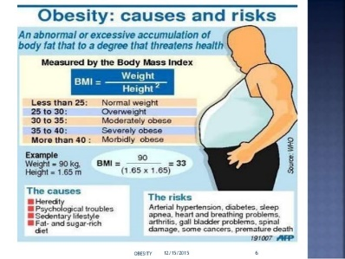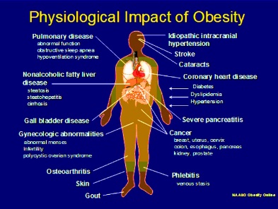
Fig. 1 Fig.2
Risk of Obesity
The risk of obesity is more than just been overweight but can lead to several health issues. Obesity can be the root cause of many health problems such as type 2 diabetes, high blood pressure, some heart diseases (including cardiovascular diseases), liver disease, high cholesterol, infertility, gallbladder diseases, cancer, stroke,
Research Findings on Obesity
Generally, obesity can be prevented by living a healthy lifestyle, unless, if it is inherent (caused by genetics) such that the individual has no control over the condition. However, if an individual has already been diagnosed as obese then they will need to change their lifestyle and begin to exercise regularly, follow a healthy eating plan and in some cases seek medical treatment.
REFERENCES
1.Aiswarya Thomas student at Academy Of Pharmaceutical Sciences Pariyaram Follow. “Obesity and Its Pathophysiology.” SlideShare, Schemas, 19 May 2016, www.slideshare.net/aiswarya1995/obesity-56164051.
2. Anthony N Fabricatore , Thomas A Wadden. “Psychological Aspects of Obesity.” Clinics in Dermatology, U.S. National Library of Medicine, 22 Aug. 2004, 14:44, pubmed.ncbi.nlm.nih.gov/15475235/.
3. Jennifer. “‘Obesity Problem’: Results From a Casual Google Search Term.” Like This Page, Blogger, 24 Sept. 2015, www.likethispage.com/2011/06/obesity-problem-results-from-casual.html.
4. Purnell, Jonathan Q. “Definitions, Classification, and Epidemiology of Obesity.” Endotext [Internet]., U.S. National Library of Medicine, 12 Apr. 2018, www.ncbi.nlm.nih.gov/books/NBK279167/.
5. WHO. “Obesity.” World Health Organization, World Health Organization, 25 May 2018, 13:59, www.who.int/westernpacific/health-topics/obesity.

