Restaurant CONCEPT: GreenSpoon - A Sustainable Culinary Journey

- Name: Mihai Serban
- Student ID number: 2244688
- Module title: Food & Beverage Operations BMIH4002
- Lecturer’s name: Antoinette Milne
- Word Count: 414

Restaurant Concept: "GreenSpoon - A Sustainable Culinary Journey"
Located in the bustling heart of Manchester, UK, the Hotel Trinity is home to the Green Spoon, a sustainable and innovative dining concept that redefines the culinary experience. The restaurant is strategically located on the ground floor of the hotel, allowing it to cater to both hotel guests and local residents seeking an eco-friendly dining experience. Dedicated to offering locally sourced, organic, and seasonal cuisine, GreenSpoon offers a delectable fusion of global cuisine influenced by the growing awareness of sustainable living and mindful consumption.
Target Audience:
The primary target audience of our business is conscious diners, including both millennials and Gen Z, who prioritize sustainability and are enthusiastic about exploring environmentally responsible dining options. Also let’s not forget that Manchester is home for 2 of the most loved football teams in the UK and not only, therefore football fans across UK are also targeted. As well as attracting health-conscious individuals, families, and professionals who seek a culinary adventure without compromising on taste, quality, or sustainability, we aim to provide an experience centered around healthy, delicious, and sustainable cuisine.
Location:
Manchester's vibrant culture and commitment to sustainability provide the perfect backdrop for GreenSpoon's concept. “Manchester, a truly vibrant community in the North West of England has a wealth of culture and heritage to be proud of. “ (Robin Sweet, 2017) Our restaurant, located within Hotel Trinity, offers guests of the hotel and locals a guilt-free dining experience based on the core values of environmental responsibility and community support. It serves as an accessible and welcoming oasis both for hotel guests and locals.
Reasoning Behind Menu Choices:
Each of our menu choices is carefully crafted to balance taste, nutritional value, and sustainability. To reduce our carbon footprint and support regional farmers, we prioritize locally sourced ingredients. We make sure our menu is always fresh and promotes biodiversity by focusing on seasonal produce. Plant-based dishes and ethically sourced meat and seafood dishes are all thoughtfully crafted to minimize waste.

To accommodate diverse dietary preferences, we offer gluten-free, vegan, and vegetarian options on our menu. In partnership with local food artisans and suppliers who share our commitment to sustainability, our goal is to create an eco-conscious dining experience that inspires our guests without sacrificing the pleasure of savoring delicious, thoughtfully prepared food.

GreenSpoon aims to minimize environmental impact through energy-efficient practices, waste reduction, and community engagement, fostering sustainability and culinary exploration, creating jobs and economic opportunities in its communities. The restaurant also aspires to become a leading advocate for sustainable dining practices in the heart of Manchester, setting an example for the hospitality industry at large.
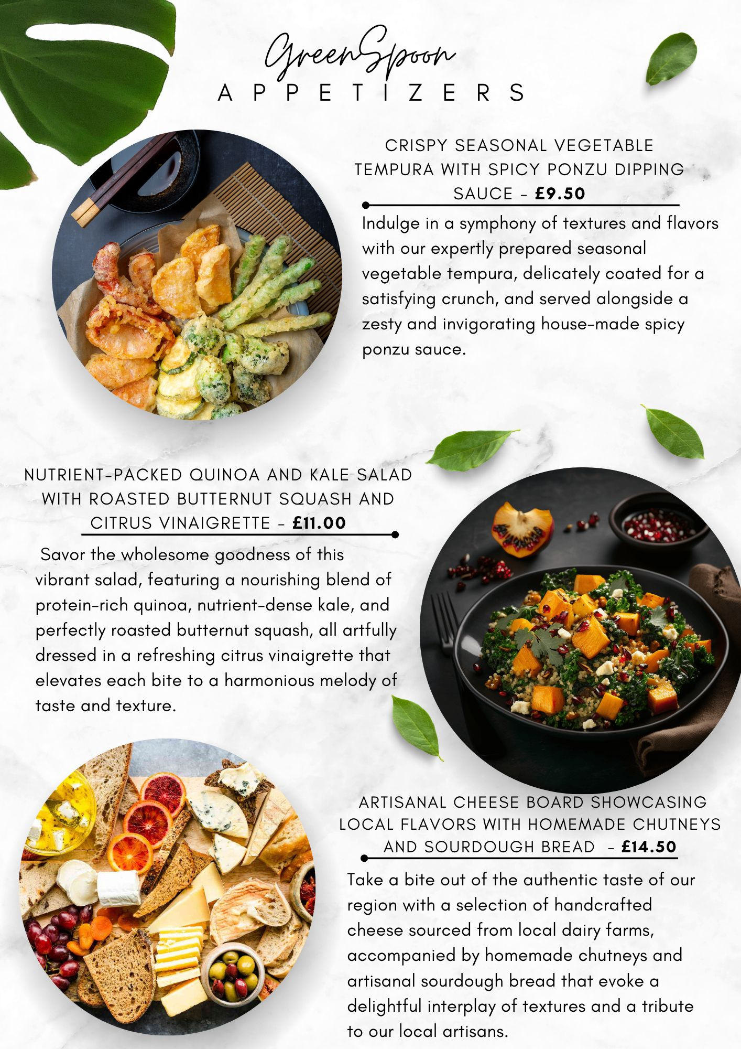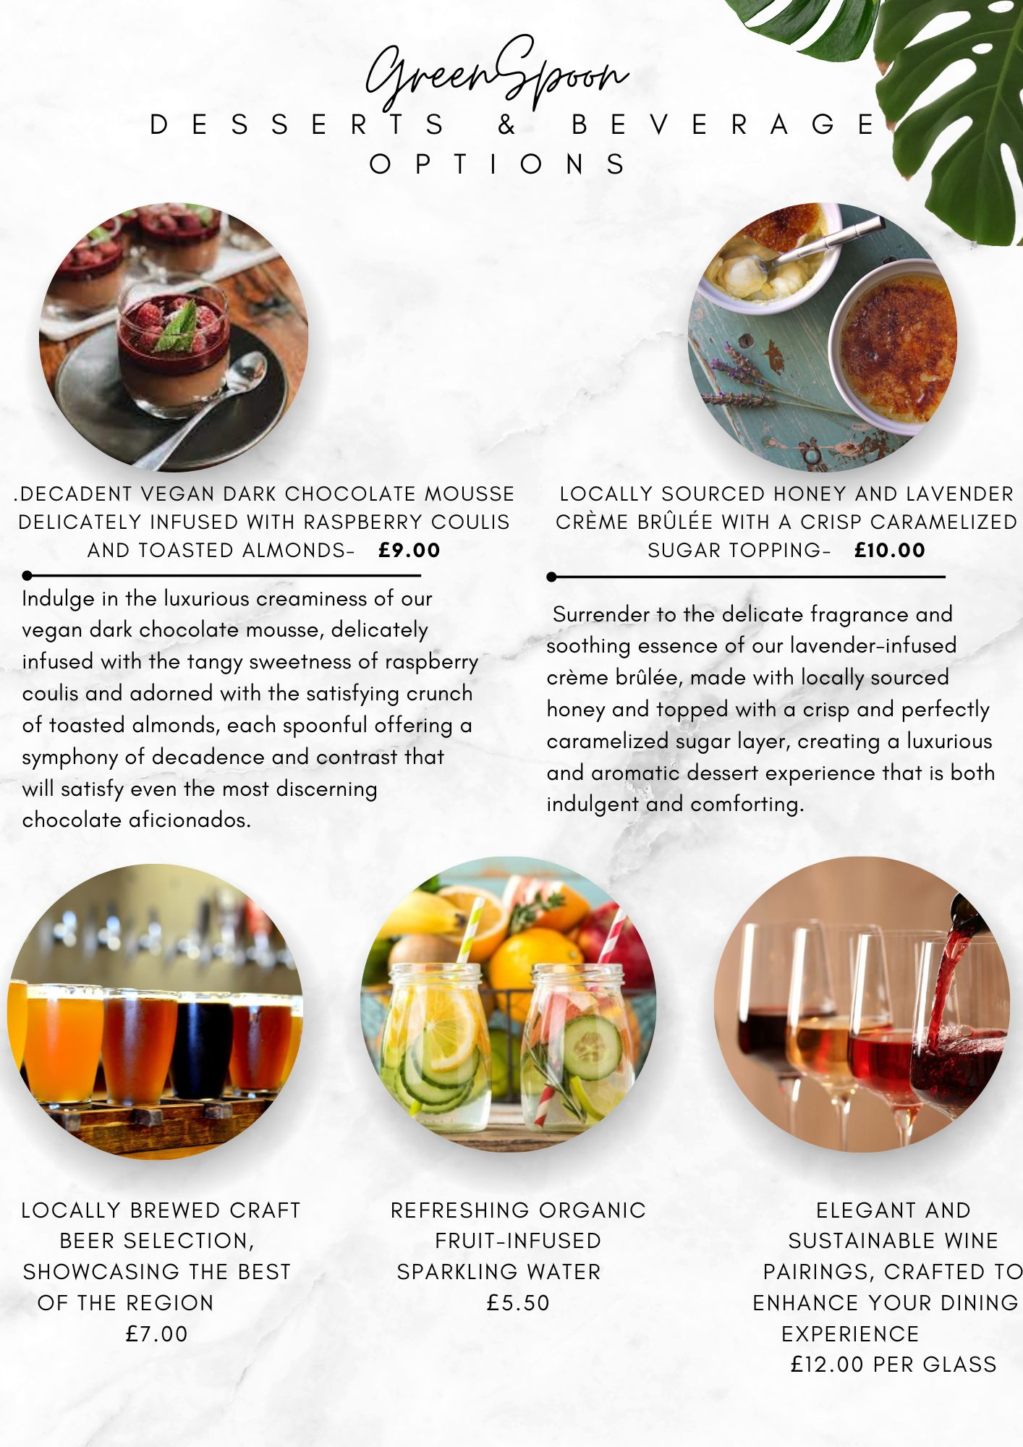

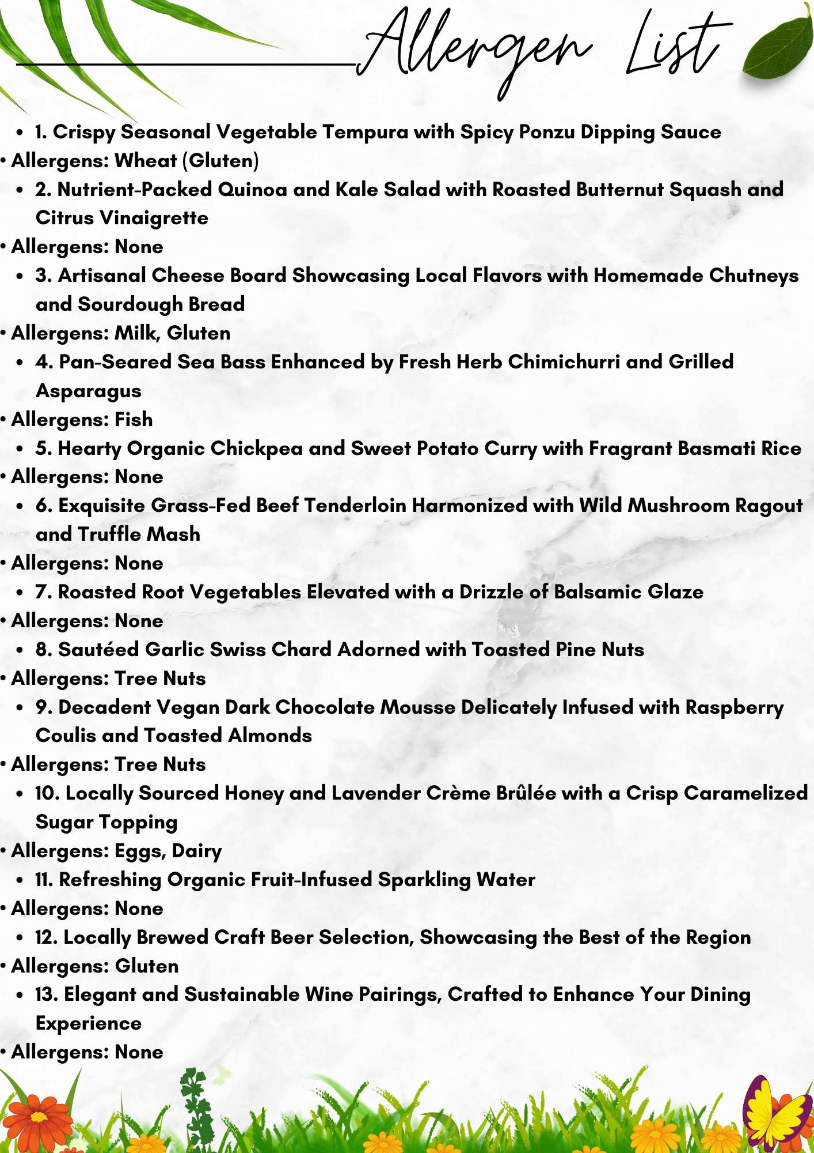

Ali Conn (2023) - GREEN CONSCIOUSNESS: A CULINARY JOURNEY TOWARDS SUSTAINABILITY Available at https://saharvest.org/in-the-news/green-consciousness-a-culinary-journey-towards-sustainability/ (Accessed on 10th November 2023)
Better Food. (n.d.). Embrace Eating Locally. Available at https://betterfood.co.uk/embrace-eating-locally/ (Accessed on 10th November 2023)
Delizzious. (n.d.) - Vegetable Tempura with Ginger Ponzu Sauce. Available at https://delizzious.com/vegetable-tempura-ginger-ponzu-sauce/ (Accessed on 11th November 2023)
Food Standards Agency. (2023). Allergen guidance for food businesses. Available at https://www.food.gov.uk/business-guidance/allergen-guidance-for-food-businesses (Accessed on 12th November 2023)
Laura Meyer (2020) sweet potato chickpea curry with pomegranate basmati rice Available at https://www.honey-street.com/recipes/sweet-potato-chickpea-curry-pomegranate-rice (Accessed on 12th November 2023)
Manchester Wire. (n.d.) - The Best Manchester Farmers Markets and Organic Groceries Where You Can Shop Local. Available at https://manchesterwire.co.uk/guide/the-best-manchester-farmers-markets-and-organic-groceries-where-you-can-shop-local/ (Accessed on 12th November 2023)
Nicole Torres (2016) - Why Sourcing Local Food Is So Hard for Restaurants Available at https://hbr.org/2016/06/why-sourcing-local-food-is-so-hard-for-restaurants (Accessed on 11th November 2023)
Robin Sweet (2017) - Culture and Heritage in Manchester. Available at: https://manchesterarchiveplus.wordpress.com/2017/12/27/culture-and-heritage-in-manchester/ Accessed on 10th November 2023)
Sona Khachatryan (2023) - From Farm to Table: The Benefits of Sourcing Local Ingredients for Your Restaurant Available at https://orders.co/blog/the-benefits-of-sourcing-local-ingredients-for-your-restaurant/ (Accessed on 11th November 2023)

World Economic Forum. (n.d.). Sustainable food system solutions. Available at https://www.weforum.org/impact/sustainable-food-system-solutions/?gad_source=1&gclid=Cj0KCQiAuqKqBhDxARIsAFZELmLD1lhMWDDMnqN4rImQHZO3ZJ1_Kj7lgSl3czy7oFYrkPVwr5YPJscaAlWnEALw_wcB (Accessed on 11th November 2023)
Zoe Pickburn (2021) - Making Your Restaurant Allergen List: Tips for Chefs and Managers. Available at https://www.marketman.com/blog/restaurant-allergen-list-tips/ (Accessed on 11th November 2023)

