Reflective portfolio

Fozeea Jabeen
1914129
BMSW 4005
Professional and Career Development
Portfolio of work (Task 3)
Charles Nimoh

Contents

Section 1: Page 3

Section 2: Page 9

Reflection: Page 14

References Page 16

Reflective Portfolio:

Using the PDP method, I was able to identify different skills that I already hold and skills I needed improvement on in order to be able to fulfill the requirements of the job I applied to (diagram 1) which was a career in administration. The plan was created step by step by the following processes: Identify, plan, action and review once the plan was made.

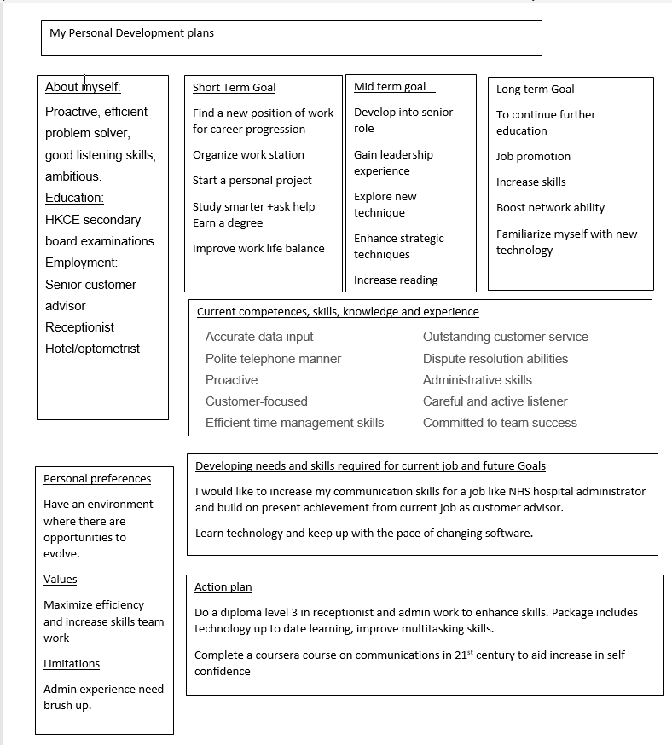
Table 1: A personal development plan
The key finding was to have self-evaluation done in order to gain some insight into the strengths and weaknesses I hold. There were many tools used which aided me to evaluate and gain insight and self-awareness. For example, the 16-personality test helped me to understand what personality I had and how there were different attributes associated with this personality type. (Free personality test | 16Personalities, 2020) (diagram 2). The personality test is called Myers-Briggs Type Indicator (MBTI). This was an essential tool which accurately described my personality and my result was INFP-T, a mediator. Within the results I could see an average of different traits with a percentage that aided me in creating awareness of my own nature. Those traits included introversion, intuitiveness, observation, assertiveness, turbulence, thinking, feelings, judging and prospecting. The percentage would shift focus on what was dominant according to my own personality trait based on a set of questions answered for the quiz.
The test revealed the type of career paths I should take up and one of the main outcomes was my personality likes to help people and have a calling to connect with people which was very accurate. These are skills that I already possess due to my current job as a financial advisor and similarly skills I would like to enhance and improve as the job I would like to apply for (NHS admin) would have to often work with different teams, people and thus require me to be adaptable with communication. This was then included into the personal development plan as this was a skill I wanted to improve on. The most important part of the career I aspire to work in would be administration role where communication is the crux of the work (Meinert and Meinert, 2020). This communication could come in various ways not just verbal and it would include many challenging and difficult interactions that require important and very efficient skills in communication. By creating this self-awareness about myself I can work more productively and build better relationships with my colleagues
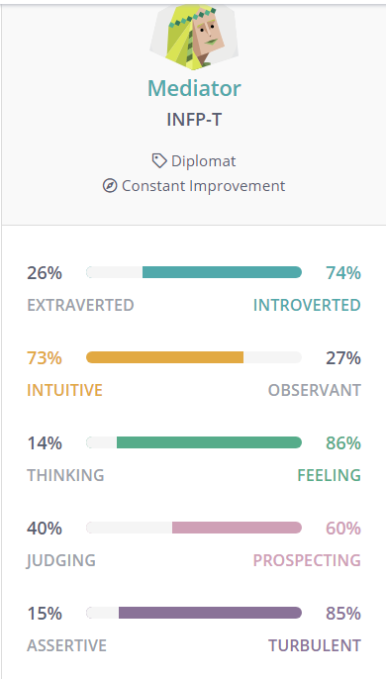
Table 2 Myers-Briggs personality result
Another tool I used was assessing the type of learning style I suited the most (Self-Assessments, 2020) (table 3). Learning techniques can vary in many ways therefore it was essential for me to find out which method should be adopted to increase my knowledge. I would find this very essential to my chosen career. Currently we have trainings in place within the job sector which provides professional development learning throughout the course of the year. My main learning style is reading however after the usage of this tool the outcome came to light was that I was a mainly visual learner. This has enhanced my personal awareness regarding how best I can learn. Although I always knew I had a preference for learning via colours/tutorials/directions I didn’t know it was precisely visual learning. This is something I will prioritize in my learning and would greatly benefit me especially as according to my personal development plan one of my main goals to become skillful for this new job application is to do a diploma level 3 In admin and receptionist work. I achieved these skills prior in a job I have already done as a receptionist but I definitely need an improvement. By incorporating these new skills (visual learning style) within training and learning I can enhance and optimize my learning.
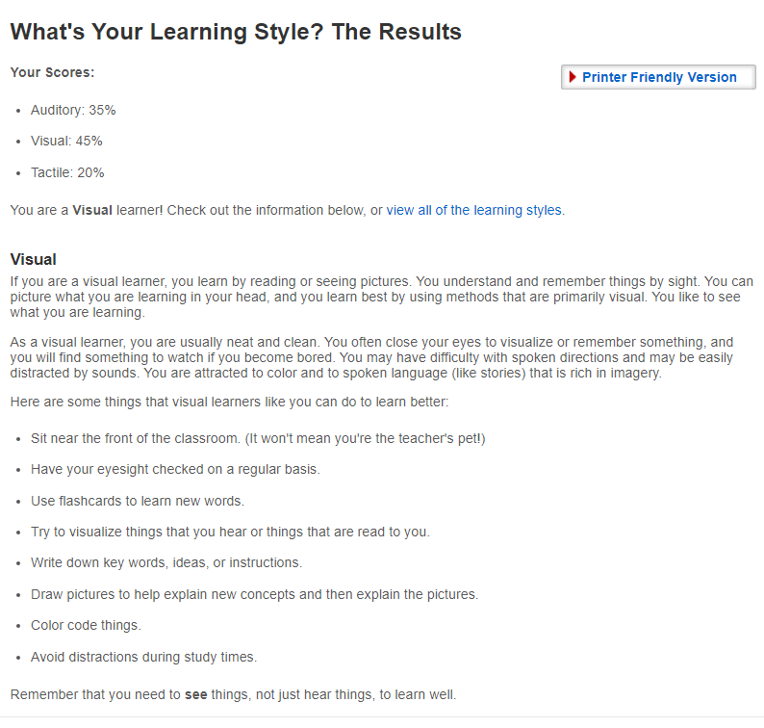

Image 1: Demonstrates results of learning style test
The third tool I used was a self-awareness tool which was essential to realize what category I fell into. There were 4 main categories:
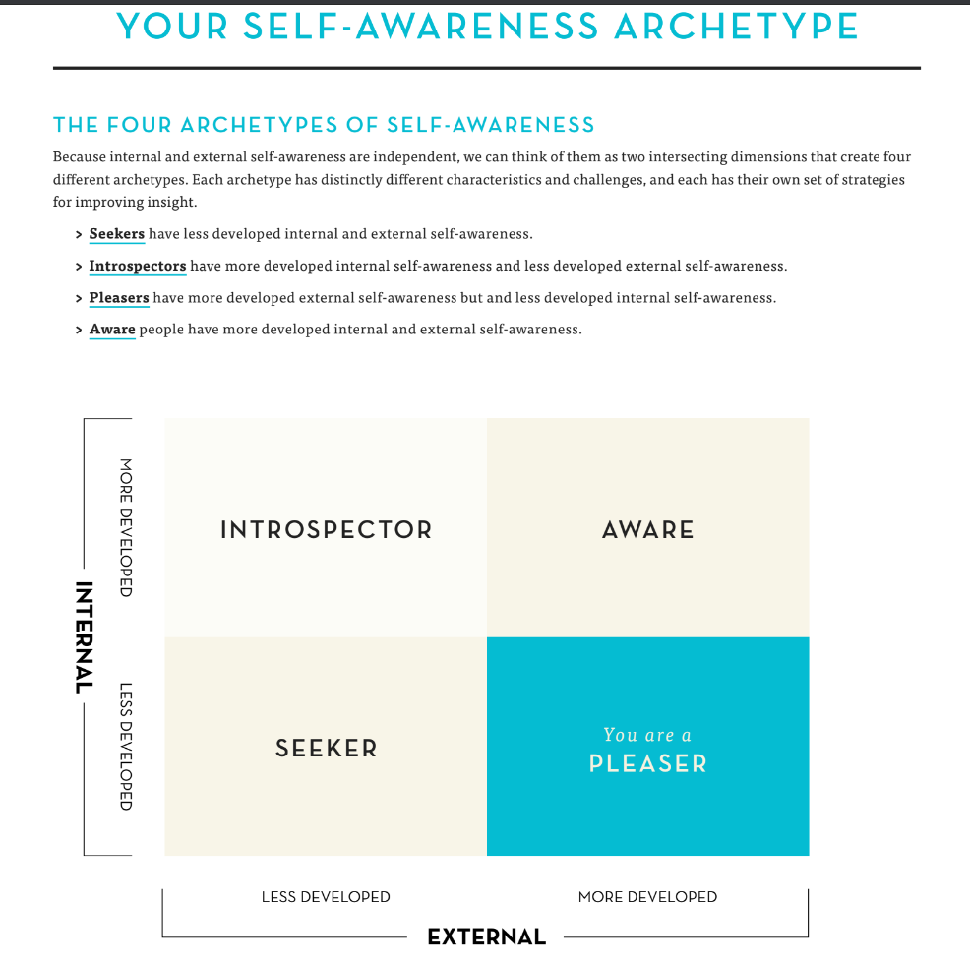

Diagram 1 A breakdown of different archetypes of self-awareness
My result was people pleaser which showed that I had little internal awareness and more external awareness hence this outlined the importance of having deeper self-introspection in order to maximize internal self-awareness.
The administration role requires work to be carefully done methodically, in an organized manner and with efficiency. The job specification outlines the main skills required to work within this particular organization and they require a person who has motivation and enthusiasm within this dimension. They also require the following skills:
- Organized
- Good listener
- Be tech savvy
- Strong interpersonal skills
- Detail orientated
- Ability to stay calm under pressure
- conflict resolution skills
- decision making and judgment skills
- team work
- flexible regarding work schedule
- ability to multitask and prioritize
- professional appearance and attitude
Accurate data input  Polite telephone manner  Proactive  Customer-focused  Efficient time management skills  Effective cash handling  Clear communicator | Outstanding customer service  Dispute resolution abilities  Administrative skills  Careful and active listener  Committed to team success  Quality assurance controls  Sharp problem solver
In comparison to these after conducting the analysis tools I identified my own strengths and weaknesses and could now appropriately identify my own skills as following:
These were included within the PDP plan where I assessed my skills. These skills are essential as the main job included Patient facing roles and medical team working. The fact that I acquired this from previous experience definitely gives me an edge. The financial advisor role has allowed me to enhance my skills such as dispute resolution abilities which I faced multiple times over the course of my work. Thus, I can take on challenging situations confidently with apt knowledge as from experience I am aware there would be multiple disputes or challenges that would require solving. Having listening skills is an important quality to have within the administrative role as there would be multiple opportunities that would require to take in as much information as possible within a time limit. One main challenge I still face is having to complete tasks under a strict deadline which can create pressure therefore this is an essential skill I would like to improve on. Communication is of utmost important in this role thus I would take up course on coursera which provides further training in communication hence any learning obtained I could use this to aid me to optimize my work. I also frequently wrote an online record in the method of blogs which aided me to keep a log and monitor any gaps in my learning, skills and progression therefore collating all this information together it allowed me to create an effective plan which could identify what skills required improvement and what my weaknesses and strengths were.
Section Two:
As a part of joining a new organization some of the key tasks is to ensure appropriate training and learning is in place for the new members. Some methods can incorporate tools which could enhanced self-awareness thus promote a positive environment where all members can co-operate with each other.
The first tool I would add is a learning style adopted from the Johari model (Johari Window: Model and Free Diagrams – BusinessBalls.com, 2020) (This theory applies appropriately especially to team work and development thus understanding relationships between employee and employer. This theory was made by Joseph Luft and Harry Ingham to create a focus primarily on personal soft skills which include personality, behaviour traits, emotional aspect and interpersonal skills. There is a window model which emphasizes on information about a particular individual which focuses on motivation experience, any skills acquired, views and attitude.
The model can be applied in the same manner for groups too just like individuals. The model has 4 different sections called regions or areas or quadrants that means piece of information that is known by a person but is not known to others. Another area also includes blind areas where there is some information which people don’t understand regarding themselves. Another area is called avoided self where the person does know certain things about himself but this information is unknown to other and lastly another area is called unknown area which means information which is not known to themselves but also not known to others. The model is extremely beneficial for the use of understanding team members who are particularly new.
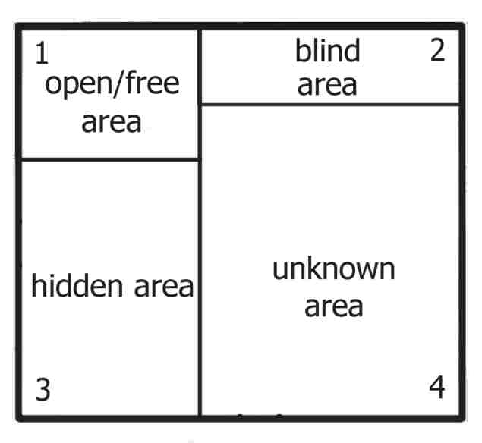

Diagram 2: An example of Johari window applied on a new employee (Johari Window: Model and Free Diagrams – BusinessBalls.com, 2020)
This is an example of a new member joining the team. This display shows how the unknown area is larger than the rest which demonstrates other have little knowledge about them and they too at the start may not have that much self-awareness (only in this particular example) thus implying it could be somebody who has just started their career or have newly graduated. The model itself can give a good explanation on how people can gain self-awareness and thus give deeper insight into how these attributes can enhance team work efficiency. (Johari Window: Model and Free Diagrams – BusinessBalls.com, 2020)
Another tool which can be included is the Honey and Mumford which were devised by Peter Honey and Alan Mumford and mainly consisted of 4 different styles of learning this included Activist, theorist, pragmatist and Reflector as shown in the diagram below (Honey and Mumford — University of Leicester, 2020). Individuals can fall into any category however the main emphasis was on how these learning styles are utilized by individuals in order to maximise their potential and develop further opportunities. A questionnaire has been devised which can collate information and thus identify the particular learning style that is most suited to that individual. However, Mumford emphasised that to have maximum efficiency you should try to adopt different learning styles.

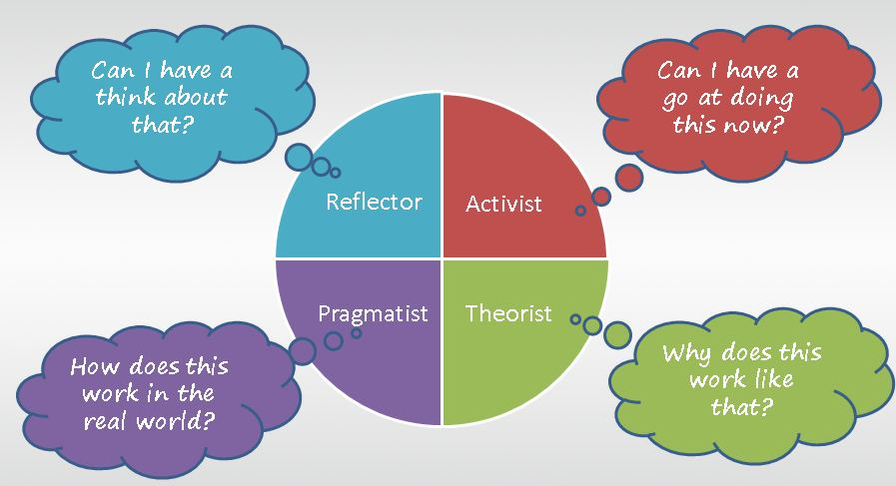
Diagram 3 A Honey and Mumford theory pie chart. (Honey and Mumford Learning Styles - A simple picture, 2020)
The activist learns things by actively doing them rather than learning via reading etc. They need to put in the physical effort and immerse themselves fully in order to gain experience of any kind. Their main methodology can consist of competitions, roleplays, discussions, using tools. However, require constant input of excitement from the task otherwise once it finished, they would look for a new activity. The theorist likes to identify the different theories for actions. For theorists it is of utmost importance to model, gather information to aid their learning thus placing information into a logical way. Their main learning styles are storytelling, background reading, identifying statistics. The learning has to be broken down step by step in order to maximise learning from this approach and the main preference in this style is rational and objective approach rather than subjective thus rigidly rejecting any notion that doesn’t fit this style. The pragmatist choses to place theory styles and concepts into the practical world and try to understand how the two fit. They are also called experimenters who ruminate on practical decision making and problem solving. Pragmatists often learn via case studies, discussions, problem solving and finding time to think. The reflector learns via observations and thinking. They like to stand back and observe to understand concepts and experiences therefore taking time to come towards a conclusion. The reflector enjoys learning from other’s experiences, taking into account of all different angles, theories, philosophies and takes them into account for their own learning and achieving different conclusions. The main way of learning is via questionnaire, self-analysis, quizzes and discussions.

Incorporating these tools would aid the new employees to identify their own particular style of learning which is essential to the team. When a appropriate learning style is implemented an individual can assess their gaps in their learning needs and therefore can undertake the learning or training associated to gain knowledge thus incorporate in their team which would hopefully bring in harmony within the team.

Another learning style is VARK style of learning which was devised by Fleming and Mills (VARK - A Guide to Learning Styles, 2020). The VARK acronym is V for Visual, A for aural, R is reading and W is for write. The V is for visual which includes learning via diagrams, tables, pie charts and graphs. These can also include symbols.
Aural or auditory learning consists of information learnt via hearing or speaking. These can consist of face to face learning e.g. lectures, phone, emails and online chats etc or include speaking and then recording yourself to hear you back. The have the need to say it and learn it again.
Reading/Writing is another style which consists of information learnt via reading words. These learners depend on textual methods. Such people prefer writing and reading the information to understand the information.
Kinaesthetic learning is based on experiences which can stimulate particular type of learning and give emphasis to previous experiences.
The final type of tool to incorporate is SWOT analysis. This is an acronym for strengths, weaknesses, opportunities and threat (SWOT Analysis: – How to Develop a Strategy For Success, 2020). I would use this analysis for team work and in the reflection part of the learning and training part of the process. This type of tool is used essentially to identify potential hazards in working environment and eliminate them and prevent failure of a system.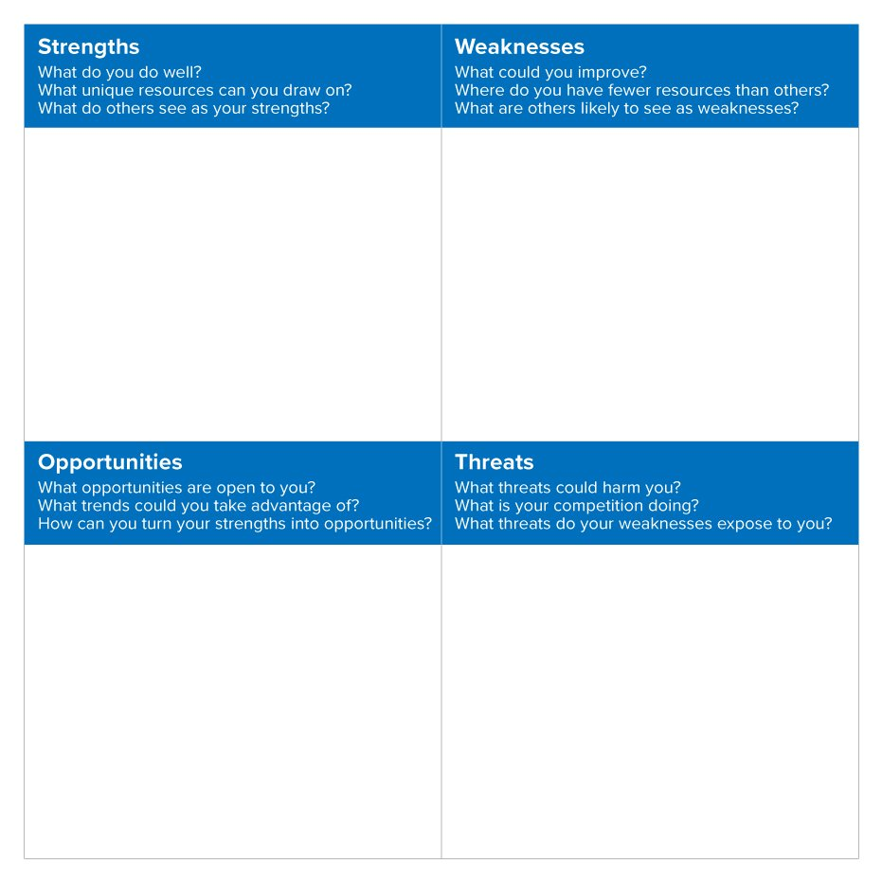
Diagram 4 (SWOT Analysis: – How to Develop a Strategy For Success, 2020)
Each section of the swot analysis is a tool used to identify learning needs and opportunities. The strengths show what positive achievements were made by the organization and it could include many attributes such as resources, materials etc. Weaknesses is to show honesty and understand where the faults could lie and what is contributing to this weakness and how we can tackle these challenges. Opportunities can be identifying and creating chances which can allow for something positive to happen. These could evolve from some developmental areas and thus create a pathway which can be advantageous and allow a greater impact on company success. Any changes such as policies, personal profiles, development via training of staff could be considered opportunities. Threats on the other hand could be any attribute which is likely to show negative impact. These could be hinderance to company progression and growth therefore should be carefully monitored within teams.

Reflection:
This course has given me insight into why learning and developing this learning was of utmost importance. Throughout the progression of the course, it allowed me evolve in terms of self-awareness. Before the course I was not aware of the different tools and methodology that was present in order to create a personal development plan however using this course’s learning material as a template I was effectively able to understand how this plan can allow me to work toward realistic goals which were broken down in a time line method (example short term and long term) (Scivicque, 2020). The process allows for clarity and is a reference to be used to allow personal growth, develop interpersonal skills and something that has the possibility to undergo constant review and changes. In order to create the PDP I had used many tools to already identify the skills I presently had i.e. my strengths and what areas of improvement were still needed i.e. weaknesses.
Alan Maddocks helped develop the PDP idea at the university of Loughborough showed the importance of this plan and provided insight into why many students felt discouraged to use it due to lack of tutor/lecturer commitment towards the value of the plans (Adenekan, 2020).The higher education academy has mentioned PDP as an integral part of student education where it would help create a structure for individuals to follow and would be an essential tool which would give them authority to have independent reviews and responsibility to develop their learning hence creating am optimum learning experience. The use of blogs which I would use and fill in constantly allowed me to create an almost diary like concept where I could record my weekly actions, learning and therefore critically analyse how I am progressing and whether or not I need further aid.
The tools used within the courses such as personality test really allowed me to reflect on my own traits. The test has many advantages and has an essential use too as it allows me to understand what career type would suit my nature. It strips away the notions I possess about myself and gives detailed analysis of each aspect of my personality.
I have realised via the course and experience where my passion and focus really lies and where I would see myself progressing towards once the course has been completed. Administrative jobs always allured me but I was not as aware as I am after attending this course regarding my own capabilities within this sector. This is essential especially after working 20 years in the same role I feel as though this is the perfect time to now progress in my career towards health and social care field. Being an NHS administrator would pave that way for me to achieve my goals. Hence by using the tools I was able to explore my options and grasp accurately where I would see myself long term.
In addition, the current role that I am working in has felt more satisfying overall after this course. A lot of the skills that were obtained via this course was implemented in my practical areas of work for example: learning styles that suited me best (visual learning) have now been utilised in order to efficiently study any training materials I received at work. I made posters outlining the training subjects and added colour to make it visually enticing and definitely saw an improvement with the rate at which I was able to grasp the different contexts provided in the training.
Furthermore, attending classes introduced me to various people with different backgrounds hence allowing me to improve my communication skills which was a very essential priority for me in order to progress career wise and evolve my interpersonal skills. I learnt to tailor my communication when talking/chatting to individuals as per their needs. It also allowed me to harness my skills as well as build my confidence via group presentations which is something I was not exposed to before. I also felt immensely inspired by the group and learnt to stay up to date with current affairs as they introduced me to various groups on social media that were all working towards the same goals.

References:
Adenekan, S., 2020. Why Personal Development Planning (PDP) Matters. [online] career-advice.jobs.ac.uk. Available at: <https://career-advice.jobs.ac.uk/professional/why-personal-development-planning-pdp-matters/> [Accessed 30 November 2020].
16Personalities. 2020. Free Personality Test | 16Personalities. [online] Available at: <https://www.16personalities.com/free-personality-test> [Accessed 5 December 2020].
DPG Community. 2020. Honey And Mumford Learning Styles - A Simple Picture. [online] Available at: <https://community.dpgplc.co.uk/blog/honey-and-mumford-learning-styles-a-simple-picture> [Accessed 3 December 2020].
Www2.le.ac.uk. 2020. Honey And Mumford — University Of Leicester. [online] Available at: <https://www2.le.ac.uk/departments/doctoralcollege/training/eresources/teaching/theories/honey-mumford> [Accessed 18 November 2020].
Businessballs.com. 2020. Johari Window: Model And Free Diagrams – Businessballs.Com. [online] Available at: <https://www.businessballs.com/self-awareness/johari-window-model-and-free-diagrams/> [Accessed 1 December 2020].
Meinert, D. and Meinert, D., 2020. What Do Personality Tests Really Reveal?. [online] SHRM. Available at: <https://www.shrm.org/hr-today/news/hr-magazine/pages/0615-personality-tests.aspx> [Accessed 24 November 2020].
Scivicque, C., 2020. Professional Development Plan Basics: The Purpose And Benefits Of A PDP - Eat Your Career. [online] Eat Your Career. Available at: <https://eatyourcareer.com/2019/06/professional-development-plan-basics-the-purpose-and-benefits-of-a-pdp/#:~:text=A%20PDP%20provides%20a%20visual,timeline%20for%20achieving%20your%20goals.> [Accessed 30 November 2020].
Educationplanner.org. 2020. Self-Assessments. [online] Available at: <http://www.educationplanner.org/students/self-assessments/index.shtml> [Accessed 29 November 2020].
Mindtools.com. 2020. SWOT Analysis: – How To Develop A Strategy For Success. [online] Available at: <https://www.mindtools.com/pages/article/newTMC_05.htm> [Accessed 28 November 2020].
VARK - A Guide to Learning Styles. 2020. VARK - A Guide To Learning Styles. [online] Available at: <https://vark-learn.com/introduction-to-vark/the-vark-modalities/> [Accessed 1 December 2020].

