Dylan Payne
2214463
Renishaw Quality Technician

Andrew Thorne
Lecturer



MAZAK FJV 250 MAINTENANCE STRATEGIES
BEng Mechanical and Manufacturing Engineering Plant and Asset Engineering (acma 6007 – 2025)
Word Count: 2367
Contents
Figures 2
1. Introduction 3
1.1 Overview of the Assignment's Purpose 3
1.2 Introduction to Renishaw 3
1.3 The Mazak FJV-250 Machining Centre 3
1.4 Current Maintenance Strategy 3
2. Current Maintenance Strategy Critical Review 4
2.1 Mazak FJV-250 Maintenance Strategy 4
2.2 Current Maintenance Strategy Strengths 4
2.2.1 Breakdowns & Downtime Prevention 4
2.2.2 Regular Lubrication & Component Checks 4
2.2.3 Detailed Checklists & Schedules 4
2.3 Current Maintenance Strategy Weaknesses 5
2.3.1 Potential Inefficiencies or Unnecessary Tasks 5
2.3.2 Reactive Elements Present 5
2.3.3 Impact on Production Due to Maintenance Downtime 5
2.4 Current Strategy Justification 5
3. Maintenance Strategy Evaluation 6
3.1 Preventative Maintenance 6
3.2 Predictive Maintenance 7
3.3 Condition-Based Maintenance 7
3.4 Reactive Maintenance 7
3.5 Total Productive Maintenance 8
3.6 Strategy Comparison Summary 8
4. Cost & Resources 9
4.1 Cost Breakdown for Implementing Changes 9
4.1.1 Hardware and Software Costs 9
4.1.2 Training 9
4.1.3 Transition Downtime 10
4.2 Human Resource Impact 10
4.3 Change Management & Implementation Challenges 10
5. Conclusion & Recommendations 11
6. References 12
7. AM10 PM Schedule 13

Figures
Figure 1 - The evelution of maintenance strategies (Christiansen, 2025) 6

1. Introduction

1.1 Overview of the Assignment's Purpose

This report provides a comprehensive analysis of the maintenance strategies employed for the Mazak FJV-250 machining centre at Renishaw. It critically evaluates current preventative maintenance routines, explores potential enhancements, and assesses the resources and costs associated with implementing improved maintenance practices. The objective is to ensure that the Mazak FJV-250 operates at peak performance, thereby supporting Renishaw's commitment to precision and reliability in manufacturing.

1.2 Introduction to Renishaw

Renishaw is one of the largest suppliers of measuring systems and manufacturing systems in the world. High accuracy and precision is provided by their products, which collect data to give customers and end users traceability and assurance in what they are manufacturing. With more than 5,000 workers spread over 36 countries, it is a multinational corporation (Renishaw Media Hub, 2024).

1.3 The Mazak FJV-250 Machining Centre

The Mazak FJV-250 is a high-precision, high-productivity vertical machining centre designed for complex and accurate machining tasks. Its double-column construction ensures rigidity, facilitating the efficient machining of workpieces such as dies, moulds, and aerospace components (Mazak.com, 2025). Equipped with the RAMTIC system (Renishaw Automated Milling Turning Inspection Centre), the Mazak FJV-250 offers user-friendly operation and is integral to Renishaw's mass production manufacturing processes, delivering the precision required for high-quality components. RAMTIC was developed in the early 1990s and automates tool setting, part alignment, and in-process measurement, ensuring tight tolerances and reducing scrap rates (Albert, 2024).

1.4 Current Maintenance Strategy

For the Mazak FJV-250, Renishaw uses a time-based preventative maintenance approach that includes monthly, six-monthly, and annual procedures. These scheduled activities include tasks such as cleaning filters, lubricating components, inspecting critical parts, and performing system diagnostics. The primary objective to this routine is to prevent equipment failures, extend the machine's lifespan, and maintain consistent production quality. This report will delve into the specifics of these maintenance routines, evaluate their effectiveness, and propose enhancements to optimise the maintenance strategy further.

2. Current Maintenance Strategy Critical Review

2.1 Mazak FJV-250 Maintenance Strategy

Renishaw employs a time-based preventative maintenance strategy for the Mazak FJV-250, with scheduled servicing at monthly, six-monthly, and annual intervals. Additionally, operators conduct daily health checks at the beginning of each shift to identify immediate concerns.
Key maintenance activities include:
- Monthly: Lubrication, filter cleaning, spindle vibration checks, coolant system inspections.
- Six-Monthly: Hydraulic oil changes, deep cleaning of swarf and coolant systems, greasing of ATC and Z-axis components.
- Annually: Replacement of key wear components, hydraulic system checks, machine levelling, and ball-bar testing.
This structured approach minimises sudden failures, ensuring the Mazak FJV-250 remains operational within the precision tolerances required for Renishaw’s production (Cotterell, 2021).

2.2 Current Maintenance Strategy Strengths

2.2.1 Breakdowns & Downtime Prevention
The goal of regular maintenance is to minimise unscheduled downtime by identifying and resolving possible issues before they become serious failures. Preventive maintenance has been shown to dramatically reduce the probability of unplanned equipment failures (Jonge, et al., 2013).

2.2.2 Regular Lubrication & Component Checks
Scheduled lubrication and inspections help maintain optimal machine performance and extend the lifespan of critical components. Proper lubrication practices are essential for minimising wear and preventing component failures.

2.2.3 Detailed Checklists & Schedules
Utilising structured maintenance schedules and checklists ensures comprehensive coverage of all necessary maintenance tasks, promoting consistency and thoroughness in maintenance operations. The use of standardised procedures aids in maintaining maintenance quality and reliability (Jonge, et al., 2013).

2.3 Current Maintenance Strategy Weaknesses

2.3.1 Potential Inefficiencies or Unnecessary Tasks
Time-based maintenance may lead to performing maintenance activities that are not immediately necessary, resulting in inefficiencies and increased operational costs. As noted by (Swanson, 2001), preventive maintenance can sometimes lead to unnecessary maintenance actions if not properly managed.

2.3.2 Reactive Elements Present
Despite a preventive maintenance strategy, certain unforeseen issues may still require reactive maintenance, indicating potential gaps in the preventive maintenance plan. This highlights the possible need for a more predictive approach to maintenance.

2.3.3 Impact on Production Due to Maintenance Downtime
Scheduled maintenance activities, while necessary, can interrupt production schedules, leading to potential delays and reduced throughput. Balancing maintenance needs with production demands remains a critical challenge.

2.4 Current Strategy Justification

Historical data may have indicated that regular, scheduled maintenance aligns with the operational reliability goals of the Mazak FJV-250, justifying the preventive maintenance approach. Preventive maintenance has been shown to improve equipment reliability and performance, whereas implementing predictive maintenance requires additional monitoring technologies and specialised expertise, which may involve significant investment. The current preventive maintenance strategy may have been chosen considering available resources and the existing skill set of the maintenance team. As highlighted by (Swanson, 2001), the implementation of advanced maintenance strategies requires careful consideration of resource availability and organisational capabilities. Preventive maintenance offers a structured approach to risk management by addressing potential issues at scheduled intervals, thereby reducing the likelihood of catastrophic failures. This proactive stance is particularly important within the machine shop environment for mass production reliability. Proactive maintenance strategies are essential for minimising risks associated with equipment failures.

3. Maintenance Strategy Evaluation

The current time-based preventative maintenance strategy for the Mazak FJV-250 ensures regular servicing but lacks condition-based monitoring and predictive maintenance techniques. This absence may contribute to frequent breakdowns, particularly related to spindle alignment issues. Additionally, the lack of data tracking and resource flexibility further impedes maintenance efficiency.

Figure 1 - The evelution of maintenance strategies (Christiansen, 2025)
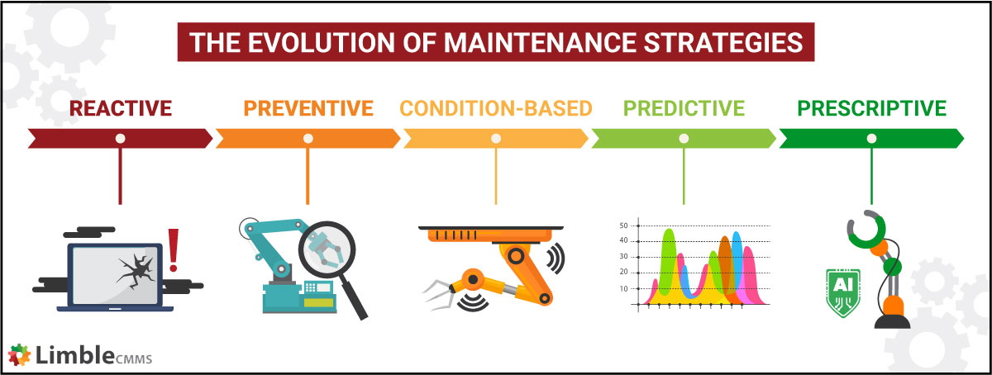

3.1 Preventative Maintenance

Regardless of the equipment's current state, preventative maintenance involves carrying out maintenance tasks at predetermined intervals. This strategy is straightforward to implement and can prevent unexpected failures by regularly servicing equipment. A study by (Jonge, et al., 2013) found that preventative maintenance works well for equipment with predictable wear patterns and can be advantageous when maintenance costs are low in comparison to the cost of unexpected failures. On the other hand, preventative maintenance can lead to unnecessary maintenance activities, resulting in increased downtime and operational costs. As noted by (Ahmad & Kamaruddin, 2012), this approach may not be optimal for all equipment types, especially those with unpredictable failure modes, as it does not account for the actual condition of the machinery.

3.2 Predictive Maintenance

Predictive maintenance utilises data analytics to predict equipment failures, thereby reducing downtime and operational costs. Deloitte's position paper highlights that predictive maintenance can increase productivity by 25%, reduce breakdowns by 70%, and lower maintenance costs by 25% (Deloitte Analytics Institute, 2022). Additionally, this report claims that predictive maintenance increases equipment by 10-20%, whilst reducing the overall maintenance costs by 5-10% and maintenance planning time by 20-50%. However, implementing predictive maintenance requires significant initial investment and specialised labour. (Patel, et al., 2023) notes that while predictive maintenance offers advantages such as cost savings and increased efficiency, challenges such as data quality, initial investment and training persist.​

3.3 Condition-Based Maintenance

This approach involves continuous, real-time equipment monitoring, which makes it possible to identify changes in equipment conditions right away and respond quickly to new problems (Patel, et al., 2023). This means that maintenance is only performed when required, thereby reducing unnecessary servicing and associated costs. According to a review article, the key to condition-based maintenance is to action maintenance requirements proactively before failures can occur. They also go on to state that condition-based maintenance can be more cost-effective than traditional time-based maintenance since it concentrates resources on equipment that actually needs maintenance, which in turn improves the operating efficiency (Li, et al., 2020). But, according to (Jonge, et al., 2013), implementing condition-based maintenance requires significant investment in monitoring equipment and data analysis capabilities. Furthermore, the effectiveness of this strategy is contingent upon the accuracy of condition monitoring techniques and the ability to interpret the data correctly, which can be complex and resource-intensive.

3.4 Reactive Maintenance

Repairing equipment only after a failure has occurred is referred to as reactive maintenance or run-to-failure maintenance. It is commonly used when equipment is non-critical or when the cost of preventive maintenance outweighs the consequences of failure. As noted by (Mobley, 2002), reactive maintenance may be the most economical strategy for non-critical systems with low downtime consequences or inexpensive repairs. However, many studies criticise reactive maintenance for its unpredictability and high long-term costs. According to (Eti, et al., 2006), reactive maintenance often results in unplanned downtime, higher repair costs, and a reactive maintenance culture that lacks foresight.

3.5 Total Productive Maintenance

Total productive maintenance is a maintenance strategy that seeks to maximise the productivity of equipment by engaging all employees in proactive and preventive maintenance activities. It integrates maintenance into the daily responsibilities of machine operators. (Nakajima, 1988) emphasised that operator involvement increases equipment availability, reduces minor stoppages, and fosters a sense of ownership, leading to a more engaged workforce and better machine care. However, critics argue that total productive maintenance can be resource-intensive and culturally difficult to implement, particularly in large organisations. According to (Ahuja & Khamba, 2008), the success of total productive maintenance heavily relies on factors such as varied complexities of the production systems and equipment, leadership support, cross-departmental cooperation, and the companies objectives and policies.

3.6 Strategy Comparison Summary

Renishaw’s current time-based preventive maintenance provides structure but lacks flexibility, often failing to reflect actual machine condition. This can lead to unnecessary maintenance or unexpected failures. A shift toward condition-based maintenance would allow maintenance to be performed when truly needed, based on equipment health. Predictive maintenance could further improve this by using real-time and historical data to anticipate failures, though it requires investment in sensors and analytics.

In contrast, reactive maintenance is ill-suited for the Mazak-FJV’s, as the cost of unplanned downtime on critical machinery outweighs any savings from delaying repairs. Total Productive Maintenance offers a complementary approach by involving operators more directly in routine maintenance, enhancing early fault detection and fostering shared responsibility, although it would require additional training investment. Overall, integrating condition-based maintenance, selectively adopting predictive maintenance, and introducing total productive maintenance principles would form a more resilient, efficient maintenance strategy for Renishaw’s high-production environment.

4. Cost & Resources

4.1 Cost Breakdown for Implementing Changes

Transitioning from a strictly time-based preventive maintenance approach to a predictive maintenance or condition-based maintenance model offers long-term efficiency gains but carries significant short-term investment. The main cost categories associated with this transition include:

4.1.1 Hardware & Software Costs
To implement predictive maintenance on the Mazak FJV-250, a suite of sensor technologies, monitoring systems, and analytics platforms would be required. These include:
- Vibration sensors for spindle health monitoring.
- Thermal cameras/sensors to detect abnormal temperature spikes in motors and bearings.
- Oil particle counters and coolant condition monitors.
- Condition monitoring software platforms to analyse real-time data (e.g., Siemens MindSphere, FANUC MT-LINKi, or bespoke dashboards) (Mobley, 2002).

Estimated costs:
- Sensor hardware (per Mazak FJV-250): £2,000 – £4,000
- Data acquisition and processing systems: £1,500
- Software license or integration costs: £2,000 – £5,000
- Installation and commissioning: £1,000

Total estimate (per Mazak FJV-250): £6,500 – £11,500.

4.1.2 Training
Training in the interpretation of diagnostic data, the use and upkeep of new sensors and software, and the proper handling of alarms and condition-based triggers will be necessary for operators and engineers.

Training costs (based on average technical training rates of £500–£1,000 per person):
- Maintenance technicians at £750 (average)
- Operators at £500

4.1.3 Transition Downtime
Installation of sensors and commissioning of software may require machine downtime. The overhead costs for the Mazak FJV-250, (including the operator wage, power, air, coolant etc), is £75.51 per hour. The setup rate and labour run rate is £38.24 per hour. Assuming an average of 6 hours of machine downtime per machine:
- 6 hours × £75.51 = £453.06 lost overhead
- 6 hours × £38.24 = £229.44 lost labour/setup

Total transitional downtime cost: £682.50 per Mazak FJV-250

4.2 Human Resource Impact

Implementing different maintenance strategies and other improvements will affect the current workforce structure and responsibilities.

- Requirement for Specialist Engineers - While existing technicians can be trained to handle most predictive maintenance systems, advanced diagnostics may require external consultants or hiring condition monitoring specialists. This would represent a significant ongoing cost but could be offset by the reduction in emergency repairs and unscheduled downtime.
- Operator Involvement - Shifting toward operator-assisted maintenance or total productive maintenance would require operators to take on additional basic tasks, such as sensor checks, visual inspections, and system alerts response. This increases their engagement and equipment ownership but may reduce their productivity unless carefully balanced with workload.

4.3 Change Management & Implementation Challenges

Resistance to change may slow adoption, especially if staff perceive the new system as a threat to their expertise or their roles. As argued by (Kotter, 2007), successful change management must address emotional and behavioural resistance through education, communication, and involvement. a shift to predictive maintenance would require a phased training programme, pilot implementation, and ongoing support.

5. Conclusion & Recommendations

The Mazak FJV-250 plays a critical role in Renishaw’s mass production capabilities, and its reliability is directly linked to the effectiveness of the maintenance strategy employed. The current time-based preventive maintenance system has provided a structured framework to minimise breakdowns and maintain production standards. However, this strategy also introduces limitations such as unnecessary maintenance activities, production interruptions, and reactive elements when unanticipated failures still occur. Furthermore, the lack of predictive tools limits the ability to anticipate failures, particularly for critical components.

Recommendations:
- Introduce Condition-Based Monitoring - Begin by integrating sensors and monitoring systems to collect data on machine temperature, vibration, oil condition, and coolant quality. The upfront investment is justified by improved decision-making and a potential reduction in unnecessary servicing.
- Enhance Operator Involvement - Utilise elements of total productive maintenance to involve machine operators in basic maintenance tasks such as visual inspections and first-level troubleshooting. This can improve fault detection and promote shared ownership of equipment reliability.
- Maintenance Hybridisation - A hybrid maintenance strategy combining preventive, predictive, and total productive maintenance approaches would allow Renishaw to benefit from structured routines while utilising real-time data for dynamic maintenance decisions and promoting a proactive maintenance culture.

Overall, while Renishaw’s existing maintenance framework has served the Mazak FJV-250 well, it now presents an opportunity for improvement. Incorporating condition-based and predictive maintenance strategies, supported by training, change management, and gradual implementation, would strengthen operational reliability, reduce costs over time, and maintain Renishaw’s commitment to high-quality manufacturing.

6. References
Ahmad, R. & Kamaruddin, S., 2012. An overview of time-based and condition-based maintenance in industrial application. Computers & Industrial Engineering, 63(1), pp. 135-149.
Ahuja, I. & Khamba, J., 2008. Total productive maintenance: literature review and directions. International Journal of Quality & Reliability Management, 42(4), pp. 709-756.
Albert, M., 2024. RAMTIC system still ticking. [Online]
Available at: https://www.renishaw.com/sl/8985.aspx?srsltid=AfmBOopmCHATfYy-VDh7A6vSD8huAOu1CY9-w9KG-K303eLVjL--154h
[Accessed 09 Feburary 2025].
Christiansen, B., 2025. 5 Types of Maintenance Management Strategies. [Online]
Available at: https://limblecmms.com/blog/maintenance-strategy/
[Accessed 28 March 2025].
Deloitte Analytics Institute, 2022. Predictive Maintenance: Taking proactive measures based on advanced data analytics to predict and avoid machine failure, s.l.: Deloitte Consulting GmbH.
Eti, M. C., Ogaji, S. O. t. & Probert, S. D., 2006. Development and implementation of preventive-maintenance practices. Applied Energy, 83(10), pp. 1163-1179.
Jonge, B. d., Teunter, R., Klingenberg, W. & Tinga, T., 2013. A comparison of time-based maintenance and. Groningen: University of Groningen.
Kotter, J. P., 2007. Leading Change: Why Transformation Efforts Fail, s.l.: Harvard business school.
Li, Y., Peng, S., Li, Y. & Jiang, W., 2020. A review of condition-based maintenance: Its prognostic and operational aspects, s.l.: Higher Education Press 2020.
Mazak.com, 2025. Products. [Online]
Available at: https://www.mazak.com/uk-en/products/
[Accessed 09 February 2025].
Mobley, R. K., 2002. AN INTRODUCTION TO PREDICTIVE MAINTENANCE. 2nd ed. Woburn: Elsevier Science.
Nakajima, S., 1988. Introduction to TPM: Total Productive Maintenance.. Portland: Japan Institute for Plant Maintenance.
Patel, M., Vasa, J. & Patel, B., 2023. Predictive Maintenance: A Comprehensive Analysis. 2023 2nd International Conference on Futuristic Technologies (INCOFT) , Volume 979-8-3503-0884-6/23, pp. 1-7.
Renishaw Media Hub, 2024. Company biographies. [Online]
Available at: https://www.renishaw.com/en/company-biographies--32462
[Accessed 09 February 2025].
Swanson, L., 2001. Linking maintenance strategies to performance. International Journal of Production Economics, 70(3), pp. 237-244.

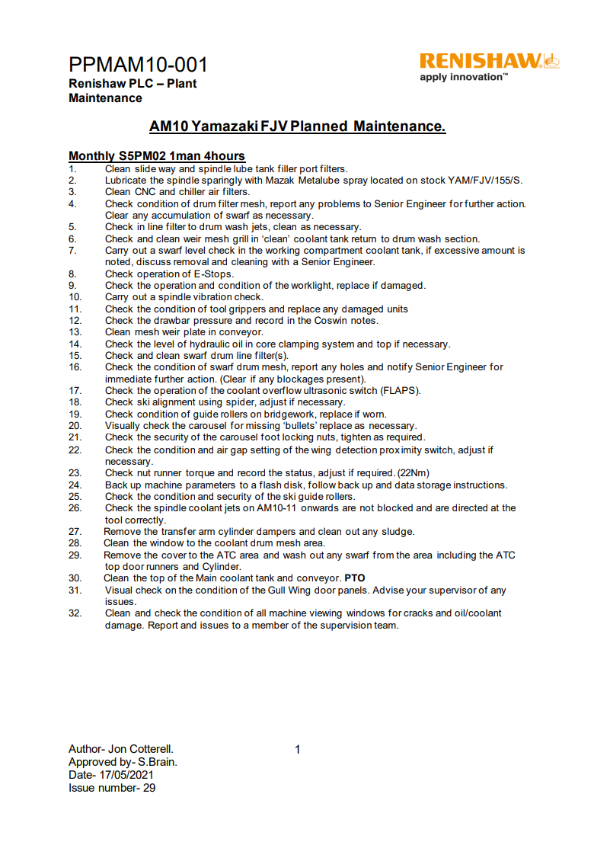
7. AM10 PM Schedule


