Managing a Hardware/Software Project Integrated with Enterprise and Innovation Group Project
Katarzyna Pindel
Web Development
2020
Contents
Introduction 1
1. Risk management 1
Risk Exposure calculation 2
2. Sustainability 2
2.1 First order sustainability 2
2.2 Second order sustainability 4
2.3 Third order sustainability 5
3. Ethical and Legal issues 5
3.1 The British Computer Society Code of Conduct 5
3.2 The General Data Protection Legislation 5
4. Quality Assurance Issues 6
Bibliography 8

Introduction
Success (Latin successus) is the ambiguous word used is in many situations and is used to describe a variety of events. Nevertheless, the most popular term for it is to achieve a successful outcome of a given undertaking or achieving the intended goal, in this case in the science field. By saying success, we mean not only the entire project life cycle-proper construction of the device, designing a working software and website, but also other important factors that will affect the future of the device, but many other integrated factors. These important factors are risk management, sustainability, ethical and legal issues so as quality assurance issues that comes with the implementation of the project CloudMe.inc- a cloud an SSD based storage device.

Risk management
Every project, program or any undertaking is subject to certain risks. It is impossible to predict all the details and possible delays in advance, to force the people involved to promise to meet the deadline or to curse fate so that it does not make any malicious prank. However, the risk can be reduced by properly planning the entire process, identifying project points most vulnerable to errors and estimation of the probability of their occurrence. Such action allows to respond quickly enough to emerging problems and significantly accelerate the pace of work. The risk of low product quality and exceeding the budget or schedule is very high. In the nineties of the 20th century, the independent analytical and consulting company Standish Group International began researching the successes and failures of IT projects. Every two years, the company publishes a report entitled CHAOS Report, in which it presents statistical data covering areas of IT project activities in many branches of the US economy, including industry, trade and services, banking, education and healthcare. The first report summarizing 1994, covered 365 different enterprises implementing over 8,000 applications, presented a rather pessimistic picture. According to surveys Overall, the success rate was only 16.2%, while challenged projects accounted for 52.7%, and impaired (cancelled) for 31.1% [1]. Incomplete success means that the project has been implemented, although with at least one deviation from the previously assumed plan. CHAOS Report authors include exceptions:
- failure to meet the assumed schedule
- exceeding the assumed costs,
- fewer requirements being met,
- producing a product of inferior quality.
There are many other elements involved in preventing the project from succeeding, which may have:
- Technical nature- related to product complexity, software or hardware malfunction,
- Security nature- related to data breach, security issues such as hacking,
- Human nature- related to social conflicts, the availability of parties involved,
- Mentioned before financial nature-related to the financial structure, going over the set budget,
- Time- related to time management and schedule,
- Organizational nature- related to the decision-making process and hierarchical relationships,
- High volume of competition and a product that does not meet customer expectations.
To minimise all risks related to hardware and software malfunction UWTSD computing students must meet notoriously changing requirements, eliminate software and hardware compatibility issues, improve project architecture and fix security vulnerabilities. It is important to have a shared vision, mission and goal, appropriate roles in the project, flexibility of the group working on the project, sufficient time frame for analysis and decision making, creating a schedule consisting of: identifying all activities, establishing the order of their implementation and estimating the time of execution, determination of the financial value in the project, appropriate data integration, appropriate tooling and architecture as well as appropriate communication which will be understood and infallibly interpreted by the other party within the group. There should be, also, a contingency plans, cost and time reserves implemented for the project.

Risk Exposure calculation
Security nature risks have a law nature and they are very dangerous and expensive to deal with. Regulations are very serious for user’s data breaching and the penalties can reach up to:
- higher maximum amount- 20 million Euros or 4% of total years worldwide turnover,
- standard maximum amount- 10 million Euros or 2% of total years worldwide turnover [2],
The risk exposure for data breach can be calculated as follows:
The business can be fined for up to 20 million Euros,
The probity in this case would be 0.001.
Euros 20milions x 0.001 = Euros 20000

Sustainability
A very important part, when implementing the project into life, has sustainability. When making decisions about production and consumption, people's quality of life and the state of the environment must be taken into consideration. To improve that quality of lives and to create inclusive conditions, the ecosystem that ensures man's existence must be preserved and protected.

2.1 First order sustainability
The project team aimed to create a device which generates less waste and leads to the production of more products with less input of materials. According to Google proceedings over 90% of worlds produced information are stored on magnetic media [3] and most of the time on hard disk drives. The chart below shows a global HDD shipment (hard disk drive) since the fourth quarter of 2010. The total figures for the third quarter of 2019 are 83milion hard drives were shipped worldwide [3]. As it can be observed they are a large amount when it comes to production and sales of HDD.
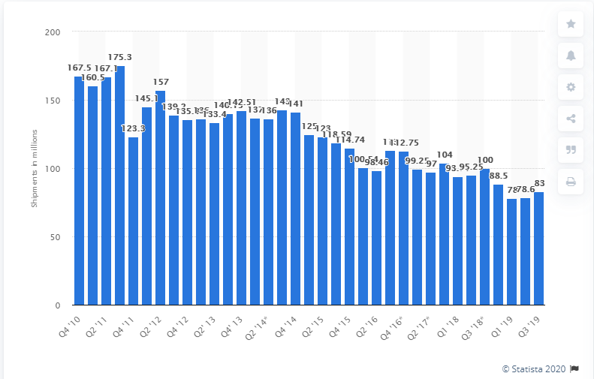
Figure 1- HDD worldwide shipments
Such excessive production as well as the sale of electronic and electrical equipment around the world generates a huge amount of electrical and electronic waste. Presoft engineering, inc. providing a result from Backblaze’s study stating that generally hard drives can lasts for three to five years on average [5]. The graph below is illustrating the hard drives survival rates in 4 years duration.

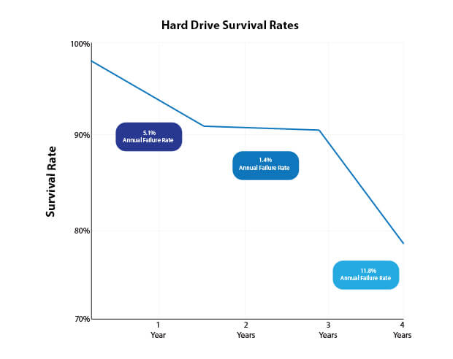
Figure 2- Hard drive life rates

E-waste definitely belongs to the group of hazardous waste. Many electronic wastes simply end up in landfills. Toxic chemicals contained in electronics can then freely release into the atmosphere or accumulate in the soil, affecting the immediate environment and the people living in it. Another way to recycle is simply to burn your electronics. This, however, releases into the atmosphere such hazardous ingredients such as lead, mercury, arsenic, cadmium, selenium and hexavalent chromium and flame retardants. Electronic waste is also widely exported by developed countries to those just developing, often in violation of international law. In the United Kingdom alone, in 2003 at least 23 metric tons of undeclared e-waste was illegally exported [6]. They came mainly to the Far East, to China, Africa and to India itself it reached 0.6 million tons by 2014 [6]. In response to such a serious problem, as an e-waste is, the project could be a great solution. Its large capacity and automatic backup will provide, not only, enough space to store customers important data, so there is no need to buy more electronic media but also it is great way reduce the e-waste and necessity of buying new products. The device will prevent media magnetic media storage from fast deterioration in time as all the data will be backed up automatically in cloud.

2.2 Second order sustainability
Around a fifth (21%) of UK greenhouse gas emissions came from road transport in 2017 [8]. In 2018 the average level of carbon dioxide emissions for all licensed cars in UK was 141.9 grams per kilometre according to Statista statistic- Global Business Data Platform [9]. Another statistics showing a average amount of trips people n United Kingdom made in 2017- 975, which is around 19 trips per week and a average distance in miles travelled in 2017- 6580 miles [10].
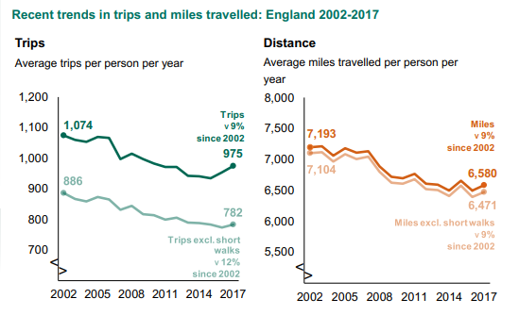
Figure 3- Trips and miles travelled in UK during 2002-2017
The potential profits from using Projects device would be cost and the reduced amount of millage done by the device’s user. Also, the number of cars would be reduced too, solving the CO2 emissions issues. Substantially an average vehicle driver who uses the portable device would not have to use a car to drive home or workplace to back up their files. Also, there would involve less travel to work to share important files with the manager or other business associate, as the cloud account can be shared leading to flexible home working, teleconferencing and mobile computing.

2.3 Third order sustainability
World energy consumption in 2018 increased almost twice as fast as the average rate recorded since 2010 - International Energy Agency (IEA) reported [11], where only in UK the residential sector is responsible for about one third of overall electricity demand and up to 40% of peak demand [12]. The device has 12V battery build in, large capacity and automatic back up which means it can be used any time of the day. There is no need for constant high demand for electricity, which will result in less traffic on the grid.

Ethical and Legal issues
An inseparable stage, of the Projects lifecycle, that needs attention is the ethical and general social consequences of all decisions related to introduction of the device to the market. The main task is to protect the public (consumers) against possible negative effects of implementation of the devices into the market and may they not be the result of deliberate criminal conduct or the result of carefree behaviour.

3.1 The British Computer Society Code of Conduct
The project is responsible for society, client and the company [11] and comply with The British Computer Society (BCS) code of conduct. Stakeholders as IT professional must and they will proceed with professional ethical standards:
- Contribute to the good of society and man- in any way avoid harming other people, be trustworthy, fair and operating without discriminating against people, honour property rights, including copyrights and patents, respect the privacy of others, respect the confidentiality of information,
- Strive to achieve the highest quality, efficiency and dignity both in the process and in relation to the product,
- Acquire and maintain professional qualifications,
- Know and respect existing law of profession,
- Accept and perform proper professional control,
- Assess computer systems fully and accurately and their environmental impact, including possible risk analysis,
- Honour contracts, agreements and commitments,
- Manage the funds available to build IT systems that improve the quality of working conditions,
- Design a system adapted to the user's requirements,
- Define and support policies that protect the dignity of users and others who can be affected by the system.

3.2 The General Data Protection Legislation
Project also is responsible to follow The General Data Protection Legislation and protect personal information of all individuals that are using the device. All stakeholders (project creators) must comply with the law and make sure all regulations are followed. They must protect natural persons in connection with the processing of personal data and on the free flow of such data and against all kinds of threats, both internal and external, conscious or unconscious. Even though the project stakeholders are not planning on creating an actual database, all user’s important files will be transferred through Google Drive API. The stakeholders must make sure no data is being leaked during this process and all data is being consciously used by any members of the project. The policy applies to all project members and aims to apply safeguards to achieve the following objectives and ensure [12]:
- Legality - ensure the protection of privacy and processed data in accordance with the law,
- Security - ensure an adequate level of data security by undertaking the appropriate level of security,
- Individual rights - enable persons whose data is processed to exercise their rights and to respect these rights,
- Confidentiality - ensuring that information are not disclosed or disclosed to unauthorized persons, entities or processes,
- Integrity - ensure that data will not be altered or destroyed in an unauthorized manner,
- Authenticity - ensure that the identity of the subject or resource is as declared,
- Non-repudiation - ensure that stakeholders will not deny their participation in all or part of the exchange of data with another entity [12].

Quality Assurance Issues
While developing the discussed project, the team members were primarily aimed at ensuring the creation of a product that would meet the expectations of the modern customer. Like with every new product there are many factors that may affect its quality. When assessing product quality, the stakeholders need to pay attention to many external so as internal qualities of the software (following ISO 25010 Software product quality [14]), like:
- Functionality,
- Reliability (reliability of the code, no downtime, no dropped packets),
- Usability (performance, efficiency and user satisfaction, lack of errors in software, no hardware malfunction),
- Efficiency,
- Maintainability,
- Portability.
There are also many technical issues that might affect a quality of projects product that is closely related to the usable quality:
- user satisfaction that results from satisfaction with the external appearance and the actual use of the product,
- and compatibility - at the same time ensuring technical quality and ergonomic.
There are three sets of requirements that need to be completed to call a project a success. The first entry requirement is necessity of creation an appropriate plan followed by set of expected results, (regarding to the functionality, reliability and usability of hardware and software) that will later be compared with the final result. Due to growing competition, stakeholders are facing the need to optimize usability and define measurable project goals. At the implementation stage there is a requirement of conducting usability tests at every stage of the software design. The process provides the opportunity to make rapid changes, which reduces the risk of failure of the whole project. The focus should be on systematic adjustments to ongoing operations and proper communication between team members, based on good organizational skills, to help to achieve set goal which is working hardware and software up to the highest level of satisfaction. The last phase of quality measures is exit requirements. These requirements are at the end of the whole project’s lifecycle, a final testing to make sure that the device matches the requirements of each customer's final product without any outstanding errors. It should be checked whether the improvement measures have brought the adopted requirements, in the first stage. It should be remembered that not only the purpose of this project is important, but also the way of assessing individual factors determining the quality level: free identification of problems, collecting information and analysing data, planning changes and searching for alternative solutions, acting with the use of various methods and tools, the ability to assess the results.

Bibliography

[1] | T. S. G. Report, “CHAOS,” 2014.
[2] | ICO, “Data Potection penalties,” [Online]. Available: https://ico.org.uk/for-organisations/guide-to-data-protection/guide-to-law-enforcement-processing/penalties/.
[3] | W.-D. W. a. L. A. B. ´. Eduardo Pinheiro, “Failure Trends in a Large Disk Drive Population,” Amphitheatre Pkwy, 2007.
[4] | statista, “Global hard disk drive (HDD) shipments 2010-2019, by quarter,” [Online]. Available: https://www.statista.com/statistics/275336/global-shipment-figures-for-hard-disk-drives-from-4th-quarter-2010/.
[5] | J. S., “How Long Do Hard Drives Last? Lifespan And Signs Of Failure,” [Online]. Available: https://www.prosofteng.com/blog/how-long-do-hard-drives-last.
[6] | M.-N. B. D. M. T. N. M. P. D. M. Devin N.Perkins BS, “E-Waste: A Global Hazard,” Annals of Global Health, vol. 80, no. 4, pp. 286-295, 2014.
[7] | M. S. a. R. C. Santhanam Needhidasan, “Electronic waste – an emerging threat to the environment of urban India,” J Environ Health Sci Eng, 2014.
[8] | O. f. N. Statistics, “Road transport and air emissions,” 16 September 9079. [Online]. Available: https://www.ons.gov.uk/economy/environmentalaccounts/articles/roadtransportandairemissions/2019-09-16.
[9] | N. Sönnichsen, “Average CO2 emission figures for all licensed cars in Great Britain 2001-2018,” 24 October 2019. [Online]. Available: https://www.statista.com/statistics/464270/average-co2-emission-figures-for-all-licensed-cars-in-great-britain-uk/.
[10] | A. E. -. J. C. -. M. S. -. F. C. Darren Stillwell, “National Travel Survey:,” 2017. [Online]. Available: https://assets.publishing.service.gov.uk/government/uploads/system/uploads/attachment_data/file/729521/national-travel-survey-2017.pdf.
[11] | IEA, “Global Energy & CO2 Status Report 2019,” 2018. [Online]. Available: https://www.iea.org/reports/global-energy-and-co2-status-report-2019.
[12] | B. A. J. Torriti, “Explaining shifts in UK electricity demand using time use data from 1974 to 2014,” in Energy Policy, 2018, pp. 544-557.
[13] | M. Kerber, “Professionalism – BCS Codes,” [Online]. Available: https://www.cs.bham.ac.uk/~mmk/teaching/commskills/s4.pdf.
[14] | B. T. C. I. f. IT, “BCS Code of Conduct,” [Online]. Available: https://www.bcs.org/membership/become-a-member/bcs-code-of-conduct/.
[15] | GOV.UK, “Data protection,” [Online]. Available: https://www.gov.uk/data-protection.
[16] | I. 25000, “ISO/IEC 25010,” [Online]. Available: https://iso25000.com/index.php/en/iso-25000-standards/iso-25010.
[17] | SQA, “ISO 9126 Software Quality Characteristics,” [Online]. Available: http://www.sqa.net/iso9126.html.

