Student Name: Shamis Hamid
Student number: 2541245
Lecturer Name: Osman Elgawi
Programme Title: CertHE Computing Skill for Workplace
Module: Software Solutions for Business
Module Code: ACCA4026
Assignment Title: Component 1- Coursework: Portfolio

Table of Contents
Task 1 – Contemporary e-Commerce Website Builders/Software Solutions 3
Task 2a – Mind Mapping: Description and Benefits in Business Operations 4
Task 2b – Mind Map 6
Task 3a – Office Applications for Creating, Storing, Presenting and Analysing Information/Data 7
Introduction 7
Microsoft Word 7
Microsoft PowerPoint 9
Microsoft Excel 10
Microsoft Access 12
Task 3b – Practical Application of Microsoft Excel Features 15
Microsoft Excel 15
Task 4a – Communication and Collaboration Applications 19
Microsoft Teams – Communication Application 20
Microsoft OneNote – Online Collaboration Application 22
Conclusion 24
Task 4b – Practical Application of Communication and Collaboration Applications 25
Introduction 25
Collaboration Application – Microsoft OneNote 26

Task 1 – Contemporary e-Commerce Website Builders/Software Solutions
The rapid growth of online retail has increased demand for website builders that enable businesses to create secure, attractive and user-friendly e-commerce stores without requiring extensive programming knowledge. Modern e-commerce platforms provide integrated tools for website design, payment processing, inventory management and customer engagement. Two widely adopted contemporary solutions are Shopify and Wix eCommerce, both of which offer comprehensive features for businesses of different sizes.
Shopify is a cloud-based e-commerce platform designed specifically for creating and managing online stores. It enables businesses to build professional websites through a drag-and-drop interface while providing access to a large marketplace of themes and applications that extend website functionality [1]. Shopify includes built-in tools for managing products, processing customer orders, tracking inventory and accepting payments through multiple payment gateways. The platform also supports mobile commerce, allowing customers to browse and purchase products using smartphones and tablets. Security is another significant advantage, as Shopify provides SSL certificates, automatic updates and compliance with Payment Card Industry Data Security Standards (PCI DSS), helping businesses protect customer information [2]. Furthermore, integrated analytics enable business owners to monitor sales performance, customer behaviour and marketing effectiveness, supporting informed decision-making.
In contrast, Wix eCommerce combines website design flexibility with online selling capabilities. Wix is particularly suitable for small businesses, freelancers and start-up organisations seeking an intuitive platform with extensive design customisation [3]. Its visual drag-and-drop editor allows users to create unique websites without coding experience while incorporating e-commerce functionality such as product catalogues, secure payment processing and shipping management. Wix also provides marketing features including email campaigns, social media integration and search engine optimisation (SEO) tools, helping businesses improve their online visibility and attract potential customers [3]. Artificial intelligence (AI)-powered design assistance further simplifies the website creation process by generating personalised website layouts based on user preferences.
Although both platforms provide comprehensive e-commerce functionality, they are designed with different priorities. Shopify places greater emphasis on scalability and dedicated online retail management, making it suitable for businesses expecting significant sales growth or managing large inventories [1]. Its extensive app ecosystem allows organisations to expand functionality as business requirements evolve. Conversely, Wix focuses more heavily on creative website design and ease of use, making it an attractive option for smaller businesses that require a visually distinctive website alongside integrated e-commerce features [3].
Overall, Shopify and Wix represent two leading contemporary e-commerce website builders that simplify the process of establishing an online business. Shopify offers robust commercial features, advanced inventory management and scalability for growing enterprises, whereas Wix provides exceptional design flexibility and accessibility for users with limited technical expertise. The choice between these platforms ultimately depends on organisational requirements, budget and anticipated business growth, but both solutions demonstrate how modern e-commerce software enables businesses to establish a professional online presence with relatively low technical barriers [1]–[4].

Task 2a – Mind Mapping: Description and Benefits in Business Operations
Mind mapping is a visual thinking and organisational technique that presents information around a central topic using connected branches, keywords, images and colours. Rather than recording information in a traditional linear format, a mind map allows ideas to be organised into related categories, making it easier to understand complex information and identify relationships between different concepts. Developed and popularised by Tony Buzan, mind mapping has become widely used in education, project management and business because it encourages creative thinking while improving the organisation of information [5]. Today, many organisations create digital mind maps using software such as XMind, MindMeister and Microsoft Visio to support collaboration and planning across teams.
One of the main benefits of mind mapping in business operations is that it improves clarity and organisation. Businesses often deal with large volumes of information, including projects, customer requirements, financial data and operational processes. A mind map breaks complex topics into smaller, connected sections, enabling employees to see the overall picture while focusing on individual tasks. This structured approach helps managers prioritise activities, allocate resources effectively and reduce the risk of overlooking important information [6].
Mind mapping also encourages creativity and innovation, both of which are essential for organisations operating in competitive markets. Because ideas are recorded visually rather than sequentially, employees can explore multiple solutions without restricting their thinking. Brainstorming sessions that use mind maps often produce more creative ideas because participants can freely add new branches and identify links between concepts that may not have been obvious using conventional note-taking methods [5]. This supports product development, marketing campaigns and strategic planning by encouraging innovative problem-solving.
Another important advantage is improved communication and collaboration. Digital mind mapping applications enable multiple users to contribute to the same project simultaneously, making them valuable tools for remote and hybrid teams. Team members can clearly visualise objectives, responsibilities and project milestones within a single diagram, reducing misunderstandings and improving communication across departments. A shared visual representation of information also supports meetings by ensuring everyone has a common understanding of business goals and priorities [7].
Mind mapping further enhances planning, decision-making and productivity. Managers frequently use mind maps to develop business strategies, manage risks, plan projects and document organisational processes. By presenting information in a logical and connected format, decision-makers can evaluate alternatives more efficiently and identify the potential impact of different choices before implementing them. Employees also save time because information is easier to review and update than lengthy written documents, leading to improved workflow efficiency and better project management [8].
Overall, mind mapping is an effective business tool that supports both individual and organisational performance. It enables businesses to organise information visually, stimulate creative thinking, strengthen communication and improve planning and decision-making. As organisations increasingly adopt digital technologies and collaborative working practices, mind mapping software continues to play an important role in enhancing productivity, innovation and operational efficiency across a wide range of business functions [5]–[8].

Task 2b – Mind Map
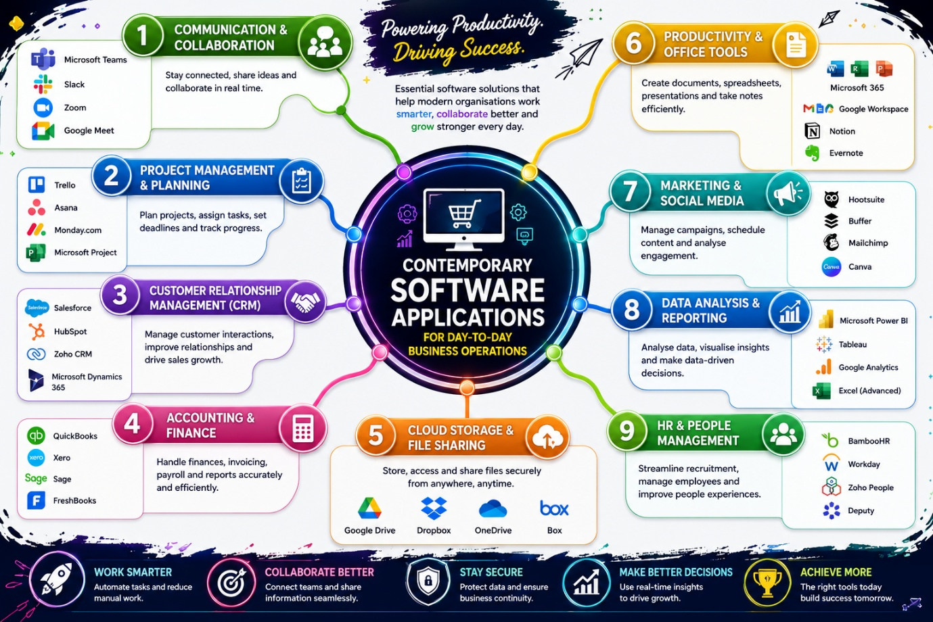

Task 3a – Office Applications for Creating, Storing, Presenting and Analysing Information/Data

Introduction
Office productivity software helps organisations manage information, improve communication and support decision-making. These applications enable users to create documents, analyse data, deliver presentations and organise information efficiently, while improving productivity through automation and collaboration [9].
Microsoft Office is one of the most widely used productivity suites because its integrated applications support a range of business tasks and allow information to be shared easily between programs. For example, Excel data can be used in Word reports or PowerPoint presentations, while Access stores and manages large datasets for analysis [10].
This report examines four Microsoft Office applications—Microsoft Word, Microsoft PowerPoint, Microsoft Excel and Microsoft Access—and evaluates their key features, business benefits and limitations.

Microsoft Word


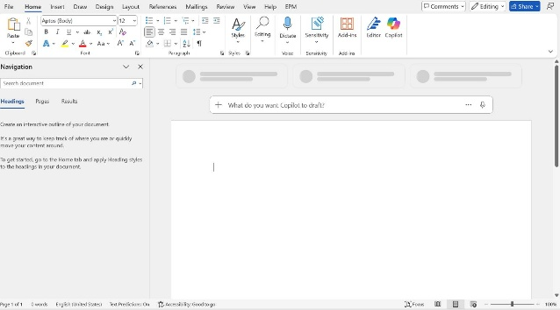[5]
Microsoft Word is a widely used word processing application for creating, editing and formatting business documents such as letters, reports, contracts and meeting minutes. It provides professional formatting tools that help organisations produce clear and consistent documentation [9].
Major Features
- Document templates
- Text formatting
- Spell and grammar checking
- Tables, images and SmartArt
- Headers, footers and page numbering
- Mail Merge
- Real-time collaboration
- Track Changes and Comments
- OneDrive auto-save
Mail Merge is particularly useful for creating personalised letters or emails from Excel or database information, saving time and improving consistency.
Benefits in Business Operations
Word enables organisations to create professional documents using standardised templates, supporting consistent branding. Collaboration features such as Track Changes and Microsoft 365 allow multiple users to edit and review documents efficiently. It also integrates well with Excel, PowerPoint and Access, making it easy to produce comprehensive business reports [10].
Limitations
Large documents with many images may become slow to edit, and Word is not suitable for analysing large datasets. Formatting may also change when files are opened in non-Microsoft word processors.
Overall, Microsoft Word remains a leading business application due to its flexibility, collaboration tools and ease of use.

Microsoft PowerPoint
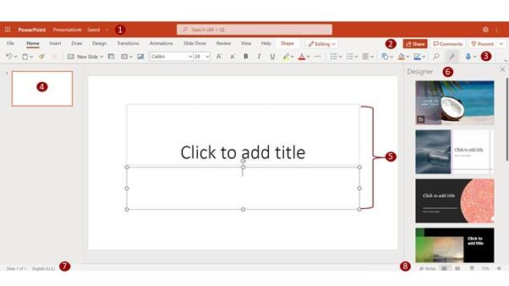
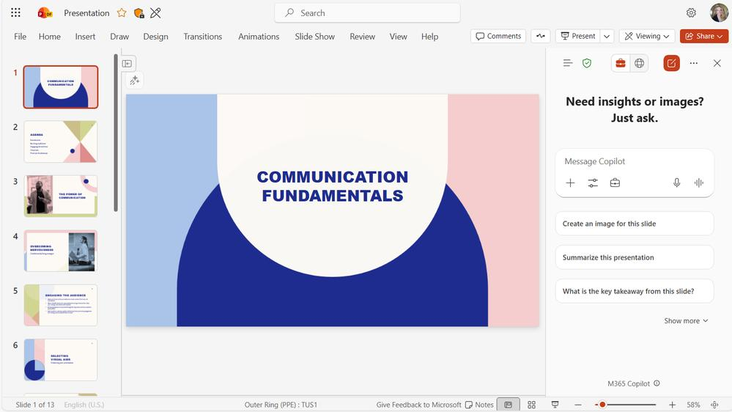
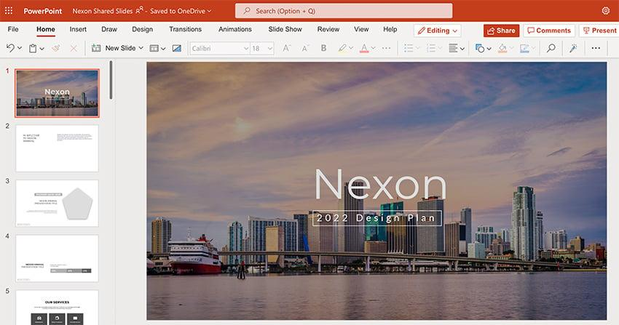[5]
Microsoft PowerPoint is presentation software used for staff training, meetings, client presentations and project proposals. It combines text, graphics, charts and multimedia to communicate information clearly and effectively [11].
Major Features
- Presentation templates and themes
- SmartArt and charts
- Images, videos and icons
- Animations and transitions
- Presenter View and Speaker Notes
- Presentation recording
- Live presentations through Microsoft Teams
Benefits in Business Operations
PowerPoint improves communication by presenting information visually through charts, diagrams and graphics. It supports collaboration via cloud storage, allowing multiple users to work on presentations simultaneously. Integration with Excel enables charts to update automatically, improving accuracy and reducing duplicated work [12]. Presentations can also be shared online or recorded for remote training.
Limitations
Overusing text or animations can reduce audience engagement. PowerPoint also has limited data analysis capabilities and relies on Excel for calculations and chart creation.

Microsoft Excel
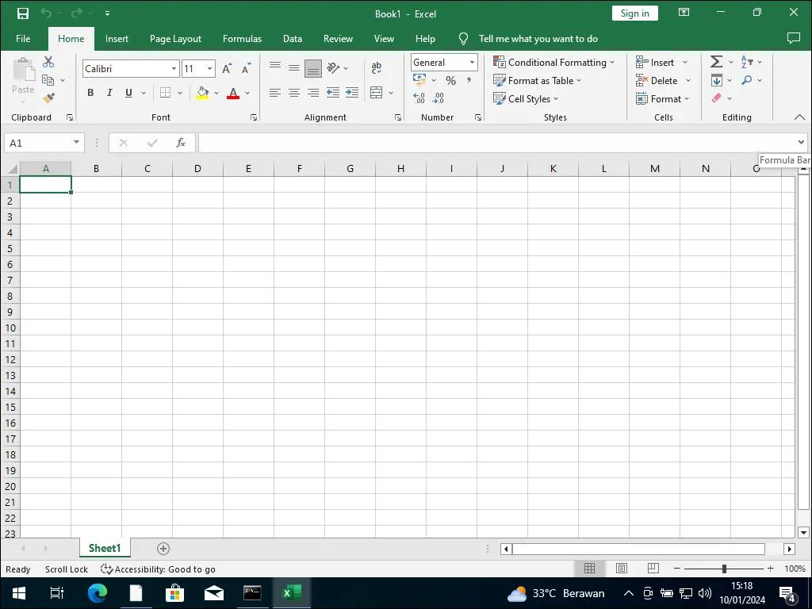
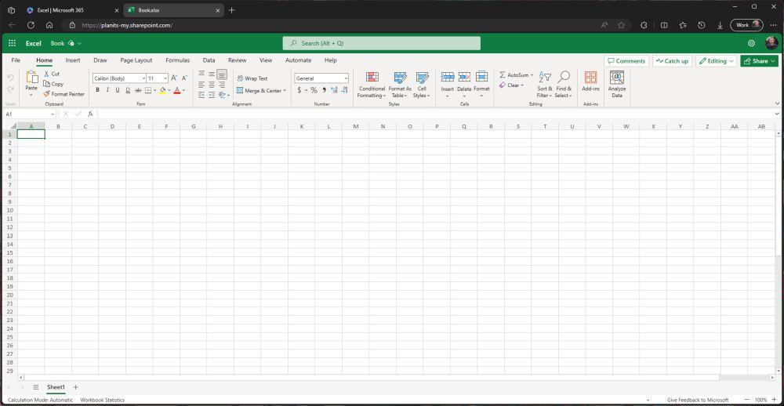
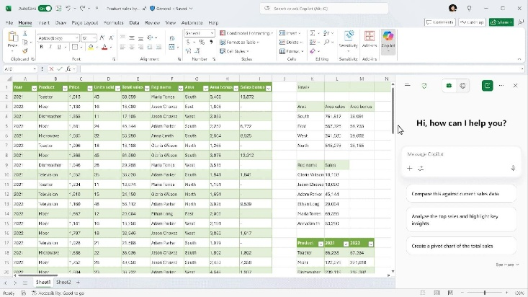[5]
Microsoft Excel is a spreadsheet application used to organise, analyse and visualise data. It is widely used for budgeting, forecasting, payroll, inventory management and performance reporting, helping organisations make informed business decisions [4].
Major Features
- Formulas and functions (e.g. IF, SUM, VLOOKUP)
- Pivot Tables and Pivot Charts
- Conditional Formatting
- Charts and graphs
- Sorting and filtering
- Goal Seek
- Macros and VBA
- Microsoft 365 collaboration
Excel automatically updates calculations when data changes, improving accuracy and reducing manual work.
Benefits in Business Operations
Excel helps businesses analyse financial and operational data using charts, dashboards and Pivot Tables. Automation through formulas and macros increases productivity, while cloud collaboration allows multiple users to work on the same spreadsheet simultaneously [4].
Limitations
Large datasets can reduce performance, and incorrect formulas may produce inaccurate results. Excel is also less suitable than Microsoft Access for managing large relational databases.
Overall, Excel remains an essential tool for business analysis, reporting and data-driven decision-making.

Microsoft Access
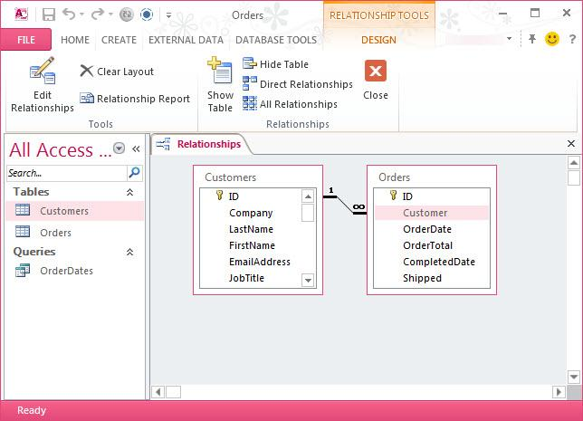
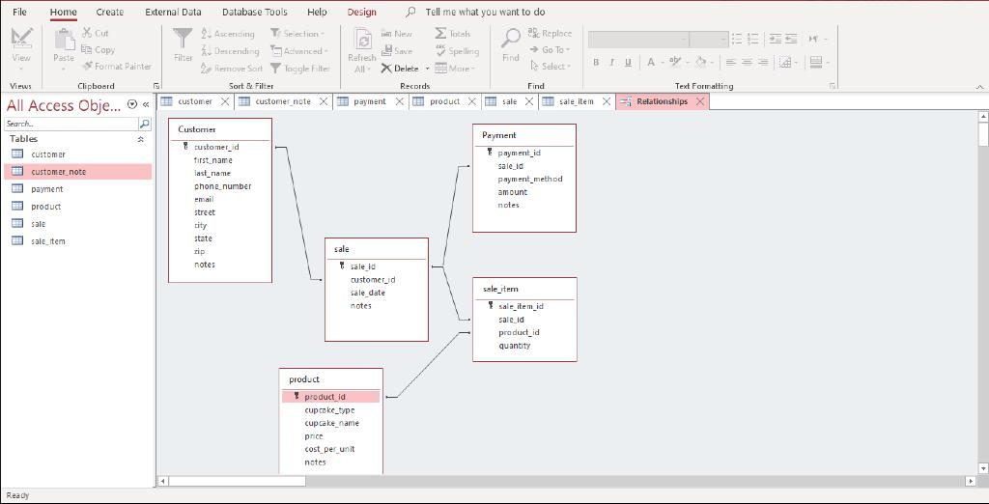
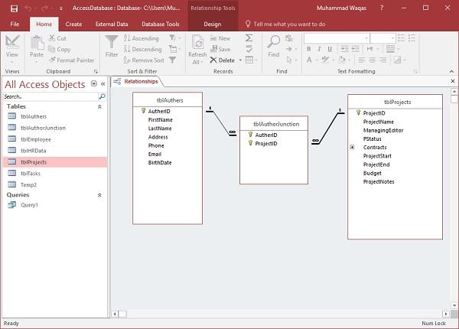[5]
Microsoft Access is a relational database management system (RDBMS) used to store, organise and retrieve large amounts of structured data. Businesses use it to manage customer records, employee information, stock, suppliers and assets efficiently [3].
Major Features
- Relational tables
- Primary and foreign keys
- Queries
- Forms and reports
- Table relationships
- SQL support
- Data import/export
- Microsoft Office integration
Access links related data across tables, reducing duplication and improving data accuracy. Queries also allow users to quickly search and retrieve information.
Benefits in Business Operations
Access improves efficiency by providing secure, organised data storage with customised forms and reports. It supports data integrity through validation rules and integrates with Excel for further analysis and reporting [3].
Limitations
Access is best suited to small and medium-sized organisations. It requires more database knowledge than Word or Excel, and larger businesses often use systems such as SQL Server for greater scalability.
Overall, Microsoft Access is an effective solution for managing structured business data without the cost of enterprise database software.
Comparison of Microsoft Office Applications
The table below compares the four Microsoft Office applications discussed in Task 3a.
Application | Primary Purpose | Major Features | Business Benefits | Limitations
Microsoft Word | Create and edit documents | Templates, Mail Merge, Track Changes, formatting tools | Professional documentation, collaboration, document management | Limited data analysis capabilities
Microsoft PowerPoint | Create presentations | Themes, animations, SmartArt, multimedia, Presenter View | Improves communication and audience engagement | Limited analytical functionality
Microsoft Excel | Analyse numerical data | Formulas, Pivot Tables, charts, dashboards, automation | Data analysis, reporting, forecasting and decision-making | Formula errors and performance issues with extremely large datasets
Microsoft Access | Store and manage databases | Tables, queries, forms, reports, relationships | Efficient database management and data integrity | Requires database knowledge and is less scalable than enterprise database systems

Conclusion
Microsoft Word, PowerPoint, Excel and Access each perform distinct but complementary roles within modern business operations. Word enables organisations to create professional documents, while PowerPoint improves communication through visually engaging presentations. Excel supports numerical analysis, financial management and business reporting, whereas Access provides structured database management for storing and retrieving large volumes of information.
Together, these applications enable organisations to create, store, analyse and present information efficiently while supporting collaboration and informed decision-making. Their ability to integrate seamlessly through Microsoft 365 further enhances productivity by allowing information to flow easily between applications. Although each application has certain limitations, their combined functionality provides businesses with a comprehensive office productivity solution capable of supporting a wide range of operational and strategic activities.

Task 3b – Practical Application of Microsoft Excel Features
Introduction

Microsoft Excel
Microsoft Excel provides powerful tools for analysing data, automating calculations and supporting business decisions. This practical activity tested two commonly used features—the IF Function and Pivot Table—using a retail sales dataset.
Feature 1 – IF Function
The IF Function automatically classifies data based on conditions, reducing manual work and improving consistency. In this exercise, it identified products as High Volume or Normal Volume using the formula:
Screenshot 1 – Creating the IF Function
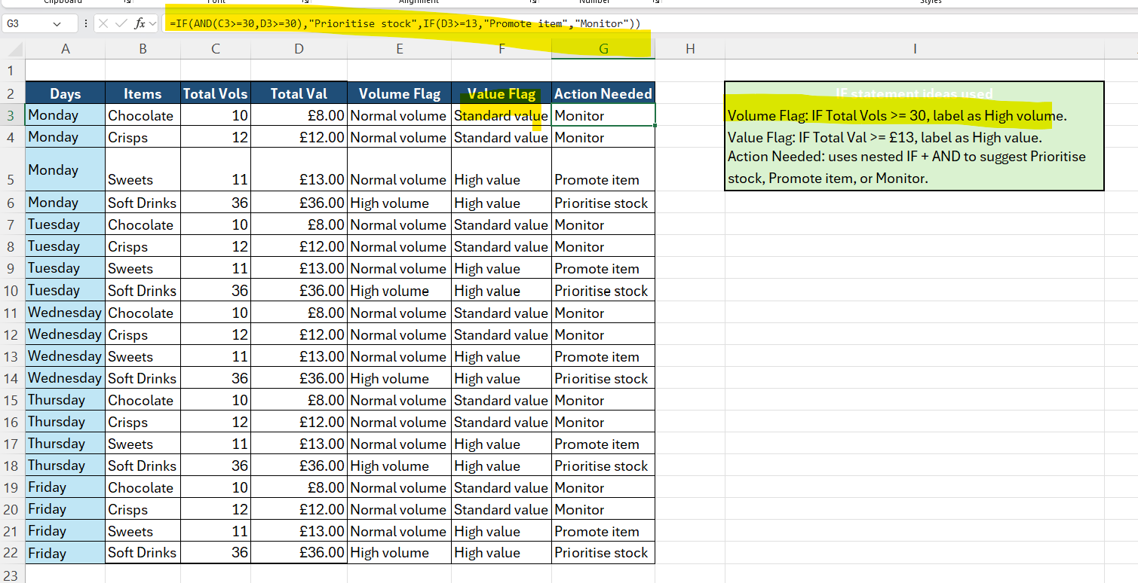
Figure 3.1: Creating the IF Function to classify sales volume.
The formula entered into cell E3 was:
=IF(C3>=30,"High volume","Normal volume")
This formula checks whether the value in Total Vols is greater than or equal to 30. If the condition is met, Excel returns "High volume"; otherwise, it returns "Normal volume".
This approach removes the need for manual classification and ensures every record is assessed consistently.
Screenshot 2 – Completed IF Function Results
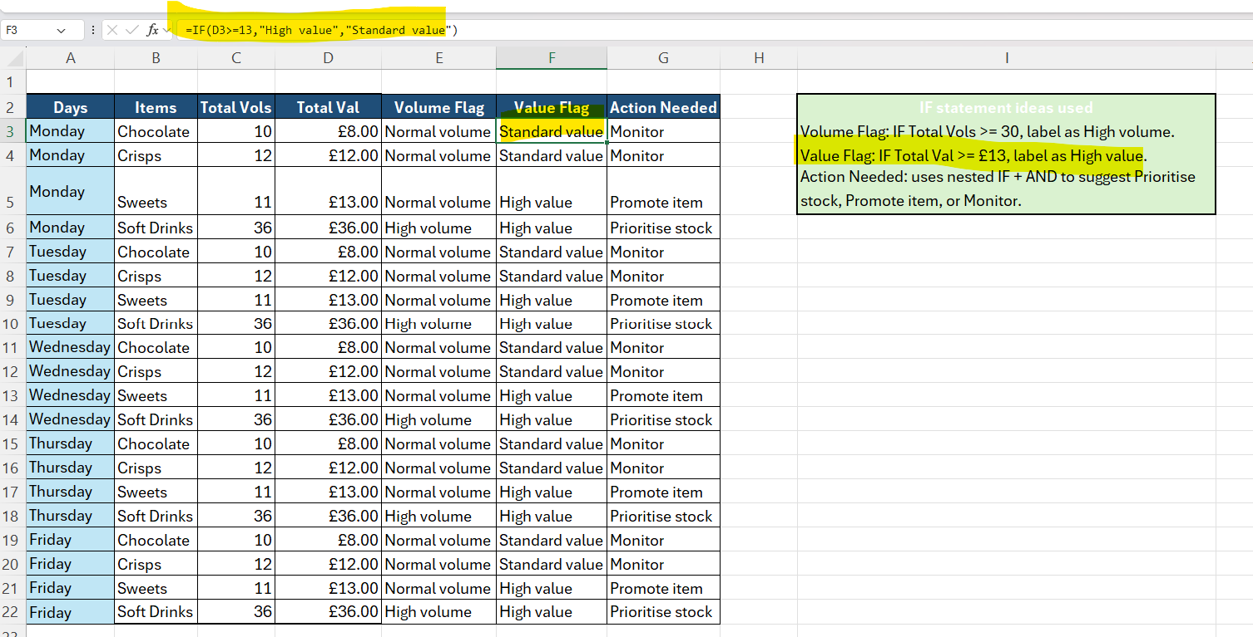
Figure 3.2: Results generated using the IF Function.
After copying the formula throughout the worksheet, Excel automatically classified each product according to its sales volume.
Additional nested IF functions produced Value Flag and Action Needed columns, recommending actions such as Prioritise Stock, Promote Item or Monitor.
Business Benefits
- Automates decision-making
- Improves consistency
- Speeds up reporting
- Reduces errors
- Supports stock management
Feature 2 – Pivot Table
A Pivot Table summarises large datasets quickly, making it easier to analyse sales performance. Using the retail dataset, sales were grouped by product and day to display total sales value and volume.
For this exercise, a Pivot Table was created using the same retail sales dataset.

Screenshot 3 – Creating the Pivot Table
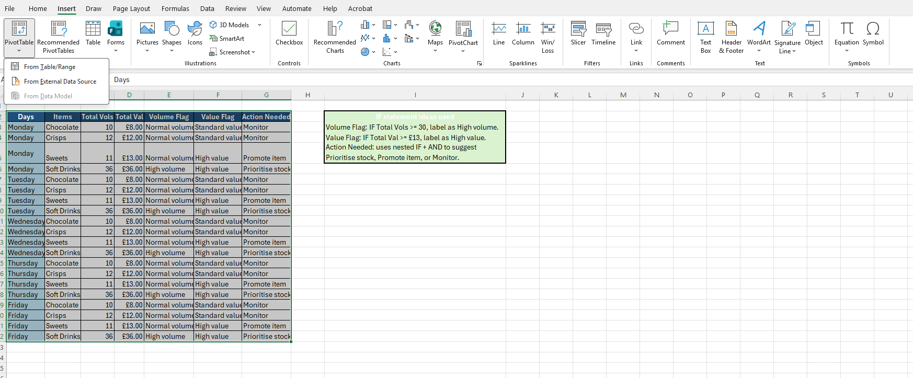
Figure 3.3: Configuring the Pivot Table fields.
The Pivot Table was created by selecting the sales dataset and choosing:
Insert → PivotTable
The following fields were added:
Area | Field
Filters | Days
Rows | Items
Values | Sum of Total Value
Values | Sum of Total Volume
This configuration enabled Excel to automatically summarise the sales information by product.

Screenshot 4 – Completed Pivot Table


Figure 3.4: Pivot Table summarising product sales.
The Pivot Table displayed the total sales value and total sales volume for each product.
The summary quickly showed:
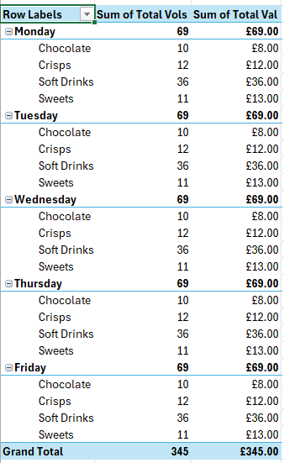
Rather than manually adding hundreds of records, Excel generated these totals instantly.
This provides managers with a clear overview of product performance.
Screenshot 5 – Expanded Pivot Table Analysis
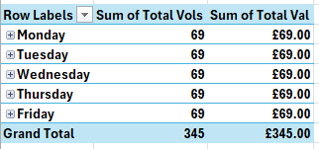
Figure 3.5: Pivot Table displaying daily sales breakdown.
The Pivot Table was expanded to display sales grouped by each day of the week.
This allowed managers to analyse:
- Daily sales performance.
- Product demand.
- Sales trends.
- Individual product contributions.
- Weekly performance comparisons.
By expanding and collapsing categories, users can quickly move between summary information and detailed records.
Feature 2 – Pivot Table
A Pivot Table summarises large datasets quickly, making it easier to analyse sales performance. Using the retail dataset, sales were grouped by product and day to display total sales value and volume.
Business Benefits
- Summarises large datasets instantly
- Supports management reporting
- Identifies trends and patterns
- Saves time
- Improves decision-making
Evaluation
Both features demonstrated how Excel improves business efficiency. The IF Function automated product classification, while the Pivot Table converted detailed sales data into clear management reports. Together, they reduce manual processing, minimise errors and support faster decision-making.

Task 4a – Communication and Collaboration Applications
Analyse one contemporary Communication and one Online Collaboration application/tool used frequently in the modern business world and document a summary of their key features.
Introduction
Cloud-based communication and collaboration tools enable employees to communicate, share files and work together from any location, supporting remote and hybrid working [6], [8].
This report analyses Microsoft Teams as a communication tool and Microsoft OneNote as an online collaboration application, highlighting their key features and business benefits.

Microsoft Teams – Communication Application



[4]
Microsoft Teams is a cloud-based communication platform that combines messaging, video meetings, file sharing and collaboration in one application. It is widely used to support remote and hybrid working by enabling real-time communication across teams and locations [6].
Key Features
- Instant messaging
- Audio and video meetings
- Screen sharing
- File sharing
- Team channels
- Calendar integration
- Microsoft 365 integration
- Meeting recording
- Mobile and desktop access
Benefits to Business Operations
Teams improves communication by bringing conversations, meetings and documents together in one platform. It supports collaboration on Word, Excel and PowerPoint files, reduces travel through virtual meetings, and enables employees to work from any location using cloud access [6].
Limitations
Teams depends on a reliable internet connection, and new users may require training. Large numbers of notifications or channels can also become distracting. Overall, it remains one of the leading communication tools for modern organisations.

Microsoft OneNote – Online Collaboration Application
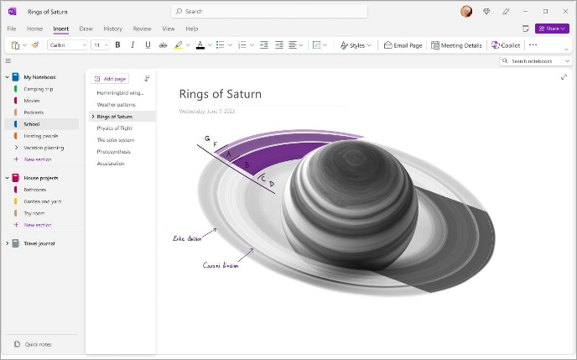
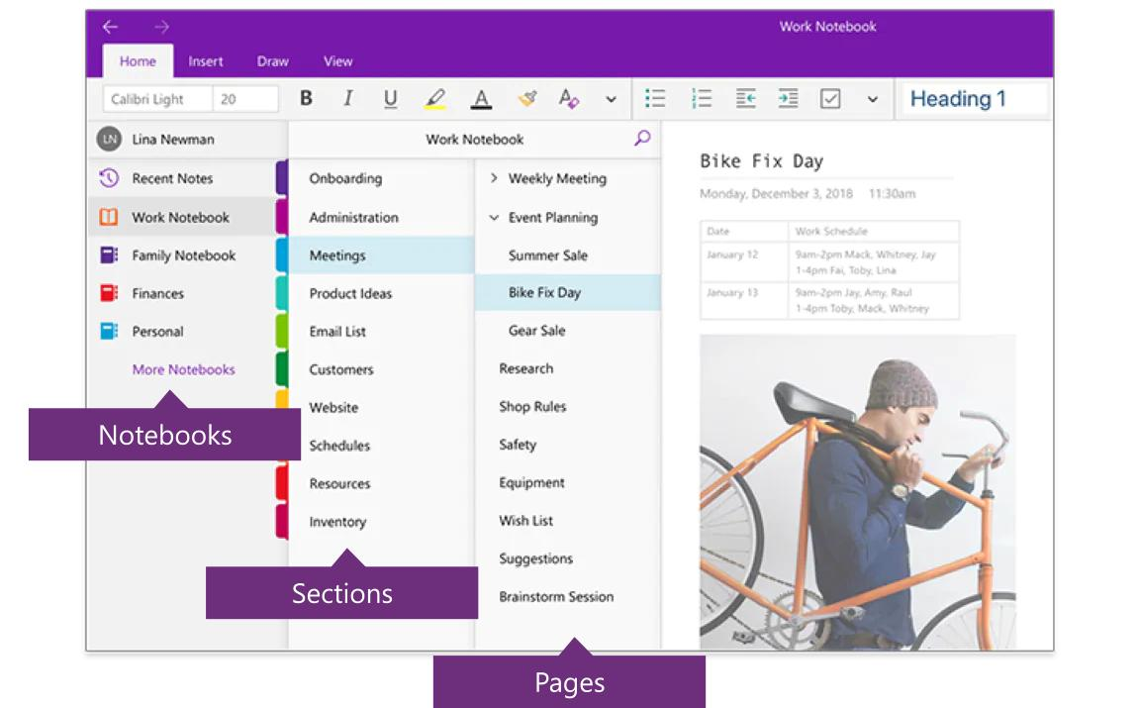
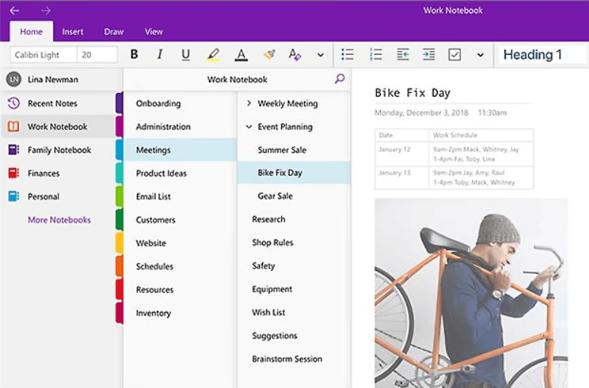
[4]
Microsoft OneNote is a cloud-based digital notebook that allows users to capture, organise and share notes, documents and multimedia. Stored in OneDrive, notebooks can be accessed and edited from multiple devices, supporting real-time collaboration [8].
Key Features
- Digital notebooks
- Sections and pages
- Real-time collaboration
- Cloud synchronisation
- Handwritten notes
- Audio recording
- Document attachments
- Search and tagging
- Microsoft 365 integration
Benefits to Business Operations
OneNote helps businesses organise meeting notes, project information and procedures in one searchable location. Cloud syncing ensures everyone has access to the latest information, while integration with Teams, Outlook and Word improves collaboration and productivity [8].
Limitations
OneNote has fewer formatting features than Word and is less suitable for formal reports. It also offers limited project management functions and may experience synchronisation delays when offline.
Overall, OneNote is an effective tool for organising business knowledge and supporting collaborative working.
Comparison of Microsoft Teams and Microsoft OneNote
Feature | Microsoft Teams | Microsoft OneNote
Primary Purpose | Communication | Collaboration and knowledge management
Main Function | Messaging, meetings and calls | Organising and sharing information
Real-Time Collaboration | Yes | Yes
Cloud Storage | Microsoft OneDrive | Microsoft OneDrive
File Sharing | Excellent | Excellent
Video Conferencing | Yes | No
Meeting Notes | Integrated | Excellent
Mobile Access | Yes | Yes
Microsoft 365 Integration | Full integration | Full integration

Both applications complement each other within the Microsoft 365 environment. Microsoft Teams focuses primarily on communication through messaging and virtual meetings, while OneNote provides an organised collaborative workspace for storing, sharing and managing information.

Conclusion
Modern organisations increasingly rely on cloud-based communication and collaboration technologies to improve productivity, support remote working and enhance teamwork. Microsoft Teams provides a comprehensive communication platform that enables instant messaging, video conferencing and document sharing, allowing employees to communicate efficiently regardless of location. Microsoft OneNote complements these capabilities by offering a collaborative digital notebook that supports knowledge management, project organisation and information sharing.
Although both applications have minor limitations, their integration within Microsoft 365 creates a powerful digital workplace that improves organisational communication, collaboration and operational efficiency. Together, they enable businesses to respond more quickly to challenges, improve employee engagement and maintain effective collaboration across distributed teams.

Task 4b – Practical Application of Communication and Collaboration Applications

Introduction
Communication and collaboration applications have become essential tools within modern organisations, enabling employees to communicate effectively, share information and work together regardless of location. Cloud-based platforms improve productivity by supporting real-time communication, document sharing and collaborative working. For this practical activity, one feature from Microsoft Teams (Communication Application) and one feature from Microsoft OneNote (Collaboration Application) were tested to demonstrate their practical use in supporting business operations.
Communication Application – Microsoft Teams
Feature Tested: Instant Messaging (Chat)

Microsoft Teams Chat was tested by sending a professional message requesting feedback on an updated business report. The feature enables instant communication, file sharing and real-time collaboration without relying on email.
In business, Teams Chat improves communication by supporting quick responses, group discussions and searchable conversation history.
Business Benefits
- Instant communication
- Reduces email use
- Supports remote and hybrid working
- Easy file sharing
- Improves teamwork and decision-making
- Searchable conversation history
Overall, Microsoft Teams Chat enhances collaboration and helps organisations communicate more efficiently.

Collaboration Application – Microsoft OneNote
Feature Tested: Cloud-Based Notebook and Document Organisation
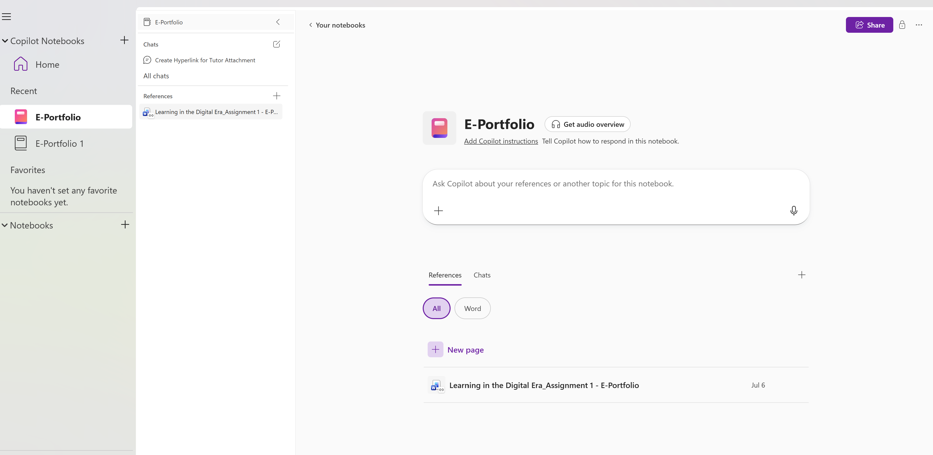
Figure 4.2: Managing digital notebooks using Microsoft OneNote.
Microsoft OneNote was tested by accessing an online notebook containing coursework and project information. The application allows users to create multiple notebooks, organise information into sections and pages, and synchronise content automatically through Microsoft OneDrive.
The notebook interface enables users to store notes, documents, images, web links and research materials within a single location. This creates a structured digital workspace that can be accessed from multiple devices, allowing employees to continue working whether they are in the office, at home or travelling.
Because notebooks are stored in the cloud, updates are automatically saved and synchronised, ensuring that users always access the latest version of their work without needing to manually save files.
Business Benefits
- Organises information efficiently.
- Supports cloud storage and automatic synchronisation.
- Reduces paper-based documentation.
- Enables information to be accessed from multiple devices.
- Improves project organisation.
- Supports collaborative working through shared notebooks.
Microsoft OneNote therefore provides an effective solution for organising business information while improving accessibility, collaboration and productivity.
Additional Practical Feature – Shared Reference Management
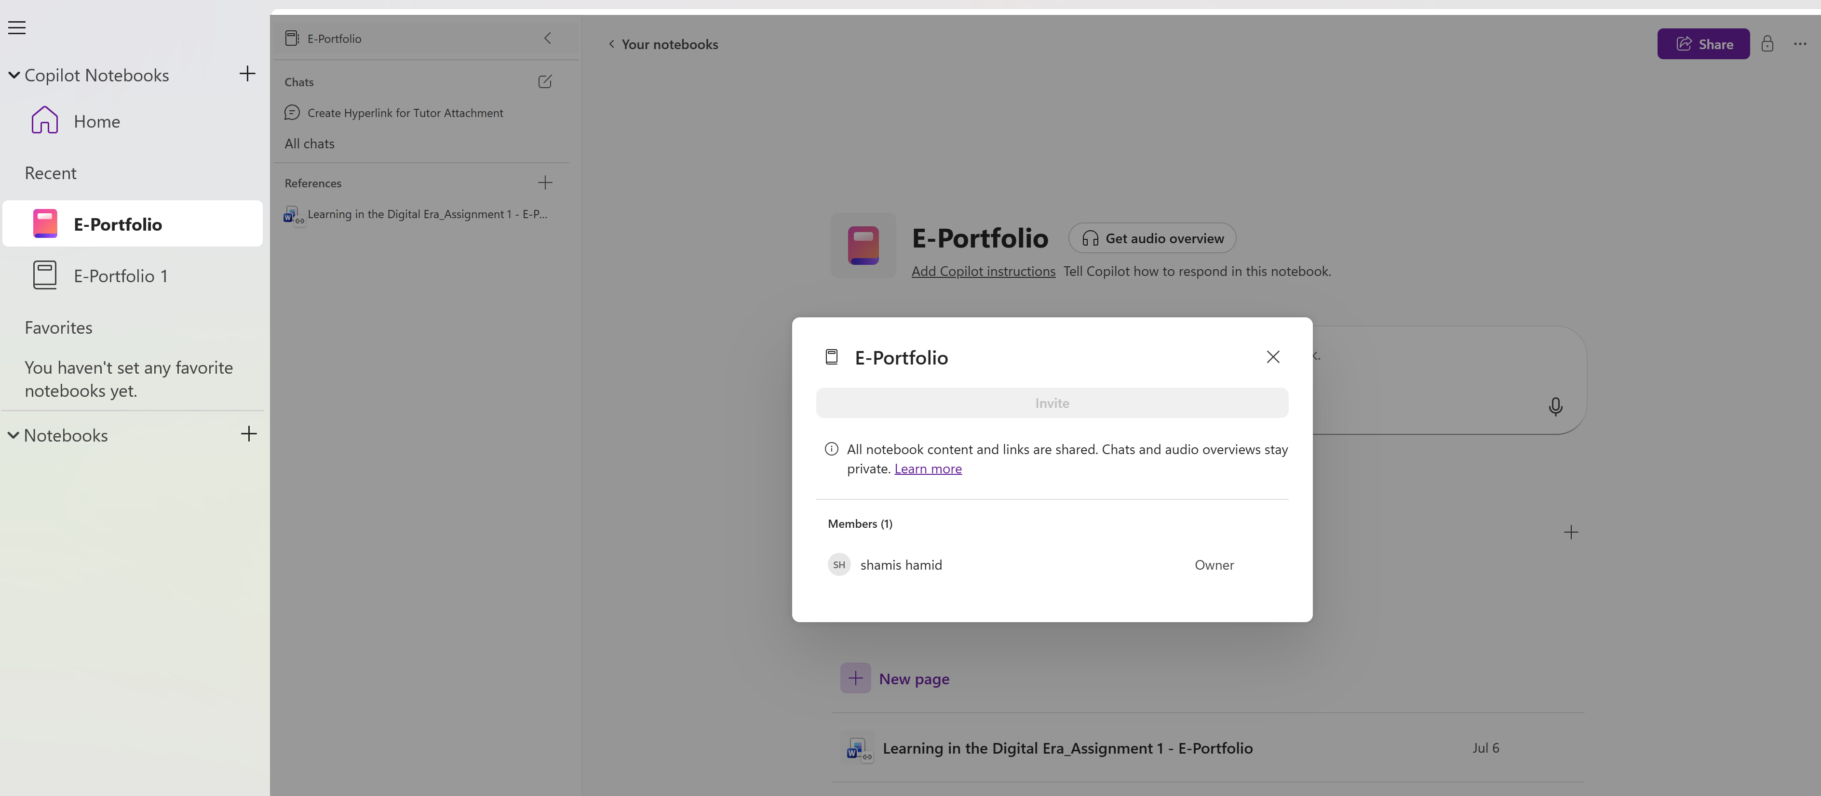
Figure 4.3: Organising shared reference materials within Microsoft OneNote.
The final practical activity demonstrated how Microsoft OneNote can organise shared project resources in a single digital notebook. Team members can access, update and organise information in real time, making collaboration more efficient.
Integration with Microsoft Word and other Microsoft 365 applications keeps project documents stored centrally, reducing duplication and improving productivity.
Business Benefits
- Centralises project information
- Supports collaboration and knowledge sharing
- Improves document organisation
- Increases productivity through cloud access
- Reduces misplaced information
Evaluation
The practical activities showed how Microsoft Teams and Microsoft OneNote work together to support modern business operations. Teams enables instant communication and file sharing, while OneNote provides a central space for organising shared notes and documents. Together, they improve communication, collaboration, knowledge sharing and support flexible, remote working.

IEEE References
Task 1
[1] Shopify, What is Shopify and How Does It Work? Available: https://www.shopify.com/uk/blog/what-is-shopify
[2] Shopify, Shopify Security. Available: https://www.shopify.com/security
[3] Wix, Wix eCommerce. Available: https://www.wix.com/ecommerce
[4] Oracle, What Is E-Commerce? Available: https://www.oracle.com/uk/cx/ecommerce/what-is-ecommerce/
Task 2
[5] T. Buzan and B. Buzan, The Mind Map Book: Unlock Your Creativity, Boost Your Memory, Change Your Life. Harlow, U.K.: Pearson Education, 2010.
[6] T. Buzan and C. Griffiths, Mind Maps for Business: Revolutionise Your Business Thinking and Practice. Harlow, U.K.: Pearson Education, 2013.
[7] MindMeister, "What is Mind Mapping?" Available: https://www.mindmeister.com/pages/mind-map
[8] A. A. Mento, P. Martinelli and R. M. Jones, "Mind Mapping in Executive Education: Applications and Outcomes," Journal of Management Development, vol. 18, no. 4, pp. 390–416, 1999.
Task 3
[3] Microsoft, Microsoft Access Documentation. Available: https://support.microsoft.com/access
[4] Microsoft, Microsoft Excel Documentation. Available: https://support.microsoft.com/excel
[5] Microsoft, Microsoft PowerPoint Documentation. Available: https://support.microsoft.com/powerpoint
[7] Microsoft, Microsoft Word Documentation. Available: https://support.microsoft.com/word

Task 4
[6] Microsoft, Microsoft Teams Documentation. Available: https://support.microsoft.com/teams
[8] Microsoft, OneNote Help & Learning. Available: https://support.microsoft.com/onenote

