Manifesto’s

What are people?
- We are creatures of habit and repetitiveness
- We are animals of spontaneity and randomness
- We are reckless and careless at times
- We are responsible and calculating
- We can be violent monsters
- We can be kind and warm like a mother to her child
- We divide ourselves needlessly
- We are all equal

Statement 1: We are creatures of habit and repetitiveness
This statement feels particularly true in modern times as so many people are stuck in a routine of; get up, go to work, eat, sleep, repeat. And even if it is not this exact routine, it is something very similar to it. “It is something that we try to tell ourselves that isn’t true and that we control our future, but the truth is that it’s in our nature to seek out patterns and avoid change. Even the most unpredictable people have habits” (Jennifer Nguyen, M.S., BCBA, 2021). She goes on to make some very interesting points about how the reason we are creatures of habit is because it shows a path of least resistance for us and how habit allows us to repeat a task without having to relearn it every time. Whilst some may say that whilst we are animals that tend to repeat certain habits that benefit our survival, we still have the choice and decision-making skills that allow us to be our own person choose what to do with our lives. I only agree with this statement to a certain degree as whilst we are capable of making minor decisions that may alter the course of our lives in a sort of butterfly effect, how we go about making those minor decisions is all down to our own little habits.

Statement 2: We can be violent monsters
This statement can be seen throughout all human history with the countless wars and battles that have taken place over the years. With modern humans having weapons of mass destruction and guns that are capable of wiping out entire crowds of people in mere seconds, to the earliest discovered human remains being buried with spears for hunting and war. An interesting article on this topic states that our hands were actually designed to be more effective weapons. Because of the way we hit people, one with the thumb closed against the index and middle fingers, provides a safer way to hit someone with force. Given that none of our primate cousins have the ability to make such a fist, Carrier and his co-authors propose that our hand proportions may have evolved specifically to turn our hands into more effective weapons (Josh Gabbatiss, 2017). This is very interesting research as it suggests that human beings have evolved from primitive primates, barely able to use tools, into creatures that have been designed by nature to be a more effective hunter and a more effective killer.

Statement 3: We divide ourselves needlessly
This statement. Is unfortunately true throughout history and is especially relevant in modern history. Whilst this may have been more understandable a couple thousand years ago when people were divided by tribes and people were right to be cautious about things they had not encountered before as almost every creature that they encountered was trying to kill them or was capable of killing them. However, in modern times we have divided our society into race, gender, sexuality and social class which is just unnecessary. Some say that human division is a result of culture, a human invention (Steven Grosby,2005). This would suggest that we as humans are divided mentally and physically by nations borders as we divide based on different cultures from different nations and that is where other large divisions such as race come from.

Bibliography
- Nguyen. J (2021) creatures of habit. Available at: https://www.villiv.org/post/creatures-of-habit (Accessed: 11 November 2022)
- Gabbatiss. J (2017) Nasty, Brutish and Short: Are Humans DNA wired to kill. Available at: https://www.scientificamerican.com/article/nasty-brutish-and-short-are-humans-dna-wired-to-kill/ (Accessed: 12 November 2022)
- Grosby. S (2005) “human divisiveness” in Nationalism: a very short introduction. Oxford university press, p.98. (Accessed: 13 November 2022)

semiotics
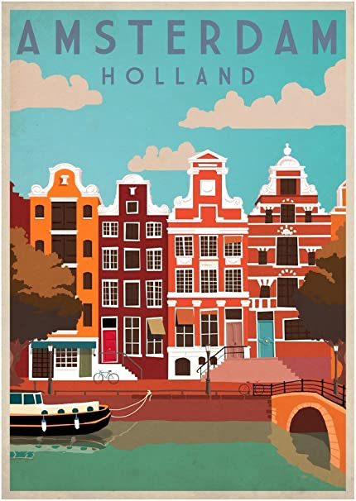
Denotation
Denotation is the literal meaning to that person (Chris Condon, Mark Perry, Robert O’Keefe, 2004). The denotation of this image shows a row of brightly coloured buildings with bicycle’s outside on the street next to the trees that run along the riverbank. It also shows a blue sky in the background with white clouds. It is very important that the denotation of an image is clear because the first thing that everyone is going to see that can entice them in to thinking about the actual meaning behind the poster and it gets them to read more into the connotation of an image rather than just taking it at face value. The denotation is sort of like a book cover, it is the thing that gets you interested in the book you’re reading. If every book you read had a boring cover, then you probably wouldn’t have read it in the first place.
Connotation
The connotation of a language expression is clearly distinct from its sense, denotation and reference (Keith Allan, 2007). The connotation of this image is that Amsterdam is a vibrant city because of the use of bright and bold colours. The use of red and orange colouring on the buildings could be referring to the Red-Light District in the city which is a popular tourist attraction. The input of two trees in the image suggests that Amsterdam is quite a green city as it implies that the trees that are on either side of the image run all along the riverbanks. The image also includes two bicycles which plays into the popular stereotype that Amsterdam has lots of bicycles. It also shows of the environmentally friendly side of Amsterdam: because bikes are used a lot in the city there is very low pollution levels hence the use of a clear, blue sky in the background.
Iconic signs
In this image, the creator has included a large amount of objects and design styles that are a well-known part of Amsterdam and that are unique to the city. The way we interpret a ‘sign’ is what allows it to be signified ( Lesley Lanir, 2019). The association between this image and the viewer is completely based on their previous knowledge of Amsterdam. The significance of the connotation of this image would greatly differ between someone who knows nothing about Amsterdam and someone who lives in Amsterdam. However, even if this were the case, the image portrays a good image of Amsterdam and would allow anyone who perhaps didn’t know a lot about the city before seeing the poster, a better understanding of what the city is like and may give them an interest in visiting the city in the future. Thus the poster is achieving its purpose by portraying Amsterdam in a positive way.
Conclusion
To conclude, when I first saw this poster I merely saw it as a way for Amsterdam to put its name out there. However, after researching the deeper meaning of the image I have gained a greater understanding for why each part of the image was included in the final poster.
Bibliography
- Condon, C., Perry, M. and O'Keefe, R. (2004) Denotation and connotation in the human – computer interface: The 'save as ...' command, Taylor & Francis. Available at: https://www.tandfonline.com/doi/abs/10.1080/01449290310001637415?journalCode=tbit20 (Accessed: November 23, 2022).
- Lanir, L. (2020) Charles Sanders Peirce: Symbolic, iconic, and indexical signs, Medium. Medium. Available at: https://medium.com/@llanirfreelance/charles-sanders-peirce-symbolic-iconic-and-indexical-signs-29e0e40bef1d (Accessed: November 23, 2022).
- Allan, K. (2006) The pragmatics of connotation, Journal of Pragmatics. North-Holland. Available at: https://www.sciencedirect.com/science/article/abs/pii/S037821660600172X (Accessed: November 23, 2022).

Practised based writing
The iPhone is one of, if not the biggest smart phone in the world at the moment. The iPhone has been a prominent part of the market share for smartphones since its release in 2007. When it released, the first iPhone was recognised for its touch screen abilities which it won awards for, making it more popular and sought after than other phones at the time. Although, critics at the time said that it was too expensive to compete in the market. To combat this, the next iPhone to be released was half the cost of the original and it contained more storage capability. Apple continued to release iPhones which only increasing its popularity and allowing apple to control between 10%-20% of the market share for all smart phones for over a decade. However, over the years, Apple has been drenched in controversies including the use of sweat shops to make their products (Brian Merchant,2017). Sweatshops have been known to dump chemicals into the surrounding environment which pollutes the air, water and soil as well as damages the wildlife eco systems in the area. This article by the guardian seemed to cause a decrease in sales in 2018 as shown on Statista.
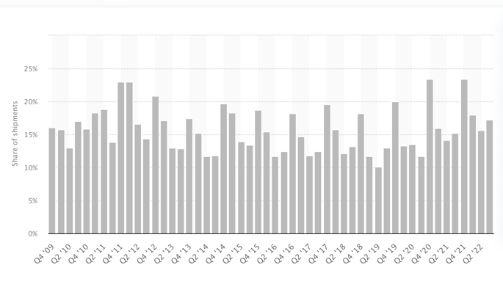
In today’s society, Apple claims that they have been carbon neutral since April of 2020 and that 100% of renewable energy was sourced for all Apple facilities (apple,2021). According to Apples 2021 environmental report, greenhouse gas emissions have slowly been decreasing since 2016 with their total carbon footprint going from 29,500,000 metric tons of CO2 a year in 2016 to 22,600,000 metric tons of CO2 per year in 2020. Not only that, but Apple have also stated that they have reduced the plastic in their packaging for iPhones by 65% since 2015 and that 100% of all virgin wood fiber are from responsible sources (Apple,2021).
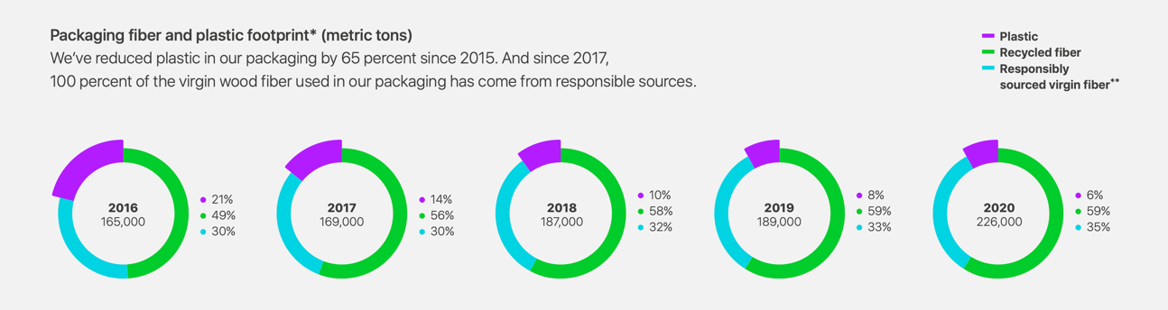

In my opinion, I think that in recent times Apple is very supporting for trying to save the environment and is doing their part for trying to do so, by reducing carbon dioxide emissions and reducing the amount of non-recyclable materials used in iPhones and the packaging that they come in. Although I also believe that they a large part of the reason why the environment is in the state it is today. I see Apple’s target for net zero carbon emissions for 2030 is more of a penance for causing their part in causing damage to the environment.
From a designer’s point of view, I view the use of only recycled and renewable materials in iPhones as admirable as it is quite a challenge to undertake, but they have managed it non the less. 99% of the tungsten used in the iPhone 12 was recycled by using the material from older Apple products that were no longer in use. According to Apple’s 2022 environmental progress report, all Apple products include recycled tin and rare earth elements as well as most products using recycled aluminium and recycled plastic.
Bibliography
- Apple (2021). Environmental Progress Report. [online] Available at: https://www.apple.com/environment/pdf/Apple_Environmental_Progress_Report_2021.pdf
- Apple (2022). Environmental Progress Report. [online] Available at: https://www.apple.com/environment/pdf/Apple_Environmental_Progress_Report_2022.pdf
- Merchant, B. (2017). Life and death in Apple’s forbidden city. [online] The Guardian. Available at: https://www.theguardian.com/technology/2017/jun/18/foxconn-life-death-forbidden-city-longhua-suicide-apple-iphone-brian-merchant-one-device-extract
- Montgomery, A. (2019). The evolution of Apple’s iPhone. [online] Computer World. Available at: https://www.computerworld.com/article/2604020/the-evolution-of-apples-iphone.html#slide3
- Statista (2022). Global smartphone market share 2019 | Statista. [online] Statista. Available at: https://www.statista.com/statistics/271496/global-market-share-held-by-smartphone-vendors-since-4th-quarter-2009/

