Reflection
After completing my presentation, I will now be reflecting on this feedback given to me. Coach has given me a wide range of feedback from my pace while talking to the type of language, I will be using the feedback given to me by coach to reflect on my performance and find where improvements need to be made or find where I did well. By reflecting is shows that I am towards my required standards and learning outcomes (Costley et al, 2018). By reading my feedback, I can see that I had a good pace. Throughout the presentation my pace was maintained at around 136 words a minute, at around 2 minutes I began to speak to slow but I picked it back up and continued a good pace. By keeping this pace, it shows confidence in my speaking and that I knew the information, that I had done research on this skill and understood what I was talking about. My good pace also shows that I had practiced the presentation and had an idea of what was going to be said and I had been over it multiple times to make sure I knew what I was saying. By reflecting it allows for you to find and appreciate the positives and to help find ways to improve (Health and Care Professions Council,2021) my presentation I did began to use filler words such as “umm”, the prevent this in future I could have more practice runs to help know what I was going to say to prevent the need to use filler words, instead I could have paused to think about what was going to be said and taken my time to know what was going to be said. By using filler words, it shows a lack of confidence on some areas of my presentation which to a listener would show a lack of polish which leads them to believe there was a lack of practice from me. Self-reflection is now seen as a new competency which the work force is demanding at an increased rate (Brownhill, 2021) which makes reflection on this presentation important as it helps me develop this skill further much like I said I would in my presentation. Another piece of feedback that was given to me by coach was my pitch, it was monotone in some sections of the presentation which would cause my audience to lose interest. A way this could be improved would be to emphasise key points to show my knowledge on the subject and have listeners feel that I know what I am speaking on and that I had an interest in what I was talking about. This would also help with my pronunciation of certain words and my tone would be less monotone meaning my pronunciation of these words would be stronger and clearer.By having students understand their own achievements it is more likely to lead to a decrease in appeals of their work, and those who do self-reflect and also peer reflection will help them access deeper learning (Jisc, 2015) which is why reflecting on my presentation will help me with future assignments as it helps me understand myself better and show me where improvements are needed. Coach also gave me the feedback of my repetitive use of certain words such as best, also and very. A way this could be improved would be to expand my descriptive vocabulary and use other types of linking words to make a sentence more interesting making my vocabulary less repetitive and make the presentation more interesting for the listener. I was given feedback on my use of inclusive language. In the presentation I did not use any language that may offend or upset. This shows that my language was appropriate for everyone who would listen to my presentation People consciously reflect on what they do in their lives and as a result of this it can add and enhance meaning (Costley et al, 2018). The final piece of feedback given to me by coach was my originality. During my presentation I was believed to have been reading off the slides to often meaning that to whoever listening It would seem that I was not well read on the subject, that I had not practiced before I did the presentation, and I was uninterested in what I was presenting. A way I could have avoided this would be to have had less information on the slides making it easier to talk about the information without seeming like I’m just reading off a slide. Another way would be to have used different vocabulary to what was used on the slides to lessen the similarity between what I was being said and what was written on the slides. I could have also added more information while I was presenting to extend the slide and show that I wasn’t reading off the slide showing I had remembered the information already on the slide and more.After reflecting on the feedback given to me by coach, I can see that I did well with my pace and my speaking. I had kept the pace well, I used inclusive language and used very little repetitive language. This was all due to the many practices I did before filming the final one. However, it was shown that I read off the slides too often which was due to a lack of confidence on my part in my memory of the information. While speaking I was too monotone, this could easily have been avoided had I emphasised the key points more. According to Porter (2017) Reflecting gives a person a second to pause and begin to sort through any experiences or observations. I feel this reflection has been good for me as I now understand my presenting skills and what parts need to be improved more than others, where I was doing well and coach has also given reasons as to why they would be a weakness.

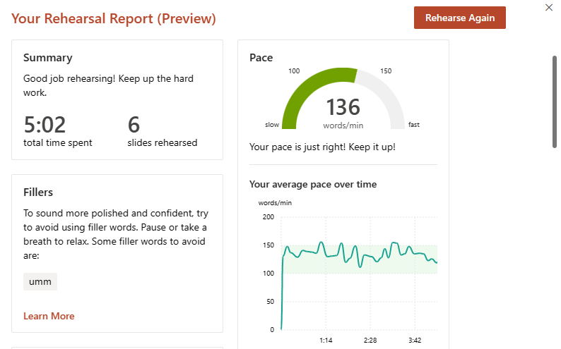

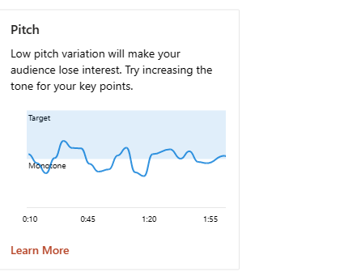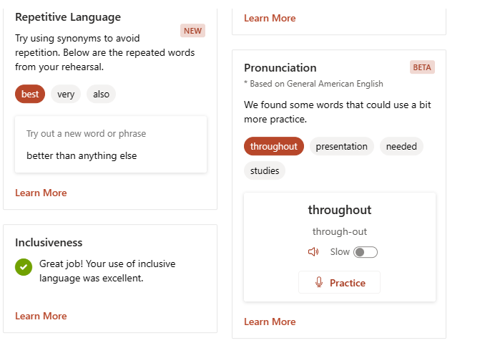

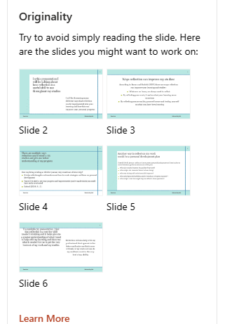
https://uowtsd.sharepoint.com/teams/EducationStudiesLevel4Carmarthen_GRP-EmmaLewis/Shared%20Documents/Recordings/New%20channel%20meeting-20231025_151413-Meeting%20Recording.mp4?web=1

Reference list
Cottrell, S. (2019) study skills handbook. 5th edn. London: Red Globe Press.

Burns, T. and Sinfield, S. (2022) Essential Study Skills. 5th edn. London: Sage Publications.

Costley, C., Abukari, A., Helyer, R., McAlinden F.,Loh E.,Anthonisz, S., Perry, C. (2018) ‘Learning through Reflection: the Critical Role of Reflection in Work-Based Learning (WBL)’ Journal of Work-Applied Management, 7 (1), PP. 15-27. DOI: https://doi.org/10.1108/JWAM-10-2015-003

Porter, J. (2017) Why you should make time for self-reflection (even if you hate doing it). Available at: https://hbr.org/2017/03/why-you-should-make-time-for-self-reflection-even-if-you-hate-doing-it (Accessed 24 October 2023).

Brownhill, S. (2021) ‘Self-Reflection: The Why, The What, and The How’. The Research Centre for Teaching, Learning and Curriculum (TLC), October 1. Available at: https://ctlc.blogs.bristol.ac.uk/2021/10/01/self-reflection-the-what-the-why-and-the-how-by-simon-brownhill/ (Accessed: 24 October 2023).

Jisc (2015) ‘Student Self Reflection’ Transforming Assessment and Feedback with technology. Available at: https://www.jisc.ac.uk/guides/transforming-assessment-and-feedback/self-reflection# (Accessed 25 October).

Health and Care Professions Council (2021) Reflection is a process which helps you gain insight into your professional practice by thinking analytically about any element of it. Available at: https://www.hcpc-uk.org/standards/meeting-our-standards/reflective-practice/what-is-reflection/#:~:text=Reflection%20allows%20you%20to%20identify,process%20and%20learn%20from%20them. (Accessed: 26 October 2023)

