

User virtual reality sickness effects from different locomotion methods

By
Jordan Griffiths

Supervisor: Nabeel Masih
Second Marker: Phil Organ

Project submitted as part of the requirements for the award of BSc (Hons) Computing (Applied Computing)

April 2023

DECLARATION

I, Jordan Michael Griffiths declare that I am the sole author of this Project; that all references cited have been consulted; that I have conducted all work of which this is a record, and that the finished work lies within the prescribed word limits.

This work has not previously been accepted as part of any other degree submission.

FORM OF CONSENT

I Jordan Michael Griffiths hereby consent that my Project, submitted in candidature for the B.Sc. (Hons)Applied Computing) degree, if successful, may be made available for inter-library loan or photocopying (subject to the law of copyright), and that the title and abstract may be made available to outside organisations.

Abstract
Virtual Reality (VR) technology has advanced rapidly in recent years. Offering users an immersive experience that can transport them to entirely different worlds. However, one issue that has arisen with the increased use of VR is virtual reality sickness, which can cause symptoms such as nausea, headaches, and disorientation.
This report provides an overview of the background of VR technology, including its process, current applications, and limitations. It also explores the literature surrounding VR and VR sickness, highlighting the various factors that contribute to these symptoms, such as the user's exposure time, the type of VR hardware used, and the virtual environment itself. To further investigate the relationship between VR and VR sickness, a research of measurement methods was taken to masure the correlation of virtual reality movement methods and the severity of virtual sickness symptoms.
To aid this a a virtual environment was designed and created using Unreal Engine 5. Six participants were recruited to test the environment using appropriate consent forms. The three different movement methods in questions were teleporting, walking(in-place) and jumping. Prior to testing a MSSQ(Motion Sickness Susceptibility Questionnaire)was given to the user. Post-testing, data was collected from the participants using VRLEQ(Virtual Reality Locomotion Experience Questionnaire) and SSQ (Simulator Sickness Questionnaire). The data was then presented diagrammatically, and minor statistical analysis was performed.
In conclusion to the experiment, there is a definite correlation between virtual reality movement methods and virtual reality sickness. There is also possible correlations between MSSQ and SSQ scores. Further potential correlations include the relationship between the usability scores of the movement methods to the participants SSQ scores and what they responded to as the ‘most sickness inducing movement method’. Measurements within this report are not perfect, yet are highly prevalent in the literature, with some needing to be more used, for example the VRLEQ. This is so that researchers can accurately determine if the data gathered with this measurement tool is adequate. The experiment could also be improved by including more participants and a more sophisticated and usable virtual environment.

Contents
Abstract 3
Chapter 1 – Introduction 7
Chapter 2 – Research & Literature Review 7
Research 7
Literature review 12
Chapter 3 - Research And/or Development Methodology 15
Research Question 15
Method 15
Chosen hardware and software 15
Inputs 16
Experiment 16
Target Group 16
Questionnaires and calculations 16
SSQ 18
Experiment validity 18
Experiment reliability 19
Chapter 4 Design and Implementation 20
Design 20
Virtual environment design 20
Implementation 22
VR Environment 22
Blueprint codes 27
Necessary Interface 29
Experiment Results 30
MSSQ 30
Post Experiment questionnaire 31
VRLEQ 31
SSQ 34
Statistical analysis 38
Correlations 38
Experiment Conclusion 40
Chapter 5 – Evaluation 41
Data Conclusions 41
Link to literature 41
Aims and objectives 41
Recommendations 42
Chapter 6 - Conclusions and Recommendations 42
Conclusion 42
Recommendation 43
Chapter 7 – Reflection 43
What did I learn? 43
How did it change me as a person? 43
Chapter 8 – References 44
Bibliography 44
Appendices 49
Research 49
Environment design 52
Blueprint code 57
Testing 59
Tables 64

Figure 1 - VR Process 8
Figure 2 - Console controller 9
Figure 3 - Meta Quest 2 Touch controllers 10
Figure 4 - VR Tracking Process 10
Figure 5 - Meta Quest 2 HMD 11
Figure 6 - VR Environment Use case diagram 20
Figure 7 - VR Environment untextured plan 21
Figure 8 -VR Environment textured plan 22
Figure 9 - VR Environment untextured starting area 23
Figure 10 - VR Environment platforms 23
Figure 11 - VR Environment platforms 24
Figure 12 - - VR Environment Platforms to textured area 24
Figure 13 - VR Environment Textured area 25
Figure 14 - VR Environment platforms to jumping area 25
Figure 15 - - VR Environment platforms to jumping area 26
Figure 16 - VR Environment Jumping area prompt 26
Figure 17 - VR Environment Alternate locomotion reminder 26
Figure 18 - VR Environment Alternate platforms to objects 27
Figure 19 - - VR Environment prompt to user 27
Figure 20 - VR Environment Teleport method blueprint 28
Figure 21 - VR Environment Jumping method blueprint 28
Figure 22 - VR Environment Joystick movement blueprint 28
Figure 23 - - VR Environment Interface widget 29
Figure 24 - VR Environment interface buttons blueprint 29
Figure 25 - VR Environment interface alternate locomotion blueprint 30
Figure 26 - MSSQ score by users 31
Figure 27 - GEQ Score by dimension 32
Figure 28 -GEQ Score by user 33
Figure 29 - SUS score by movement methods 33
Figure 30 - System Usability Scale score by user 34
Figure 31 - SSQ by dimension score 36
Figure 32 - SSQ total score by user 37
Figure 33 - Scatter graph of MSSQ and SSQ 39
Figure 34 – SUS score by movement method 39

Table 1 - VRLEQ dimensions and statements 18
Table 2 - SSQ Symptoms and Weightings 18
Table 3 - VRSQ (questions 1-3) 31
Table 4 - SSQ Form 35
Table 5 - Questionnaire Miscellaneous questions 37
Table 6 - MSSQ Statistical analysis 38
Table 7 - VRLEQ Statistical analysis 38
Table 8 - SSQ Statistical analysis 38
Table 9 - Questions 5-10 from the post-experiment questionnaire 40

Chapter 1 – Introduction
Project Aims - In this report I will be detailing ‘User Virtual Reality sickness effects from locomotion methods. This will involve how users may encounter virtual reality sickness, the severity of the effects, how long the effects may last. Other interest may look to see what movement method is the most severe and is there any possible way to measure this.
Objectives of Project- To achieve this aim, I will acquire virtual reality hardware, specifically the ‘Meta Quest 2’ including peripherals. With the help of suitable computer hardware, I will use an appropriate software game engine, specifically the ‘Unreal Engine 5’ to create a virtual environment that will test various mode of transport in VR. Locomotion methods include the walking function, teleportation function and the jumping function. Post testing, I will conduct user testing to measure virtual sickness symptoms, as well as the usability of the environment created. and attempt to find further mitigation strategies.
Structure to report – To begin the report I will be detailing a review of research and literature found with this field of study. I then will discuss the research of development methodology. After this I will then design and implement the chosen methodology, with evaluation of findings and recommendations to further improve methods of completing the project.

Chapter 2 – Research & Literature Review
In this section I will be discussing the research and literature relating to the topic of my independent project. I will first be detailing the research of VR(Virtual Reality) as well as ‘VR Sickness’ and then detail and critique the existing literature that relates to the topic of ‘VR Sickness’.

Research
Before critiquing the existing literature, I must first research the topic of VR technologies and VR sickness to better understand the topic.
What is VR? According to research, VR(Virtual Reality) is a term used to describe the use of imaginary worlds that have been generated through the use of computers [1] [2]. Definitions also include a ‘artificial environment that is experienced through stimuli’ or ‘computer generated environment that can be experienced as if it was real’ [1] [2].
To aid in this research I conferred to LinkedIn Learning to research the topic of VR. LinkedIn Learning course “Understanding Augmented and Virtual Reality: An Introduction” by Catherine Henry [3] taught me an understanding of VR, its innovative technologies and where they can be applied to. The course taught me the different sectors VR can be used in, such as sports, shopping and the entertainment industry. The course also taught the innovation that companies such as Meta is driving forward, which could develop a “Metaverse”.
Similarly, I also conferred to Craig Barr’s “Virtual Reality Foundations” [4] LinkedIn Learning course. This course has taught me that the different aspect of VR technologies that work as a foundation to grow out of. This includes the equipment involved, applications of VR within industries such as filmmaking, visualisation and even architecture.
Yet, to fully research the intricacies of the subject, I will need to delve into detail how VR works along with the equipment needed. According to author ‘Steven M. LaValle’ [5], the definition of virtual reality is inducing artificial sensory stimulation on an organism that has no understanding of the interface [5]. The major aspects that are involved in the definition are the:-
- Organism – This would be the individual that experiences the virtual simulation through interaction [5].
- Awareness – The individual will be unaware of the interface to the simulation and thus will be immersed into the virtual world [5].
- Targeted behaviour – This will involve the individual experiencing and interacting with the virtual environment such as moving or interacting with objects in a game [5].
- Artificial sensory stimulation – This according to the author involves ‘one or more senses’ being used within the virtual environment [5].
To further understand VR, one must understand the technologies that deliver the experience. The main piece of hardware relating to VR is the head mounted display [6]. This piece of hardware would allow a user to view a virtual environment as any other method of display such as monitor [6]. The head mounted display uses the orientation and positioning tracking to capture in environment interaction [6]. With the head mounted display speakers or earphones may be used to output any audio from the virtual environment [6].
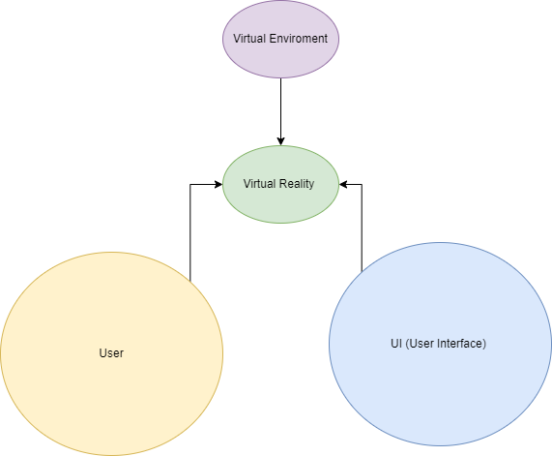
Figure 1 - VR Process
Using a process displayed within Matjaz’s ‘Virtual Reality Technology and Applications’ [7], The process would follow three factors that would combine into the ‘virtual experience’. The factors consist of the User), UI( User Interface and the Virtual Environment [7].
The User factor consists of:-
- Engagement
- Interaction Experience
- Immersion
The User interface will consist of:-
- The input
- The output
- Interactivity with Virtual environment
The Virtual Environment will consist of :-
- Simulated environment
- Working physics
- Potential shared user space
These factors will then lead to typical virtual reality experience. To deliver the experience there must be a virtual reality environment made with a compliment of interactivity, using differing tools such as Unity or Unreal Engine. There must be a UI to which a user may interact with the environment and there also must be a user to perceive and immersive themselves within the virtual environment [7].
Software is another vital part within VR. It is an element that makes it possible. Software concerning VR can be categorised into hardware interfaces, world creation software and applications [8]. The hardware interface are a sort of ‘libraries’ for certain software to make the process easier for computing power [8] [9], yet can also make the process of writing coding for applications easier for certain hardware. There is such a thing as open-source hardware interface software, which can be very important to developers of VR applications, as this can increase efficiency and speed of development [8]. Another important category of software are world creation applications, which can include the various game engines available to download [8].
After viewing the software, we must now look how a user may interact with the virtual environment.
Users in virtual reality can interact with the environment using various hand input devices [10]. Author ‘Jerald’ then separates the class which comprises of ‘World-grounded devices’, ‘tracked handheld controllers’, ‘non tracked handheld controllers’ to even ’hand worn devices’ and even the users bare hands [10]. An example of a world grounded devices is a keyboard as well as joysticks, and trackballs [10]. Examples of non-tracked handheld devices may include Xbox or PlayStation controls which offer gamepads and joysticks [10].
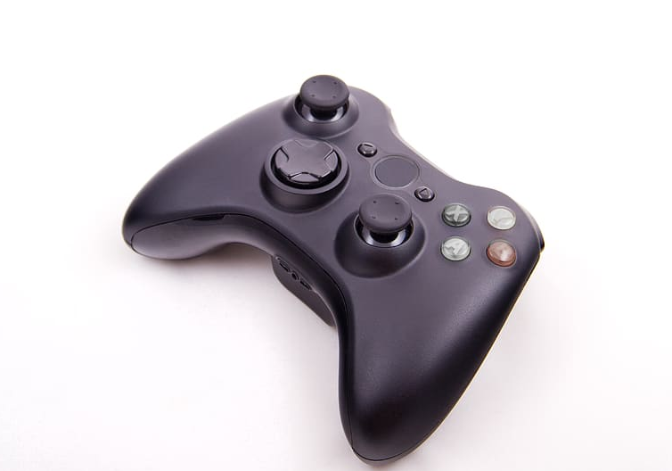
Figure 2 - Console controller
Yet an important device class for VR are the tracked handheld controllers, which can also be referred to as ‘wands’ in the literature [10]. They are important for VR applications as they can not only offer buttons and joysticks, but they also the ability to tracking. Tracking is a vital component of VR which affects not only the handheld devices but also the way a user can interact with VR environments.
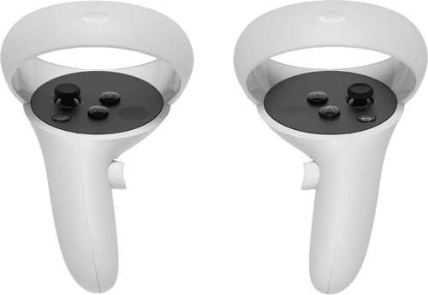
Figure 3 - Meta Quest 2 Touch controllers
Now we must ask what is ‘tracking’? Tracking is the method that is utilised by the sensors of the virtual reality head mounted display to track movement performed by the user [11]. Not only are the sensors used to track the users movements, but the buttons of the VR controller may also act as a tracking mechanism as well as the controller itself [11].
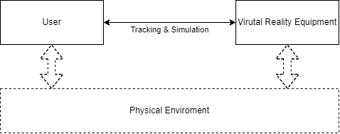
Figure 4 - VR Tracking Process
In figure 4, we can see the process of tracking on the user with virtual reality equipment [11]. This process seen is important for virtual reality systems to help figure out the positions and what orientation the user is to then give the user stimuli within the virtual environment [11].
With the aid of tracking, the user may further interact with the virtual environment they are in, in multiple ways [10] [12] [13]. The first being locomotion, which detail how the user travels within the virtual environment [12] [13]. The ways a user may travel in the environment by walking with the joystick, which can enable the user to not physically move in their physical environment, yet they may also choose to physically walk in their environment to interact with virtual environment [12] [13] .An additional method that can be used to move in a virtual environment is the teleportation function that can be done with the VR controls [12] [13]. In LaValle chapter on Interaction, the author states that in terms of locomotion within a virtual environment, these methods can give the user a sense of virtual reality sickness due to ‘vection’ [13]. The author describes that methods such as lowering viewpoints that are close to the ground, reduction in the contrast of the virtual environment and even giving the user tasks to perform may reduce sickness [12] [13].
Yet with tracking and software how do users see in VR? To see virtual environments there are 3 approaches, hand-held displays, world fixed displays and head mounted displays [13] [14] [15]. An example of hand held displays are mobile devices such phones or tablets, they are mostly used for augmented reality and less with virtual reality, yet the it is still possible for VR development [13] [14] [15]. An example of world fixed displays is a computer monitor which is also commonly used to display virtual reality environment. Head tracking can be implemented for world fixed displays, yet won’t have the same effect as head mounted displays as the stimuli generated will be lesser [13] [14] [15].
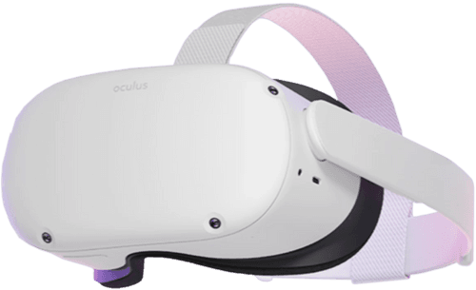
Figure 5 - Meta Quest 2 HMD
Finally, the device class that the project will be focussing on will be HMDs or Head mounted Displays [13] [14] [15]. A an example of a head mounted display could be the widely used Meta Quest 2, which enables tracking of positions and orientation, which will be essential for this project [13] [14] [15]. The display works by having 2 small lenses that act as the display to the virtual environment, which delivers a immersive experience [13] [14] [15].
Now to the subject focus of the project, virtual reality sickness. But what is virtual reality sickness? Virtual reality sickness, also referred to as motion sickness or cyber sickness, are the sickness symptoms felt through the sense of motion [16] [17] [18] [19]. The difference with Virtual Sickness is that the symptoms are brought with the sense of immersion and motion a user feels within a virtual environment [16] [17] [18] [19].
The symptoms that are found with VR sickness are usually:-
- Nausea
- Discomfort
- Headaches
- Disorientation
- Dizziness
- Vertigo
- Vomiting
Another interesting aspect to virtual reality sickness is that after use, sickness symptoms may last up to several hours and at worst case days [16] [17] [18] [19]. The general cause of these symptoms are not fully known as many different elements of virtual reality may contribute to the effects [16] [17] [18] [19]. One of the most notable theories is a ‘sensory overload’ such as sudden fast movements that may be unnatural to the human eye, as well as the field of view that one can see through a head mounted display [16] [17] [18] [19]. This is why research suggests decreasing or removing the amount of locomotion is a viable strategy to reduce VR sickness [16] [17] [18] [19].
Now how does one measure VR sickness? Research suggests that questionnaires or simulator sickness questionaries are a viable strategy to measure a user’s VR sickness symptoms, which implement scoring systems to measure the severity of the overall symptoms [16] [17] [18] [19].

Literature review
After conducting research of virtual reality, we must now look at what the literature has found on virtual sickness and cases for measuring said sickness, that can be related to my project.
An example of a case of study looking at virtual reality sickness measurements looked at HMDS and their related content [20]. They then measurement the sickness using SSQs to determine [20]. They also studied the effects with a different test user characteristic such as age, experience and gender [20]. Similarly, a study done in 2000 studied the effects of VR sickness through exposure duration to virtual environment [21]. They concluded that the longer the exposure a user has to VR, the more likely the user will get sickness symptoms [21]. They also concluded that the more a user is exposed to VR the more likely that the user will grow accustomed to the effects of the virtual environment [21]. They conducted this study with the use of a checklist SSQ which contained 26 symptoms.
In comparison, in 2005 a study was done to measure the effects of headaches and discomfort that are associated with the use of head mounted displays relating to symptoms related to the users eye and other symptoms not related to the eye [22]. The main method for observing this is again a questionnaire that is posed to a group of users, one before the immersion of a virtual environment and one after [22]. The results found within the study has concluded that the study of virtual sickness can be done before the immersion and use of head mounted displays, yet the symptoms of sickness can decrease fast [22]. The questions also most useful for the questionnaire are 13 questions, 8 symptoms not related to the eye and 5 related to the eye [22].
More recently, a study done in 2022 was conducted to review cybersickness related to head mounted displays relating to individual users [23]. The study delves into the many factors of VR including the elements of VR such as hardware and software while also considering the human factors such as history with cyber sickness, as well as demographics such as age [23]. One element that makes this study like my aims and objectives is that it also takes into account the navigation methods that are taken within the virtual environment, which include walking, teleporting and even steering [23].
A similarity to my project is that they also found recommended mitigation strategies to significantly reduce the cybersickness symptoms through the reduction of the field of view in the simulation, as well as the combination of blurring techniques and elimination of visual cues such as teleportation and snap turns [23]. An interest point is that the studies research had found was that there was no impact from cybersickness in hardware devices such as the ‘Oculus Rift DK2’ compared to ‘Oculus Rift DK1’ and authors assumed that the changes within content of the virtual environment bring more changes than the factors of the hardware [23] [24]. Other interesting finds within research is also the limitation of latency and the delay between the action taken of a user compared to when its acted upon in the virtual environment.
In other research, one study investigates the clinical predictors of cybersickness within VR with relations to users with hight stress [25]. They looked at two groups and tested them with the use of VR video as opposed to a VR environment. They tested the videos with different levels of shaking and used a SSQ and FMS(Fast Motion sickness Scale) [25]. The two groups were made depending on age range, such as one group was ages 19-39 whereas the next group was aged 40-59 [25].
To further explore the exposure time to VR and the potential symptoms that is brought with it, studies done to research the temporal effects of VR sickness was made in 2018 [26]. The study used the popular SSQ questionnaire to gain measurements. One finding the study had gained was that after a certain point in exposure to VR, although sickness symptoms can increase due to exposure time, there will be a certain threshold for when sickness symptoms begin to stop increasing in severity or even decrease [26]. Devices used within the study are once again the popular HMD devices which were the HTC Vive and Oculus Rift [26]. The study predicts that the popularity of standalone headsets might increase in the future, which could be proven correct considering these models are no longer in production and are replaced with devices such as the ‘Meta Quest 2’ [26]. The research conducted into the theories of cybersickness, the theories they have retrieved are the common ‘Sensory Conflict Theory’, which involves when motion sickness symptoms arise from a conflict of two senses such as visual and audio [26] [27]. Alternate theories also include the ‘Postural Instability Theory’ which includes motion sickness not coming from a sensory conflict, but from the postural status of the user not feeling accustomed to the sense of height or swaying within the virtual environment [26] [28].
To refer to previous research author ‘LaValle’ studied possible theories causing VR sickness, while also looking at methods to measure symptoms and recommendations to VR developers that can lead to improve the overall user experience [29] [17]. Much like the theories researched by ‘Duzmanska’ [26], author ‘LaValle’ also states the possibility of the ‘Sensory Conflict theory’, yet also proposes alternate plausible theories such as ‘forced fusion and fatigue’ which involves of eye strain and fatigue developing due to the these having to put more effort in to work when viewing virtual environments [17].
Once again like other journal articles, a recent study done in 2022 looked at the patterns of VR sickness relating to long exposure times reaching 7.5 hours of immersion in the virtual environment [30]. Thee study tested users based on HMD devices such as HTC Vive and compared user sickness with LCD display devices [30]. The settings of the headset was set at a 1440x1600 resolution per eye display, with a field angle of 110 degrees [30]. The research method they conduct was testing with 22 participants aged 20-27 years old and ensured that the users had 7+ hours of sleep a week beforehand, while also ensuring that a written a consent form was given to users, fully explaining the details of testing [30]. The user testers would also be withdrawn from testing at any point [30]. The experiment was also conducted with the use of a pre-experiment questionnaire, while also providing g a SSQ post testing [30].
Further research done on the effects of display factors show a conference publication done in 2020, looked into the effects of a field of view restrictor on VR HMDS to see the effects of virtual sickness [31]. The user study was done by having users traverse a virtual environment using a field of view restrictor with eye tracking while also using one that was head fixed [31]. The study found there was no difference in the measurements of VR sickness when testing both these restrictors [31]. The devices used in the study was the HTC Vive Pro, with a refresh rate of 90 and a field of view of 110 degrees [31]. The game engine Unity was also used for the virtual environment [31].
One important aspect of this project are the locomotion aspects of VR, a survey in 2019 shows ‘real’ techniques that can be used for VR applications with HMDs used [32]. The survey delves into the techniques and categorises them into different travel methods [32]. These being ‘warnings’, ‘scaling’, ‘unmediated’, ‘redirection’, ‘resetting’ and ‘dynamic virtual environment’ [32].They are categorized like this to represent the action of the user and the feedback they would gain from the application [32]. The study also emphasises that the real locomotion of a VR application should be the physical movement of user, enabled with tracking, delivers an immersive experience to an application [32].
In comparison a more recent study in 2022 categorised the locomotion techniques in an alternative way, whereas they group the techniques based on room-scale, controller based, motion based and teleportation-based navigation [33]. Room-scaled movement involves the physical movement of the user and their actions to translate into the virtual environment. Controller based navigation involves the use of controllers such as a joystick, which can be chair based for the user to navigate in the virtual environment. Motion based, in comparison to room scale navigation, emphasises more on the ability to walk in place or use gestures within the VR environment to navigate. Finally teleportation based navigation entails the user using a joystick to point and instantly teleport in the environment.
A common recurring method to measure the effects of VR sickness symptom is the use of SSQ/MSQ or simulation/motion sickness questionaries [34]. This measurement became the standard among research to measure motion sickness related symptoms done through the research of author ‘ Kennedy’ in 1993 [34].
As much as Kennedy’s SSQ/MSQ is used throughout the literature, it is still not quite the standardised test method, as shown in 2018 journal article of Applied Ergonomics, author ‘Kim’ researched the possibilities of a VRSQ or a virtual reality sickness questionnaire [35]. The research combined a SSQ with elements of VR and developed it to test out user sickness with 24 users [35]. The researchers concluded that a significant find was that sizes of buttons and target selection were factors that contributed to motion sickness [35].
Further review of the research has found that some studies criticise the use of SSQ’s to measure the discomfort a user can find within VR head mounted displays [36]. The study states that a largely ignored are the symptoms of digital eye strain as well as the ergonomics [36].
Upon review of certain literature, one measurement that can be used for virtual reality environment us the UEQ or the user experience questionnaire [37]. It allows measurement for the overall experience for games. It can also be tailored towards a virtual environment through an integration with a system usability scale [38].
Upon further research of measurements, a VRLEQ can be an appropriate measurement of VR experience as well as the overall usability of the environment itself [38]. If used in conjunction with a SSQ, it could perhaps have potential to show significant correlations to user sickness [38]. Many instances within the literature also implement a use of a MSSQ or motion sickness susceptibility question, prior to testing [35] [39]. They also suggest that the MSSQ can aid with the measurement of virtual reality sickness and may correlate the use of a MSSQ and a SSQ.
To summarise many research articles have committed studies to the effects of motion sickness or VR sickness and the severity of their symptoms. In its widespread use, the MSQ or SSQ has been used in most of the research articles or at least recommended as a suitable measurement method when testing sickness symptoms. The various research, within their individual studies, have tested various parameters of VR and VR equipment, as well as various VR environment settings to determine sickness effects on users. The various studies have also proposed various mitigation strategies that can help decrease the effects a user may have from their exposure to a immersive virtual environment.

Chapter 3 - Research And/or Development Methodology
In this chapter, I will research and document the methodology I have chosen to conduct to complete the aims and objectives of this project.
Research Question
Research question: - Does VR navigation methods such as teleporting, jumping and walking in an immersive environment lead to motion sickness symptoms that vary in severity.
Method
The methodology being used in the project is an experimental hypothesis test using (one-tailed) hypothesis testing.
My experiment hypotheses are as follows:-
- What is the impact of virtual reality sickness on users
- Does having experience with virtual reality head mounted display affect the severity of sickness symptoms
- Are the locomotion methods chosen within the virtual reality environment (Teleportation, smooth joystick movement and jumping), affect the severity of VR sickness symptoms more so than others.
- Will there be a correlation between VRSQ score and a MSSQ scores
To test this, I will conduct testing on 6 users determining the status of the hypotheses. This will be done by giving the users a pretesting questionnaire determining their susceptibility to motion sickness(MSSQ). I will design and create a virtual environment that enables these locomotive methods to be used by the user. They will need to traverse the course using said locomotion methods and retrieve 2 objects. They then will need to return to the starting location of the test area, where the testing will finish.
Post testing, the user will be given a virtual reality sickness questionnaire, as well as a virtual reality experience questionnaire that implements system usability scale to measure the experience of the user concerning locomotion methods and the usability of the environment created. The purpose of this is to see if the environment serves its testing purposes and to see if there is a correlation to the users preferred locomotive method, in comparison to the VR sickness symptoms.
The justification for using these methods is because measurement methods shown throughout the research and literature as the MSQ, VRSQ and VRLEQ show the best potential in helping me meet project aims and objects [23] [35] [38] [39] [40] [41] [42] [43].

Chosen hardware and software
The vital piece of hardware used for this project will be the Meta Quest 2 with a 128GB of space, along with its touch controllers. Once vital piece if accessory is the link cable, which will allow the Quest 2 establish a connection to the desktop PC, which will be important, as it will allow the virtual environment to be packaged and installed onto the Quest 2 headset.
The chosen software to conduct the experiment is the game engine Unreal Engine 5. This was chosen as it allows me to create a virtual environment to which the locomotion methods can be tested. The engine version I will choose is 5.01, will using the default VR template. With this game engine I will need Oculus app as well as the secondary software application Side Quest, Visual studio 2019) and Java to allow me to create and package the virtual environment to the Quest 2 headset. The reasoning for Visual Studio 2019 is because the various tools and packages allows Unreal Engine to package for android devices, including the Meta Quest 2 headset.
To create and generate the virtual environment, I will need a suitable computer desktop with sufficient specification. My home computer will have the AMD Ryzen 5 2600 Six-Core Processor 3.40 GHz, 16 Gb RAM, GTX 1070Ti GPU, keyboard and mouse.
To perform any data analysis, software such a Excel will be used to generate diagrams and minimal statistical analysis.

Inputs
The inputs for the experiment will be the Meta Quest 2 headset as it allows for tracking. While the next inputs will be the Quest 2 touch controllers themselves. The reasoning for these inputs is because they will be necessary to track the user withing the virtual environment and then use the 3 movement methods that can be studied.

Experiment
Prior to the experiment, a MSSQ or Motion Sickness Susceptibility questionnaire will be given to the user. The reasoning behind this to potentially eliminate any unreliable correlations that are potentially between the movement types and the VR sickness symptoms. The reasoning behind this that found in research and the literature surrounding the subject, it has been found that an MSQ is a valid method for measuring the susceptibility a user can have for motion sickness, which will be usefully to se which user has a greater risk for motion sickness through the experiment [44] [45]. In my research I found that a suitable form available to download that may be used for testing is one from the BBC and from the University of Westminster [46] [47]. It was first developed by ‘J F Golding’ [48].
To study VR sickness symptoms, the user will be given a post-test questionnaire for VR experience/usability as well as a VR sickness symptom questionnaire. The reasoning for this is to study the experience the user had within the virtual environment, while also measuring the usability of the environment. The reasoning for the VR sickness symptom question is because it will measure any common symptoms a user gets when they are in a virtual reality environment. I will also be measuring the time the sickness symptoms last post testing. The reasoning for this is because I will need to measure if there are any correlations between the sickness symptom and reduced effect. The VR experience and usability form as well as the VRSQ form I have used is a altered questionnaires found within the literature [38] [49].

Target Group
The target group for the experiment are members of any gender and from age of 20+. Further the criteria for the target group will be users with or without virtual reality experience. The experiment will need to give a user environment that can be traversed through entirely through VR, while feeling immersed.

Questionnaires and calculations

MSSQ
Upon completion of the questionnaires, I will perform calculations to gain their measurements. This will apply to the MSSQ, VREQ and the VRSQ.
For the MSSQ I will need to perform the calculations for both sections of the questionnaire form. These sections are A(childhood) and B(Adult), which follow a 5-point scale. These are :-
- Never travelled - t
- Never felt sick - 0
- Rarely felt sick - 1
- Sometimes felt sick - 2
- Frequently felt sick - 3
To calculate the susceptibility scoring for the participant, they will answer a total of 9 transportation methods, which are :-
- Cars
- Buses or Coaches
- Trains
- Aircraft
- Small Boats
- Ships, e.g. Channel Ferries
- Swings in playgrounds
- Roundabouts in playgrounds
- Big Dippers, Funfair Rides
Calculations will work by adding up the number of raw total sickness scores from the MSA and MSB sections using the 5-point scores which are T,0,1,2,3. The add up the total t scores in both sections. Further calculations work by taking the raw total sickness score and dividing it by the number of t scores, which will then be added by the total amount of transportation methods experienced. Finally add both section scores together to get the MSSQ score [50].

VRLEQ
One of the questionnaires that will be given post-experiment will be a VRLEQ. The reasoning for this is to measure the experience and usability score towards the virtual environment. This will be done separately by giving the questionnaire based on the three movement methods walking, teleporting and jumping[38]. The questionnaire itself is structured with 26 questions, 1-16 being based on the game experience questionnaire [51], while question 17-26 based on the system usability scale questionnaire [52]. The questionnaires will be measured with a 5-point Likert scale of 0-4(0 =Not at all, 1=Slightly,2=Moderately ,3=Fairly,4= Extremely) for the game experience section and (0=Strongly disagree, 1=Disagree,2=Unsure,3=Agree,4= Strongly Agree) being used to define usability [38]. Being issued differently we will be able to see scores based on the movement method in question[38].
For the user experience the dimensions below will be assigned to 2 questions, which will allow me to gain a better understanding of user experience and usability of the virtual environment[38].
Table 1 - VRLEQ dimensions and statements
The justification for using a VRLEQ is that it is suitable measurement method that is found in the literature to measure both a UX and SUS. The only limitation is the limited amount of usage through said literature [38].
https://www.researchgate.net/publication/327098420_Systematic_Review_and_Validation_of_the_Game_Experience_Questionnaire_GEQ_-_Implications_for_Citation_and_Reporting_Practice

SSQ
Finally, the last questionnaire given to the user will be a VRSQ or a SSQ. This will measure the users sickness symptoms and then will be able to compare to other users sickness scores, VRLEQ scores and even for potential correlation with MSSQ scores [49] [50]. The questionnaire used was the one researchers ‘Bimberg’ and ‘Merchant’ uses to gain an understanding of sickness symptoms. I will calculate the questionnaire based on the weightings below used in ‘Bimberg’s’ research [49].
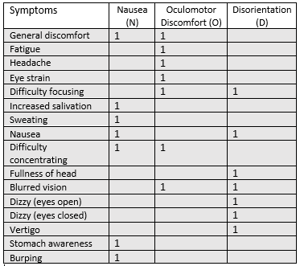
Table 2 - SSQ Symptoms and Weightings
The calculations will consider the weighted symptoms of Nausea (N)=9.54, Oculomotor Discomfort (O)=7.58 and Disorientation(D)=13.92.The total score of the SSQ will then be calculated by the total symptom score, then multiplied by their respective weighting. The reasoning for this as these dimensions are those frequently reported regarding sickness symptom types when interacting with virtual reality [38] [49] [50]. The reasoning is that many times that a ‘VRSQ’ is implemented in an experiment, it can be calculated without the Nausea(N) dimension, whereas the SSQ includes the Nausea(N) dimension.

Experiment validity
The validity of this experiment is that it implements various methodologies that can be found in various literature that implements various survey/experimental designs to measure the symptoms of virtual reality sickness and correlate it to other factors that can be changed, such field of views, specific individual susceptibility towards motion sickness. Most of research discussed that implements these experiment methodologies follow similar parameters and inputs of experimenting with VR head mounted displays, as well as the locomotion methods that can be implemented into a virtual reality environment [23] [35] [38] [39] [40] [41] [42] [43].
Further validity of this experiment is that various literature experiment with the VR sickness symptoms relating to specific movement methods such as sudden fast movements through actions such as driving, running, sprinting, teleportation, joystick moving, etc. These pieces of research literature also implement strategies of using various game engines such as Unity or Unreal engine to create the environment. Some research journals will also apply a MMSQ pre testing, with a SSQ post testing to gain their desired measurements, with calculations to follow to gain an understanding with potential correlations [44] [45] [46] [47] [48] [49] [50] [53] [54] [55] [56] [57].

Experiment reliability
The reliability of the experiment will be dependent on the usability and implementation of the desired locomotion methods and design of the virtual environment. Reliability will also depend heavily on the number of participants that can test the virtual environment and locomotion methods. Another dependant would be the validity and accuracy of the calculations and scores with the implementation of the MSSQ, VRLEQ and VRSQ.

Chapter 4 Design and Implementation
In this chapter I will be discussing the design of the experiment and then the implementation of the experiment.

Design

Virtual environment design
Using draw.io, I created a mapping to the process that the participant will follow by in the virtual environment. It will start out by the user opening the environment, viewing the instructions of testing as well as the viewing controls to the Meta Quest 2 touch controllers. The user should then begin the task by traversing the environment to retrieve one or two objects. They will be doing this by using the objective methods Teleportation, walking and jumping. Once retrieved, the user will traverse the environment back to the starting area, where testing will be ended.
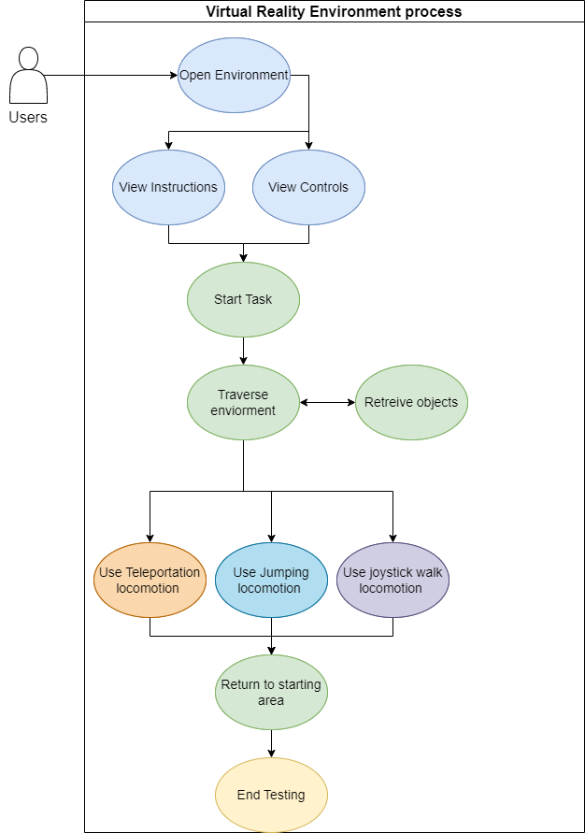
Figure 6 - VR Environment Use case diagram
This process can be seen in figure 6.
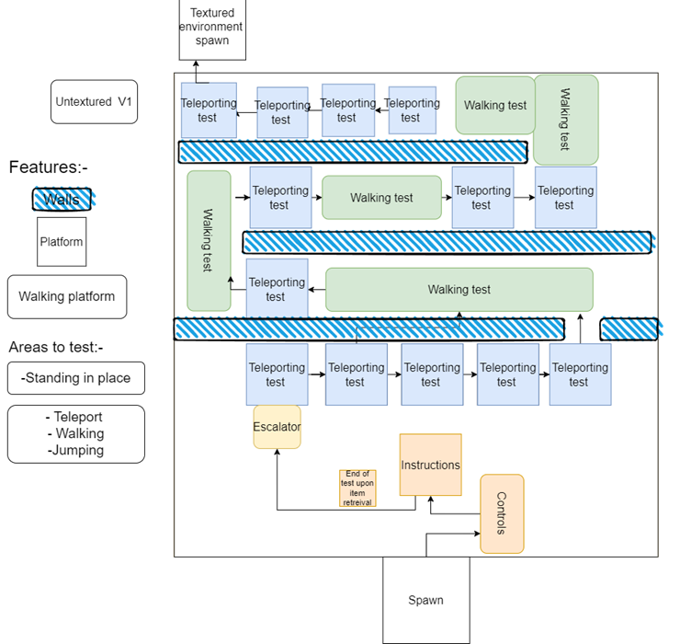
Figure 7 - VR Environment untextured plan
Shown in figure 7, we can see the planned environment. It will start with a untextured environment that will lead into different section with a textured environment. The areas will be designed with platforms that vary in sizes. The reasoning behind this is to allow the participant to use the different movement methods accordingly. There will be prompts to the user to what section is the best to use a certain movement method. The best positions that the user will be in is a standing position. This is there is some feeling to a sickness symptom effect, while also following health and safety by the user does not have to physically move to navigate the virtual environment.
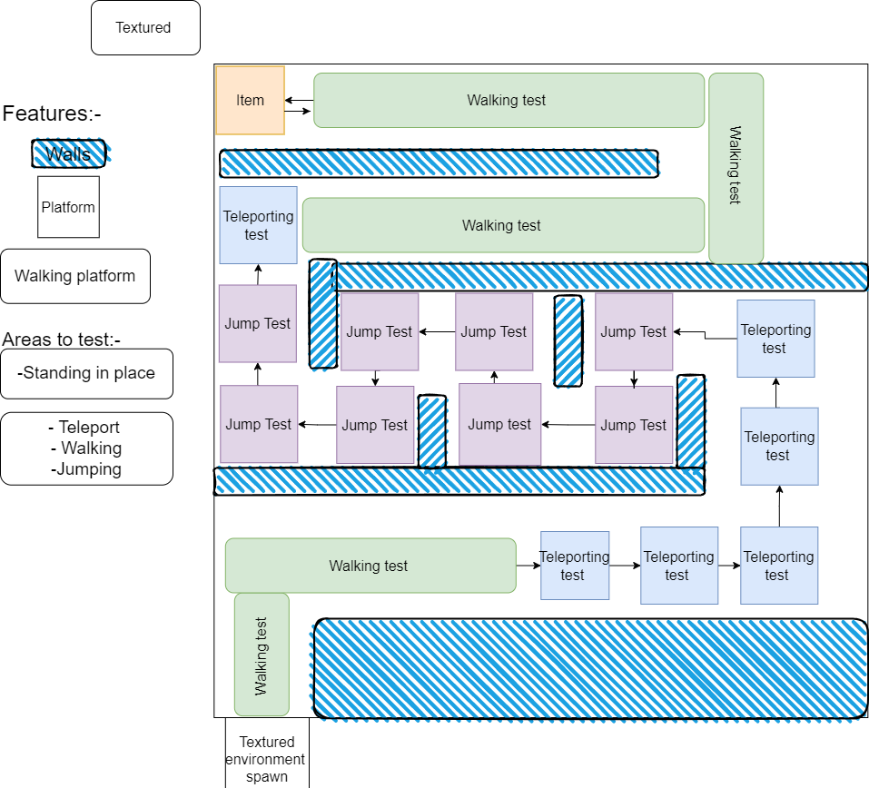
Figure 8 -VR Environment textured plan
Shown in figure 8, we can see the design of the textured environment. The layout is necessary to implement the desired movement methods to study. The areas if testing will again be standing in place for the user with various platforms for the user to traverse. Once the user retrieves the objects, they will then traverse back to the spawn/ starting location, where the test will end and the VRLEQ and SSQ will be given to the user.
To then conclude the experiment, results of the questionnaire will be provided diagrammatically. Results may then be evaluated on further with descriptive statistics to find any correlations.

Implementation
To now implement the experiment, The process of creating the virtual environment will begin in Unreal Engine 5.01.

VR Environment
Using the standard VR Template within Unreal Engine 5, I redesigned the starting VR template environment to look like that of my designed experiment designs.
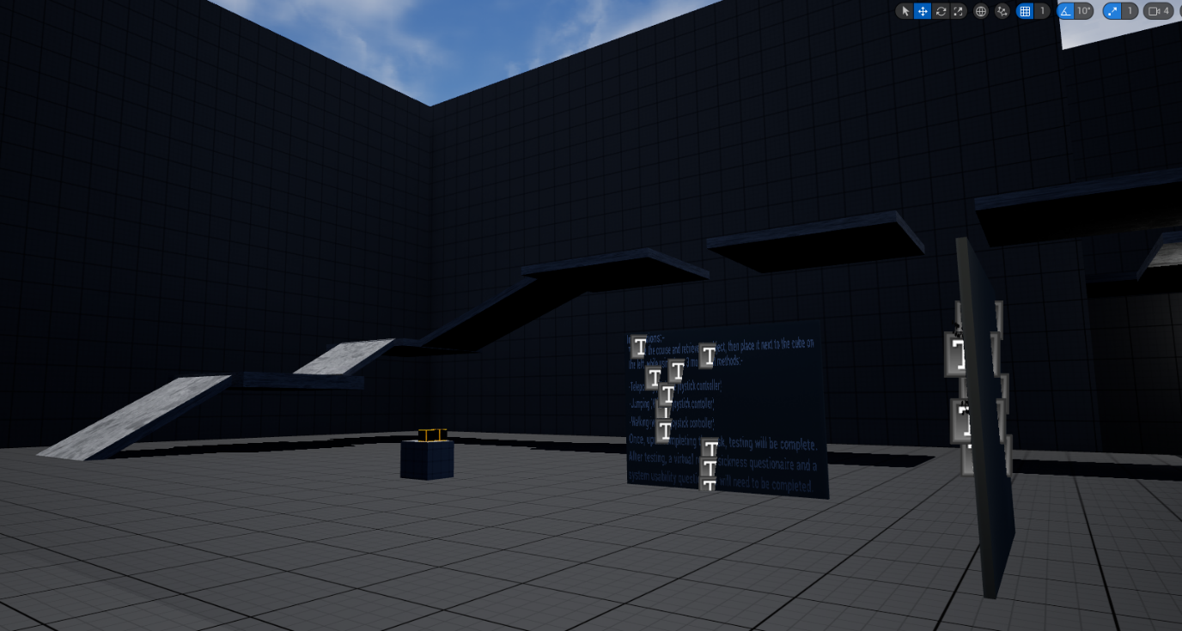
Figure 9 - VR Environment untextured starting area
In figure 9, we can see the starting location of the virtual environment. The user will see the instruction and controls and then proceed to perform the task.
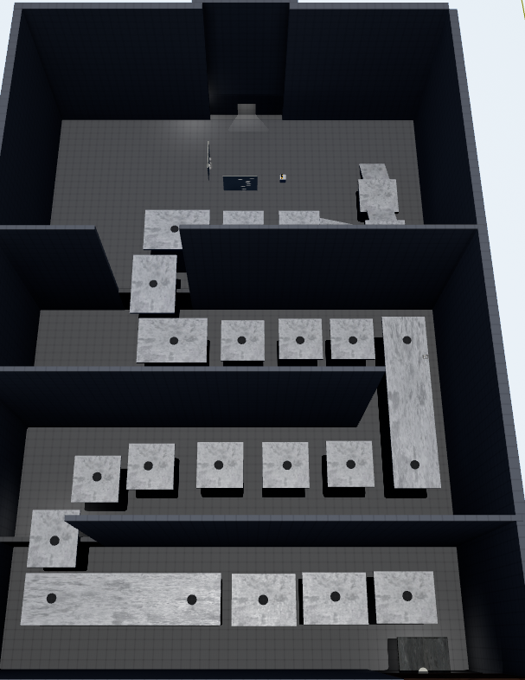
Figure 10 - VR Environment platforms
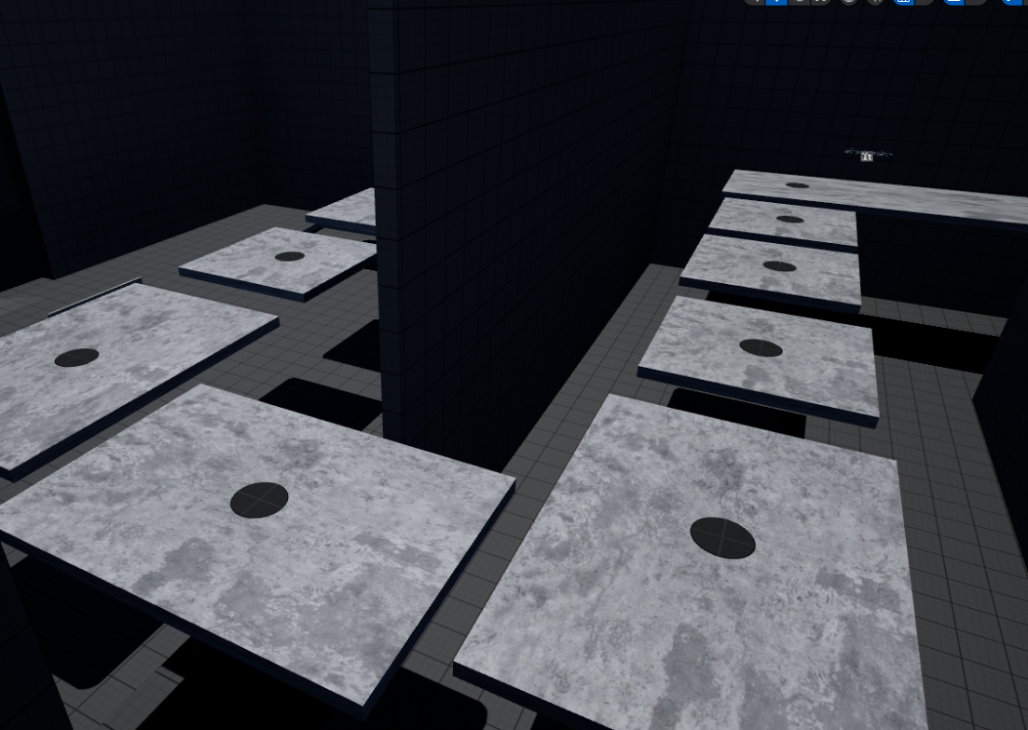
Figure 11 - VR Environment platforms
As seen in figures 11, we can see that the user will be able to traverse the environment using the platforms and retrieve the objects.
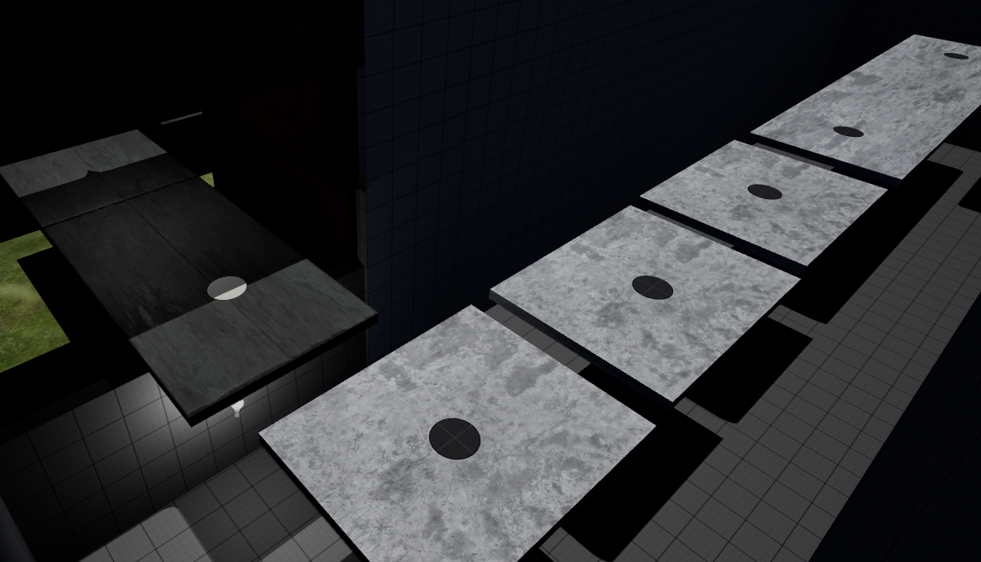
Figure 12 - - VR Environment Platforms to textured area
The user will then traverse into the second area that is textured as seen in figures 12.
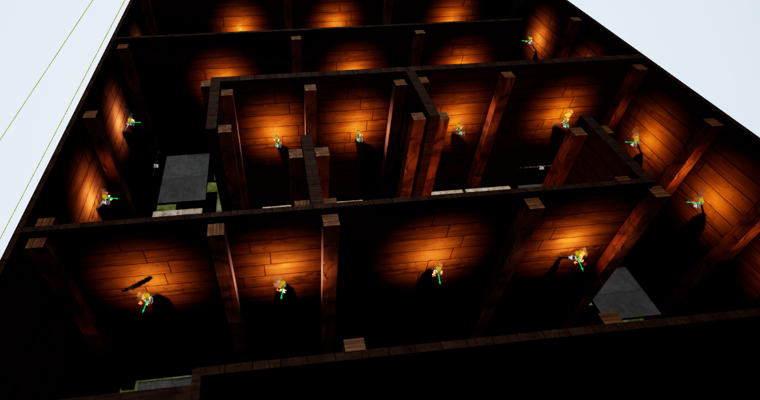
Figure 13 - VR Environment Textured area
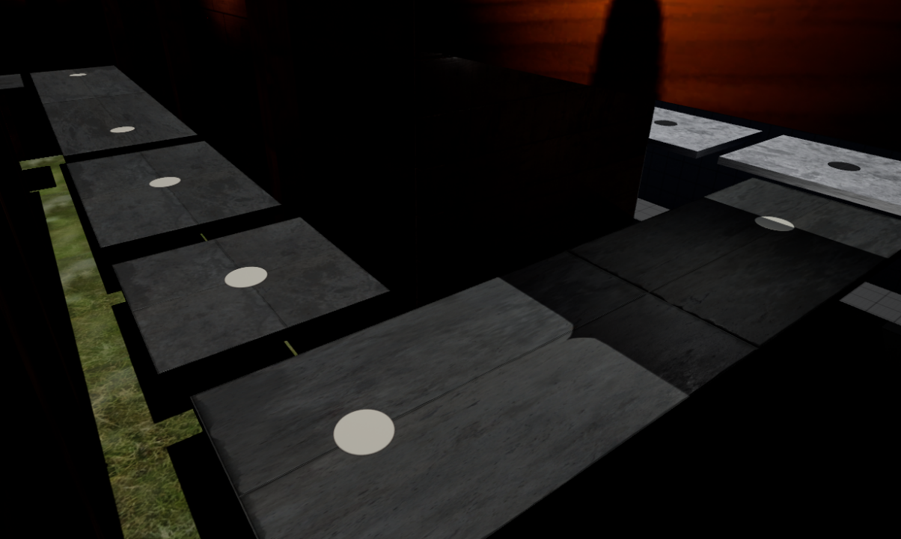
Figure 14 - VR Environment platforms to jumping area
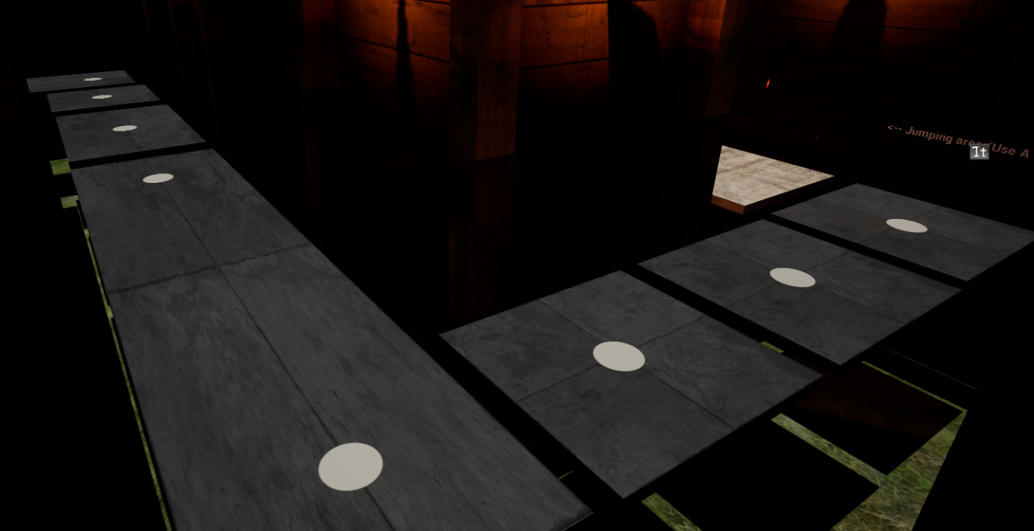
Figure 15 - - VR Environment platforms to jumping area

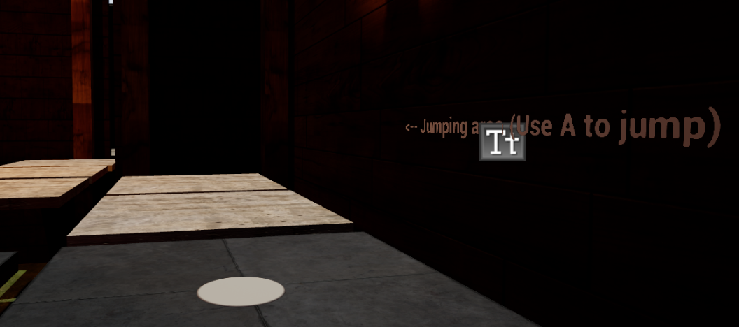
Figure 16 - VR Environment Jumping area prompt
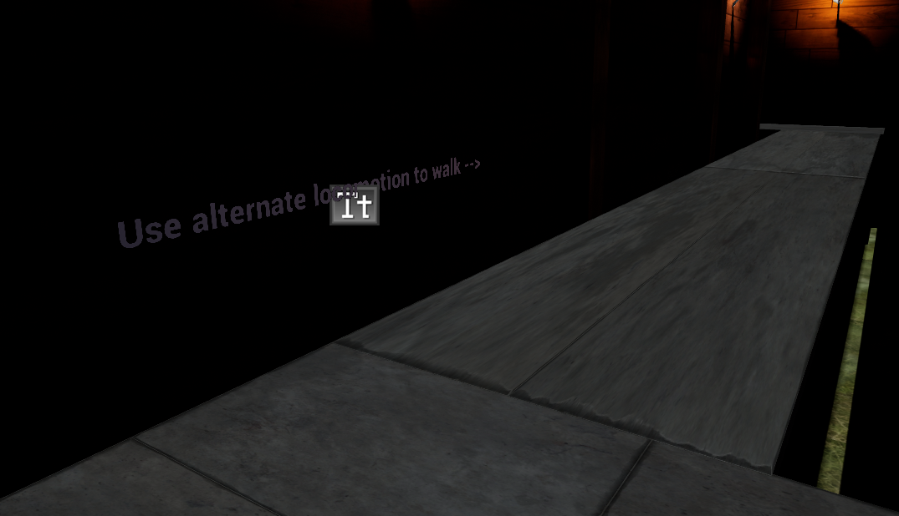
Figure 17 - VR Environment Alternate locomotion reminder
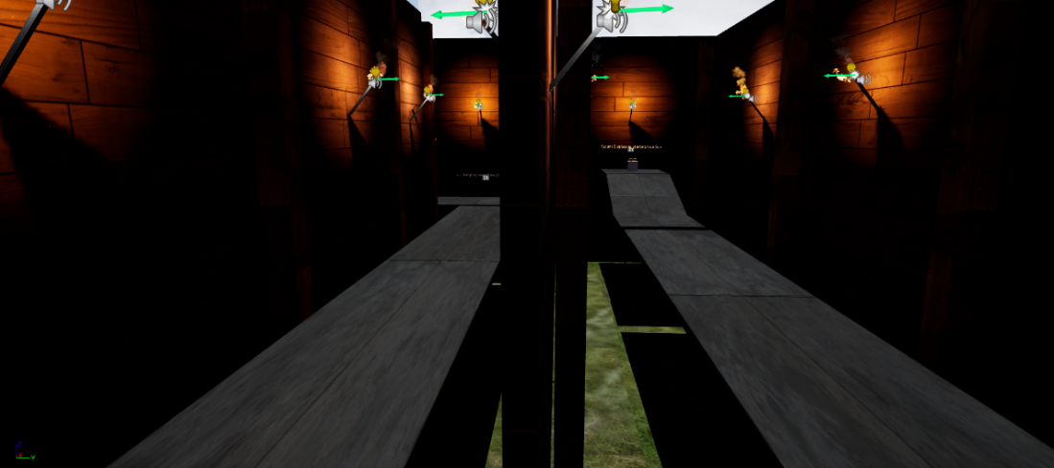
Figure 18 - VR Environment Alternate platforms to objects
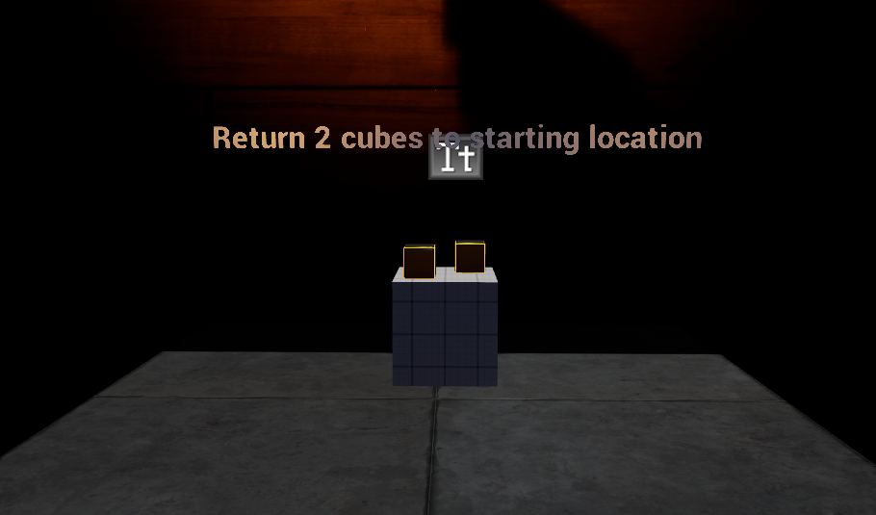
Figure 19 - - VR Environment prompt to user
Shown in figures 19, the user can use the movement methods to reach the objects and then return to the starting area, where the testing will end and they will answer the post experiment questionnaires.

Blueprint codes
To implement the movement methods, I researched methods to implement all 3 required locomotion methods to begin the testing through the use of YouTube videos [58] [59] [60]. The videos provided a step-by-step process of editing the default player pawn and inserting new blueprints to enable the desired movement methods to come into effect.
Through trial and error, I encountered difficulty trying to get the 3 movement methods to work on a single pawn class. The pawn class is what the user would ‘possess’ when using the application and use the movement methods that it had bee set up with. To remedy this, I followed one of the videos encountered to implement a ‘Smooth Locomotion’ system [59].
This would enable a user to switch from a default movement method the player pawn is set to, which uses teleporting for movement, to a alternate locomotion mode, which enables walking. The player pawn class would also have a blueprint that can enable jumping in both modes. The justification for using these methods is due to time constraints, it was the only way that the environment can meet the requirements, while leaving time for participant testing the environment [59].

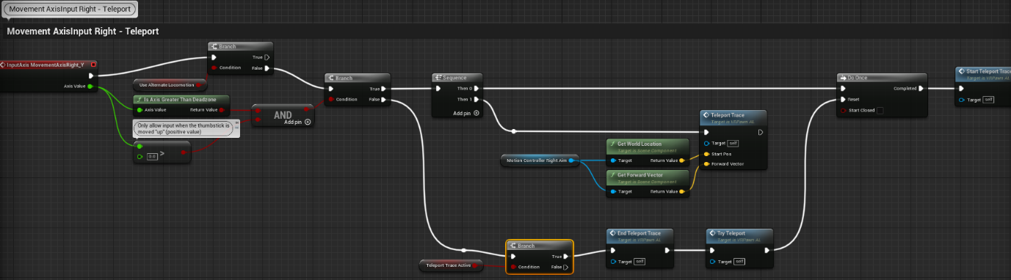
Figure 20 - VR Environment Teleport method blueprint
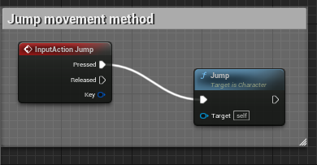
Figure 21 - VR Environment Jumping method blueprint
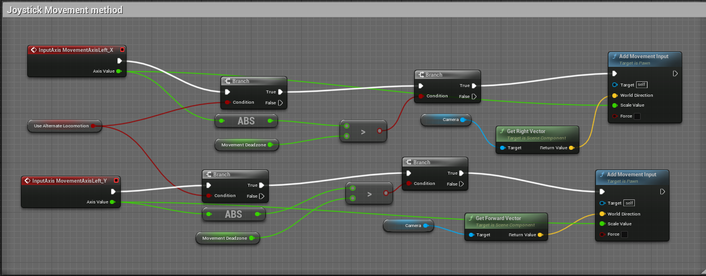
Figure 22 - VR Environment Joystick movement blueprint

Shown in figures 22, we can see the blueprint classes that allow for the locomotive requirements to be met within the virtual environment [59].

Necessary Interface
To implement this alternate locomotive mode, the process required an interface be made so the user may check/uncheck a box in the menu interface that a user be access through the menu button on their Meta Quest 2 touch controllers [59].
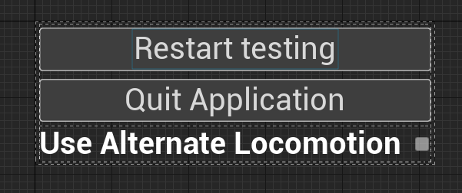
Figure 23 - - VR Environment Interface widget
As shown in figure 23, the menu interface offers a chance for the participants to alternate between locomotion modes to access different movement methods in the environment. The menu also offers the default options that allow the participant to exit the environment and restart it [59].
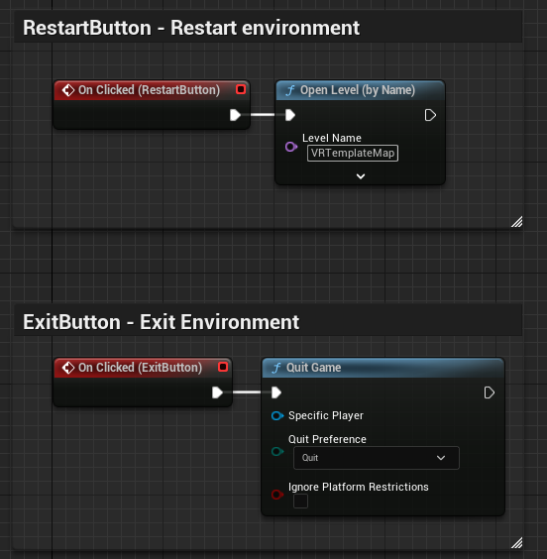
Figure 24 - VR Environment interface buttons blueprint
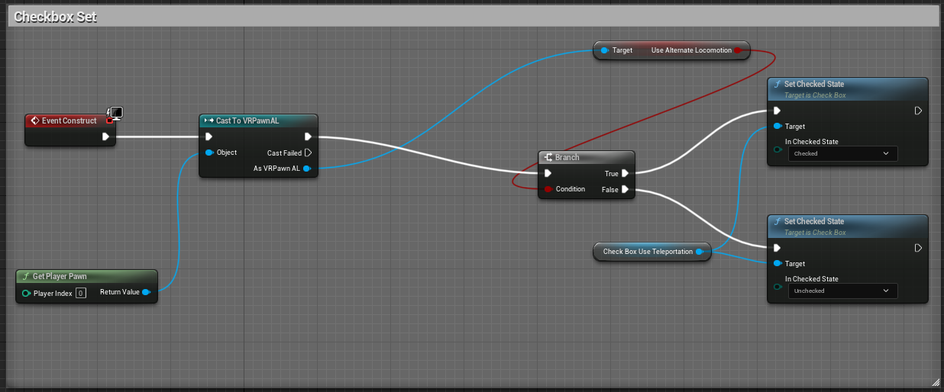
Figure 25 - VR Environment interface alternate locomotion blueprint
Shown in figure 24 and 25, the blueprint architectures that allow the options in the interface to function [59].

Experiment Results
With the virtual environment developed, we can now pursue participant testing in the experiment.
In this experiment is the investigation of VR sickness, motion sickness susceptibility and the usability of the environment. Prior to these testing the participant was given a consent form, to which they may withdraw from the study at any time. The consent form briefed the participants on the aims and objectives of the project as well as the risks that can come with the experiment.
6 users were recruited as participants, with all 6 users completing the experiment. The users completed the experiment in varying time lengths which averaged to around 9 minutes total. After said experiment, the users were immediately given the post-experiment questionnaire, which consisted of the VRLEQ, which combine the elements of a GEQ and a SUS questionnaire, after which a SSQ was implemented to measure the virtual reality sickness symptom score that can retrieve scores from each individual user.

MSSQ
To first gain a measurement of a participant’s susceptibility to motion sickness, I implemented a questionnaire using the short version of the MSSQ [50]. The were measurement is calculated through 9 transportation types divided into 2 sections. The questionnaire is also measured on a 4-point Likert scale from 0-3. The 2 sections which would be MSA and MSB.MSA being the participants early childhood and MSB being the last 10 years. Following ‘Merchant’s’ calculations [50], I would take the score of each section and divided it by the number of transportation types that were not experienced by the user. Then I would add both MSA and MSB together to get the MSSQ score. The maximum scoring for the MSSQ is 54, which suggests that the user would be highly susceptible to motion sickness, as well as VR sickness.

Figure 26 - MSSQ score by users
Here in figure 26, we can see a diagrammatical output of the users MSSQ scores, showing their individual scores. Looking at their scores we can see that 3 out of 6 users are likely susceptible to motion sickness, which can predict the likelihood of participants feeling VR sickness symptoms. After we gain the SSQ user scores, we then may use figure to compare to the output of the SSQ to see if there are any correlations.

Post Experiment questionnaire
To first begin the questionnaire was introduced with section 1, being a user background. The questions being :-
- What is your age
- What is your gender
- Have you had any VR experience
User | Question 1 | Question 2 | Question 3
User 1 | 23 | Male | Yes
User 2 | 24 | Male | No
User 3 | 59 | Male | No
User 4 | 27 | Female | Yes
User 5 | 26 | Female | No
User 6 | 61 | Female | No
Table 3 - VRSQ (questions 1-3)
As we can see in table 3, users 1-6 answers differ slightly. The age range of the users range from 23 to 61, with 2 groups being male and female. 2 out 6 users have experience with virtual reality, them being users 1 and 4.

VRLEQ
Upon section one’s completion, the user will proceed to section 2 which comprises of the VRLEQ. The VRLEQ consists of statements based on the Game Experience Questionnaire. The scoring of the questionnaire is based around the user experience of the virtual environment. It consists of 16 statements that have sub dimensions that measure experience. These being Immersion, Competence ,Negative affect, Flow ,Tension, Positive affect, Challenge and Tiredness. These dimensions will measure the varying experiences within the virtual environment. They are measured on a 5-point Likert scale, 0 being ‘Not at all’, 1 being ‘Slightly’,2 being ‘Moderately’ ,3 ‘Fairly’ and 4 being ‘Extremely’.

Figure 27 - GEQ Score by dimension
As seen in figure 27, the users GEQ score was gathered repeatedly, according to the movement method per user. Seen in figure 27 is the average of all GEQ scores under the sub dimensions, with a standard error bar.

Figure 28 -GEQ Score by user
In figure 28, we can see the total GEQ score by individual users. The scores were calculated by adding up all individual dimension score across the 3 movement methods and then divided by the number of dimensions and movement methods. The results were then rounded up to the nearest 1, which is now provided in figure 28.
Questions 17-26 follow the same principle as a system usability scale. The questions are also placed on a 5-point Likert scale of 0-4. With the scale being 0 as ‘Strongly disagree’, 1 as’Disagree’,2 as’Unsure’,3 as ’Agree’ and 4 being ‘Strongly Agree’.
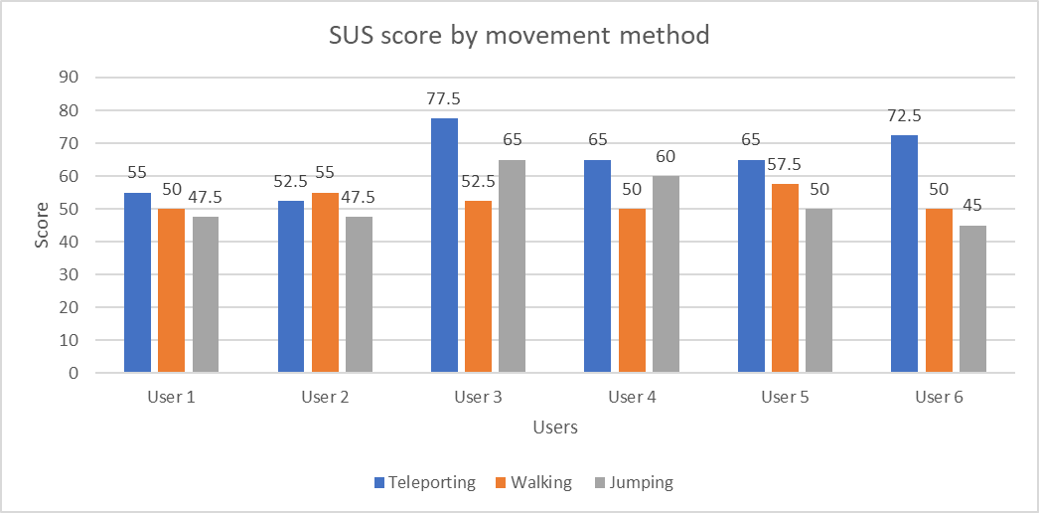
Figure 29 - SUS score by movement methods

The scores retrieved were rated depending on the movement method. As seen in figure 29, users have responded varying to the usability of the movement methods. With users such as 1 rating the usability of the movement methods.

Figure 30 - System Usability Scale score by user
Shown in figure 30 is the average of the 3 movement method scores by users. To retrieve the scores for the system usability scale, the question ratings are turned into scoring [61] [62]. With questions 1,3,5,7 and 9 being counted as 1 being reduced from whatever the user scored [61] [62]. Whereas the even numbered questions like 2,4,6,8 and 10 being whatever the number to be deducted from 5 [61] [62].

SSQ
After the VRLEQ section, the participant will answer the SSQ. This will give me the data to establish if the movement methods in question can affect users giving them sickness symptoms. The questionnaire consists of 16 symptoms that are measure on a 4-point Likert scale.
The following questionnaire, unlike the VRLEQ was only answered once per participant.
Table 4 - SSQ Form
The user would then answer the following based on the symptoms they had felt within the virtual environment. The way the SSQ is calculated is by the weighting of the subscales, as well as with a total score. The subscales were calculated according to their weighting as seen in table 2 . The calculations were done through following the calculations of ‘Merchant’s’ and ‘Shiur’s’ [50] [63].

Figure 31 - SSQ by dimension score
As seen in figure 31, we can see the user’s SSQ score by dimension. We can then see that the hights scoring dimension is disorientation among the users, with the second highest scoring dimension being oculomotor discomfort. This shows that the user has felt more disorientation and eye related symptoms such as vertigo and eye strain, compared to the feeling of nausea.
To put the severity by dimensions into perspective, we can perform the calculation of the maximum number on the Likert scale being 3. We then can find the “maximum” number for the dimensions, which assumes a cap to the severity a user can feel in the dimensions. The maximum number to Nausea(N) being 200.34, Ocular Discomfort(O) being 159.18 and Disorientation(D) being 292.32. This shows that the closer the user is to these scores by a subscale, the more severe they felt the subscale related symptoms [63].

Figure 32 - SSQ total score by user
As seen in figure 32, we can now see the total scoring of the users SSQ. This would be separate from the subscales, yet still calculated with a weight factor from the symptoms. As seen in the figure, the highest scoring is users 2,5 and 3. To get a perspective on the scoring and the severity the maximum number of the Likert scale is 3, which applies to all symptoms. Perform calculations in the same manner we did with the total scores we can figure out what the “maximum” number of total scores, which is 235.62. This then would assume that the closer the user score is to that “maximum” the more severe the users felt sickness symptoms [63].
After then performing the SSQ, the user will be greeted with miscellaneous questions that establishes the validity of the questionnaire as well as any other unlisted symptoms they have felt and the time scale the user had felt the symptoms, post experiment.
The questions listed are:- 5-10
- Have you felt symptoms that have not been listed above:-
- How long did you feel the effects listed above last for after testing?
- Did you feel the longer you were in the virtual environment, the more severe the symptoms got?
- Out of the 3 movement methods (Teleportation, Smooth walking and jumping), which was the most sickness inducing.
- Did the snap turn function with the virtual environment affect sickness symptoms felt throughout the experiment.?
- Did you answer these questions seriously and truthfully?
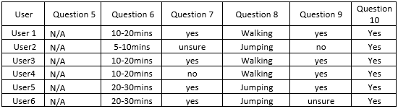
Table 5 - Questionnaire Miscellaneous questions
Seen in table 5, we see the users responses to questions 5 to 10. None of the users felt any symptoms that were not listed within the questionnaire and all estimates that sickness symptoms lasted around 25 minutes after testing. On the 7th question 4 out 6 participants also felt that the longer they had been the virtual environment the more severe the sickness symptoms got, with only 1 out of the 6 participants feeling unsure. In the 8th question, the participants were on a 50/50 split on what they thought was the most sickness inducing method. With participants 1,3 and 4 believing that the walking method felt more sickness inducing, while participants 2,5,6 believing the jumping was the most sickness inducing method.
Question 9 and 10 were delivered to gather some data to see the validity of the experiment. With question 9 mentioning the possible effect of the snap turning motion, participants, 1,13,4 and 5 felt that the motion influenced the sickness symptoms felt in the experiment, with participant 2 responding with no and participant 6 being unsure.
Finally question 10, asked if the participants answered the questionnaires seriously and truthfully. All participants responded with yes.

Statistical analysis
Statistical analysis was also performed on the questionnaire scores gathered.
Table 6 - MSSQ Statistical analysis
Shown in table 5, we can see the mean, median and the standard deviation of all the MSSQ scores.
Table 7 - VRLEQ Statistical analysis
In table 7, we can see the statistical analysis of VRLEQ scores, which consisted of the GEQ and the SUS questionnaires. We can see the mean, median and standard deviation of both scores.
Table 8 - SSQ Statistical analysis
Taking the results of SSQ, we could also then perform the statistical analysis of the SSQ scores, based on the subscales as well as the total scores. Shown in table 8, we could see the mean, median and standard deviation of the scores.

Correlations
From what I could gather from the data, there might be small possible correlations between MSSQ scores and SSQ scores, as well as SUS scores and the questionnaires responses.

Figure 33 - Scatter graph of MSSQ and SSQ
Shown in figure 33, we can see a scatter graph of SSQ scores with comparison to MSSQ scores. With in the figure, we could see that the lower the MSSQ score the lower the SSQ score, whereas the participants with higher MSSQ score have higher SSQ scores. This could be clearer we compare figures 26 and 32.

Figure 34 – SUS score by movement method
Table 9 - Questions 5-10 from the post-experiment questionnaire
Shown in figure 34 are the system usability scale score. When compared to responses from the questionnaire, we can see that the users saw that the lease usable movement method differs between the walking and jumping locomotion method. Whereas the participants deem the teleporting method to be more usable. In comparison to the responses in the questionnaire, we can see that the most sickness inducing locomotion methods are walking and jumping, which could suggest a possible correlation between a) the usability of the locomotion and participant sickness or b) the users experience with the movement method in question relating to the movement method.

Experiment Conclusion
In conclusion, the responses from the experiment are somewhat expected from studying the research. Yet sickness effects related to nausea that scored as high as they did per user was not expected. The reasoning for this is that the literature suggests that nausea related symptoms were not to common when users delved into immersive virtual environments and suffer from VR sickness.
With multiple participants involved, I would say that they both support and differ from each other. With users scoring low on them MSSQ, then scoring a lower SSQ. In comparison, we have users that scored high on the MSSQ while then scoring high on the SSQ. Once again, the participants support and differ from each other with a 50/50 spilt on what movement type is the most sickness inducing.
Through a research and literature review, research suggested that there would be a definite response from virtual reality locomotion methods in correlation to the effect virtual sickness [23] [35] [38] [39] [40] Research also suggested that the methodologies such as MSSQ and SSQ are viable methods that can measure a participants susceptibility to motion sickness and the symptoms effects suffered through the use of a simulated environment their symptom severity [41] [42] [43] [44] [45] [46] [47] [48] [49] [50].

Chapter 5 – Evaluation
In this chapter I discuss and evaluate the data that has been gathered in the implementation phase of the experiment. I also analyse if the data is sufficient and if it relates to the literature review. It will also involve if the data gathered has made me meet my aims and objectives, yet what could be improved upon if the experiment was repeated.

Data Conclusions
Based on the data collected, I can conclude that my data suggests that there is a link between VR environments, their movement methods and their correlation to VR sickness. Another conclusion that I can draw from the data is the possible correlations that there is between MSSQ and SSQ scores. One possible correlation that can be made it is the correlation between SUS scores (within the VRLEQ) between participant responses to what they think is the most sickness inducing movement method.

Further conclusions that can be drawn from the data gathered is that users that have experience with VR also gain higher SSQ score than I had thought. This can be seen in figure 32 with user 1 having a score of 59. This does also suggest that users with VR experience can have ‘accumulated’ to the virtual environment and the locomotion methods that a user can experience. This can be shown in figure 32 where user 4 has a SSQ score of 43.92. This does not mean that they do in fact, accumulate to the sickness symptoms nor do the users that have no VR experience generate higher SSQ scores [30].

Link to literature
It has been shown in research that there is distinct evidence that a MSSQ and SSQ questionnaire, are viable tools to measure the effects of susceptibility and VR sickness symptoms [23]. Research also suggests that there are different factors that can be considered when measuring sickness symptoms, which is age [23]. Taking the literature into account [25] there might be some link between age for example one study did 2 large groups that varied in age, which resulted in different sickness responses [25].
My data also backs up the literature by detailing the type of sickness symptoms that are felt in a virtual reality environment and the degree of severity [17]. Author ‘LaValle’ also stated that a user’s susceptibility for motion sickness should be considered with the design of the experiment. My data also links back to the literature and agrees that movement methods and locomotion types that include fast motion can greatly affect a user through virtual reality sickness, when using a head mounted display [32]. Other links back to literature is the possible correlation between the users exposure time and the severity of their sickness symptoms, as some research suggest that long exposure time led to more severe VR sickness symptoms [30].
Overall, the methodologies in this experiment link back and agree to the literature review, with results produced off the methodologies of authors that have performed similar experiments measuring VR sickness in relation to a virtual environment.

Aims and objectives
In relation to my aims and objectives, I believe I have met them, as through this experiment, I have gathered data that suggests that there is an impact on virtual reality sickness on users. The data gathered has also met my aim of measuring the possible virtual reality sickness effects from 3 desired movement methods within the virtual reality environment. Data that has been gathered also suggests that one movement method is more severe for VR sickness compared to another movement method. I have also gathered data that suggests possible correlations between MSSQ and SSQ scores as well as potential correlations between system usability scale scores by movement method and what movement method the participants seem to think is the most sickness inducing.

Recommendations
If I were to do this experiment again, I would first refine the virtual environment and take all environment attributes into account such as snap turning. I could even remove the function entirely as some literature suggests [25] [23]. I would also refine the questionnaire and responses to take more details about the time it took to complete the virtual environment experiment as this could be used to compare to how a user felt the sickness symptoms post testing [30].
A vital aspect that would be improved upon, if the experiment was repeated, is to gain more participants for testing the virtual environment. Including more movement methods in a more complex virtual environment could also lead to more data that can define the possible correlations that have been measured in this experiment.

Chapter 6 - Conclusions and Recommendations

Conclusion
In conclusion the research question as well as my aims and objectives have been met. Through research and a literature review, I was able to gain an understanding on the methodologies that could be used to measure VR sickness relating to locomotion effects. The research and literature encountered is also valid and reliable in discussing the many attributes about VR, as well as the movement methods that can be encountered within the virtual environment. The research within this report has also discussed the various devices that is included with VR as well as the process if how VR works.
Methodologies encountered were both valid and reliable, a portion of the methodologies are close to being the standard in literature, yet still leave room for debate. One methodology used within the experiment is a up to date questionnaire form from recent literature that measures data relating to the users experience with the virtual environment itself and the usability of the movement methods in question.
In the design and implementation phase, a virtual environment was made configured to a suitable head mounted display, which a participant could be given to test. In the pre-testing the participant was given an ethical consent form discussing the aims and objectives of the project, while also offering necessary options to withdraw from testing. While testing, the participant was in a safe and secure environment that was suitable for a virtual reality experience. After testing the environment and movement methods, participants were given a suitable questionnaire form that included various measurement methods that have been found in the literature to measure a user’s background, their experience with virtual reality experience data concerning their experience with the experiment experience, the usability of the movement methods and virtual reality sickness symptoms they had felt.
To summarise the data, I have made them presentable diagrammatically, as well as performing minimal statistical analysis. The data was then evaluated in relation to my aims and objectives, as well as in relation to the research and literature review.

Recommendation
In recommendation of the project, there are many areas that could be improved upon to deliver more precise results concerning virtual reality sickness relating to VR movement methods. One way to do this is first verify the reliability of the VRLEQ form, which could be refines and used more in the literature to establish its validity. Further recommendations include refinement of the virtual environment more, making the movement methods more usable, perhaps even adding more movement methods to gain a better understanding of the severity of sickness effects that participants may feel. This would then allow more data to be analysed with more participants in mind, that could lead to a better understanding of VR sickness effects with the different locomotion types.
To make the virtual environment more effective in presenting movement types, time and planning should be taken more into account when creating the virtual environment, as many things can go wrong. An example of this in my environment, there was issues involved effectively creating a ‘pawn’ class that implemented the desired movement methods. To resolve this further research was done to resolve the problem.

Chapter 7 – Reflection
In this chapter I will reflect on the project, the work that has been done and what I have learned from it and how it changed me as a person.

What did I learn?
During my study of the subject matter, I have learned the many aspects to virtual reality and the associated processes. One vital aspect that I learned was the various methods that it took to measure virtual sickness and the severity of its effects through calculations.
One of the things I also learned relating to Unreal Engine 5 and the virtual environment, was the importance of planning. Before beginning to create a virtual environment, it was essential to have a clear idea of what the finished environment should look like. This involves identifying the purpose of the environment, the required movement methods, and the desired user experience.
I found that creating a detailed plan helps to avoid mistakes and ensures that the final environment meets the intended aims and objectives. I also learned about the importance of optimizing the virtual environment for performance, as a poorly optimized environment can cause issues such as lag or low frame rates which would unnecessarily induce severe VR sickness.
What I could have done better is to plan more ahead, taking time to complete certain tasks as well as time it takes to complete other assignments on my course.

How did it change me as a person?
Reflecting upon this report, I have learned how to plan and detail the subject within a chapter of a report. I have also learned how to find and manage any research and literature that I have encountered, as well as organise the sources that I plan to speak about within a chapter.
I have also learned the practicality of creating and packaging applications that can be intended for devices such as Android and even video game environments that can be intended for VR.

Chapter 8 – References

Bibliography

[1] | J. Jerald, “What is virtual reality?,” in The VR Book: Human-Centered Design for Virtual Reality, Morgan & Claypool, 2015, pp. 9-13.
[2] | P. C. Grigore C. Burdea, “Introduction,” in Virtual Reality Technology, John Wiley & Sons, 2003, pp. 3-14.
[3] | C. Henry, “Understanding Augmented and Virtual Reality: An Introduction,” LinkedIn Learning, 27 1 2022. [Online]. Available: https://www.linkedin.com/learning/understanding-augmented-and-virtual-reality-an-introduction/transforming-your-business-today?autoplay=true&u=77966930. [Accessed 28 11 2022].
[4] | C. Barr, “Virtual Reality Foundations,” LinkedIn Learning, 29 6 2017. [Online]. Available: https://www.linkedin.com/learning/virtual-reality-foundations/visualization?autoplay=true&u=77966930. [Accessed 2 12 2022].
[5] | S. M. LaValle, “Introduction,” in Virtual Reality, Cambridge University Press, 2019, pp. 1-9.
[6] | J. Jerald, “An Overview of Various Realities,” in The VR Book: Human-Centered Design for Virtual Reality, ACM, 2015, pp. 31-43.
[7] | D. N. S. B. Matjaž Mihelj, Virtual Reality Technology and Applications, Springer Netherlands, 2013.
[8] | W. R. a. A. B. C. Sherman, “The future of virtual systems,” in Understanding virtual reality: Interface, application, and design, Morgan Kaufmann, 2018, pp. 454-457.
[9] | F. X. T. B. V. L. a. C. M. J. Li, “Formalizing hardware/software interface specifications,” in IEEE/ACM International Conference on Automated Software Engineering, Lawrence, 2011.
[10] | J. Jerald, “Classes of Hand Input Devices,” in The VR book: Human-centered design for virtual reality, Morgan & Claypool, 2015, pp. 311-321.
[11] | S. M. LaValle, “Hardware,” in Virtual Reality, Cambridge University Press, 2019, pp. 40-49.
[12] | S. M. LaValle, “Tracking,” in Virtual Reality, Cambridge University Press, 2019, pp. 250-286.
[13] | S. M. LaValle, “Interaction,” in Virtual Reality, Cambridge University Press, 2019, pp. 288-316.
[14] | A. B. C. William R. Sherman, “ INTERFACE TO THE VIRTUAL WORLD--OUTPUT,” in Understanding Virtual Reality, Elsevier Science, 2003, pp. 115-203.
[15] | J. Jerald, “ An Overview of Various Realities,” in The VR book: Human-centered design for virtual reality, Morgan & Claypool, 2015, pp. 29-45.
[16] | J. Jerald, “ADVERSE HEALTH EFFECTS,” in The VR book: Human-centered design for virtual reality, Morgan & Claypool, 2015, pp. 159-223.
[17] | S. M. LaValle, “Comfort and VR Sickness,” in Virtual Reality, Cabridge University Press, 2019, pp. 352-360.
[18] | D. N. B. Matjaž Mihelj, “Visual Displays,” in Virtual Reality Technology and Applications, Springer, 2014, pp. 115-122.
[19] | P. C. Grigore C. Burdea, “VR Health and Safety Issues,” in Virtual Reality Technology, John Wiley & Sons, 2003, pp. 269-277.
[20] | R. a. D. H. Qiao, “A Study on the Virtual reality sickness Measurement of HMD-based Contents Using SSQ,” Journal of Korea Game Society, vol. 18, no. 4, pp. 15-32, 2018.
[21] | K. M. S. W. P. D. Robert S. Kennedy, “Duration and Exposure to Virtual Environments: Sickness Curves During and Across Sessions,” Presence: Teleoperators and Virtual Environments, vol. 9, no. 5, pp. 463-472, 2000.
[22] | S. L. W. J. S. &. M. Ames, “The development of a symptom questionnaire for assessing virtual reality viewing using a head-mounted display.,” Optometry and vision science : official publication of the American Academy of Optometry, vol. 82, no. 3, pp. 168-176, 2005.
[23] | P. L. &. R. B. Nana Tian, “A review of cybersickness in head-mounted displays: raising attention to individual susceptibility,” Virtual Reality, vol. 26, pp. 1409-1441, 2022.
[24] | P. G.-A. A. G. Z. A. e. a. Caserman, “Cybersickness in current-generation virtual reality head-mounted displays: systematic review and outlook,” Virtual Reality, vol. 25, pp. 1153-1170, 2021.
[25] | H. K. D. C. W. e. a. Kim, “Clinical predictors of cybersickness in virtual reality (VR) among highly stressed people,” Scientific Reports, vol. 11, pp. 1-11, 2020.
[26] | P. S. a. A. S. Natalia Dużmańska, “Can Simulator Sickness Be Avoided? A Review on Temporal Aspects of Simulator Sickness,” Frontiers in Psychology, vol. 9, 2018.
[27] | J. T. &. B. J. J. Reason, Motion sickness, Academic Press, 1975.
[28] | G. E. R. &. T. A. Stoffregen, “An ecological Theory of Motion Sickness and Postural Instability,” Ecological Psychology, vol. 3, no. 3, pp. 195-240, 1991.
[29] | S. M. LaValle, “Recommendations for Developers,” in Virtual Reality, Cambridge University Press, 2019, pp. 348-352.
[30] | S. C. &. D. Weng, “The temporal pattern of VR sickness during 7.5-h virtual immersion,” Virtual Reality, vol. 56, pp. 817-822, 2022.
[31] | I. B. e. a. Adhanom, “The effect of a foveated field-of-view restrictor on VR sickness,” in In 2020 IEEE conference on virtual reality and 3D user interfaces (VR), 2020.
[32] | J. C. C. a. A. Perrotta, “A survey of real locomotion techniques for immersive virtual reality applications on head-mounted displays,” Computers & Graphics, vol. 85, pp. 55-73, 2019.
[33] | C. D. Boletsis C, “ A Typology of Virtual Reality Locomotion Techniques,” Multimodal Technologies and Interaction, vol. 6, no. 9, 2022.
[34] | N. E. L. S. B. &. G. L. Robert S. Kennedy, “Simulator Sickness Questionnaire: An Enhanced Method for Quantifying Simulator Sickness,” The International Journal of Aviation Psychology, vol. 3, no. 3, pp. 203-220, 1993.
[35] | J. P. Y. C. M. C. Hyun K. Kim, “Virtual reality sickness questionnaire (VRSQ): Motion sickness measurement index in a virtual reality environment,” Applied Ergonomics, vol. 69, pp. 66-73, 2018.
[36] | M. C. E. R. J. G. a. A. B. Teresa Hirzle, “A Critical Assessment of the Use of SSQ as a Measure of General Discomfort in VR Head-Mounted Displays,” in In Proceedings of the 2021 CHI Conference on Human Factors in Computing Systems, New York, 2021.
[37] | A. P. M. &. G. J. Somrak, “Suitability and Comparison of Questionnaires Assessing Virtual Reality-Induced Symptoms and Effects and User Experience in Virtual Environments,” Sensors (Basel), vol. 21, no. 4, 2021.
[38] | C. Boletsis, “A User Experience Questionnaire for VR Locomotion: Formulation and Preliminary Evaluation,” in International Conference on Augmented Reality, Virtual Reality and Computer Graphics, Lecce, 2020.
[39] | J.-R. C. F. M. Yuyang Wang, “VR Sickness Prediction for Navigation in Immersive Virtual Environments using a Deep Long Short Term Memory Model,” 2019 IEEE Conference on Virtual Reality and 3D User Interfaces (VR), vol. 10, no. 11, pp. 1874-1881, 2019.
[40] | C. Nodder, “Surveys and Questionnaires for UX Projects,” Linkedin Learning, 12 12 2019. [Online]. Available: https://www.linkedin.com/learning/surveys-and-questionnaires-for-ux-projects/know-what-you-want-to-learn?autoplay=true&u=77966930. [Accessed 14 12 2022].
[41] | E. &. K. H.-T. &. Y. B. hang, “Virtual Reality Sickness: A Review of Causes and Measurements,” International Journal of Human-Computer Interaction, vol. 36, pp. 1-25, 2020.
[42] | T. a. K. A. a. F. B. a. K. A. Weißker, “Spatial Updating and Simulator Sickness during Steering and Jumping in Immersive Virtual Environments,” 2018 IEEE Conference on Virtual Reality and 3D User Interfaces (VR), pp. 97-104, 2018.
[43] | A. M. G. J. F. &. G. M. A. Bronstein, “Vertigo and dizziness from environmental motion: visual vertigo, motion sickness, and drivers' disorientation,” Seminars in neurology, vol. 33, no. 3, p. 219–230, 2013.
[44] | R. C. A. R. P. I. J. D. S. H. A. S. K. G. B. V. P. H. G. P. Recenti M, “oward Predicting Motion Sickness Using Virtual Reality and a Moving Platform Assessing Brain, Muscles, and Heart Signals,” Frontiers in Bioengineering and Biotechnology, vol. 9, 2021.
[45] | K. B. T. M. C. M. T. D. Ugur E, “xpansion to the Motion Sickness Susceptibility Questionnaire-Short Form: A Cross-Sectional Study,” Journal of audiology & otology, vol. 26, no. 2, pp. 76-82, 2022.
[46] | BBC, “Motion Sickness Susceptibility Questionnaire Short-form (MSSQ-Short),” 2013. [Online]. Available: http://downloads.bbc.co.uk/scotland/tv/trustme/motion_sickness_susceptibility_questionnaire.pdf. [Accessed 16 4 2023].
[47] | University of Westminster, “Motion Sickness Susceptibility Questionnaire Short-form (MSSQ-Short),” 2013. [Online]. Available: https://www.westminster.ac.uk/sites/default/public-files/general-documents/MSSQ-short-form.pdf. [Accessed 16 4 2023].
[48] | J. F. Golding, “Motion sickness susceptibility questionnaire revised and its relationship to other forms of sickness,” Brain research bulletin, vol. 47, no. 5, pp. 507-516, 1998.
[49] | T. W. a. A. K. P. Bimberg, “On the Usage of the Simulator Sickness Questionnaire for Virtual Reality Research,” in 2020 IEEE Conference on Virtual Reality and 3D User Interfaces Abstracts and Workshops (VRW), Atlanta, 2020.
[50] | R. K. Wasim Merchant, “An Overview of Cybersickness Self-Report,” June 2022. [Online]. Available: https://cradpdf.drdc-rddc.gc.ca/PDFS/unc392/p814963_A1b.pdf. [Accessed 18 4 2023].
[51] | Y. d. K. K. P. W.A. IJsselsteijn, “The Game Experience Questionnaire,” pp. 1-9, 2013.
[52] | J. Brooke, “SUS: A Retrospective,” Journal of Usability Studies, vol. 8, no. 2, pp. 29-40, 2013.
[53] | M. L. I. a. F. Peinado, “Walking in VR: Measuring Presence and Simulator Sickness in First-Person Virtual Reality Games,” in Conference of the Spanish Association for Videogames Sciences, 2016, pp. 49-60.
[54] | V. &. B. M. I. Sevinc, “Psychometric evaluation of Simulator Sickness Questionnaire and its variants as a measure of cybersickness in consumer virtual environments,” Applied ergonomics, p. 82, 2020.
[55] | W. B. Stone, “Psychometric evaluation of the Simulator Sickness Questionnaire as a measure,” Iowa State University ProQuest Dissertations Publishing, Iowa, 2017.
[56] | E. K. B. O. T. M. C. M. E. &. T. D. O. Ugur, “Expansion to the Motion Sickness Susceptibility Questionnaire-Short Form: A Cross-Sectional Study,” J Audiol Otol, vol. 26, no. 2, pp. 76-82, 2021.
[57] | R. M. W. Kirollos, “Comparing cybersickness in virtual reality and mixed reality head-mounted displays,” Frontiers in Virtual Reality, vol. 4, 2023.
[58] | T. U. Takeaway, “UE5.1 META QUEST VR Smooth Locomotion QUICK SETUP!,” YouTube, 8 1 2023. [Online]. Available: https://www.youtube.com/watch?v=GlctYwY-m2w. [Accessed 2 4 2023].
[59] | GDXR, “Smooth Locomotion For UE4 VR (Half-Life Alyx Style) 4.27 - UE5,” YouTube, 24 6 2021. [Online]. Available: https://www.youtube.com/watch?v=4OtoDzHtFtY. [Accessed 3 4 2023].
[60] | V. Playground, “Creating a Locomotion VR Character - Unreal Engine 5,” YouTube, 4 6 2021. [Online]. Available: https://www.youtube.com/watch?v=JRMEzqOHJ5U. [Accessed 2 4 2023].
[61] | K. Betteridge, “What Every UXC Client Should Know About SUS Scores,” User Experience Center, 2023. [Online]. Available: https://www.bentley.edu/centers/user-experience-center/what-every-client-should-know-about-sus-scores. [Accessed 18 4 2023].
[62] | J. Brooke, “SUS-A quick and dirty usability scale,” in Usability Evaluation In Industry, CRC Press, 1996, pp. 189-194.
[63] | J. S. K. T. T.-C. H. Jannis Vogel, “Simulator Sickness Questionnaire (SSQ) of the Application DTinVR,” 12 3 2021. [Online]. Available: https://data.mendeley.com/datasets/yrtyprggf9. [Accessed 19 4 2023].

Appendices

Research

Environment design

Blueprint code

Testing

Tables
User | Question 1 | Question 2 | Question 3
User 1 | 23 | Male | Yes
User 2 | 24 | Male | No
User 3 | 59 | Male | No
User 4 | 27 | Female | Yes
User 5 | 26 | Female | No
User 6 | 61 | Female | No

