Additional Pyrotechnic Questions.

Q1

Chemically, what is the difference between a gasless and a gassy delay?
- A gassy delay generally uses organic fuels (TNC, Purpurin, Charcoal, Glucose) and nitrates as oxidants. They produce a high volume of gassy products.
- A gasless delay is generally comprises a metal / metal oxide (Thermite). The mixture burns to form solid reaction products.
When would each type be used?
- Gassy delays are used in vented situations.
- Gasless delays are required when the system is sealed from the outside world to prevent pressurisation and burn rate acceleration that would result from gas generation.
Explain the balance between conductivity and porosity in the functioning of a pyrotechnic delay.
- If we look at the delay as a column of pressed powder the porosity of the column will deprnd on the particle size of the powders and the compaction load. A porous delay will allow hot gasses to permeate the medium and speed the reaction.
- If the delay is made of heat conducting materials (Metals) a highly compacted delay, although nonporous, will allow transfer of heat through the column via conduction, increasing the burn rate.
- These two mechanisms may compete.

Q2
See below the spectra of a blue and a red flare.
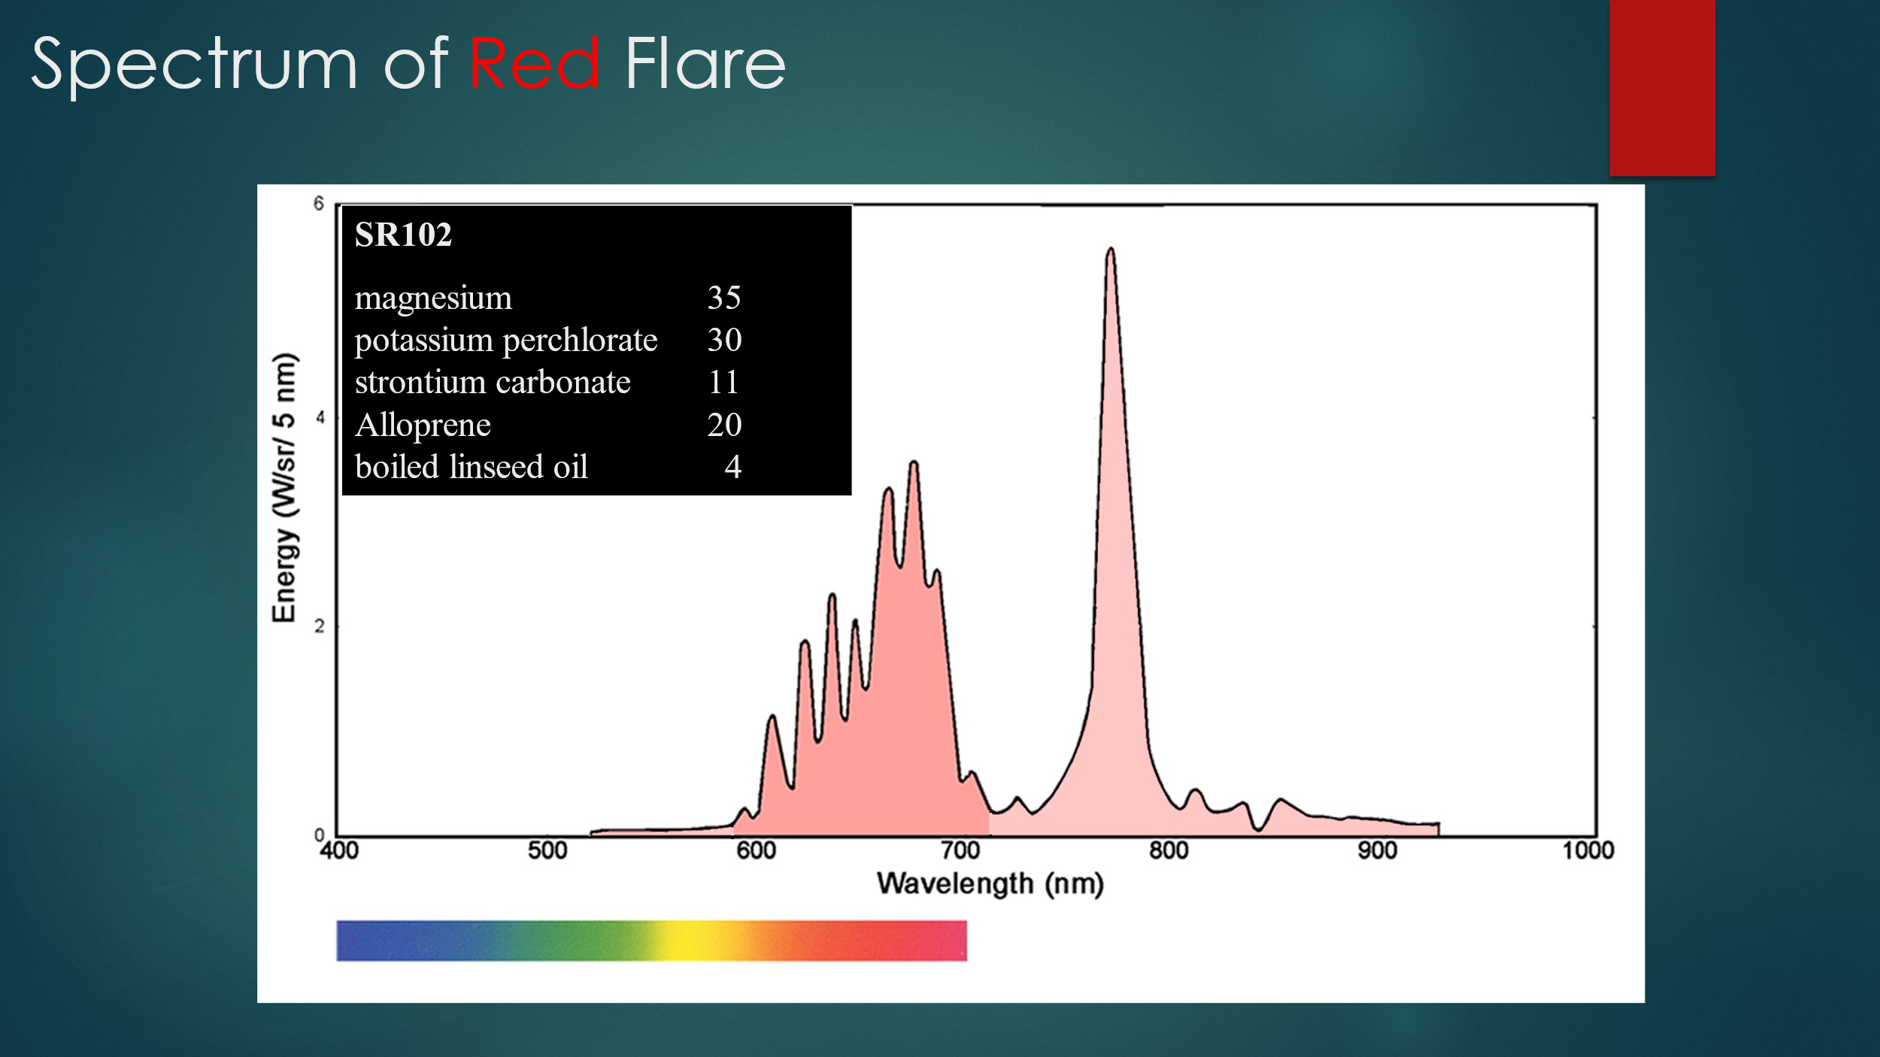

What do these spectra tell us about the combustion of each flare?
- The blue flare has a much lower infra-red contribution than the red flare. (very little contribution above 760nm) The red flare is burning much hotter.
- The blue flare uses organinc, rather than metallic fuels to reduce temperature.
Why do we need different combustion regimes?
- Copper requires a low heat to give a blue colour. Overheating the copper results in a greenish flame.
- The Chlorine generates Cu-Cl or Sr-Cl radicals which emit very strongly in their respective wavebands. The Cu-Cl radical exists as a quatromer in the flame and gives an intense blue. If this is overheated this dissociates into a dimer, which emits a weak green colour.

Q3
Explain the hazards associated with manufacturing coloured smokes and phosphorus smokes on the same site.
- Modern phosphorus smoke compositions are manufactured from powdered red phosphorus and a heater mixture, (e.g. a fuel and a nitrate).
- Coloured smoke compositions are manufactured from a heater mixture (Lactose and potassium chlorate) and a dyestuff.
- Chlorates and phosphorus together make very sensitive mixtures (Armstrong’s mixture) which ignite very readily and may approach detonation speeds when doing so. The two are considered incompatible as the mixtures are incredibly sensitive.
What precautions should be taken if the decision is taken to proceed in the manufacture of both types and why?
- The two processes, including ingredient storage, must be rigorously separated.
- Workers must be made to wear separate and identifiable PPE for each process.
- Workers must be made to wear separate and identifiable footwear for each process.
- Records should be maintained of the processes run in particular shops to avoid future contamination.
- There should be separate waste management streams for each process.

