LCMB7023 HUMAN CAPITAL MANAGEMENT Component 1

PROGRAM: Master of Business Administration

MODULE:Human Capital Management

MODULE CODE: LCMB7023
ASSESSMENT Component 1: Individual Report
LECTURER: Eno Maycock(Birmingham)

STUDENT NAME: Ram Jiva Godhaniya
STUDENT ID: 2539630

WORD COUNT: 2680

Table of Contents
TASK A: Designing Innovative Working Practices 3
1. Evaluation of traditional work design versus contemporary innovative working practices 3
2. Recommendation of innovative working practices suitable for NexSpace Health Systems 7
TASK B: Breeding an Environment Where Talent May Grow 11
1. Designing a strategic talent ecosystem to enhance talent management 11
1.1 Creating an ecosystem for developing and flourishing talent 11
1.2 Incorporation of strategic Talent Management Frameworks 13
1.3 Focusing on Employee Experience (EX) 13
2. Develop a comprehensive talent growth strategy for NexSpace Health Systems 14
TASK C: Reflective Report 16
Reference List 18

TASK A: Designing Innovative Working Practices

1. Evaluation of traditional work design versus contemporary innovative working practices
Traditional work design is characterised by a structured approach with a clear chain of command, fixed schedules, and hierarchical structure, whereas contemporary work design is flexible with employee autonomy, strategic job design, and demand-driven resource planning, with a focus on balancing employee well-being and optimising productivity (Lamovšek et al. 2025). NexSpace Health Systems (NHSX), whose workforce strength stands at 600, suffers from declining innovation, creativity, limited knowledge-sharing across teams, lack of focus on employee well-being, and a high attrition rate. HR teams in 26% of organisations reported that up to 19% of staff engaged in voluntary turnover in 2025, with 61% of employees citing excessive workload and 42% citing a lack of schedule flexibility as reasons for turnover (HR.com, 2026). To combat this, modern workspaces can incorporate digital technology to match work design to human competencies (Parker and Grote, 2022).
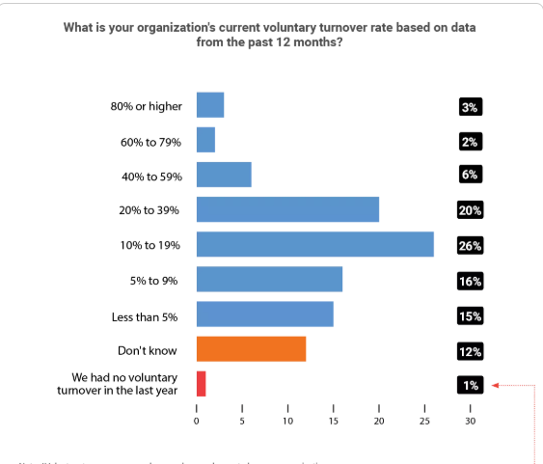
Figure 1: Voluntary employee turnover rate
(Source: HR.com, 2026)
NHSX needs to focus on employee well-being to reduce the attrition of highly talented employees. This can be overcome with High-Performance Work Systems (HPWS), which would allow NHSX to implement team-based work design, structured information-sharing infrastructure, flexible schedules, effective upskilling initiatives, performance-linked incentives, and functional feedback loops to help with faster decision-making (Wei and Fu, 2026). Tuckman’s team development can be integrated with HPWS as well to improve morale of 600 employees of NHSX.
Forming- Access to centralised knowledge, clear cross-functional responsibilities, and clearly guiding new recruits and operational duties.
Stroming- 360⁰ feedback to quickly address workplace conflict and personal psychological safety issues
Norming- Structured information-sharing framework and designing cross-team training initiatives
Performing- Performance-based incentives to facilitate innovative and creative outputs
Adjourning- Linking internal pathways to promotion after project completion on the basis of performance
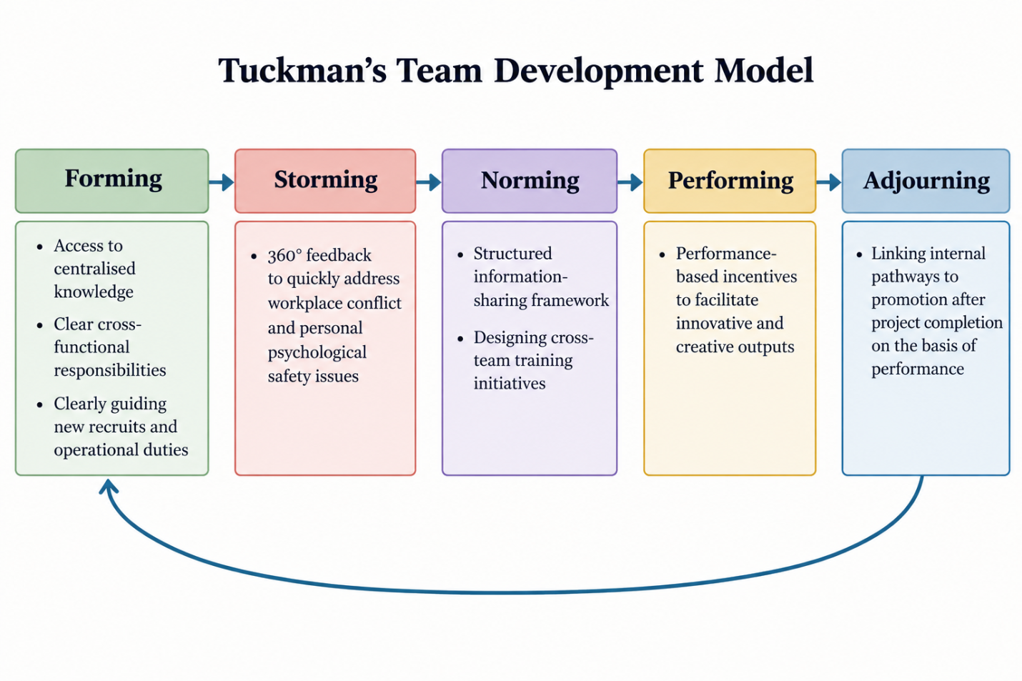
Figure 2: Tuckman’s team development to enhance collaboration efficiency at NHSX
(Source: Blanchard and Parisi-Carew, 20000)
High-Involvement Work Systems (HIWS) can guide NHSX to engage in work design that is focused on establishing employee autonomy, cross-team knowledge sharing, and enabling attracting incentive framework (Cahyadi et al., 2024). The following perks of performance management can be attained with HIWS.
Goals & Objectives- Instead of top-down hierarchy, co-creation of team-level objectives
Agreed action plan- Efficient resource planning to encourage self-directed learning for employees
Performance- Cross-team knowledge sharing helps to enhance AI models
Review feedback report- Failure is seen as a learning opportunity through instant knowledge sharing
Agreement- Negotiable job design, high employee autonomy, cross-team accountability
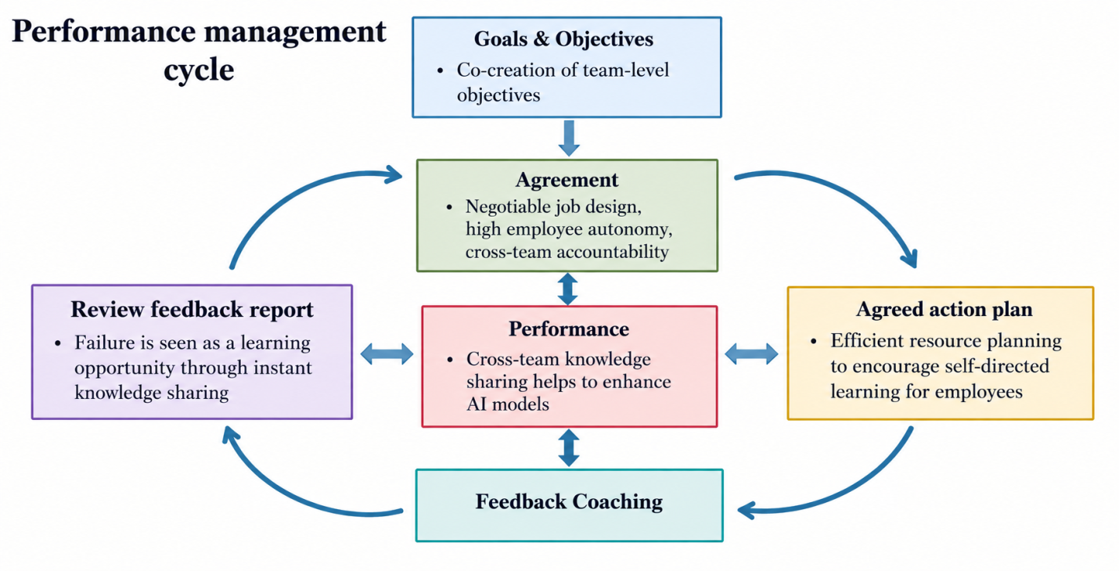
Figure 3: Performance management cycle with HIWS
(Source: Adapted from Armstrong, 2022)
Agile Working can address NHSX’s challenge of declining creativity, experimentation, and innovation by developing a rapid iterative cycle that helps to act quickly on the basis of cross-team feedback to train and test AI models in healthcare solutions and run clinical tests. Agile-based methodologies help to reduce medical device development time by 20-40% (Dataintelo, 2026).
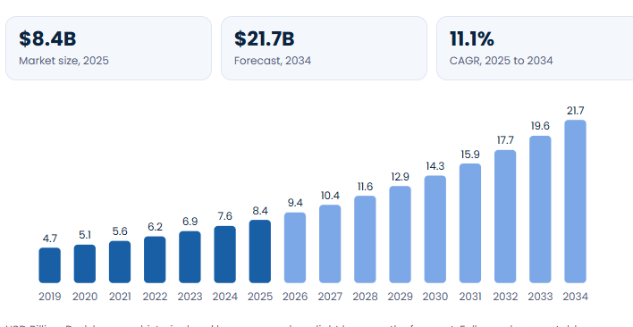
Figure 4: Growth of agile-based medicine development methodologies
(Source: Dataintelo, 2026)
Similarly, Hybrid Working Models and Flexible Working Practices offer greater autonomy to employees, as they can establish a clear boundary between hierarchical instructions and their own judgement. As NHSX operates on a multinational scale, flexibility of work schedules to produce innovative outcomes with AI architecture. In addition, Sociotechnical Systems Theory (STS) helps to engage in work design that remains human-centric despite the integration of advanced digital tools (Wei and Fu, 2026). The human-centric work design is imperative for NHSX, an AI-enabled organisation, to create seamless collaboration between human staff and automated tools.

2. Recommendation of innovative working practices suitable for NexSpace Health Systems
NHSX should develop an integrated and updated work design that prioritises cross-team collaboration and inter-team knowledge sharing, while focusing on employee well-being. The following measures can be implemented to achieve an innovative infrastructure with contemporary work design.

Recommended measures | Theoretical integration | Integrated impact on improving organisational performance
Cross-functional collaboration | STS- Ensuring incorporated digital tools enhance human competence, without complicating work distribution with the 600 employees  HIWS-Encouraging employee autonomy, effective power distribution, and structured information-sharing | - Increased employee participation and cross-team knowledge-sharing;  - Preserving autonomy of human employees by creating human-centric work design even with advanced technologies  - Cross-functional teams are 30% more likely to produce innovative outcomes in an AI-led environment (Deloitte, 2026).
Hybrid and flexible working | Goal Setting theory- Establishing specific, measurable objectives to achieve improved outcome  Control theory- Concentrating more on project outcomes rather than constant supervision  Social Cognitive theory- Encouraging self-efficacy among employees | - Establishing synergy among hybrid team members spanning across the UK, UAE, and India  - Stronger cross-team collaboration facilitated by digital tools  - Autonomy over work schedules offers greater work-life balance  - Prevents burnout, which causes 56% of employee attrition (HR.com, 2026)  - Flexible work arrangements help to uphold employee well-being and increase retention rate
Employee autonomy | HPWS- Spontaneous self-directed task participation is possible with independent decision-making capability  Tuckman’s team development model- Structural individual autonomy is necessary to improve team performance | - Setting clear goals, objectives, and assigning responsibilities, defined performance metrics, but allowing employees to decide how they will execute the tasks  - Managers’ roles being converted into coach or guide rather than being limited to a supervisor  - Closes the gap of lack of autonomy, which causes burnout for 40% of employees (Culture Monkey, 2026).
Agile project teams | Belbin’s team role- Enhances cross-functionality with self-management entitlement to team members  Goal setting theory- Breaking complex tasks into short-term, time-bound responsibilities to efficiently manage workloads | - Encouraging active participation, as 74% of employees who have decision-making rights are more engaged in their job (Culture Monkey, 2026)  - Active feedback loop helps instant identification of mistakes and facilitates improved innovation  - Improved cross-team information sharing to increase interconnectedness  - Linking project outcomes with promotional pathways reduces employee turnover
Digital collaboration technologies | HIWS- Enables decentralised decision-making with digital communication tools  Control theory- Digital real-time dashboards help to access cross-team feedback loop | - Incorporation of video conferencing tools, digital communication platforms, real-time information-sharing dashboards, project management platforms, and AI-supported knowledge management tools is necessary for NHSX (Deschênes, 2024).  - They strengthen accountability, strengthen knowledge-sharing infrastructure.
Table 1: Designing innovative work practices for NHSX
(Source: Self-developed)
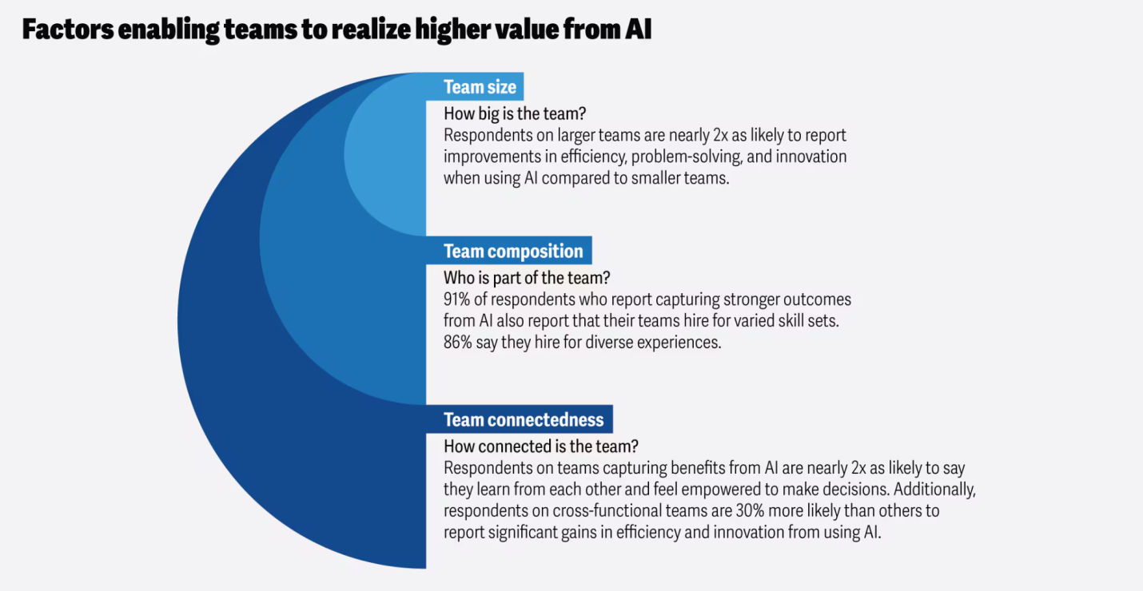
Figure 5: Importance of team connectedness to capture value from AI
(Source: Deloitte, 2026)

TASK B: Breeding an Environment Where Talent May Grow

1. Designing a strategic talent ecosystem to enhance talent management
To attract and retain talent, NHSX must develop an ecosystem where employees develop and perform at their highest potential.

1.1 Creating an ecosystem for developing and flourishing talent
Learning Organisation (Senge)
NHSX management team should prioritise developing a learning culture that strengthens digital literacy, cross-functional project participation, and embeds structured knowledge-sharing. Senge outlined five disciplines for human capital to strengthen their skill set (Havens, 2025).
- Personal mastery
NHSX should actively help its employees to figure out their professional ambitions. With the support of management, employees can develop new skills, enhance their capability, and in turn help NHSX overcome difficult challenges with utmost dedication.
- Mental models
The HR team of NHSX should concentrate on creating a protected workplace where employees can freely question the established assumptions and company norms. This will encourage employees to share unique ideas, cultivating a culture of innovation.
- Shared vision
With Senge’s theory, NHSX must focus on building collective commitment for its 600 employees centred on a common purpose. NHSX must not only develop a common vision, but unify employees by encouraging spontaneous participation by co-creating the vision to achieve the goal.
- Team Learning
NHSX must encourage employees to engage in post-project reflective discussion, judgement-free open dialogue interactions, and feedback exchanges. This helps employees share ideas openly, learn from their mistakes, and engage in experiments.
- Systems thinking
Employees must understand that their responsibilities impact the entire organisation with a causal relationship. This will help employees understand that they are an integral part of organisational success.
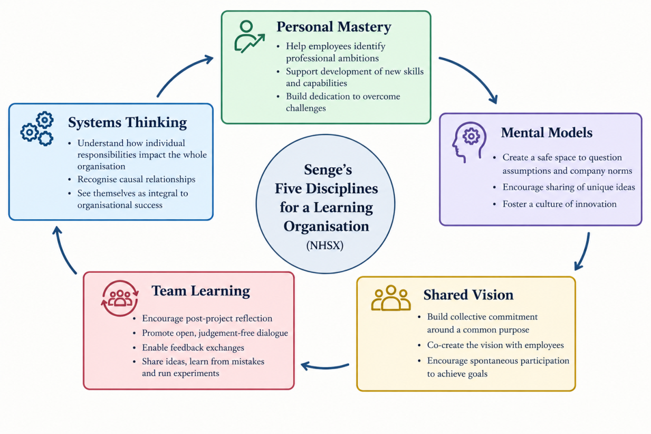
Figure 6: Diagrammatic representation of Senge’s learning organisation
(Source: Self-developed)
Growth Mindset (Dweck)
This enables NHSX to convert its traditional work design into a flexible one where employees are guided with organisational support, career pathways, and promotional opportunities. Linking incentives and promotional opportunities with self-directed learning and acquiring new skills helps to create an employee development ecosystem (Frederick et al. 2026). By developing a growth mindset, employees can be directed to engage in creative experiments.
Psychological Safety (Edmondson)
It is crucial to ensure that employees feel safe to speak up when they identify a flaw or associated risks in a healthcare technology, because otherwise the flow of innovation and creativity will be stagnant. NHSX may establish a confidential feedback channel to ensure employee safety, as 87% of professionals substantiate the need to establish psychological safety training initiatives (Career Trainer, 2026).

1.2 Incorporation of strategic Talent Management Frameworks
Incorporation of Talent Management Frameworks will help NHSX to improve recruitment channels, allocate resources more effectively, and engage in strategic succession planning. Identification of specialised skills and emerging skills will lead to better resource planning and succession planning.
Job Crafting Theory
Instead of passive participation, employees intrinsically attempt to improve their performance.
- Task crafting
Employees will proactively modify their tasks to ensure improved outcomes.
- Relational crafting
Employees are encouraged to intentionally communicate and collaborate with other team members to refine the quality of their work.
- Cognitive crafting
Employees identify the underlying value of their tasks instead of focusing on superficial attributes, which substantiates sustainable employment practice (Afnek and Khadem, 2026).
Self-Determination Theory
The NHSX management team must ensure the psychological growth of employees and their mental well-being with three elements: autonomy, competence, and relatedness. These three elements are foundational pillars of intrinsic motivation, increased satisfaction, and greater engagement for improved performance (McAnally and Hagger, 2024).

1.3 Focusing on Employee Experience (EX)
As soon as an employee is recruited and has undergone onboarding, an individual digital employment lifecycle portal should be created until the employee leaves the organisation. It should cover basic organisational information, organisational culture, gives access to internal knowledge repository, makes them aware of performance management processes, gives access to learning resources, connects them succession planning frameworks, informs them of potential career pathways, and connects with feedback mechanism.

2. Develop a comprehensive talent growth strategy for NexSpace Health Systems
Talent growth strategy will certainly become quite a crucial factor for NexSpace Health Systems (NHSX) as it will ensure skill enhancement of the employees while engaging and retaining them at the same time. In this context, the findings by Urme (2023) have mentioned that proper talent growth strategy can become crucial in skill enhancement and employee engagement simultaneously. The steps that will form the talent growth strategy are mentioned below:
- Identifying the weaknesses and needs
At the very first stage, the weaknesses and needs of the 600 employees will be identified so that the training sessions can be personalised for every employee. As per the viewpoints of Fraile et al. (2023), early identification of employee weakness can be crucial in personalising the training process for meeting the needs.
- Providing personalised training sessions
The next step will be to provide personalised training sessions to every needful employee so that their respective weaknesses and shortcomings can be mitigated at the earliest. In the words of Suwannasin and WONG (2025), personalised training sessions for the employees can convert weaknesses into strengths by skill development.
- Active monitoring of the progress
Apart from providing appropriate training sessions, an active monitoring of the performance and progress will also be ensured so that the needful customisations can be initiated. In this context, the statements by Macedo et al. (2024) have argued that active monitoring during training sessions becomes crucial in optimising loads and customising training requirements.
- Providing feedbacks
Providing 360⁰ feedback will be prioritised for every employee during the training process so that they can reflect on their own performance and shortcomings. According to the viewpoints of Jin et al. (2023), a proper feedback system for the employees can help them to reflect their own performance. Hence, the chances of performance improvement will be increased quite significantly.
- Ensuring rewards and appreciation
Rewards and appreciation for each employee will be ensured so that they are encouraged for performance enhancement. Rewards and appreciation for the employees for their exemplary performance can be quite crucial in encouraging them to achieve excellence (Imran et al., 2025). This step can also enhance their engagement levels in the best possible ways.
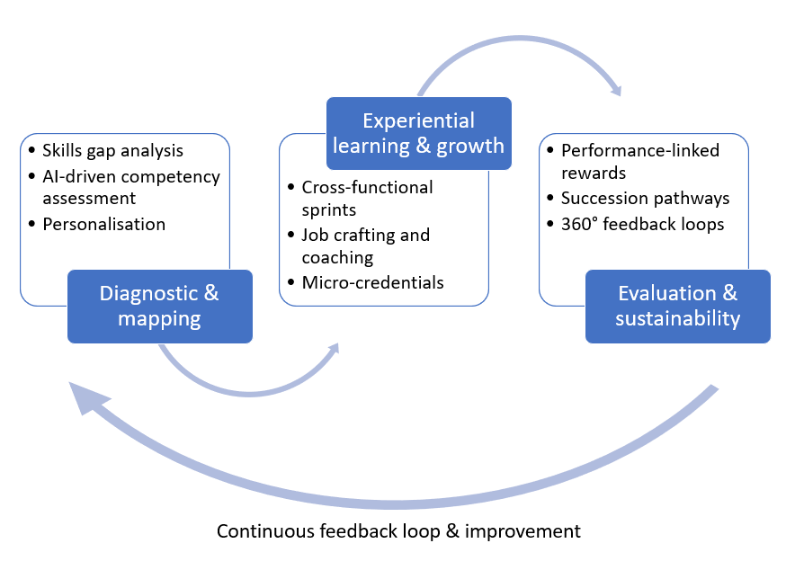
Figure 7: Diagrammatic representation of the comprehensive talent growth strategy for NexSpace
(Source: Self-developed)

TASK C: Reflective Report
Description
As a strategic tool, artificial intelligence can play a crucial role in workforce planning by analysing the ongoing trends and skill gaps. In this regard, Venugopal et al. (2024) have stated that artificial intelligence in human resource management can help in planning the workforce. On the other hand, Benabou et al. (2024) have argued that incorporation of artificial intelligence in human resource management becomes crucial in automated sourcing and skill matching (AI as a Strategic Tool).

Feelings
Considering the ethical judgment and responsibilities, it is evident that though artificial intelligence can suggest algorithmic proposals for decision-making, the final verdict remains on human will. This factor will certainly ensure empathy and compassion in any kind of decision-making such as hiring and firing that can have an impact on the employee's career.

Evaluation
I have used AI in three different instances in managing the human resources such as analysing the performance of the team members, planning the workforce and job allocations according to the skillsets. I have observed that incorporation of artificial intelligence has been partially successful in helping me to make decisions regarding job allocations based on the performance (Reflective Analysis).

Analysis
In this case, artificial intelligence lacked emotional intelligence and empathy towards my team members, and made decisions solely based on the performance levels (AI as a Strategic Tool). In several cases, I have observed that some of my team members need some more time to adjust with the changing environment at the workplace.
I think that AI can be utilised in different instances in managing human resources. For instance, I also utilised AI for managing a human resource management scenario to understand the strategic approach that the tool takes for managing workforce effectively. AI showcased high precision in mapping core competencies to immediate task requirements. However, I also noticed that there is a blind spot regarding human nuance (AI as a Strategic Tool).

For instance, during the task allocation part, the AI allocated multiple complex tasks to a single person due to the person’s skill-set resulting in ignoring the psychological burnout it can cause. On the other hand, the AI handed the other two with 2 to 3 tasks only due to less skill-set and ignoring the concept of onboarding skill learning curve or development opportunities (AI as a Strategic Tool).

Conclusion
Implementation of AI has helped to make informed decisions about employee performance and aids in professional decision-making.

Action Plan
Here, I need to develop my skills of communication so that the interaction levels with my team members can be enhanced in an effective way (Reflective Analysis). I have observed that proper communication is crucial in improving the interaction levels (Fatih et al., 2025). I would also need to develop the skills of emotional intelligence so that being empathetic and compassionate towards the team members can become easier. In this case, earning the trust and loyalty of the employees will be easier, which will further enhance their engagement levels to a great extent.

In order to bridge the gap between data-driven efficiency and empathetic leadership, it is crucial to develop my interpersonal communication and emotional intelligence skills (Personal Action Plan). Moving beyond transactional status updates by introducing bi-weekly, structured one-on-one check-ins focused on employee well-being can be beneficial in ensuring I understand the human context behind operational numbers.

Reference List
Afnek, R. and Khadem, A., (2026). ‘Crafting Your Employability: How Job Crafting Relates to Sustainable Employability Under the Self-Determination Theory and Role Theory’. Sustainability, 18(2), p.979. https://doi.org/10.3390/su18020979
Armstrong, M., (2022). Armstrong's handbook of performance management: An evidence-based guide to performance leadership. Kogan Page Publishers.
Benabou, A., Touhami, F. and Demraoui, L. (2024, May). Artificial intelligence and the future of human resource management. In 2024 International Conference on Intelligent Systems and Computer Vision (ISCV) (pp. 1-8). IEEE. https://www.researchgate.net/profile/Adil-Benabou/publication/383078701_Artificial_Intelligence_and_the_Future_of_Human_Resource_Management/links/66e0a990fa5e11512cb0f223/Artificial-Intelligence-and-the-Future-of-Human-Resource-Management.pdf
Blanchard, K. and Parisi-Carew, E., 2000. The One Minute Manager Builds High Performance Teams, William Morrow and Company. Inc., New York.
Cahyadi, A., Marwa, T., Poór, J., Maulana, A. and Szabó, K., (2024). ‘High-involvement human resource management practices and employee resilience: The mediating role of employee technology adaptation—A case study of South Sumatra’. Administrative Sciences, 14(11), p.292. https://doi.org/10.3390/admsci14110292
Career Trainer, (2026). Psychological Safety Training Statistics. [Online]. Available at: https://careertrainer.ai/en/reports/psychological-safety-training-statistics/ [Accessed on: 21/09/2026]
Culture Monkey, (2026). How autonomy in the workplace builds trust, accountability, and innovation in 2026. [Online]. Available at: https://www.culturemonkey.io/employee-engagement/autonomy-in-the-workplace/ [Accessed on: 21/09/2026]
Dataintelo, (2026). Agile-Based Medical Devices Design Market. [Online]. Available at: https://dataintelo.com/report/global-agile-based-medical-devices-design-market [Accessed on: 22/09/2026]
Deloitte, (2026). Bridging the AI value gap: Are team dynamics the missing link?. [Online]. Available at: https://www.deloitte.com/us/en/insights/topics/talent/ai-roi-and-team-structure.html [Accessed on: 20/09/2026]
Deschênes, A.A., (2024). ‘Digital literacy, the use of collaborative technologies, and perceived social proximity in a hybrid work environment: Technology as a social binder’. Computers in Human Behavior Reports, 13, p.100351. https://doi.org/10.1016/j.chbr.2023.100351
Fatih, M., Fauzi, N. and Norman, E. (2025). Effective communication in building healthy and productive relationships. MES Management Journal, 4(1), pp.662-671. https://pdfs.semanticscholar.org/da57/db6b2fbbb5fa492d53f970e5ac53dd6de358.pdf
Fraile, F., Psarommatis, F., Alarcón, F. and Joan, J. (2023). A methodological framework for designing personalised training programs to support personnel upskilling in Industry 5.0. Computers, 12(11), p.224. https://www.mdpi.com/2073-431x/12/11/224
Frederick, K.D., Lewis, L.S., Larson, S., Cooley, J., Cleven, A.J., Dawson, S., Blackwood, E.R. and Williams, C.A., (2026). ‘Dweck’s Growth Mindset Theory in Health Professions Education: A Bibliometric Review’. Medical Science Educator, pp.1-9. https://doi.org/10.1007/s40670-026-02862-w
Havens, S., (2025). ‘An Integrated Framework Combining Kotter, Albrecht, and Senge for Sustainable Organizational Transformation’. https://papers.ssrn.com/sol3/Delivery.cfm?abstractid=5216097
HR.com, (2026). HR.com’s State of Employee Retention 2025-26. [Online]. Available at: https://www.hr.com/en/resources/free_research_white_papers/hrcoms-state-of-employee-retention-2025-26_mh1v0oy3.html [Accessed on: 20/09/2026]
Imran, U.D., Ghazwan, M.F. and Firmansyah, F. (2025). The effect of recognition and appreciation on employee motivation and performance. Economics and Digital Business Review, 6(1), pp.1-18. https://ojs.stieamkop.ac.id/index.php/ecotal/article/view/1890/1261
Jin, S.H., Im, K., Yoo, M., Roll, I. and Seo, K. (2023). Supporting students’ self-regulated learning in online learning using artificial intelligence applications. International Journal of Educational Technology in Higher Education, 20(1), p.37. https://link.springer.com/content/pdf/10.1186/s41239-023-00406-5.pdf
Lamovšek, A., Radević, I., Mohammed, S.S. and Černe, M., (2025). ‘Beyond the office walls: Work design configurations for task performance across on‐site, hybrid and remote forms of work’. Information Systems Journal, 35(1), pp.279-321. DOI: 10.1111/isj.12542
Macedo, A.G., Almeida, T.A., Massini, D.A., de Oliveira, D.M., Espada, M.C., Robalo, R.A., Hernández-Beltrán, V., Gamonales, J.M., Vilela Terra, A.M. and Pessôa Filho, D.M. (2024). Load monitoring methods for controlling training effectiveness on physical conditioning and planning involvement: a narrative review. Applied Sciences, 14(22), p.10465. https://www.mdpi.com/2076-3417/14/22/10465
McAnally, K. and Hagger, M.S., (2024). ‘Self-determination theory and workplace outcomes: A conceptual review and future research directions’. Behavioral sciences, 14(6), p.428. https://doi.org/10.3390/bs14060428
Parker, S.K. and Grote, G., (2022). ‘Automation, algorithms, and beyond: Why work design matters more than ever in a digital world’. Applied psychology, 71(4), pp.1171-1204. DOI: 10.1111/apps.12241
Suwannasin, S. and WONG, W.K. (2025). Personalized Training's Impact on Job Performance: Serial Mediation of Learning Effectiveness and Skill Development. Asian Administration and Management Review, 8(2). https://so01.tci-thaijo.org/index.php/AAMR/article/download/279171/179680/1145043
Urme, U.N. (2023). The impact of talent management strategies on employee retention. International Journal of Science and Business, 28(1), pp.127-146. https://www.researchgate.net/profile/Umma-Urme/publication/374147805_The_Impact_of_Talent_Management_Strategies_on_Employee_Retention/links/65102e7a61f18040c220d870/The-Impact-of-Talent-Management-Strategies-on-Employee-Retention.pdf
Venugopal, M., Madhavan, V., Prasad, R. and Raman, R. (2024). Transformative AI in human resource management: enhancing workforce planning with topic modeling. Cogent Business & Management, 11(1), p.2432550. https://www.tandfonline.com/doi/pdf/10.1080/23311975.2024.2432550
Wei, W. and Fu, X., (2026). ‘Building High Involvement Work Systems in the Digital Era: Employee Experience‐Oriented Digital HRM and Employee Involvement’. Human Resource Management, 65(4), pp.953-973. https://doi.org/10.1002/hrm.70058

