Academic writing semester 2

Module code: M4X01498
Student no: 1902008
Student name: Abigail Louise Crimlis

Feature driven development (FDD)

- Introduction
- Agile methodology? PG 1
  - The principles of agile
- Inside FDD PG 2-4
  - FDD explained
    - The Meta-process-model
    - Best practices of engineering
- Project management in FDD PG 4-5
  - Team structure
  - Tracking progress
  - A client centric approach
- Summary PG 6
- References PG 6

- Introduction
FDD is a founding component of agile methodology, developed before the agile manifesto was invented in 2001. This report covers the knowledge needed to create a development plan under FDD protocols. It introduces the reader to the meta-process-model and engineering practices that are incorporated into the development cycle. You will also learn how it can increase productivity and efficiency within your projects, as well as the benefits of using a client-centric business model.

PG 1
- What is agile methodology?
Agile methodology is the practice of iterative development project models, it is defined in the Agile manifesto [1] “while there is value in the items on the right, we value the items on the left more.” Agile methodologies are known for their focus on high quality results and the ability to refactor and implements new items throughout the process.
2.1 The principles of agile.
There are 12 principles of agile methodology, these where curated by developers and project managers from all over the world as a “bible” for agile development frameworks.
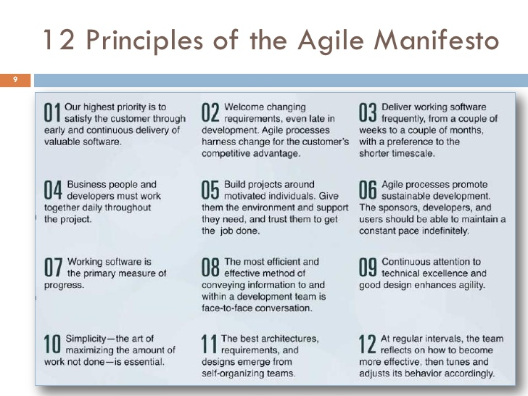
Src: Glen Allemen 8/2/2011

PG 2
- Inside FDD
3.1 FDD explained
Feature driven development is a software development process that focuses on incremental steps to complete a given feature. For example, a checkout feature on an ecommerce website would be labelled as a “step” within the process. It is a client-centric model meaning there is emphasise on the stakeholders and collaboration throughout the team. FDD was first introduced in “Java modelling in color” [2] by the creators Jeff De Luca and Peter Coad, it was developed to assist with the project management of a large contract in Japan and the increasing complexity of managing over 1000 members of staff.
  - The meta-process-model
The life cycle of FDD follows 5 basic principles that are best depicted on the diagram below: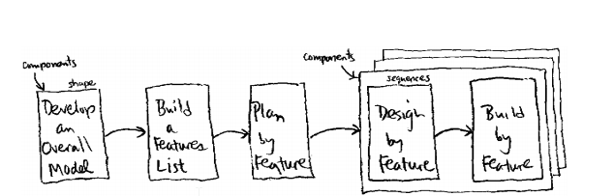
The meta-process-model - Src: [2]

Develop an overall model: This is the first step within the process model, the project scope and requirements are identified. The chief programmer (development team) and the Domain expert (client representative) have the most input, story cards are introduced to write details on each feature.
Build a Feature list: Taking the materials produced in the previous stage, the chief programmer separates each feature into “sets”, these are specific to each domain within the overall model. The Domain expert reviews the documents and compiles one single feature list.

PG 3

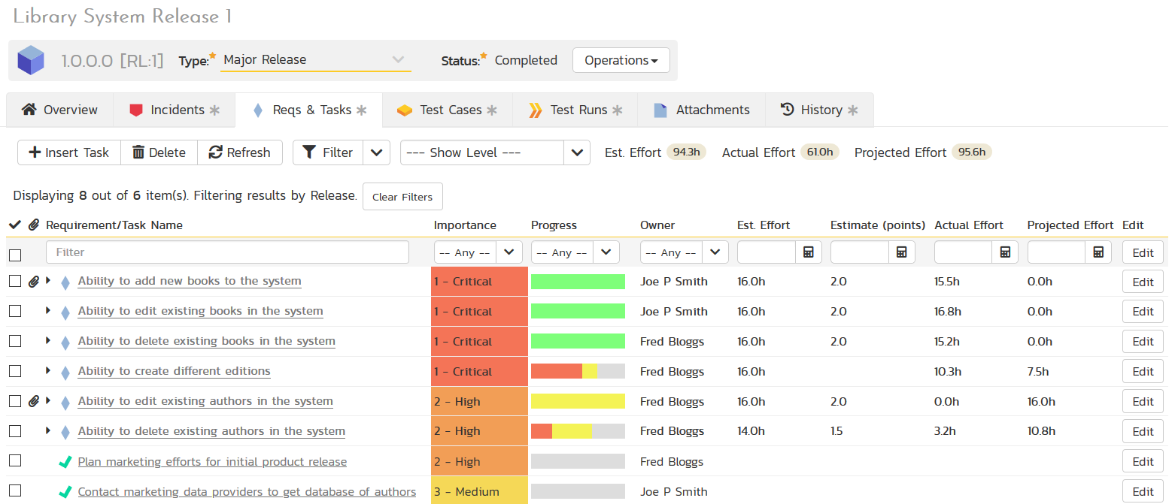
Feature list example / src: inflectra.com
Plan by feature: The chief programmer and domain expert agree on a timescale and budget in which is viable to complete all the features from the previous stage. The chief programmer then decides how many iterations are needed to complete the project.
Design by feature: Within this phase of the planning process, the chief programmer assigns class ownership throughout the team for each feature on the requirements list. The class owner then writes pseudo code for the given feature and presents it to the QA manager for inspection.
Build by feature: Iteration development commences, small modules of a given feature are created and shown to the client for review. Each change within the feature is classed as an ‘iteration’ which consistently builds upon the first version. This phase repeats until the project has been completed.
[5]

3.1.2 Best practices of engineering
The meta-process-model has many sub-processes involved within the development cycle, the founding methodologies of the FDD framework is based upon several best practices of engineering:
- Domain object modelling
An overview of real-world entities and the relationships in which they share when finding solutions for a problem domain. “if you only model one thing in agile, model the domain” [3]
- Developing by feature
Small incremental steps are taken to complete a final product/project. Each separate part of the project is broken down into small features that will take no more than 10 days to complete.
PG 4

- Individual class ownership
This technique allows only the ‘class owner’ to amend or refactor a specific class within the project, by restricting access in this way the refactoring process and debugging of the code is more efficient. XP (extreme programming) uses ‘collective code ownership’ meaning all members of the team can edit and refactor all classes including the source code, these main differences are usually the deciding factor when it comes to deciding on a methodology according to Berczuk.S etl [4]
- Feature teams
A cross functional team is composed of specialists each within their own individual area (programming, testing, project management, design etc), they are long-lived meaning they stay together for the duration of the project.
- Inspections
FDD uses two forms of inspections, the first been the design model. All aspects of the chosen solution are thoroughly examined, if the solution is deemed acceptable by all
parties the design is accepted, the process moves on. The second is code inspection, chosen features are examined and debugged, if the codes passes the inspection, testing can begin.
- Configuration management
All aspects of the process model create a mass amount of paperwork, filled with diagrams and reports. This stage in the process is used to audit all parts of the project to check for irregularities or to abandon the parts that were deemed unacceptable in the previous versions.
- Regular builds
Are the methodologies that are used to track progress throughout the life cycle of the project. An up-to-date build is always available to show to the client and to highlight any errors or design implements that might need editing.
- Visibility of progress results
Project managers use progress reporting at all stages to direct the project in the right direction. These are updated at regular intervals throughout the life cycle.

- Project management in FDD.
FDD focuses highly on team collaboration and client involvement. The FDD model process is run on a Fortnightly cycle, meaning developers complete each phase of a feature within 2 weeks, yielding instant results for the managers and new focus points for the developers [2]
- New small features added regularly
- Frequent and tangible results

PG 5
- Easy flow to the development process
- Keeps all staff engaged
- Allows for multiple stages to be completed at the same time
4.1. Team Structure
Team structure in FDD defines the way in which the project runs. FDD is better suited for large teams working on complex software solutions, the structure is an integral part of the methodology to ensure smooth integration on the task at hand. The main roles are as follows:
- Project Manager
- Chief Architect
- Development Manager
- Chief Programmer
- Class Owner
- Domain Expert
4.2 Tracking Progress
There are 6 main milestones within the development cycle. Three milestones occur during the ‘Design by feature’ phase. This ensures that the elements within the feature list have been designed and Pseudo code has been presented by the class owner. The final 3 milestones are met during the ‘build by feature phase’ each iteration of the development process is thoroughly tested and inspected before it can be shown to the client.

4.3 A client centric approach
The approach is popular among the business community according to the survey published by Lamberti.L in 2013 [6] The survey showed that business owners that offer a client-centric approach are more likely to secure the client than a more resource/product centric technique. FDD includes the clients within all aspects of the decision-making process, the client decides on the feature’s that are needed and has the final say during the testing stages, leading to a greater level of satisfaction throughout the entirety of the project.

PG 6
Summary
To summarize, FDD was first developed in 1997 to solve the issues faced when managing a large project. FDD is a founding component of the Agile methodologies and the principles in which they comprise.
Built upon several engineering concepts, FDD incorporated these and made its own model in which to ensure maximum productivity within a project.
FDD is a client centric model, meaning the client is kept involved throughout the entirety of the project, changes are easily made due to the fluidness of the agile methodology and client satisfaction is much higher.

REFERENCES

[1] Beck, K el: “Agile manifesto”, Published: 2001, Available: http://agilemanifesto.org/ Accessed: 9th March 2020
[2] De Luca, Jeff el: “Java Modeling In Color With UML” ISBN:0-13-011510-X, Published: 1999. Publisher: Prentice Hall PTR 1999
[3] Box, G: “Domain Modelling” Updated: 29th October 2018, Scaled Agile, Available: https://www.scaledagileframework.com/domain-modeling/ Accessed: 6th April 2020
[4] Berczuk S el: “Balancing individual versus Collective code ownership” Published: April 14 2006, CM Crossroads, Available https://www.cmcrossroads.com/article/balancing-individual-versus-collective-code-ownership Accessed: 9th March 2020
[5] Nawaz Z et: “Simplified FDD Process Model”. Published: September 2017. IJ Modern Education and Computer Science, 2017, issues: 9, pg. 53-39. Accessed: 7th April 2020 Available: https://www.researchgate.net/publication/319365945_Simplified_FDD_Process_Model
[6] Lamberti L: “Customer Centricity: the construct and the operational antecedents”, Published in: Journal of Strategic Marketing, issue: 21, pg. 7. Released: August 2013. Available online: https://www.researchgate.net/publication/257636962_Customer_centricity_the_construct_and_the_operational_antecedents Accessed: 13th April 2020

