

RESULT

ASSIGNMENT DETAILS AND FEEDBACK
SOUTH WEST WALES CENTRE FOR TEACHER EDUCATION
Sections marked with * should be completed by module lead
Student name: | Charlotte Beynon | Student P number: | 1703365
Programme: * | Secondary Post Graduate Certificate in Education
Module: * | Curriculum Development and Enhancement | Module Level (6 or 7): | Level 7
Module code: * | ECSP7002 | Contribution to Overall  Module Assessment (%): * | 100
Module Lead:* | Jan Barnes
Assignment Title:* | Reflections on Teaching and Learning | Assignment No (x of x): | 1
Start date:* |  | Submission deadline:* | 14th May 2018 –full submission
Return date of provisional marks & written feedback:* | 11th June 2018

Referencing: | In the main body of your submission you must give credit to authors on whose research your work is based. Append to your submission a reference list that indicates the books, articles, etc. that you have read or quoted in order to complete this assignment (e.g. for books: surname of author and initials, year of publication, title of book, edition, publisher: place of publication).
Submission: | All assignments must be submitted to Turnitin unless otherwise instructed by the Lecturer.  Note: the Turnitin version is the primary submission and acts as a receipt for the student. Late submission of the electronic version of the assignment will result in a late penalty. Penalties for late submission: Up to one week late, maximum grade D. Over one week late, Refer. Only the Extenuating Circumstances Panel may grant an extension. | Date: | 13/05/18
Module lead to tick to indicate if a hard copy version of the assignment must be submitted.* | YES
 | NO | √

What is the impact of verbal drilling and repetition techniques on vocabulary acquisition and retention?

Introduction
For this assignment, I will refer to my placement school as “School X”, and each learner by a designated number in accordance with BERA guidelines (BERA, 2011).
For this assignment, I have chosen to explore the impact and effectiveness of drilling on language acquisition and retention, as it appears to be a key strategy used in the Modern Foreign Languages (MFL) classroom not only in School X, but in other schools that I have experienced language teaching and learning. I recognised that the class that I have chosen, had a particular skills deficit in terms of recall of vocabulary, thus I decided that the learners would benefit from this research as it would help to identify whether verbal repetition truly helps them to commit language to memory successfully, or whether other methods have a more positive impact for this specific purpose.
For context, School X is a mixed, English medium 11-16 comprehensive school consisting of around 485 pupils (The Welsh Government, 2017). The school is known for having a high eligibility for Free School Meals (FSM) percentage, which in 2017 was around 50%, which is 32% and 33% higher than the Local Authority and Welsh percentages respectively (The Welsh Government, 2017). According to School X’s Estyn report (2016), this proportion is one of the highest for all secondary schools in the country. In addition, Estyn (2016) also states that around 70% of the pupils in the school live in the 20% most deprived areas in Wales.
Moreover, the percentage of Additional Learning Needs (ALN) pupils with School Action (39%), School Action Plus (16%), and Statemented (12%) interventions again exceeds that of the Local Authority (16%, 7%, and 4%) and Welsh (15%, 8%, and 2%) averages (The Welsh Government, 2017). Furthermore the school has a considerable amount of EAL learners on their role with almost 9% of its learners having English as an additional language (The Welsh Government, 2017).
The class I conducted the interventions on is a year 10 class of thirteen learners, consisting of seven boys and six girls. This class is of a mixed ability, which is clear to see in their target grades for GCSE, and their current attainment levels from previous summative assessments (Appendix 1). Most learners are on target to achieve their predicted grades at GCSE, however, five learners (38.5%) are currently achieving below their predicted abilities (Appendix 1). Two learners (15.4%) are on FSM, whereas ten learners (76.9%) are identified as having an ALN, and School Action interventions have been put in place accordingly (Appendix 1). Furthermore, there are four learners who have been identified as having English as an Additional Language (EAL) with each learner having different home or background languages (Appendix 2).

Literature Review
The effectiveness and necessity of drilling within the language classroom, is a topic that has seen much debate within the MFL teaching field. Drilling, as defined by Hájková (2014) is “a technique based upon guided oral repetition of sentences, chunks of language, or words in the Target Language” (TL) (p. 12). Essentially, learners listen to some sort of model, and repeat what is heard (Tice, 2004). It can be argued that this technique gained momentum due to the World War II demands for fluent speakers of other languages (Griffiths and Parr, 2001). Drilling was used to train military personnel to achieve conversational proficiency (Griffiths and Parr, 2011: Hájková, 2014). This eventually morphed into what is now known as the Audiolingual method that came out of the 1960s, an approach based upon behaviourist principles of repetition and habit formation, which depended heavily on drilling to achieve automatic and desired responses (Griffiths and Parr, 2001; Hájková, 2014; Smith and Conti, 2016; Conti, 2017).
Drilling became a widely used technique for language teaching, however, it gradually began to lose popularity with the introduction of the Communicative Approach, which favours “authentic” and spontaneous use of language, leaving the choral responses and recitation nature of drilling behind (Hájková, 2014; Thornbury, 2010). Despite this, drilling continues to be used by professionals in the field for vocabulary instruction, however, it is very unlikely to find a practitioner that bases their teaching mainly, or solely, on drills (Tice, 2004; Hájková, 2014).
Furthermore, drilling is linked to the necessity of recycling language, and there is a general consensus from the literature that frequent exposure to vocabulary is essential to have a positive impact upon TL memorisation and retention. It has been argued that learners need to be exposed to a word between ten and sixteen times before it can be committed to memory (Pachler and Redondo, 2007; Smith, 2018). This is reiterated by Alp (2016) and Butler et al. (2010) that students need to be exposed to words multiple times before they can understand, retain, and reproduce them in context. An obstacle to retention is that the human brain forgets information at a high rate whilst in the Working Memory (WM) (Conti, 2017). Without repetition or “rehearsal”, 42% of the vocabulary taught in a lesson will be forgotten in 20 minutes, and around 60% within the first 48 hours of exposure, thus commitment to Long Term Memory (LTM) will fail, and the vocabulary will need to be relearnt (Smith and Conti, 2016).
To understand the benefits of drilling, and other techniques, one must understand how the memory retains language, in order to select appropriate interventions for our learners. When vocabulary is taught it enters the Working Memory, which is only capable of holding information for a short period of time, thus thoughts are lost almost instantly if a conscious effort is not made to store them (Shejbalová, 2006; Gathercole and Alloway, 2007; Smith and Conti, 2016). With this short span, it is important that one does not overload the WM, as it will have a negative impact on the acquisition and retention process (Brabeck, Jeffrey, and Fry, n.d). Taking this into account, drilling can be considered a feasible way of helping to combat the decay of information in the WM, and to contribute to the process of retention by ensuring the learners are using the vocabulary after initial exposure (Tice, 2004; Mohammed, n.d).
Unlike the WM, the capacity of the LTM is apparently limitless, and it is the responsibility of the WM to pass on information to be able to retain and recall it (Brabeck et al, n.d). Once the “memory” is created and stored in the LTM, it is stored permanently, forgetting is highly unlikely, and failure to recall is more likely due to inability to retrieve the word (Shejbalová, 2006; Smith and Conti, 2016). In terms of how it is retained, a learner will receive the vocabulary, which will eventually make its way from the WM, into the LTM via electrical pulses along the brain cells (Smith and Conti, 2016). These pulses help to create connections between neurons, which allows information to flow between them (Smith and Conti, 2016; Brabeck et al, n.d). Formation of memories and connections in the LTM can take up to days, weeks, and years to create, and the more regularly that neurons communicate, the stronger and more efficient connections become (Smith and Conti, 2016).
In order to deepen these connections and help recall, the memory, or in this case the vocabulary, needs to be activated multiple times (Macaro, 2003; Smith and Conti, 2016; Brabeck et al, n.d). As previously mentioned, although drilling and oral repetition recycles vocabulary, it normally takes place immediately after exposure, thus helping with holding in the WM. However further repetition is clearly needed on top of this, hence why drilling’s reputation within the MFL teaching community has changed considerably since the introduction of Audiolingual methods.

A number of professionals within the literature state that although there is a necessity for repetition and recycling, drilling is not the only means to achieve this. Drilling has been heavily criticised by many as being ineffective, with emphasis being put upon the need to reject behaviourist principles for language learning (Hájková, 2014). Brabeck et al. (n.d), argue that rote repetition does not improve performance when faced with production tasks, and suggest that Direct Practice is more effective for this purpose. They state that Direct Practice allows for rehearsal and repetition, however, it allows the learners to attain new knowledge and skills in the process that they will be able to adapt for future contexts (Brabeck et al, n.d). They argue that this occurs when a learner intentionally repeats activities of a similar nature to improve their performance, which in turn increases automaticity (Brabeck et al, n.d). Although it does not seem much different to the concept of drilling, they highlight that this practice should be viewed as deliberate goal directed rehearsal and reflection, and base their repetition around tasks to improve learners’ retention skills (Brabeck et al, n.d). This can also be applied to the context of vocabulary in that using task based repetition exposes the learners to the vocabulary in the same manner as drilling, although it is more likely to be in context, combined with already acquired skills, which in turn, can strengthen the connections between neurons, which impacts upon retention.
Reinforcing this task based focus, Smith and Conti (2016) believe that giving learners extensive reading tasks will contribute to language acquisition and retention. This type of task fits with the notion of implicit instruction, or inductive methods of acquiring specific language chunks. Conti (2017) suggests that there tends to be an overemphasis on explicit forms of teaching and learning, such as drilling and rote repetition, and a larger focus needs to be upon implicit methods that allow frequent exposure, whilst also placing the vocabulary items in context. Alp (2016) reinforces this sentiment in that instead of simply focusing on the vocabulary and their meanings, teachers should “show” learners rather than “tell” them the meanings, and state that practitioners should us examples and context, questions, and visuals to actively involve the learners in the learning process.
Moreover, he argues that by helping them to decipher and understand vocabulary in context, it will enable them to recall the information easier. Furthermore, Cauchy (2014) also encourages what he describes as “desirable difficulty” which is explained as a situation where initial learning is made difficult in order to increase efficacy of recall in future contexts. He argues that tasks should encourage learners to develop their ability to decipher language for themselves, rather than being explicitly told. Finally, Butler et al. (2010) cite Stahl (2005) who states that vocabulary instruction should provide learners with opportunities to encounter the words multiple times, and in as many different contexts as possible to ensure that the vocabulary is fully understood. These methods take the recycling of the vocabulary that drilling provides to a higher level, which allows the learners to interact more with the language, and use higher order thinking skills that drilling has been said to lack (Conti, 2017).
This highlights the fact that one of the main characteristics of drilling is that it is very controlled (Griffiths and Parr, 2001; Hájková, 2014). Learners become “passive entities” that have little input into the learning process, as it is the teacher that dictates the activity (Griffiths and Parr, 2001; Hájková, 2014). Griffiths and Parr (2001) argue that practitioners that use drilling as a key part of their teaching, pay no attention to the fact that learners are part of the process, and may have useful contributions to their own language acquisition. Although a very strong sentiment, it is clear that language learning is more of a complex and creative process that needs active engagement and contributions from those who are learning, and to have a positive impact upon learning, it needs to consist of more than just the ability to recite language through “monotonous chanting” as Tice (2004) states.
An additional criticism of drilling made by some practitioners is the fact that it does not provide learners with an in depth view of vocabulary, but rather solely the words’ translations (Richards, 1979). Smith (2018) highlights the fact that many teachers of languages are reluctant to use drilling, as they fear it encourages rote learning rather than true understanding of the TL and attached concepts. Richards (1979) also argues that vocabulary teaching needs to be more than just memorising words, it needs to ensure that learnings are interacting with vocabulary on all levels. For example he mentions semantics, the meaning of suffixes and prefixes, in terms of MFL, gender structures, agreements, and emotional connotations to name a few. Moreover, Butler et al. (2010) reiterates Richards’ point, as they argue that vocabulry learning becomes effective when active engagement goes beyond definitional knowledge. Breaking down the words and phrases gives the learners a true understanding of the vocabulary, its logical relationship with other words, and how it functions in a range of contexts, rather than simply scraping the surface (Richards, 1979; Butler et al. 2010).
In terms of the impact of drilling on retention, Conti (2017) argues that repetition without the inclusion of these higher order thinking skills, creates weaker memory traces, whereas these become stronger when cognitive investment is much deeper. Conti (2017) seems to favour activities, much like those outlined by Smith and Conti (2016) and Alp (2016), which allow the learners to sort and classify the vocabulary, and allow them to be more creative in the acquisition process, and believes that this aids acquisition significantly better than simple word recognition. Moreover, low cognitive input can lead to boredom and disengagement, rendering the intervention as lacking efficacy in terms of helping learners acquire the TL, and as a result, unnecessary to the teaching process (Tice, 2004; Hájková, 2014).
In addition to these task based approaches, another method of language acquisition that has grown in popularity in the MFL teaching community, is the notion of vocabulary learning through natural communication and interactions (Griffiths and Parr, 2001). Griffiths and Parr (2001) cite Krashen (1976) who insists that language and vocabulary cannot be learnt formally, but rather it is acquired through everyday conversation and utterances. Smith and Conti (2016) agree with this view, to a certain extent, as they state that most vocabulary that is learnt in a learner’s mother tongue (L1), and second language (L2) is learnt incidentally through normal classroom interactions. They also suggest that learners are quicker to understand and retain vocabulary unconsciously when exposed to it in practice on multiple occasions. This again complies with the need for recycling of language, but again shows that acquisition and retention should take place within an authentic context. These methods can be said to fall under the Communicative Approach to language teaching, which favours “authentic” experiences within the classroom setting.
Although it can be said that this method of vocabulary teaching is the ideal, it is very difficult for practitioners in this country to achieve frequently, due to the little time that is given to MFL instruction (Guest and Pachler, 2001; The Welsh Government, 2015; Tinsley and Board, 2017). Despite the Welsh Government’s actions to promote the position of languages in the country, timing and frequency of MFL lessons continues to be insufficient. Therefore, although in theory this method may be beneficial, it is easy to understand why teachers favour other methods, and make use of drilling despite its down falls, because it allows use of vocabulary despite strict time constraints.

Despite the criticisms that drilling has faced for encouraging low cognitive effort from learners, when used correctly, and for the correct ability of learners, it can positively impact retention of vocabulary. It can be said that the techniques for acquisition of vocabulary in the TL should differ according to level of the learners (Smith and Conti, 2016). Explicit instruction, such as drilling, is essential for beginners that are limited in terms of reading and listening, due to their lack of knowledge of the TL (Hájková, 2014; Smith and Conti, 2016). With an inadequate vocabulary range, learners will not be able to access some of the “implicit” methods, such as reading and writing, as they will have significant difficulties understanding, and as a result deciphering the language required (Alp, 2016). Drilling offers the opportunity to repeat vocabulary as it is heard, increases the learners’ confidence to use it, and as a result help with acquisition (Hájková, 2014). Moreover, despite the criticisms made by Griffiths and Parr (2001) of drilling being too controlled, Tice (2004) argues that drills generate a focus upon accuracy, which is important, especially for those who are beginners to the learning process, thus it can be deemed necessary in the correct stages and contexts within lessons.

Therefore, one can see from this context, that drilling does seem to have a useful and effective place within language and vocabulary instruction. Smith and Conti (2016) go on to argue that despite level of ability, rote learning works well for some learners who will learn the words by heart, reproduce them in a testing context, and transfer their knowledge to additional contexts. However, they argue that this method will not always work for every learner, and as a result we must explore other methods to ensure that acquisition and retention is achieved (Smith and Conti, 2016).
Furthermore, the attitude of the learners themselves towards drilling will affect its impact on vocabulary acquisition and retention. It is said that learners expect to be exposed to drilling and verbal repetition techniques, and feel that it is essential to the language learning process (Tice, 2004; Smith and Conti, 2016). Smith and Conti (2016) argue that learners appreciate the clarity and the perceived “mastery” that they achieve through drilling, even if it is not the most effective way of developing their language. Moreover, Hájková (2014) found in her study of drilling, that on the whole, learners appreciate oral repetition as it allows the ”ease of memorisation”, which contributes to the idea that drilling has a positive impact upon retention of TL vocabulary (p. 51).
In contrast, Hájková (2014) also suggests in her study that learners tend to associate drilling with a primary school environment, and may not be entirely comfortable with using it. In this country, as the majority of MFL instruction being conducted within a secondary school context, it is fair to consider that this may be a contributing factor to the criticism that drilling faces. Furthermore, Pachler and Field (2001) cite Heafford (1990) who observed pupils attitudes to differing tasks, concluded that choral repetition had a low value amongst learners, whilst drilling had mixed value (pp.53-54). Two tasks that appeared to have a high value amongst learners was listening to the TL, and individual reading activities (Heafford, cited in Pachler and Field, 2001). Pachler and Field (2001) do caution that this study was based upon unstructured observations of attitudes rather than a structured empirical study, however, it is an interesting view upon how learners themselves perceive tasks such as drilling. This is also reinforced by Hájková’s study (2014) where the majority of the learners identified the lack of need to think about the vocabulary or chunks to be a disadvantage of the drilling method.
Taking all of this into account, although drilling has faced criticism, professionals continue to support the habit forming approach for internalisation, and argue that it has a place in the MFL classroom, if the learners can understand its purpose and benefits (Pachler and Field, 2001; Mohammed, n.d). Hájková (2014) reiterates this by stating the fact that although there are some problems with the technique, there are also clear benefits that make it a tool that all teachers should at least have as part of their repertoire.

School Policy and Practice
In terms of the School and Departmental Plans and Policies, there is nothing within them that outlines specific methods that MFL practitioners should follow for effective language instruction. Be that as it may, it is clear from my own observations and teaching practice, that lessons that include the introduction of vocabulary should contain elements of drilling in order to help the learners to hear, understand, and practice the new elements of language. There have been occasions where feedback from my mentor and other MFL teachers has included comments that encourage more drilling (Appendix 3). Moreover, it is not simply an expectation from within the department itself, but also from others outside of MFL. For example, feedback from my Senior Mentor, whose specialised subject is Physical Education, included comments about the need to drill unknown language (Appendix 4), thus it is clear to see that other practitioners expect to see this technique included in the MFL classroom, within School X’s community.
However, I have also been encouraged by my mentor to allow the learners to figure out language rules and meaning of language in various other ways, not simply through direct instruction and drilling methods. Thus, despite an emphasis upon drilling in a vocabulary teaching and learning context, practitioners do not solely depend upon this method of instruction, in order to vary the learners experience of vocabulary learning, expose them to a number of ways that have a positive impact upon acquisition and retention, and to also help them to develop their higher order thinking and cognitive abilities.

Methodology & Ethics
Prior to undertaking any research of interventions, I was required to select a sample group, and to explore methods for conducting my research and collection and analysis of any data.
In regards to the selection of a sample group, Cohen, Manion, and Morrison (2007) suggest that there is no “correct” sample size, as it depends upon the nature of the research. However, they suggest that thirty participants is considered to be the minimum amount of participants required to carry out a statistical analysis of the data collected (p. 101). Consequently, I attempted to attain a sample size that matched this as closely as possible, nonetheless, this was difficult due to the fact that School X is much smaller than other schools in the general area, with much smaller classes. As a result, I was very limited with my selection of a sample group.
Moreover, the sample needs to depend upon more than simply size, but also which members of a “population” or specific group of people, will be chosen as participants (Vanderstoep and Johnston, 2009). The literature seems to suggest that random sampling is a favoured method, as it allows anyone within a population to be chosen (Cohen et al, 2007; Vanderstoep and Johnston, 2009). However, there are a number of other means of sampling that are suggested that are more specific and narrowly focused (Cohen et al, 2007; Vanderstoerp and Johnston, 2009).
For the purpose of this research, I needed to identify a deficit of vocabulary retention skills in a very small population, thus I chose to use what Cohen et al. (2007) refer to as “Purposive Sampling”, and what Vanderstoep and Johnston (2009) refer to as “Non-Random Sampling” (p. 114; p. 27). These techniques allow for the selection of participants based upon specific characteristics that need to be addressed (Cohen et al, 2007; Vanderstoep and Johnston, 2009). Therefore, the year 10 group that I selected displayed the particular characteristics and skills gap necessary for my research to take place.
Moreover, it was important to carefully select the type of data to be collected, in terms of quantitative or qualitative data types (McAteer, 2013). McAteer (2013) argues that both forms can be used within action research, however, it is useful to have a quantitative base, for qualitative data to support. An advantage of quantitative data, as suggested by Vanderstoep and Johnston (2009) is that the outcomes will have the ability to more accurately reflect the overall “population” from which the sample was selected (p.7). However, they state this in regards to the use of a larger sample of people, whereas Cohen et al. (2007) argue that testing conducted upon a single class within a school context, does not allow researchers to make assumptions about the wider context due to its narrow scope. Despite this fact, I chose to collect quantitative data for my chosen intervention research, as I deem it to be more appropriate for my purposes. This is due to the fact that numerical data should demonstrate clearly whether progression has taken place after the introduction of the interventions (Kothari, 2004).
Although much of the literature highlights the usefulness of qualitative data in action research, with Vanderstoep and Johnston (2009) suggesting that it is more suited to a smaller sample size such as that of my study, the fact that it can be considered as a “less reliable form” deterred me from considering it as a form of data collection (McAteer, 2013). It is deemed to be “less reliable” as it can easily be affected by a number of variables, such as bias of the researcher, the nature of the project, and the individual bias of the sample group (McAteer, 2013). This is particularly true of action research as the role of researcher is carried out in conjunction with the role of the teacher, potentially causing bias from both researcher and participants. Thus, qualitative means of data collection were not considered for this research.
Cohen et al. (2007) suggest that testing is an effective means of collecting data, as they can be adapted easily for individual purposes, and to identify and analyse various elements of learners’ performances. For example, they state that “placement testing” or pre-tests incorporated into research allow the researcher to identify learners’ initial strengths and weaknesses, and to gain a view of their abilities prior to the introduction of interventions (Cohen et al. 2007). Moreover, they mention the notion of formative testing that assesses learner progression during the intervention process, and also summative testing, that measures progression and achievement at the end of an intervention period (Cohen et al. 2007).
I identified that this process of testing would not only be best suited to the nature of the research, but also to the demands of an MFL classroom, and generic classroom expectations and practice. It is extremely common within the school system and practices that both formative and summative assessment methods are important to the development of learners. Therefore, I decided to use these testing methods, to identify and analyse learner progression, and the impact of the interventions.
Furthermore, Cohen et al. (2007) suggests that all of the tests should be equal in terms of level of difficulty. As a result, I ensured that both the pre-tests and formative post-tests conducted for each intervention were exactly the same, namely that the same vocabulary was tested during the both tests. In addition, I ensured that all tests supplied the learners with the TL language, and required them to simply write the equivalent in English. In regards to the summative post-test, I ensured that I again used language that had been used in the initial pre-test and formative post-test, to maintain the level of difficulty. However, the number of vocabulary items did differ depending on topic, and during the summative post-test, which will be explained in more detail shortly.
Finally, due to time restraints and the nature of the research, this study lends itself to a “one shot” approach, rather than a longitudinal study, thus limiting it in the sense that it does not allow the researcher to assess and identify the long term impact of the interventions upon learner vocabulary retention (Cohen et al. 2007). However, this should not hinder the action research nature of this study as it still aims to improve the understanding of practitioners and learners in regards to methods that aid language acquisition.

In terms of ethical considerations, there were a number of elements to consider before any research and data collection was conducted. The main difficulty was the need to gain the correct balance between conducting the interventions as a researcher, whilst also fulfilling my role as a teacher. I had to ensure that my duty to uphold and respect the rights of the learners’ was not affected by my research. Cohen et al. (2007) refer to this as a cost/benefit ratio which can be said to underpin action research.
As a result, I ensured that the learners were able to make their own decisions as to whether to be part of the research or not. I followed BERA guidelines, and made sure that all learners were able to give informed consent, of their own accord (BERA, 2011). The necessity for informed consent arises from upholding the basic rights of participants, and their right to know that they are part of a study, to consent to research that may impose limitations to their rights, and their right to withdraw at any time (Social Research Association, 2002; Cohen et al, 2007, p. 52; Vanderstoep and Johnston, 2009; BERA, 2011). Moreover, it is important to communicate to participants their right to confidentiality and anonymity, and that any data used will not be identifiable as theirs (SRA, 2002; BERA, 2011).
Prior to the interventions being carried out, I ensured that all learners were fully aware of the nature of the research and its purpose, their right to withdraw at any time, and their right to anonymity and confidentiality. I expressed this both verbally and distributed formal content forms to ensure that all learners fully understood, and were able to make their own informed decisions (Appendix 15). Pupils were also given the opportunity to pose any questions about the process, outcome or areas of concern before being given the consent forms.
To ensure that the learners did not feel pressurised into consenting to their data being used, I explained that their decision would not affect them either negatively nor positively. No preferential treatment or incentives were offered, and likewise, no negative consequences were communicated to the learners. This was due to the fact that I wanted to avoid learners feeling that it was obligatory to participate (SRA, 2002; Cohen et al. 2007). Ultimately, all of the learners in the sample gave their consent to carry out the interventions, and to the use of their data.
Furthermore, to maintain my formal obligation to the learners of anonymity and complete confidentiality, I followed what is outlined by BERA (2011) the SRA (2002) and the Data Protection Act (1998) in terms of data storage. I assigned individual numbers to the learners to ensure that their data could not be traced back to them by any other party other than themselves and myself. Any physical data, namely the pre and post-test vocabulary sheets, were identified by the distributed numbers, and stored accordingly. Moreover, any data stored on my personal laptop, USB or One Drive has been encrypted to decrease the likelihood of others gaining access to the information, whilst again using the learners individual identification number to ensure that learners would not be identifiable if data was secured by another party (The British Government, 1998).

Evaluation
Lessons and Resources
My research aimed to take place over four consecutive lessons; one lesson for non-drilling techniques of vocabulary instruction, one for the drilled technique, one for consolidation of the vocabulary, and one for a final post-test. However, due to additional school commitments, such as literacy and numeracy support and school trips, I had to extend my research to a further lesson.
In regards to vocabulary, I wanted to ensure that the language that I was going to use for this research was meaningful for all learners. Butler et al. (2010) state that vocabulary that is taught to learners should be that which they will find useful in the real world, and in as many contexts as possible. Therefore, I selected language that the learners would useful to the learners in real life situations. Moreover, due to the fact that the class is working towards their GCSE exams, the vocabulary had to be relevant to the WJEC main themes and sub topics (WJEC, 2016). By coincidence, in the department’s scheme of work, the next sub topics under the main theme of “town and area” were the weather and directions (Appendix 5). Thus, these words would be able to be used in authentic situations, and also contributes to the overall learning process for their exams.
I also decided to teach the vocabulary as “chunks”, meaning learners would be exposed to “groups of words” which would count as one item each, for example, “Hace buen tiempo” or “Siga todo recto”. I followed the suggestions made by Conti (2017) and Sanatullova-Allison (2014) due to the fact that learning chunks of two or more words would allow the learners working memory to retain more vocabulary overall than simply interacting with individual words. Furthermore, Conti (2017) states that within the MFL teaching field, there is an over emphasis on the teaching of single words, which has proved to be less effective than teaching through “functional chunks”.
For the weather topic, there were eleven vocabulary chunks that needed to be addressed, whereas there were only nine for the topic of directions. This was not an issue as some of the directions chunks were longer than those for weather, which meant that overall, a similar amount of language was to be addressed, at a similar difficulty level.
Finally, when choosing which topic to teach with each intervention, I decided with the advice of my tutor, that I would use drilling for the directions lesson as it is more likely that they will need to express themselves verbally with this language more often, as opposed to the weather. This also complies with what much of the literature states in that to be effective, drilling needs to have a clear purpose that is communicated to the learners for them to understand what they are doing, and how it relates to what they are learning (Mohammed, n.d). Moreover, as argued by Tice (2004), “monotonous chanting” of decontextualized vocabulary is useless to the learners, thus by using a real life context and purpose for the drilling intervention, it ensures that it becomes more meaningful to the learners development.

For both introductory lessons, I introduced the vocabulary through the baseline pre-tests outlined by Cohen et al (2007). The vocabulary appeared on the board via PowerPoint, and the learners needed to decipher their meaning without any input from myself or my mentor. Each student had small sheets with the vocabulary chunks written in the TL, and were required to write the corresponding English. Furthermore, this process was also applied to the formative post-tests for both of these lessons. Initially, I was going to use applications that offered multiple choice questions, such as “Kahoot” and “Quizizz”, however, I decided to conduct the tests in the way previously stated as it would offer a “true” baseline, rather than the educated or lucky guesses that could be produced from multiple choice questioning.
For the non-drilled weather lesson, I allowed the learners to decipher the vocabulary as a group, whilst also giving them visual clues on the board, following Alp’s (2016) “show don’t tell” method to ensure that the learners are actively involved in the learning process. Once they had a general understanding of the chunks, they had to complete four individual reading tasks. These tasks were differentiated in terms of foundation and higher tier difficulty, but all required the use and understanding of the new vocabulary chunks (Appendix 6). I used reading activities as a means of a more implicit recycling of language, as promoted by Smith and Conti (2016) as they are said to contribute positively to language acquisition and retention. Furthermore, Heafford’s study (Cited in Pachler and Field, 2001) also claimed that learners tend to regard reading activities as having high value for vocabulary learning.
With repetition and recycling of language held in high regard, and Smith and Conti (2016) stating that just over 40% of the vocabulary learnt is lost within twenty minutes from first exposure, I felt it important for the learners to be further exposed to the language. I used a listening activity from School X’s software to in order to achieve this. This ensured that the learners were able to hear the language, in order to use it verbally in other contexts, whilst also enabling them to recycle it. This was done with the aim of incorporating elements of what Brabeck et al. (n.d) identify as Directed Practice, as repetition and rehearsal of language is taking place, with a clear purpose and context, in order to avoid promotion of “rote learning”.
Finally, as this lesson was a double for the learners, during the second hour, learners had to address feedback from a previously extended written activity. In order to further recycle the language, learners were asked to respond to their feedback and to include elements about the weather in their redraft.

In contrast, after the initial baseline test, the vocabulary to be taught in the drilling lesson was individually and verbally presented to the learners. I tried to use multiple different drilling methods to ensure that the content was kept interesting and varied for the learners. For example, I used methods suggested by Hájková (2014), namely, the repetition/imitation drill, and the back-chaining drill. However, Hájková (2014) also mentions the “mumble drill” which allows the learners to say the word to themselves multiple times to get used to the chunks at their own pace, and she also states that this particular method of drilling helps considerably with retention. As a result, I decided to use this drill in particular to help encourage memorisation and commitment to LTM.
Drilling was further reinforced in follow up activities where learners had to identify, say, and repeat the directions that appeared on the screen to demonstrate their understanding, but also to ensure that they were again using drilling methods as much as possible. Furthermore, I ensured that the learners again recycled language, predominantly through reading and speaking activities. I did this so that the activities were varied enough to maintain interest from the learners, but also allowed them to interact with the vocabulary introduced immediately and in different contexts. This was to avoid what Thornbury (2010) describes as “the boredom factor”, to ensure that motivation and engagement did not diminish, and that the drill retains its purpose and efficacy (Tice, 2004; Hájková, 2014).
Formative post-tests were carried out as plenaries at the end of both of the research lessons, however, I thought it was important that the learners be tested again after a period without formal “interventions” taking place. The summative post-test incorporated both sets of vocabulary in one test; seven addressing weather, and a further seven on directions following the same structure as the initial pre and post-tests. I separated the vocabulary into two columns, with their corresponding topic headings to ensure that there was no confusion. Although not all of the language from each topic were used, I tried to vary the chunks in terms of the difficulty of the language.
Furthermore, with the importance of recycling of vocabulary after initial exposure highlighted by much of the literature (Pachler and Redondo, 2007; Butler et al, 2010; Smith and Conti, 2016; Alp, 2016; Conti, 2017; Smith, 2018), I ensured that I used both sets of vocabulary as many times as possible during the lessons that immediately followed, as suggested by Brabeck et al. (n.d). For example, in any reading and writing activities, elements of the weather and directions were included within them to allow the learners to gain further exposure.
Moreover, I ensured that a small piece of homework was given to the learners after all vocabulary chunks were introduced, to ensure that recycling was also taking place between lessons. This is due to the fact that Conti (2017) states that 80% of the vocabulary will be lost during the first week after exposure, thus, the learners need to be able to access the chunks outside of the classroom context. These homework tasks were in the form of spelling and vocabulary tests, were to be conducted on the online “Show My Homework” site that the school uses. The tests had the English translation and a sound file for the learners to be able to identify and spell the Spanish words. This application also ensures that if learners were to make mistakes, they are highlighted, and are made to redo the test until they no longer make the error. I also used the homework as starting point for my final post-testing. I chose the chunks where errors commonly occurred, whilst also using those the learners found easier to identify to ensure that there was a mixture of difficulty.

Results
From the initial pre-tests, the baseline knowledge of the learners was relatively even. For the non-drilled pre-test the learners had a mean score of 3 out of 11 vocabulary chunks identified correctly (Appendix 7), however, “scores” varied from learner to learner as demonstrated by the graph in Appendix 8. The drilled pre-test was very similar in that the mean score of the learners was relatively low (2 out of 9 chunks correctly identified) (Appendix 9).
For both interventions, the results from the formative post-tests show that regardless of intervention, all learners significantly improved their scores after exposure had taken place, with mean scores of 10 and 9 respectively (Appendices 7 and 9). In the initial non-drilled post-test, all learners, with the exception of learner 4, were able to identify all 11 vocabulary items correctly, with some learners significantly increasing their initial pre-test scores, such as learners 5 and 11 who achieved a 91% increase (Appendix 10). Similarly, all learners in the drilled post-test were able to increase their scores considerably, with three increasing by 100%. These results demonstrate that in the short-term, both forms of intervention were successful in their aims of ensuring that learners were able to immediately recall the language chunks introduced in the lesson.
Furthermore, in regards to the spelling and vocabulary tests that were assigned as homework tasks, I have not included any data or scores from these tasks as a number of learners did not finish the tasks, and the vast majority simply did not attempt them. Therefore, I believe that this element is of little use or significance, as it would have had very little impact upon the acquisition and retention processes

Impact on acquisition and retention came specifically into consideration during the summative post-test. Nearly half of the learners had considerably low scores, whilst others excelled in this test (Appendix 11). Furthermore, in terms of results split by topic, 8 learners were able to correctly identify more of the non-drilled weather vocabulary chunks than drilled direction vocabulary (Appendix 12). This was relatively surprising as the learners appeared to struggle with the weather vocabulary more so than the directions on initial learning. However, these results support the views of professionals such as Alp (2016) and Conti (2017) who state that learners retain vocabulary better when it is used in context, and they allowed to decipher the language for themselves. From these results, one could argue that non-drilled methods create a stronger memory trace as they increase the amount of cognitive investment needed in the initial exposure (Conti, 2017).
However, it is important to mention that the majority of the learners that scored zero on the directions section, did not attempt that section at all, which is due to a number of different factors. As Shejbalová (2006) highlights, there are a number of important factors outside of teaching methods that affect the successful retention of language by learners. For example, they mention that an individual’s ability level and their background data can significantly affect their performance and ability to retain new language information (Shejbalová, 2006). This can be seen to be true, particularly for learner 4, who is considerably weaker than the majority of the class, which is reflected in their test scores for all tests (Appendices 1, 8, 10, and 12).
On the other hand, Shejbalová (2006) and Brabeck et al. (n.d) also identify that learner motivation is necessary to ensure effective acquisition of vocabulary in MFL. This was a particular issue with this class, with a number of individuals lacking motivation, which is reflected by their final post-test scores (Appendix 12). This is due to the fact that these particular learners openly show resentment and a dislike of Spanish, and as a result, do not always put in as much effort as is expected of them. This was certainly the case during the summative post-testing phase where learners openly refused to continue with the test.
Taking this into account, I believe that the results from the summative post-test are not entirely reliable, as it is not a true representation of the vocabulary acquisition of the class overall. It is also not a true reflection of which intervention is the most effective for vocabulary acquisition as the learners did not make a conscious effort to recall the vocabulary. Therefore, I have made the decision to omit the results of the learners that made no attempt, to focus upon those that tried both vocabulary sets. This should, in theory, give a more accurate representation of the effectiveness of the interventions.
The graph of the individual learners’ results from the summative post-test (Appendix 13) suggests a different outcome than the previous collection of data (Appendices 11 and 12). This graph clearly demonstrates that learners 3, 6 and 8 were able to recall a significantly higher amount of vocabulary chunks from the drilled intervention (Appendix 13). Learners 3 and 8 in particular were able to correctly identify over double the amount of the drilled vocabulary than the non-drilled vocabulary (Appendix 13). This can be seen to suggest that drilled interventions are effective in aiding retention of vocabulary, in contrast to those in the literature that have argued its inefficacy (Griffiths and Parr, 2001; Smith and Conti, 2016). These results, to an extent, support the fact that when used within the correct context, drilling can be an effective means of instruction, and has a positive effect upon retention (Pachler and Field, 2001; Hájoková, 2014; Smith and Conti, 2016; Mohammed, n.d).
However, learners 2 and 13 were able to recall and identify more of the non-drilled vocabulary chunks, and learners 9 and 11 were able to identify the same amount of chunks from both interventions (Appendix 13). These results could be seen to support the view that more implicit methods of instruction, can also have a positive impact upon learners’ acquisition and retention of language (Smith and Conti, 2016; Brabeck et al, n.d). However, in terms of the mean scores collected from both lists of chunks in the summative post-test, the graph (Appendix 14) implies that the drilled intervention had a slightly more positive impact upon acquisition and retention of vocabulary.

Conclusions
In conclusion, it is fair to say that both drilling and non-drilling methods have the potential to offer a positive impact upon vocabulary acquisition and retention.
Taking into account the results and the context in which they were conducted and collected, this research study offers a small insight into whether drilling does have a place within vocabulary instruction, and whether it is beneficial to language development.
As can be seen in Appendix 14, drilling seemed to impact slightly more effectively for the purpose of recall. This supports what the literature argues, in that drilling as a technique has a place within the MFL classroom (Tice, 2004; Hájková, 2014; Smith and Conti, 2016). On the other hand, there was not a significant difference between the interventions on vocabulary recall (Appendix 14). Therefore, one could argue that, more implicit means of vocabulary instruction achieve a similar impact upon the acquisition and retention of vocabulary in language learners (Richards, 1979; Butler et al, 2010; Conti, 2017).
Moreover, all learners showed a clear improvement and progression from both of their pre-tests, and formative post-tests (Appendices 8 and 10). This could be attributed to the fact that essential repetition and recycling of language took place in both lessons, in slightly different ways (Butler et al, 2010; Alp, 2016; Smith, 2018) However, it could be argued that this is due to the fact that “memory decay” had not set in, and is solely a representation of their understanding and retention in their immediate WM (Tice, 2004; Mohammed, n.d).
On the contrary, one must take into account that this was an extremely small scale study, which has a number of limitations. Thus, it would be unwise to make a judgment upon the impact of drilling based solely upon this study. Moreover, the results which give the most “useful” insight into the efficacy of the two techniques is based upon only half of the sample, which significantly affects its reliability and usefulness to researchers who would like to learn more about this.
Nonetheless, this study has offered at least an insight into the potential impact that drilling, and additional interventions can have upon the acquisition and retention of TL vocabulary items, and would benefit from further research and studies.

Limitations and suggestions for further development
There are a number of limitations that have been identified throughout the course of this research, which give rise to a number of recommendations for its further development. Firstly, time restraints had a significant impact upon this study. We had to plan our interventions almost immediately after staring in our second teaching placement, however, we had to go through an induction and observation process, and a half term break before the intervention could take place. In addition, we were unable to start collecting data without ethics forms being accepted, which further hindered the start and completion of our research.
Secondly, time restraints meant that we were relatively constricted in terms of the length and frequency in which we could carry out our interventions. I believe that this research would benefit from an extended period of time, in order to repeat interventions in a number of different contexts, with a range of vocabulary. I believe that with more opportunities to carry out interventions formally, one could achieve a more reliable representation of the impact of the differing techniques. As this research was limited to a few lessons, with a limited number of learners, I believe that it does not allow for an overall judgement to be made. Taking all of this into account, in order to develop this study, I would recommend that further research should take place with a more flexible and extended period of time, in order to ensure that all interventions to be carried out as effectively as possible, and to also to give a less restricted view of the impact on acquisition and retention.
Furthermore, the sample size itself could be consider to not be very representative of the wider “population” (Cohen et al. 2007). As there were only thirteen learners involved in the study, this limited the scope of the research, and its outcomes. For future research I would recommend following Cohen et al.’s (2007) suggestion of creating a larger sample size that represents a much larger portion of the targeted population to get a wider range of outcomes, to make a more informed and reliable judgment on drilling’s impact.
In addition, there are also some limitations to the homework element of the research. For example, practitioners have to trust their students to complete the homework in order to reap the benefits. In regards to my class, only two learners actually completed the homework, with others failing to complete it or even acknowledge it. However, this lack of interest in the homework task may have been due to the fact that list learning can be, “off putting” and “uninspiring” homework tasks (Smith and Conti, 2016, p. 53). Therefore, for homework tasks to be more effectively use to aid the study, I would recommend that Direct Practice be incorporated into the exercises (Brabeck et al, n.d). Thus, the learners will be interacting with the language outside of a formal class setting, however, the exercises and tasks would be significantly more meaningful and more useful in their impact upon acquisition.
On the other hand, I believe that personal attitudes towards homework and learning in general limited the study. As previously mentioned, motivation is an essential part of the language learning process, and learners need to be committed to their own learning in order to effectively retain vocabulary (Shejbalová, 2006; Brabeck et al, n.d). For future research, I would recommend that the interventions be conducted upon learners that have the drive and enthusiasm for language learning, in order to gain the most accurate outcomes as possible.
In addition, I also believe personal attitudes to be an aspect that limits the efficacy of the drilling intervention itself. Although Smith and Conti (2016) and Hájková (2014) argue that learners expect to encounter drilling, and find it a useful, there is also literature that supports the contrary (Heafford, 1990 cited in Pachler and Filed, 2001; Hájková 2014). With reflections from the learners themselves in these studies mentioned, it is clear that drilling interventions are held in low regards. I found this to be particularly true with the class in this research, in that they were reluctant to carry out the drilling method for fear of embarrassment, and again due to their lack of motivation. Thus, I would recommend that if this research were to be carried out again, careful selection of the class and participants should take place to ensure that a true representation of the impact of the interventions is portrayed.

Word count: 8, 786.

Reference List
Alp, A. 2016. For Teachers Who Don’t Want to be Drill and Kill Experts: Part IV – Teaching Vocabulary [Online] Available at: http://aysinalp.edublogs.org/2016/03/17/for-teachers-who-dont-want-to-be-drill-and-kill-experts-part-iv-teaching-vocabulary/ [Accessed: 1 May 2018].
Brabeck, M. Jeffrey, J. and Fry, S. n.d. Practice for Knowledge Acquisition (Not Drill and Kill): Designing Activities with the Goal of Transferring Knowledge [Online] Available at: https://www.apa.org/education/k12/practice-acquisition.aspx [Accessed: 1 May 2018].
British Educational Research Association. 2011. Ethical Guidelines for Educational Research [Online] Available at: http://content.yudu.com/Library/A2xnp5/Bera/resources/index.htm?referrerUrl=http://free.yudu.com/item/details/2023387/Bera&skipFlashCheck=true [Accessed: 28 April 2018].
Butler, S et al. 2010. A Review of the Current Research on Vocabulary Instruction, The National Reading Technical Assistance Centre.
Cauchy, M. 2014. Desirable Difficulties [Online] Available at: https://classteaching.wordpress.com/2014/05/26/desireable-difficulties/ [Accessed 28 April 2018].
Cohen, L. Manion, and L. Morrison, K. 2007. Research Methods in Education. 6th ed. Oxon: Routledge.
Conti, G. 2017. 13 Commonly Made Mistakes in Modern Language Instruction [Online] Available at: https://gianfrancoconti.wordpress.com/2017/07/15/13-commonly-made-mistakes-in-modern-language-instruction/ [Accessed: 29 April 2018].
Estyn. 2016. A Report on School X [Online] Available at: https://tinyurl.com/ycne4s4e [Accessed: 4 May 2018].
Gathercole, S. and Alloway, T. 2007. Understanding Working Memory: A Classroom Guide. London: Harcourt Assessment.
Griffiths, C. and Parr, J. 2001. “Language-Learning Strategies: Theory and Perception”, in ELT Journal, vol. 55 (3) pp. 247-254.
Hájková, J. 2014. “The Current Position of Drill in ELT”, Dissertation, Charles University, Prague.
Kothari, C. 2004. Research Methodology: Methods and Techniques. Delhi: New Age International.
Macaro, E. 2003. Teaching and learning a Second Language. London: Continuum.
McAteer, M. 2013. Action Research in Education. London: SAGE.
Mohammed, Z. n.d. The Advantages and Disadvantages of Practice and Drills in Teaching [Online] Available at: http://education.seattlepi.com/advantages-disadvantages-practice-drills-teaching-3685.html [Accessed: 5 May 2018].
Pachler, N. and Field, K. eds. Learning to Teach Modern Foreign Languages in the Secondary School: A Companion to School Experience. 2nd ed. London: RoutledgeFalmer, pp. 84-101.
Pachler, N. and Redondo, A. 2007. A Practical Guide to Teaching Modern Foreign Languages in the Secondary School. Oxfordshire: Routledge.
Richards, J. 1976. “The Role of Vocabulary Teaching”, in TESOL Quarterly, vol. 10 (1), pp. 77-89.
Sanatullova-Allison, E. 2014. “Memory Retention in Second Language Acquisition and Instruction: Insights from Literature and Research” in The IAFOR Journal of Language Learning, vol. 1 (1), pp. 1-13.
Shejbalová, D. 2006. “Methods and Approaches in Vocabulary Teaching and their Influence on Students’ Acquisition”, Dissertation, Masaryk University, Czech Republic.
Smith, S. 2018. Becoming an Outstanding Languages Teacher. London: Routledge.
Smith, S. and Conti, G. 2016. The Language Teacher Toolkit. (s.l) (s.n).
Social Research Association. 2002. Ethical Guidelines 2002 [Online] Available from: http://the-sra.org.uk/wp-content/uploads/SRA-Ethics-guidelines-2002.pdf [Accessed: 28 April 2018].
The Welsh Government. 2015. Global Futures: A Plan to Improve and Promote Modern Foreign Languages in Wales 2015-2020.
The Welsh Government. 2017. School X [Online] Available at: http://mylocalschool.wales.gov.uk/School/6704076?lang=en [Accessed: 4 May 2018].
Thornbury, S. 2010. R is for Repetition, an A-Z of ELT [Online] Available from: https://scottthornbury.wordpress.com/2010/12/05/r-is-for-repetition/ [Accessed: 5 May 2018].
Tice, J. 2004. Drilling 1 [Online] Available at: https://www.teachingenglish.org.uk/article/drilling-1 [Accessed: 29 April 2018].
Tinsley, T. and Board, K. 2017. Language Trends 2016/17: The State of Language Learning in Secondary Schools in Wales. Cardiff: Welsh Government.
Vanderstoep, and S. Johnston, D. 2009. Research Methods for Everyday Life: Blending Qualitative and Quantitative Approaches. San Francisco: Jossey-Bass.
WJEC. 2016. WJEC GCSE in Spanish [Online] Available at: http://www.wjec.co.uk/qualifications/spanish/r-spanish-gcse-from-2016/wjec-gcse-spanish-spec-from-2016-e.pdf?language_id=1 [Accessed: 30 April 2018].

Texts cited by others

Heafford, M. 1990. “Teachers May Teach, but do Learners Learn?” in Language Learning Journal, vol. 1, pp. 88-90.

Krashen, S. 1976. “Formal and Informal Linguistic Environments in Language Learning”, in TESOL Quarterly, vol. 10, pp. 157-168.

Stahl, S. (2005). Four problems with teaching word meanings (and what to do to make vocabulary an integral part of instruction). In E. H. Hiebert and M. L. Kamil (Eds.), Teaching and learning vocabulary: Bringing research to practice (pp. 95–114).

Appendix 1 – Overview of student attainment and relevant data (FSM, ALN etc).

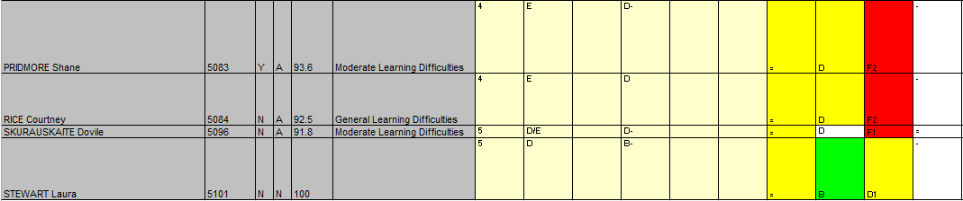
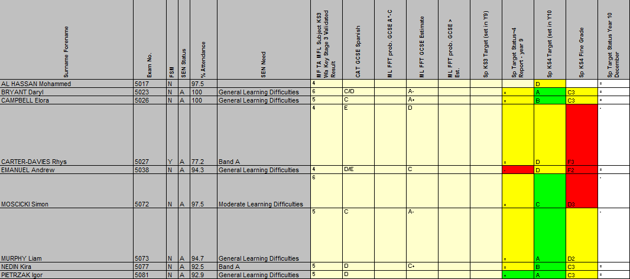

Appendix 2 – List of home/background language of EAL learners, and Stage of English learning.

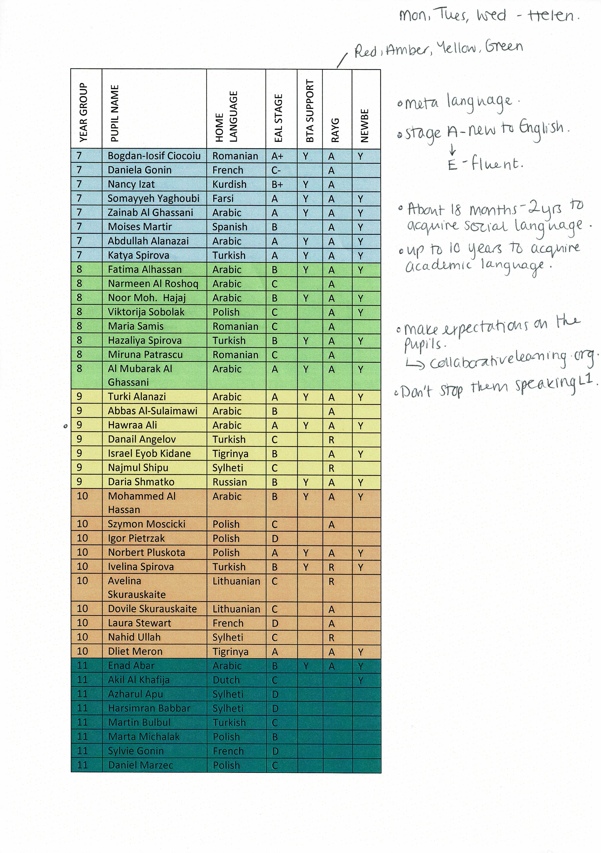

Appendix 3 – Comments made by subject mentor concerning drilling and its usage in the classroom.

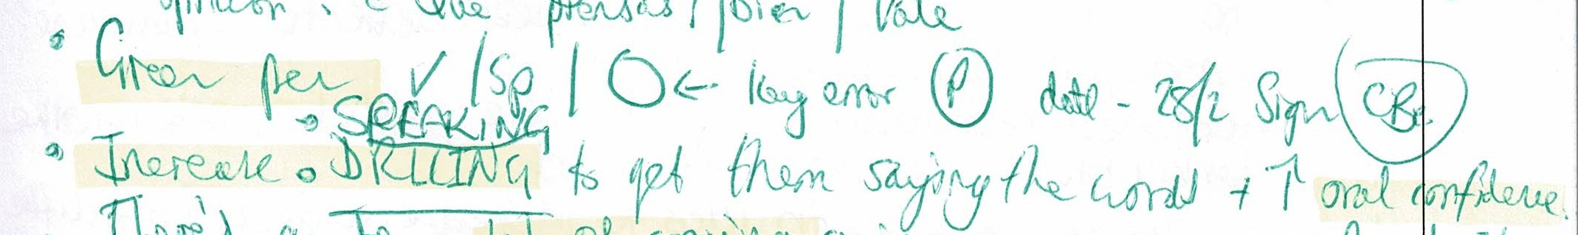

Appendix 4 – Comment from non-specialist Senior Mentor in regards to drilling.

Appendix 5 – Department Scheme of Work outlining the theme and subtopics for lessons.

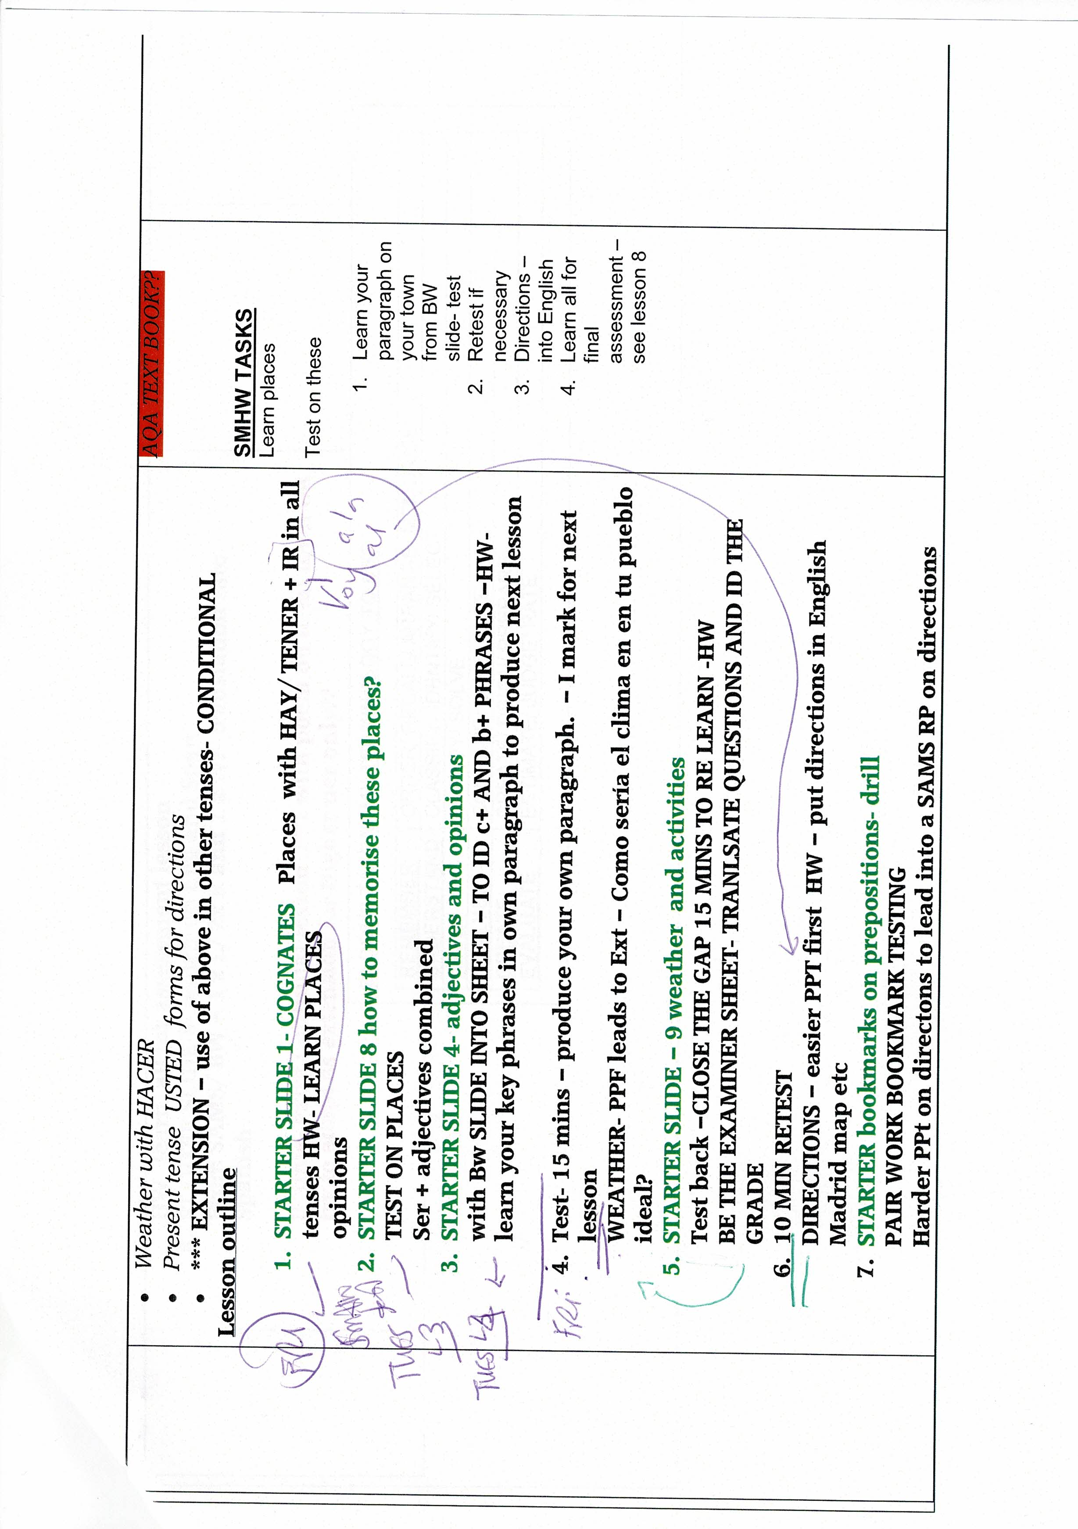
Appendix 6 – Non-drilling intervention lesson reading text, with accompanying activities.
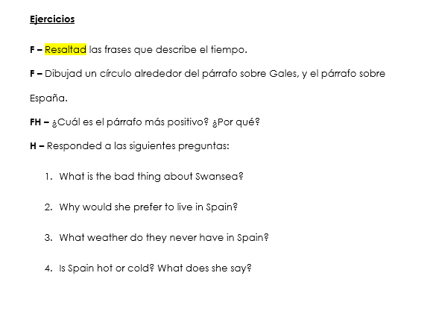
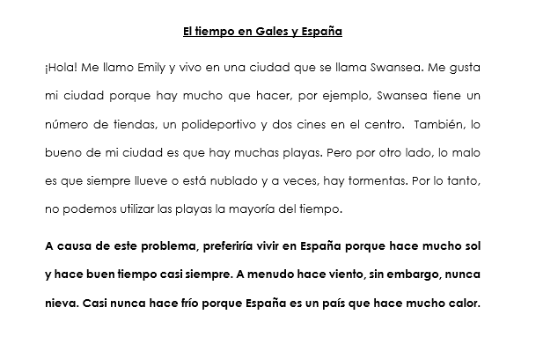

Appendix 7 – Mean results of the initial pre-test and post-test for the non-drilling intervention lesson.

Appendix 8 – Results of initial pre-test and post-test for the non-drilling intervention lesson, by individual learner achievements.

Appendix 9 – Mean results of the initial pre-test and post-test of the drilling intervention lesson.

Appendix 10 – Results of the initial pre-test and post-test of the drilling intervention by individual learner achievements.

Appendix 11 - Results of the summative post-test by topic (weather and directions) and by individual learner achievements.

Appendix 12 – Overall results of the summative post-test (14 chunks in total) by individual learner achievements.

Appendix 13 – Result from the summative post-test of learners that attempted both vocabulary sets, by individual learner achievement.

Appendix 14 – Mean results from the summative post-test of learners that attempted both vocabulary sets, by intervention method.

Appendix 15 – Example of consent forms distributed to learners.


