University of Wales Trinity Saint David

Wales institute of Science and Arts



CFD and Emissions Modelling

Engine Performance and Emissions ACEA7005

Joseph Britton

2104278

April/202
Table of Contents

Table of figures iii
Table of tables iv
Table of equations iv
1. Introduction 1
1.1. Background 1
2. Literature review 2
2.1. Sustainability of biofuels 2
2.2. Properties and benefits of Biobutanol and Bioethanol 2
2.3. Emissions reduction with biofuels 3
2.4. Dual-fuel combustion strategies with ethanol and ethanol 4
2.4.1. Spark ignition 4
2.4.2. Compression ignition 4
3. Methodology & validation 5
3.1. Diesel engine validation 5
3.2. Iso-octane engine validation 8
3.3. Development of dual-fuel strategy 11
4. Realis Wave analysis and strategy proposal 16
4.1. Realis Wave model creation 16
4.2. Comparing E80Bu20 to iso-octane 18
4.3. EGR analysis 19
4.4. FER analysis 20
4.5. Final strategy proposal 22
5. Conclusion 24
References 25

Table of figures
Figure 1 - Bowl profile replicating Claas diesel engine parameters (A) Full sector mesh (B) Piston crown and bowl topology 6
Figure 2 - Comparison of simulated and measured cylinder pressures for Claas engine for 1000RPM to 2200RPM 7
Figure 3 - Comparison of simulated and measured cylinder pressures for Claas engine for 1000RPM 7
Figure 4 - Investigation of ignition timing for iso-octane validation comparing simulated and measured pressures for Ford sigma engine at 2500RPM 9
Figure 5 - Simulated pressure for iso-octane at 2500RPM investigating increasing spark duration 10
Figure 6 - Accumulated chemical heat released and unburnt composition density for increasing spark duration at 2500RPM 10
Figure 7 - Investigation of initial composition temperatures for iso-octane validation comparing simulated and measured pressures for Ford sigma engine at 2500RPM 11
Figure 8 - Accumulated chemical heat released and unburnt composition density for increasing initial composition at 2500RPM 11
Figure 9 - Stoichiometric fuel blend for dual fuel (E80B20) 12
Figure 10 - Comparison of iso-octane and E80Bu20 at 2500RPM 12
Figure 11 - Comparison of combustion characteristics for E80Bu20 for initial composition temperatures ranging between 250k to 400k for 2500RPM 13
Figure 12 - Comparison of combustion characteristics for E80Bu20 for ignition timing ranging from -15 degrees BTDC to – degrees BTDC for 2500RPM 14
Figure 13 - Final engine tuning for E80Bu20 through Ansys Forte at 2500RPM 14
Figure 14 - Single cylinder model within Wave for fuel combustion validation 16
Figure 15 - Combustion validation for single cylinder model in Wave for 2500RPM 17
Figure 16 - Three-cylinder 1.0 litre turbocharged engine architecture in Wave, recreating Ford EcoBoost engine 17
Figure 17 - Wiebe curve using exported 50% burn point, combustion duration and the exponent of the Wiebe function from Ansys Forte 18
Figure 18 - Combustion comparison between E80Bu20 and iso-octane at 2500RPM 18
Figure 19 - Comparison of Brake power and torque for E80Bu20 and iso-octane 19
Figure 20 - Comparing combustion of E80Bu20 for EGR ranging between 0% and 30% at 2500RPM and 0.95FER 20
Figure 21 - Comparing performance and emissions of E80Bu20 for EGR ranging between 0% and 30% at 2500RPM and 0.95FER 20
Figure 22 - Comparing combustion of E80Bu20 for FER ranging between 1 and 0.5 at 2500RPM and 0% EGR 21
Figure 23 - Comparing performance and emissions of E80Bu20 for FER ranging between 1 and 0.5 at 2500RPM and 0% EGR 21
Figure 24 - NOx concentration for ranging FER at 1380RPM and 30% EGR for E80Bu20 22
Figure 25 - Engine power and torque for ranging FER at 30% EGR for E80Bu20 22
Figure 26 - Final proposed strategy combustion characteristics for E80Bu20 (30% EGR and FER=1.0) 23

Table of tables
Table 1 - Properties of Bioethanol and Biobutanol (Obergruber, et al., 2021) (U.S. Department of Energy, 2025) (Heywood, 2018) 2
Table 2 - Engine specifications for Claas engine for replication within the Ansys Forte sector mesh generator 6
Table 3 - Engine specifications for Ford Sigma engine for replication within the Ansys Forte sector mesh generator 8
Table 4 - Parameter study for analysing initial composition temperature of E80Bu20 for 2500RPM 13
Table 5 - Setup specification for single cylinder Wave model 16

Table of equations
$Wiebe MFB=1-e-aθ-θ0∆θm+1$ Equation 1 5
$C8H18+12.5O2+3.76N2→8CO2+9H2O+47N2$ Equation 2 8
$Total mass of iso-octane=8×12.01+18×1.007=114.21kg/kmol$ Equation 3 8
$Total mass of air=12.5×32+12.5×3.76×28=1716kg/kmol$ Equation 4 8
$AFR=1716114.21≈15.02$ Equation 5 8
$Fuel mass fraction=114.21114.21+1716≈0.062$ Equation 6 8

Introduction
Due to the current demands set by global regulations placing increasing pressure on the vast motor industry, the need for research and development to the performance and efficiency of internal combustion engines (ICE) is paramount. Whilst electrification dominates much of the current workings of industry, providing a greener image from the outward perspective, ICEs are expected to remain as crucial competitors within industry if developments to reduce emissions production. Using suitable extrapolation of the proposed 2035 regulations for emissions, an improved engine architype and combustion strategy will be proposed fuelled by a non-carbon-based or synthetic alternative.
To fight environmental factors, biofuels such as bio-butanol and bioethanol become alternative renewable substitutes. Such biofuels, derived from organic matter, will have the potential to reduce emissions of greenhouse gases by serving as a low-carbon or carbon-neutral fuel alternative to conventional petroleum-based fuels. Bio-butanol, for example, contains more energy and is better suited to existing engine technology, whereas bioethanol enjoys the same benefits of emissions reduction and is already extensively used. The 2035 emissions regulations, which are intended to further constrain the CO₂ emissions of ICEs, have placed tremendous pressure on the motor industry to develop innovative solutions. Such fuels and technology shall be launched by car producers to fulfil new standards, therefore making biofuels an attractive solution for fulfilling regulatory requirements as well as an easy step to a cleaner transport system.

Background
Biofuels like bioethanol and bio-butanol are renewable fuels derived from organic material. The sustainable production of biofuels has the potential to decrease life-cycle CO₂ emissions significantly when compared to fossil fuels. For example, a GREET model-based analysis estimated 32%–48% less greenhouse gas emission from vehicles operated on bio-butanol when compared to gasoline-fuelled vehicles on a well-to-wheel basis. Moreover, the production of bioethanol from food waste is considered a green process. that can significantly contribute to greenhouse gas emissions savings (Wu, et al., 2008) (Konti, et al., 2020). Dual-fuel combustion strategies, in which biofuels are mixed with traditional fuels like diesel or gasoline, are promising solutions to realise the optimal combustion efficiency and emission characteristics of ICEs.

Literature review

Sustainability of biofuels
Biofuels are renewable energy sources made from organic materials, they are categorised based on sources and technologies used for their production. First-generation biofuels are produced directly from food crops, where common examples include bioethanol and biodiesel. Despite their renewability, concerns have been raised around disruptions to the food chain and land usage for production (Ye, et al., 2024). Whilst second generation biofuels are produced from non-food biomass, including agricultural residues, waste oils and lignocellulosic materials. These aim to overcome the food-versus-fuel dilemma associated with first-generation biofuels. Furthermore, third-generation biofuels come from algae and other microorganisms, which yield large amounts of oils to be converted, this can be cultivated on non-arable land and utilise wastewater. The final- fourth generation biofuels, type involves genetically engineered organisms designed to produce biofuels more efficiently. Some approaches in doing so aim to capture and store carbon dioxide during the production process, leading to carbon-negative fuels (Lozano, et al., 2020).

Properties and benefits of Biobutanol and Bioethanol
A comparison of key fuel properties is summarised in Table 1 (Obergruber, et al., 2021) (Obergruber, et al., 2021) (U.S. Department of Energy, 2025) (U.S. Department of Energy, 2025) (Heywood, 2018) (Heywood, 2018). Ethanol offers a very high-octane rating and strong knock resistance, while butanol contributes higher energy density and improved volatility characteristics, balancing the trade-offs when blended.
Table 1 - Properties of Bioethanol and Biobutanol (Obergruber, et al., 2021) (U.S. Department of Energy, 2025) (Heywood, 2018)
Property | Bioethanol | Biobutanol
Energy density (MJ/L) | 21-24 | 29-30
Research octane number (RON) | ~108 | ~94
Reid vapor pressure (kPa @ 37.8°) | ~16.4 | ~2.2
Latent Heat of Vaporisation (kJ/kg) | ~904 | ~585
Water Solubility (g/100g H₂O) | Completely miscible | ~7.7g/100g water

An advantage for the use of Biobutanol is its compatibility with existing infrastructure and applications within automobiles. Butanol’s lower oxygen content allows up to 11.7% v/v gasoline under the dame oxygen limits and studies show 16% isobutanol (iB16) can be used in replacement of E10 (U.S. Department of Energy, 2025). In contrast, Ethanol can corrode existing fuel systems due to its hydroscopic properties which mean it readily mixes with water. Ethanol-blended gasoline is typically limited by regulations to E10–E15 in conventional engines, in part due to material compatibility and water tolerance issues.

Emissions reduction with biofuels
Substitution of bioethanol and biobutanol for fossil fuels is a hopeful route to reducing net CO₂ emissions from transport. While these alcohols do emit CO₂ upon combustion, they obtain their carbon from biomass and therefore come very close to being carbon-neutral on a lifecycle basis. Ethanol is low in carbon and high in oxygen per molecule and has a lower CO₂ emissions per unit of energy than gasoline. It is, nonetheless, lower in energy density and thus higher in consumption per km, which limits tailpipe CO₂ reduction unless efficiency in the engine is maximised (Han, et al., 2020). Lifecycle analyses show that bioethanol and biobutanol can reduce GHG emissions by 35–80% based on feedstock, with highest savings from second-generation sources like lignocellulose (Fernández, et al., 2021).
Alcohol fuels are much cleaner regarding local emissions. Both butanol and ethanol reduce particulate matter (PM) due to their inherent oxygenation and lack of aromatics, which promotes complete combustion. Tests in diesel engines show up to 50% PM reduction with low blends of butanol, with near-zero soot in higher blending ratios under exhaust gas recirculation (EGR) operation (Han, et al., 2020) (Fernández, et al., 2021). Ethanol blends also yield soot reductions, especially under medium load. The drawback is an inclination to raise CO and hydrocarbon (HC) emissions when there is poor combustion, mainly due to lower combustion temperatures and delayed ignition. This can be regulated by after-treatment systems.
NOx emissions are engine configuration dependent. Alcohol blends work to decrease peak temperatures, which can suppress NOx. Ethanol-diesel blends have shown reductions in NOx with lean burn and EGR strategies. Butanol blends can raise NOx if combustion is more complete and peak temperatures are increased. Sensitive calibration, including timing and application of EGR, needs to be achieved to achieve NOx and PM reduction simultaneously (Han, et al., 2020).
Feedstock continues to dictate sustainability. First-generation biofuels like corn ethanol or ABE butanol provide poor returns but create land use and food security issues. Second-generation alternatives produced from waste or lignocellulosic feedstock bypass such concerns and deliver more robust GHG savings of up to 80%. Further, these alcohols are sulphur-free, which means there are no SOx emissions, and reduce significantly carcinogens such as benzene and 1,3-butadiene when compared to petrol or diesel. Therefore, sustainably produced butanol and ethanol from dual-fuel systems offer a genuine pathway to cleaner burning and reduced carbon, underpinning 2035 emissions targets.

Dual-fuel combustion strategies with ethanol and ethanol

Spark ignition
In SI engines, ethanol is already widely used as a dual fuel blend component alongside gasoline, with the likes of E10, E15 and E85. Recent research has also included the likes of biobutanol as a ternary blend alongside ethanol and gasoline to utilise the advantages presented from all three fuel sources. A study performed by Zhao and Wang found that increasing butanol in E10 blends raised the brake thermal efficiency (BTE) of the engine relative to plain E10, thanks to more charge cooling and knock reduction, and the power output remained like E10 (Zhao & Wang, 2020). This addition prolonged ignition delay and prolonged combustion duration, reducing knock intensity and allowed stable operation even at higher alcohol fraction. This suggests a synergistic effect: ethanol provides high octane, while butanol provides energy density, and together in gasoline they can burn more efficiently with controlled combustion phasing. Zhao’s study further noted the introduction of EGR which allowed stable combustion even at higher butanol contents, thus cutting the production of NOx and mitigating the tendency of increased cylinder pressure due to the faster burning.

Compression ignition
In compression-ignition (CI) engines, dual-fuel strategies typically involve either direct blending of alcohols into diesel or dual-injection systems, where alcohol is port-injected, and diesel provides ignition. Direct blending can improve particulate emissions but often suffers from poor miscibility and cold start issues with ethanol, limiting substitution levels without significant engine modification (Fernández, et al., 2021). Dual-injection strategies, while offering higher substitution ratios and improved combustion efficiency (Birhanu, 2022), require complex fuelling systems and are more suited to compression-ignition engines designed around diesel combustion. Given the objectives of this project — to optimise combustion for a downsized, boosted spark-ignition (SI) engine using a high-ethanol biobutanol blend — a CI strategy was not pursued. Instead, SI operation allows full exploitation of ethanol’s high knock resistance and biobutanol’s improved energy density, while maintaining compatibility with standard port fuel injection and ignition control systems. Additionally, in compression ignition contexts, ethanol’s poor miscibility with diesel can be improved using surfactants such as tri-n-butyl phosphate, enhancing its application potential (El-Sheekh, et al., 2023).

Methodology & validation
The workings of this research utilise Ansys Forte to model the combustion of the fuel, whilst the combustion strategy is investigated with the use of Realis Wave. The reason behind the use of two software packages is perform analysis with the best computational efficiency. Forte is better at combustion modelling in comparison to Wave, however, simulations can become cumbersome to model very intricate systems due to the 3D CFD modelling. In contrast, Wave simulations can be performed much quicker, allowing better use of time to allow for the best findings. Forte will be used to find the Wiebe function for the fuel, this allows calculation of three parameters which Wave requires to model combustion, these being 50% burn point, combustion duration and the exponent of the Wiebe function, ‘m’ in Equation 1.
$Wiebe MFB=1-e^{{-a\left(\frac{θ-θ_{0}}{∆θ}\right)}^{m+1}}$ Equation 1

Diesel engine validation
Initial workings aimed to validate the accuracy of Forte simulations through comparison to real data gathered from a Claas engine. The engine geometry (including bore, stroke, connecting rod length and bowl profile) is replicated within the Forte sector mesh generator in accordance with the specifications stated through Table 2, also the bowl topology and profile can be seen in Figure 1. To optimise computational efficiency, a sector angle of 45° is selected, this allows a suitable area of the cylinder to be analysed alongside enough area for the placement of the injector nozzle for the spray model, whilst not being so large as to prolong simulation times without necessity. The mesh seen through Figure 1A is the standard mesh supplied through the Quick-start_SectorMesh tutorial provided by Ansys, this ensures suitable selection of cell count for the best ratio of simulation time to accuracy (Ansys, 2021). The remaining setup parameters for soot modelling, spray modelling and initial conditions are left as the standard values provided through the tutorial content as a basis for validation.
Table 2 - Engine specifications for Claas engine for replication within the Ansys Forte sector mesh generator
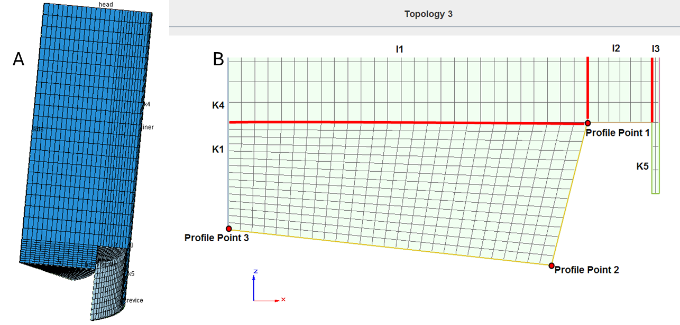
Figure 1 - Bowl profile replicating Claas diesel engine parameters (A) Full sector mesh (B) Piston crown and bowl topology
Simulating this model through the range of RPM range of the provided data from Claas (1000RPM to 2200RPM) is done and comparisons of simulated and measured values are shown in Figure 2. Clear discrepancies can be seen throughout the RPM range between the peak values for pressure, this is due to the lack of tuning to the system as RPM increases. In the measured data, the fuel delivery to the engine will alter as RPM increases alongside boost pressure from the turbocharger. As these parameters were simulated as constant throughout the range of RPM there is a clear reason for the inaccuracies seen. Also to note is the smoothness in pressure increase and decrease from simulated data, this is due to a lack of noise in data retrieval, as is present in the measured data due to sensor-induced noise, combustion variability, and mechanical tolerances. These disturbances introduce fluctuations in actual cylinder pressure readings due to factors like sensor thermal drift, mechanical vibrations, and cycle-to-cycle combustion inconsistencies (Vollberg, et al., 2022).

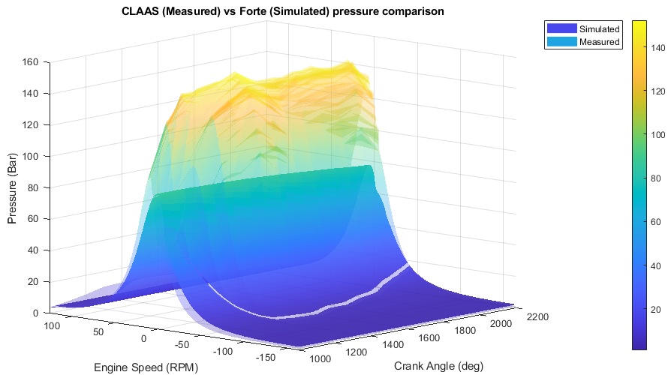
Figure 2 - Comparison of simulated and measured cylinder pressures for Claas engine for 1000RPM to 2200RPM
When analysing for a singular RPM, in this case 1000RPM, cylinder pressures are more representative of the measured data, see Figure 3. This now proves the ability of the system to accurately model the combustion of the model. To further validate this model by altering simulation setup to replicate the measured data to a higher accuracy would be a poor use of time resources as the accuracy of this model is not the objective of this analysis, rather the ability of the simulation to model the combustion with rough accuracy.
Figure 3 - Comparison of simulated and measured cylinder pressures for Claas engine for 1000RPM

Iso-octane engine validation
With the validation of the simulation for diesel, now petrol fuelling can be analysed and compared to existing pressure data from a ford sigma engine, as done with the diesel validation case the engine parameters must be replicated within the sector mesh generator for this new geometry, seen in Table 3. Through initial analysis, the given value for clearance height in does not correlate directly to the squish parameter within the Forte sector mesh generator, leading to subsequent testing of squish values to find a value of 4.93mm to provide the simulation with a matching compression ratio.
Table 3 - Engine specifications for Ford Sigma engine for replication within the Ansys Forte sector mesh generator
Ford sigma engine parameters | Value
Bore (mm) | 79
Stroke (mm) | 81.4
Connecting rod length (mm) | 137
Compression ratio | 11.16
Clearance height (mm) | 7.29
Bowl Profile | Flat piston crown

Unlike the diesel model which introduces the fuel to the cylinder through direct injection, the petrol model will be modelled with the fuel as part of the initial composition entering the cylinder alongside the air. This requires calculations of the mass fractions of the fuel (iC8H18), and air (comprised of O2 and N2) at stoichiometric combustion. This is done through balancing the stoichiometric combustion reaction, iso-octane combusts in the presence of oxygen and nitrogen from air, yielding carbon dioxide, water, and nitrogen as products, this can be seen in Equation 2.
$C_{8}H_{18}+12.5\left(O_{2}+3.76N_{2}\right)→8{CO}_{2}+9H_{2}O+47N_{2}$ Equation 2
In this reaction, 1 mole of iso-octane requires 12.5 moles of oxygen, accompanied by 3.76 times as many moles of nitrogen. Now, stoichiometric air-fuel ratios can be calculated through understanding the mass fractions of the components in correspondence with Equation 2. The resultant calculations are shown in Equations 3 through 6. Resulting in 6.2% of the initial composition being fuel.
$Total mass of iso-octane=\left(8×12.01\right)+\left(18×1.007\right)=114.21kg/kmol$ Equation 3
$Total mass of air=\left(12.5×32\right)+\left(12.5×3.76×28\right)=1716kg/kmol$ Equation 4
$AFR=\frac{1716}{114.21}≈15.02$ Equation 5
$Fuel mass fraction=\frac{114.21}{114.21+1716}≈0.062$ Equation 6
Another difference between this validation and the diesel validation is the introduction of a spark plug as the sigma engine and all other iso-octane powered ICE is SI. Spark timing and duration must be estimated using literature to as a basis for investigation. The Ford sigma data will be compared for the 2500RPM, this replicates a medium load scenario where engine is neither idling nor at full load.
Suggested spark ignitions times vary for this load case with a range of -20 to 0 degrees hence a sweep though of these values is conducted to determine which is most suitable, for this initial investigation, spark duration is set to 8 degrees (Olesky, et al., 2014) (Han & Hwang, 2013). Analysing this investigation through Figure 4, it is clear the closer to top dead centre (TDC), 0 degrees crank angle, the better the correlation to measured data. However, due to the slightly decreased peak pressure seen comparing -2.5 and 0 degrees before TDC (BTDC), a value of -2.5 BTDC is selected for continuing analysis.
Figure 4 - Investigation of ignition timing for iso-octane validation comparing simulated and measured pressures for Ford sigma engine at 2500RPM
The next investigation performed revolved around the spark duration with began at 5 degrees sweeping through to 20 degrees, these values were informed through the findings of Papagiannakis et al. (Papagiannakis, et al., 1027). Through initial analysis, it seems that spark duration has little effect on combustion through Figure 5, yet with further interrogation of the data through Figure 6 it is clear that 7.5 degrees of spark duration provides the best combustion with the fastest complete combustion as is seen with the early return to 0 for the unburnt composition density, at the point in which this parameter returns to 0 is the point of combustion completeness. This finding is reinforced through the words of Heywood and Chupka, where findings indicate a spark duration between 7 and 10 degrees maximise the rate of flame kernel development and helped reduce combustion variability in light-load SI engines (Heywood, 2018) (Chupka, et al., 2015).
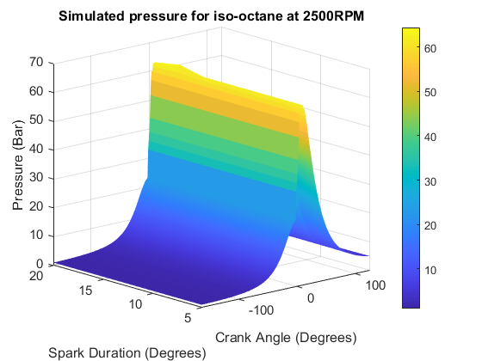
Figure 5 - Simulated pressure for iso-octane at 2500RPM investigating increasing spark duration
Figure 6 - Accumulated chemical heat released and unburnt composition density for increasing spark duration at 2500RPM
The final input parameter for consideration is initial composition temperature, this is tested for a range of 300k to 500k. This range is selected because it spans from cool intake charge conditions to high compression-induced pre-ignition temperatures, capturing the thermodynamic variability seen in realistic engine operation. It's a validated and widely used interval for evaluating combustion sensitivity and ignition behaviour in SI engine studies as stated by Heywood and Leite (Heywood, 2018) (Leite, et al., 2024). Through analysis of both Figure 7 400k and 425k both replicate the Sigma data with the best accuracy, however when analysing Figure 8 400k has a slow rate of combustion from its longer unburnt composition density duration in comparison to 400k which completes the combustion cycle fully at a faster rate, leading to the optimum setup to use as a basis for the dual duel investigation to follow.
Figure 7 - Investigation of initial composition temperatures for iso-octane validation comparing simulated and measured pressures for Ford sigma engine at 2500RPM
Figure 8 - Accumulated chemical heat released and unburnt composition density for increasing initial composition at 2500RPM

Development of dual-fuel strategy
Within Forte, the dual fuel simulation can be done through a simple mixture of both fuels, done at a ratio of 80% ethanol to 20% butanol, the stoichiometric blend for this can be seen in Figure 9 with a ratio of 9.38:1. Initial combustion strategy began by replicating the strategy used for iso-octane due to the similarities in combustion for this blend. The initial strategy for this fuel will be run using identical parameters as to that of the iso-octane simulation previously as a point of comparison between the two due to their similarities in combustion.

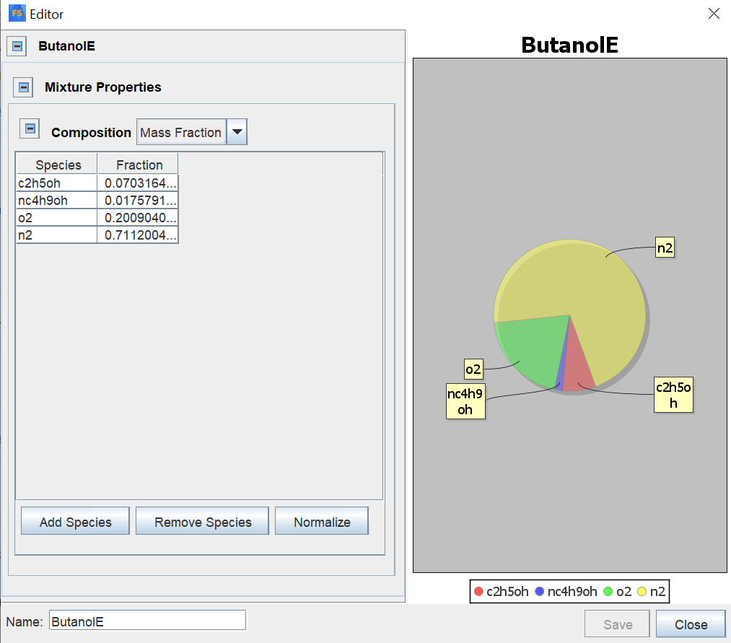
Figure 9 - Stoichiometric fuel blend for dual fuel (E80B20)
The initial testing comparing iso-octane and the dual fuel blend using the iso-octane strategy for both can be seen in Figure 10. Using the same strategy for combustion, E80Bu20 struggles to combust, as depicted from the low rate of chemical heat release. This requires alterations to the proposed combustion strategy through informed decisions from literature to promote combustion of the mixture.
Figure 10 - Comparison of iso-octane and E80Bu20 at 2500RPM
This discovery requires interrogation of the results from Figure 10 to analyse why the mixture is not combusting fully, where the first conclusion and testing point would be revolving around intake temperatures. As stated by Hieu, ethanol’s high latent heat of vaporisation and auto-ignition temperature require elevated intake temperatures to ensure complete vaporisation and successful ignition, particularly at medium load (Hieu, et al., 2023). Their findings show that increasing intake mixture temperature not only advances the start of combustion but also significantly reduces combustion variability. The initial strategy used an initial composition temperature of 425k, as the temperature requires reduction, a study was performed in accordance with the parameter studies seen in Table 4.
Table 4 - Parameter study for analysing initial composition temperature of E80Bu20 for 2500RPM
Run | Initial composition temperature (k)
Nominal | 250
Run 1 | 275
Run 2 | 300
Run 3 | 325
Run 4 | 350
Run 5 | 375
Run 6 | 400

Figure 11 - Comparison of combustion characteristics for E80Bu20 for initial composition temperatures ranging between 250k to 400k for 2500RPM
The results in Figure 11 show no improvement to the combustion of the fuel, leading to another investigation which aims to advance the ignition timing. This modification agrees with the workings of Kim, who states that ethanol port injection combined with spark advance improves combustion stability and efficiency in spark-ignition engines (Kim, et al., 2015). Their study highlights that advancing ignition timing helps compensate for ethanol’s slower flame speed and higher resistance to auto-ignition. As no clear improvement was made through the alterations made to initial composition temperature, an intermediate value of 300k is selected for subsequent analysis where ignition timings range for -5 to -15 degrees BTDC. The results from this study are depicted through Figure 12, there are still issues with completing combustion, so the conclusion is the system needs a stronger combustion due to the lack of increasing pressure after the initial combustion which is evident from the pressure graphs. To remedy this, a boosting is applied by increasing the initial composition pressure, mimicking a turbocharging effect. This will increase the density of the mixture allowing for a larger combustion event.
Figure 12 - Comparison of combustion characteristics for E80Bu20 for ignition timing ranging from -15 degrees BTDC to – degrees BTDC for 2500RPM
With the increasing of initial composition pressure to 1.52 Bar, the results are shown through Figure 13. This model required additional adjustments to piston, liner and head temperatures to ensure a smooth and complete combustion.
Figure 13 - Final engine tuning for E80Bu20 through Ansys Forte at 2500RPM
Now with a valid combustion profile, the next step of the process is to export the Wiebe function of the mixture for use in Realis Wave. This requires the use of the Rassweiler and Withrow method to determine the 50% burn rate point, combustion duration and exponent of the Wiebe function ‘m’. By separating the pressure rise due to combustion from the volume-induced pressure change using a polytropic model, the cumulative heat release profile can be constructed. This MFB profile is then used to extract the exponent ‘m’ in the Wiebe function, see Equation 1, which governs the shape and steepness of the combustion rate curve. This method, as described by Brunt is widely adopted for its simplicity and accuracy in spark ignition combustion diagnostics (Miller, et al., 1998). Using the curve fitting tool within MATLAB to obtain the exponent ‘m’, the resultant value is 1.4027, This value shows correspondence with research into both ethanol and butanol combustion.

Realis Wave analysis and strategy proposal

Realis Wave model creation
Using the foundations built within Ansys Forte, the project can start to model the fuel within Wave. This will allow for proper strategy formulation due to the decreased simulation times and complexity of simulation. The initial modelling began with the creation of a single cylinder model to validate combustion, enhancing computational efficiency, before moving on to more complex models for strategy testing. The single cylinder model is gathered through the Wave tutorial quick start models and built upon to allow for the dual fuel analysis, this model can be seen in Figure 14.
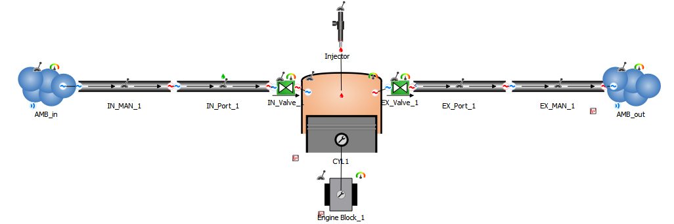
Figure 14 - Single cylinder model within Wave for fuel combustion validation
Once this model is setup using the parameters specified in Table 5, validation of fuel combustion can be completed, providing the results seen in Figure 15, thus validation combustion of the fuel within Wave. Leaving the next task to model this fuel within a more advanced system for emissions and performance analysis.
Table 5 - Setup specification for single cylinder Wave model
Variable | Case 1
RPM | 2500
AFR | 9.38
EGR Fraction | 0
Compression ratio | 10
FER | 0.95
Start of injection (Degrees) | -37
Boost pressure (Bar) | 1.5
50% Burn point | 13.03
Combustion duration | 56.9478
Exponent in Wiebe function | 1.4269
Figure 15 - Combustion validation for single cylinder model in Wave for 2500RPM
The model seen in Figure 16 replicates the Ford EcoBoost engine, this architecture provides a strong basis to work off as it models a small form factor engine with boosting, which is the type of ICE that can realistically be used under extrapolated regulations. This model is gathered and modified through the engine database within Wave. With the correct fuel file uploaded using the ‘CreateFuelFiles’ tutorial to create a multi fuel with the correct ratios, alongside the burn profile, see Figure 17, initial testing can be carried out.
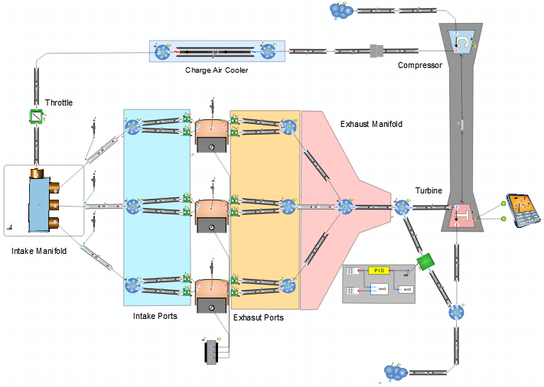
Figure 16 - Three-cylinder 1.0 litre turbocharged engine architecture in Wave, recreating Ford EcoBoost engine

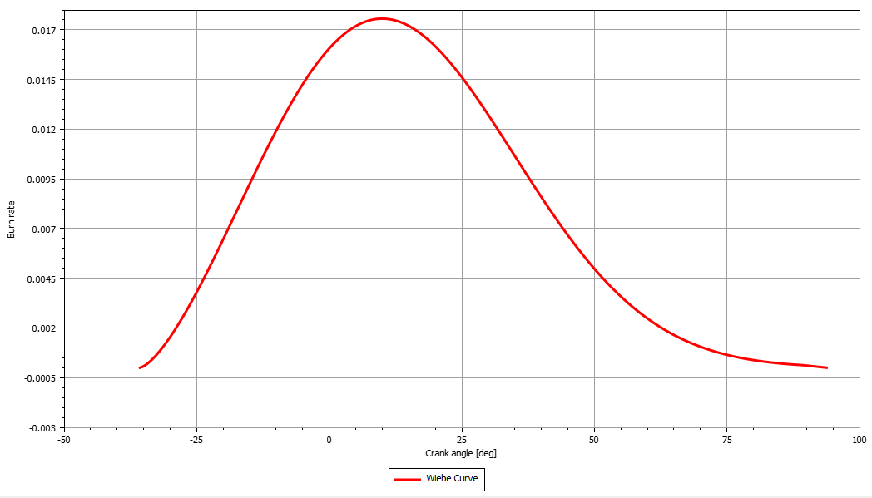
Figure 17 - Wiebe curve using exported 50% burn point, combustion duration and the exponent of the Wiebe function from Ansys Forte

Comparing E80Bu20 to iso-octane
Using the standard model to compare results, we can validate the correct combustion of the fuel blend through expected trends. As stated through these workings, the fuel blend combusts at a cooler rate with a higher energy release, alongside a longer combustion period and lower NOx emissions. All four of these conclusions are validated through analysis of Figure 18. Additionally, looking at Figure 19, the new fuel blend provides better performance characteristics with 10.31BHP more peak power and 35.36Nm more peak torque, with peak torque coming very early in the rev range of the engine. These improvements mean the fuel can be tailored to suit several uses from performance use to hyper efficient economy uses dependant on the needs. This comparative analysis is performed without the introduction of an EGR system and at stoichiometric combustion, leaving further improvement to strategy to be investigated.
Figure 18 - Combustion comparison between E80Bu20 and iso-octane at 2500RPM
Figure 19 - Comparison of Brake power and torque for E80Bu20 and iso-octane

EGR analysis
Looking at the investigation performed in Figure 20, peak pressures fall steadily with the introduction of EGR due to the dilution of the fuel and increased specific heat capacity, leading also to cooler combustion, this trend is similarly observed by Han through their study on a similar fuel blend (Han, et al., 2020). The workings of Shang confirm the accumulated heat released curve with the flattening and shifting of the curve with rising EGR, a consequence of slower chemical kinetics due to lower oxygen content, alongside the decreasing Nox emissions which validates the suppression of thermal Nox through reduced flame temperatures also consistent with Shang’s and Liu’s findings (Shang, et al., 2023) (Liu, et al., 2013). Whilst Figure 20 highlights the benefits of introducing EGR, Figure 21 shows some of the disadvantages of this introduction. As EGR increases, both engine power and torque exhibit a steady decline, due to the reduced oxygen availability and charge dilution weakening the combustion event, similarly observed by (Choi, et al., 2017). Despite the large decreases in Nox and HC concentration with EGR increases, supported by Yao, there is decreasing volumetric efficiency as inert gas displaces the fresh air volume, thus decreasing trapped air mass flow (Yao, et al., 2019).
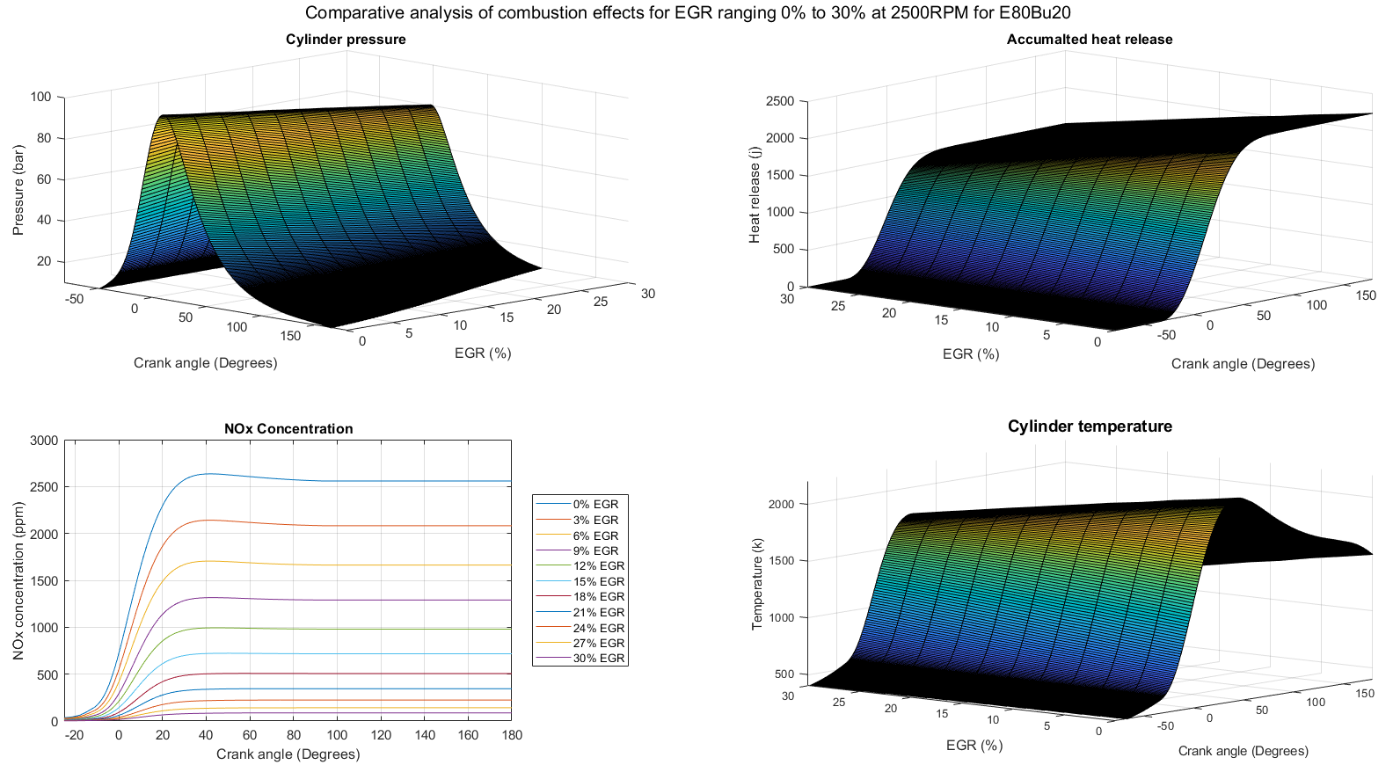
Figure 20 - Comparing combustion of E80Bu20 for EGR ranging between 0% and 30% at 2500RPM and 0.95FER
Figure 21 - Comparing performance and emissions of E80Bu20 for EGR ranging between 0% and 30% at 2500RPM and 0.95FER

FER analysis
Similar trends are seen across Figure 20 and Figure 21 as Figure 22 and Figure 23 with the reduction of FER (leaner mixtures), cylinder pressure, accumulated heat release and peak combustion temperatures all decline significantly. A result of reduced fuel energy and slower combustion kinetics, these trends being consistent with the works of (Karavalakis, et al., 2015). Szybist and Bunting also report lowering Nox concentration with leaner operation, also observed here, resultant off lowering combustion temperature on their study on lean-burn alcohol fuels (Szybist & Bunting, 2015). Figure 23 highlights the shift in power and torque with increases towards leaner mixtures, reinforced by the increased heat release at these richer mixtures. Simultaneously, HC emissions rise under richer conditions, showing increasing incomplete combustion, however, this trend tapers off once stoichiometric combustion is reached, alongside Nox emissions which decrease once FER=1.0 is reached, these findings consistent with the work of (Jung, et al., 2020).
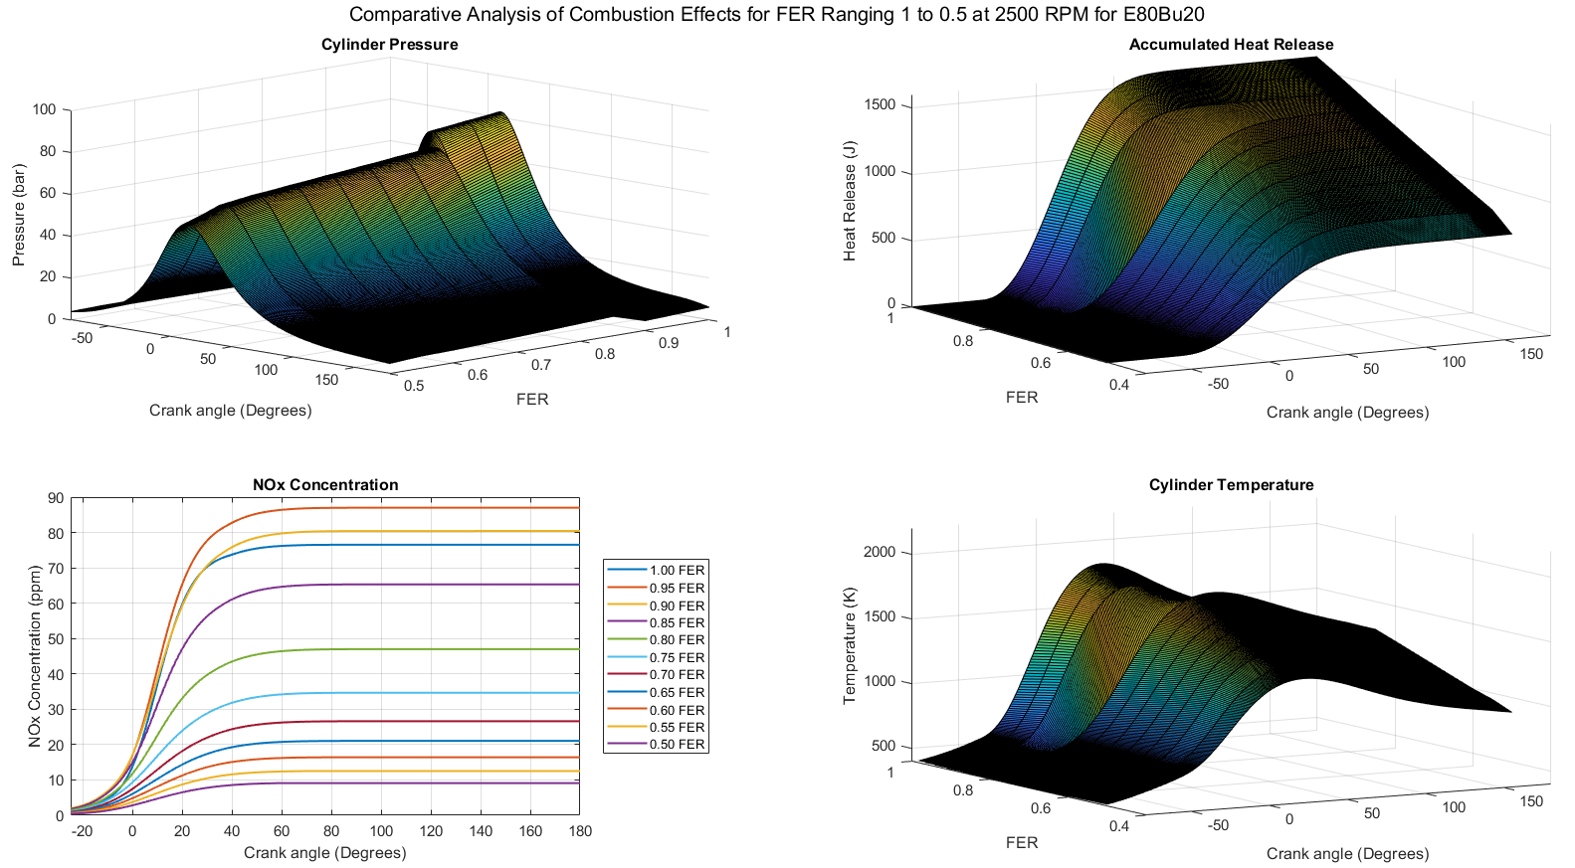
Figure 22 - Comparing combustion of E80Bu20 for FER ranging between 1 and 0.5 at 2500RPM and 0% EGR
Figure 23 - Comparing performance and emissions of E80Bu20 for FER ranging between 1 and 0.5 at 2500RPM and 0% EGR

Final strategy proposal
The trend in Figure 24 is fully consistent with combustion theory as reducing the FER reduces the peak combustion temperature and oxygen availability, both essential for NOx formation by the thermal Zeldovich mechanism, as agreed with the findings of (Wu, et al., 2022) which states that leaner mixtures in combination with moderate EGR has a considerable suppressive effect on NOx formation in ethanol-blended SI engines. It is also noted that the rate of NOx reduction decreases as the FER declines below approximately 0.7, suggesting that the primary NOx formation pathways are almost closed under very lean conditions. However, very lean mixtures suffer from stability issues and misfire, which can lead to higher HC and CO emissions, already addressed by (Feng, et al., 2020).
Figure 24 - NOx concentration for ranging FER at 1380RPM and 30% EGR for E80Bu20
In Figure 25 is the corresponding engine power and torque outputs across the same FER range at 30% EGR. As expected, power and torque steadily decrease as the mixture becomes leaner. This is due to the lower fuel energy content in the mixture and slower combustion rates, resulting in reduced pressure rise and mechanical work output, similar trends are seen in Koike’s assessment of E85 fuelled boosted engines under lean and high EGR conditions (Koike, et al., 2018).
Figure 25 - Engine power and torque for ranging FER at 30% EGR for E80Bu20
The final combustion characteristics for 30% EGR and FER = 1.0 confirm that the project objectives have been achieved, see Figure 26. Cylinder pressure and cumulative heat release plots show stable, complete combustion across the full speed range, validating the effectiveness of the proposed ignition and boost strategy. NOx emissions remain consistently low, indicating successful emissions control with EGR without loss of combustion stability. The torque and power plot confirms good low-to-mid range performance with maximum power at 5200 RPM, realizing the goal of balancing emissions reduction with realistic engine output. In general, the final strategy properly integrates sustainable biofuels with performance and emissions goals.
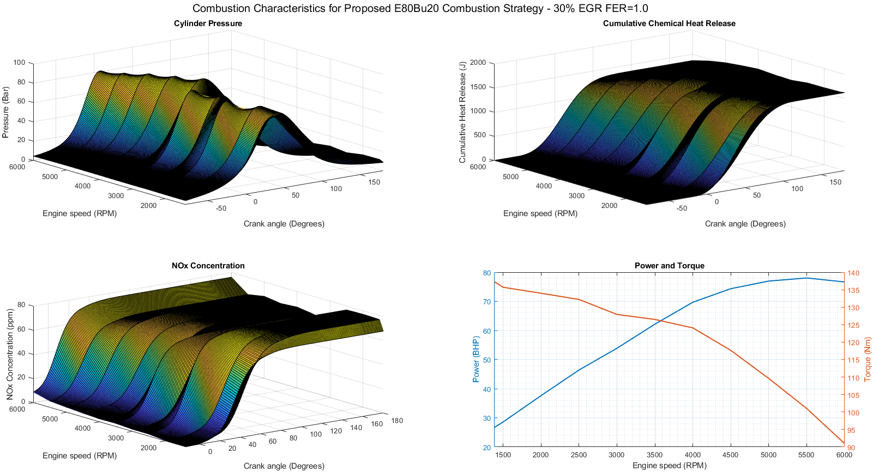
Figure 26 - Final proposed strategy combustion characteristics for E80Bu20 (30% EGR and FER=1.0)

Conclusion
This project was successful in establishing and verifying a combustion strategy for an E80Bu20 blend fuel, meeting the main targets of reducing emissions, maintaining engine performance, and meeting future regulation requirements. By coupling high-resolution CFD combustion simulation within Ansys Forte with engine performance simulation within Realis Wave, the optimal approach — 30% EGR, stoichiometric FER of 1.0, and moderate intake boosting — was found to deliver stable combustion, significantly reduced NOx emissions, and robust low- to mid-range engine performance. The E80Bu20 blend took advantage of the complementary fuel characteristics of ethanol and biobutanol to ensure clean combustion at an acceptable performance compromise. The most effective optimisation techniques like ignition timing retard and intake pressure lowering were at the forefront in managing issues arising from the alcohol blend's high latent heat and low volatility. These findings confirm that sustainable, renewable fuels represent a cost-effective replacement for traditional fossil fuels in spark-ignition engines without revolutionary re-design of the engine to meet future standards of emissions. Overall, the project demonstrates that effective formulation of combustion strategy can close the gap between on-road engine performance and environmental sustainability.

References
Ansys, 2021. Fore Tutorials. Canonsburg: ANSYS, Inc..
Birhanu, B., 2022. Investigation of Performance and Emission Characteristics of Diesel-Ethanol PCCI Engine. International Journal of Research in Science, 21(1), pp. 25-40.
Choi, Y., Kim, S. & Lee, C., 2017. Effect of EGR and Alcohol Blending on Performance and Emissions Characteristics of Gasoline Engines. SAE International Journal of Engines, 10(3), pp. 1425-1435.
Chupka, G., Christensen, E., Fouts, L. & Alleman, T., 2015. Heat of Vaporization Measurements for Ethanol Blends Up To 50 Volume Percent in Several Hydrocarbon Blendstocks and Implications for Knock in SI Engines. SAE International Journal of Fuels and Lubricants, 8(2), pp. 251-263.
El-Sheekh, M., El-Nagar, A., El-Kelawy, M. & Bastawissi, H., 2023. Solubility and stability enhancement of ethanol in diesel fuel by using tri-n-butyl phosphate as a new surfactant for CI engine. Scientific reports, 13(1).
Feng, Z., Liu, H. & Yao, M., 2020. Effects of Ethanol Blends and Lean-Burn Strategy on Combustion Stability and Emissions in a Spark-Ignition Engine. Fuel, 276(1).
Fernández, D., Lapuerta, M. & German, L., 2021. Progress in the Use of Biobutanol Blends in Diesel Engines. Energies, 14(11).
Han, J., He, W. & Somers, L., 2020. Experimental Investigation of Performance and Emissions of Ethanol and n-Butanol Fuel Blends in a Heavy-Duty Diesel Engine. frontiers in Mechanical Engineering, 6(26).
Han, S. & Hwang, S., 2013. Experimental Study on the Cycle-to-Cycle Combustion Variations in a Spark Ignition Engine. Journal of Energy Engineering, 22(2), pp. 197-204.
Heywood, J. B., 2018. Internal Combustion Engine Fundamentals. 2nd ed. New York: McGraw-Hill Education.
Hieu, P. et al., 2023. Impacts of Ethanol Proportion and Charged Temperature on the Combustion Charecteristics of HCCI Engines. Journal of southwest Jiaotong university, 58(8), pp. 653-668.
Jung, Y., Park, S. H. & Lee, C., 2020. Effect of Combustion Phasing on Performance and Emissions Characteristics in a Stoichiometric Spark-Ignited Engine Fueled with Ethanol and Gasoline Blends. Applied Energy, 264(1).
Karavalakis, G., Short, D., Bakeas, E. & Stournas, S., 2015. Effect of Ethanol–Butanol–Gasoline Blends on the Performance and Emissions of a Spark-Ignition Engine. Energy, 82(1), pp. 168-175.
Kim, N., Cho, S. & Min, K., 2015. A study on the combustion and emission characteristics of an SI engine under full load conditions with ethanol port injection and gasoline direct injection. Fuel, 195(1), pp. 373-384.
Koike, M., Sato, Y. & Senda, J., 2018. Combustion and Emission Characteristics of a Lean-Boosted Spark Ignition Engine Fueled with High-Ethanol Content Fuel. SAE Technical paper, 196(1).
Konti, A., Kekos, D. & Mamma, D., 2020. Life Cycle Analysis of the Bioethanol Production from Food Waste—A Review. Energies, 13(9).
Leite, C., Brequigny, P., Boree, J. & Foucher, F., 2024. Early flame development characterization of ultra-lean hydrogen–air flames in an optical spark-ignition engine. Proceedings of the Combustion Institute, 40(1-4).
Liu, J., Wang, H., Wang, Z. & Zhou, L., 2013. Effects of EGR on Combustion and Emissions Characteristics in a Diesel Engine Fueled with Alcohol-Diesel Blends. Journal of Energy Engineering, 139(3).
Lozano, E., Pederson, T. & Rosendahl, L., 2020. Integration of hydrothermal liquefaction and carbon capture and storage for the production of advanced liquid biofuels with negative CO2 emissions. Chemical Physics, 279(1).
Miller, R. et al., 1998. A Super-Extended Zel'dovich Mechanism for Nox Modeling and Engine Calibration, Dearborn: SAE international.
Obergruber, M. et al., 2021. Physicochemical Properties of Biobutanol as an Advanced Biofuel. materials, 14(4).
Olesky, L. et al., 2014. The effects of diluent composition on the rates of HCCI and spark assisted compression ignition combustion. Applied Energy, 124(1), pp. 186-198.
Papagiannakis, R., Rakapoulos, D. & Rakapoulos, C., 1027. Theoretical Study of the Effects of Spark Timing on the Performance and Emissions of a Light-Duty Spark Ignited Engine Running under Either Gasoline or Ethanol or Butanol Fuel Operating Modes. Energies, 10(8).
Shang, Y., Tang, X. & Jin, C., 2023. Effect of EGR on Combustion and Emissions Characteristics of n-Butanol Combined Injection SI Engines. Sustainability, 15(12).
Szybist, J. P. & Bunting, B. G., 2015. Potential Synergies of Drop-In Biofuels with Advanced Engine Technologies for Passenger Vehicles. SAE International Journal of Fuels and Lubricants, 8(1), pp. 58-70.
U.S. Department of Energy, 2025. Biobutanol. [Online]
Available at: https://afdc.energy.gov/fuels/emerging-biobutanol
[Accessed 18 April 2025].
Vollberg, D. et al., 2022. Smart in-cylinder pressure sensor for closed-loop combustion control. Journal of Sensors and Sensor Systems, 11(1), pp. 1-13.
Wu, M., Wang, M., Liu, J. & Huo, H., 2008. Assessment of potential life-cycle energy and greenhouse gas emission effects from using corn-based butanol as a transportation fuel. Biotechnol, 24(1), pp. 1204-1214.
Wu, X., Zhang, W. & Jiang, D., 2022. Influence of Lean Combustion and EGR on Emissions Characteristics of a Gasoline-Alcohol Blend SI Engine. Energy reports, 8(1), pp. 1453-1465.
Yao, M., Zheng, Z. & Liu, H., 2019. Progress and Challenges in Homogeneous Charge Compression Ignition Combustion and Emission Control Using Alcohols. Renewable and Sustainable Energy Reviews, 105(1), pp. 406-424.
Ye, Y. et al., 2024. Biofuel production for circular bioeconomy: Present scenario and future scope. Science of the Total Environment, 935(1).
Zhao, L. & Wang, D., 2020. Combined Effects of a Biobutanol/Ethanol-Gasoline (E10) Blend and Exhaust Gas Recirculation on Performance and Pollutant Emissions. ACS Omega, 5(7), pp. 3250-3257.

