MARKETING ESSENTIALS BMIH4005

STUDENT ID : 2227582

ANDREEA URSU

WORD COUNT: 1353

Marketing Plan Hilton Hotel Cardiff

Introduction
Founded in 1919 by Conrad Hilton, the first Hilton hotel emerged in Texas in 1925, boasting elevators, air shafts, and innovative room design. Rapid expansion followed, including landmark moves like being the first hotel listed on the NYSE in 1946 and introducing TVs in 1947. Today, Hilton, with 7,000 properties globally, is a pinnacle of hospitality excellence. (Momin, 2023)
Designed for Hilton Hotel Cardiff, this marketing plan targets current challenges and seizes opportunities in the dynamic hospitality sector. Utilising SOSTAC, 4 Ps, 5 Cs and Ansoff's Matrix, it offers strategic guidance and key theories to elevate market positioning, customer satisfaction, and overall business performance, tailored for the management team's considerations.
Situation
External Analysis
Cardiff's Events Scene
Cardiff's thriving events scene, while attracting global attention, presents challenges like transport issues and a shortage of hotel rooms. (Mosalski, 2022)
For Hilton Cardiff, this underscores an opportunity to strategically expand accommodations, addressing the demand surge during major events, enhancing visitor experiences, and capitalizing on the city's dynamic event-hosting reputation.
5C
The 5 C's of marketing—Company, Customer, Collaborators, Competitors, and Climate—constitute a vital framework for business analysis. Customer focus involves understanding buyer behaviour and motivation. Competitor evaluation emphasizes strategies and strengths. Collaborators include those contributing to product creation. Climate considers external factors like economic trends, shaping the business context. (Birt, 2023)
Customers
Hilton's customer analysis reveals a slightly higher representation of females. Recognizing this, tailored marketing strategies and services can better meet the preferences of the predominant female customer demographic. (SimilarWeb) (See Appendices General Distribution & Age Distribution)
Collaborators
Hilton's main competitors include Marriott, IHG, and Hyatt. Adopting a collaborative advertising strategy with dominant online travel agencies (OTAs) like Booking.com, Airbnb, and Expedia can be strategic. (SimilarWeb) (See appendices, Market Leaders)
Competitors
Hilton's main competitors include Marriott International, InterContinental Hotels Group (IHG), and Hyatt Hotels. (See Appendices: Traffic & Engagement By Audience)
Internal Analysis
SWOT Analysis
(See appendix SWOT)
SOSTAC Model
SOSTAC, a marketing planning model by PR Smith, provides a structured approach: Situation, Objectives, Strategy, Tactics, Action, and Control. It guides logical and iterative planning, crucial for effective digital marketing strategies and assessments. (Chaffey, 2023)
Situation
The Welsh Government's decision to redirect subsidies impacts Hilton Hotel Cardiff politically, economically, socially, technologically, environmentally, and potentially legally. Although the hotel doesn't control air services, collaboration with local authorities, airlines, and stakeholders can enhance the overall customer travel experience. Supporting environmental initiatives at Cardiff Airport, such as carbon offset programs, aligns with sustainability trends. The hotel can also explore technological collaborations with airlines to improve fleet efficiency. (Barry, 2022) (See appendix PESTLE Analysis)
Customer segmentation
Given Hilton's global presence, it likely attracts a significant number of business travellers and its commitment to ESG may resonate with environmentally conscious customers. (2023)
Hilton's Tru brand targets millennials with a digital-first approach, offering mobile check-in, keyless entry, and a revamped front desk. Emphasizing mobile convenience, Tru provides complimentary Wi-Fi, digital room selection, and a Digital Key. The Command Centre, acting as a modern front desk, features a social media wall, aligning with evolving traveller expectations for seamless, tech-friendly experiences. (Samuely, 2023 Hilton's 'Waitographer' service transforms waiters into certified mobile photographers, aligning with social media trends and Instagram's popularity. This caters to young adults, enhancing brand visibility through gastronomic experiences. (Global Data Tourism, 2022)
Marketing Mix
Hilton's unique selling points are its wide range of hotel options, flexibility in responding to market shifts, and adaptable franchising model, which guarantees the hotel industry's continued expansion. (Luenendonk, 2019) By taking advantage of this adaptability, Hilton Cardiff can meet the requirements of big events and establish itself as the area's go-to option for lodging and other event-related services.
Objectives
Strategic Solution
Hilton Hotel in Cardiff can address transport and accommodation challenges during major events by forming partnerships with local transport services, creating event packages with accommodation and transportation, and actively engaging with local authorities for long-term transport infrastructure solutions, contributing to a seamless guest experience. (See appendix SMART Strategy)
Hilton Hotel Cardiff plans a strategic partnership with Cardiff Airport and the Welsh Government to tackle transport and accommodation challenges during major events. The collaboration entails coordinated planning for seamless transportation, aligning with public transport improvements and participating in the North Wales Metro program. Exclusive packages with airlines, featuring streamlined travel options, shuttle services, and digital check-in, will be explored. A strong focus on environmental sustainability includes eco-friendly practices and carbon offset programs, aiming for a stress-free, eco-conscious experience, benefiting both the hotel and the broader event ecosystem.
The Ansoff Matrix, a pivotal tool in strategic planning, assesses growth strategies by examining the intersection of existing and new products with existing and new markets. Developed by H. Igor Ansoff, it aids in gauging the risk and viability of expansion initiatives, providing a fundamental framework for business growth analysis worldwide. (Peterdy, 2023)
Market Penetration
Increase market share for event-related accommodations within Cardiff.
Intensify marketing efforts targeting local event attendees.
Offer loyalty programs for recurring event bookings.
Collaborate with local event organizers for exclusive partnerships.
Product Development
Enhance the range of services and offerings for event-related accommodations.
Introduce specialized event packages with exclusive amenities.
Upgrade technology for streamlined event-related services.
Collaborate with local businesses for complimentary event services.
Market Development
Expand Hilton Cardiff's reach to attract event attendees beyond the local market.
Partner with event organizers from neighbouring regions.
Tailor marketing campaigns to attract attendees from nearby cities.
Explore collaborations with travel agencies targeting event tourism.
Diversification
Explore entirely new services or markets related to big events.
Introduce event planning and coordination services.
Explore partnerships for transportation and logistics for event attendees.
Assess opportunities for hosting niche events or conferences.
Utilize digital channels, social media, and the hotel website to promote these packages.
Tactics
By implementing the RACE framework, Hilton Cardiff can systematically reach its target audience, prompt action, convert interest into bookings, and engage in long-term relationships with event organizers, thereby enhancing its presence and desirability during major events in the area.
Reach
Utilize targeted online and offline advertising to reach potential participants in the events, travel agents and airline personnel.
Engage in industry-specific publications and platforms to increase visibility.
Act
Encourage the target audience to consider Hilton Cardiff for event-related accommodations.
Create visually appealing and informative event packages showcasing tailored amenities.
Develop a user-friendly online booking system for easy access to event packages and promotions.
Convert
Convert interest into bookings, especially for large groups or event participants.
Offer exclusive promotions or discounts for early bookings, emphasizing the value proposition.
Implement a seamless booking process with personalized customer support for inquiries.
Engage
Foster long-term relationships with event organizers for ongoing partnerships.
Establish and nurture partnerships with event organizers, offering mutually beneficial incentives.
Conduct post-event surveys and feedback sessions to continuously improve offerings based on participant experiences.
Action
Below is a Gantt chart outlining the proposed action plan, delineating the scheduled activities, milestones, and their respective timelines in an academic format.

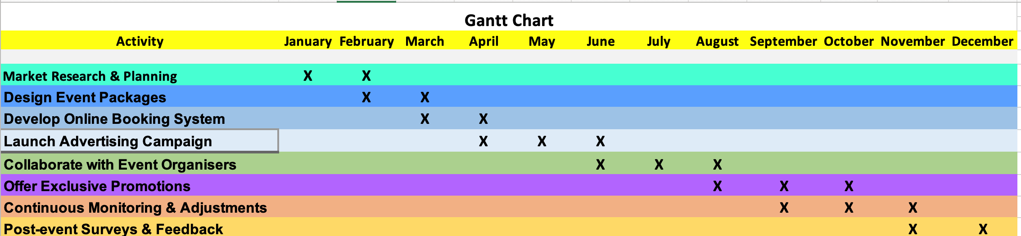

Control
Conversion Rate KPI - Measures the success of booking processes and exclusive promotions by calculating the percentage of inquiries converted into event-related accommodations bookings. A higher rate signals effective strategy implementation. (Käppele, 2021)
Engagement Metrics KPI - Tracks post-event survey completion and satisfaction scores, crucial for gauging engagement and long-term relationships, reflecting effective partnership engagement. (Stocker, 2023)
Overall Marketing ROI KPI - Assesses the comprehensive Return on Investment for the entire marketing plan, offering a conclusive measure of success in achieving objectives and enhancing the hotel's desirability during major events. (Elphick, 2023)
Conclusion
This comprehensive marketing plan for Hilton Hotel Cardiff strategically addresses challenges and capitalizes on opportunities in the dynamic hospitality sector. By leveraging the 5Cs, SWOT analysis, and PESTLE factors, the plan identifies key customer demographics, collaborator partnerships, and external influences crucial for success. The SMART strategy, anchored in the Ansoff Matrix, provides a targeted approach to transportation and accommodation challenges during major events. Implementation tactics, guided by the RACE framework, focus on reaching, acting, converting, and engaging, ensuring a systematic and effective communication mix. Key performance indicators, such as conversion rates and engagement metrics, will measure success, contributing to Hilton Cardiff's enhanced desirability during major events.

References

(2023) Travel with Purpose | Environmental, social and governance at Hilton. Available at: https://esg.hilton.com/wp-content/uploads/sites/4/2023/04/Hilton-2022-Environmental-Social-and-Governance-Report.pdf (Accessed: 02 November 2023).

Barry, S. (2022) North to South Wales air route scrapped by the Welsh Government, Business Live. Available at: https://www.business-live.co.uk/economic-development/north-south-wales-air-route-24176732 (Accessed: 03 November 2023).

Birt, J. (2023) 5 C’s of marketing analysis: Definition, tips and example - indeed, Indeed. Available at: https://www.indeed.com/career-advice/career-development/5-cs (Accessed: 04 November 2023).

Chaffey, D. (2023) Sostac Marketing Planning Model Guide, Smart Insights. Available at: https://www.smartinsights.com/digital-marketing-strategy/sostac-model/#:~:text=SOSTAC®%20is%20a%20planning,how%20do%20we%20get%20there%3F (Accessed: 01 November 2023).

Elphick, D. (2023) Hotel investment: What is a good ROI for a hotel? Little Hotelier. Available at: https://www.littlehotelier.com/blog/increase-your-revenue/hotel-investment/ (Accessed: 14 November 2023).

Global Data Tourism, (2022) Hilton taps into generation hashtag with world’s first ‘waitographer’, Hotel Management Network. Available at: https://www.hotelmanagement-network.com/comment/hilton-generation-hashtag-waitographer/?cf-view (Accessed: 10 November 2023).

Hilton named Most Valuable Hotel Brand by Brand Finance (2023) Stories From Hilton. Available at: https://stories.hilton.com/releases/hilton-named-most-valuable-hotel-brand-by-brand-finance-for-eighth-consecutive-year# (Accessed: 01 November 2023).

Käppele, C. (2021) Conversion rate in a hotel - what is important to know, happy hotel. Available at: https://happyhotel.uk/lexicon/hotel-conversion-rate/ (Accessed: 09 November 2023).

Luenendonk, M. (2019) Business model of hilton hotels, Cleverism. Available at: https://cleverism.com/business-model-hilton-hotels/#:~:text=136.3-,USP,not%20afraid%20to%20question%20itself. (Accessed: 04 November 2023).

Momin, A. (2023) Hilton SWOT ANALYSIS: Your helpful guide to the hotel chain, PESTLE Analysis. Available at: https://pestleanalysis.com/hilton-swot-analysis/ (Accessed: 01 November 2023)

Mosalski, R. (2022) The three huge issues risking Cardiff’s ability to host world-class events, Wales Online. Available at: https://www.walesonline.co.uk/news/wales-news/three-huge-issues-risking-cardiffs-24109209 (Accessed: 29 October 2023).

Peterdy, K. (2023) Ansoff matrix, Corporate Finance Institute. Available at: https://corporatefinanceinstitute.com/resources/management/ansoff-matrix/ (Accessed: 05 November 2023).

Samuely, A. (2023) Hilton checks in millennial-friendly hotel brand with mobile-centric features, Marketing Dive. Available at: https://www.marketingdive.com/ex/mobilemarketer/cms/news/strategy/22132.html#:~:text=Hilton%20Worldwide%20is%20ramping%20up,and%20a%20reimagined%20front%20desk. (Accessed: 06 November 2023).

SimilarWeb (2023). Website Performance. [online] Similarweb.com. Available at: https://pro.similarweb.com/#/digitalsuite/websiteanalysis/overview/website-performance/.

Similarweb (2023). SimilarWeb Identity. [online] secure.similarweb.com. Available at: https://pro.similarweb.com/#/digitalsuite/websiteanalysis/audience-interests/.

Stocker, M. (2023) Measuring Partner Program Performance: Metrics You should be tracking: Workspan, Work Span. Available at: https://www.workspan.com/blog/measuring-partner-program-performance-metrics-you-should-be-tracking (Accessed: 12 November 2023).

Appendices

SWOT Analysis
Strengths
Renowned Brand: Hilton is a globally recognised and respected brand in the hospitality industry. Hilton remains the world's most valuable hotel brand, exceeding pre-pandemic value at $11.7 billion. Seven other Hilton brands also ranked in the top 50. Hilton emphasizes innovation and sustainability through its Travel With Purpose initiative, recognized for the highest Sustainability Perceptions Value. (2023)
In 2022, Hilton advanced its Travel with Purpose strategy, setting ambitious environmental and social goals, and emphasizing emissions reduction, responsible practices, and community impact. Recognized for sustainability, inclusivity, and global workplace excellence, Hilton remains dedicated to being a positive force for good. (2023)
Diverse Accommodation Options: Offering a range of room categories and amenities caters to diverse guest preferences. (2023)
Commitment to ESG: Hilton has a strong commitment to environmental and social responsibility. (2023)
Weaknesses
Dependence on Economic Conditions: The hotel industry is sensitive to economic downturns, impacting occupancy rates.
Potential Overreliance on Luxury Segment: Depending on the positioning, Hilton may face challenges if there's an economic downturn affecting luxury travel.

PESTLE Analysis
Political
The Welsh Government's decision reflects political considerations, influencing the overall travel landscape. Hilton Hotel in Cardiff may need to align its strategies with government policies, particularly those related to transportation and tourism.
Economic
Changes in the economic landscape, such as the redirection of subsidies, may impact the hotel's clientele, especially if there's a shift in business travel. Hilton Hotel Cardiff should be adaptable to potential changes in corporate bookings and economic trends.
Social
The evolving social patterns, including the shift to hybrid and homeworking, can influence travel behaviours. Hilton Hotel Cardiff should tailor its services to meet the changing needs of guests who may have different purposes for travel.
Technological
Leveraging technology to enhance guest experiences and collaborating with airlines to improve technological aspects of their fleets can contribute to the hotel's competitiveness and overall customer satisfaction.
Environmental
Supporting and promoting environmental initiatives at Cardiff Airport aligns with sustainability trends. Hilton Hotel Cardiff can participate in or advocate for eco-friendly practices, such as carbon offset programs, contributing to a positive environmental image.
Legal
Remaining compliant with legal regulations related to the hospitality industry, environmental standards, and safety protocols is crucial. Hilton Hotel Cardiff should stay informed about potential legal implications arising from changes in government policies. (Barry, 2022)

SMART Strategy
(For Hilton Hotel Cardiff to address transport and accommodation challenges during major events)
Specific
Hilton Hotel Cardiff will establish a collaborative partnership with Cardiff Airport and the Welsh Government to provide seamless transport and accommodation solutions for major events. The focus is on creating a stress-free and environmentally conscious experience for event attendees.
Measurable
Implement exclusive event packages, including streamlined transportation services, to increase guest satisfaction during major events by 20%. Track the number of attendees opting for these packages and the corresponding reduction in transportation-related challenges.
Achievable
Collaborate with Cardiff Airport and the Welsh Government on transportation logistics, shuttle services, and sustainable initiatives. Leverage existing infrastructure and partnerships to create efficient transport solutions.
Relevant
Align with the Welsh Government's public transport improvements and the North Wales Metro program. Ensure the strategy contributes to the overall success of major events, benefiting both the hotel and the local event ecosystem.
Time-bound
Roll out the collaborative strategy six months before the next major event, allowing for effective planning, promotion, and coordination. Conduct regular reviews to assess the strategy's impact and adjust for continuous improvement.

Gender Distribution

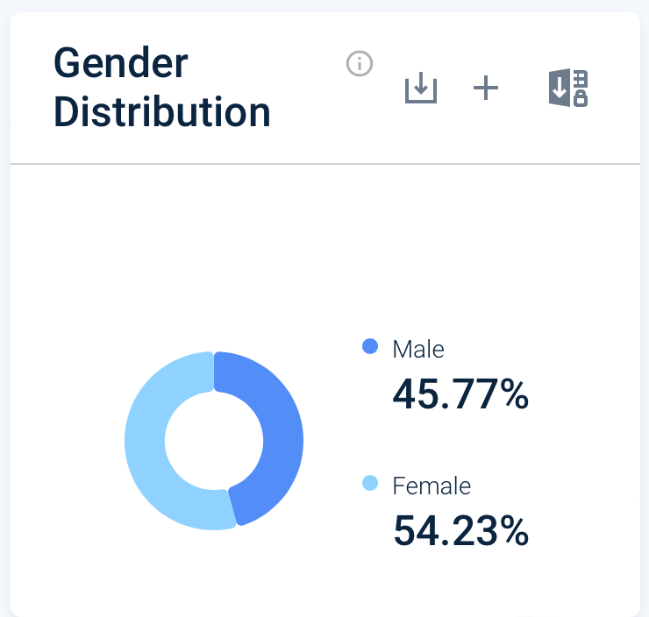
(SimilarWeb)

Age Distribution

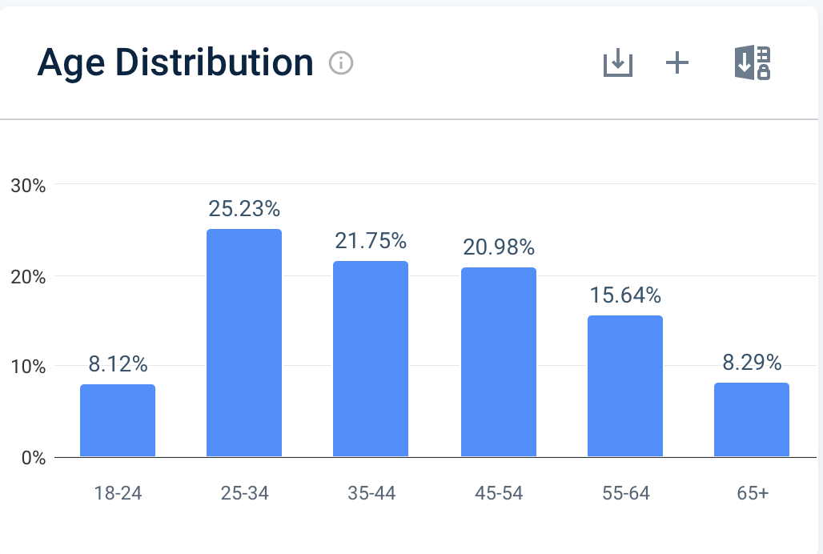

Traffic & Engagement by Audience
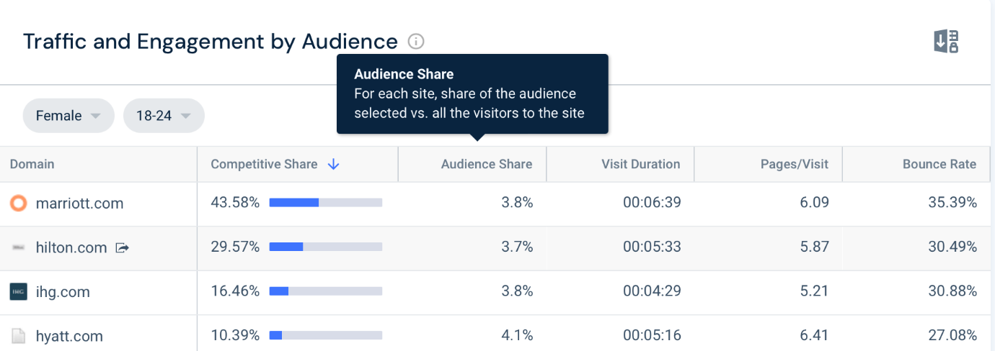
(SimilarWeb)

Market Leaders

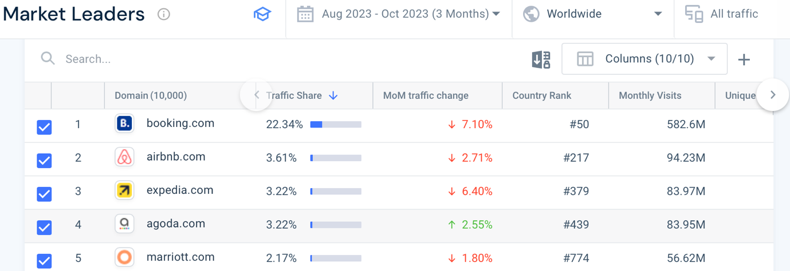
(SimilarWeb)

PRESENTATION SLIDES



