Stanislav Iliyanov Stoyanov
Student number :2029652
Module: Accounting Fundamental
Module code: LCBB4001
Lecturer : dr.Widin Bongaso Sha`ven
University of Wales Trinity Saint David

ACCOUNTING FUNDAMENTAL
Table of Contents
Introduction 3
Discussions 3
Answer for question 1 3
1. a. Presentation of business financial statement in associated to present trial balance details 3
1. b. Analysis concept associated to balancing position of business financial statement 7
Answer for question 2 9
2. a. Presentation of different financial ratios associated to business performance of Chocco plc for 2020 and 2019 9
2. b. Analysis the present financial performances of Chocco plc in associated to accounting ratios 11
Conclusions 13
References 14

Introduction
Financial and accounting are considered as an essential approach of business economic aspects that generally provide a proper structural guidance based on which operating performances and essential strategic influences are also being formulated. During the formulation of business financial performances some of IFRS and AS guidelines are required to be initiated properly, so that a true and fair view of accounting can be presented. Under this report, a brief presentation associated with the business accounting approach mainly evaluated with the support of which business accountability performances can be measured.

Discussions

Answer for question 1

1. a. Presentation of business financial statement in associated to present trial balance details
Application of “financial accounting” is recognised as the part of business group’s performances that mainly engaged in recording and maintaining day to day transactions in a structural basis. Financial statement is generally recognised as the combined form of such daily transactions with the support of which business financial compatibility can efficiently evaluated and also measured the overall financial performances for both internal and external stakeholders. Such financial statement are included trading accounting; that contains detail presentation associated to business production performances primarily, Profit and Loss accounting; contains a details approach associated to business profit after considering all the necessary details associated to business expenditure that generally occurred in the current accounting period (McLaney, and Atrill, 2016). Application of business retained earning accounts are generally provide the detailed presentation associated to business net profit amount that mainly distributed among investors as the way of dividend mainly, so that a proper business sustainability presentation can be initiated. Apart from that, presenting business balance sheet is also considered as the detailed presentation of business assets and liability details that mainly indicate the prime capacity of business at the present situation depending on which business borrowings and other investment approach can be formulated.
Under this report mainly, on behalf of provided trial balance details associated to Kedison PLC, the overall profit and loss, retained earnings and balance sheet has been presented with the support of which primary capacity of the business can efficiently measure.
Computation of business Profit and Loss statement for current accounting period associated to Kedison PLC
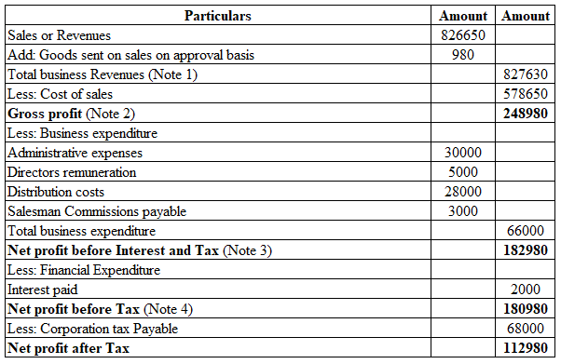
Note 1: Analysis of business revenue: Under this performances mainly the goods which is sent to the buyer on the basis of sale on approval basis is also considered as the part of business revenue on the closing date balances for efficient revenue balance presentation purpose.
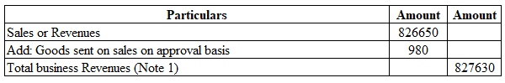
Note 2: Analysis of business gross profit: In order to compute the level of business gross profit mainly the gross revenue amount is deducted from cost of goods sold level so that accurate business profit can be measured.
Note 3: Analysis of Net profit before interest and tax: From the value of business gross profit some relevant business expenditures has been deducted with the support of which business net profit has been computed accordingly. However, this profit is indicating the results before charging interest and tax related expenditure mainly.
Note 4: Analysis of Net profit after tax: From the computed value of Net profit before interest and tax, the relevant charges associated to business interest expenditure and tax charges has been deducted to compute Net profit after tax amount.
Computation of business retained earnings for current accounting period associated to Kedison PLC
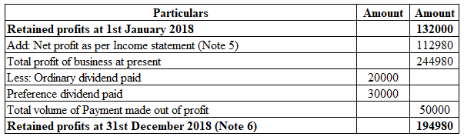
Note 5: Analysis about net profit: Here, the profit that resulted from the computed results of income statement mainly applied to recognise the current total remains profit amount positively considering previous year profit level.
Note 6: Analysis about retained earnings: From the previous and current net profit amount relevant dividend changes has been deduction mainly for recognising the actual amount of profit that remains in the hand of business at closing accounting period.

Computation of business balance sheet for current accounting period associated to Kedison PLC
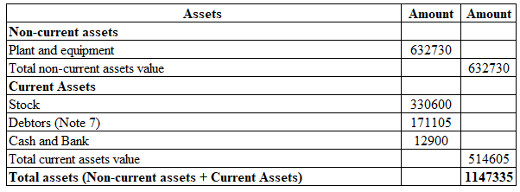
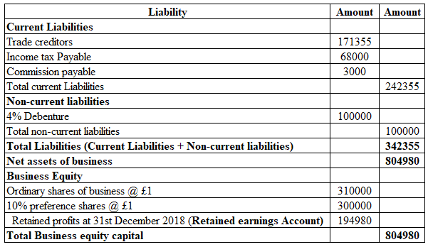
Note 7: Analysis accounting receivable or debtor: Under this computation mainly with the volume of debtors, the goods that send on approval basis are summed up, as the cash has not been received yet and considered it as outstanding due balance mainly.
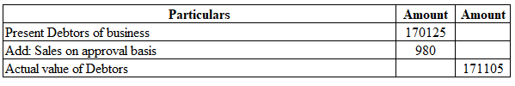

1. b. Analysis concept associated to balancing position of business financial statement
The father of accounting Luca Pacioli during the period of 1494 invented the double entry book keeping process with the support of which every business transaction is maintained with a proper structural format. According to such an accounting system every transaction associated with the business generally contains two different accounting approaches that generally brings the assurance about transaction consistency (Wood, 2015). For example; purchase good against cash payment; under this transaction while the purchase is resulting in business stock increase (Debit balance), cash balance will simultaneously decrease (Credit balance) and as a result neutral approach mainly noticed associated with business performance primarily.
Apart from that, application of this approach is not only noticed in relation to cash transactions only, instead of that in case of considering the business credit performances the applied concept of such a double entry process can also be noticed in order to present a significant approach associated with business growth as well. For example; machinery acquired from creditors also provides double impacts associated with increase of business machinery volume (assets side) and increase the creditors balance (liability side) in a simultaneous manner. In relation to general approach, it can be considered that presentation of such accounting brings one positive and one negative balance, however in this case it impacts both the accounts with the positive approach and increases both the side of business balance with an equal amount for presenting the double entry approach fundamentally (John Dyson, 2017).
Application of the double entry bookkeeping process also provides a level of positive approach regarding reduction of accounting errors associated with transactions and also boosts up the positive approach associated with balancing accounts as well. As debit in one accounting balance offset a credit approach over another account and depending on which generally the summation of all the debit must be equal to sum of credit balance as well.
The balance sheet also used to follow this particular approach associated with the double entry concept with the support of which the level of business financial balance is generally tallied in both side assets and liabilities with the equal amount. In a simplified approach the fundamental equation associated to business balance sheet is; Liability +Capital = Assets, that represents with the combined from of both the secured, unsecured and current liability amount along with the level of business capital balance a positive similarity can efficiently noticed for business non-current and current assets level that indicates the efficiency approach associated to business accounting performances.
In accordance with the above computed business balance sheet for Kedison PLC, it can be noticed the overall business assets balance is presenting the level of 1147335 as total assets balance, while on the same aspects the current liability and non-current liability balance of the business are indicating 342355 including business equity it resulted to 804980 and in aggregate around (342355+804980) = 1147335 respectively. From that approach it can be recognised that, this business is also following the approach associated with the business double entry approach with the support of which business sustainability level can efficiently be managed as well.
From that approach, it can be considered that the presentation of business double entry concept is essential in order to bring a positive financial performances including operating growth in a satisfactory order, so that effective organisational sustainability can be initiated. It is also providing an assurances regarding accountability approach of business financial balance so that a proper stability growth can also be recognised by the investors for efficient business return.

Answer for question 2

2. a. Presentation of different financial ratios associated to business performance of Chocco plc for 2020 and 2019
Return on Capital employed
Formula | 2020 | 2019
Net operating profit | 805 | 699
Capital employed | 7225 | 7041
Result | 11% | 10%

Return on equity ratio
Formula | 2020 | 2019
Profit after tax | 431 | 366
Net worth | 3088 | 2912
Result | 14% | 13%

Earnings per share
Formula | 2020 | 2019
Net profit | 431 | 366
Outstanding share | 600 | 600
Result | 72% | 61%

Net profit margin
Formula | 2020 | 2019
Net profit | 431 | 366
Outstanding share | 600 | 600
Result | 72% | 61%
Assets turnover ratio
Formula | 2020 | 2019
Revenue | 6738 | 6441
Total assets | 9736 | 10087
Result | 69% | 64%

Stock holding period
Formula | 2020 | 2019
Inventory * 365 | 258420 | 240535
Cost of goods sold | 3235 | 3096
Results | 80 | 78

Debtor collection period
Formula | 2020 | 2019
Trade receivable X 365 | 455885 | 469755
Revenues | 6738 | 6441
Ratios | 68 days | 73 days

Current ratio
Formula | 2020 | 2019
Current Assets | 2303 | 2355
Current Liability | 2511 | 3046
Ratios | 0.92 | 0.77

Gearing ratio
Formula | 2020 | 2019
Total Debt | 4137 | 4129
Shareholders Fund | 3088 | 2912
Ratios | 1.34 | 1.42

2. b. Analysis the present financial performances of Chocco plc in associated to accounting ratios
Return on Capital employed: Fundamentally, it indicates the primary approach associated to business net operating margin level regarding business capital employed volume for understanding current accounting approach of business mainly. Related to present performances it can be observed that a positive increase in this particular ratio due to efficient volume of profit increases associated with business capital structures (Dyson, 2010). The primary reason behind such increase in profit is associated with the business expenditure deduction approach that provides a satisfactory approach related to the operating approach of such performances in a satisfactory manner.
Return on equity ratio: It also indicates the same approach like return on capital employed volume, however under this particular performance business profits after tax are basically computed and instead of capital employed the net worth level of the business and generally evaluated. Associated with the present applied financial data, it can be recognised that the overall performance of this computed ratio is expanding in the present period due to lower expenditure structure and positive volume of business revenue level (Amelia and Sunarsi, 2020). However, management can initiate some level of growth initiative through revenue increase for efficient growth in future.
Earnings per share: Applied this concept primarily applied to evaluate whether the business ingrained in sufficient levels of business profit performances in associated outstanding share amounts or not. It also measures the basic operating approach of a business group with the support of which external investors can provide efficient capital investment in the market for business capitalisation approach and other positive expansion efficiently (Almeida, 2019).
If the overall volume of earnings per share is increasing it will indicate a positive expansion of business operating capability as well as financial stability as well. In the case of this particular computation this approach is also noticed. This is indicating that compared to previous periods, the present level of business is expanding in a convenient manner in order to provide satisfactory business growth as well.
Net profit margin: Application of this evaluation generally provides whether the business is contacting their overall operating approach in a satisfactory manner for some significant strategic development is required so that proper growth can be initiated in the future. As per the present detailed presentation generally an increasing approach is noticed that indicating the overall marketability of business is comparatively sustainable as it is positively expanded (Nariswari and Nugraha, 2020). However, some of the significant changes including strategic initiatives required to be formulated in a convenient manner so that a basic operating growth can be initiated in the future.
Assets turnover ratio: It is initiated to recognise whether the pressure generated level of business revenue is insufficient in associated to the present assets structure of the business or not. It is also initiated to recognise some significant development activities associated to business operating level as well with the support of which proper structural growth including sustainability of approach of the business can be initiated. Under this result, as the overall performance of the business is expanding compared to previous result therefore it can be recognised that the business is developing in the present situation (Nofiana and Sunarsi, 2020).
Stock holding period: Presentation of this evaluation mainly applied to recognise whether the current stock volume of the business is in the position of holding or not. In relation to present computed performances it is mainly recognised that the level of such performances for this business are expanding, which means the level of stock performances remains in the business for a long time. However, for maintaining the stock performances this ratio level is needed to be lower so that the operating sustainability can efficiently approach.
Debtor collection period: With the support of this particular evaluation the management can positively realise whether the present outstanding debtor amount has remained for collection for a long time period or not. It is also applied to proceed the general strategic initiatives associated with collection strategy and also credit control initiatives in a proper structural manner so that a proper accountability growth and other developments can efficiently be initiated. According to the present computed business results, performance of this approach is basically indicating a reduction level that indicates the business revised their collection policies properly so that a proper and advanced collection approach can be formulated.
Current ratio: Fundamentally it is initiated to recognise the liquidity approach including performances of business depending on which some structural growth including stability initiative can be formulated. It is also initiated to measure a proper stability approach related to business liquidity structure with the support of which business investment processing and other beneficial approaches can also be structured (Nuryani and Sunarsi, 2020). As per current computation it is indicating a positive increase compared with the previous level and at the present situation if the business is intended to remain this particular position with a strong support therefore a proper collection strategy including payback initiative must be formulated in a satisfactory manner.
Considering the above computer results and evaluations it can be recognised that the present performance structure of this business group is developing in the present situation compared to the earlier stage with a positive increase in profit and liquidity structure. However, a proper initiative related to market share performances is also required to be formulated so that a proper engagement of external investors can be noticed and associative success in the future can also be formulated properly.

Conclusions
This report is a detailed presentation associated with accounting performances of the business Kedison PLC with the support of which basic operating growth and other developments can be structured. It provides detailed presentation associated with financial ratio computation for Chocco plc also, with the support of which general growth initiatives can efficiently be measured as well.

References
Almeida, H., 2019. Is it time to get rid of earnings-per-share (EPS)?. Review of Corporate Finance Studies, 8(1), pp.174-206.
Amelia, RW and Sunarsi, D., 2020. The Effect of Return On Assets and Return On Equity on Debt To Equity Ratio at PT. Kalbe Farma, TBK. Ad-Deenar: Journal of Islamic Economics and Business , 4 (01), pp.105-114.
Dyson, J.,. 2010. Accounting for Non-Accounting Students, London, 8th Edition, FT Pitman Publications.
Horngren C. and Forster, G., 2014. Cost Accounting, a managerial emphasis, 15th Edition, London: Prentice Hall International.
John R. Dyson. 2017. Accounting for non-accounting students, 8th edition, Financial Times Prentice Hall.
McLaney, C. and Atrill, P. 2016. Financial accounting for decision makers, 10th edition, FT Prentice Hall.
Nariswari, TN and Nugraha, NM, 2020. Profit Growth: Impact of Net Profit Margin, Gross Profit Margin and Total Assets Turnover. International Journal of Finance & Banking Studies (2147-4486) , 9 (4), pp.87-96.
Nofiana, L. and Sunarsi, D., 2020. The Influence of Inventory Round Ratio and Activities Round Ratio of Profitability (ROI). JASa (JurnalAkuntansi, Audit danSistemInformasiAkuntansi), 4(1), pp.95-103.
Nuryani, Y. and Sunarsi, D., 2020. The Effect of Current Ratio and Debt to Equity Ratio on Deviding Growth. JASa (JurnalAkuntansi, Audit danSistemInformasiAkuntansi), 4(2), pp.304-312.
Wood, F., .2015. Frank Wood's Business Accounting, 13thEdition. Pearson Education Limited.

