University Personal Development Show-Reel Justification

-BA Creative Computer Games Design: Critical Review-
-M6X0245-

-Joel David Gray-
-P143919-



Contents

Cover Page 1
Contents 2
Abstract 3
Introduction 4
Personal Development in University 5-6
Pre-University Skillset 5
Development in University 5-6
Show-Reel Content Justification 7-8
Trackers Express 7
Skill Build 8
Conclusion 9
Further Work 10
References 11
Bibliography 12
Appendices 13

Abstract

This document will cover the journey of the student Joel David Gray, as they entered the University of Trinity St David with unrefined skills that had little relevance towards theoretical or practical game design, reflecting on their development within the university.
The following years studying Creative Computer Game Design saw the student develop their academic, artistic and technical knowledge and skill related to game design preparing the student for industry experience as a technical artist role. The course covered many important aspects such as team working, play testing, optimisation skills, theoretical knowledge and planning/documenting skills all relevant on the subject whilst also training the student with industry direct software skills.
The current skillset of the student and its relevance to the university was represented in a portfolio show-reel aimed towards advertising the student as a trained technical artist. This covered the major project and the skills learnt from it relevant to the industry as well as additional content relevant to the student’s time developing on the course and showcasing their skills in an industry perspective.

Introduction

This document covers the artistic, technical and academic development of the student Joel David Gray in the Creative Computer Game Design course in the University of Trinity St David and how this development is represented within the student’s video portfolio.
The personal development section will summarise important factors in the student’s University career foremost by assessing what skills the student had before the course. Followed by an assessment of each of the following years in how they influenced the student’s development and trajectory related to the Creative Computer Game Design subject. Show-Reel Content Justification will explain the reasoning in the structure and choice of the content found within the students show-reel. Both major sections will be assessed in how they reflect on the student’s current abilities and their representation of the student’s university career.
A conclusion will summarise the student’s journey within the university followed by a further work section that will focus on further work that the student could do to continue their current trajectory as a technical artist.

Personal Development in University

-Pre University Skillset-
To understand how the student developed throughout university it is key to know what the student’s capabilities were before enrolling in the facility. Before the student began their studies in Creative Computer Games Design the student had completed their A-Level qualifications of which the subjects had limited relevance or application to game design. The student was enrolled in the foundation year to ensure the necessary skills for the course were developed, however the student did have some familiarity with game design.
The student’s knowledge of game design was self-studied from educational online video series such as Extra Credits (Extra Credits, n.d.) and Mark Brown (Brown, n.d.), backed with extensive gaming experience as well as development projects such as Carved Stars (Gray, 2017) (working with a node based scripting engine GGmaker (Rpgmakerweb.com, 2018) on a sprite based game). Experience with the node based system and the knowledge of some game design theory/practicality would influence the decision to work within Unreal Engine 4 (Unrealengine.com, n.d.) as a technical artist later providing a basic understanding of game logic.
-Development in University-
The foundation year developed essential documentation, creative and professionalism skills not focused specifically on game design. Different modules covered a variety of skills from Character/Level Design, 3D Modelling, Sound Effect Design, Picture/Video editing skills, academic documentation and Python scripting. The array of skills developed in these modules created an understanding of many software packages that would later be key to the Technical Artist role as Creative Skillset (Creativeskillset.org, n.d.) describes that an understanding of many software is key for the role.
The first team oriented project Tim Whisky (Gray, 2017) to create a 3D game level in the Unreal Engine 4 (Gray, 2017) allowed the student to develop key engine skills, most notably troubleshooting and researching to accomplish the desired level in the game engine. This is another key skill as described by Creative Skillset (Creativeskillset.org, n.d.). This basic knowledge of the game engine was a major factor in how the student specified in the later years.
With the existing experience from foundation year the student’s most notable project for the next three academic years began development, Project Trackers Express (Gray, 2017) that was intended to be finished in two academic years. The existing knowledge of Unreal Engine 4 allowed the student to define a role quickly in the team, learning to divide work and trust other team members to complete work. The student’s knowledge of game design was expanded and refined studying the history of the industry and game design theory, from sources such as Scott Rogers (Rogers, 2010) giving the student the ability to make educated design choices aware of the ramifications.
While the head start in engine was beneficial the student would often become most focused on proving what they could do and how far they could push themselves rather than focusing on the academic task. With guidance the student slowly understood about what was possible for a small team to accomplish and to focus on the tasks that were essential to the project instead of adding content alone because it was simply possible. This taught the student to focus on the project before their individual skills and to rely on and help the team to have a successful completed project.
By the end of the second year the student had an understanding on most of the 3D game pipeline able to work in a variety of software learnt from helping teammates again in Trackers Express (Gray, 2017) and working on small projects over the summer to keep skills in good practice as well as to develop new ones as such as the internal project Skill Build. The student moved more towards gameplay mechanics in the second year learning the value of play testing and ensuring a clean game experience with extensive documentation and gameplay direction changes showing the student how others perceived their work making the student more perceptive and critical of their own work
By the third year the student was given a chance to work again with the existing project Trackers Express (Gray, 2017) to make a better game experience. This opportunity was valuable and the student chose to work off and extensively modify the existing game, to show and focus on a polished product, a skill the student needed to develop. The year saw the student refine the ‘artist’ part of the technical artist to make a visually good game experience and to optimise and learn what was visually possible working on the PlayStation 4 Development kits. This refined one of the students most important skills as a Technical Artist, the essential balance to integrate art into the game “without sacrificing either the overall artistic vision or exceeding the technical limits of the chosen platform.” (Creativeskillset.org, n.d.)
Show-Reel Content Justification

The video show-reel was divided into two main sections. Content developed major project, Trackers Express (Gray, 2017) and additional material created to showcase skills obtained throughout the course referred to as ‘Skill Build’. The show-reel intended to represent a showcase of content that would represent the student’s desired position, in this scenario a Technical Artist, within one and a half minute reflecting a video portfolio that would be presented to employers. Therefore, the video is introduced and ended with professional contact information as seen in existing video show-reel examples.

-Trackers Express-
Project Trackers Express was undertaken for most of the student’s time in the university and completed recently. This shows the student’s most recent work that showcases a more current technical demonstration of abilities that has developed over a long time in the university. The project showcases core skills employers look for in a technical artist, notably teamwork and communication, a balance of gameplay and visuals as well as a fully completed project finished within a limited timeframe.
It is not engaging to show the students work in a visual scripting format as the complex structures are not wholly understood by a wider audience or feasible to cover extensively in the portfolio videos limited timeframe. As such the student chose to show content such as a sped up completed shader being manipulated, and an animation graph influencing a character as well as a shot of the completed level to showcase the more visual aspect of the work. Likewise, gameplay was shown foremost to represent the technical aspect in a manner quickly understandable by most and engaging to watch visually, though it cannot be wholly understood without playing the game itself.
The music chosen for the video Electronic Phase was created by Corey Davies, the composer/SFX artist of Trackers Express. The student chose music from this artist as this represented an aspect of teamwork that the student had great experience with in the University as the student had worked closely with the artist when working on Trackers Express.

-Skill Build-
The skill build project was chosen to appear in the video as the project was created early within the Students University career and housed many incomplete projects such as the Pond Fisher (Gray, 2017) and internal Tower serving as a testing file for features in University projects. As such this project had remnant old projects ready to be retooled and with the student’s current capabilities for the show-reel showcasing history and current skills. For example, the ‘dither’ effect created for Trackers Express was created and shown dithering, and early beam particles intended for UFO Escape (Gray, 2017) fully realised with the student’s current capabilities and showcased as ‘Energy effects’.
To keep a consistent theme in the variety of widely different content shown in the Skill Build section, the background and 3D scenery was kept to simple geometric shapes with plain colours so the focal point would be on what is being shown. This is further emphasised that when possible to draw attention the focal points would have moving components so that the motion contrast against the motionless background as seen with these examples [Appendix 1]. This kept this section of the video comprehensive in theme and allowed the student to express a wide array of varied skills without overwhelming the viewer.
The ending section of the Skill Build video section ends with footage of Trackers Express on an old TV that the camera pans into before transitioning to the Trackers Express content of the show-reel. This represents how the skills obtained between the two projects are transferable and how they greatly influence the student’s current capabilities.

Conclusion

The student entered the university with unrefined skills that had little relevance towards theoretical or practical game design having only self-studied relevant aspects. This resulted in the participation of a foundation year that laid the groundwork in a variety of technical, artistic and academic skills that would influence the decision to specify as a technical artist. The first year of studies saw the student apply existing skills and learning 3D skills in a team environment that would prepare the student for industry experience, teaching the student to rely on others.
The second year promoted the value of playtesting that taught the student to incorporate and consider alternate perspectives in how their work was perceived influencing the direction of future projects to be focused on the game experience. The third year saw the student pushing and refining their skills in a limited timeframe delivering a game project based off their previous work, the student worked on balancing artistic quality to technical capabilities to further achieve the role of the technical artist.
The portfolio video exhibited the student’s current capabilities in the format of a show-reel for a technical artist that the student sought to become. Showing the major project of Trackers Express as it represented the most relevant skills achieved within the university most importantly fulfilling the role as a completed project involving teamwork. The Skill Build section reflected the student’s existing skills archived over the course of the university career updated with the student’s current capabilities to show what the student is capable of with their acquired skills obtained within the university career.

Further Work

Though the student has a strong understanding of most of the 3D production pipeline there are gaps in the student’s technical abilities that can be rectified, notably the knowledge of the rigging and animation process is weak due to lack of experience traded for refining other skills such as work on shaders and particle effects. The development of the animation skillset would allow the student as a technical artist to help team members and troubleshoot problems related to animation more quickly and successfully.
While the course has provided strong facilitation of the artistic aspect of the technical artist, the technical side can be further improved with a knowledge of programming languages such as C++ as this allows for deeper control on various software like Unreal Engine 4 but was not quintessential the development of the major projects. Greater control using languages like C++ is necessary for the full production of a video game, though not often the role of the technical artist, the ability to create tools and gameplay aspects is hugely beneficial to a game project (Creativeskillset.org, n.d.).
Working in team projects has been core to the development essential for working in industry, as seen in projects such as Trackers Express (Gray, 2017) though industry experience would further the desired skills in a realistic working environment providing experience.

References

Brown, M. (n.d.). Game Maker's Toolkit is creating videos on game design | Patreon. [online] Patreon. Available at: https://www.patreon.com/GameMakersToolkit [Accessed 4 May 2018].
Creativeskillset.org. (n.d.). Technical Artist (Games). [online] Available at: http://creativeskillset.org/job_roles/339_technical_artist_games [Accessed 4 May 2018].
Extra Credits. (n.d.). [online] Available at: https://becausegamesmatter.com [Accessed 4 May 2018].
Gray, J. (2017). Craved Stars. [online] Joel David Gray Technical Artist. Available at: https://joelgray0.wixsite.com/joelthegray/carved-stars-2014-2015 [Accessed 4 May 2018].
Gray, J. (2017). Tim Whiskey. [online] Joel David Gray Technical Artist. Available at: https://joelgray0.wixsite.com/joelthegray/tim-whisky-2015 [Accessed 4 May 2018].
Gray, J. (2017). Trackers Express 1st Year. [online] Joel David Gray Technical Artist. Available at: https://joelgray0.wixsite.com/joelthegray/trackers-express-1st-year-2015-2016 [Accessed 4 May 2018].
Gray, J. (2017). Trackers Express 2nd Year. [online] Joel David Gray Technical Artist. Available at: https://joelgray0.wixsite.com/joelthegray/trackers-express-2nd-year-2016-2017 [Accessed 4 May 2018].
Gray, J. (2017). Trackers Express 3rd Year. [online] Joel David Gray Technical Artist. Available at: https://joelgray0.wixsite.com/joelthegray/copy-of-trackers-express-2nd-year-2 [Accessed 4 May 2018].
Gray, J. (2017). Pond Fisher. [online] Joel David Gray Technical Artist. Available at: https://joelgray0.wixsite.com/joelthegray/copy-of-ufo-escape-2017 [Accessed 4 May 2018].
Gray, J. (2017). UFO Escape [online] Joel David Gray Technical Artist. Available at: https://joelgray0.wixsite.com/joelthegray/ufo-escape-2017 [Accessed 4 May 2018].
Rogers, S. (2010). Level up!. Chichester: Wiley.
Rpgmakerweb.com. (2018). GG Maker Free Trial | RPG Maker | Create Your Own Game!. [online] Available at: http://www.rpgmakerweb.com/download/free-trials/trial-gg-maker [Accessed 4 May 2018].
Unrealengine.com. (n.d.). What is Unreal Engine 4. [online] Available at: https://www.unrealengine.com/en-US/what-is-unreal-engine-4 [Accessed 4 May 2018].

Bibliography
Chegg.com. (n.d.). What does a Technical Artist do?. [online] Available at: https://www.chegg.com/career-center/explore/technical-artist [Accessed 4 May 2018].
Hayes, J. (2008). The Code/Art Divide: How Technical Artists Bridge The Gap. [online] Gamasutra.com. Available at: https://www.gamasutra.com/view/feature/130074/the_codeart_divide_how_technical_.php [Accessed 4 May 2018].
Sokanu.com. (2018). Technical Artist. [online] Available at: https://www.sokanu.com/careers/technical-artist/ [Accessed 4 May 2018].
YouTube. (2014). Unreal Engine Technical Artist Portfolio. [online] Available at: https://www.youtube.com/watch?v=y8NplBBT8tM [Accessed 4 May 2018].
YouTube. (2017). Technical Artist Demoreel - ZG 2017.4. [online] Available at: https://www.youtube.com/watch?v=IliOQISX0mg [Accessed 4 May 2018].
YouTube. (2016). Tool Development Demo - Technical artist Hannah Liu. [online] Available at: https://www.youtube.com/watch?v=u-hG_jzVfp8 [Accessed 4 May 2018].

Appendices

Appendix 1 [Images showing moving features in Skill Build video section]:
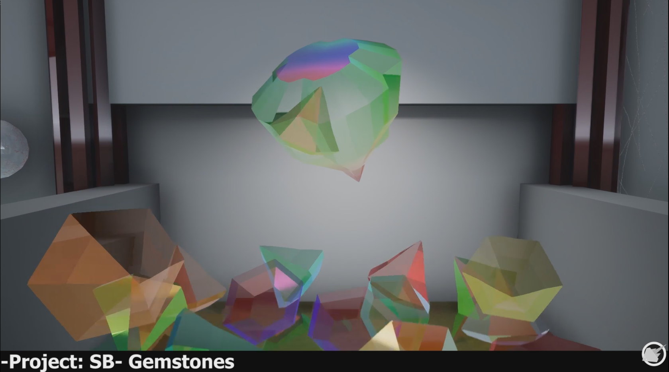
Gems bounding with physics enables on a moving base showcasing refraction.
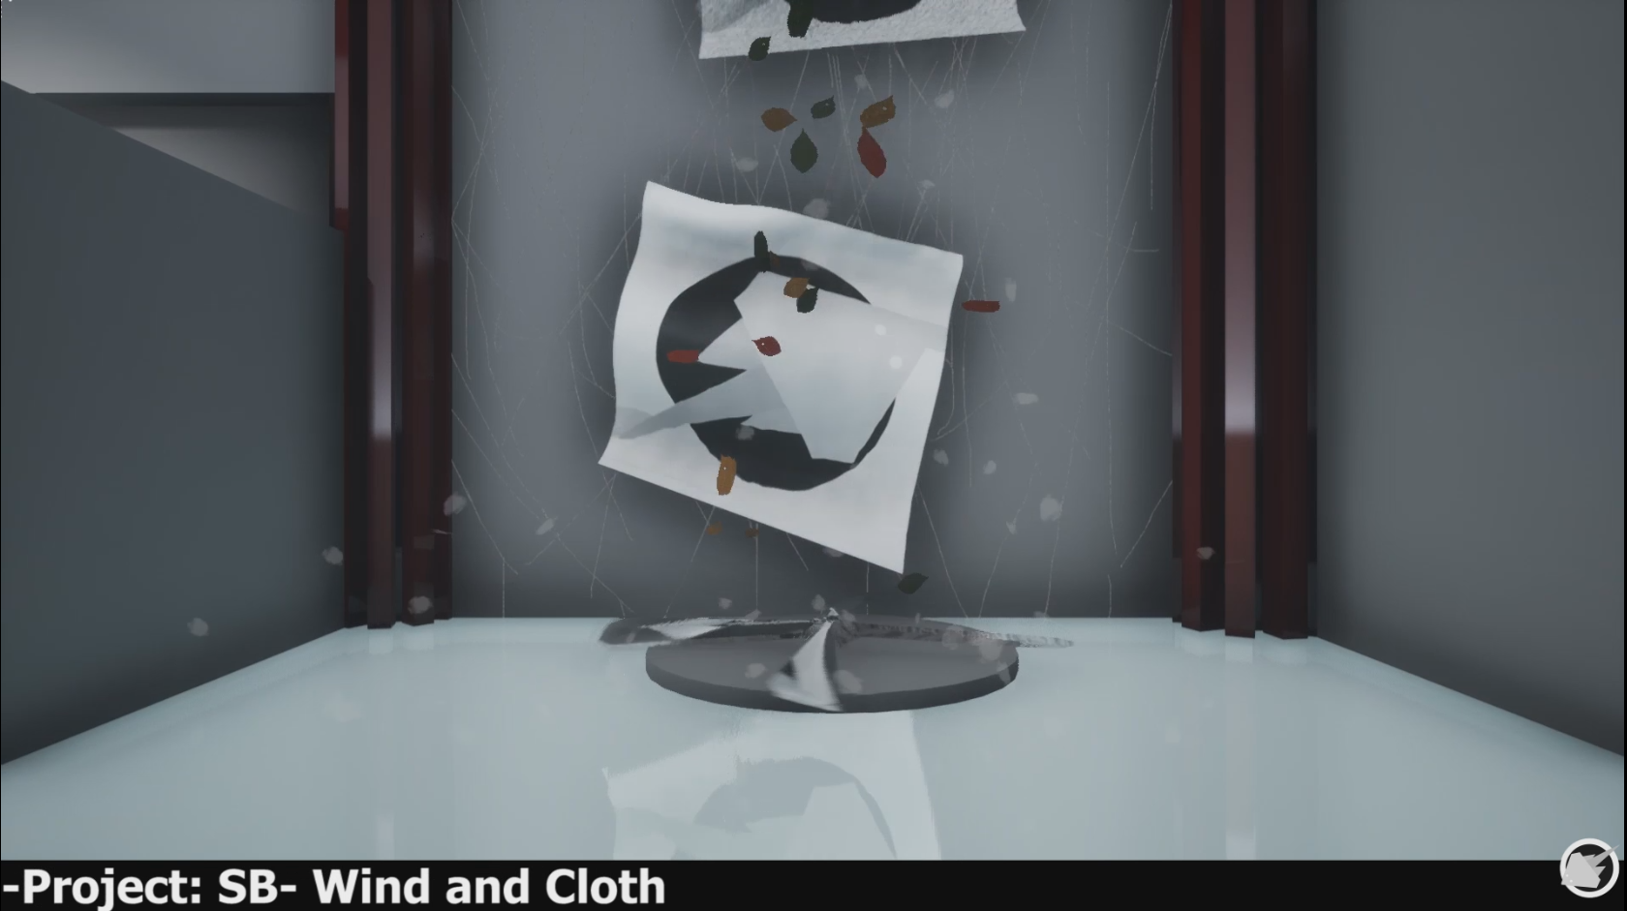
Rotating fan blades drawing the eye to the wind effects.

