Design Thinking and Digital Innovation in the M&S Customer Journey.

Module Title: - Design Thinking and Innovation
Module Code: - LCLM6002
Student Name: - Petronela Prazniciuc
Student Number: - 2310054
Lecturer’s Name: - Akash Puranik

Table of Contents
Introduction 3
Key consumer & industry trends and data that affect the organisation 3
Part 1. Innovation Analysis and Current Customer Journey in M&S. 4
Innovation Ambition Matrix 5
Core Innovation. 5
Adjacent Innovation 6
Transformational Innovation 7
Customer Journey Mapping: Understanding the causes of customer pain points. 7
Integrating Theory: Using Academic Models Lemon & Verhoef (2016) 10
Part 2. Proposed Digital Transformation 11
Conclusion. 13
References. 15

Introduction

Marks & Spencer (M&S) is one of the UK’s most recognised retailers, founded in 1884 by Michael Marks and Thomas Spencer. Over the years, it has grown into a large multi category business with around 64,000 employees worldwide and strong operations in Food, Clothing & Home. Today, the company’s main objectives focus on offering “trusted value,” improving product quality, expanding market share and strengthening its digital and omnichannel capabilities. Currently holds around 10% of the UK Clothing & Home market and between 4.2% and 4.5% of the grocery market. Its main competitors in Food include Tesco, Sainsbury’s, Aldi, Lidl and Waitrose, while in clothing it competes with Next, John Lewis, Zara, H&M and online retailers such as ASOS and Amazon. This competitive environment has pushed M&S to rethink how it delivers value and how it connects with modern customers. The wider UK retail industry is also changing quickly. The rising cost of living has made customers more careful with spending, meaning they expect good value, strong promotions and fair pricing. Shopping behaviour is now highly omnichannel, with people switching between the M&S website, app, and sparks loyalty programme and physical stores. This creates higher expectations for convenience, fast navigation, real-time stock updates and seamless checkout. In Clothing & Home, online returns caused by sizing issues continue to grow, and customers increasingly expect retailers to act responsibly in terms of sustainability and data security. Although M&S invests heavily in improving its core food products around 70% of its innovation budget its digital development has not moved at the same pace. As a result, customers still face problems such as slow online journeys, offers and inconsistent stock information. Understanding these challenges through the customer journey perspective shows why M&S must now strengthen its digital innovation to deliver a smoother, more personalised and more modern retail experience. M&S Annual Report (2024/2025)

Key consumer & industry trends and data that affect the organisation

The UK retail market is changing quickly, and several key trends are directly affecting Marks & Spencer. With the rising cost of living, customers are becoming more price-sensitive and increasingly expect strong value and meaningful promotions from retailers. At the same time, shoppers now behave in an omnichannel way, moving between the website, app, Sparks loyalty and physical stores, and they expect all these touchpoints to connect smoothly without friction. Convenience has become a major driver of satisfaction, meaning customers want fast websites, easy checkout processes and accurate, real-time delivery or stock information. In clothing, online returns continue to rise because customers are unsure about sizing and fit, creating both operational and sustainability challenges for M&S. (Kim & Kim, 2023). Sustainability expectations are also increasing, with consumers preferring brands that demonstrate clear ethical and environmental responsibility. So, with all of that they face strong competition from digital-first retailers like Amazon, Next and ASOS, who excel in personalisation and seamless online journeys. Finally, concerns about data privacy and digital security have grown following cyber incidents in the sector, meaning digital trust is now essential for customers choosing where and how they shop. (Zhang, Li & Chen, 2024).

Part 1. Innovation Analysis and Current Customer Journey in M&S.

Marks & Spencer has been trying to improve the way customers experience its mark, especially as more people mix online and in-store shopping. Most of the innovation still focuses on improving what it already does well such as making food products healthier, upgrading stores, and making the website easier to use. These are helpful, but they also show that they are not totally moved into more advanced digital innovation yet. This becomes clear when looking at the current customer journey. Although M&S offers a strong brand, quality products and reliable services and customers still face some challenges. In example, online shoppers often struggle with sizing accuracy, checkout can feel slow or complicated. These issues show where the customer journey breaks down and where M&S needs more digital support. By analysing how customers move from discovering the brand to buying, returning items and interacting with incentives it becomes easier to see which areas work well and which need improvement. Understanding this journey helps highlight opportunities in adding virtual try on tools, improving stock information and making rewards more personalised to create a smoother and more modern shopping experience. (Beckers, van Doorn & Verhoef, 2022).

Innovation Ambition Matrix

In applying the Innovation Ambition Matrix to Marks & Spencer’s Food division, it becomes clear that the organization continues to invest heavily in core innovations, allocating around 70% of its innovation spending to improvements that strengthen its existing products, operations and customer experience. This will add in a consistent M&S’s strategy of maintaining its reputation for quality, freshness and reliability, while positioning itself as a unique and healthy supermarket for everyone. Core innovations typically focus on bringing value of the product quality, expanding healthier ranges, improving supply chain efficiency and modernizing stores to deliver a more appealing food shopping experience. By strengthening these foundational elements, it will ensure that its food offering remains competitive and aligns with growing customer expectations for nutritious, convenient and ethically sourced products. This core-focused investment pattern reflects the company’s ambition to differentiate itself in the UK grocery market by promoting accessible premium quality and healthier choices and building the capabilities needed for adjacent and transformational innovation in the future. M&S Annual Report (2024/2025).

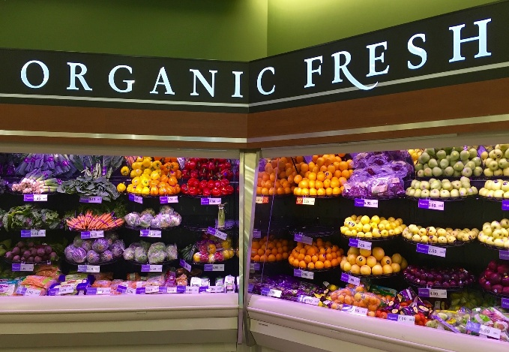
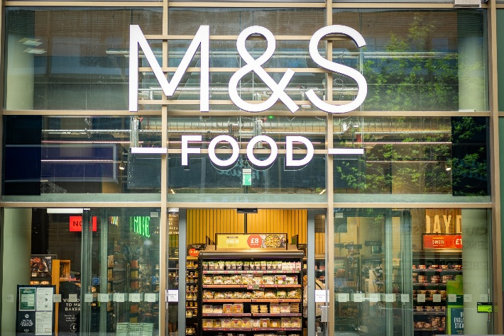

Core Innovation.

The goal of this core is to become a unique and healthy subsidiary of the supermarket, and 70% of the money allocated for the evolving process will be put towards this and it will be categorized into two parts, that of core market and core products in the food section. As we well know people focus a lot on the value and advantageous prices of food but to come with the healthiest options from a nutritional point of view. So a main example for which all customers love to enjoy in their daily life in the existing customer category we will put the recipe with sourdough for bread which will come in an improved version with a much fresher and slightly salty taste, in versions with bran and seeds, then coming for the menus prepared with a more authentic and organic taste for sauces and their quality, shakes that will come in large quantities to have a healthy snack between meals. An option to have more organized shelves for chilled items, more vegetables, green salads, to accentuate the point on green. Customers will benefit from a free organic shake, a protein bar of their choice after purchasing a prep meal deal, all leading to a healthier lifestyle and a desire for vitality and energy throughout the day.
In the existing product category, we will add the freshest eggs directly from farmers, vegetables and fruits from orchards and gardens, fresh cheeses and in larger quantities that come directly from farms. The packaging of ready-to-eat products should be with attention to paper and plastic should be eliminated as little as possible, removing artificial preservatives from the bakery line and adding longer-lasting fruits using improved packaging. Pizza preparations should be adapted with a more authentic Italian taste, which should come in different crusts of your choice, acidic juices should be replaced with more natural ones and yogurts should also come packaged in a more enriched version with kefir. Reducing salt and sugar in products, serving pastries always hot and fresh. (Based on my personal experience)

Adjacent Innovation

The adjacent customer and products category will include high protein porridge pots, along with acai bowls, yogurt with seeds and granola, all to have something healthy for all those who don't have time for breakfast and want to keep them energetic throughout the day. Pre-cooked chicken breast strips in packages, larger portions along with well-portioned portions of rice with controlled carbohydrate content and protein-rich snacks with nuts, eggs and lean meat. For all products with salt and sugar, they should be modified by adding a lot of Himalayan salt and the sugar substitute should be figs, honey, natural sweeteners, retail jars of sauces used in spicy meals and mild versions with a prominence on glass ones. In protein bars, they should be packed with a lot of protein, in cheesecake desserts, they should come with much lighter versions, and in ready-made menus, they should come with protein salad + edamame + vitamin water, and coconut water to increase the nutritional quality in a much higher value ratio and to have a positive and satisfying effect in the food industry, everything should be reported in a good change with an algorithm as efficient as possible for the health of humanity. Personal development experience and Batat (2022).

Transformational Innovation

In the new transformation category for customers, a section of shelves is introduced that will include especially nutritious foods created for those with certain health problems and for the elderly where it will be easier for them to find them. An easy recipe application that only requires adding products to the cart and the application with the help of the selected products will offer you healthy meal ideas for all ages. A new place will be open for customers, where passersby who are in a hurry can sit in a new, tastefully decorated place for a break to enjoy something fresh and tasty. (From my own experience I noticed how important it is to have a good, organic lifestyle.)
In the new transformational category for products but also for the customer, something completely new and special will be brought into a small sales section where it will be called a salad box. Here everyone will choose, at their own pleasure, from all the salad ingredients, what they want their salad to contain, in a few words I say a take-away salad box for all the greedy people who want to try something new and unprecedented. Also in the product category, something completely new and satisfying will be included, a menu of bottled yogurt with a pretzel included. There will be different types of pretzels (with sesame seeds, poppy seeds, with cheese) as well as filled ones and sausages and ham.

Customer Journey Mapping: Understanding the causes of customer pain points.

In analysing Marks & Spencer’s innovation activities and current customer experience, this study focuses specifically on the core Clothing & Home customer segment, defined as mid-income, quality-oriented, predominantly omnichannel UK shoppers who engage frequently with both digital and in-store environments. Customer Journey Mapping requires a clearly delineated customer segment to avoid generalised assumptions and to enable evidence-based interpretation of customer needs, emotions and behaviours (Lemon & Verhoef, 2016). By narrowing the scope to this primary segment, the analysis can more accurately determine where innovation efforts align or fail to align with real customer expectations. For most customers, this journey begins with awareness, often through social media, store displays or online browsing. At this stage performs well because of its strong brand reputation, but customers still want more personalised messages that match their interests. In the consideration stage, customers explore products on the website or app, where they appreciate the high-quality product images but may struggle with things like unclear sizing or slow navigation. (Wedel & Kannan, 2023). The purchase stage is usually smooth in store but can feel frustrating online due to checkout delays or stock not matching what the website shows. After buying, customers move into the post-purchase stage, where M&S’s flexible returns policy is a strength, but online returns especially for third-party brands can feel confusing. Finally, in the loyalty stage, many customers enjoy rewards but often feel the offers are too general and not tailored to their actual shopping habits. Mapping out this journey helps highlight the moments where customers experience friction, and it also shows where digital tools like virtual features, better stock accuracy, or smarter personalised rewards could make the M&S experience smoother, more enjoyable and more in line with modern shopping expectations. Richardson (2010) Week 4.
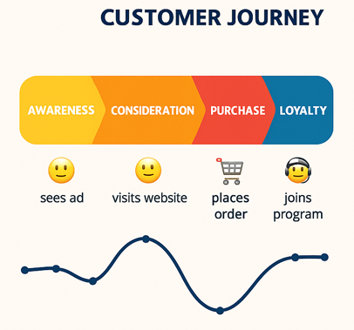

───────────────────────────────────────────────────────────────────────────
M&S CUSTOMER JOURNEY MAP (CURRENT STATE)
───────────────────────────────────────────────────────────────────────────

STAGE 1: AWARENESS
Touchpoints: Social media, Email marketing, Shop windows, Website
Pain Points: Weak targeting, limited personalised messaging
Gains: Strong brand reputation, aspirational content
Digital Opportunities: AI-driven targeting, predictive content tools

───────────────────────────────────────────────────────────────────────────

STAGE 2: CONSIDERATION
Touchpoints: Website browsing, Mobile app, Reviews, Sparks offers
Pain Points: Sizing uncertainty, inconsistent navigation, slow page load
Gains: High-quality product imagery, broad range (incl. third-party brands)
Digital Opportunities: Virtual try-on, AI size recommendations, improved search

───────────────────────────────────────────────────────────────────────────

STAGE 3: PURCHASE
Touchpoints: Checkout, Click & Collect, In-store POS
Pain Points: Payment friction, cyberattack-related trust issues, stock mismatch
Gains: Multiple fulfilment options, efficient store operations
Digital Opportunities: One-tap checkout, biometric payment, real-time stock sync

───────────────────────────────────────────────────────────────────────────

STAGE 4: POST-PURCHASE
Touchpoints: Delivery, Customer service, Returns portal, Store returns desk
Pain Points: Marketplace return complexity, long refund times
Gains: Generous return policies, strong in-store service
Digital Opportunities: QR-based returns, automated refund tracking, self-service kiosks

───────────────────────────────────────────────────────────────────────────

STAGE 5: LOYALTY
Touchpoints: Sparks app, Emails, Push notifications
Pain Points: Generic offers, limited emotional engagement
Gains: Free treats, reliable brand experience
Digital Opportunities: AI-personalised rewards, loyalty gamification, predictive offers.

───────────────────────────────────────────────────────────────────────────

.

Integrating Theory: Using Academic Models Lemon & Verhoef (2016)

Lemon and Verhoef’s (2016) customer experience model help explain why certain stages of the M&S customer journey work well while others create frustration. Their theory argues that customer experience is not shaped by a single moment, but by the entire sequence of interactions a customer has with a brand across different online and offline touchpoints. This idea is important for M&S because customers often switch between the website, mobile app, loyalty program and physical stores when deciding what to buy. According to Lemon and Verhoef (2016), every touchpoint, whether it is an advert, a product page, the checkout screen or the returns process contributes to how customers feel about the brand. When these touchpoints are not coordinated, the overall experience becomes inconsistent, where is exactly what happens with them when customers face issues in sizing uncertainty, slow checkout or generic offers. Using this theory in the customer journey map allows us to see that improving only one part of the journey is not enough and the touchpoints must connect in a way that whole experience feels natural and intuitive. This aligns with the findings, it needs more transformational digital innovation to strengthen the full customer journey, not just isolated improvements.

Part 2. Proposed Digital Transformation

Marks & Spencer continues to invest heavily in its Food division, with around 70% of innovation spending focused on core improvements such as better product quality, healthier options and trusted sourcing. This supports M&S’s goal of being a unique and healthy supermarket for everyone. But, as the analysis in Part 1 showed, placing so much innovation investment into products means that the digital customer experience has not kept up with modern expectations. Research shows that shoppers now expect seamless movement between digital and physical channels and value convenience, speed and personalisation (Grewal, Roggeveen & Nordfält, 2023). Because M&S has not invested enough in these areas, several issues are causing friction in the customer journey.
The cause that several parts of the current M&S customer experience are not working smoothly is of the loyalty offers that remain mostly generic, which makes customers feel unseen. Online shoppers still experience slow navigation, missing stock updates and a checkout process that can feel longer than necessary. These problems arise because M&S has prioritised core product innovation instead of digital touchpoint integration. Academic research shows that customers judge brands based on the entire journey across channels, not individual moments, so poor digital performance affects overall satisfaction (Lemon & Verhoef, 2016). Another issue comes from the absence of personalised food guidance. Customers who want healthier food or specific diets such as gluten-free, vegan or high-protein receive little digital support. Yet research highlights that personalised healthy choices significantly increase satisfaction and wellbeing in food retail (Batat, 2022). Finally, stock inaccuracy remains a major source of frustration, and UK grocery shoppers now expect real-time information to make fast decisions (Mintel, 2024). Together, these problems show that M&S’s digital offer is not fully aligned with what modern customers want.
What the problem means for the customer
These gaps create clear problems for M&S customers. First, they do not feel personally understood because Sparks does not match their preferences or dietary needs. Studies confirm that loyalty programmes only work when rewards feel meaningful and personalised (Beckers, van Doorn & Verhoef, 2022). Second, unclear stock information makes planning difficult and undermines trust. Third, slow checkout or complicated navigation reduces convenience something customers strongly value in today’s digital retail environment (Kumar & Reinartz, 2022). Finally, minimal digital guidance for healthier choices contradicts M&S’s brand promise of supporting customer wellbeing. In short, customers want a journey that feels simple, personal, fast and reliable, but the digital tools currently provided do not achieve this.
Project plan
The U-ICE system will be delivered through a clear and practical project plan that focuses on solving the main customer problems identified earlier. The project begins by confirming the exact pain points such as general offers, slow checkout, and inaccurate stock information and then moves into designing the digital features needed to fix them. Once these issues are defined, the team develops the AI personalisation engine, allowing ignites to offer healthier and more relevant recommendations. (Wedel & Kannan, 2023). At the same time, a smart meal-planning tool and digital nutrition support are built to strengthen M&S’s position as a healthy supermarket. The next phase focuses on improving convenience by adding real-time stock visibility and one-tap checkout, ensuring the buying process is fast and reliable. After this, U-ICE introduces easier post-purchase features such as QR-code returns, automatic refunds, and smart food substitutions. (Grewal et al., 2023). These features are tested in selected stores and online channels before the final rollout. This step-by-step plan ensures each stage of the customer journey is improved in the right order, creating a smooth, connected and supportive experience across all touchpoints, consistent with research showing that successful customer experience requires aligned and integrated interactions (Lemon & Verhoef, 2016).
Improved Customer Journey
With U-ICE, the M&S shopping journey becomes much easier and more personal. Customers receive food offers and ideas that match their real habits, making the experience feel relevant from the start. Shopping becomes smoother because stock information is accurate, product details are clearer, and checkout is fast. After buying, returns and substitutions are simple and stress-free. Overall, the journey feels connected, convenient and designed around what customers genuinely need, making M&S a more enjoyable place to shop. (Zhang, Li & Chen, 2024).
Why this beautifully will succeed
This digital initiative will succeed because it fixes the problems that matter most to M&S customers. Instead of offering generic rewards or slow, unreliable online experiences, U-ICE creates a journey that feels personal, simple and helpful at every stage. Customers will finally get offers that reflect their tastes, accurate stock information they can trust, and a checkout process that respects their time. The healthier meal ideas and personalised guidance also connect directly to M&S’s mission of being a supermarket that supports better living. By removing frustration and adding practical digital tools that genuinely make shopping easier, M&S builds trust, loyalty and repeat visits. In a market where customers choose convenience and personalisation above all else, offering a smooth, connected experience gives M&S a strong advantage. This solution succeeds because it is not just a technical upgrade it is a better way of caring for customers and helping them enjoy shopping again. (Beckers et al., 2022; Grewal et al., 2023).

Conclusion.

In conclusion, this assignment shows that while Marks & Spencer continues to invest heavily in strengthening its core Food offering—spending almost 70% of its innovation budget on product quality, healthier options and trusted sourcing the digital side of the customer experience has not kept pace with what modern shoppers expect. The analysis using the Innovation Ambition Matrix and the customer journey map made it clear that customers appreciate M&S’s food quality and brand trust yet still face several digital frustrations such as generic Sparks offers, slow checkout, unclear stock information and limited support for healthier choices. These issues are consistent with research showing that customer experience depends on smooth and well-connected touchpoints across different channels (Lemon & Verhoef, 2016) and that customers increasingly expect convenience, personalisation and real-time accuracy in grocery shopping (Grewal et al., 2023; Mintel, 2024).
The proposed U-ICE system directly responds to these challenges by offering a simple but meaningful digital transformation plan that integrates the entire M&S journey. Its features in personalised healthy meal recommendations, real-time stock visibility, one-tap checkout and QR-code returns—solve the core problems identified in Part 1 and t also supports the mission of being a healthy supermarket for everyone by giving customers guidance and tools that fit their lifestyle, which aligns with studies linking digital engagement to consumer wellbeing (Batat, 2022).
The improved future journey becomes more connected and emotionally positive, giving customers relevant offers, confident choices, quicker purchases and supportive post-purchase experiences. This builds long-term loyalty, especially when Sparks rewards start reflecting real customer behaviour (Beckers et al., 2022). In the end, U-ICE succeeds because it does more than upgrade technology it removes the everyday frustrations that customers face and replaces them with simple, helpful digital experiences. This balance between strong product innovation and meaningful digital innovation positions M&S to compete more effectively in the modern retail landscape, supporting both customer satisfaction and long-term business growth. In a market where customers increasingly choose brands that make life easier, healthier and more personal, the U-ICE initiative gives M&S a strong foundation for future success.

References.

https://moodle.uwtsd.ac.uk/course/view.php?id=12601
Richardson, A. (2010). Week 4 Using Customer Journey Maps to Improve Customer Experience. Harvard Business Review
Week 5 Strategic Management of Innovation Implementation in the Company. Academy of Strategic Management Journal. Retrieved from Academy of Strategic Management Journal
Marks & Spencer Group plc. (2024). Annual Report and Financial Statements 2024.
https://corporate.marksandspencer.com/sites/marksandspencer/files/2025-05/Marks-and-Spencer-Group-plc-Annual-Report-and-Financial-Statements-2025_INTERACTIVE_FINAL.pdf
Batat, W. (2022). Experiential marketing and consumer wellbeing in the food sector. European Journal of Marketing, 56(3), pp.813–839.
Marks & Spencer Group plc. (2025). Annual Report and Financial Statements 2025
https://corporate.marksandspencer.com
Beckers, S.F., van Doorn, J. and Verhoef, P.C. (2022). Loyalty programs in the digital era: A customer engagement perspective. Journal of Interactive Marketing, 57, pp.52–69.
Batat, W. (2022). Experiential marketing and consumer wellbeing in the food sector. European Journal of Marketing, 56(3), pp.813–839.
Grewal, D., Roggeveen, A.L. and Nordfält, J. (2023). Digital transformation and the future of retailing. Journal of Retailing, 99(1), pp.5–22.
Kim, J. and Kim, M. (2023). Technology-enabled returns and customer satisfaction in online retailing. Journal of Retailing and Consumer Services, 71, 103228.
Kumar, V. and Reinartz, W. (2022). Customer experience management: Toward implementing end-to-end customer journeys. Journal of Service Research, 25(3), pp.1–18.
Lemon, K.N. and Verhoef, P.C. (2016). Understanding customer experience throughout the customer journey. Journal of Marketing, 80(6), pp.69–96.
Wedel, M. and Kannan, P.K. (2023). Marketing analytics for data-rich environments. Journal of Marketing, 87(2), pp.1–27.
Zhang, T., Li, H. and Chen, Y. (2024). Understanding consumer perceptions in omnichannel retail: A customer experience perspective. Journal of Business Research, 168, 114231.
Zhang, Z. (2024). The role of digital transformation in enhancing economic, social and environmental benefit: Take Marks & Spencer as Example. University of Manchester.

