University of Wales, Trinity St. David
Investigating VM, Hypervisors and Networking
BEng Computer Systems and Electronics
Author/student: Thorbjørn R. Kristiansen
Lecturer: Dr. Tim Bashford, UWTSD
February 2018

Contents
Introduction 2
Worksheet 1 – IP addresses, RRAS and LAN 3
Task 1 – Static IP Addresses 3
Task 2 – Enabling RRAS 4
Task 3 – Adding Routing Protocols and Interfaces 5
Task 4 – Local Area Networking 7
Task 5 – Observational Tasks 8
Worksheet 2 10
Task 1 – Address Resolution Protocol 10
Task 2 – Setting up an FTP Server 11
Task 3 – Packet Filtering 14
Task 4 – Filtering FTP Services 15
Task 5 – Only Allow FTP 16
Task 6 – Observational Tasks 18
Worksheet 3 20
Task 1 – Understanding Different TCP/IP Configurations 20
Task 2 – Installing the DHCP Server 21
Task 3 – Authorising the DHCP Server 21
Task 4 – DHCP Scopes 21
Task 5 – Configuring Reservations 22
Task 6 – Observational Tasks 23
Worksheet 4 25
Task 1 – Understanding Active Directory and DNS 25
Task 2 – DNS zones 27
Task 3 – DNS Application 28
Task 4 – Observational Tasks 29
Worksheet 5 – Evaluation of Clustering Strategies 31
References 32

Introduction
The initial task was to create 3 virtual machines utilising SCVMM software. Microsoft Server 2012 R2 was installed on two of the machines, and Microsoft Windows 7 was installed on the client machine.
The three machines were named as follows:
- Cardiff (server)
- Swansea (server)
- Lab (client)
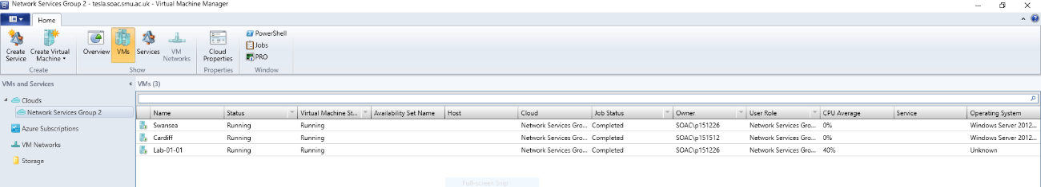
Figure 1 - Three virtual machines set up in SCVMM

Worksheet 1 – IP addresses, RRAS and LAN
Introduce scenario to worksheet. Copy/paste introduction?

Task 1 – Static IP Addresses
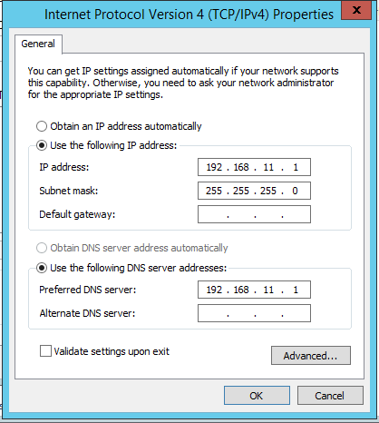
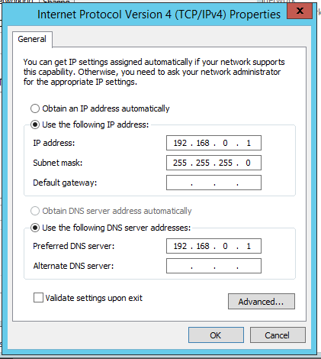
The goal for task 1 was in part to set up the virtual machines (see introduction) and to assign them static IP-addresses.
Figure 3 - Cardiff 11-network
Figure 2 - Cardiff 0-network
As seen in figure 2 and 3, Cardiff was split into two networks. The 0-network exists primarily to communicate with Lab, and the 11-network communicates with the Swansea server.
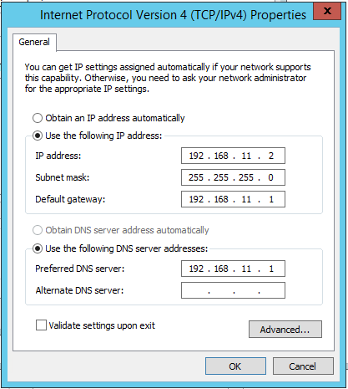
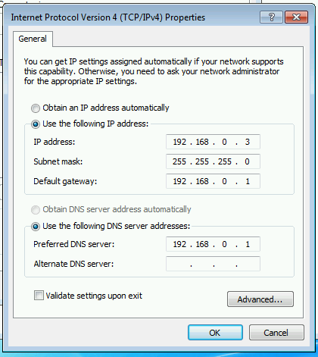
Figure 5 - Swansea static IP
Figure 4 - Lab static IP
In figure 5, we see the IP-configuration for the Windows 7 client. Its default gateway is Cardiff’s 0-network. Figure 5 illustrates the Swansea server’s connectivity, with Cardiff’s 11-network as the default gateway.

Task 2 – Enabling RRAS
The next step was to enable the routing and remote access service (RRAS), to enable the machines to communicate without the need for a physical/external router.
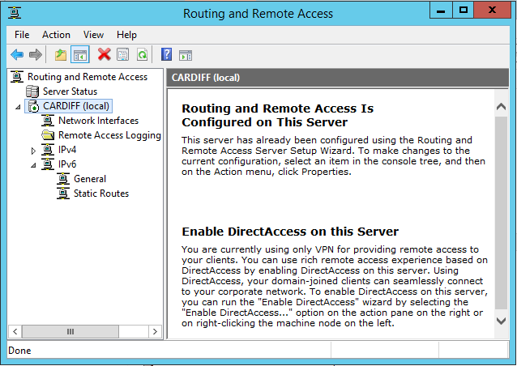
Figure 6 - RRAS enabled
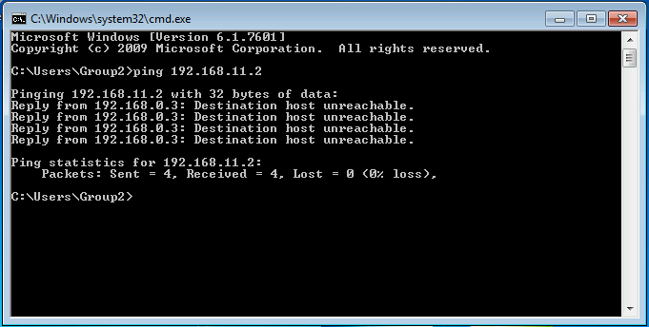
Figure 7 - Ping failed from Lab to Swansea
As seen in figure 6, the RRAS is enabled but unconfigured. This is reflected in figure 7, where the ping from Lab to Swansea failed.

Task 3 – Adding Routing Protocols and Interfaces
Now we add two routing protocols to Cardiff, making it the backbone of the network. These protocols allow for Swansea and Lab to get directions on where to send packets.

As we can see in the next 4 figures, the ping is now successful between all machines.
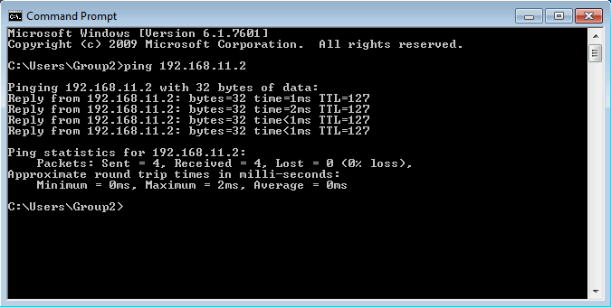
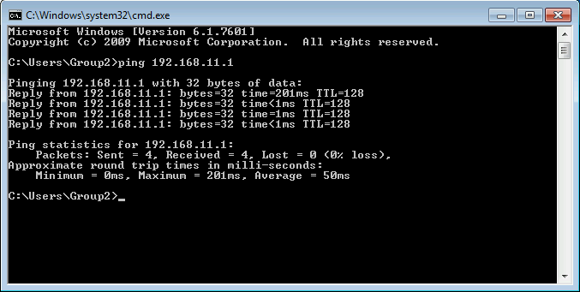
Figure 9 - Successful ping from Lab to Swansea (using Cardiff as router)
Figure 8 - Successful ping from Lab to Cardiff

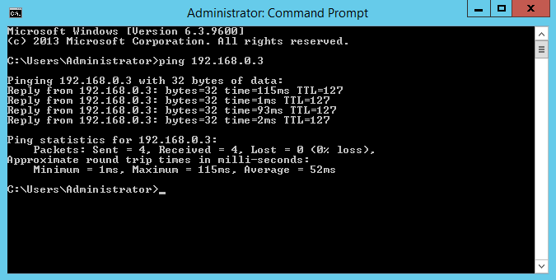
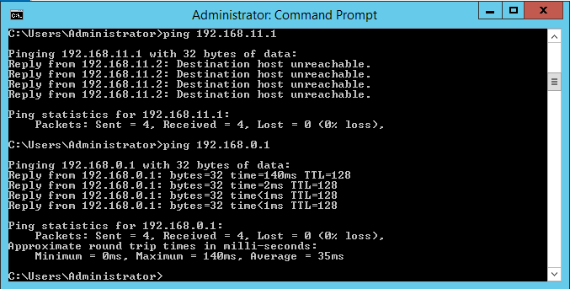
Figure 11 - Successful ping from Swansea to Lab (using Cardiff as router)
Figure 10 - Successful ping from Swansea to Cardiff

Task 4 – Local Area Networking
By opening the route print window by running it from the command prompt on Cardiff using the command route print, we see the route table (figure 12). 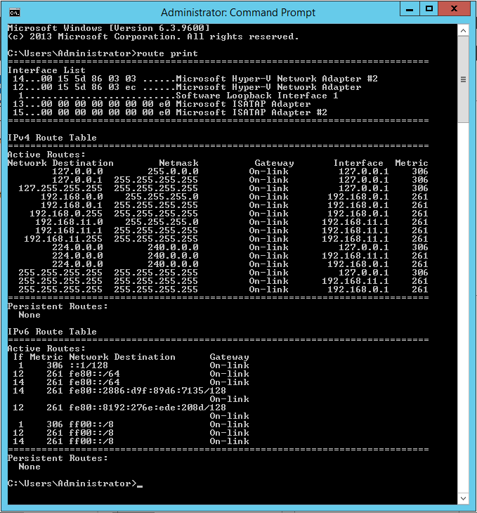
Figure 12 - Route print table
This gives us valuable information on which gateways the packets much use to arrive at its designated location. A great tool for troubleshooting, and, for the inclined, it also gives the opportunity to understand the network in a more advanced way.

Task 5 – Observational Tasks

Identify the benefits of Type 1 Hypervisor software services and briefly evaluate some suitable products
The main benefits of type-1 hypervisors is their ability to run directly on the hardware of the host machine[1]. Here, the overlying operating system shares resources with the underlying hypervisor, making it run faster and more efficient[2].

Define the role of Routers in the Network Architecture, what types can be used?
The routers are the different machines’ tool for communicating with each other. They send the packets to their wanted destination, as instructed by the computer itself, guided by IP addresses[3]. Routers can be internal, like the type used in this assignment. They can also be wireless, with modem capabilities built in. Routers can be classified after what their job is, not only the way they are engineered. Edge routers and core routers are an example[4].

Identify and discuss the usage of common Routing Protocols, what are the associated benefits of using Routing Protocols?
According to Cisco, routing protocols can be classified by their purpose, operation and behaviour[5]. The different protocols allow for different characteristics in scalability, implementation complexity and resource usage among others. Using routing protocols are important because they offer a standardised communication language, which makes it easier for the end-user to operate the system efficiently[5].

Define the role of Routing Tables, and what they are. Break down and analyse the information a Routing Table provides us with.
The routing tables main role is to aid troubleshooting. Maintaining networks and fixing issues requires an in-depth understanding of the different paths machines use to communicate regardless of the users understanding of a specific routing protocol. This is the main purpose of a routing table[6]. As seen in figure 12, the routing table provides us information on what gateway an interface uses, as well as which subnet mask it is assigned to.

What is the Subnet Mask, what is the significance of this in the Routing Table?
The subnet mask matches the IP address to the network ID. Since subnetting separates the host addresses from the network addresses, the routing table provides a way to visualise the way the network is interconnected[7].

Worksheet 2
This worksheet will explain the significance of advantages such as packet filtering, and the principles of FTP servers. It will also go through the ARP process in closer detail and explain through proper filtering techniques how to avoid contradictory filtering.

Task 1 – Address Resolution Protocol
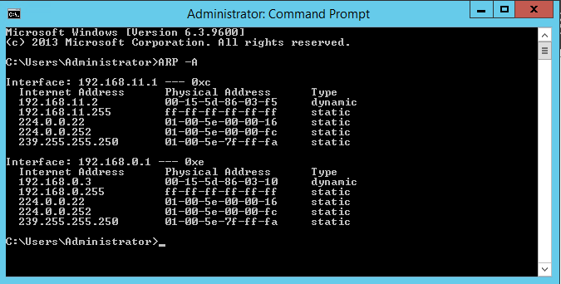
This task demonstrates how to obtain network information on the link layer using the Address Resolution Protocol (ARP). The query ARP-A was ran in the command prompt on Cardiff, and the table in figure 13 got generated.
Figure 13 - ARP network link information
Figure 13 illustrates what IP address is associated with each physical address at the current moment, and their change depending on them being static or dynamic as also shown on the right.

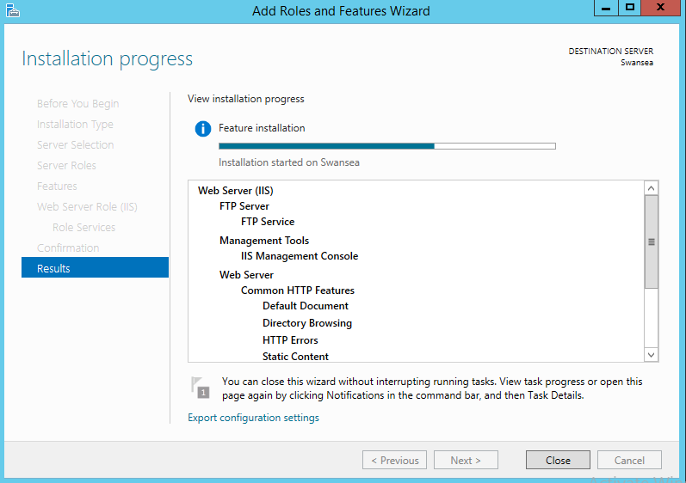
Task 2 – Setting up an FTP Server
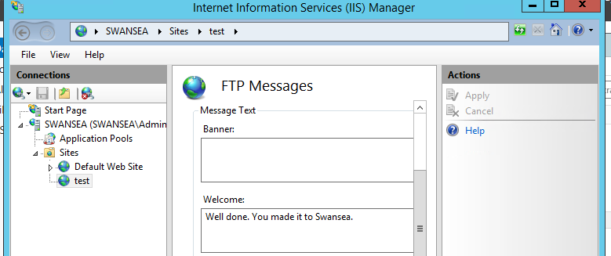
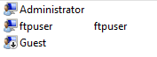
After installing the FTP service from the server manager dashboard on Swansea (figure 14), a new FTP user was created using the tools from the users and groups settings (figure 15), with the instructed username and password in the worksheet. A root folder was selected, as well as the authentication method (basic) and the Secure Sockets Layer (SSL) (turned off). The user was given read/write privileges over the Swansea server, and a banner was created to help identify the FTP server when connected to (figure 16). The working banner can be seen in figure 17.
Figure 16 - FTP server welcome banner set
Figure 15 - New FTP user
Figure 14 - FTP service installing

A new file was created in the root directory, so the actual FTP functionality could be assessed.
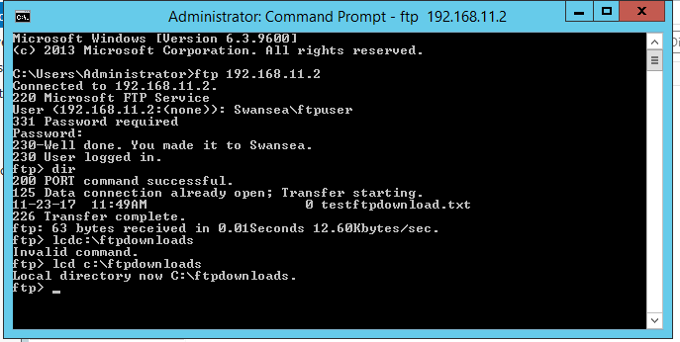
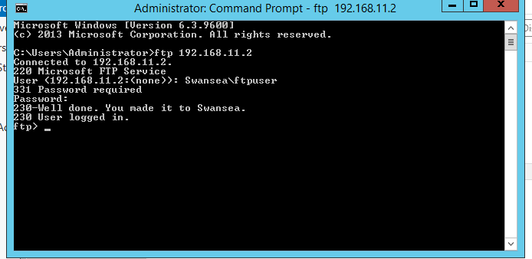
In the Cardiff server, a new folder dedicated for FTP downloads was created. Then, the command ftp 192.168.11.2 was executed in the command prompt. The login credentials previously created were typed in (figure 17) and the dir command was utilised to show the contents of the directory previously created. The host directory for downloads needed to be set with the command Local Directory Change: lcd c:\ftpdownloads, as seen in figure 18.
Figure 17 - Successful login to Swansea FTP server from Cardiff
After this was done, the FTP server was tested with the command get testftpdownload.txt (name of the file previously created). This initiated the download, and the file appeared in the folder created for FTP downloads (figures 19).
Figure 18 – Local Directory Change successful
Figure 19 - Test file download complete
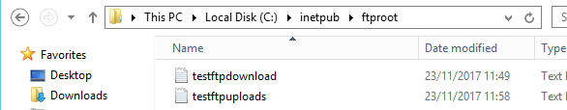
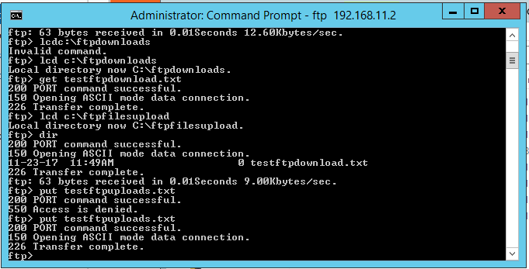
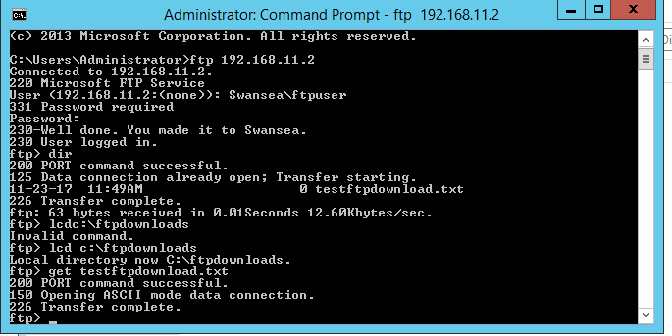
The upload was tested in the same manner, with a new folder created for uploading files on Cardiff, and the folder was chosen as the default folder using the lcd command. A new file was created, named testftpuploads.txt, and the command put testftpuploads.txt was used to upload the file to Swansea (figure 20 and 21).
Figure 20 - FTP upload from Cardiff to Swansea completed
Figure 21 - Uploaded file in upload directory

Task 3 – Packet Filtering
The main purpose of this task was to demonstrate the capabilities of packet filtering and how to correctly set it up. For proof of concept, a ping from a client which has had its packet flow blocked by the inbound filter should fail.
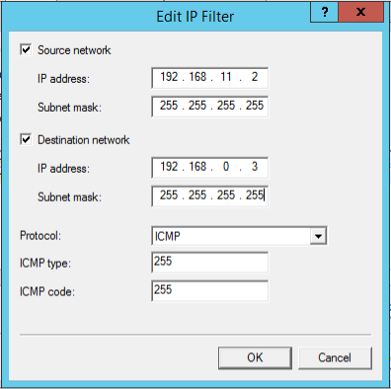
The filter was set up on the 11-network on the router (Cardiff) to block packets coming from Lab to Swansea (figure 22). The 0-network was left untouched.
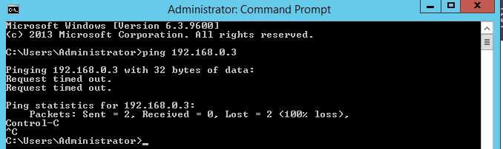
Then, two individual pings were performed to illustrate that only the 11-network interface had been affected by the packet filtering options. In figure 23, we see the ping being blocked by the filter when trying to communicate from Swansea to Lab. In figure 24, we see the packet arriving at Cardiff’s unchanged 0-network interface as predicted.
Figure 23 - Packets blocked by inbound filter
Figure 22 - Filter setup at Cardiff's 11-network interface
Figure 24 - Normal packet flow to Cardiff's 0-network interface

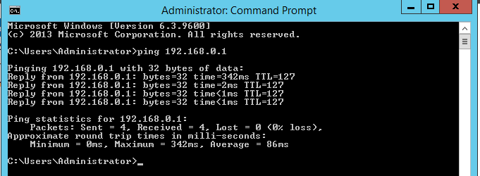
Task 4 – Filtering FTP Services
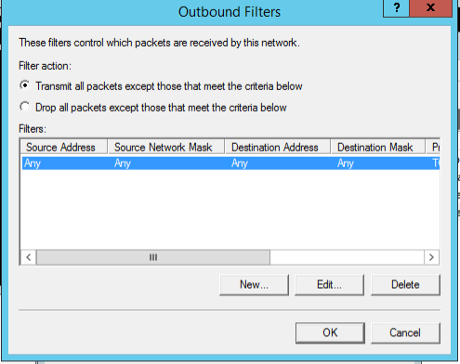
Before any new filters were created, the existing ones were removed to avoid contradictory filtering. The task at hand was to filter out all connections to the FTP server on Swansea. A new filter was created on the router (Cardiff) with these attributes (figure 25).
Figure 25 - Outbound filter set up on Cardiff
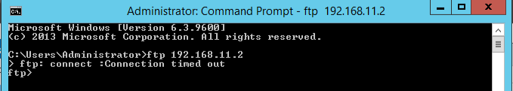
This was tested by attempting to connect to the server (figure 26).
Figure 26 - Connection to the FTP failed

The filters where then removed again, preparing for the task of filtering out all access to the FTP-server, except for connections from Cardiff. This required an inbound filter blocking all TCP-ports used for FTP. The filter was tested by attempting to connect from Cardiff itself and the other machines. The screenshots for this are regrettably missing along with the rest of task 4, although the result for this experiment is the same as in figure 26.
The filters were again removed, and a new filter was put in place to block only Cardiff from accessing the FTP server.

Task 5 – Only Allow FTP
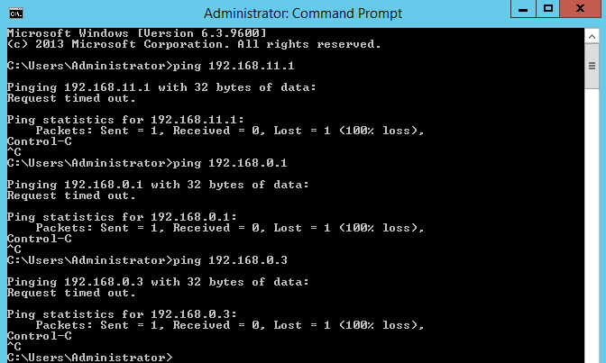
The Cardiff server was set up with inbound and outbound filters excluding all traffic except TCP-ports 20 and 21. This allowed for FTP-traffic to flow through.
Figure 27 – Swansea is unable to ping anywhere
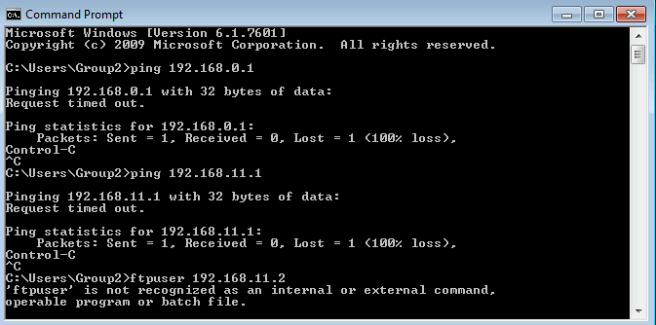
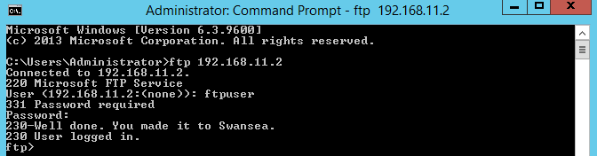
As a result, pings are blocked in all directions, and only FTP traffic is allowed to flow (figures 27, 28 and 29).
Figure 29 - Lab cannot utilise FTP or Ping anywhere
Figure 28 - FTP request from Cardiff is still functional

Task 6 – Observational Tasks

Describe (using appropriate illustrations) how the ARP process operates in Networking
The address resolution protocol process resolves which interface a packet should be sent by utilising the MAC-address of the interface. This is shown below[8]:
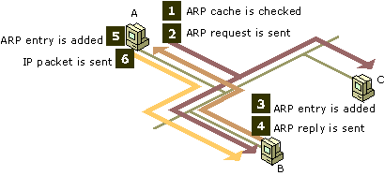
Image courtesy of Microsoft Technet[8]
This makes it possible to send data to a specific receiving party, as well as identifying where the data came from.

Explain what packet filtering is, and why it is called IP Packet filtering. Also explain why you would use packet filtering in your network and what the benefits are
Packet filtering is used to control which machines can receive/send packets, or more specifically, what types of packets are allowed through. Packet filtering can utilise the opening or closing of ports, or simply allowing or blocking different services depending on their type. It is an extremely important tool when connecting an intranet to the internet. This provides an extra layer of security, and works as a form of access control[9].

Why is it possible for contradictory filters to occur when you use packet filtering? Give an example of a Contradictory Filter:
Contradictory filters appear as a result of a breach in logic. Example: If a filter on Cardiff’s 0-interface allows FTP data, and another filter on Cardiff’s 11-interface blocks it, the packets can still get through the other channel to reach its destination. This renders both filters useless.

FTP Server is just one Role/Service we can configure our Server to provide? What other roles can the Server provide that would benefit our Infrastructure in both a local and remote context?
Several services are required for a network to operate smoothly. DNS services are important for resolving actual address names, making it easier for the end-user to remember URL’s[10]. DHCP makes setting up new interfaces and peripherals easier, as it assigns IP-addresses automatically and keeps a record of the nodes connected to the network, reducing the administration effort[11]. RRAS gives the machine routing capabilities, which is useful for controlling packet flow over different interfaces[12].

Worksheet 3
Worksheet 3 will cover TCP/IP configuration utilising the DHCP protocol. As part of the pre-setup, each machine was given three network interfaces on its networks. The original static IP-addresses were written down for future use.

Task 1 – Understanding Different TCP/IP Configurations
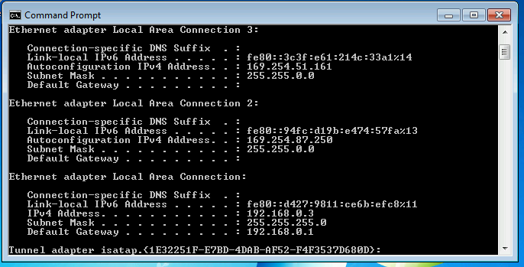
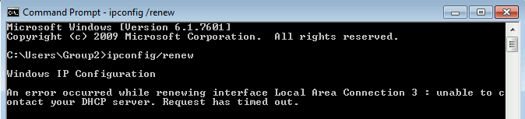
Here, we set the 0-network on Lab client to automatic private IP addressing through the GUI. Then the command prompt was opened, and the ipconfig/release command was executed. This ensures that all static IP-addresses are removed. Then, the ipconfig/renew command was executed to renew the IP addresses. The machine now lacks a DHCP server (figure 30).
Figure 31 - Autoconfiguration enabled, see subnet masks
Figure 30 - Computer is unable to contact the non-existing DHCP-server.
In figure 31, we see the subnet masks has changed to 255.255.0.0, and the IP-addresses are in the APIPA-range. Theres also no default gateway, which means Autoconfiguration has been enabled.

Task 2 – Installing the DHCP Server
The cleared static IP-addresses from the previous task were now reinstated to their former values. Next was installing the DHCP server, this was done simply by using the post-install wizard for DHCP in the GUI of the Cardiff machine.

Task 3 – Authorising the DHCP Server
This task was simply authorising the DHCP server, to prepare it for Active Directory. This was also done in the Cardiff GUI. No screenshots are provided for this task and the previous due to their simplicity.

Task 4 – DHCP Scopes
A question posed in this task was: Why are reservations important when using DHCP? Reserved IP-addresses are often a good idea for hardware and units that never leave the network or units that require extra stability and continuous connections like servers and printers.

Part A – Creating Scope Lease
To set DHCP scopes on our network, we added a new DHCP scope in the IP configuration window of the Cardiff machine. The scope was set between 192.168.0.2 to 192.168.0.254.
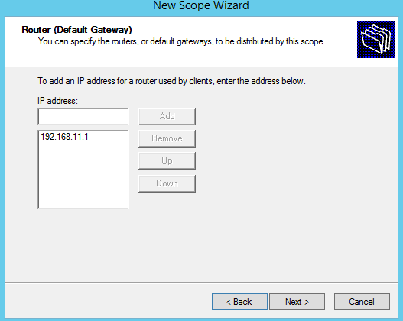
Figure 32 - DHCP scope window

Part B – Obtaining IP Address
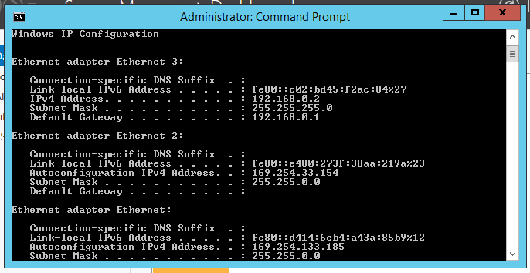
In Swansea’s TCP/IP settings, the server was set to obtain IP addresses and DNS servers automatically. The IP addresses where thereafter released and renewed through the command prompt.
Figure 33 - Swansea's IP address after DHCP scope configuration. See Ethernet 3.

Task 5 – Configuring Reservations

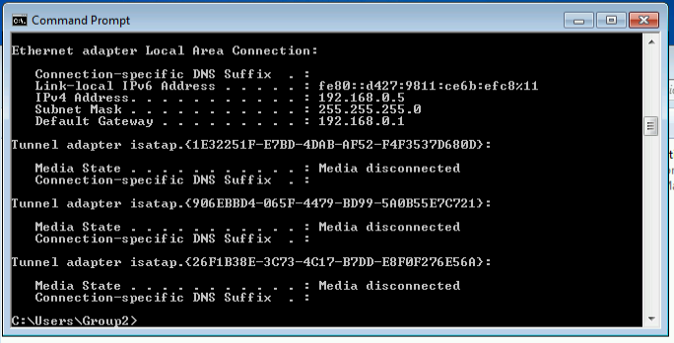
The IP address lease for Swansea was changed to a reserved address. Thereafter, the 0-network on the client was changed to be reserved by using its MAC-address as a reference point. The new reserved IP address was set to 192.168.0.5, which we see after a renew in figure 34.
Figure 34 - Lab IP address 0.5
As a proof of concept and understanding, the IP reservation was changed manually to 0.3, and the renew revealed once again that the change had gone through. See figure 35.

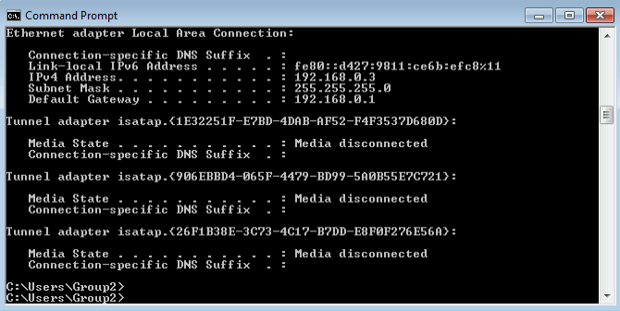
Task 6 – Observational Tasks
Figure 35 - Lab IP address as 0.3

Define the role of the DHCP Server in your Network?
The DHCP server assigns IP addresses to the different devices connected to the network. It also assigns default gateways and subnet masks. The main purpose of DHCP is to reduce the administration effort, making the network more autonomous[11].

What happens when we have dynamically configured TCP/IP for our NIC, but then consequently cannot contact a DHCP server?
If no DHCP server is available, Autoconfiguration is activated, and the NIC gets assigned an IP address in the APIPA range.

Illustrate, with illustrations, the 4-stage process involved when DHCP clients look to obtain an IP address via DHCP.
The DHCP clients talk to the server in 4 steps, known as the DORA-process. This is an abbreviation of Discover, Offer, Request and Acknowledge.
The client first broadcasts that it needs a DHCP server (discover).
The DHCP server then receives the broadcast and offers the client an available IP address (offer).
The client then requests this IP address, (request) and the server acknowledges the address assignment (acknowledge). See illustration below[13]:
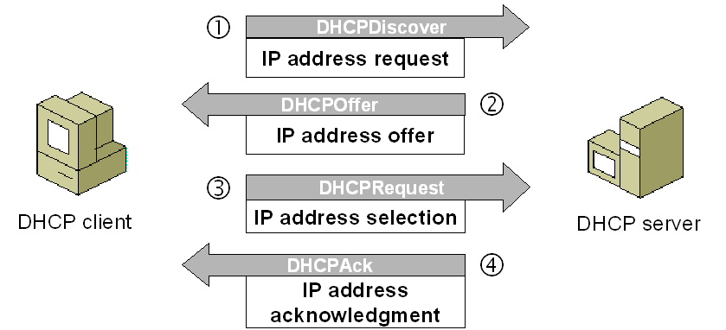
DORA process. Image and information courtesy of imedita.com[13]

Describe the advantages of using a relay agent. Explain (with descriptions and illustrations) how and why we would setup the Relay Agent on our router?
The relay agent is the technique utilised by DHCP to communicate between the server and client. The messages sent include gateway information, link information for the different interfaces, etc. This is useful when communicating across differing subnets[14].
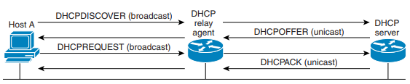
As seen in the figure above[14], this is how the DORA-handshake works on a macro-level. This also illustrates the basic setup location for a relay agent.

Worksheet 4
This worksheet will contain tasks utilising the Domain Name Service (DNS) system, and how to deploy Active Directory.

Task 1 – Understanding Active Directory and DNS
Firstly, Active Directory needed to be installed on the Cardiff server. The domain name was nwtraders.msft.
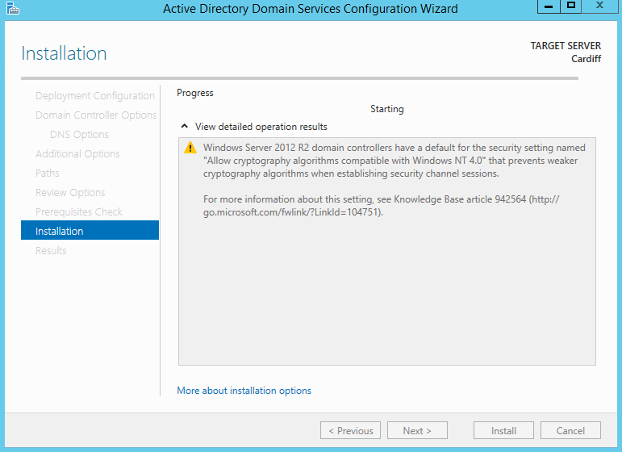
The Swansea and Lab machine were added to the domain (figures 37, 38 and 39).
Figure 36 - Setting up Active Directory on Cardiff
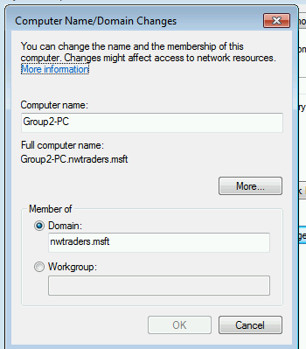
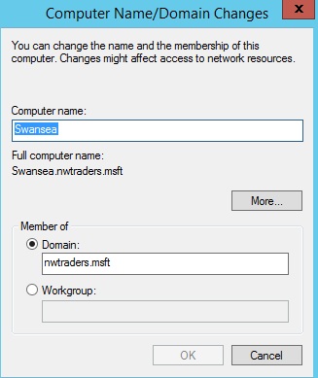
Figure 38 – Lab added to nwtraders.msft domain
Figure 37 - Swansea added to the nwtraders.msft domain
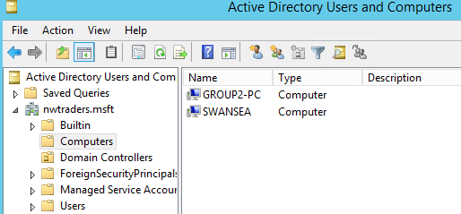
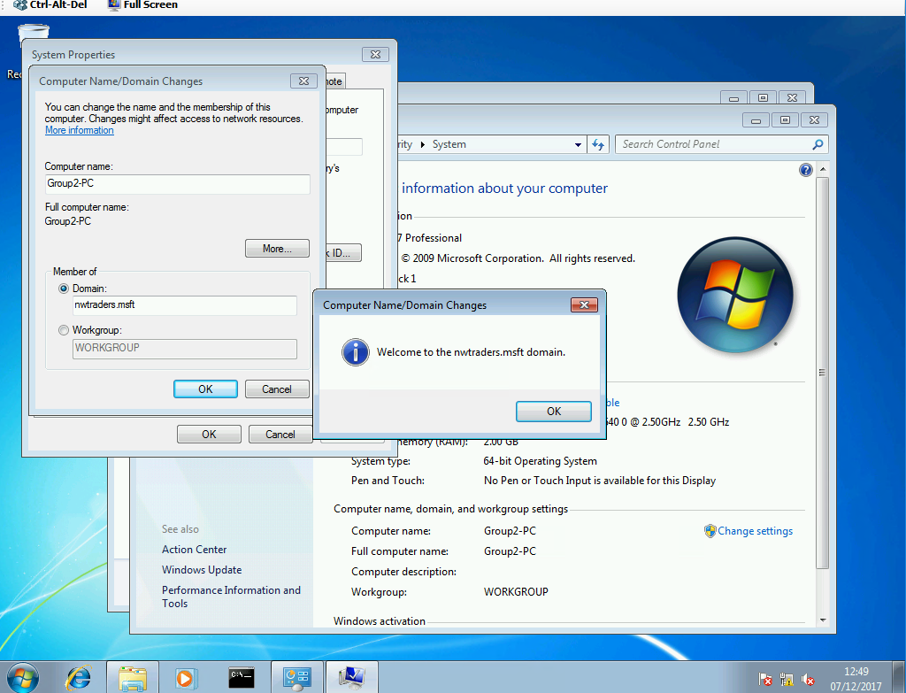
Now, we can confirm that the server and client are on the same domain from the Cardiff server’s Active Directory settings (figure 40).
Figure 40 - Active Directory listing for the nwtraders.msft domain
Figure 39 - Lab successfully joined nwtraders.msft domain
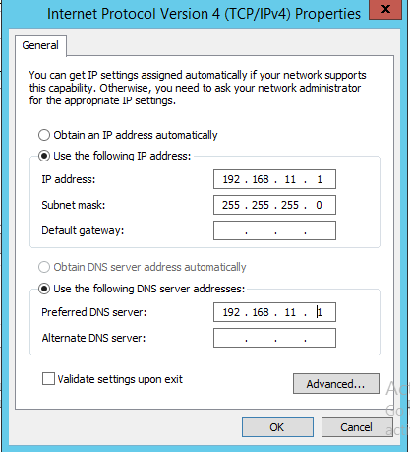
The DNS server service was installed on Swansea. In Cardiff, we made the DNS server a client of itself (figure 41)
Figure 41 – Cardiff DNS server client of itself
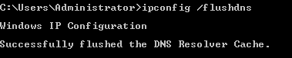
The next step was to configure the DNS server to use a DNS forwarder (figure 42). The root hints were then updated, and the DNS cache cleared (figures 43 and 44).
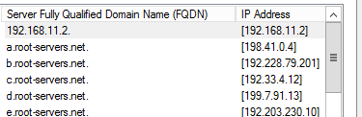
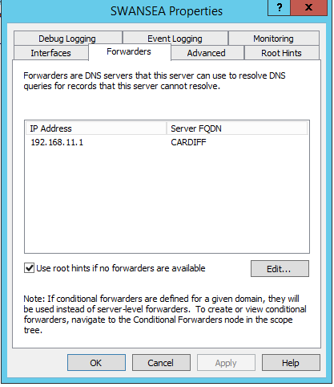
Figure 44 - DNS cache cleared
Figure 43 - Root hint table
Figure 42 - DNS forward enabled for Cardiff
There are scenarios where having control over the DNS cache and being able to clear it is useful. These scenarios include server migration, privacy issues, maintenance scenarios etc[15].

Task 2 – DNS zones
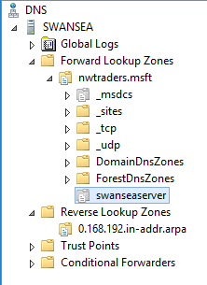
A secondary forward lookup DNS zone was created in Swansea, and was named nwtraders.msft. Zone transfers were then enabled, as seen in figure 45.
Figure 45 - Zone transfer enabled

Now, we configure the reverse lookup zone in Swansea. This was done through the previously installed DNS console, with the preferred DNS server on Cardiff as a reference (figure 46)
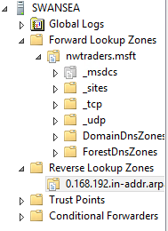
Now, a new primary forward lookup zone was created, with the prefix swanseaserver. The FQDN was now swanseatraders.nwtraders.msft.
Figure 46 - Reverse lookup zone on Swansea. Zone transfer works.

Task 3 – DNS Application
A Virtual directory was created on Swansea, with the name “test”. A default root directory for a website was created, and its location was set to the highest priority in the Virtual Directory.
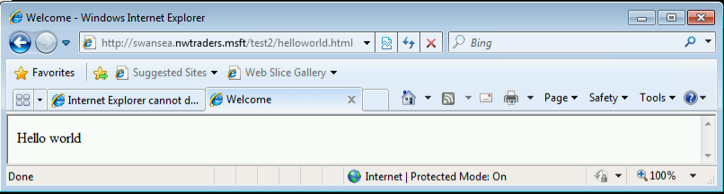
Finally, a simple HTML script was created[16] and added to the root folder to output “hello world” when entering the URL in a browser on Lab. (figure 47).
Figure 47 - Script working, page loaded

Task 4 – Observational Tasks

What steps does a client take (what is the process involved) when trying to resolve a Name to an IP address?
Anecdotally, the human brain is extremely bad at remembering numbers. This requires a service that converts IP addresses to intelligible text, e.g. google.com. The DNS server resolves names from IP addresses and vice versa. The process is as follows: The user inputs google.com into the browser. The computer does not know where or what google.com is, so it contacts a DNS resolver. The DNS resolver speaks to other DNS resolvers, hoping that one of the resolvers knows where “google” on the “com” domain is. When a result is acquired, the “google.com” query is translated to the destination IP address, and communication is established between the client (user) and the host (Google)[17].

Describe how the Recursive Query and Iterative Query Processes resolve DNS Client Requests?
The recursive query is the initial query from the host. A recursive query expects either an address or an error in return, as it is the first step of resolving an address or a name[18]. The iterative query takes it one step further, as the response must either be a location, name or address[18].

Explain the significance of root hints and how this process enables us to resolve names that are not managed (or kept in an authoritative DNS server in our network)?
The root hint file is a record of host destinations useful when querying locations or addresses outside the scope of the DNS server. If a query hits a dead-end, the query goes to the root hint list and finds an appropriate destination for the packet[19].

We have a Server called Server1, this server will be hosted in a subdomain called ‘subcontA’ with a root domain called nwtraders.msft, answer the following questions:

(1). What is the exact FQDN for this host.
The full FQDN is Server1.subcontA.nwtraders.msft.

(2). Illustrate how the Domain Name System breaks up this FQDN into Host and Domain Namespace.
This FQDN is broken up into 3 separate entities, which are as follows[20]:
- Host name (Server1)
- Subdomain (subcontA)
- Primary domain (nwtraders.msft)

Explain how DNS Zones are used in DNS, give examples to illustrate the use of multiple

zones and how these can be used to manage resource records of domains. What

important factors/characteristics do we need to be aware of?
DNS zones is a system of delegations which simplify finding specific addresses within a network. Since the internet is vast, finding a specific address is a complex task. Therefore, DNS is split up into different physical zones, each referring to the next zone. An abstraction of this can be the following: If you call a customer support hotline at any company and ask to speak to Dan in the warranty section, the person who picks up the phone doesn’t know Dan or his number. What he does know, is the number for the warranty section. The call gets forwarded to warranty, and they have their own list of numbers pointing you in the direction of Dan[21]. This abstraction also works for IP addresses and routing. The different layers of a domain name are resolved through a system of subdomains, and the different DNS servers handling them. See image below[22] for reference.
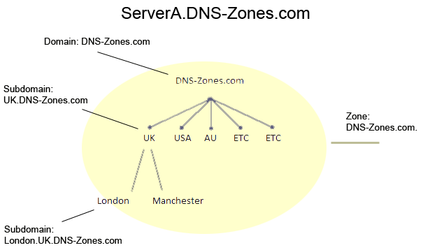

Worksheet 5 – Evaluation of Clustering Strategies
Clustering is the splitting of workload between multiple servers. A web-development system can be split in to three layers. The client tier, application tier and the data tier. Here, the client layer interacts with the user, and handles requests like ordering and site navigation. The application tier contains the applications running in the background to complete these requests. This tier uses data from the data tier, which contains all the necessary information to make the distribution do something useful[23].
This makes clustering ideal. Each tier can be handled by a separate server, in order to increase efficiency, as each tier requires different levels of server performance. These machines (nodes) work together to make the application appear seamless for the end-user, making a virtual machine[24]. The machines in the clusters are also fulfilling tasks like making the system redundant, utilising failover clusters[24]. A good example of resource delegation is the Google search engine. Google handles millions upon millions of search queries every day. This is too much for one machine to handle, so the workload is split up over several machines placed around the globe[25].

References
[1] B. Golden, Virtualization for dummies. Wiley, 2007.
[2] S. Meier, “IBM Systems Virtualization: Servers, Storage, and Software.” [Online]. Available: http://www.redbooks.ibm.com/redpapers/pdfs/redp4396.pdf. [Accessed: 14-Feb-2018].
[3] Cisco Networking Academy, “Introduction - Cisco Networking Academy’s Introduction to Routing Concepts,” Cisco Press, 2014. [Online]. Available: http://www.ciscopress.com/articles/article.asp?p=2180208&seqNum=3. [Accessed: 14-Feb-2018].
[4] D. Thakur, “Types of Routers.” [Online]. Available: http://ecomputernotes.com/computernetworkingnotes/communication-networks/what-is-routers-explain-types-of-routers. [Accessed: 14-Feb-2018].
[5] Cisco Networking Academy, “Types of Routing Protocols - Cisco Networking Academy’s Introduction to Routing Dynamically,” 2014. [Online]. Available: http://www.ciscopress.com/articles/article.asp?p=2180210&seqNum=7. [Accessed: 14-Feb-2018].
[6] Cisco Networking Academy, “The Routing Table (3.5) Cisco Networking Academy’s Introduction to Routing Dynamically,” 2014. [Online]. Available: http://www.ciscopress.com/articles/article.asp?p=2180210&seqNum=12. [Accessed: 14-Feb-2018].
[7] IPlocation.net, “What is a Subnet Mask?” [Online]. Available: https://www.iplocation.net/subnet-mask. [Accessed: 14-Feb-2018].
[8] Microsoft Technet, “ARP Process.” [Online]. Available: https://technet.microsoft.com/en-gb/library/cc940010.aspx. [Accessed: 14-Feb-2018].
[9] Microsoft Technet, “IP Packet Filtering.” [Online]. Available: https://technet.microsoft.com/en-gb/library/cc957881.aspx. [Accessed: 14-Feb-2018].
[10] M. Brain and S. Crawford, “How Domain Name Servers Work | HowStuffWorks.” [Online]. Available: https://computer.howstuffworks.com/dns.htm. [Accessed: 14-Feb-2018].
[11] Microsoft technet, “What Is DHCP?: Dynamic Host Configuration Protocol (DHCP),” 2003. [Online]. Available: https://technet.microsoft.com/en-gb/library/cc781008(v=ws.10).aspx. [Accessed: 14-Feb-2018].
[12] Microsoft Developer Network, “Routing and Remote Access Service.” [Online]. Available: https://msdn.microsoft.com/en-us/library/Aa446768. [Accessed: 14-Feb-2018].
[13] S. Singh, “DHCP Concepts and Configuration in Real Cisco Router,” 2015. [Online]. Available: http://imedita.com/blog/dhcp-in-cisco-packet-tracer/. [Accessed: 14-Feb-2018].
[14] Cisco, “Cisco Application Control Engine Module Routing and Bridging Configuration Guide Configuring the DHCP Relay Cisco Application Control Engine Module Routing and Bridging Configuration Guide DHCP Server and Client Overview.”
[15] S. Laverty, “Is There a Need to Clean the DNS Cache? | It Still Works | Giving Old Tech a New Life.” [Online]. Available: https://itstillworks.com/there-need-clean-dns-cache-25636.html. [Accessed: 14-Feb-2018].
[16] mkyong, “Html Tutorial Hello World,” 2012. [Online]. Available: https://www.mkyong.com/html/html-tutorial-hello-world/. [Accessed: 14-Feb-2018].
[17] Cisco, “Understanding the Domain Name System - Cisco,” Cisco tech support, 2005. [Online]. Available: https://www.cisco.com/c/en/us/support/docs/ip/domain-name-system-dns/12683-dns-descript.html. [Accessed: 14-Feb-2018].
[18] Catchpoint, “Name to IP Address,” Catchpoint blog, 2014. [Online]. Available: http://blog.catchpoint.com/2014/07/01/dns-lookup-domain-name-ip-address/. [Accessed: 14-Feb-2018].
[19] Microsoft technet, “Root Hints Files,” Technet. [Online]. Available: https://technet.microsoft.com/en-us/library/cc958982.aspx. [Accessed: 14-Feb-2018].
[20] Indiana University, “About fully qualified domain names (FQDNs),” IU Knowledge Base, 2017. [Online]. Available: https://kb.iu.edu/d/aiuv. [Accessed: 14-Feb-2018].
[21] ISO Training Institute, “DNS - what are DNS ZONES ? - YouTube,” 2017. [Online]. Available: https://www.youtube.com/watch?v=JIwi6ii-rzI. [Accessed: 14-Feb-2018].
[22] “DNS Zones Explained | Think Like A Computer.” [Online]. Available: https://www.think-like-a-computer.com/2011/06/11/dns-zones-explained/. [Accessed: 14-Feb-2018].
[23] Microsoft Developer Network, “Three-Tiered Distribution.” [Online]. Available: https://msdn.microsoft.com/en-us/library/ff647546.aspx. [Accessed: 14-Feb-2018].
[24] ESDS, “Cluster Computing: Definition and Architecture of a Cluster.” [Online]. Available: https://www.esds.co.in/blog/cluster-computing-definition-and-architecture-of-a-cluster/#sthash.vBg3fjN9.dpbs. [Accessed: 14-Feb-2018].
[25] C. S. Yeo, R. Buyya, H. Pourreza, R. Eskicioglu, P. Graham, and F. Sommers, “Cluster Computing: High-Performance, High-Availability, and High-Throughput Processing on a Network of Computers.”

