Nightshift Nail Lounge – 24-Hour Safe Beauty Space for Women
Individual Written Business Plan
Programme:
Certificate in Higher Education Business Skills for the Workplace
Module Name:
Enterprise and Entrepreneurship
Module Code:
LCLM4006
Student Name:
XX
Student ID Number:
XX
Lecturer:
Dr Chung Lai Johnny Wan (Birmingham)
/ Dr Charles Oham (London – use your correct campus)
Submission Date:
2 March 2026

Executive Summary
Nightshift Nail Lounge is a new 24-hour nail salon being developed in a large UK urban centre to fill an obvious gap in the night-time beauty industry. Many employees in the UK work evenings, nights, or rotating shifts however, the majority of nail salons work only standard daytime hours. This brings about a restricted accessibility to personal care services among the shifting-based female employees. The target population is NHS employees, hospitality workers, airport workers, retail workers and students, with the offer of Safe Beauty After Hours at the hands of professional nail care, backed up by CCTV cameras, access control, and late-night staffing of females only. The venture is a Private Limited Company, which increases the level of investor confidence and scalability. The model shows financial viability and potential sustainable growth with a start-up capital of £65,000 and a recurring membership income.

Table of Contents
Executive Summary 2
1. Overview of the Business Idea 4
1.1. Business Concept and Strategic Rationale 4
1.2. Legal Structure 4
1.3. Management and Operational Structure 4
2. Market Research and Environmental Analysis 5
2.1. PESTEL Analysis 5
2.2. Competitive Analysis 6
3. Marketing Communications Strategy 6
3.1. Market Segmentation and Targeting 6
3.2. Marketing Mix Strategy (4Ps) 6
3.3. Branding and Positioning 7
4. Financial Plan 8
4.1. Start-Up Funding Requirement 8
4.2. Funding Sources 8
4.3. First Month Operating costs 8
5. Conclusion 9
6. References 10

Nightshift Nail Lounge – 24-Hour Safe Beauty Space for Women (UK)

Overview of the Business Idea

Business Concept and Strategic Rationale
Nightshift Nail Lounge is a service-oriented business that has been established as a 24-hour business in a large UK urban centre in such a way that it targets women working in shift positions. In 2023, around 28 percent of UK workers had to work evenings, nights or rotating working hours, and the healthcare and hospitality industries showed the highest rate of involvement (Office for National Statistics, 2023). The conventional nail salons are in operation between the hours of 9am and 7pm which poses structural discrimination to the night laborers who need opportunity to access personal care in a flexible manner. The main customer groups are the NHS nurses, airport and hospitality staff, university students, and retail or logistics workers whose schedules may vary.
The value proposition is called Safe Beauty After Hours, which combines professional nail care with monitored CCTV, controlled entry, visible security presence, and staffing of women during late-night hours. Studies have shown that the perceptions with regard to safety is a major determinant of the consumption behaviour of women in urban night-time settings (Johansson and Haandrikman, 2023). The ability of the business to position security at its core, rather than competing on price, has created a defensible niche based on service specialisation and trust-based positioning. The strategy is in line with the increasing labour force participation by females in the UK, which in 2022 was at 72% (World Bank Group, 2023), justifying continued demands on convenient, safety-focused services.

Legal Structure
Nightshift Nail Lounge will be under a Private Limited Company (Ltd) which will offer limited liability and will help to increase investor confidence. This model promotes systematic capital investment, personal risk reduction, and facilitates the growth throughout the UK via franchising or branching in multiple cities (Kotler et al., 2021).

Management and Operational Structure
Nightshift Nail Lounge will implement lean management, with the Founder/Managing Director in charge of strategy and partnerships, two certified nail technicians running rotational shifts to ensure 24-hour service, one trained night security/reception officer controlling access and safety, and a part-time marketing coordinator in charge of digital marketing, which will be cost-effective and reliable in terms of operations.

Market Research and Environmental Analysis

PESTEL Analysis
Factor | Analysis
Political & Legal | The beauty salons in the UK should be in line with the local authority licensing regulations as well as the Control of Substances Hazardous to Health Regulations (HSE, 2023). The law on employment requires that there should be compliance with the National Minimum Wage and Working Time Regulations in night shifts (ACAS, 2023). Although compliance raises labour and administrative expenses, obvious regulatory compliance raises consumer trust and perceived professionalism and boosts brand credibility in positioning based on safety.
Economic | The UK late-night economy generates more than 36 billion every year (Meers, 2024). Demand is supported in urban centers with high population density in terms of shift-based employment, e.g. Birmingham and London. Despite the limitations on the discretional spending of households by the cost-of-living pressure, the services of personal care are relatively resilient, given the repeated patterns of consumption. Premium pricing will be viable in the urban professional segments where convenience and safety will be important.
Social | The labour force participation by female workers was at 72% in 2022 (World Bank Group, 2023), and night shifts were spread to NHS and hospitality. Females in the city complain of increased insecurity at night (García-Carpintero et al., 2022). Such overlapping trends generate sustainable demand among shift-working women of secure and late-hour beauty services.
Technological | CCTV cameras, limited access control, and online reservation systems improve efficiency of operations and the sense of security. Targeted social media marketing and mobile payments allow customers ease and data-driven interactions, minimizing transaction friction and marketing waste (Chaffey and Smith, 2022).
Environmental | Constant light use consumes more energy but an LED light can use 75 percent less than traditional bulbs (HSE, 2023). Green disposal of chemicals under COSHH coincides with environmentally friendly branding, which builds reputational capital.

Competitive Analysis
Conventional city centre nail bars, including individual high street businesses in the Bullring district of Birmingham, are generally open between 9am and 7pm. Their shortcomings are limited access by night workers, overcrowding on days, and lack of safety-oriented branding. Nightshift Nail Lounge is defensibly niche positioned in the sense that it has a unique focus on accessibility during the night and its security infrastructure is embedded in the core service model (Porter and Kramer, 1985). The entry barriers are high operation costs, investment in CCTV and controlled access systems, and hiring of trained night-shift personnel. These structural needs minimize the risk of imitation and promote first-mover advantage and sustainable competitive positioning in the UK urban night economy.

Marketing Communications Strategy

Market Segmentation and Targeting
Nightshift Nail Lounge will focus on women aged 20-45 who work or study in UK cities, and the participation in labour among women in the UK reached 72% in 2022 (World Bank Group, 2023). The healthcare and hospitality industries have a high density of night shifts, and it is estimated that there are about 1.7 million NHS staff in the country. Geographically, the salon will be setting up around hospitals, airports, universities, and transport hubs to tap into the concentrated shift-based demand. The psychographic segmentation of the target market is that of safety-conscious, time-sensitive, career-oriented consumers who give priority to reliability and controlled settings. Studies show that the perceived safety plays a significant role in the service-location decision of women at night (Nasrin and Bunker, 2024). This segment exhibits repetitive consumption behaviour in that beauty treatments are usually service cycles with four weeks (Sharma, 2025). Targeted marketing enhances the effectiveness of marketing by cutting down the acquisition cost and maximizing the customer lifetime value by ensuring reliable repeat visits and memberships.

Marketing Mix Strategy (4Ps)

Product
Feature | Strategic Rationale
24-hour manicure and pedicure services | Satisfy the unmet demand in the night-shift workers.
CCTV and controlled entry systems | Increases the feeling of safety and trust.
Premium hygiene protocols | In line with compliance with COSHH and brand credibility.

Price
Strategy | Justification
Premium suitability pricing | Reflects hours and security investment
NHS and membership concessions | Inspires repeat patronage and loyalty

Place
Location Strategy | Benefit
Urban transport hubs | Maximises accessibility
Immediacy to hospitals and universities | Captures concentrated demand clusters

Promotion
Channel | Strategic Impact
Targeted social media campaigns | Night-shift periods were determined by reaches.
NHS and university partnerships | Builds institutional trust
Referral and loyalty incentives | Growth in retention and word-of-mouth.

Branding and Positioning
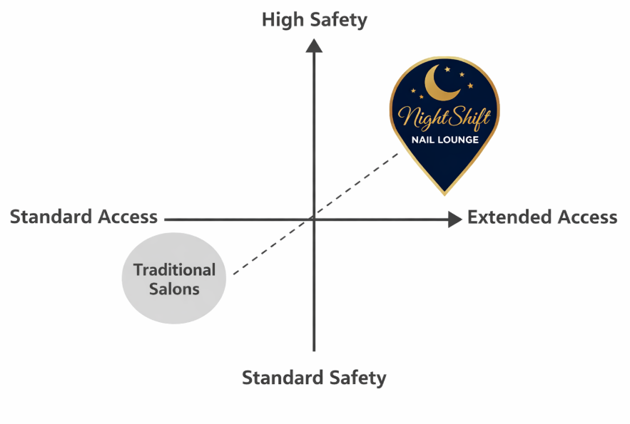

Beauty Salon Positioning Map (Author)
Safe beauty after hours is a brand that employs elements of empowerment, autonomy, and trust by applying controlled lighting, uniform staff, and tone of voice. By eliminating safety fears at the heart of the matter, emotional branding makes loyalty powerful (Armstrong and Kotler, 2020). Retention through membership stabilizes the revenue as well as cementing relational commitment.

Financial Plan

Start-Up Funding Requirement
The new capital is projected to be 65,000 which is the security-intensive positioning and location of the property in the urban UK. In the UK, the city centres it is estimated that fit-out costs are 400-800 per square metre making justification of 20,000-renovation budget. The security infrastructure investment is parallel to the perceived safety and consumer confidence research. The breakdown may be given in the following form:
Cost Category | Amount (£) | Strategic Justification
Interior renovation & furnishing | 20,000 | Good working, safe environment
Nail equipment | 10,000 | Service quality assurance
Security systems & CCTV | 8,000 | Core differentiation
Initial inventory | 7,000 | High-end product positioning
Licensing & legal | 5,000 | Regulatory compliance
Marketing launch | 5,000 | Market penetration
Working capital reserve | 10,000 | Cash-flow stability
The distribution favours safety facilities and liquidity reserves, aiding the sustainability of operations on the competitive urban markets.

Funding Sources
The diversified funding model comprises of 40% founder equity (£26,000), 40% small business bank loan (£26,000) and 20% angel investment (£13,000). Diversification minimizes over dependence on debt and exposure to financial risks (Vernimmen et al., 2022). When the firm might be expanding to other cities, the strategic mentoring and scalability is enabled by the presence of the angels. Structured capital deployment is an indicator of responsible financial planning and it raises investor confidence.

First Month Operating costs
The estimated initial month budget is around 18,000 pounds, which represents the average urban rent and shift labour premiums:
Expense Category | Amount (£)
Rent | 3,500
Staff wages | 8,000
Utilities | 1,500
Inventory replenishment | 2,000
Marketing | 1,000
Security monitoring | 1,200
Miscellaneous | 800
Energy use at night raises utility bills, but the use of LEDs alleviates the expensive spending in the long-term (Gentile, 2022). The break-even analysis shows sustainability as regards to recurring membership fee and management of the fixed costs.

Conclusion
Nightshift Nail Lounge is a new venture which will be used to fill a measurable gap in the UK night time beauty market through safety-based differentiation, 24-hour availability and professional service delivery. The model is viable in financial terms and can be expanded to serve any urban centre since it is backed by systematic funding and other recurrent revenues, and it has the capacity to generate sustainable returns and substantial community good to women.

References
ACAS. 2023. Working time and night work regulations. [Online]. Available: https://www.acas.org.uk/working-time-rules/night-workers [Accessed 2 March 2026].
Chaffey, D. & Smith, P. R. 2022. Digital marketing excellence: planning, optimizing and integrating online marketing, Routledge.
García-Carpintero, M. Á., de Diego-Cordero, R., Pavón-Benítez, L. & Tarriño-Concejero, L., 2022. ‘Fear of walking home alone’: Urban spaces of fear in youth nightlife. European Journal of Women's Studies, 29, 39-53.
Gentile, N., 2022. Improving lighting energy efficiency through user response. Energy and Buildings, 263, 112022.
HSE. 2023. Control of Substances Hazardous to Health (COSHH) [Online]. Available: https://www.hse.gov.uk/coshh/ [Accessed 2 March 2026].
Johansson, S. & Haandrikman, K., 2023. Gendered fear of crime in the urban context: A comparative multilevel study of women’s and men’s fear of crime. Journal of Urban Affairs, 45, 1238-1264.
Kotler, P., Armstrong, G. & Opresnik, M. O. 2021. Principles of marketing 18e global edition, Pearson Education Limited.
Meers, J., 2024. “Vertical drinking” in the night-time economy: alcohol licencing and proxies for “uncivilised” drinking bodies. Leisure Studies, 43, 722-738.
Nasrin, S. & Bunker, J., 2024. Gender equality through sustainable transport policy. Transport policy, 149, 59-79.
Office for National Statistics. 2023. Working patterns in the UK labour market: 2023. [Online]. Available: https://www.ons.gov.uk/releases/uklabourmarketaugust2023 [Accessed 2 March 2026].
Porter, M. E. & Kramer, M. R., 1985. Advantage. Creating and Sustaining Superior Performance, Simons, 56-68.
Sharma, M. N. 2025. A Study of Changing Scenario of Beauty and Personal Care Industry.
Vernimmen, P., Quiry, P. & Le Fur, Y. 2022. Corporate finance: theory and practice, John Wiley & Sons.
World Bank Group. 2023. Employment to population ratio, ages 15-24, female (%) (national estimate) - United Kingdom [Online]. Available: https://data.worldbank.org/indicator/SL.EMP.1524.SP.FE.NE.ZS?locations=GB [Accessed 2 March 2026].

