Web Design Written Assignment
ACCA4023
2532111
Joseph Protheroe

Table Of Contents
Table Of Contents 2
Summary of the report 3
Requirements 3
Target Audience and purpose 3
Implementation and Validation 3
Home Page 4
MOT 6
Driving Exams 8
Enforcement 10
Style.css Validation 12
Evaluation 13
SEO (SEARCH ENGINE OPTIMISATION) [3] 13
Useability [4] 13
Accsesibility [6] 14
Website Comparison 14
Website 1 [7] 15
Website 2 [8] 16
conclusion 17
References 18
Appendix 18
HomePage.html 18
MOT.html 21
DrivingExams.html 24
Enforcement.html 27
Style.css 30

Summary of the report
This written report is in regard to the design, content, implementation and validation of a HTML website I have created focused on the DVSA and the work they do, this include a brief introduction to who the DVSA are and where they are, and the work they do around MOT, Driving exams and Enforcement. It outlines the content on each page, structure design as well the overall design with the use of CSS. Will also outline any of the errors I cam across while validation the website and go into depth of what I had to do to resolve those issues to maintain compliance with WCAG 2.1. Further into this report I will also evaluate the accessibility, useability, SEO of the page. Also compared 2 websites using the WAVE tool and will present my findings within this report.

Requirements
The requirements of this website are to present the work that the DVSA undertakes and act as a brief introduction to the agency for members of the public. Because of this the page should be written in simple English with images to support the written content of the page.

Target Audience and purpose
The target audience of this website are people who wish to understand who the DVSA are and what they do, as well as people who wish to understand what else the DVSA does as they may understand that DVSA conduct driving test but may to be aware of the other duties of the organisation. Additionally, due to the inclusion of information around MOT, driving Tests and Enforcement I have also targeted people who are looking for general information around those subjects

Implementation and Validation
This section will provide screen shots of each web page I have created as well as screenshots of the validation results from the use of the W3 HTML Checker [1]. Will also validate the CSS component with W3 CSS checker [2].

Please turn over

Home Page
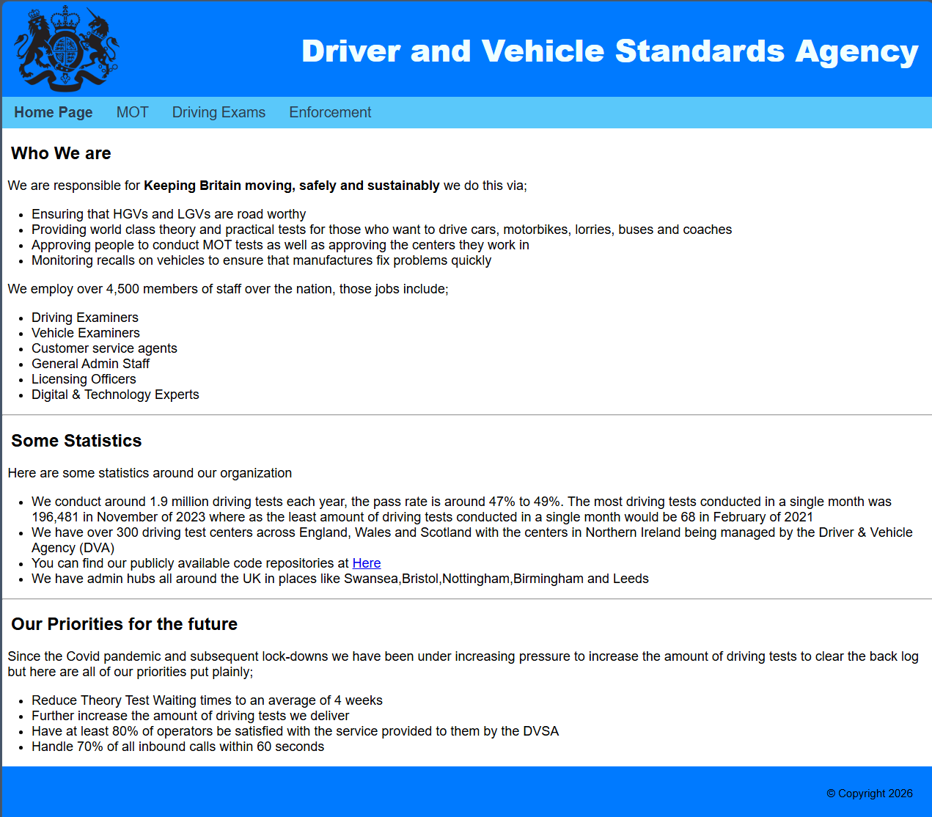
This is the Home page for my website. It contains a banner and footer as well as a navigation bar the items on navigation bar turn the same blue as the banner and the text turns white on hover. The content of the page includes a brief introduction to the organization and some statistics and the position of the organization in relation to the future

Home Page Validation
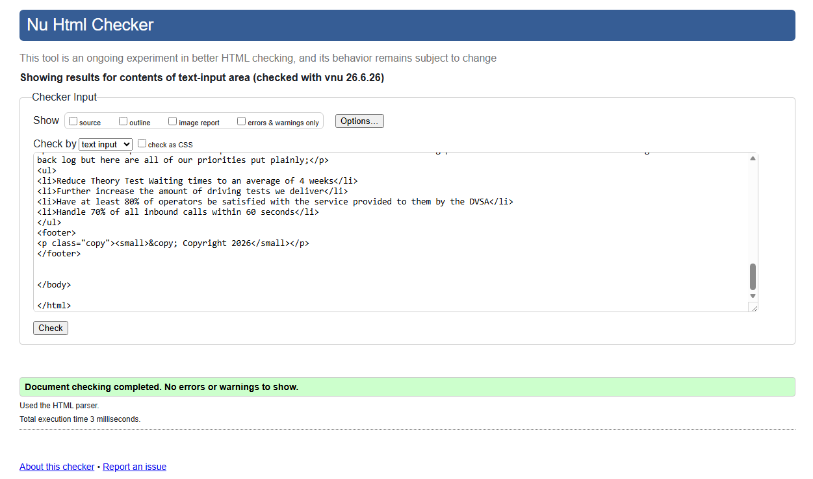
Originally, I had 3 errors on this page.
- Was regarding the lack of a language declaration in the HTML tag I rectified this by amending the tag to “<html lang="en">”
- Was regarding the image in the banner as I had incorrectly not used the alt attribute hindering the accessibility and useability of the website this was resolved by amending the tag to <img src="images/dvsa-logo.png" alt="Logo" width = “”>.
- Was also in the image used in the banner as I had left an unused width = “” in the tag as I had moved the sizing of the logo into the CSS with was resolved by amending the tag to “<img src="images/dvsa-logo.png" alt="Logo">”

MOT
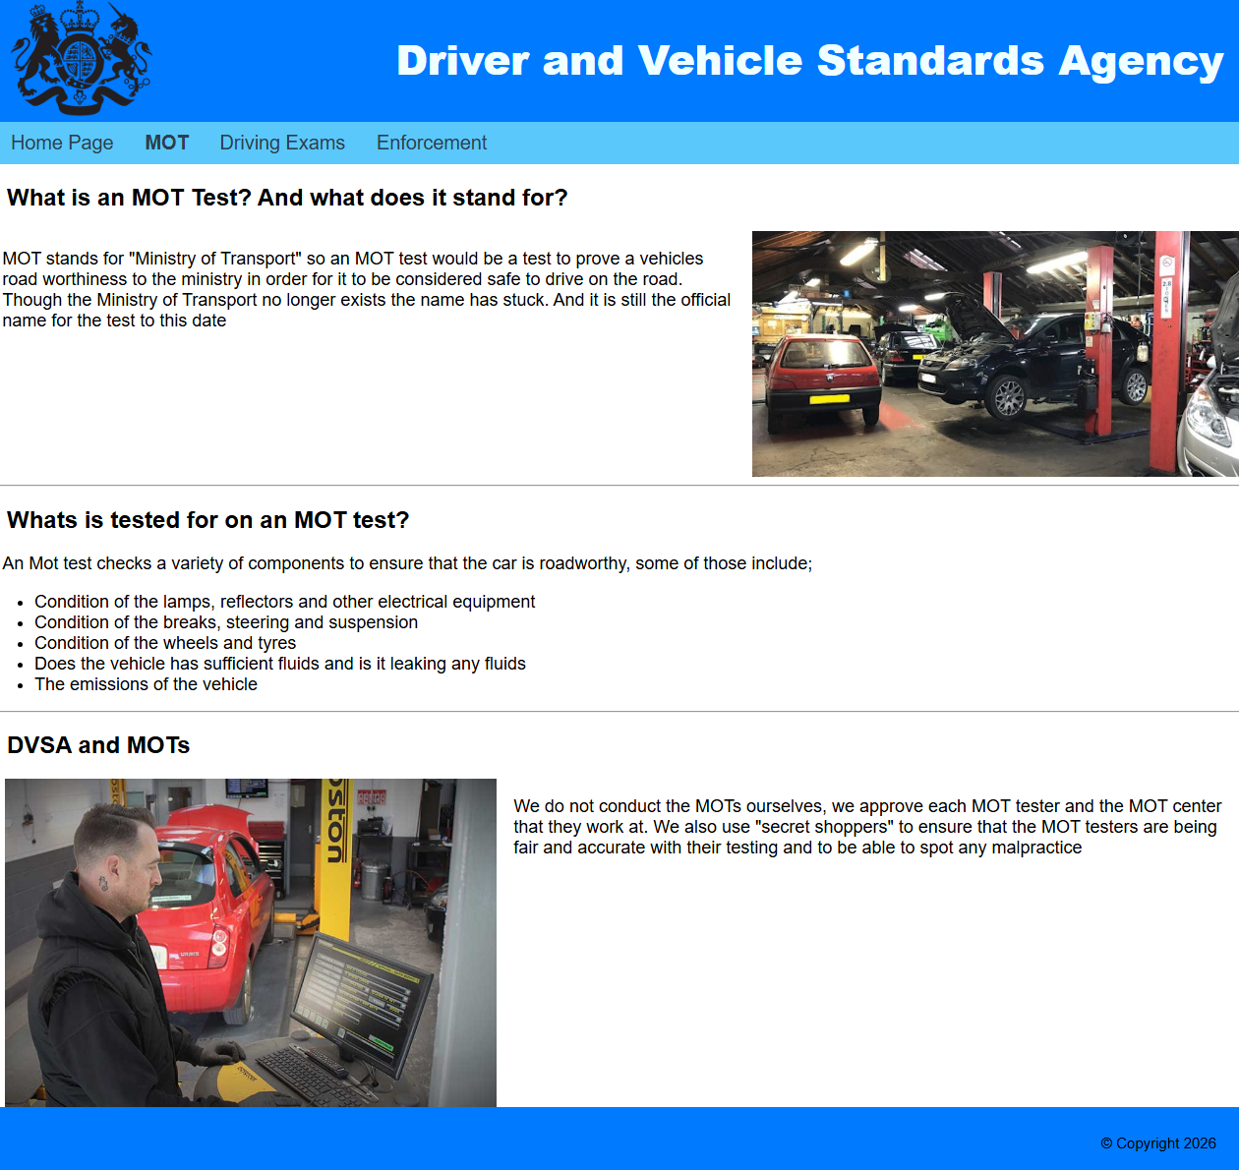
This page has the same banner, navigation bar and footer as the home page, but the written contents talk about MOT tests and are accompanied with some images. Used a class I created in CSS called “split section” which takes advantage of flex boxes to contain text and images in line with each other.

MOT Validation
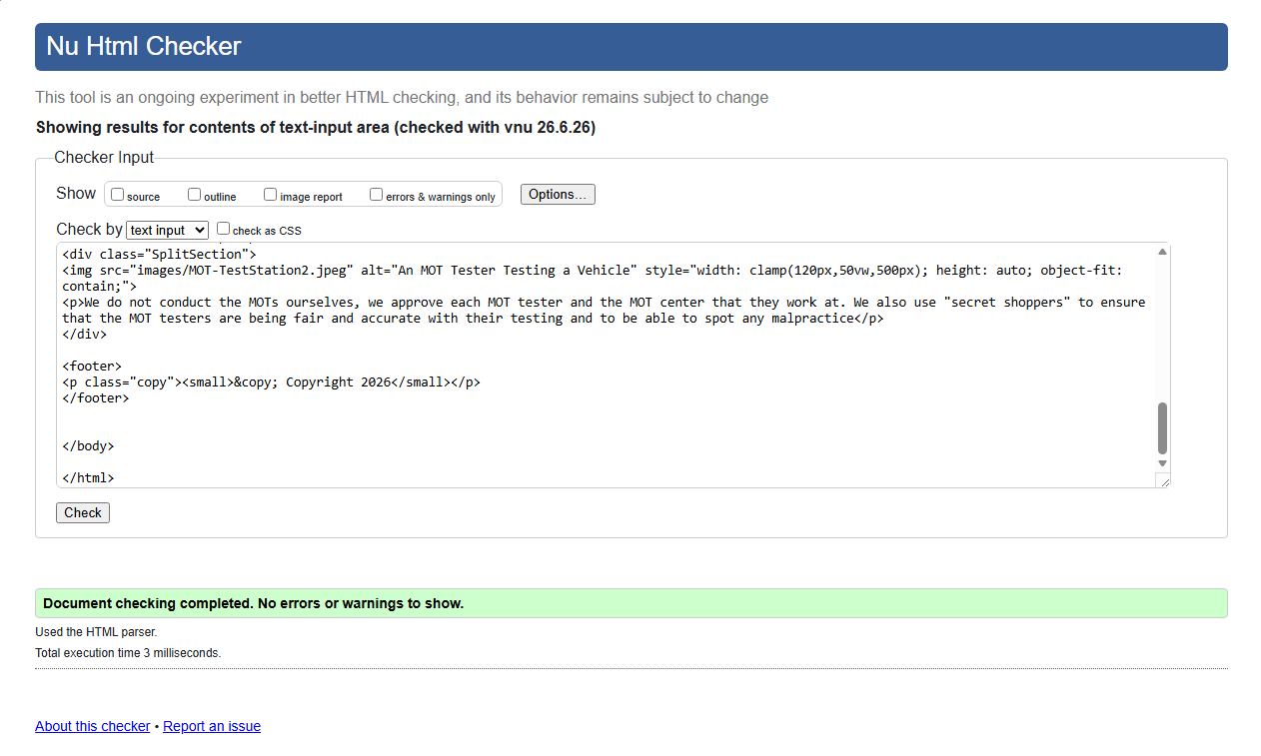
Originally, I had 3 errors on this page.
- Was regarding the lack of a language declaration in the HTML tag I rectified this by amending the tag to “<html lang="en">”
- Was regarding the image in the banner as I had incorrectly not used the alt attribute hindering the accessibility and useability of the website this was resolved by amending the tag to <img src="images/dvsa-logo.png" alt="Logo" width = “”>.
- Was also in the image used in the banner as I had left an unused width = “” in the tag as I had moved the sizing of the logo into the CSS with was resolved by amending the tag to “<img src="images/dvsa-logo.png" alt="Logo">”

Driving Exams
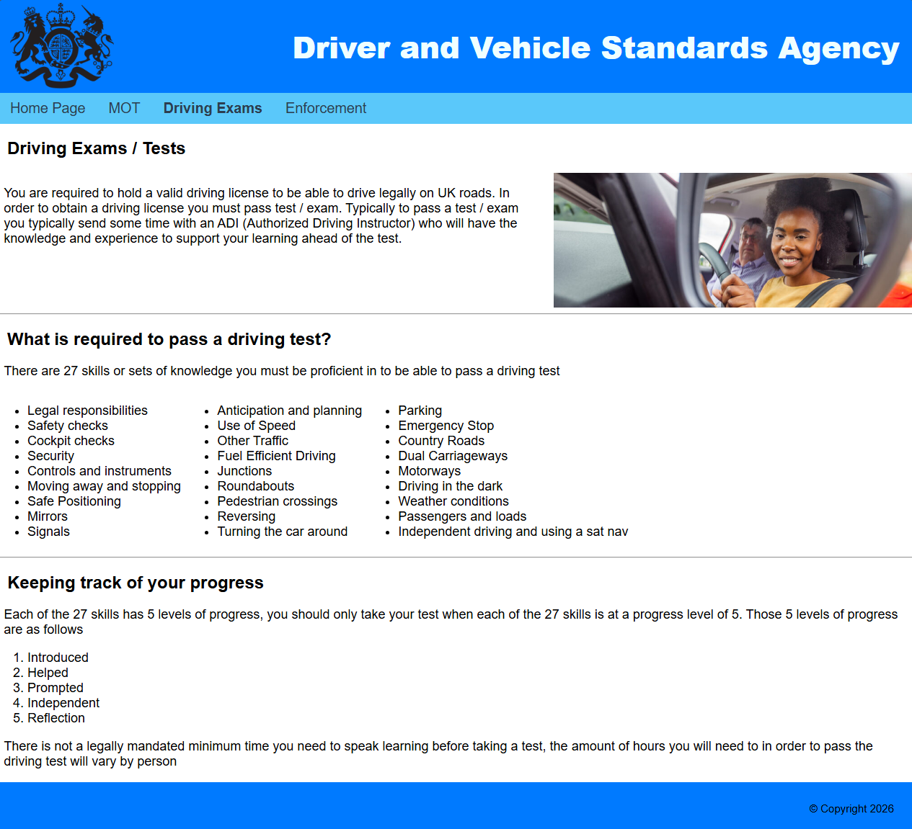
This page has the same banner, navigation bar and footer as the home page, but the written contents talk about driving tests and are accompanied with some images. Used a class I created in CSS called “split section” which takes advantage of flex boxes to contain text and images in line with each other, this class is also used in the “What is required to pass a driving test section” to be able to display 3 columns of bullet points.

Driving Exams Validation
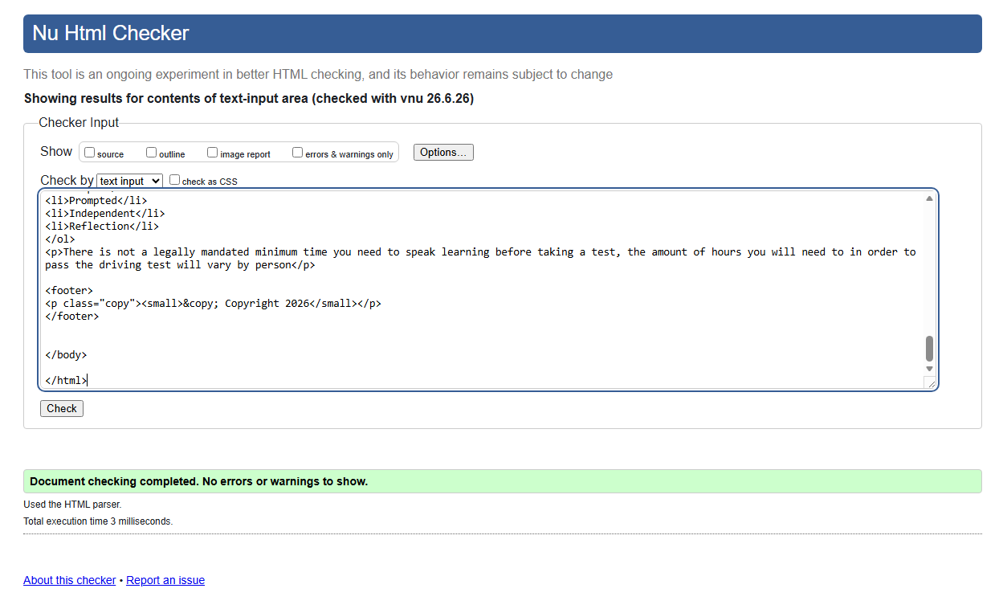
Originally, I had 3 errors on this page.
- Was regarding the lack of a language declaration in the HTML tag I rectified this by amending the tag to “<html lang="en">”
- Was regarding the image in the banner as I had incorrectly not used the alt attribute hindering the accessibility and useability of the website this was resolved by amending the tag to <img src="images/dvsa-logo.png" alt="Logo" width = “”>.
- Was also in the image used in the banner as I had left an unused width = “” in the tag as I had moved the sizing of the logo into the CSS with was resolved by amending the tag to “<img src="images/dvsa-logo.png" alt="Logo">”

Enforcement
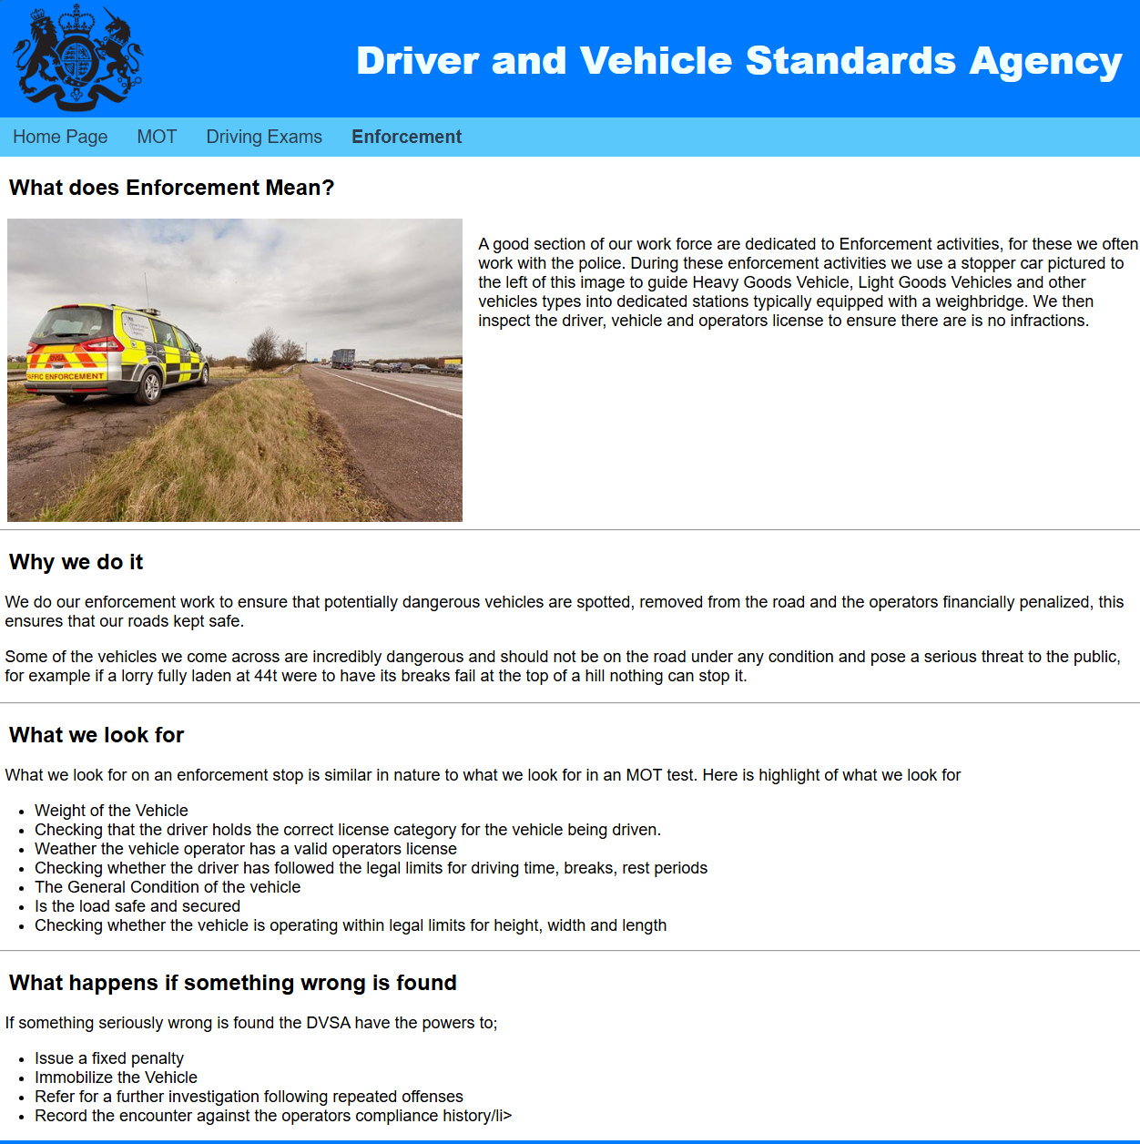
This page has the same banner, navigation bar and footer as the home page, but the written contents talk about the enforcement activities done at the DVSA and is accompanied with some images. Used a class I created in CSS called “split section” which takes advantage of flex boxes to contain text and images in line with each other.

Enforcement Validation
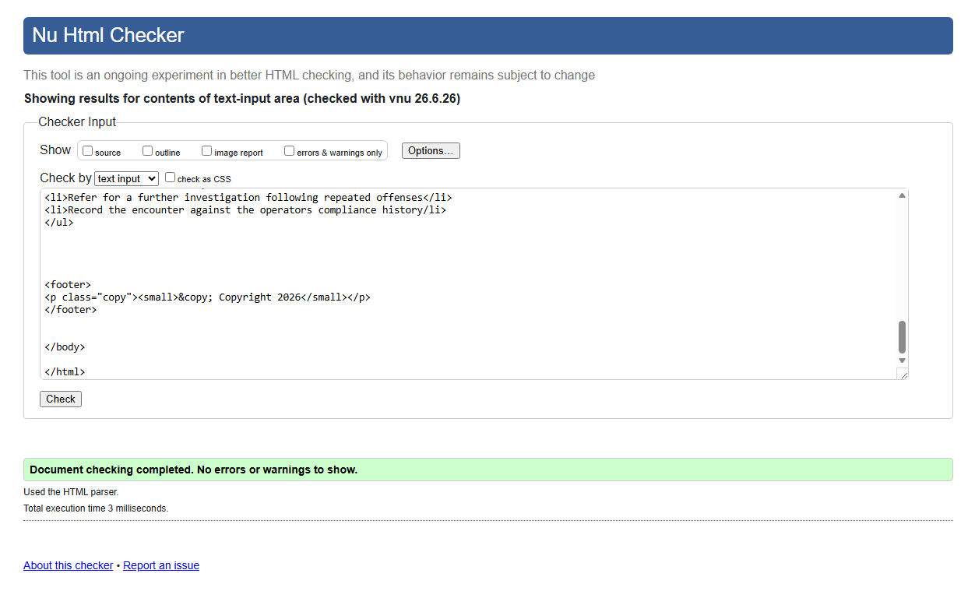
Originally, I had 3 errors on this page.
- Was regarding the lack of a language declaration in the HTML tag I rectified this by amending the tag to “<html lang="en">”
- Was regarding the image in the banner as I had incorrectly not used the alt attribute hindering the accessibility and useability of the website this was resolved by amending the tag to <img src="images/dvsa-logo.png" alt="Logo" width = “”>.
- Was also in the image used in the banner as I had left an unused width = “” in the tag as I had moved the sizing of the logo into the CSS with was resolved by amending the tag to “<img src="images/dvsa-logo.png" alt="Logo">”

Style.css Validation
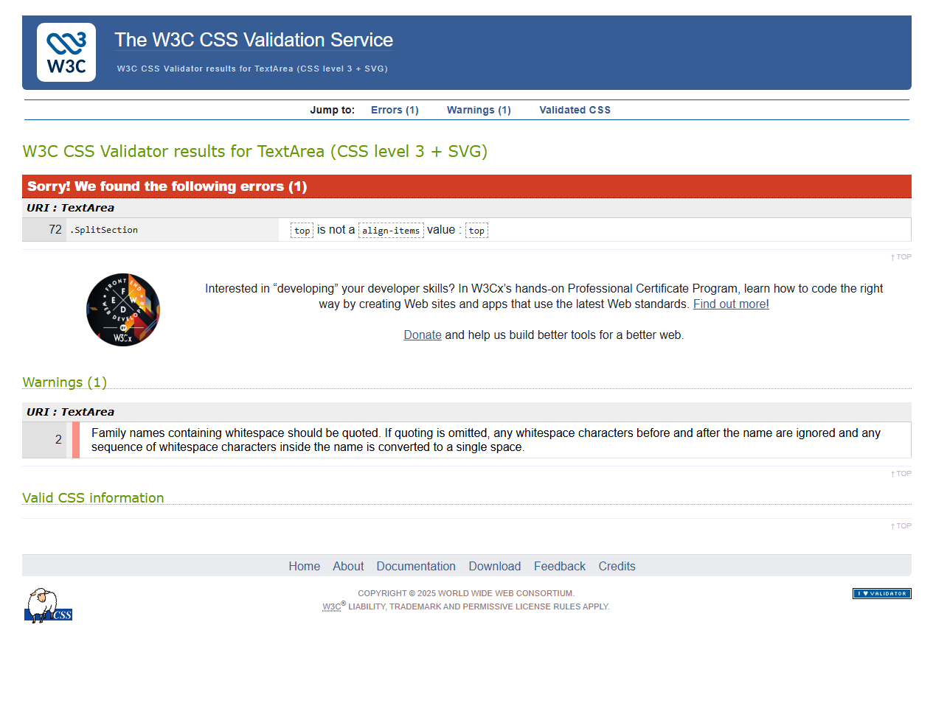
To correct these 2 errors / warnings, I;
- On line 72 I changed “align-items: top;” to “align-items: flex-start;”
- On line 2 I changed “font-family: Helvetica, Arial sans-serif;” to “font-family: Helvetica, Arial, sans-serif;”
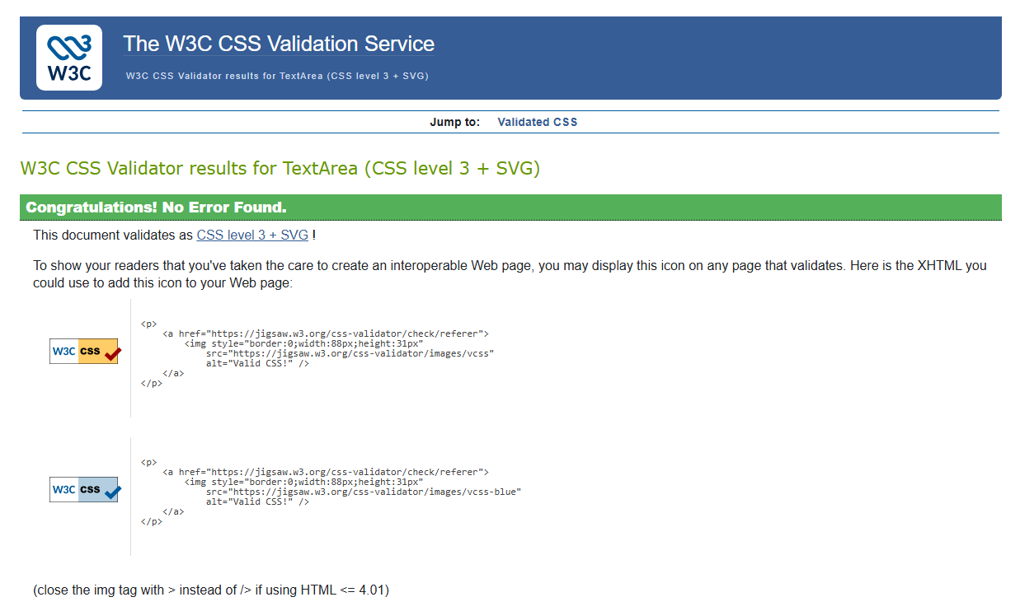

Evaluation
In this section I will evaluate my website and discuss generally about the website, discuss how optimised it is for search engines, how useable and accessible it is. In each section I will briefly summarise why that evaluation is important then I evaluate my website against each section.

SEO (SEARCH ENGINE OPTIMISATION) [3]
SEO which stands for search engine optimisation and is the practice of optimising a web site to increase the amount of data made available to search engines to gain more visibility and clarity about what is included on the website. The use of SEO has been shown to be statistically significant on “organic rankings and traffic, with content quality, keywords, and backlinks serving as primary drivers” [3]. This increase in ranking can positively affect a web site especially one that sell a product or service an increase in viewership is directly related to an increase in sales. An increase in ranking for a non-sale aligned website would also be beneficial as even if a page is purely informational as the information contained within the website would be read by more people.
The website I have created has some SEO due to the use of alt tags on images if published this means that the images on my website would be accessible from something like google images, which when clicked through would increase the number of visits to my site. The website also has titles for each page as well as the use of H1 and H2 headings allowing a search engine to be able to understand what content is on each page.

Useability [4]
Usability is an important factor for all software quality models. It is the key factor in the development of successful interactive software applications. [4]
As the quote suggests, usability is a key factor when developing software, this can be directly applied to web design and development due to the similarity of how we consume both. ISO 9126 (2001) [5] breaks usability down into 5 components those being
Understandability | The capability of the software product to enable the user to understand  whether the software is suitable, and how it can be used for particular  tasks and conditions of use.
Learnability | The capability of the software product to enable the user to learn its  application.
Operability | The capability of the software product to enable the user to operate and  control it.
Attractiveness | The capability of the software product to be attractive to the user.
Usability compliance | The capability of the software product to adhere to standards,  conventions, style guides, or regulations related to usability
The website I created fits the above break down or useability well. The use of simple design supports the understandability of the page via the use of horizontal rules “<hr>” to create distinct sections of each page. Although Learnability is not very applicable to a static webpage, the webpage is learnable due to the use of a consistent Banner, Navigation bar and Footer creating similarities between all pages reinforcing the user’s knowledge of how to navigate the site. The web site is also operable again due to the static navigation bar across all the pages allowing the user to navigate between pages easily. The website is somewhat attractive, although the purpose of the website was not simply be good to look at but to be informative, the website’s primary chosen font was Helvetica and makes use colour in the header and footer of the website to add some sense of style to the site.

Accsesibility [6]
The accessibility of a site is important and should be a key priority of any website. There is multiple standard now in place to enforce accessibility across websites one of those being WCAG.
The website I have created is accessible. Use contrasting text colours in the header of each page to contrast against the darker blue background to ensure that users with diminished eyesight will still be able to read the text. Also used CSS so that when one of the navigation links is hovered over and the background colour changes to the above mentioned darker blue the text also changes to white to ensure that the text is still readable even when hovered. The addition of the “alt” tags for images can also support the use of screen readers as the screen reader will be able to give the user and prompt for what the image is of.

Website Comparison
In this section I will evaluate 2 websites and compare them and then finally give my conclusions

Website 1 [7]
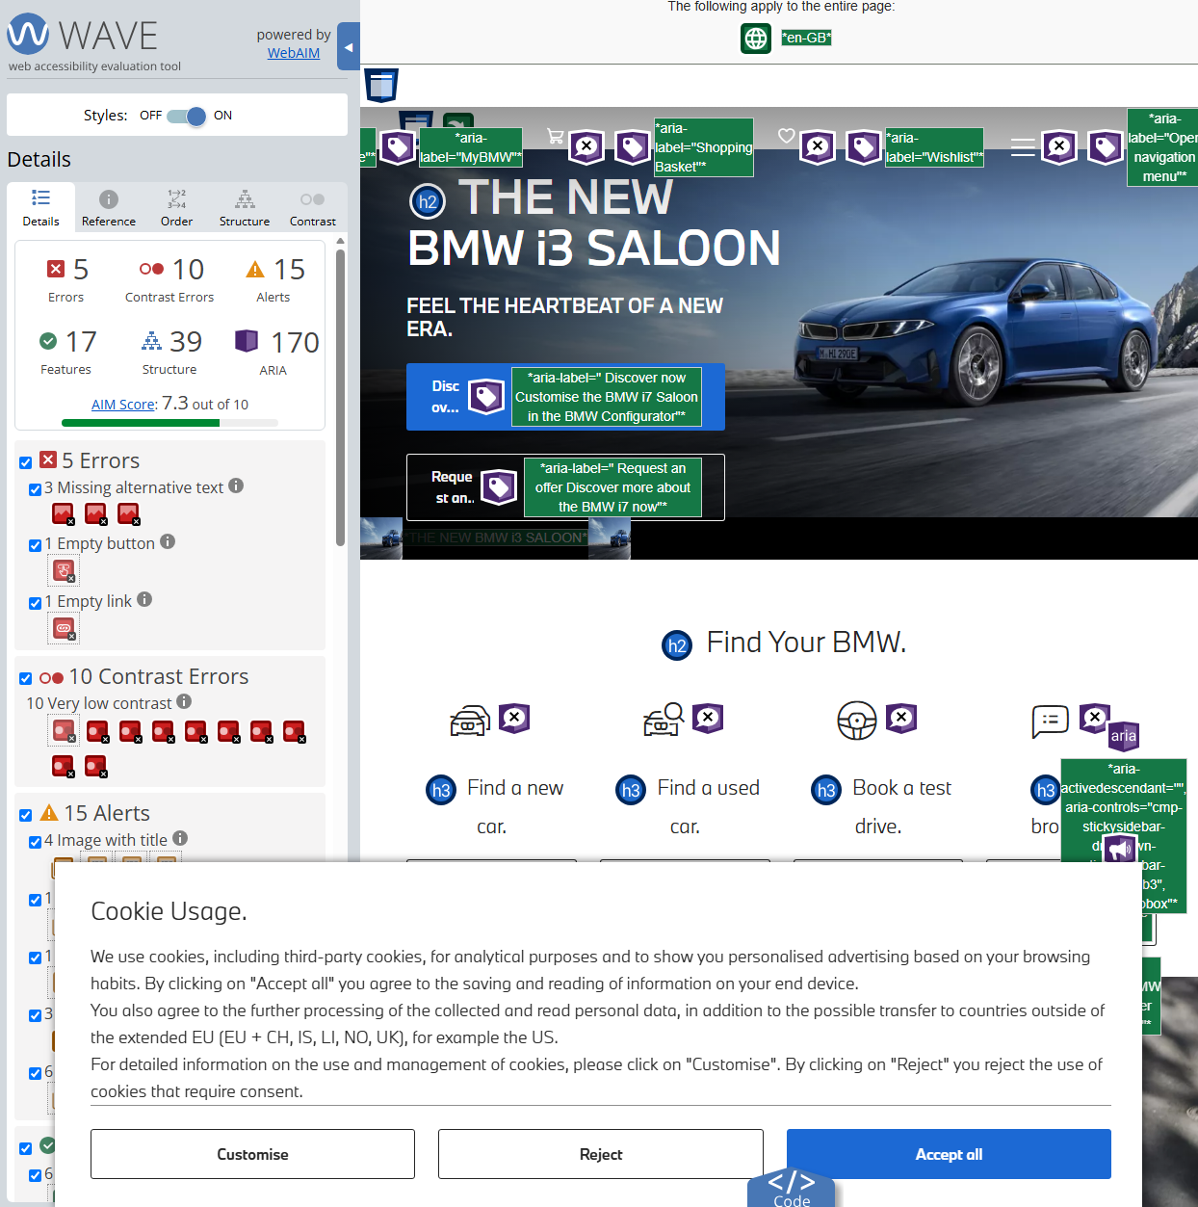
Score 7.3
SEO: There is 1 H1 heading, 6 H2 Heading and 24 H3 Heading giving a search engine a great deal of information to be able to use. There are lots of images used on the website but 3 of them are missing alt text meaning that they will not be as useful to SEO
Useability: The website is very useable with a navigation bar in the header links away to their 4 main services presented near the top of the page with a more detailed set of links positioned at the bottom of the page.
Accessibility: This is where I think the score has dropped for this site as they use white text over images where they conflict causing areas of low contrast though I do think the WAVE tool has been overly aggressive with some of its metrics. The site also contains 217 Aria elements to aid assistive technologies

Website 2 [8]
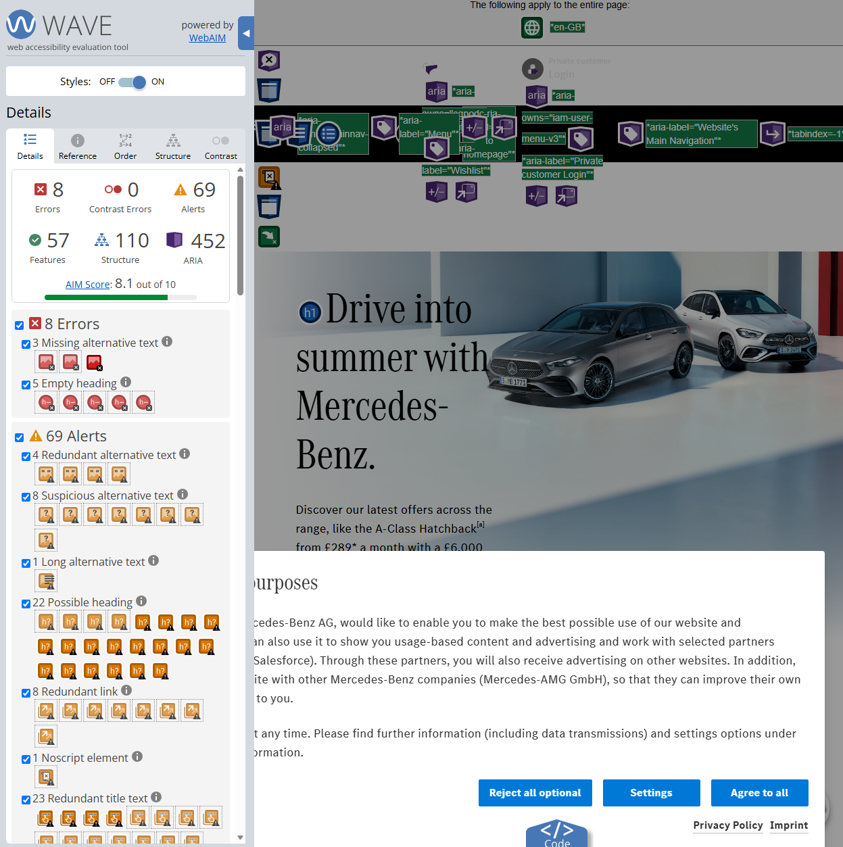
Score 8.1
SEO: There is 2 H1 heading, 43 H2 Heading and 29 H3 Heading giving a search engine an immense amount of information to be able to use. However, there are multiple empty headings on the site that may cause a drop in organic rankings. There are lots of images used on the website but 3 of them are missing alt text meaning that they will not be as useful to SEO
Useability: The website is very useable with a navigation bar in the header with a more detailed set of links positioned at the bottom of the page.
Accessibility: The accessibility of the site is very good with 0 contrast issue reported by WAVE however they are again missing 3 alt tags on images. The site has an impressive 448 ARIA elements creating a very accessible website.

conclusion
Personally, to look at I prefer the BMW website and their cars but due to a few reasons the Mercades website is superior in a few ways. Firstly, the accessibility of the BMW site is not up to the spec of Mercades, the BMW site has issues with contrast with the text against the images they have in multiple places, additionally the Mercedes site makes better use of ARIA attributes as the BMW site has217 whereas the Mercades site has 448 ARIA attributes. Secondly is the amount of content, the Mercades site had a lot more information on its home page this can be seen in the difference between the amount of headings on each page, the Mercedes site has 2 H1 heading, 43 H2 Heading and 29 H3 Headings, where as the BMW site only has 1 H1 heading, 6 H2 Heading and 24 H3 Heading, furthermore just looking past the heading count the content contained within the Mercades site is greater than the BMW site as the BMW site act simply as a homepage whereas the Mercades sites also has sections for all of its car models as well as a section for their partner producers Maybach and AMG. However both sites are excellent at scaling, both sites can be viewed easily on the smallest size I can make my browser window, and the scaling is very dynamics with every size between being easily viewable. Both Sites also project a very luxurious feel which is inline with each brands image.

References

[1] | W3, “Nu Html Checker,” [Online]. Available: https://validator.w3.org/. [Accessed 28 06 2026].
[2] | W3, “ CSS Validation Service,” [Online]. Available: https://jigsaw.w3.org/css-validator/validator.html.en. [Accessed 28 06 2026].
[3] | P. Usmany, R. Rachmawati, E. Rembe, F. Sopacua, T. Santosa, A. Arifin, A. Fitria and S. Suhardi, “The Effectiveness Of Search Engine Optimization (SEO) In Marketing: A Meta-Anlysis Study,” Journal of Economic, Bussines and Accounting (COSTING), vol. 7, pp. 807 - 811, 2024.
[4] | A. Madan, “Usability evaluation methods: a literature review,” International Journal of Engineering Science and Technology, vol. 4, no. 2, 2012.
[5] | International Standard Organisation , ISO 9126, 2001.
[6] | . J. Ara, C. Sik-Lanyi and A. Kelemen, “Accessibility engineering in web evaluation process: a systematic literature review,” Universal Access in the Information Society, vol. 23, no. 2, pp. 653 - 686, 2024.
[7] | BMW, “Index,” [Online]. Available: https://www.bmw.co.uk/en/index.html.
[8] | mercedes-benz, “Homepage,” [Online]. Available: https://www.mercedes-benz.co.uk/.

Appendix

HomePage.html
<!DOCTYPE html>
<html lang="en">

<head>
<meta charset="utf-8">
<title>Home Page</title>
<link rel="stylesheet" href="Style.css">
</head>

<body>
<div class="banner">
<img src="images/dvsa-logo.png" alt="Logo">
<h1><b>Driver and Vehicle Standards Agency</b></h1>
</div>
<ul class="nav">
<li><b><a href="HomePage.html">Home Page</a></b></li>
<li><a href="MOT.html">MOT</a></li>
<li><a href="DrivingExams.html">Driving Exams</a></li>
<li><a href="Enforcement.html">Enforcement</a></li>
</ul>

<h2><b>Who We are</b></h2>

<p>
We are responsible for <b>Keeping Britain moving, safely and sustainably</b> we do this via;</p>
<ul>
<li>Ensuring that HGVs and LGVs are road worthy</li>
<li>Providing world class theory and practical tests for those who want to drive cars, motorbikes, lorries, buses and coaches</li>
<li>Approving people to conduct MOT tests as well as approving the centers they work in</li>
<li>Monitoring recalls on vehicles to ensure that manufactures fix problems quickly</li>
</ul>
<p>We employ over 4,500 members of staff over the nation, those jobs include;</p>
<ul>
<li>Driving Examiners</li>
<li>Vehicle Examiners</li>
<li>Customer service agents</li>
<li>General Admin Staff</li>
<li>Licensing Officers</li>
<li>Digital & Technology Experts</li>
</ul>
<hr>

<h2><b>Some Statistics</b></h2>
<p>Here are some statistics around our organization</p>
<ul>
<li>We conduct around 1.9 million driving tests each year, the pass rate is around 47% to 49%. The most driving tests conducted in a single month was 196,481 in November of 2023 where as the least amount of driving tests conducted in a single month would be 68 in February of 2021</li>
<li>We have over 300 driving test centers across England, Wales and Scotland with the centers in Northern Ireland being managed by the Driver & Vehicle Agency (DVA)</li>
<li>You can find our publicly available code repositories at <a href="https://github.com/dvsa">Here</a></li>
<li>We have admin hubs all around the UK in places like Swansea,Bristol,Nottingham,Birmingham and Leeds</li>
</ul>
<hr>

<h2><b>Our Priorities for the future</b></h2>
<p>Since the Covid pandemic and subsequent lock-downs we have been under increasing pressure to increase the amount of driving tests to clear the back log but here are all of our priorities put plainly;</p>
<ul>
<li>Reduce Theory Test Waiting times to an average of 4 weeks</li>
<li>Further increase the amount of driving tests we deliver</li>
<li>Have at least 80% of operators be satisfied with the service provided to them by the DVSA</li>
<li>Handle 70% of all inbound calls within 60 seconds</li>
</ul>
<footer>
<p class="copy"><small>&copy; Copyright 2026</small></p>
</footer>

</body>

</html>

MOT.html
<!DOCTYPE html>
<html lang="en">

<head>
<meta charset="utf-8">
<title>MOT</title>
<link rel="stylesheet" href="Style.css">
</head>

<body>
<div class="banner">
<img src="images/dvsa-logo.png" alt="Logo">
<h1><b>Driver and Vehicle Standards Agency</b></h1>
</div>
<ul class="nav">
<li><a href="HomePage.html">Home Page</a></li>
<li><b><a href="MOT.html">MOT</a></b></li>
<li><a href="DrivingExams.html">Driving Exams</a></li>
<li><a href="Enforcement.html">Enforcement</a></li>
</ul>

<h2><b>What is an MOT Test? And what does it stand for?</b></h2>
<div class="SplitSection">
<p>MOT stands for "Ministry of Transport" so an MOT test would be a test to prove a vehicles road worthiness to the ministry in order for it to be considered safe to drive on the road. Though the Ministry of Transport no longer exists the name has stuck. And it is still the official name for the test to this date</p>
<img src="images/MOT-TestStation.jpeg" alt="An MOT Test Station" style="width: clamp(150px,50vw,500px); height: auto; object-fit: contain;">
</div>
<hr>

<h2><b>Whats is tested for on an MOT test?</b></h2>
<p>An Mot test checks a variety of components to ensure that the car is roadworthy, some of those include;</p>
<ul>
<li>Condition of the lamps, reflectors and other electrical equipment</li>
<li>Condition of the breaks, steering and suspension</li>
<li>Condition of the wheels and tyres</li>
<li>Does the vehicle has sufficient fluids and is it leaking any fluids</li>
<li>The emissions of the vehicle</li>
</ul>
<hr>

<h2><b>DVSA and MOTs</b></h2>
<div class="SplitSection">
<img src="images/MOT-TestStation2.jpeg" alt="An MOT Tester Testing a Vehicle" style="width: clamp(120px,50vw,500px); height: auto; object-fit: contain;">
<p>We do not conduct the MOTs ourselves, we approve each MOT tester and the MOT center that they work at. We also use "secret shoppers" to ensure that the MOT testers are being fair and accurate with their testing and to be able to spot any malpractice</p>
</div>

<footer>
<p class="copy"><small>&copy; Copyright 2026</small></p>
</footer>

</body>

</html>

DrivingExams.html
<!DOCTYPE html>
<html lang="en">

<head>
<meta charset="utf-8">
<title>Driving Exams</title>
<link rel="stylesheet" href="Style.css">
</head>

<body>
<div class="banner">
<img src="images/dvsa-logo.png" alt="Logo">
<h1><b>Driver and Vehicle Standards Agency</b></h1>
</div>
<ul class="nav">
<li><a href="HomePage.html">Home Page</a></li>
<li><a href="MOT.html">MOT</a></li>
<li><b><a href="DrivingExams.html">Driving Exams</a></b></li>
<li><a href="Enforcement.html">Enforcement</a></li>
</ul>

<h2><b>Driving Exams / Tests</b></h2>
<div class="SplitSection">
<p>
You are required to hold a valid driving license to be able to drive legally on UK roads. In order to obtain a driving license you must pass test / exam. Typically to pass a test / exam you typically send some time with an ADI (Authorized Driving Instructor) who will have the knowledge and experience to support your learning ahead of the test.
</p>
<img src="images/DrivingTest1.jpg" alt="An MOT Tester Testing a Vehicle" style="width: clamp(120px,50vw,500px); height: auto; object-fit: contain;">
</div>
<hr>

<h2><b>What is required to pass a driving test?</b></h2>
<p>There are 27 skills or sets of knowledge you must be proficient in to be able to pass a driving test</p>
<div class="SplitSection">
<ul>
<li>Legal responsibilities</li>
<li>Safety checks</li>
<li>Cockpit checks</li>
<li>Security</li>
<li>Controls and instruments</li>
<li>Moving away and stopping</li>
<li>Safe Positioning</li>
<li>Mirrors</li>
<li>Signals</li>
</ul>
<ul>
<li>Anticipation and planning</li>
<Li>Use of Speed</Li>
<li>Other Traffic</li>
<li>Fuel Efficient Driving</li>
<li>Junctions</li>
<li>Roundabouts</li>
<li>Pedestrian crossings</li>
<li>Reversing</li>
<li>Turning the car around</li>
</ul>
<ul>
<li>Parking</li>
<li>Emergency Stop</li>
<li>Country Roads</li>
<li>Dual Carriageways</li>
<li>Motorways</li>
<li>Driving in the dark</li>
<li>Weather conditions</li>
<li>Passengers and loads</li>
<li>Independent driving and using a sat nav</li>
</ul>
</div>
<hr>

<h2><b>Keeping track of your progress</b></h2>
<p>Each of the 27 skills has 5 levels of progress, you should only take your test when each of the 27 skills is at a progress level of 5. Those 5 levels of progress are as follows</p>
<ol>
<li>Introduced</li>
<li>Helped</li>
<li>Prompted</li>
<li>Independent</li>
<li>Reflection</li>
</ol>
<p>There is not a legally mandated minimum time you need to speak learning before taking a test, the amount of hours you will need to in order to pass the driving test will vary by person</p>

<footer>
<p class="copy"><small>&copy; Copyright 2026</small></p>
</footer>

</body>

</html>

Enforcement.html
<!DOCTYPE html>
<html lang="en">

<head>
<meta charset="utf-8">
<title>Enforcement</title>
<link rel="stylesheet" href="Style.css">
</head>

<body>
<div class="banner">
<img src="images/dvsa-logo.png" alt="Logo">
<h1><b>Driver and Vehicle Standards Agency</b></h1>
</div>
<ul class="nav">
<li><a href="HomePage.html">Home Page</a></li>
<li><a href="MOT.html">MOT</a></li>
<li><a href="DrivingExams.html">Driving Exams</a></li>
<li><b><a href="Enforcement.html">Enforcement</a></b></li>
</ul>

<h2><b>What does Enforcement Mean?</b></h2>
<div class="SplitSection">
<img src="images/StopperCar.jpg" alt="A DVSA Stopper Car" style="width: clamp(120px,45vw,500px); height: auto; object-fit: contain;">
<p>A good section of our work force are dedicated to Enforcement activities, for these we often work with the police. During these enforcement activities we use a stopper car pictured to the left of this image to guide Heavy Goods Vehicle, Light Goods Vehicles and other vehicles types into dedicated stations typically equipped with a weighbridge. We then inspect the driver, vehicle and operators license to ensure there are is no infractions.</p>
</div>
<hr>

<h2><b>Why we do it</b></h2>
<p>We do our enforcement work to ensure that potentially dangerous vehicles are spotted, removed from the road and the operators financially penalized, this ensures that our roads kept safe. </p>
<p>Some of the vehicles we come across are incredibly dangerous and should not be on the road under any condition and pose a serious threat to the public, for example if a lorry fully laden at 44t were to have its breaks fail at the top of a hill nothing can stop it.</p>
<hr>

<h2><b>What we look for</b></h2>
<p>What we look for on an enforcement stop is similar in nature to what we look for in an MOT test. Here is highlight of what we look for</p>
<ul>
<li>Weight of the Vehicle</li>
<li>Checking that the driver holds the correct license category for the vehicle being driven.</li>
<li>Weather the vehicle operator has a valid operators license</li>
<li>Checking whether the driver has followed the legal limits for driving time, breaks, rest periods</li>
<li>The General Condition of the vehicle</li>
<li>Is the load safe and secured</li>
<li>Checking whether the vehicle is operating within legal limits for height, width and length</li>
</ul>
<hr>

<h2><b>What happens if something wrong is found</b></h2>
<p>If something seriously wrong is found the DVSA have the powers to;</p>
<ul>
<li>Issue a fixed penalty</li>
<li>Immobilize the Vehicle</li>
<li>Refer for a further investigation following repeated offenses</li>
<li>Record the encounter against the operators compliance history/li>
</ul>

<footer>
<p class="copy"><small>&copy; Copyright 2026</small></p>
</footer>

</body>

</html>

Style.css
body {
font-family: Helvetica, Arial, sans-serif;
margin: 0;
}

.banner{
background-color: #007AFF;
padding-top: clamp(0.1em,0.4vw,0.75em);
padding-bottom: clamp(0.1em,0.4vw,0.75em);
display: flex;
align-items:center;
gap: clamp(1px,1vw,20px);
}
.banner h1{
text-align: right;
font-size: clamp(1.8em, 4vw, 2.6em);
color: azure;
padding-right: 0.5em;
margin-left: auto;
}
.banner img{
padding-left: 1em;
height: clamp(70px,10vw,120px);
width: auto;
}

ul.nav {
position: relative;
list-style-type: none;
margin: 0;
padding: 0;
overflow: hidden;
background-color: #5AC8FA;
}
ul.nav li {
float: left;

}
ul.nav li a {
display: block;
color: #2c3e50;
text-align: center;
padding: 0.5em 16px;
text-decoration: none;
font-size: 1.1em
}
ul.nav li a:hover {
background-color: #007AFF;
color: azure;
}

p{
padding-left: 0.4em;
font-weight: 400;
font-size: 18px;
}
li{
font-weight: 400;
font-size: 18px;
}
h2{
padding-left: 0.5em;
font-weight: 400;
font-size: 24px;
}

.SplitSection{
display: flex;
align-items: flex-start;
gap: 10px;
}

img{
padding-left: 10px;
}

footer{
background-color: #007AFF;
position: relative;
left: 0;
bottom: 0;
width: 100%;
padding: 0.5em;
}
footer p.copy{
text-align: right;
padding-right: 2em;
}

