Natalie Thomas 1712163
Leanna Jenkins, April Fuge and Sarah Rees
LANS Mega Bus
Natalie1712163@gmail.com Password – Cianjohn01

Contribution Audit
When composing our questionnaire, the following group members contributions are:
Sarah – Questions 2, 4 & 6, she also selected the colours/fonts and added relevant pictures within the header.
April – Questions 5 & 8, as well as gathering the class member emails addresses.
Leanna – Questions 9 &10, also distributed the questionnaire via email.
Natalie - Questions 1, 3 & 7, created document, shared it with the group and gathered class members email addresses.
While creating the website I was responsible for choosing the simple to use design, carefully selecting the navigation we will offer and brand identification, by inserting our logo on the header of each page.
I Compiled the ‘Home’, ‘Menu’ and ‘About Us’ pages, Sarah then inserted the ‘Location’ and ‘Contact Us’ during week 1. On week 2 April Crafted our ‘ Questions& Answers’ page, while finally Leanna added the ‘Events & Hire’ page, on week 3.

Our Questionnaire
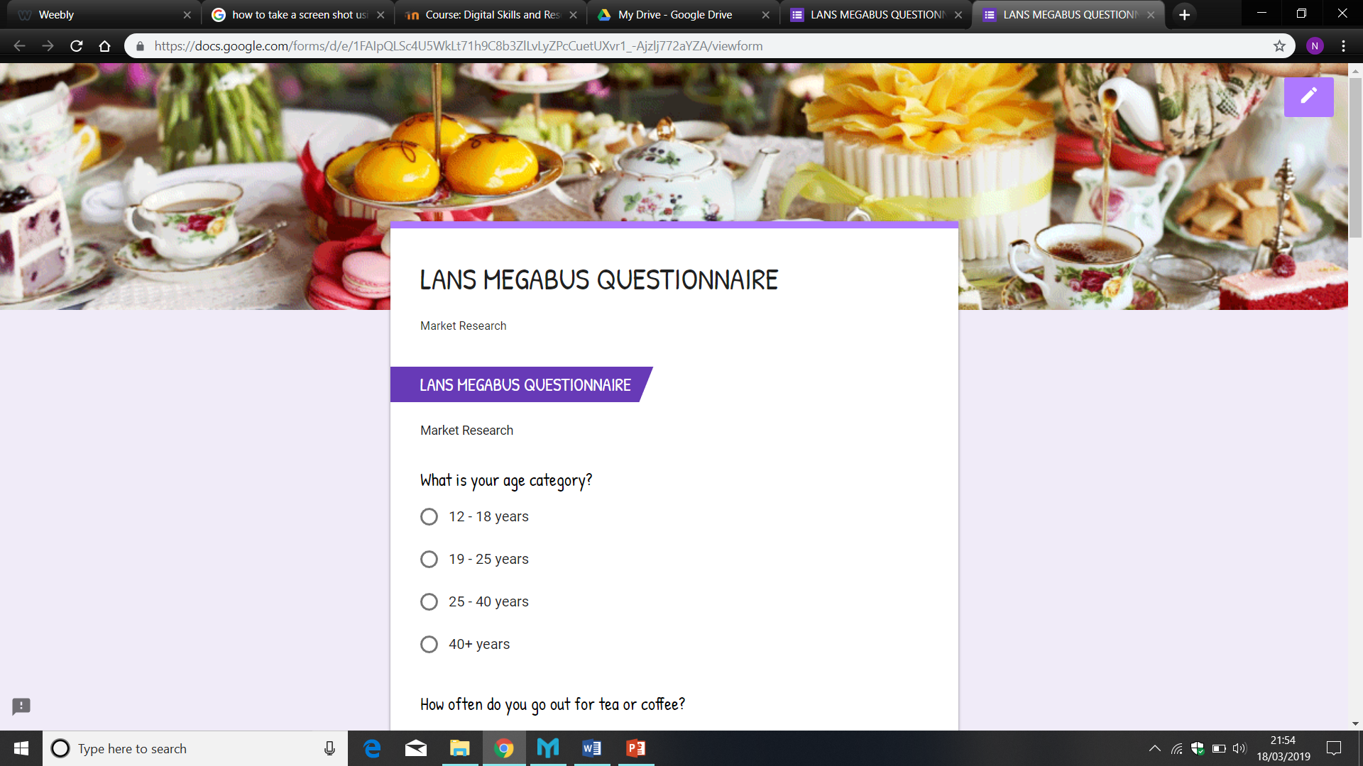

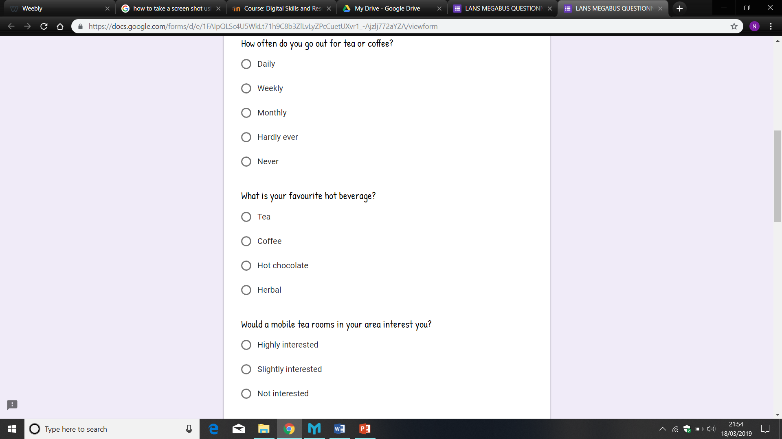

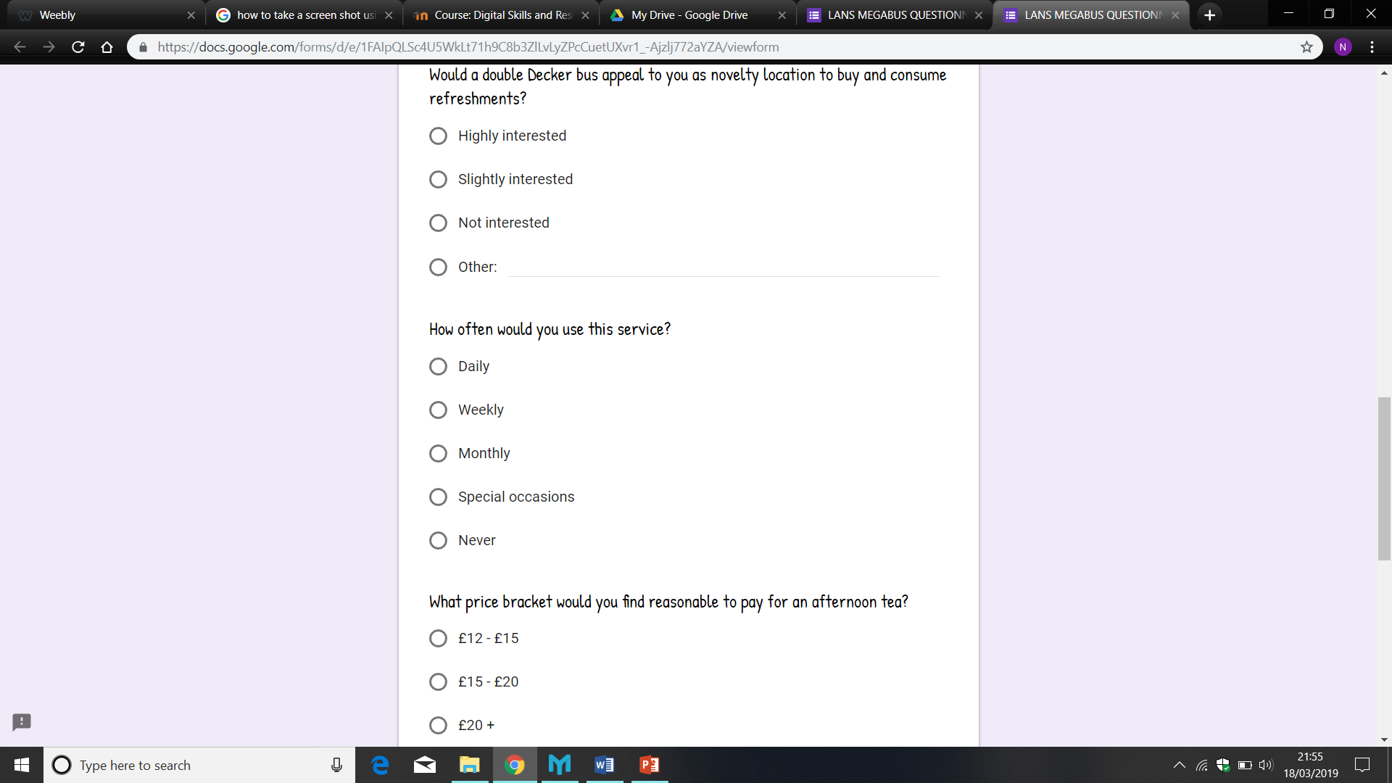

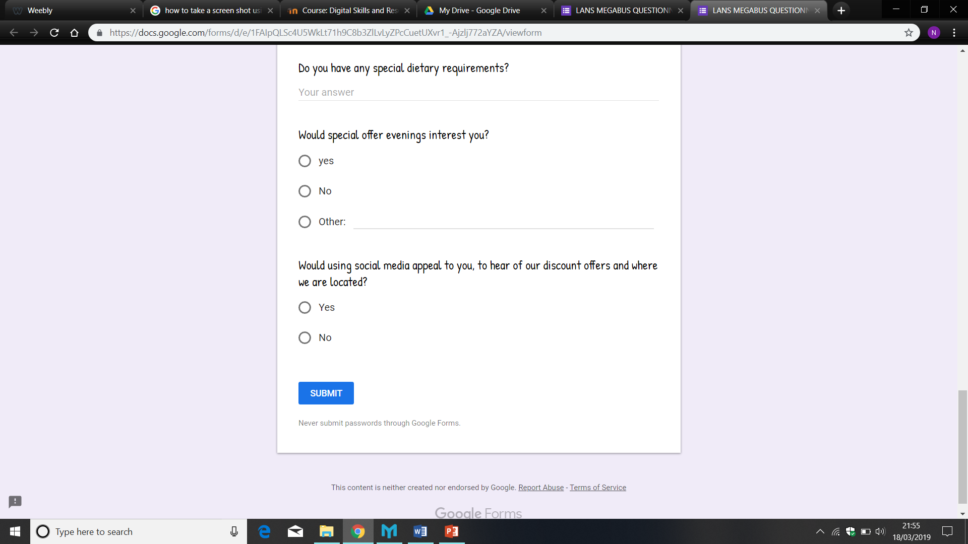

My Questions & Responses
Question 1
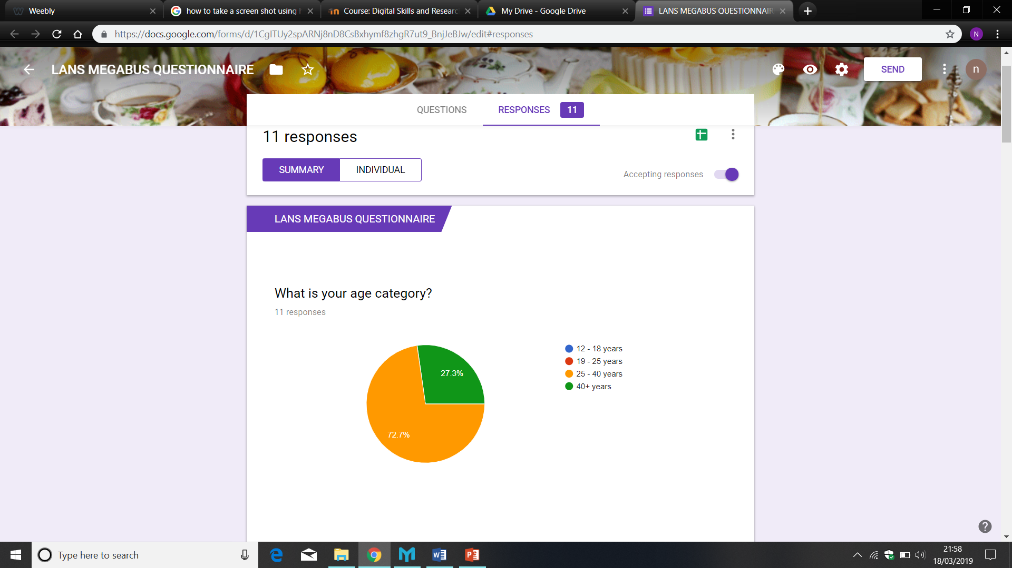

Question 3
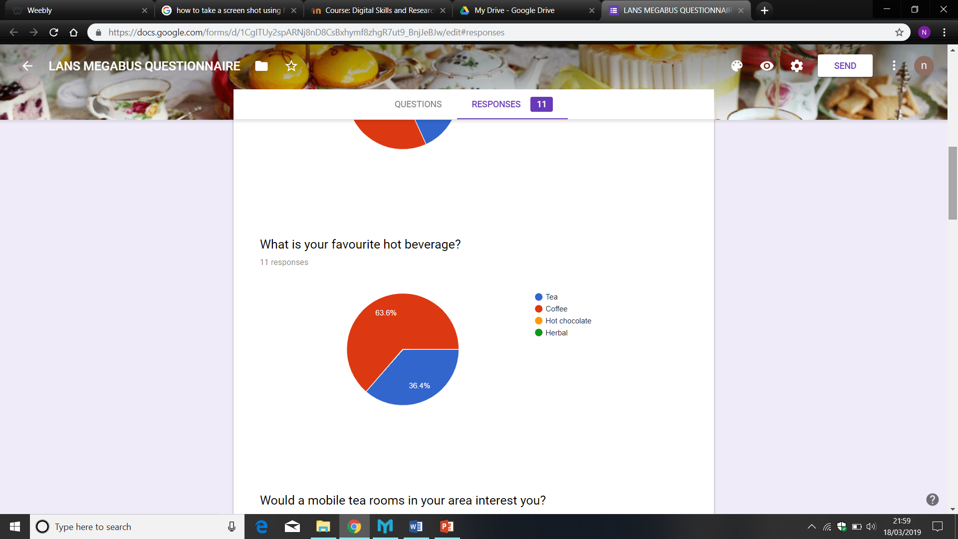

Question 7
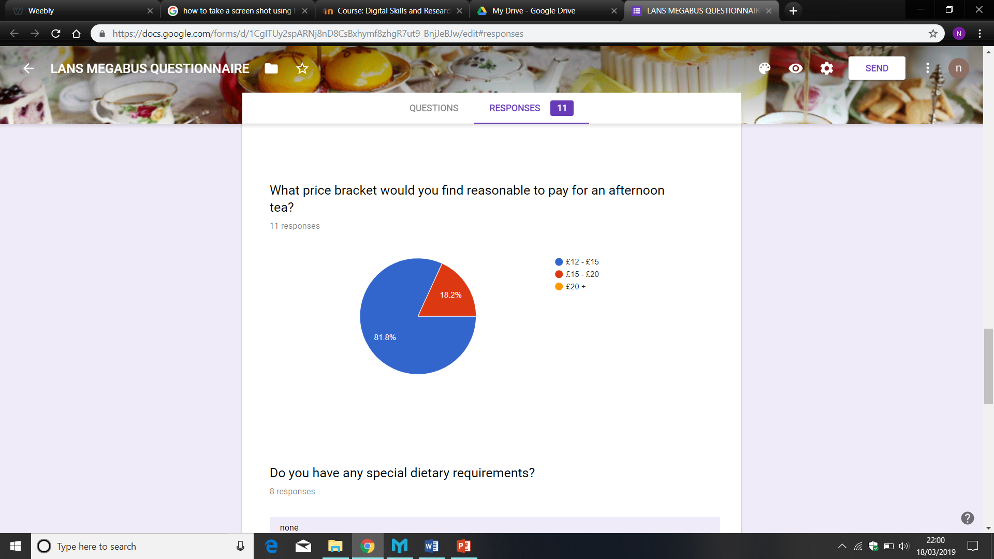

Questionnaire Findings
Using carefully selected questions, our questionnaire has been used to collectively gather primary research (information/opinions), aimed at our new potential customers.
As part of LANS marketing strategy, we found it was important to understand if there was an interest for the services we will be offering, how often they would be used and what target market we would appeal to.
My selection of questions are based around what would sell, to what age bracket and how much our potential customers would find reasonable to pay for our products. Information that is important to support for the area I am managing for our business plan.
This gave me a good insight into our preferred product portfolio, target market and how I would set our prices.
The results from the question I contributed “what is your favourite hot beverage?”, identified the preferred hot beverage by seven responses out of eleven was coffee and the remaining four preferred tea, with no one selecting herbal or hot chocolate. Helping me predict stock levels and concentrate on the products that would sell.
As part of our marketing/pricing strategy, we wanted to set our prices based on what customers thought reasonable/affordable to pay. Therefore, the last question I included “what price bracket would you find reasonable to pay for an afternoon tea?”, was key to finding out customers views to cost, enabling me to ensure they are happy to pay the prices we set.

LANS Mega Bus Website
‘Home Page’
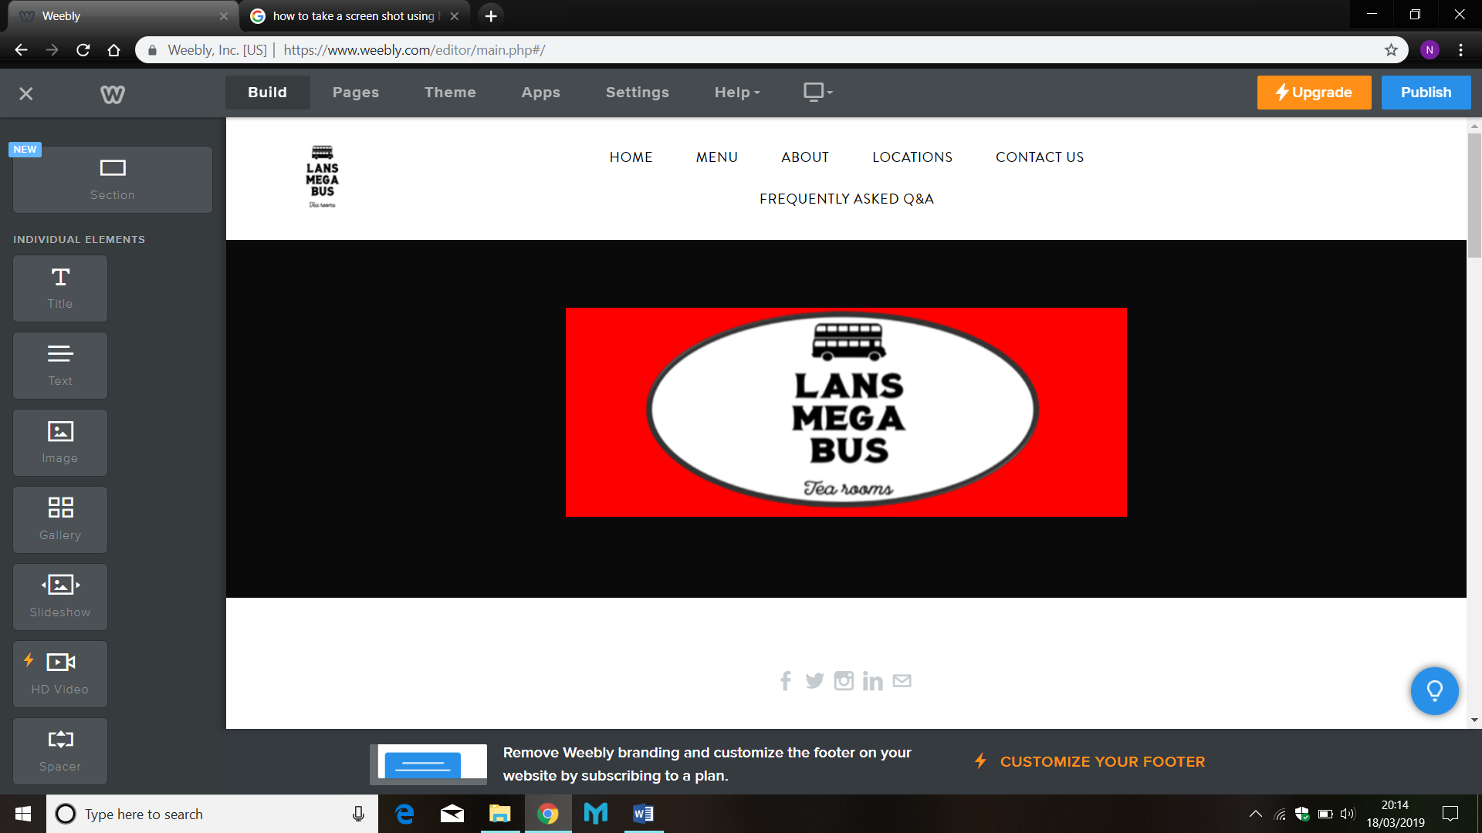

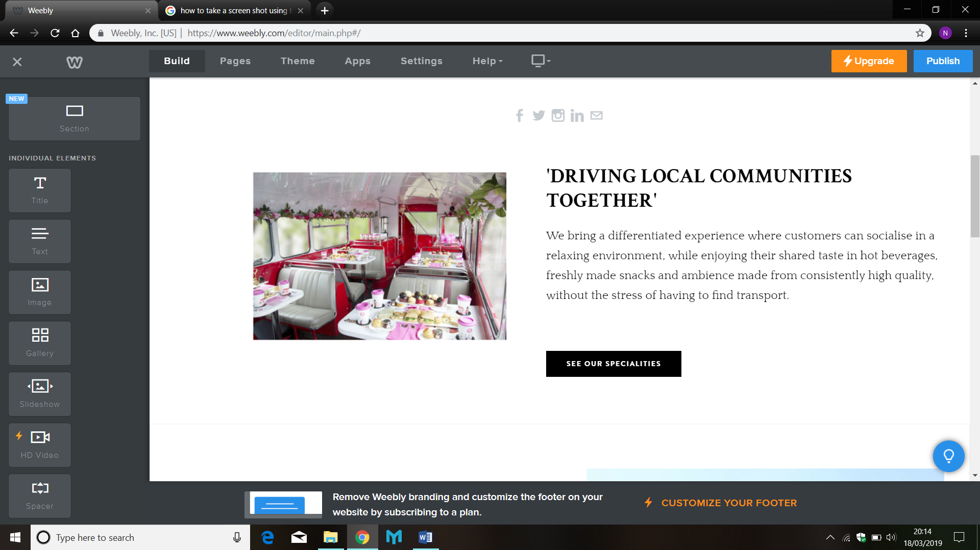
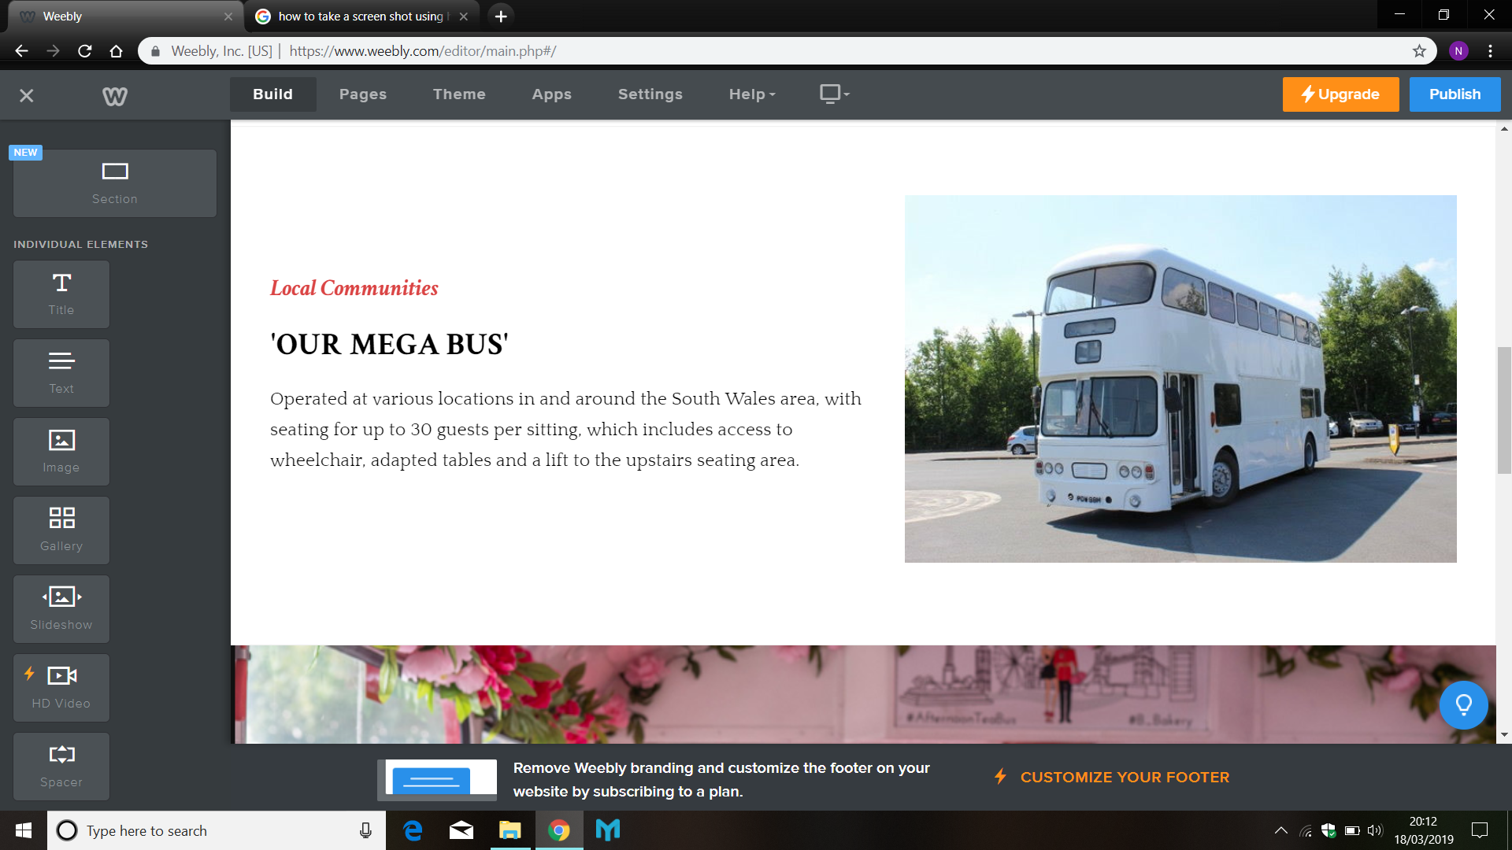

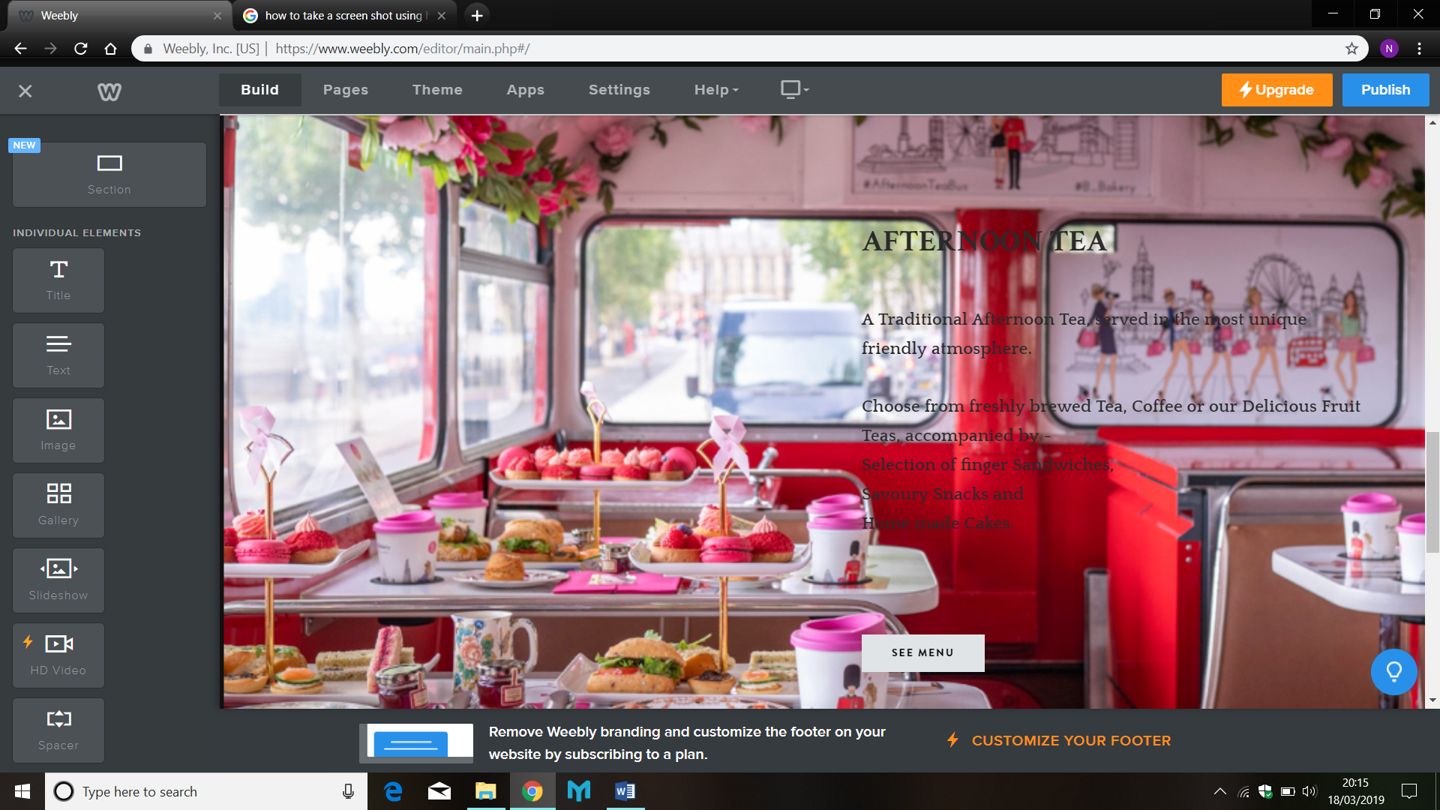

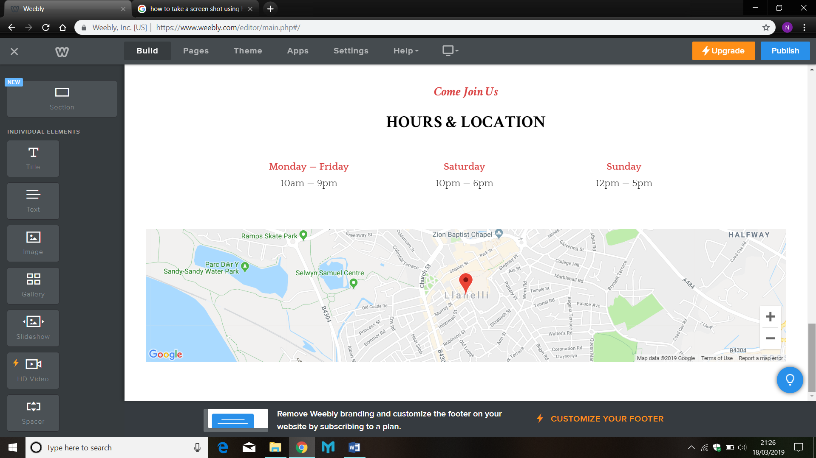

‘Menu Page’
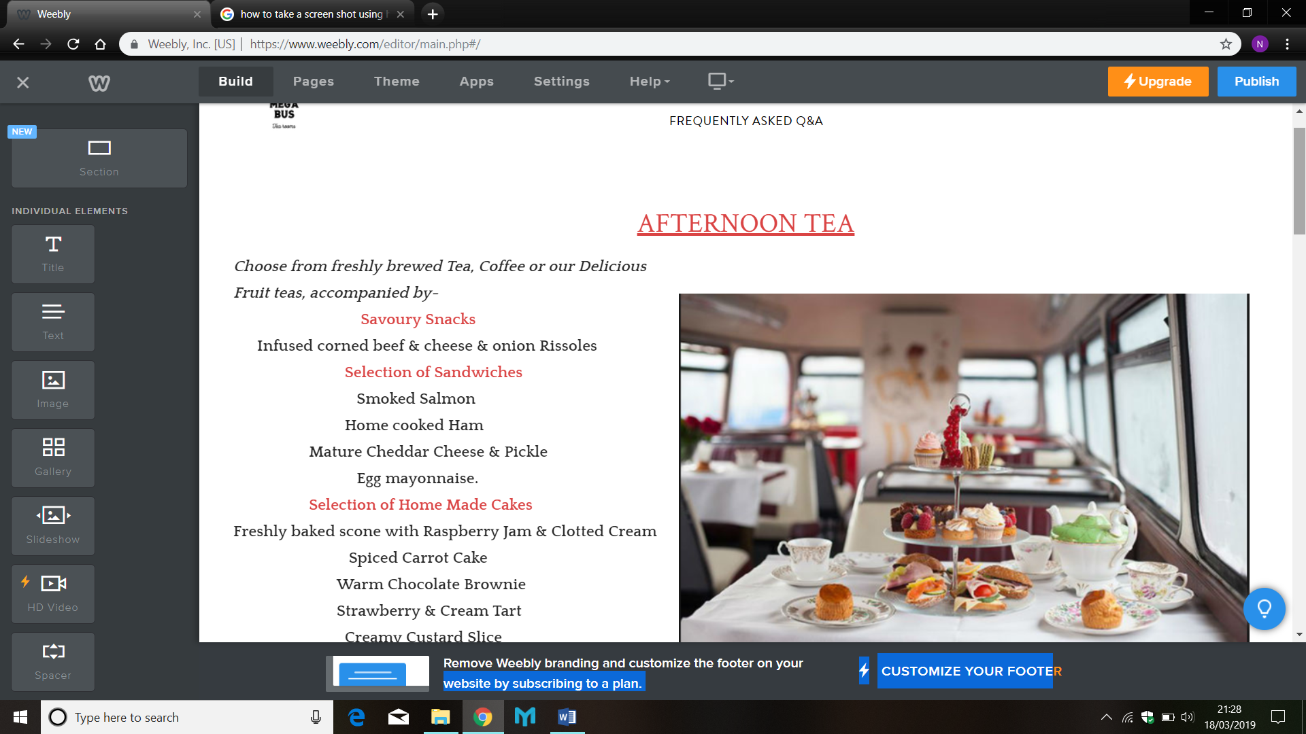

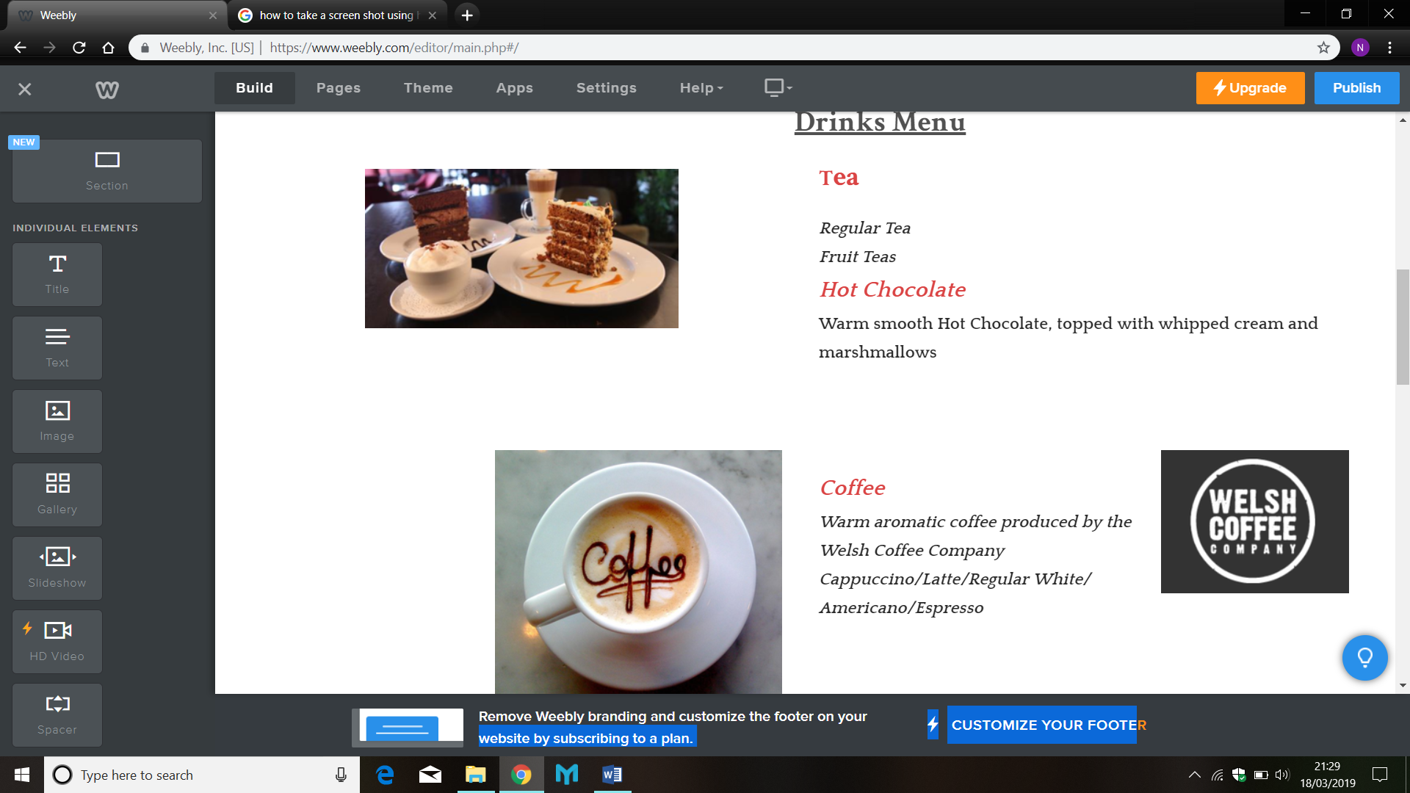

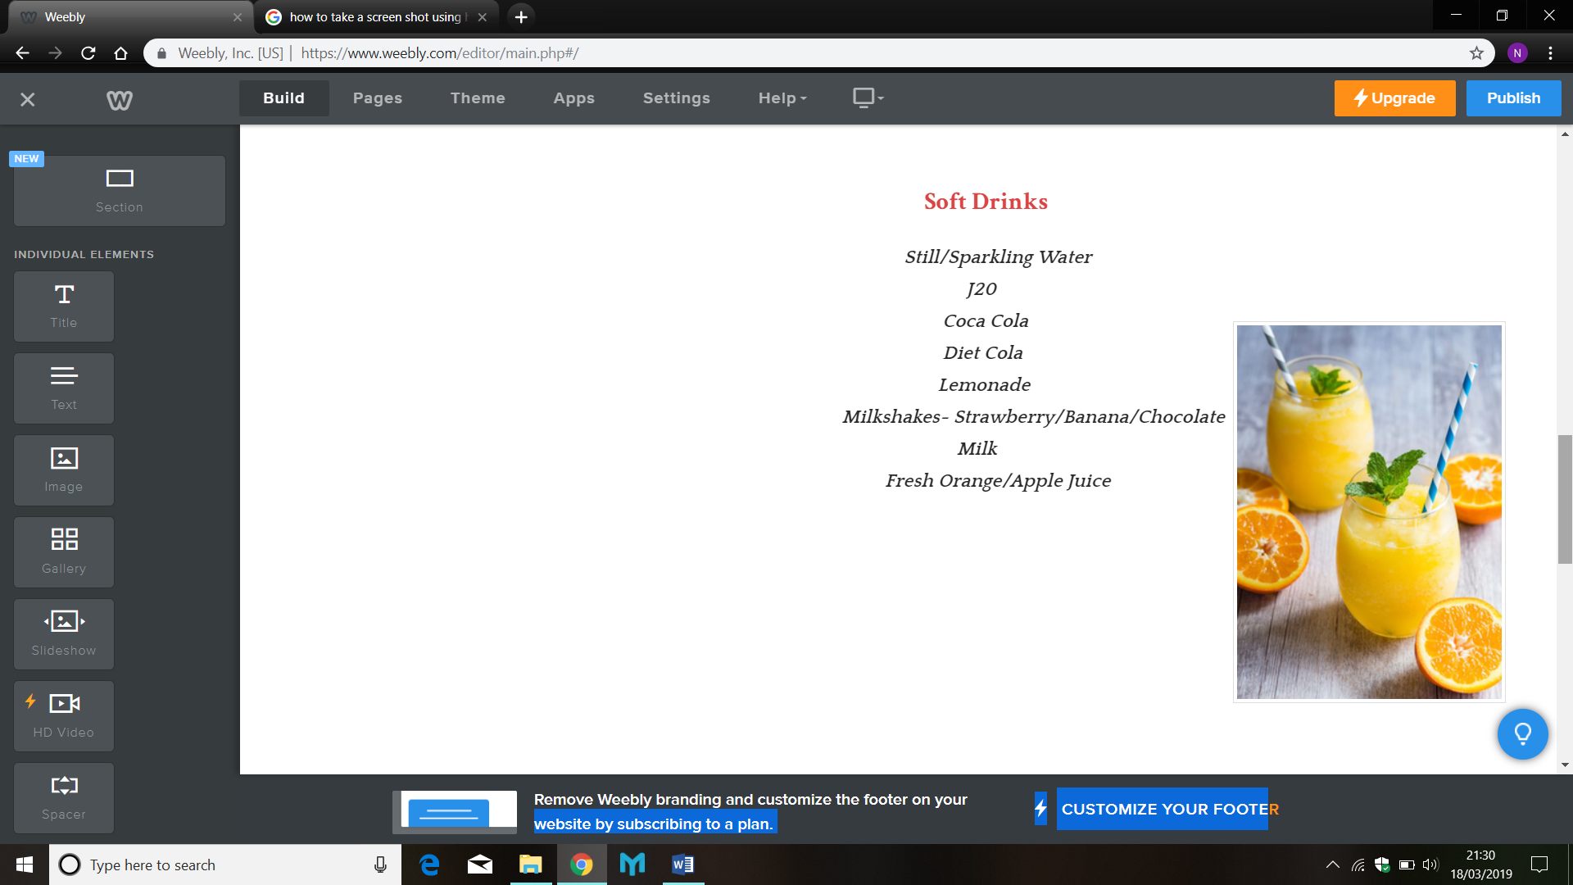

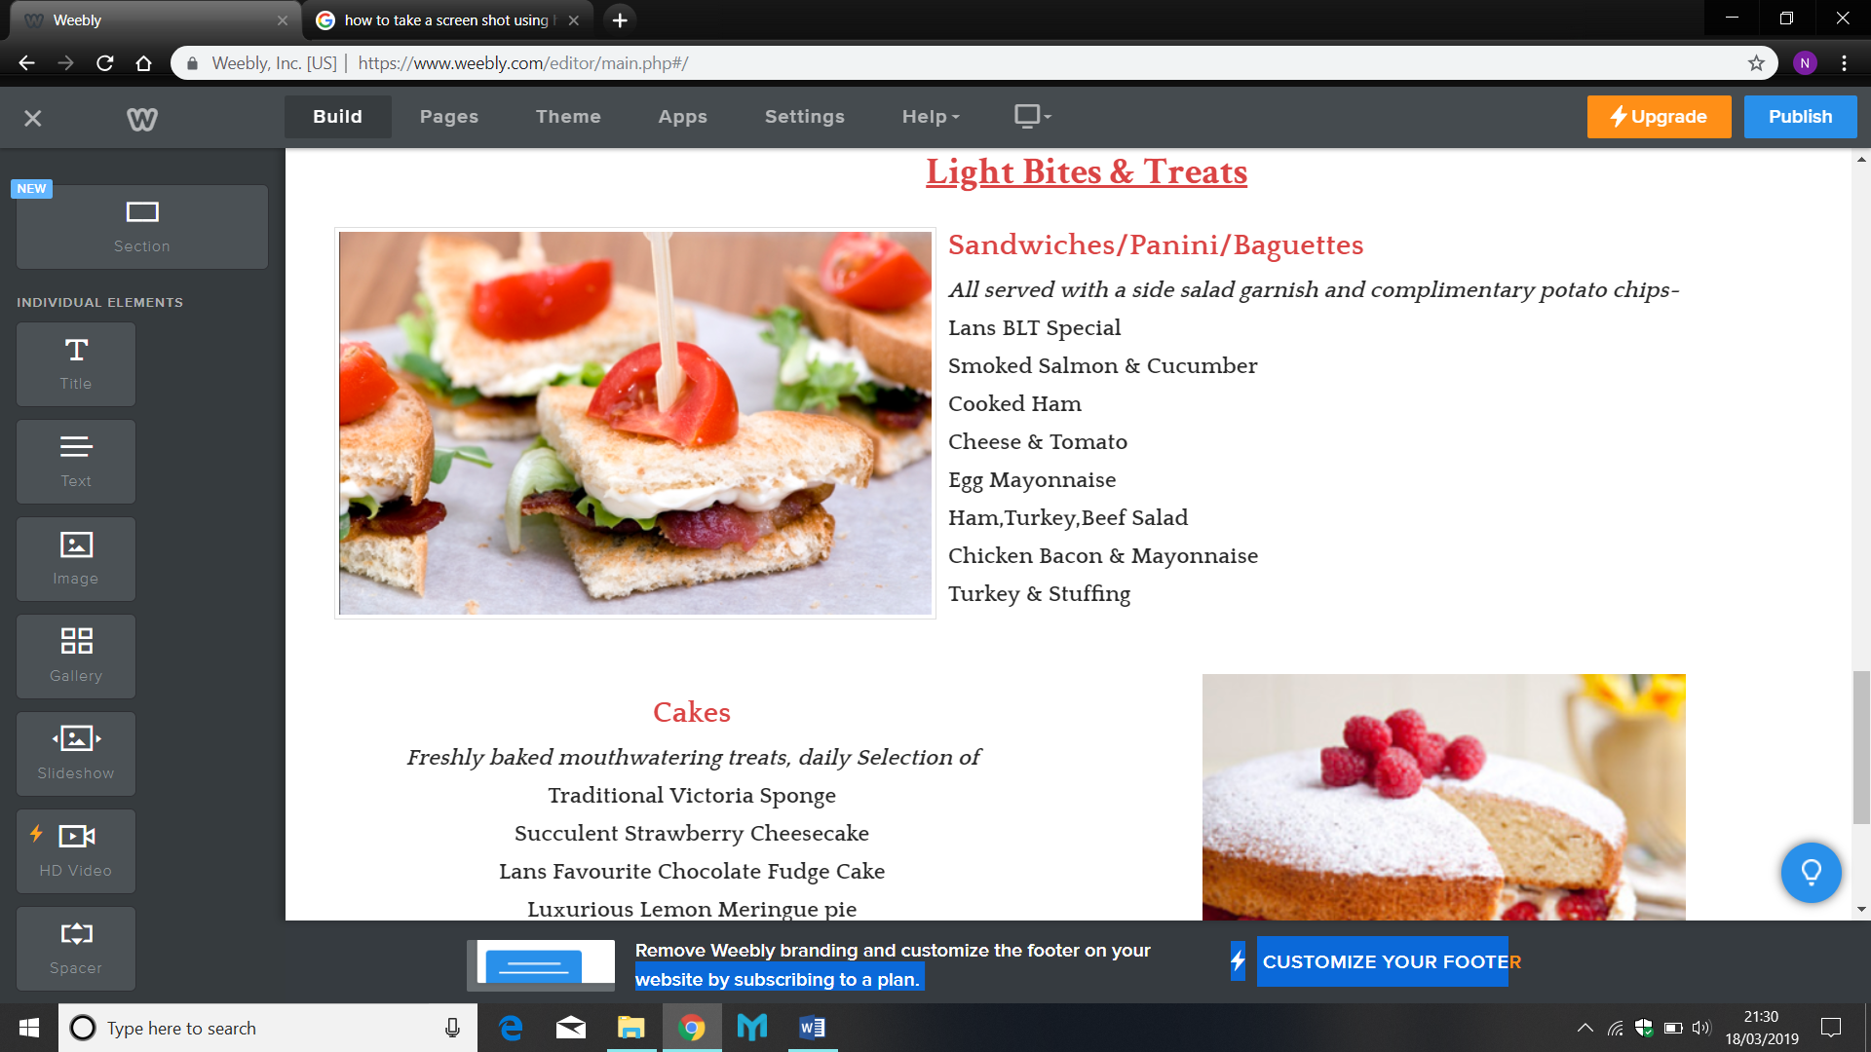

‘About Us’
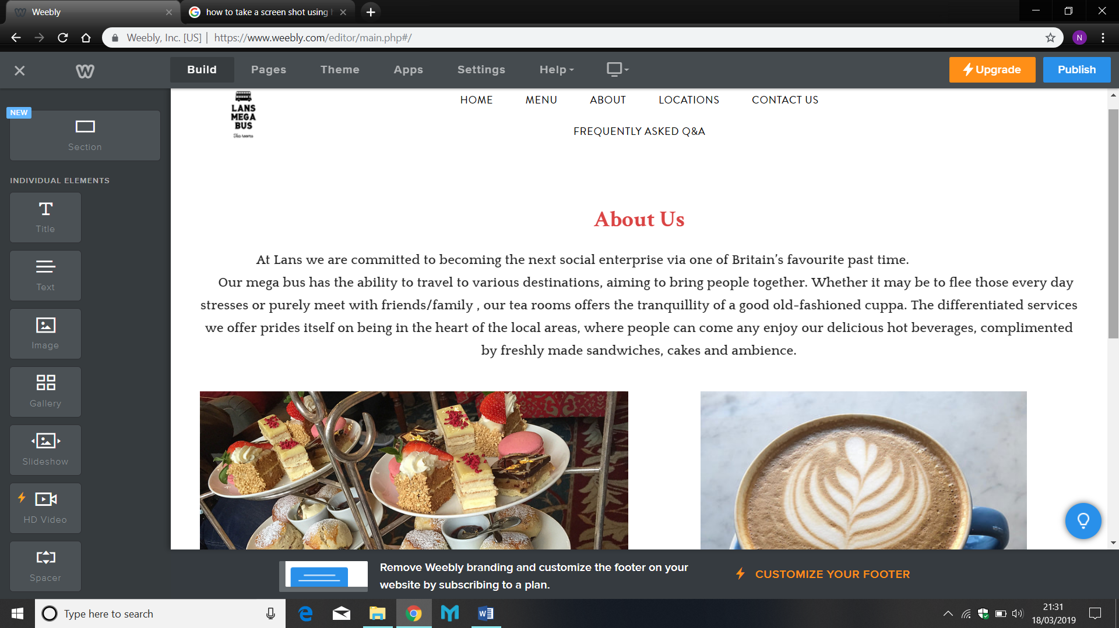

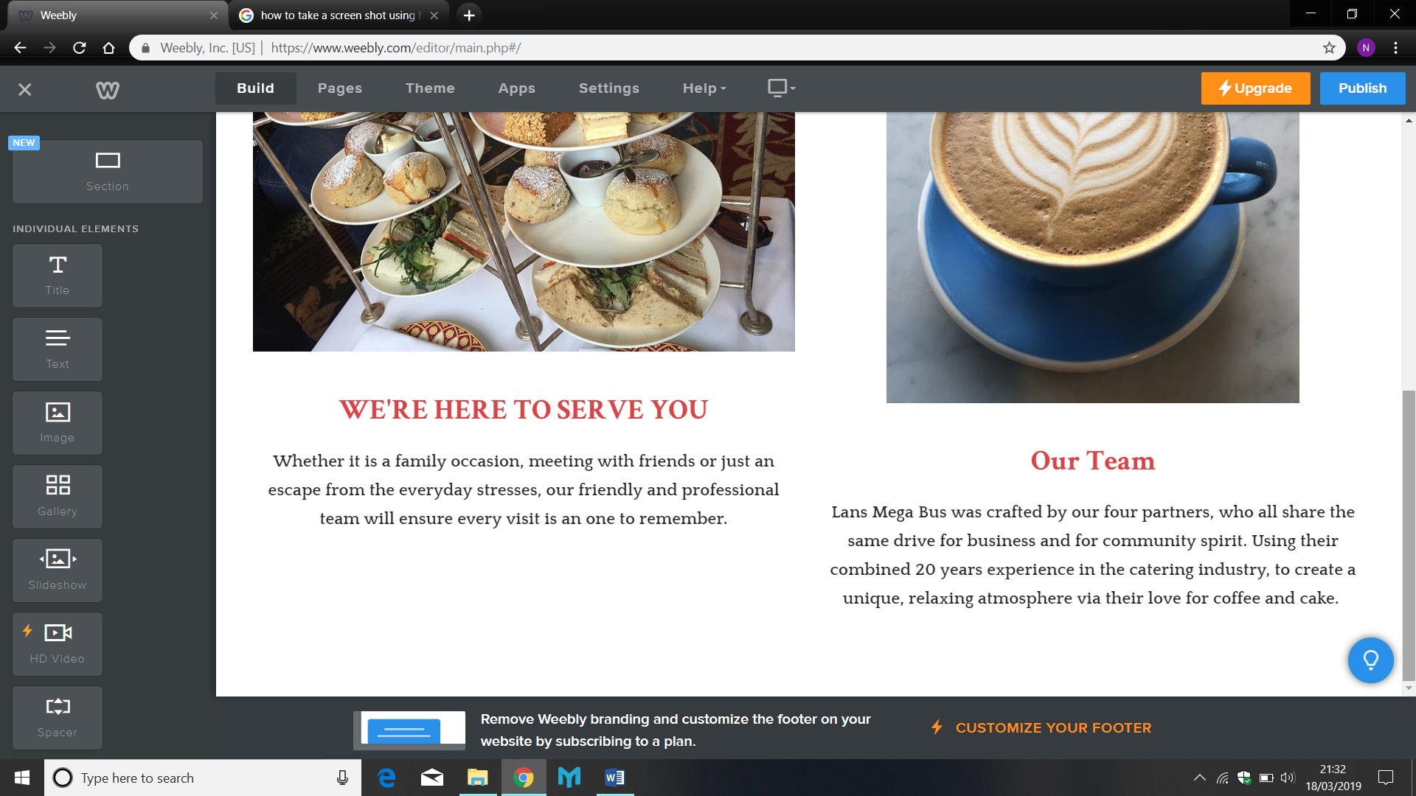

Website Contribution & Rationale
I began the process of design for our website, the template chosen helped guide me with creating an easy to use but effective web access for our customers. It was important to me to get the branding as our focus point, by inserting a header with our logo on each page, along with ensuring the navigation was simple to understand and use.
From a personal perspective, I usually read with my eyes, if I like what I see, it encourages me to read the text. Therefore, the pictures I used were carefully selected from google, ensuring they were relevant to our business and supporting each text I had written (where applicable looked delicious and eye appealing).
The ‘Home’ page includes all the key areas of our business, to help catch our audience’s attention, including links to our social media pages and delicious ‘Menu’ page, helping us connect and sell our products to our customers.
I also added the ‘about us’ page, as a personal touch, to help our target audience get a feel of who we are and what we are about.

