DBA 21st Century Business & Societal Ethics:
Assignment advice 30 November 2021. (Updated for 05-01-22)

Please read this with the general advice given on the assignment cover sheet. This draft was updated after the lecture on 4 January 2022.

Task: You are required to apply the challenging driver of Corporate Social Responsibility (CSR). The adoption of CSR must be analysed in a first, second and third sector organisation (one in each category). It is essential that you provide robust evidence of adoption (or not) and implementation (or plans for implementation) of a CSR strategy.

The article must;

- Evaluate the theoretical underpinnings of CSR and various social actors/drivers of its adoption. (40%) 3000 words

- Use a content analysis to measure CSR adoption and implementation within the organisation cases. (40%) 3000 words

- Analyse the implication of the further development of CSR in both the case organisations and their sectors. (20%) 1500 words

30 November Advice (See also the advice on the assignment cover sheet):

To live with the word target you will have to avoid using extensive quotations. Instead use paraphrasing, condensing what authors say into your own words.
Also use appendices but do reference them in your text. Put descriptive material into the appendix, number it, label it and then analyse it in the text.

For example:

Appendix 1: CSR statement of XYZ Company (XYZ, 2021).
Blah, blah blah……..

In the text:

As Appendix 1 demonstrates, the XYZ company does recognise its responsibilities to the customers and environment however says nothing about employees or fair trading and relations with other companies.

In the bibliography:
XYZ (2021) Company website, www.xyz.com (Accessed 12-11-21)

Possible structure:

Introduction.

There are no official grades allocated to this however you could insert some key definitions, CSR, sectors details etc, as well as a brief description of the way you plan to answer the question.

You might compare and contrast the sectors, but make sure you do not repeat what you are going to say in sections 2 and 3.

A small debate by Steve Griffiths which should not take over your assignment: CONVERGENCE OF SECTORS?

One factor to consider it that some people believe there is very little difference between the sectors. They all must live in a competitive, free market world, they all are influenced by government and most have some philanthropic (charity) activity. This is the opinion of Steve Griffiths, which I have not fully referenced here. There are writers who still say that the three sectors are very distinct.

There are opinions on both sides. If I were writing this report, I would have to quote sources NOT just give my opinion.

A few references here, but not by themselves good enough.

https://www.bbc.co.uk/bitesize/guides/zpx7gdm/revision/1 for a general list of sectors.

Another on the general view of the sectors but includes public -private partnerships.
https://www.investopedia.com/terms/p/private-sector.asp

Please also note that in some economies and for some organisations, the government retains a controlling interest in organisations that appear to be private, so compromising the sector definition e.g. the French government keeps a “golden share” controlling interest in corporations privatised, previously fully owned by the government. Also, the organisational structure and governance on most large operations in the PRC shows significant government influence. See this site and its description of the French golden share to stop hostile foreign takeovers. https://www.reuters.com/article/uk-france-investment-idUKKBN1K92QN

Another general sector description from the professional organisation, CIPD:
https://www.cipd.co.uk/careers/work-environments/organisation#gref

If you think the sectors are getting closer in structure and outlook, you might use the term that CONVERGENCE is happening. I made the case in the lecture on 04 January 2021, that this might be happening because the stakeholder maps you might draw for each organisation may be looking more and more the same.

The same stakeholders who can use the same pressure to try to get the organisation to do what they want, regardless of sector.

- New technology.

- Wider access to information.

- Governmental interference/interaction.

- Rules on information disclosure allows stakeholders to see what is really going on.

- Rules on audit and accountability, look very similar in all sectors.

A short article on how different companies, often offering goods seen by customers as complimentary are converging.
https://chiefexecutive.net/industry-and-technology-convergence-the-next-frontier/

Another based on private sector industry convergence:
https://redshift.autodesk.com/industry-convergence/

The same influences (drivers) can be argued for our sector discussions. Private, Public and Not for Profit, looking more similar for many operations, including CSR.

This HBR article may not say they are the same, but it says the sectors can work together to make social change: https://hbr.org/2018/05/how-companies-governments-and-nonprofits-can-create-social-change-together

This sort of collaboration as well as other factors may “blur” the difference between sectors, making your analysis more difficult depending on the cases you choose to study.

An academic article on how NFP are copying private sector companies. https://www.researchgate.net/publication/249921693_Nonprofit_and_for_Profit_Convergence_Are_Nonprofits_Increasingly_Adopting_Private_Sector_Practices

There are many others on how each sector is copying what goes on in the other ones.

This diagram is from this helpful site. https://archive.skoll.org/2008/03/25/the-blurring-of-sectors-social-entrepreneurship-emerges-at-the-nexus/ . I think it pretty much sums up my argument.

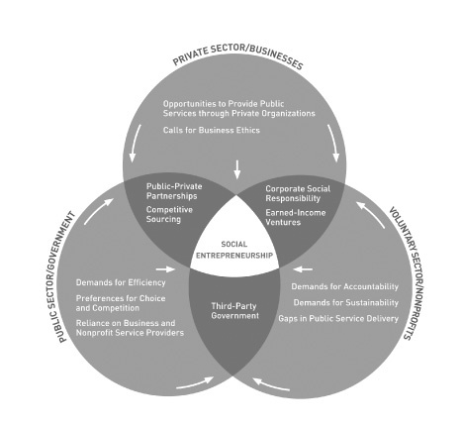
HOWEVER, the three sectors do still exist even if the differences between them are smaller in many cases. Therefore, the assignment task is still valid.

Also

Perhaps the pressures are on for

- Private sector organisations to be more socially responsible.

- Public sector organisations to work in a more free market way.

- Not For Profit (NFP) organisations to be using processes in both private and public operations, as well as their own special ways e.g. when operating as a charity…. Charitable campaigns, influenced/regulated by government and incorporating some commercial activity…..as well as not making a profit (although they often make a SURPLUS, which can then be invested back into the organisation).

As analysed in the HBR article in the text box, organisations in the different sectors often work together to achieve social objectives. Private companies may work with or create NFP organisations to focus their CSR work. NFP organisations may work with private companies or government as a source of funding. Government/public sector organisations also work with charities to achieve their objectives and have incorporated private enterprise businesses within their organizations or work in partnership to deliver services. (See the way Health organisations are working with private sector drugs developers in the pandemic).

Therefore, the private companies are not all about profit alone. Public sector organisations must think about resources, often generating their own incomes, not just taking money from government, which makes them more commercially/market orientated. NFP has always had elements of private enterprise and social objectives (like public sector organisations).

Steve Griffiths would reference this debate in the introduction. Then stick to the traditional descriptions of the sectors for section 2 (after the general discussion on CSR in section 1). For section 3 and a possible conclusion, he might challenge whether or not it is useful to talk about the sectors in the traditional way, all showing elements of CSR commitments, often with collaborations between sectors. However, if you think this creates too much complexity, stick to the traditional views of the three sectors and their differences (see text box links).

Write the introduction once you have finished the other three sections. Then you will know what you are saying and can introduce the reader and maybe give a short summary of what will follow.

Section 1.

This is where you cove the key theories about CSR and why corporations in general should adopt it and what it might look like.

The wide/narrow views and maybe some more sophisticated concepts like CSV, corporate citizenship etc. could feature.

Do set up theories so you can refer back to them in other sections.

It is likely that you will refer to a stakeholder map, which might be the easiest way to identify drivers see Fig. 1 below. This is a general map. It might not apply to all the cases you are looking at. However, they are easy to draw, can be easily inserted and do not constitute any words!! You could insert them directly into the text or use an appendix, as described above.

Figure 1: Steve’s brainstorm of drivers of CSR

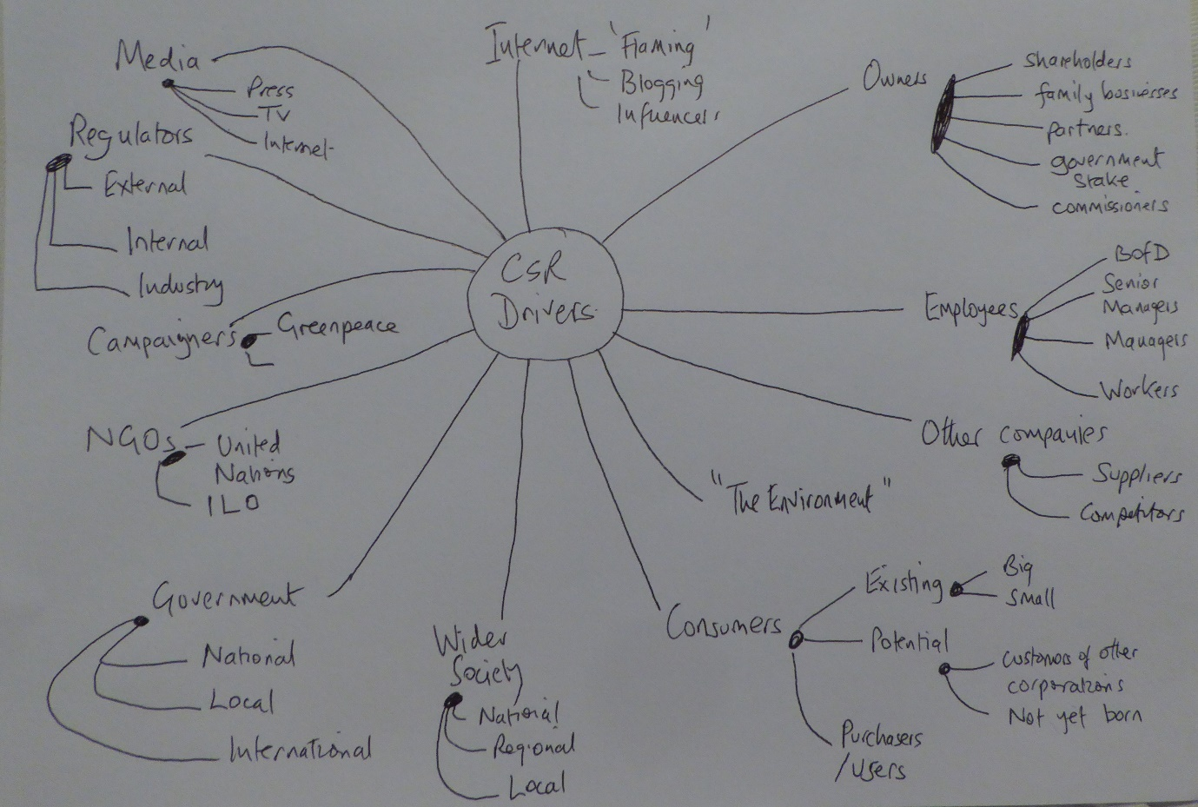

The main discussion of the table will be on which stakeholders/driver are more important. This will link to the narrow/broad discussions.
To save words apart from some examples keep detailed discussions on the three sectors to sections 2 and 3.
Your discussions might be around how the status of each stakeholder can vary for the same organisation at various times as well as for the separate organisations in different sectors.
Simplistically you would expect owners to be most powerful for private, government for public and cause/campaigners for NFP. However, things might change over time and as each type of organisation gets more and more similar to the others.

(See separate briefing document on the use of Mendelow’s Matrix)
Use this diagram to identify the most important stakeholders. Your stakeholder maps for the three sector cases might look the same but their reaction to and management of the stakeholders might be different depending on stakeholder involvement and power.

Figure 2. Mendelow’s Power/interest matrix
Source: https://blog.oxfordcollegeofmarketing.com/2018/04/23/what-is-mendelows-matrix-and-how-is-it-useful/ (Accessed 11-11-21).

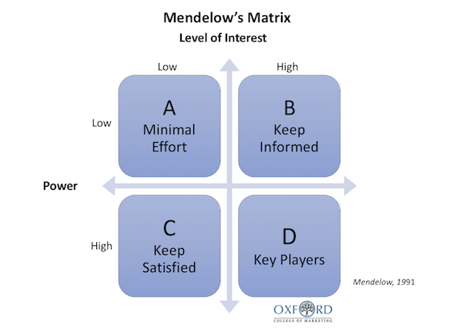

The original article for the diagram that I would quote in your assignment is:

Mendelow, A. L. (1991) ‘Environmental Scanning: The Impact of the Stakeholder Concept’. Proceedings From the Second International Conference on Information Systems 407-418. Cambridge, MA.

There are many worked examples available and sites offering the tools to make your own.
The identification of the most important stakeholders will influence the list of stakeholders that your case organisations give priority to in your analysis in section 2.

Section 2. Content analysis needs a brief discussion, merits and demerits

Choose key comparative drivers and set up a grid.
Table 1 Key CSR drivers for comparative analysis of the three sectors
Driver | Private sector: Toyota | Public Sector: NHS | NFP Sector: Greenpeace
Owners | Shareholder impacts at the annual meeting
Customers
Regulators
Campaigners
…..and others but not too many.
Evidence of policy commitment

Appendices can be used to evidence the summary put into the boxes.
There needs to be discussion/analysis/evaluation of why you inserted certain things into this grid.
You could summarise the main driver influences for each organisation.
In the lecture on 4 January, I discussed the use of 3 cases from the same industry e.g. Health: a government hospital, a private hospital and a charity/voluntary/NFP organisation. I made the case that the same industry pressures would be on all three.

However, after thinking, it might be easier for you to research three organisations in different industry, depending on how easy it is to access the information.

Section 3.
This only gets 20% so beware of repetition or writing too much compared with sections 1 and 2.
Use this section to summarise the impact of drivers in general and on the three organisations you have chosen.
Evaluate how and why they have altered their policies or operations.

Logically derive other recommendations of how they can improve or what other ways that CSR progress can be made
For example:

- Legislation

- Industry regulation

- More campaigning- demonstrations or consumer boycotts etc

- Education- of consumers, general public, suppliers etc

- Collaboration between corporations.

Bibliography

Appendices.

