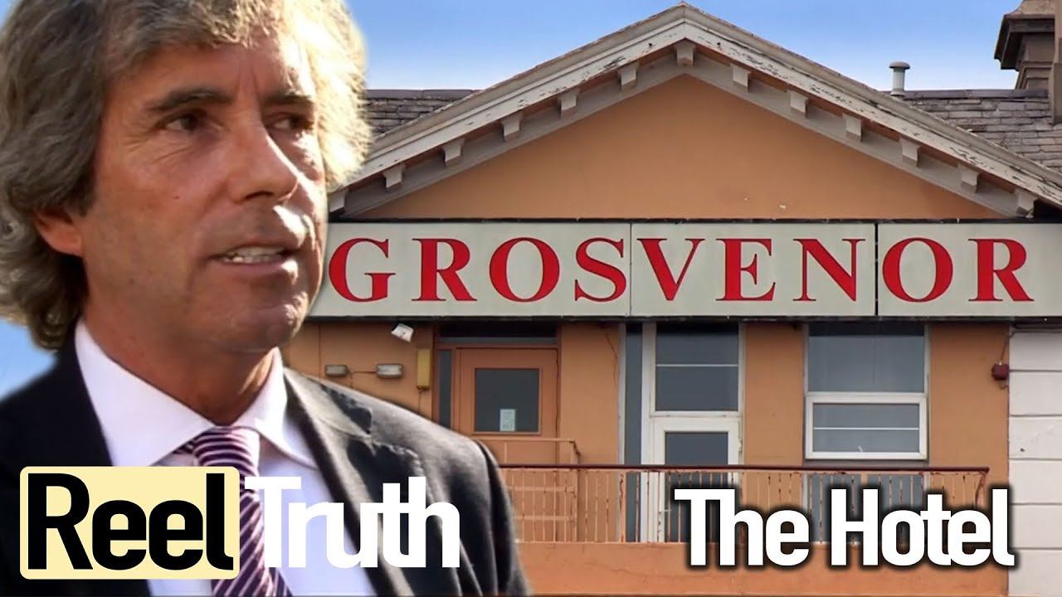
BA International Hotel Management
Management and Organizational Behaviour
M5X01924
Lecturer: Dr. Olu Adegbite
Student: Stilyana Mincheva
(1816276)

Mark the Hotel Manager

Table of Contents

Introduction 2
Case study- General Manager Mark from Grosvenor Hotel, Torquay, England 2
Two models of Organisational Behaviour 3
Two models of Leadership 4
Two models of Team working theories 5
Organizational Health Index 6
Conclusion 7
Reference List 9

Introduction

The hospitality industry is one of the most demanding business sectors of the United Kingdom. It has been observed that the people of this country are very specific regarding their preference of culinary tastes and level of service that needs to be offered to them. Many of the hospitality organisations face huge difficulties in order to meet up with these high demands. In this regard it is necessary for the hotel managers to step and adopt a leadership, people management skills in order to handle these situations effectively. The aim of this paper is to shed light on these workplace management skills that has been identified in Mark Jenkins during his tenure as the General Manager of Grosvenor Hotel, Torquay.

Case study- General Manager Mark from Grosvenor Hotel, Torquay, England

The customer centric organisations like hotels and resorts are heavily dependent on its customers without which it is difficult to attain their business objectives. Considering the scenario of The Grosvenor Hotel, it has been noted that it is one of the three stars hotels of Torquay and is a popular among the domestic tourists. The hotel also arranges marriages and other events that are an additional service to the guests (grosvenor-hotel. torquay, 2020). However, it has been observed that currently the condition of the hotel is very poor, and the management is unable to generate profit from the last one year. Under this challenging condition the hotel has appointed a new General Manager in the form of Mark Jenkins who has taken over the responsibility seven months ago.
However, it has been witnessed that Mark is facing much more difficulties in order to run Grosvenor. The financial quarters have been terrible, and this hotel has recorded loss in each of its previous quarters. As per a comment by Mark ``It's our last chance and we can't let this season go away”, to his reservation’s manager Alison it has been clearly identified that this is a do or die situation for the hotel without which is vital for its existence along the coast of Torquay (Channel 4, 2019). Summer is the wedding season for the British people and the discussion between Alison and Mark has highlighted that they have targeted the season in order to reimburse the previous losses.

Two models of Organisational Behaviour

Every hospitality organisation has some uniqueness that makes it different and for Grosvenor it was arranging the events through which it incurred heavy revenue. In this regard it is worth mentioning that the last wedding that was arranged here was seven months ago which was a disaster with two pages of negative feedback from the guests. The kitchen team, decorations team did not have any bonding and most importantly Mark was not even involved in the planning process. In the opinion of Mullins (2016), it is necessary for the heads or the supervisors of the respective departments which are not performing well needs to evaluate the situation and identify the issues responsible for the problems. As per the scenario it is necessary for Mark to incorporate an assertive model for managing the different operations. It has been found that Mark does not want to discuss the problem with Philip, the wedding coordinator of this hotel for almost twelve years but his performance has reduced after the change of hands. As per the model it is essential for the concerned head that is Philip to discuss with Mark about the issues and come to a solution for the betterment of the hotel because weddings are the chief sources of revenue in this region. Unless the issues of the previous wedding are resolved it will be difficult to arrange the wedding of Faye’s and Michael which is next on the list (Mullins, 2020).
Further, another change in the behaviour of the management that has been observed is marking of the employees and putting them in the relegation zone. Lintzeris et al. (2020), this generally demoralises an employee which has been reflected through the performance of Phillips. Instead of having a discussion with him Mark has put him in the relegation zone. As opined by Golini, Corti and Landoni (2017), unless the management supports the employees it is difficult to raise their performance. In this respect adopting a supportive model will help to understand the problems of the event management department and boost their morale. Further, it has been noted that Mark seems to run away from the failed tasks which is a negative influence on the staff and is often reflected through the conversations of Christian, the Deputy Manager and Philip who are thinking to resign and all the old and loyal staffs exiting will incur more difficulties for sustaining of this hotel.

Two models of Leadership

In the majority of the hospitality organisations it has been observed that the managers are the administrative heads along with the leaders of the respected organisations. As per the views of Fiaz, Su and Saqib (2017), it has been found that the style of leadership prevailing in the firms have a direct impact on the motivation level of the employees. Evaluating the scenario of this particular hotel it has been found that Mark is following the traits of autocratic leadership that has increased the distress of the staff. It has been found that autocratic leaders don't value the views of the subordinate employees which create misunderstandings at the workplace. Due to this Philip resigned on the day before a marriage was going to be conducted at the hotel. This demonstrates that the dedication level of the employees have reduced and they are not thinking of the betterment of the organisation because Mark does not value their work and are in a constant threat of relegation which is a new term induced by Mark after his accession. As per an incident it has been noted that Christian, the deputy manager who was arranging a marriage for the first time had a conflict with Mark because he was putting the table as per Fayes’s instruction because she wanted the dance area too be big whereas Mark did not like the positioning of the table (Channel 4, 2019). It is required to provide the service as per the requirement of the client and in this hotel due to rigidity of Mark the staff could not perform the requisite actions.
It is also worth mentioning that a hotel has various departments, and each has their distinct responsibilities. It is not possible for a General Manager to perform the entire activities single handily and in this regard transferring the leadership at few occasions is necessary. As per the views of Nguyen et al. (2017), transformational leadership helps to involve the employees in the company activities with more responsibility from their side which was also missing in this hotel. It has been noted that without even consulting with Alison, Mark handed over the keys of room number 220, the only sea facing room with a balcony to a couple which was booked almost a year ago for the mother of the bride. This created huge tensions and Faye’s was not ready to accept this kind of negligence and was even ready to cancel the wedding and demand a refund from the hotel. This demonstrated the lack of collaboration of Mark with his employees and to express his supremacy he could have done a huge loss to the hotel. Instead of leading his employees he was creating difficulties that is not what the staff expects from his manager. Further, he also ran away from the situation and Christian had to convince the client (Channel 4, 2019).

Two models of team working theories

One of the necessary skills for the leaders is to successfully manage the employees in order to maintain a positive work environment. The work in the hospitality sector is conducted in different groups in order to meet the requirements of the guests. However, it has been found that Mark did not imply any such procedures for dividing the tasks within the employees. The house keeping staff and the individual working in the kitchen need to have different skill sets that were also ignored by the respected general manager. He wanted to spend heavily on a blower to soak the water from the ground for the rain but did not recruit staff to strengthen his departments running low on employees. As per one incident it has been found that the Head Chef was not happy with the warmth of the dishes on which the soup was going to be served to the newly married bride and groom because it was done by the house keeping staffs that did not have much idea about the specific temperature (Channel 4, 2019).
In the opinion of Karabeleski and Avdic (2018), it has been found that it is necessary to consider Belbin’s Team Role in order to divide the task as per the skill set of the workers. This would have helped Mark to understand the skills required for a particular task and based on it the activities for the wedding could have been divided. However, it has been found that in the Grosvenor these rules are not followed that leads to misconception in work that often decreases the satisfaction level of the guests affecting the reputation of the hotel. According to Mehta and Kaur (2017), to increase the productivity of the organisations it is necessary to build a healthy bond within the workforce. In this respect considering the following theory it is essential to discuss the difficulties that are emerging in the work and discuss with the respective departments to find solutions and encourage the group members.
Saari, Jaafar and Ahmad (2018) have commented that based on the importance of the work the task needs to be allocated to the employees that has been highlighted in Tuckman’s Teamwork Theory. The demand and importance of every task is different that requires the support of the distinct individuals for the smooth conduction of the work. On the contrary it has been found that despite having issues with Philip regarding his effectiveness of work Mark initially allowed him to arrange the wedding which was later transferred to Christian under client’s request (Channel 4, 2019). It has also been found that there was difference in opinion within the wedding coordinator and the client because Christian was the supervisor of a wedding for the first time and was in much confusion. The GM needs to have taken the situation more seriously and have appointed a professional wedding planner in a contractual agreement for getting over this particular event.

Organizational Health Index

Factors | Mark’s Activities | Impact on The Grosvenor
Management Skills | It has been found that Mr. Jenkins has terribly failed in order to manage the business activities in the organisation. Rigid decisions without consulting with other senior officials created disruptions in work resulting in delayed and poor service to the guests. | Negative
Leadership Skill | As per the views of Mole, North and Baldock (2017), it is essential for the leaders to have a positive influence on the employees. However, it has been found all of the staff and even Philip resigned due to differences with Mark which represented his incapability to retain a loyal employee. | Negative
Team Management Skill | Mark did not have the knowledge regarding the skill set of his workers and did not divide the task in a planned manner that led to misunderstandings resulting in poor work performance. | Negative
Table 1: OHI of the Grosvenor Hotel
(Source: Channel 4, 2019)
Conclusion

Thus, it can be concluded that the General Manager Mark should involve the employees in the activities of the company with greater responsibility on their part, change his way of management by delegating more rights to the staff, encourage their initiative and creativity, and integrate them to work as a team. Management must also support employees to gain their respect and loyalty. There must be a continuous two-way process of good communication and understanding between General Manager Mark and the staff.
Finally, General Manager Mark should show respect to hotel guests, respecting their preferences, and striving to satisfy all their desires.
Reference List

Channel 4 (2019) - The Hotel: Series 2 Episode 1: The Grosvenor Hotel Torquay (2012),Available at: https://www.youtube.com/watch?reload=9&v=jxqMi8nAGmQ&feature=youtu.be [accessed on: 07/06/2020]
Fiaz, M., Su, Q. and Saqib, A., (2017). Leadership styles and employees' motivation: Perspective from an emerging economy. The Journal of Developing Areas, 51(4), pp.143-156.
Golini, R., Corti, B. and Landoni, P., (2017). More efficient project execution and evaluation with logical framework and project cycle management: evidence from international development projects. Impact Assessment and Project Appraisal, 35(2), pp.128-138.
Grosvenor-hotel.torquay (2020), Hotel Offers and Services, Available at: http://grosvenor-hotel.torquay.top-hotels-uk.com/en/ [accessed on: 10/06/2020]
Karabeleski, S. and Avdic, D., (2018). Pairing Belbin’s Team Roles towards Productivity. pp.1- 10.
Lintzeris, C.P.N., Deacon, R.M., Shanahan, M., Clarke, M.J., MacFarlane, M.S., Leung, S., Schulz, M.M., Jackson, M.A., Khamoudes, D., Gordon, D.E. and Demirkol, A., (2020). Evaluation of an Assertive Management and Integrated Care Service for Frequent Emergency Department Attenders with Substance Use Disorders: The Impact Project: Evaluating an assertive management service for frequent ED attenders with substance use disorders. International Journal of Integrated Care, 20(2). pp.1- 12.
Mehta, S. and Kaur, R., (2017). Relationship between leadership styles and job satisfaction: A comparative study on public and private sector banks. Arya Bhatta Journal of Mathematics and Informatics, 9(2), pp.315-326.
Mole, K., North, D. and Baldock, R., (2017). Which SMEs seek external support? Business characteristics, management behavior and external influences in a contingency approach. Environment and Planning C: Politics and Space, 35(3), pp.476-499.
Mullins, L (2020) Organizational Behaviour in the Workplace (12th edition) Harlow: Pearson
Mullins, L. (2016) Management and Organizational Behaviour (11th edition) Harlow: Pearson
Nguyen, T.T., Mia, L., Winata, L. and Chong, V.K., (2017). Effect of transformational-leadership style and management control system on managerial performance. Journal of Business Research, 70, pp.202-213.
Saari, N.A.C., Jaafar, W.M. and Ahmad, N., (2018). Teamwork Process Among Amanah Ikhtiar Malaysia (AIM) Participants. Case Study in Hulu Langat District. Malaysian Journal of Social Sciences and Humanities (MJSSH), 3(4), pp.50-59.

