Behaviour and Learning:
Approaches to classroom Management

ECES5016

Student Number
2213158

Part 1

Approaches to Managing Behaviour
in the Classroom

Training Materials
Booklet

Contents

Examples of Classroom Rules/Expectations……………….. 2,3

Examples of Good Practice …………….………………………… 4

Useful Resources/Links…………………………………………… 5

Task – Modelling Ideal Behaviour……………………………..… 6

References …………………………………………………………… 7

1
Example of Classroom Rules/Expectations
Primary Classroom Expectations
- Respect – Treat teachers, peers, and classroom materials with respect. Be gentle with your words and hands.
- Be a Good Listener Pay attention when teachers or classmates are speaking and follow directions given by your teachers.
- Participate – You all have something unique to contribute. Participate in activities and class discussion and express your thoughts and ideas.
- Share and Cooperate – In this preschool classroom we share materials and toys and work together.
- Have Self-control – You can show you have self-control by waiting your turn, using gentle hands, and using your words to express your feelings and needs.
- Be Responsible – Take responsibility for your belongings and help keep the class clean and organized. This includes cleaning up after activities and respecting shared spaces.
- Use Your Indoor Voice– In the classroom we use our indoor voices and don’t shout or yell.
- Use Your Walking Feet– In the classroom we walk at all times and not run so we can stay safe.
- Keep Your Hands and Feet to Yourself– No hitting or kicking others or touching anything that is not yours.
- Use Your Manners– Remember to wait your turn, say please and thank you and share.
- Be Kind– Always show kindness to teachers and classmates.
- Stay Seated– Stay in your seat when the class is working unless your teacher says it ok to move around.
- Raise Your Hand- Before you speak raise your hand and wait for the teacher to call on you.
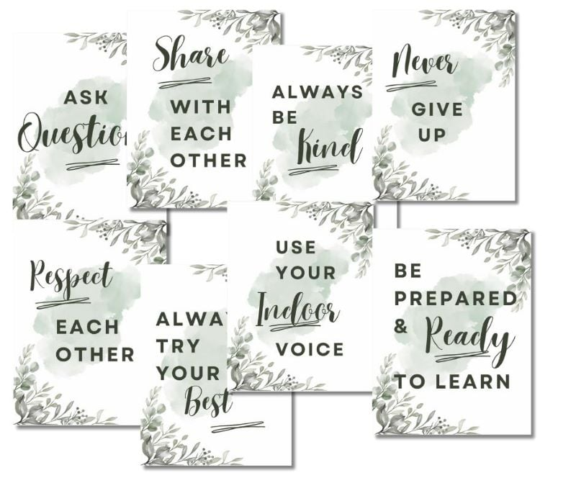
Chaylor and Mads (2020) https://chaylorandmads.com/classroom-rules-and-class-expectations/

2

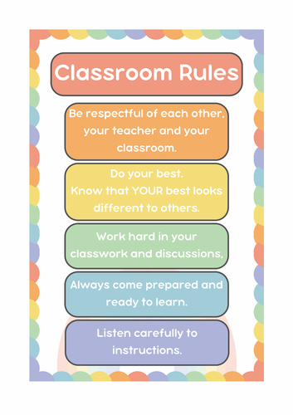 |  | 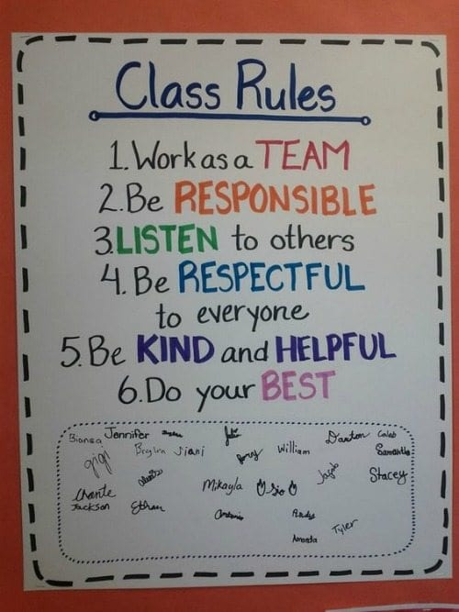
TES (no date) |  | We are Teachers (2023)
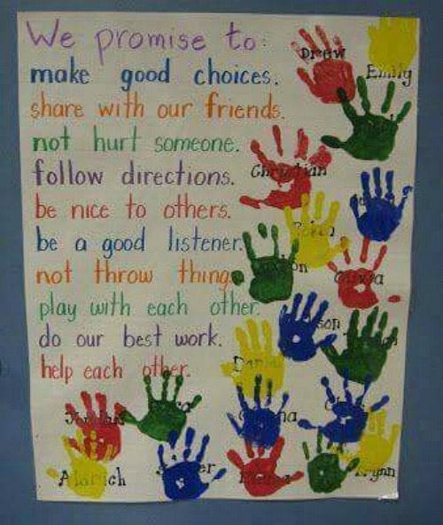 |  |  |  | 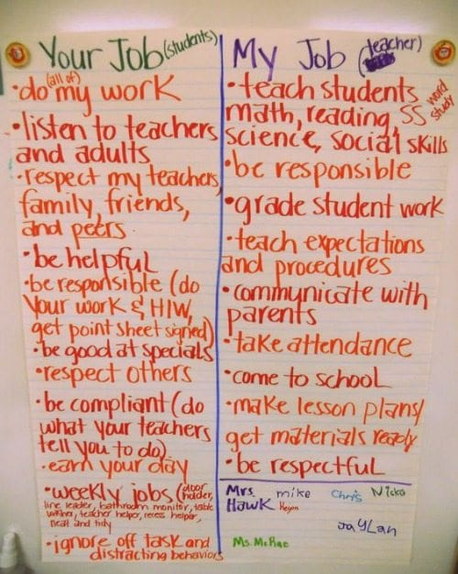
We are Teachers (2023) |  |  |  | We are Teachers (2023)

3

Examples of Good Practice

Bronylls School, Powys
Reducing Challenging behaviour through positive management
https://www.estyn.gov.wales/effective-practice/reducing-challenging-behaviour-through-positive-management-strategy

Heronsbridge School
Managing Behaviour
https://www.estyn.gov.wales/effective-practice/managing-behaviour

4

Useful Resources/Links

Positive Behaviour Manaement
National Education Union (2023), ‘Positive Behaviour Management’ Guide.
Available at: https://neu.org.uk/sites/default/files/2023-04/NEU2949W%20Positive%20behaviour%20management%20BILINGUAL.pdf

Specific Behaviour Praise - Survey
A Comparison of Two Group Contingencies on Teachers’ Use of Behaviour-Specific Praise. Journal of Behavioural Education
https://doi.org/10.1007/s10864-020-09366-6

Welsh Government
Practical approaches to behaviour management in the classroom. A handbook for classroom teachers in primary schools.
https://www.gov.wales/sites/default/files/publications/2018-12/practical-approaches-to-behaviour-management-in-the-classroom-a-handbook-for-classroom-teachers-in-primary-schools.pdf

Equality Human Rights
Guidance – Reasonable Adjustments for disabled pupils in England
https://www.equalityhumanrights.com/sites/default/files/guidance-reasonable-adjustments-for-disabled-pupils-in-england_0.docx

5

TASK – Modelling Ideal Behaviour
Desired Behaviour | How can you model  the desired behaviour | How could your pupils model  the desired behaviour
Respecting others

Resolving conflict

Listening to others

Welsh Government (2012)

6

REFERENCES

Chaylor and Mads (2020) ‘Classroom Rules & Expectations Examples’. Available at: https://chaylorandmad.com/classroom-rules-and-class-expectations/ (Accessed: 1 March 2024).
Eaves, A. E., Radley, K. C., Dufrene, B. A., Olmi, D. J., & Bernard, L. E. (2021). A Comparison of Two Group Contingencies on Teachers’ Use of Behaviour-Specific Praise. Journal of Behavioural Education, 30(2), 226–246. Available at: https://doi.org/10.1007/s10864-020-09366-6 (Accessed: 2 March 2024).

Equality Human Rights (no date) ‘Guidance – reasonable Adjustments for disabled pupils in England’. Available at: https://www.equalityhumanrights.com/sites/default/files/guidance-reasonable-adjustments-for-disabled-pupils-in-england_0.docx (Accessed: 1 February 2024).
Estyn (2014) ‘Heronsbridge School - Managing Behaviour’ Effective Practice. Available at:https://www.estyn.gov.wales/effective-practice/managing-behaviour (Accessed: 3 March 2024).
National Education Union (2023), ‘Positive Behaviour Management’ Guide. Available at: https://neu.org.uk/sites/default/files/2023-04/NEU2949W%20Positive%20behaviour%20management%20BILINGUAL.pdf (Accessed: 2 March 2024).
TES (no date) ‘ Classroom Rules/Housekeeping/Behavior Management’ Image. Available at: https://www.tes.com/en-au/teaching-resource/classroom-rules-housekeeping-behaviour-management-displays-12969983 (Accessed: 1 March 2024).
We are Teachers (2023) ’19 Classroom Management Anchor Charts’ Images. Available at: https://www.weareteachers.com/classroom-management-anchor-charts/ (Accessed: 1 March 2024).
Welsh Government (2012) ‘Practical approaches to behaviour management in the classroom. A handbook for classroom teachers in primary schools. Available at: https://www.gov.wales/sites/default/files/publications/2018-12/practical-approaches-to-behaviour-management-in-the-classroom-a-handbook-for-classroom-teachers-in-primary-schools.pdf (Accessed:27 February 2024).

7
Part 2 Powerpoint slides

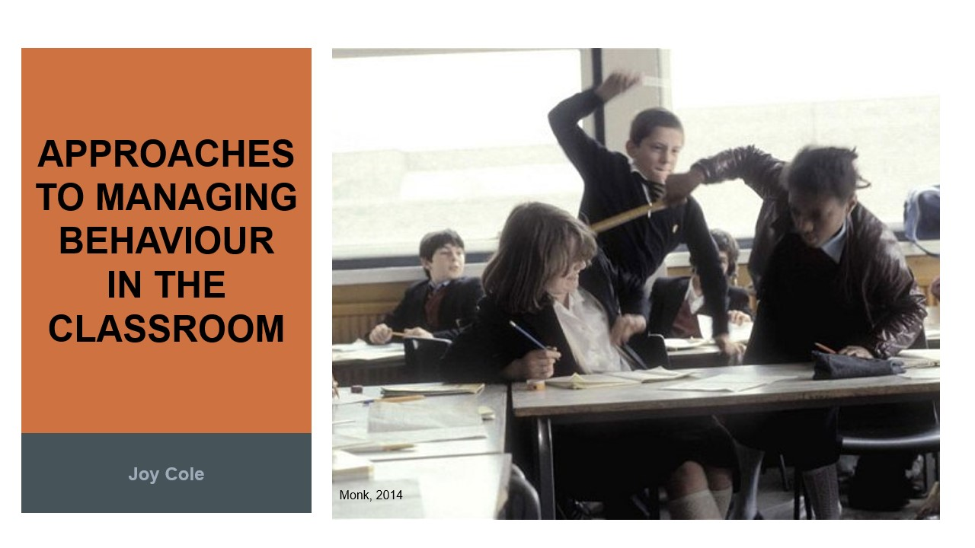
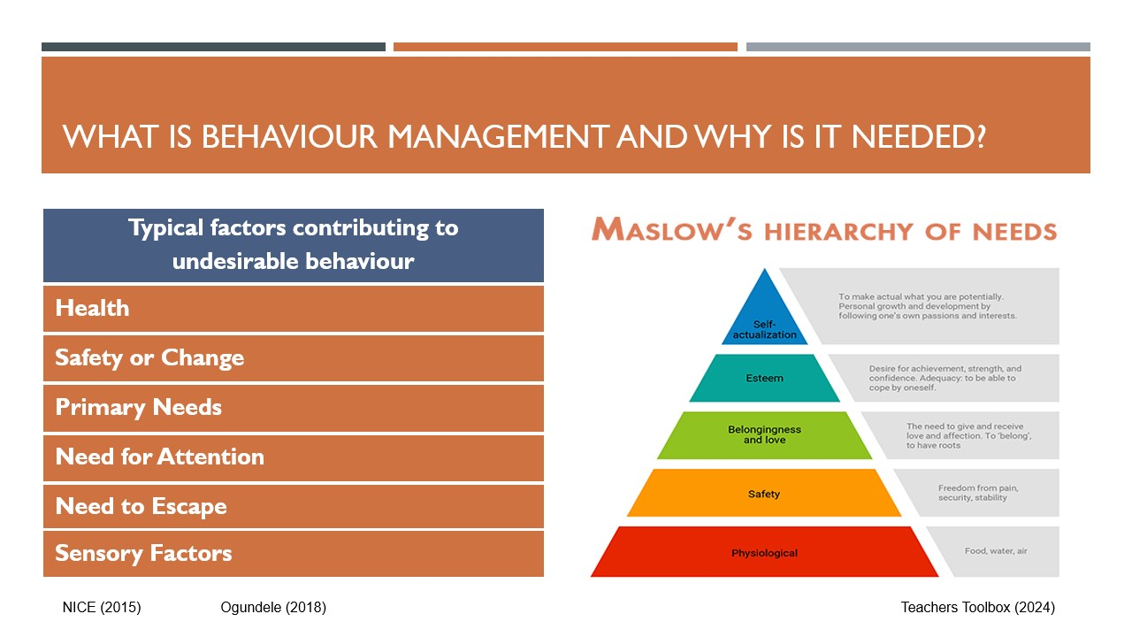
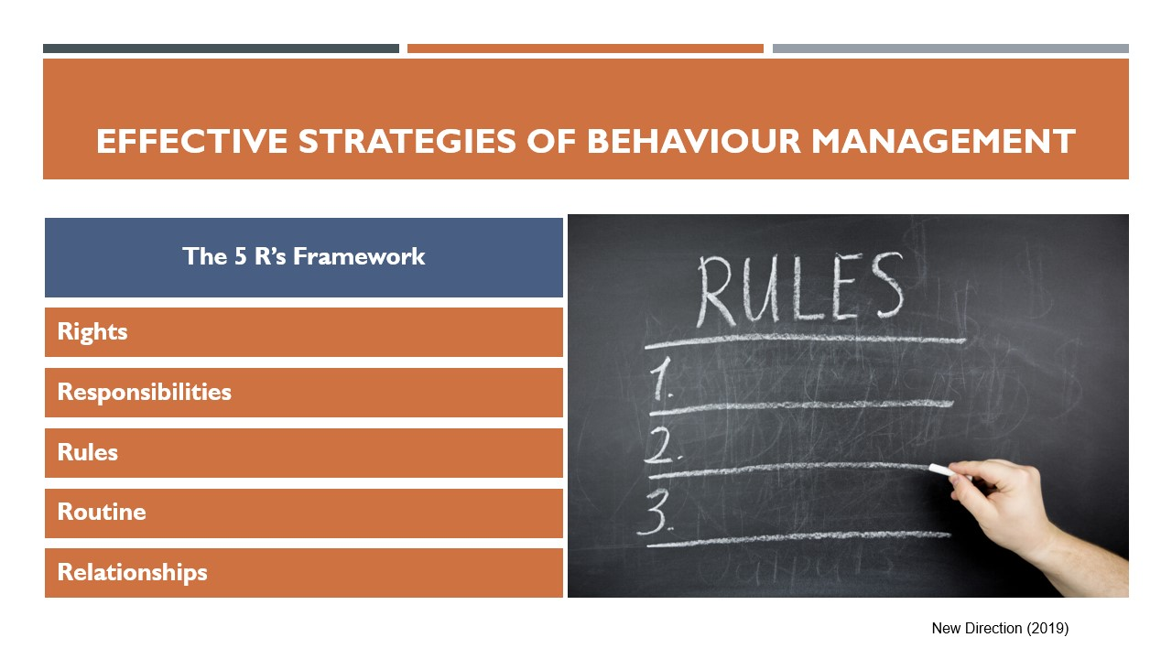

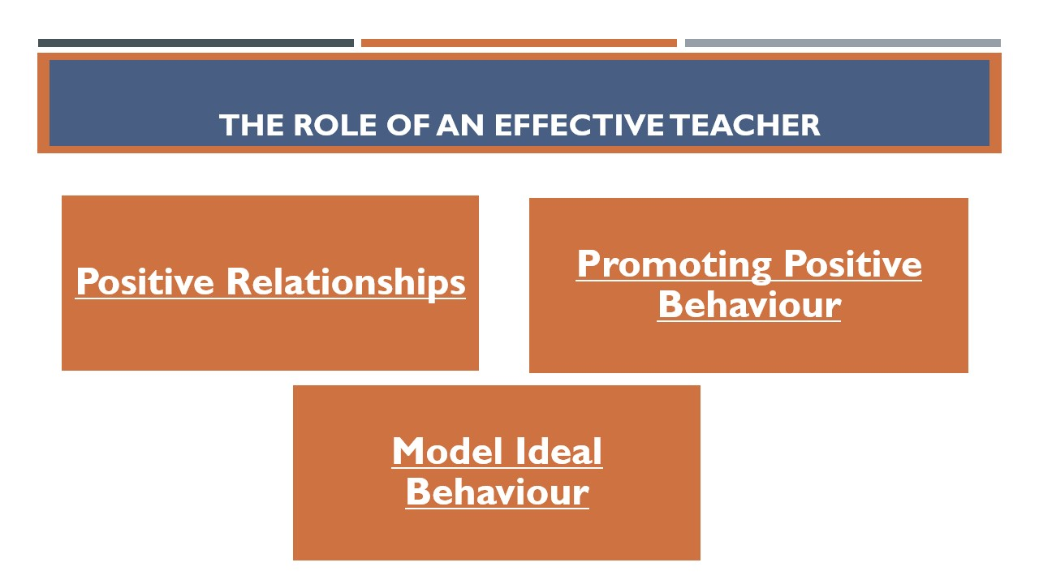

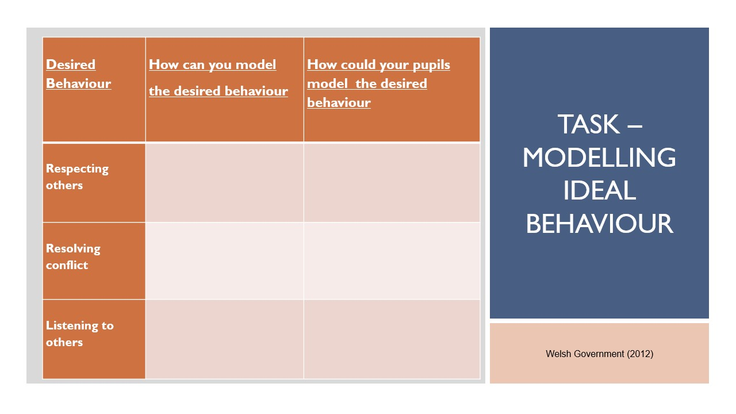

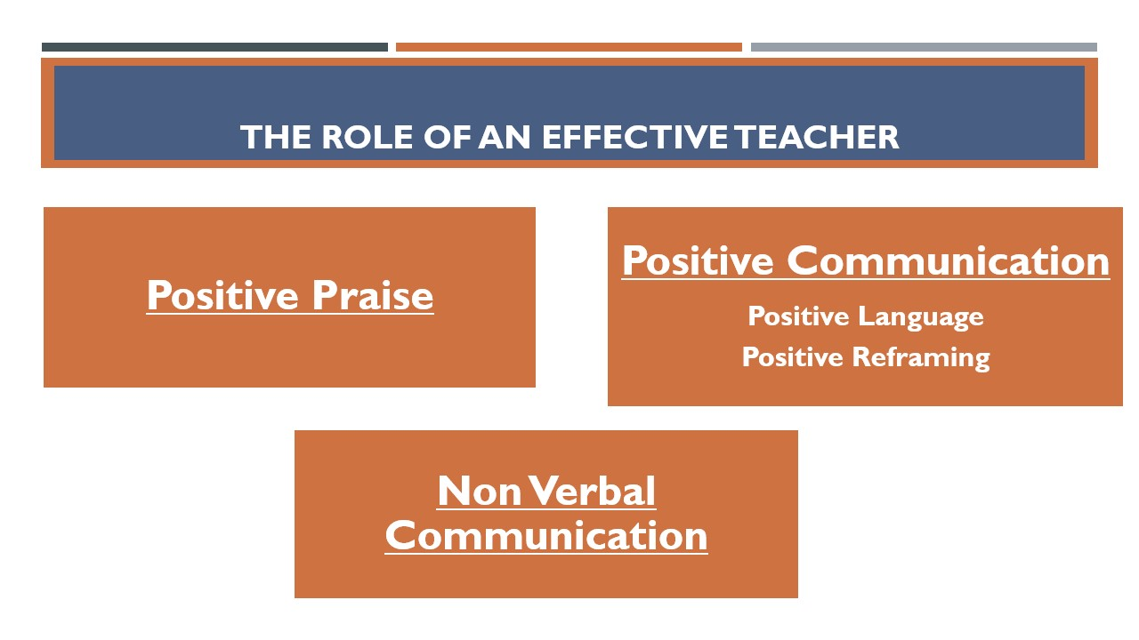

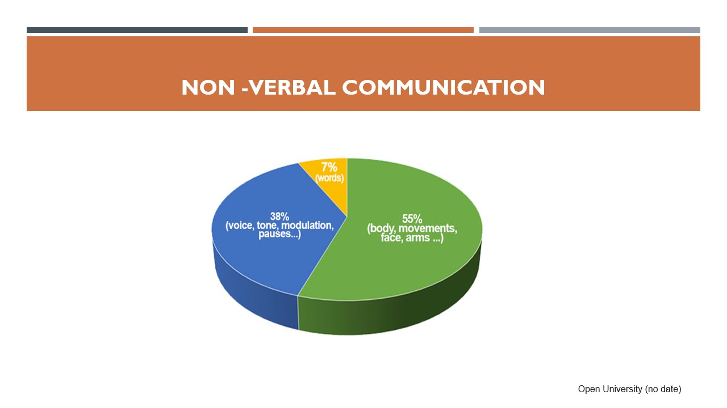

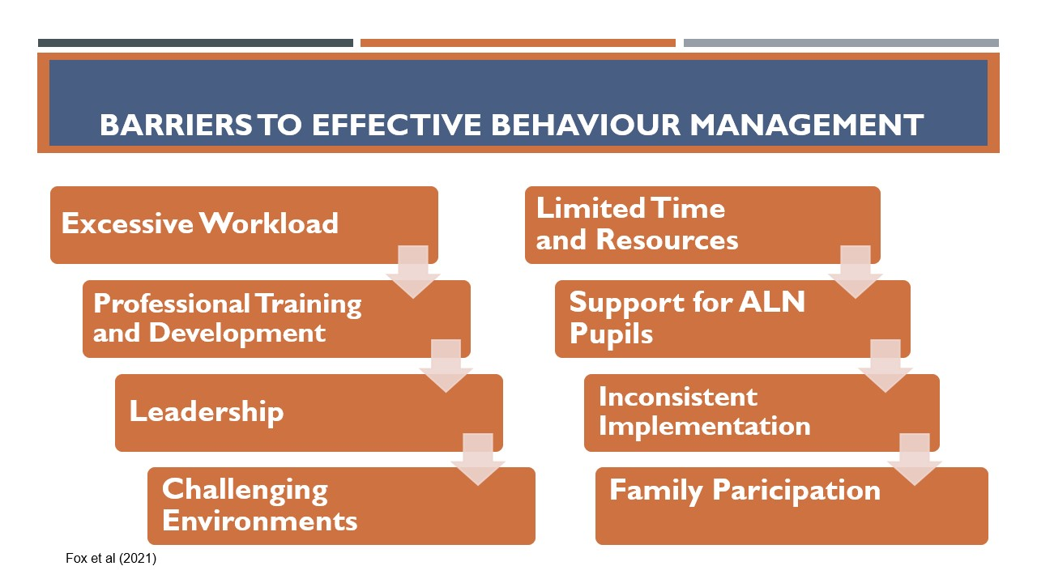

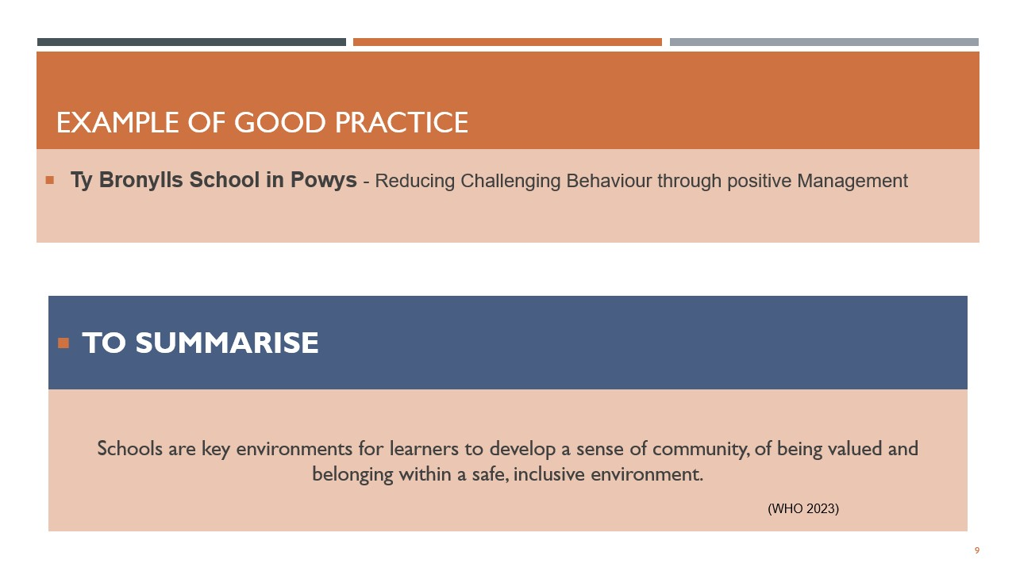

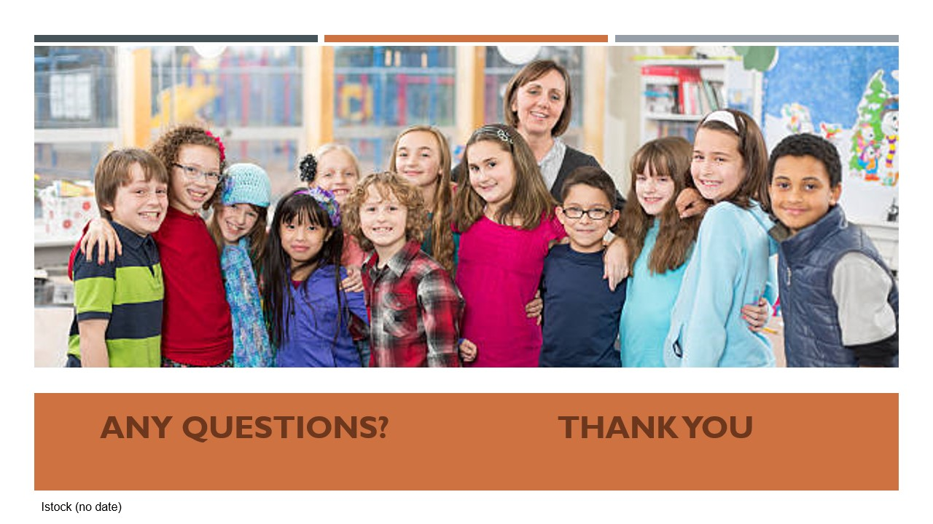

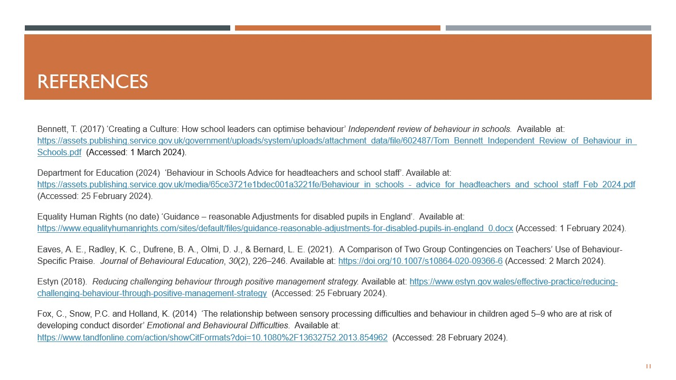
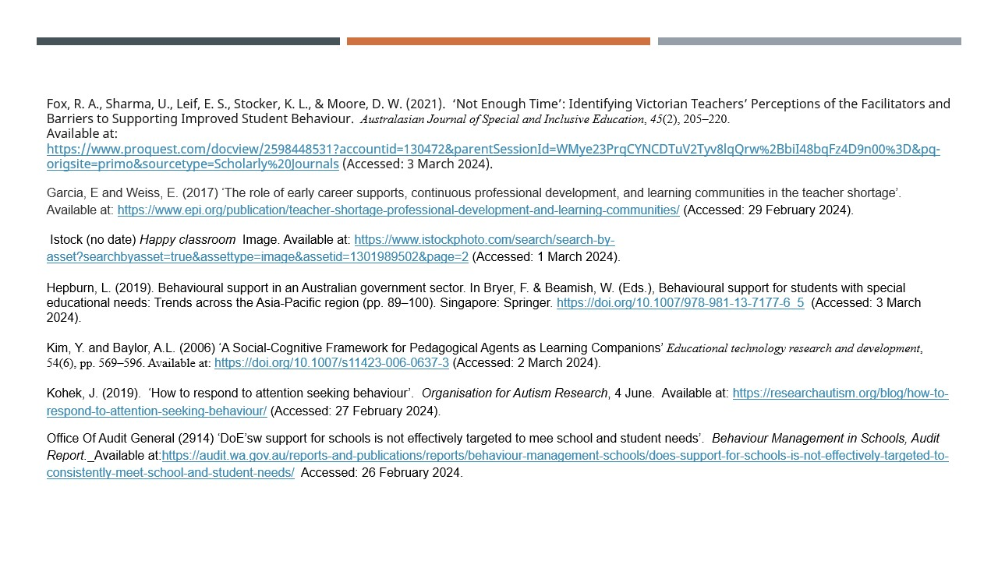
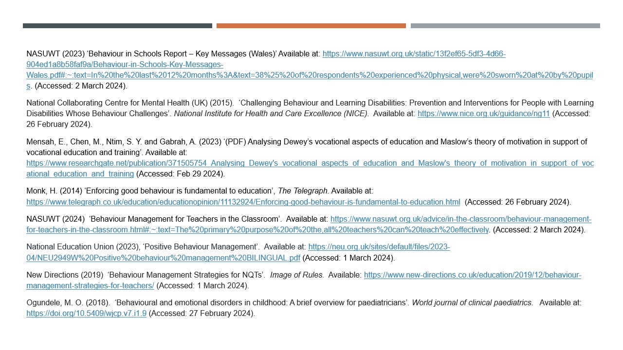
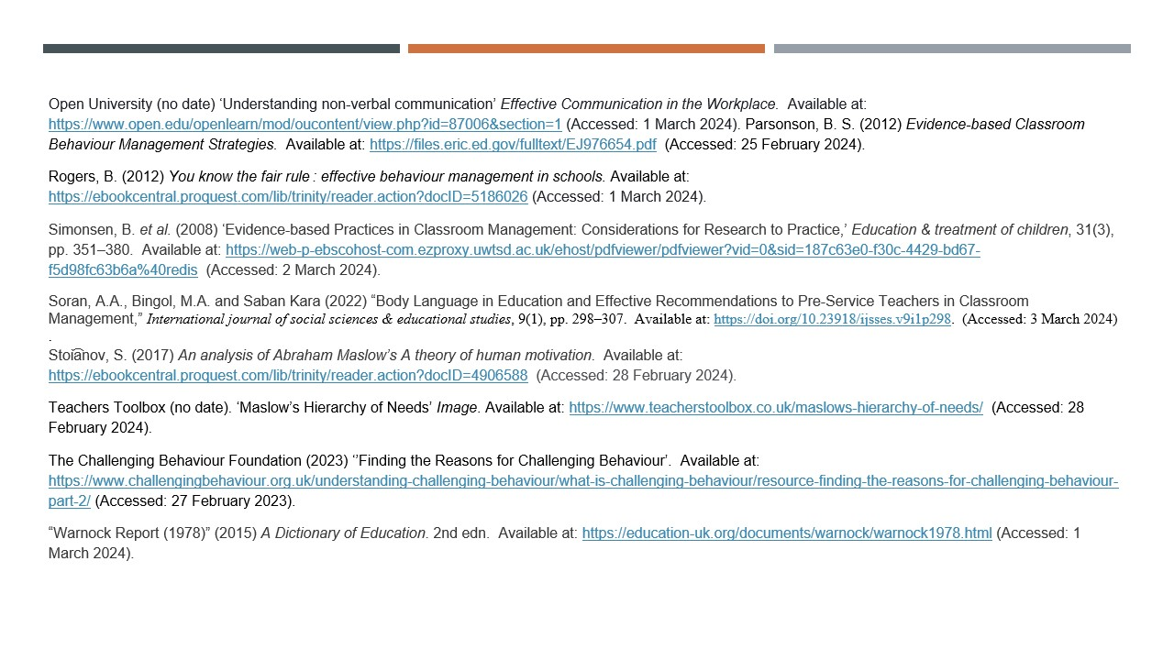
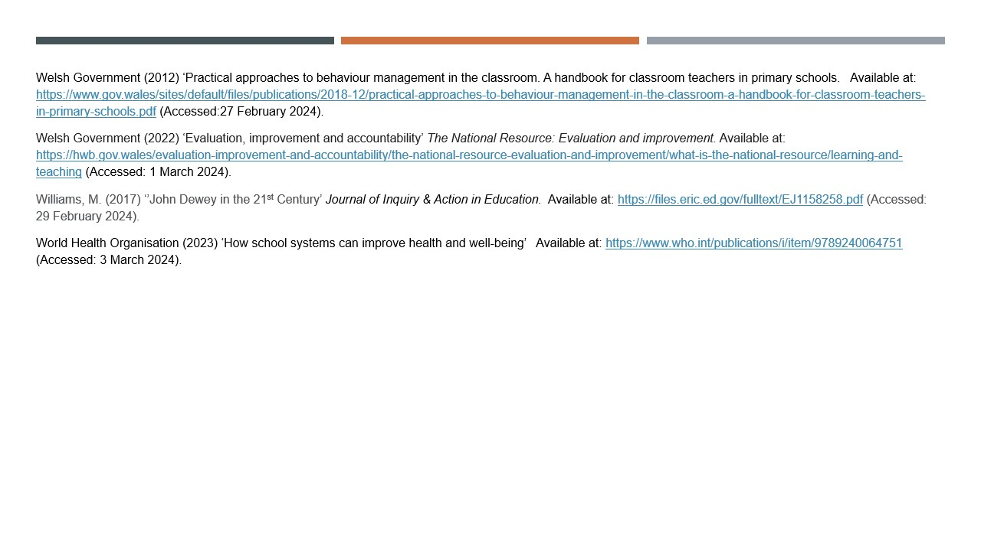

Link to the Powerpoint Slides

Behaviour Management Presentation no transcript (1).pptx

Part 3 - Link to presentation recording.
New channel meeting-20240304_143801-Meeting Recording.mp4

