Chapter 4: Research Analysis

4.1 Introduction
The aim of the primary research was to fulfil the following objectives through the completion of surveys and interviews:
- To gain an understanding of what prevents women from reporting sexual offences to Police
- To make recommendations on how women can be encouraged to report sexual offences to Police.
The survey response target according to the methodology chapter was approximately 20 participants, however due to responses through social media there have been 73 participants, which ensures for a far more detailed and fair response, as the 73 respondents are more likely to represent the general population compared to 20 respondents. The survey response allowed the first objective to be fulfilled as will be documented below. One fault in the surveys completed which I am now acutely aware of is the lack of questions regarding the respondents themselves, such as age, gender, ethnicity etcetera. which should have substantiated that the responses were provided by a sample that reflect the general population (Fink, 2003). This would’ve also clarified where certain people types such as the above might have had certain experiences or views.
Following the surveys, two interviews were completed, one with a male response officer, and one with a female detective. The responses from these interviews fulfilled the second objective as the respondents were able to suggest recommendations to improve the investigation process, thus improving the prosecution rates. This should in turn encourage sexual offence victims to report incidents when they occur.

4.2 Analysis of Surveys
To open the survey, participants were asked the below question, which refers directly to the first objective. Parti and Robinson (2021) document in their journal that the fear of being blamed is the most likely reason preventing victims from reporting sexual offences to Police, whereas the primary research below documents that this is the fourth most likely reason, with 21 of the responses choosing this option. In fact, participants responded that the fear of not being believed might be far more likely to prevent a person from reporting an incident to Police. The London City Hall review by Clare Waxman also discusses the emphasis placed on victims and their account compared to suspects, which supports the concept that victims are not being believed in the first instance (London City Hall, 2021), which reflects the below survey answers.

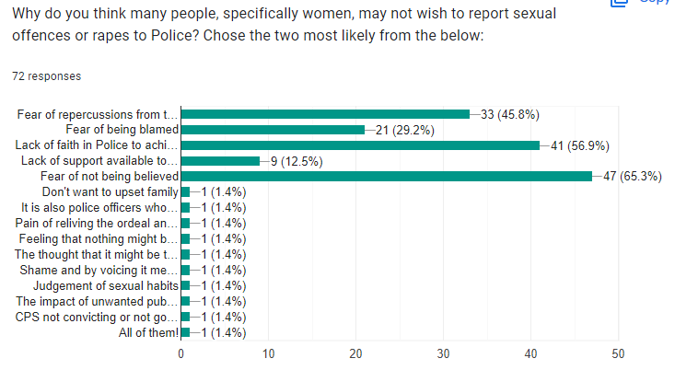

When asked what consequences victims face when reporting sexual offences or rapes, the respondents were able to provide individual answers (see Appendix A, Q4). Many respondents stated that the court process, the length of the investigation, the lack of evidence leading to no prosecutions, and the responsibility on the victim to share and re-live difficult experiences might impact their likelihood to report these things to Police. This reflects W. David Allen’s article on the under-reporting of rape, where he describes the legal process as arduous and openly hostile (Allen, 2007). Harvey et al also state a reason for the under-reporting of rapes in many cases is due to a lack of successful prosecutions, which is again evidences in the primary research responses noted above.
Following this, respondents were asked about their knowledge of the support available to victims, and the impact this might have on their likelihood to report incidents to Police (see Appendix A, Q6 and Q7). Most respondents reported that they had extremely limited knowledge regarding this, with some respondents stating that they knew of websites such as ‘RapeCrisis.org’ and ‘Women’s Aid’, whilst some who stated they had experience as victims stated they received no support, and others stated they were fully supported. When asked what impact this would have on their likelihood to report however, 55.6% of respondents stated the support available would have no bearing on their likelihood to report incidents to Police (see below image).
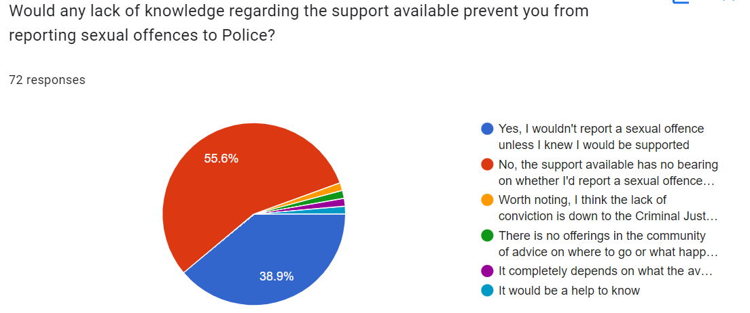
The Victim Support website (Victim Support, 2022) describes much of the support available to sexual offence victims, showing that there is in fact plenty of support available. However throughout the research completed in the literature review, there was little to no reflection on the availability of support’s impact on victims. Thus, this primary research has been completed, which documents an even divide. However, perhaps further awareness of victim support may encourage victims to report incidents, given that almost half of the respondents stating that they would require evident support in order to report incidents.

4.2 Analysis of Interviews
Given that both the primary and secondary research indicated that the lack of successful prosecutions deters victims from reporting sexual offences and rapes to Police, two officers (one response officer and one detective) were interviewed to gain an understanding of why this is occurring and how it can be prevented.
When asked what the major issues within the investigation process were (see Appendix B and 3, Q2), the interviewees provided answers such as victim withdrawal due to the length of the investigation or intimidation by the offender or court process. The government review by George and Ferguson (2021) aligns with this, by stating that victim withdrawal, evidentiary issues and partnership/resourcing issues are the main reasons behind the attrition rates. Respondent 1 (the response officer) also stated that communication issues with the CPS make the process increasingly difficult due to the lack of direct contact (see Appendix B, Q12). This correlates with an article released by the BBC where finger-pointing between the Police and CPS was discussed (Jackson, 2021). From a Police perspective, it appears that the lack of communication from the CPS makes the investigation process unnecessarily difficult, and the blame is laid on the CPS. On the other hand, respondent 2 (detective) stated that some CPS lawyers are extremely helpful and provide contact details in order to facilitate better communication (see Appendix C, Q9). Respondent 2 did, however, state that this made the whole investigation process far easier, as the CPS can be approached regularly for advise and investigation direction.
Both respondents commented on the lack of resources to respond to and carry the investigations (see Appendix B, Q6 and Q10 and Appendix C, Q8), stating that despite officers not intentionally neglecting cases, they may spread themselves so thin that not all cases can be prioritised. Respondent 2 stated that she was carrying 14 cases over 31 occurrences at the time of the interview, and it was difficult to progress each one as often as she would like. This again relates to the above research by George and Ferguson, where it was stated that lack of resourcing plays a large part in the high attrition rates in RASSO cases.
The respondents were asked several questions on potential improvements that could be made throughout the investigation and prosecution process, and the responses were varied. Respondent 1 suggested the training of further SOLOs (Sexual Offence Liaison Officers), and taking response police officers out of the equation when it comes to dealing with sexual offences, whereas Respondent 2 suggested providing response officers with more training to be able to deal with sexual offences adequately in the first instance (see Appendix B, Q2 and Q6, and Appendix C, Q4, Q9 and Q10). Further to this, Respondent 2 suggested that further resources on CID/Rape Investigation Teams to carry out the investigations more efficiently and in effect, spread the burden would assist in resolving cases more quickly, thus reducing the likelihood of victim withdrawal. When completing the secondary research, it was evident that despite authors clarifying the issues with the process, there was a distinct lack of recommendations for improvement, therefore the above recommendations do not necessarily link with any other literature already reviewed.

~ 1252 words

Bibliography
Fink, A. (2003) in How to sample in surveys. Thousand Oaks: Sage, pp. 1–2.

