BMIH5005
Personnel Resourcing and Development

Student name:Florin Nitu Lecturer name:Scott James
Student ID number:2240772 DATE:07-05-2024

Table of Contents
Essay 2
Proposal 12
1. Introduction 13
2. Discussion 15
2.1 PESTLE analysis 15
2.2 Industry Trends 16
2.3 Emergence of Different Work Modes 17
2.4 Industry examples 18
3. Evaluation and Conclusion 19
References 21
Appendix 24

Essay
An essay on the evolution of Human Resources Management (HRM) facilitates the strategic development of an international hotel brand through workforce planning, recruitment, and selection
Introduction
The development of HRM, Human Resource Management, which is a core part of the strategic development of such international hotel brands as Marriott, plays a key role in this hotel brand's continued existence. The subject of HRM in 2004, workforce planning becomes more important, because it shifts personnel with company values (Dessler, 2020). Thorough workforce planning by Marriott will need skills, the advance and succession of personnel, and the whole workforce requirements to ensure all this can be done timely. Implementation of recruitment and selection processes will also fall on part. To facilitate the continuous evolution of its HRM, Marriott resorts to modern recruitment strategies which enable them to hire the best employees in every region in the world. With the help of technology and leading social media platforms available, Marriott can access a diverse candidate pool which is the best way to overcome some of the biased issues that may affect some minority groups. In turn, this will achieve inclusion and cultural diversity within the workforce (Ahammad, Glaister and Gomes, 2019).
Discussion of the body
In addition, globally standardized selection processes help Marriott identify individuals not only with the required skills but those who are also in tandem with the organization’s values and overall purpose, thus creating a harmonious organizational culture, that then transcends international boundaries. Generally, though, Marriott's HRM evolution is a strategic step that empowers the brand to grow by putting the right people to do the job that leads to the company's growth, maintains service excellence, contributes to the brand's reputation as a top international hotel that entices guests from all parts of the world (Dessler, 2020).
The development of Human Resource Management (HRM) is noteworthy for a slew of timespans with shifts in organizational goals/agendas, societal norms, and technological advancements. In the beginning, HR managers were very involved in the tedious administrative work such as coverage for payroll, tax compliance, and employment records. Nevertheless, the second function it performs today is to fit sources of human capital with the objectives of the organization and thereby aim for business excellence. At first, HRM was reacting almost to demands and controlling with four main functions: personnel management and labour relations. (As far as this issue is concerned), study have put the main stress on the candidate’s compliance with labour laws and acts as well as his abilities in grievance management (Ahammad, Glaister and Gomes, 2019).
But when HRM started to foresee its staff as a strategic point, it changed in such a sense that it became a more proactive approach. The shift towards strategic people management which is known as strategic human resource management (SHRM) is the great transformation in the HRM. For SHRM (Society For Human Resource Management), HR sides with organizational strategy to the extent that all the employees' aspects of their work, efficiency, and other results, logically fit into the business objectives. This refers to establishing competencies lists and job descriptions and adopting a set of strategies for staffing, talent management, and performance management that are tailored to the company’s objectives (Chelladurai and Kim, 2022)
Moreover, the point of HRM is essentially moving away from employee engagement and the introduction of concepts of development. Today, human resource management theories mainly focus on making work-related decisions that support the atmosphere and employee behaviour, positively motivate them, and provide chances for training and career advancement. There are many other methods, however such as people creation of training and development programs, and feedback systems, and there are other measures of recognition and rewards. In addition, technology has been the catalyst for a major paradigm shift in HRM practices. Through automation and digitalization, administrative work has become breezy, leaving much more time for HRs to engage in strategic activities (Al-Swidi, Gelaidan and Saleh, 2021).
Furthermore, HR (human resources) departments can use data analytics tools to guide their recruitment, talent management, and employee engagement agenda. To conclude HR evolution has moved from just administration responsibility to the business role’s success charter holder. HRM is an integral part of the business as it aligns human capital in line with the business objectives, is comprised of employee engagement and development, and leverages advanced technology which all together are the driving forces of today's dynamic business environment (Chelladurai and Kim, 2022).
Human resource functions are at the heart of Marriott's planning strategic workforce and they are expected to drive the workers into the organization's mission as part of its long-term plan. Through evaluating the present and future needs of the business, HR managers from Marriot determine which positions require retraining, who can be considered for potential promotions, and which employees can be recruited for the development of their skills (BISWAJEET, 2020). All the workforce planning plans including the future staffing needs, correlating them with market forecasts and expansion plans would be done thoroughly at Marriott. Thus, it will be equipped with the appropriate talent that will drive growth and ensure that there are no lapses in the service they provide at any of their hotels worldwide. By adopting such a strategic approach, Marriott Inc. is able not only to address issues but also to look ahead to future challenges and prepare for them, which, in turn, will ensure company prosperity in the competitive hospitality industry (Al-Swidi, Gelaidan and Saleh, 2021).
The role of the HR department at Marriott is focused on nurturing young and bright individuals who will enhance the company's capacity for innovation and growth. Marriott harnesses both new technology (including digital platform(s) and diverse talent pools) to provide next-generation recruiting with a result of hospitality professionals who exhibit shared core values and devotion to quality (Bratton et al., 2021). In addition, Marriott has put solid training and development programs in place for talent management and champions internal growth that would enable employees to climb up the corporate ladder for professional advancement and skills development. Through promoting a climate of continuous learning, professional development is increased, making the workforce more competent and employees more loyal and committed to their work, which in turn pushes high employee engagement and retention (Bratton et al., 2021).
A clear depiction of the role of employee engagement and culture in workforce management and their effects on productivity as well as creating a harmonious workplace setting in Marriott is well covered. HR processes within Marriott strive constantly to create an environment where people feel that they belong to a team, are recognized for their efforts, and feel encouraged to continue their work the best way they can. In the leadership of contributions like the employee accolade programs, wellness initiatives, and diversity and Marriott provides a stage for the employees’ belonging and sense of pride. Marriott's emphasis on employee engagement and fostering a robust company culture is a feasible way of both improving employee satisfaction and performance and gaining the image of the preferred employer in the hospitality sector (BISWAJEET, 2020).
The process of strategic HR planning at Marriott starts with the short-term forecasting of labour demand and supply as they are integral to the overall process. Marriott is operating in a competitive and dynamic worldwide industry, where the changes in demand and the shift of market are the result of different causes like economic factors, seasonal trends, and competition. To have the HR team management that will work with the business objectives, Marriott relies mainly on modern forecasting methods to predict the future manpower supply and demand. It requires among others looking into historical data, the trend of the market, and the business projections to predict the demand for labour across the different departments and the locations of the business (Anwar and Abdullah, 2021).
For instance, during a busy season such as the summer one or when opening a new property, Marriott will probably face a great need for their front-line staff, i.e. housekeepers, front desk agents, and food service personnel. As an example, employers may find themselves decreasing their labour demand during economic recessions or periods of low occupancy rates, so they will have no choice but to adjust staff levels by adopting more economical practices to bring down costs. Addressing the concerns of labour demand and supply, Marriott will be able to take measures ahead of time and prevent operation disruptions, ensure high service quality, and attract more guests, consequently, debunking the notion that the presence of the hotel can harm the local population.
Subsequently, Marriott’s HRM section executes short-term planning for the labour demand and supply and outlines the strategies to match human capital initiatives with the organization’s long-term objectives. This means interacting with decision-makers in all departments in terms of setting strategic priorities and specifying the Human Resources objectives of the company and targets that move its strategy along. For instance, should Marriott strive for an increased presence in developing markets or develop its digital prowess, then the criteria for success will be hiring and developing a skilled workforce with the required language proficiency or suitable digital proficiency (Vulpen, 2019).
On top of that, providing special targets intended to boost the levels of engagement, retention, and diversity will finally result in the betterment of the workers’ working environment and consequently, enhancement of the hotel’s competitiveness within the industry. Through its goals and HR objectives, Marriott sets a target and establishes a focal point, which in turn directs all the resources so that the efforts are in line with the company’s strategic priorities. In addition to this, Marriott is now able to realistically benchmark their performance and make pertinent decisions based on data which will not only help them track their performance but also make better plans for success (Vulpen, 2019).
After laying out the goals and framework for attainment, the human resource team focuses on the execution of the initiatives and the appraisal process to track the programs' performance and effectiveness by using evaluation methods. That is why it is involved with issuing the most suitable programs and interventions by design and implementation which are related to the detailed workforce’s requirements and the aims of the strategic manager. One illustration is that Marriott can run the recruitment program, especially targeting equality-minded candidates. Further, it can provide training to skill or develop employees and establish systems of performance management that will encourage employees to work on their growth while still aligning with organizational objectives (Bratton et al., 2021).
Throughout the implementation steps, the HR department of Marriott monitors the critical factors receives feedback from the key individuals and performs evaluations to determine the impact of the performed HR programs on the business performance. Marriott can monitor metrics like employee turnover rates, employees' productivity levels, and customer satisfaction scores to measure the results of its HR interventions, detect an issue, and make the needed amends to the optimal outcome. What’s more, the assessment process is ongoing. It lets Marriott HR react to changing market conditions and implement new trends, keeping practices of HR strategy relevant and effective in the growing market (Anwar and Abdullah, 2021).
Conclusion
Marriott has been using a strategic HR planning process in a way to dedicatedly maintains its strength in the workforce for sustainable business success. Through labour predicting and categorizing, setting objectives, and implementing the programs it supports, Marriott ensures alignment between human resources and business strategy. Marriott is a company that always keeps changing, as usual evaluating and adapting, staying agile, and well-positioned to face the changing environment and not only be the same in the global field of hospitality but also compete with other companies. To conclude, with the help of HR planning, Marriott can hire the best personnel that the field has to offer, effectively train them, as well as keep them satisfied enough so that they do not switch jobs, thus, improving guests’ experience, which, in turn, causes the organization’s reputation to grow.

References
Ahammad, M.F., Glaister, K.W. and Gomes, E. (2019). Strategic agility and human resource management. Human Resource Management Review, 30(1), p.100700. doi:https://doi.org/10.1016/j.hrmr.2019.100700.
Al-Swidi, A.K., Gelaidan, H. and Saleh, R.M. (2021). The joint impact of green human resource management, leadership and organizational culture on employees’ green behaviour and organisational environmental performance. Journal of Cleaner Production, [online] 316(1), p.128112. Available at: https://www.sciencedirect.com/science/article/abs/pii/S0959652621023301.
Anwar, G. and Abdullah, N.N. (2021). The Impact of Human Resource Management Practice on Organizational Performance. [online] papers.ssrn.com. Available at: https://papers.ssrn.com/sol3/papers.cfm?abstract_id=3824689.
BISWAJEET, P. (2020). HUMAN RESOURCE MANAGEMENT, Sixth Edition. [online] Google Books. PHI Learning Pvt. Ltd. Available at: https://books.google.com/books?hl=en&lr=&id=Lif4DwAAQBAJ&oi=fnd&pg=PP1&dq=human+resource+management+&ots=UZcS8e71XG&sig=m8PtvBARw5QbWmGM5S9wB6sWJp8 [Accessed 2 May 2024].
Bratton, J., Gold, J., Bratton, A. and Steele, L. (2021). Human Resource Management. [online] Google Books. Bloomsbury Publishing. Available at: https://books.google.com/books?hl=en&lr=&id=GphcEAAAQBAJ&oi=fnd&pg=PR6&dq=human+resource+management+&ots=2PoxaLM8KH&sig=hZFXWw4rD1tpcbqXZq7fzYCRpkk [Accessed 2 May 2024].
Chelladurai, P. and Kim, A.C.H. (2022). Human Resource Management in Sport and Recreation. [online] Google Books. Human Kinetics. Available at: https://books.google.com/books?hl=en&lr=&id=dydPEAAAQBAJ&oi=fnd&pg=PR1&dq=human+resource+management+&ots=gHK9ixvVq5&sig=Na58XVzx_v6CrckFXosGy_ly52M
Collins, C.J. (2021). Expanding the resource based view model of strategic human resource management. The International Journal of Human Resource Management, 32(2), pp.1–28. doi:https://doi.org/10.1080/09585192.2019.1711442.
Dessler, G. (2020). Fundamentals of human resource management. [online] thuvienso.hoasen.edu.vn. Pearson. Available at: https://thuvienso.hoasen.edu.vn/handle/123456789/12641.
Fawehinmi, O., Yusliza, M.Y., Mohamad, Z., Noor Faezah, J. and Muhammad, Z. (2020). Assessing the green behaviour of academics. International Journal of Manpower, 41(7), pp.879–900. doi:https://doi.org/10.1108/ijm-07-2019-0347.
Fuertes, G., Alfaro, M., Vargas, M., Gutierrez, S., Ternero, R. and Sabattin, J. (2020). Conceptual Framework for the Strategic Management: a Literature Review—Descriptive. [online] Journal of Engineering. Available at: https://www.hindawi.com/journals/je/2020/6253013/.
HRMS Software (2022). How HR System Enhances Organizational Efficiency. [online] Online HRMS Software. Available at: https://hr-software.weebly.com/blog/how-hr-system-enhances-organizational-efficiency [Accessed 2 May 2024].
Mio, C., Panfilo, S. and Blundo, B. (2020). Sustainable Development Goals and the Strategic Role of business: a Systematic Literature Review. Business Strategy and the Environment, [online] 29(8), pp.3220–3245. Available at: https://onlinelibrary.wiley.com/doi/abs/10.1002/bse.2568.
Mousa, S.K. and Othman, M. (2020). The impact of green human resource management practices on sustainable performance in healthcare organisations: A conceptual framework. Journal of Cleaner Production, [online] 243(1). doi:https://doi.org/10.1016/j.jclepro.2019.118595.
Tsalis, T.A., Malamateniou, K.E., Koulouriotis, D. and Nikolaou, I.E. (2020). New challenges for corporate sustainability reporting: United Nations’ 2030 Agenda for sustainable development and the sustainable development goals. Corporate Social Responsibility and Environmental Management, [online] 27(4), pp.1617–1629. doi:https://doi.org/10.1002/csr.1910.
Vulpen, E. (2019). The 12 Key Functions of Human Resources. [online] AIHR. Available at: https://www.aihr.com/blog/human-resources-functions/.
WorldAtlas (2019). Where Is The Headquarters Of Marriott International? [online] WorldAtlas. Available at: https://www.worldatlas.com/articles/where-is-the-headquarters-of-marriott-international.html.
Ge, X. (2020). Exploring factors of corporate social responsibility in luxury hotels: The case of Marriott Hotel. [online] wkuwire.org. Available at: https://wkuwire.org/handle/20.500.12540/403.
Neupane, R. and Khanal, T.R. (2022). EVALUATION OF THE IMPACTS OF TRAINING ON EMPLOYEE PERFORMANCE IN THE UK HOTEL INDUSTRY: AN ANALYSIS OF EMPLOYEES’ PERSPECTIVES AT MARRIOTT INTERNATIONAL. International Journal of Research -GRANTHAALAYAH, 10(3), pp.57–85. doi:https://doi.org/10.29121/granthaalayah.v10.i3.2022.4534.
Sanvitale, A. (2020). Corporate Social Responsibility in the Hotel Industry: a Study of Marriott International and Odyssey Hotel Group in Partial Fulfilment of the Requirements for the Degree of Bachelor of Arts. [online] Available at: http://arno.uvt.nl/show.cgi?fid=151914.
Zhang, X., Ma, C., Dong, X., Wang, Z. and Li, X. (2023). Spatio-temporal evolution and driving factors of international chain hotels’ transnational expansion: A case study of Marriott Hotel Group. World Regional Studies, [online] 32(1), p.31. doi:https://doi.org/10.3969/j.issn.1004-9479.2023.01.2021198.

Appendix
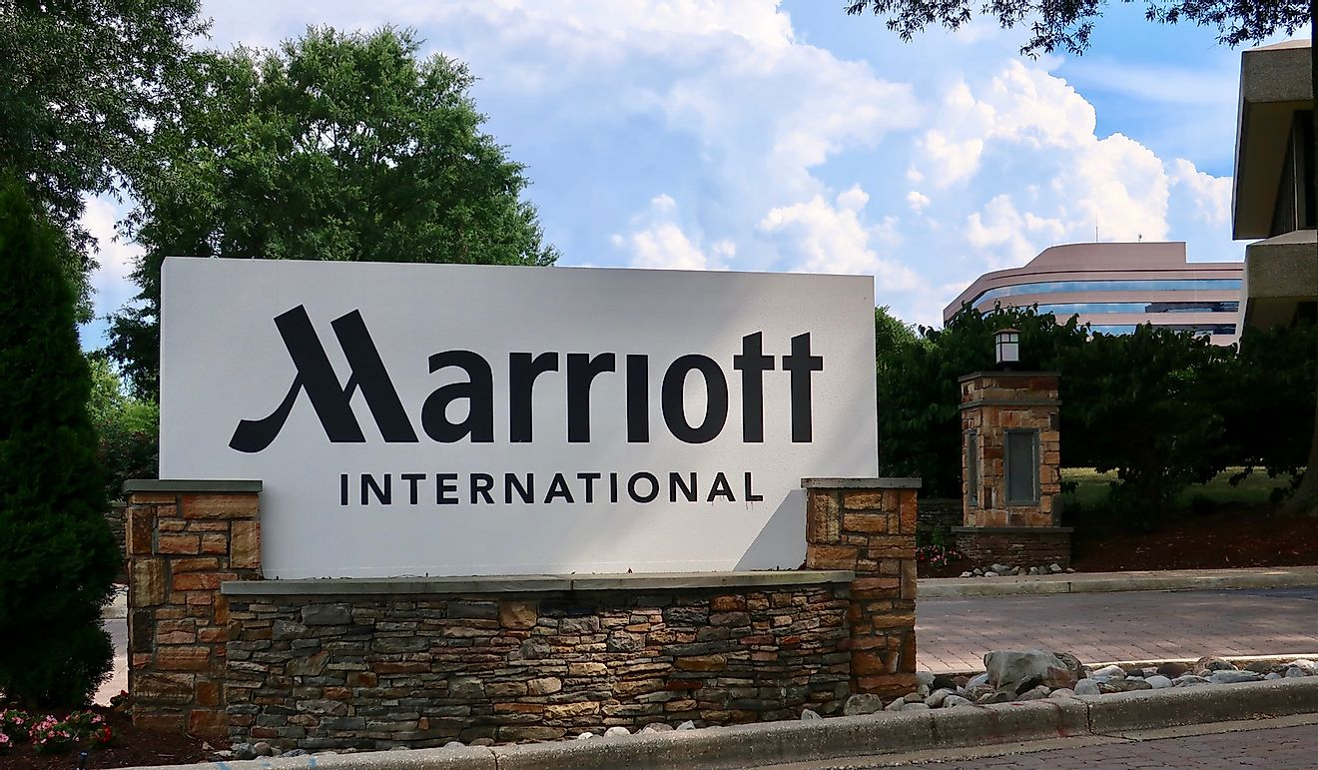
Appendix 1: Marriot
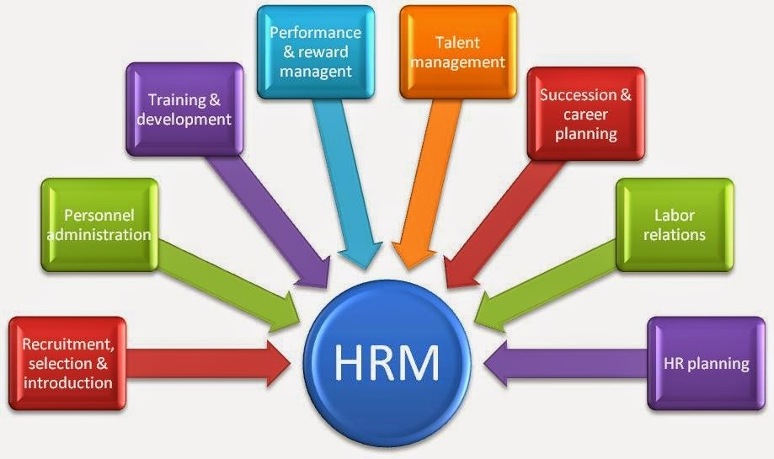
Appendix 2: HRM
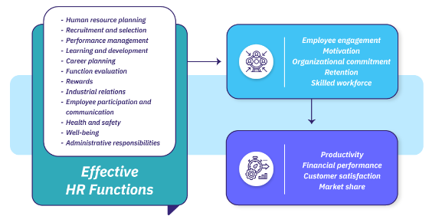
Appendix 3: HR functions

Proposal
A research project proposal on the impacts of socio-economic force on employees’ performance management and monitoring in different work modes: Hospitality HR’s perspective
Abstract
The study looks into the social-economic influence on staff performance management in hotels abroad, particularly at Hilton. Video conference systems, flexible work time formats, office time, and remote work are the four types of surveillance methods operating processes undergo. Study points to the necessity of advanced technologies, adaptability of work processes and care over staff as the key factors that define what is the most in productive terms. Opportunities for the future include expansion and upgrades in technology, encouragement to embrace flexible workplace demands, retouching performance management procedures, and giving priority to employees’ health to keep Hilton in a competitive edge and create good company culture.

1. Introduction
Hilton Background
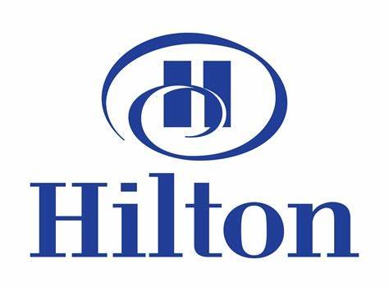
Figure 1: Hilton
Source: (Logo, 2020)
Hilton makes its mark as a worldwide brand in the hospitality sector, which is remarkable taking into account its unparalleled service and range of hotel and resort options. Over twenty-five hours of existence, Hilton has shown extreme incidence in transforming and fostering the needs of travellers globally. The company is proud of its innovative nature and its ability to give satisfaction to its customers, which has helped build its position as either the first or the largest player in the global hospitality market (Aguinis and Burgi-Tian, 2021).
Implementing Different Work Modes in the Hospitality Context
To keep pace with the changing scenario of modern work, the hospitality industry including Hilton took the initiative in implementing a few work modes that could be in line with dynamic employee needs and fulfil market demands. These modalities are a mix of hybrid working, standard offices as well and flexible work routines. Each mode opens unique opportunities and surprises, depicting its influences on performance management and control specifically (Aguinis and Burgi-Tian, 2021).
Examination of Employee Performance Management
In the hospitality industry, the performance management system is essential to provide the guests with the quality they need at the highest level, and the service provided satisfies their needs. Nonetheless, these different ways of working, make the management and supervision of employees' performance to be tricky due to the complexity and uncertainty they integrate. However, these dynamics can play vast roles that affect staff productivity and engagement, if managers know about this, then it becomes easier for them to manage the staff effectively (Aguinis and Burgi-Tian, 2021).
Identifying Current Issues
This project is dedicated to pinpointing the existing problems that impact the employee performance assessment of Hilton's hospitality employees. Such an investigation shall start with an explanation of how socio-economic issues get intertwined with various work patterns, and eventually, this will have an impact on employees, their motivation levels, and behaviours. Analysing these matters, Hilton HR will be able to make decisions about human management and improve practices that ensure cohesion (Islam et al., 2022).
Factors Impacting Employee Monitoring and Management
A myriad of social-economic aspects come into play in shaping the approaches to remote workplaces by affecting the ways employees are monitored and controlled. As for these components, they include economic conditions, technological advances, cultural norms and frequently changing organizational policies. The insight into a correlation between those factors is necessary for Hilton personnel working with performance management to develop suitable strategies and to support the right direction of Hilton as a whole (Kloutsiniotis and Mihail, 2020).
Examples of Different Work Modes
The work modes exemplification can be illustrated, by talking about hybrid work arrangements, in which workers divide their time among two locations, traditional offices with fixed working hours and locations, and flexible work schedules that enable workers to customize their hours and location based on their personal choice or necessity of the company. Under each type, some peculiarities and dissimilarities will arise that will be taken care of by individualized strategies for keeping employees in check (Islam et al., 2022).

2. Discussion

2.1 PESTLE analysis
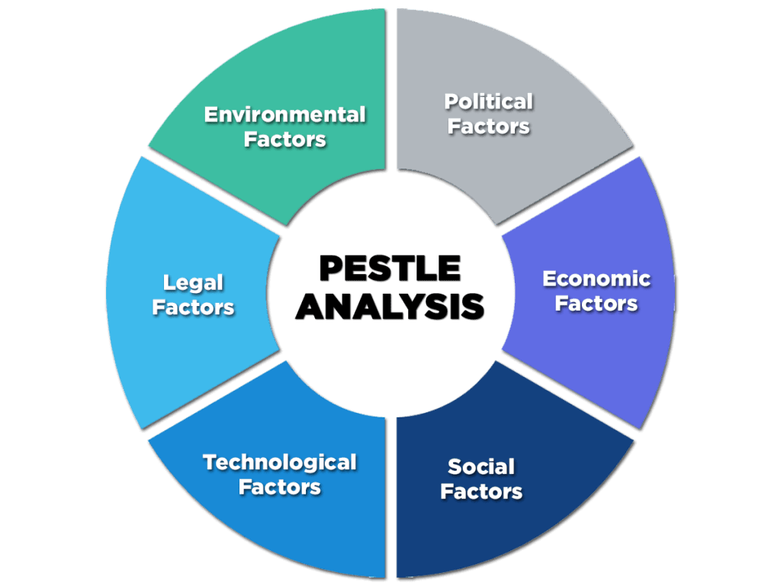
Figure 2: PESTLE analysis
Source: (Gandhi, 2020)
Political Factors
Hilton is at work in many countries, which are political nations with local politics. Political safety measures, government regulations as well as national policies about tourism, hospitality, and labour laws respectively all have a great impact on Hilton's operating level. Changes in tax laws, immigration regulations, and market incentives for tourism influence the ability of Hilton to pump in more profit and operate on a bigger scale (Awan et al., 2020).
Economic Factors
The world's economy is the most critical factor that determines the financial bottom line of Hilton. The sustainability of the economy largely rests on the GDP growth rates, exchange rates, inflation, and consumer spending patterns. Consequently, this affects the trends in transportation and tourism. Economic recessions might cause a decrease in traveling activity, which leaves at Hutton weak occupancy rates and revenue streams. Additionally, as the economic inequalities between countries are reflected in the corporate strategies and investment decisions of Hilton, they play a major contributing role to it (Islam et al., 2022).
Social Factors
Hilton does its marketing research, the customer won't centre, and service offerings range as the social trends and demographics form. Consumers' priorities are changing based on lifestyles, traditions they shift to, and their orientation towards ethical brand values. That resulted in forming a new corporate identity and marketing strategies for Hilton. Also, social perceptions towards safety during travel, wellness matters, and the way of life the Hilton operates play a vital role in hospitality and tourism (Awan et al., 2020).
Technological Factors
The importance of technological improvements (in each area of a hotel operation) cannot be understated. They improve efficiency and enhance guests' experience. Advancements in digital technology, automation, and data analytics allow Hilton to implement process efficiency, personalize services to guests, and make forward plans based on past decisions. Nevertheless, constant technological shifts are associated with the imperative additional investments: into infrastructure, cybersecurity, and staff training to match up with the competition and what your clients expect (Ghani et al., 2022).
Legal Factors
The local legal systems of various countries where Hilton operates and the compliance standards in each jurisdiction demand proper business operations and adherence to rules. These are among other aspects such as manufacturers' rights, health and safety provisions, environment regulations, and intellectual property. Legal compliance and meeting stringent industry regulations are important for Hilton to tackle risks and maintain its reputation and also high ethical standards in business (Ghani et al., 2022).
Environmental Factors
When it comes to environmental sustainability today, Hilton, like many other hotel chains, is facing the challenge of doing so. Changes in the climate conditions, shortage of resources, and the conservation of nature are the reasons behind Hilton's proceeding with sustainability initiatives, energy management plans, and eco-friendly policies. The Hilton is actively involved in adopting green technologies, cutting down its carbon footprint to the minimum, and promoting sustainable tourism as inseparable issues of its corporate social responsibility strategy and an essential part of long-term viability (Awan et al., 2020).

2.2 Industry Trends
The hospitality sector in particular has to drop anchor hard and find stable sales footing with high staff turnover and low staff retention rate. Studies show that an incredible number of employees, mainly those working in the hotels, regularly leave their jobs which makes the attrition rates vary from 30 % and up to 73 %. Some of these turnover causes include young men and women differences in the workplace, no training, poor motivation, and management styles. The situation worsens with the phenomenon of employees' shifting loyalties and inadequate employee development makes the task of retention more complicated. To this effect, the hospitality industry will be centered as the sector that has recorded comparably high turnover rates than other sectors, for instance, the leisure and hospitality sector has replaced the maximum workforce two times between the years 2001 to 2006 and in 2015, whereby, the turnover rates were 74.6% and 51.2% respectively (Camilleri, 2020).
Hilton, like a major league in the hospitality field, encounters the same problems. The franchising model, whereby the company has more than 90% of its outlets in operation, puts the chain in a vulnerable position based on franchisee performance, which may ultimately affect the brand image or negatively impact business success. Moreover, Hilton shares some risks related to economic fluctuations, competition from the alternative accommodation provider, Airbnb, reliance on its franchisees, fluctuations of currencies, regulatory risks, data security, and difficulties of retaining workforce which also impacts the industry to a great extent for higher turnover rates and retention issues (Manville and Greatbanks, 2020).
This is the place where companies like Hilton, as well as the whole industry, should be concentrating all their efforts: diversity and inclusion, improved working environment, technology to promote staff success, staff as a valuable asset, human resources development, and job satisfaction. By taking care of employee retention approaches and crafting a favorable working setting, the sector will be able to decrease rates of incapacitating turnover and enhance general employee retention (Kloutsiniotis and Mihail, 2020).

2.3 Emergence of Different Work Modes
This part of the sector has undergone many transformations in the employee mode of work, as congruous with the existing industry trends and workforce dynamics. The field of hospitality, per research, has always needed both full-time, part-time, and temporary workers to match the demand for services at any given time. In a way of being the case with Hilton which uses franchising (~90%) to run its hotels, the company exposure essentially popularity of franchisee performance, resulting in brand reputation and outcomes that are not successful (Ghani et al., 2022). This is the objective that Hilton tries to solve by improving the functionality of mobile devices enabling communication with different hotel services from a distant place, thus leaving the relevant staff less necessary. Hilton's choice over 5 years, the workforce composition has changed with a fall in full-time employees in contrast to the rise of part-time and gig staff (Ghani et al., 2022).
In 2019, full-time employees made up the largest part of the workforce in Hilton with 70%, then they were followed by part-timers with 20%, and seasonal/gig workers with a mere 10%. The result in 2023 is that 60% are full-time, 30% part-time, and 10% are unpaid, or seasonal/gig workers. This change towards the more flexible employment models has been pivotal in encouraging Hilton to take better advantage of lodging demand changes, cut labour costs, and encourage skills on an as-requested basis. While it has led to both opportunities and challenges such as issues in manning, training, and retaining the workforce, the said sector keeps fighting for better ways to address these. To counter these hurdles Hilton and other hotel companies are investing in technology-supported facilities, e.g. self-service kiosks and AI-boats, to eliminate redundancies and enrich the guest experience (Hristov et al., 2021).

2.4 Industry examples
Hilton is involved in various strategies to successfully deal with the productivity of the staff in an organization that partly works on the standard 9 to 5 hours, mostly based in the office while others work on a flexible basis. The integration of digital solutions as a new tool for the process of remote cooperation and performance evaluation is one of the examples (Manville and Greatbanks, 2020). Hilton has employed digital platforms and communication tools so that between the employees working out in the office or out of the office communication process becomes smooth and the employees get their jobs done even when they are out of the office. Employees are under the control of supervisors through these tools by tracking their progress, providing instant feedback, and seeing if the employees are in line with organizational goals, even though it is a hybrid or a remote work environment. Besides that, Hilton company has a policy of flexible work schemes to make the work environment comfortable for its employees in all respects (Mejjad, Rossi and Pavel, 2022).
Through using features of job flexibility like shift scheduling, telecommuting, and workers-friendly workplaces, Hilton employees can create a balance between work and life and yet maintain productivity at the same time. This flexibility that stimulates workers' satisfaction finally ends up in enhanced productivity and so less attrition rates. Furthermore, Hilton projects the role of technology and flexibility in managing employee performance paid off across different working modes. As well, the effect of crystal-clear expectations and performance metrics is of paramount importance in the case. Hilton staff set goals jointly regularly, conduct evaluations and design individual development plans on an ongoing basis. This provides employees with a clear and practical example of how to advance their careers and succeed in them. This systematic approach paves the way to a self-transparent system, where neither employees nor their work arrangements are allowed to take a back seat (Hristov et al., 2021).

3. Evaluation and Conclusion
Conclusion
The most significant impact of socio-economic forces on employee performance management within the hospitality environment, and Hilton in particular, has been revealed after key findings were identified through an in-depth analysis. First and foremost, the introduction of various working modes, with hybrid, office, and flexible arrangements as an example, are the factors that both challenge as well as bring performance management to a new level. Issues like technological advances, economic context, and general culture informatics considerably determine how performance is tracked down and regulated during these two ways of work. Also, although Hilton has made efforts to adjust to these changes by using the assistance of technology, promoting adaptability, and addressing the welfare of employees they must be further improved. The company has to polish its toolbox of strategies for managing performance in the context of work teams which are different which are different. If it does, it will be able to maintain its high level of proactivity, engagement, and retention of employees.
Recommendation
Improvements derived from these findings have -what managerial style should be adopted in the different modes of work. Before everything, Interior of Hilton should make added investments in ingenious technological approximate to serve as a means of conveyance for teamwork, task management, and performance evaluation (Hristov et al., 2021). One of the main areas of focus should be on coming up with cutting-edge tools and platforms that enable convenient and uninterruptible communication, and feedback exchange among the team members and provide chances to set and track the goals of the remote teams through them. Furthermore, Hilton must keep on emphasizing flexibility in terms of job arrangements by enlisting individualized work timetables, remote work choices, and alternative working spaces to correspond to the different employee behavioural needs and choices (Camilleri, 2020).
Among others, the organization should intensify its performance management processes through the completion of performance metrics, frequent goal-setting sessions, and continuous guidance, feedback, and coaching to staff members as well. By allowing all employees to access and manage their work tasks, the implementation of a digital platform will better monitor assignments, keep workers productive, and stay in line with the company's goals. Nonetheless, Hilton will highlight the necessity for the upgrading of employee wellness initiatives by establishing more wellness programs, mental health resources, and stress management initiatives (Hristov et al., 2021).

References
Aguinis, H. and Burgi-Tian, J. (2021). Talent management challenges during COVID-19 and beyond: Performance management to the rescue. BRQ Business Research Quarterly, [online] 24(3), pp.233–240. doi:https://doi.org/10.1177/23409444211009528.
Almulaiki, W.A. (2023). The Impact of Performance Management on Employee Performance. Saudi Journal of Business and Management Studies, [online] 8(02), pp.22–27. doi:https://doi.org/10.36348/sjbms.2023.v08i02.002.
Awan, S.H., Habib, N., Akhtar, C.S. and Naveed, S. (2020). Effectiveness of Performance Management System for Employee Performance Through Engagement. SAGE Open, 10(4), pp.1–15. doi:https://doi.org/10.1177/2158244020969383.
Camilleri, M.A. (2020). Using the balanced scorecard as a performance management tool in higher education. Management in Education, [online] 35(1), p.089202062092141. doi:https://doi.org/10.1177/0892020620921412.
Campos, F., Gomes, C., Cátia Malheiros and Luís Lima Santos (2024). Hospitality Environmental Indicators Enhancing Tourism Destination Sustainable Management. Administrative Sciences, 14(3), pp.42–42. doi:https://doi.org/10.3390/admsci14030042.
Gandhi, R. (2020). Pestle Analysis: A Mechanism for Analysis of Businesses. [online] Enterslice. Available at: https://enterslice.com/learning/pestle-analysis-a-mechanism-for-analysis-of-businesses/.
Ghani, B., Zada, M., Memon, K.R., Ullah, R., Khattak, A., Han, H., Montes, A.A. and Castillo, L.A. (2022). Challenges and Strategies for Employee Retention in the Hospitality Industry: A Review. Sustainability, [online] 14(5), p.2885. doi:https://doi.org/10.3390/su14052885.
Hristov, I., Appolloni, A., Chirico, A. and Cheng, W. (2021). The role of the environmental dimension in the performance management system: A systematic review and conceptual framework. Journal of Cleaner Production, 293(1), p.126075. doi:https://doi.org/10.1016/j.jclepro.2021.126075.
Islam, M.A., Hack-Polay, D., Rahman, M., Hosen, M., Hunt, A. and Shafique, S. (2022). Work environment, HR practices and millennial employee retention in hospitality and tourism . International Journal of Emerging Markets. doi:https://doi.org/10.1108/ijoem-06-2021-0859.
Kloutsiniotis, P.V. and Mihail, D.M. (2020). High performance work systems in the tourism and hospitality industry: a critical review. International Journal of Contemporary Hospitality Management, ahead-of-print(ahead-of-print). doi:https://doi.org/10.1108/ijchm-10-2019-0864.
Korotayev, A.V., Sawyer, P.S. and Romanov, D.M. (2021). Socio-Economic Development and Protests. Comparative Sociology, 20(2), pp.195–222. doi:https://doi.org/10.1163/15691330-bja10030.
Logo (2020). Available at: http://logok.org/hilton-logo/.
Manville, G. and Greatbanks, R. (2020). Performance management in hybrid organisations: A study in social housing. European Management Journal, [online] 38(3), pp.533–545. doi:https://doi.org/10.1016/j.emj.2020.04.006.
Mejjad, N., Rossi, A. and Pavel, A.B. (2022). The coastal tourism industry in the Mediterranean: A critical review of the socio-economic and environmental pressures & impacts. Tourism Management Perspectives, 44, p.101007. doi:https://doi.org/10.1016/j.tmp.2022.101007.
Muhammad, S., Khan, I. and Hameed, F. (2021). The Impact of Performance Management System on Employees Performance. International Journal of Business and Management Sciences, [online] 2(3), pp.38–47. Available at: https://www.ijbms.org/index.php/ijbms/article/view/64.
Nazneen, A., Qazi, S. and Shamim, M. (2024). Study of Impact of Green HRM Practices and Employee Performance in Hospitality Sector. Migration Letters, [online] 21(4), pp.1012–1028. Available at: https://migrationletters.com/index.php/ml/article/view/7930.
Omri, A. and Belaïd, F. (2021). Does renewable energy modulate the negative effect of environmental issues on the socio-economic welfare? Journal of Environmental Management, 278, p.111483. doi:https://doi.org/10.1016/j.jenvman.2020.111483.
Park, J. and Min, H. (Kelly) (2020). Turnover intention in the hospitality industry: A meta-analysis. International Journal of Hospitality Management, 90, p.102599. doi:https://doi.org/10.1016/j.ijhm.2020.102599.
Parmenas, N. (2022). EMPLOYEE ENGAGEMENT: TURN OVER PREVENTION STRATEGIES AND THE KEY TO IMPROVING PERFORMANCE MANAGEMENT IN A MULTINATIONAL COMPANY ARTICLE INFO ABSTRACT. JEMEB, [online] 2, pp.1–2022. Available at: https://pdfs.semanticscholar.org/618f/255921b38efe33b957c7faf17595b42dab95.pdf.
Rasheed, M.I., Okumus, F., Weng, Q., Hameed, Z. and Nawaz, M.S. (2020). Career adaptability and employee turnover intentions: The role of perceived career opportunities and orientation to happiness in the hospitality industry. Journal of Hospitality and Tourism Management, [online] 44(1), pp.98–107. doi:https://doi.org/10.1016/j.jhtm.2020.05.006.
Sarangal, R.K., Sharma, P. and Manhas, P.S. (2020). Organizational commitment, talent management and performance in hospitality industry. Journal of Tourism, Hospitality and Culinary Arts, [online] 12(3), pp.65–83. Available at: https://ir.uitm.edu.my/id/eprint/67405/.
Van Waeyenberg, T., Peccei, R. and Decramer, A. (2020). Performance management and teacher performance: the role of affective organizational commitment and exhaustion. The International Journal of Human Resource Management, 33(4), pp.1–24. doi:https://doi.org/10.1080/09585192.2020.1754881.

Appendix
Appendix 1: Hilton

Appendix 2: PESTLE analysis

