Alex Harrendence 1550540
Action Research Project 21.03.2022

‘Should Art Therapy be used as a Form of Learner Support within Post-16 Education Settings to assist with Anxiety in Students’

Introduction
This research report will critically evaluate the effectiveness of providing Art Therapy as a student support service to aid anxiety specifically within Post-16 Education Settings. Through research, it will demonstrate whether this is widely used within the UK to support students with anxiety through their studies, and if not, why. It will evaluate whether further and higher education settings are missing an opportunity to provide this specific support by identifying gaps for anxiety support offered to students. There are 4 main topics of discussion identified to be included within this research:

- Is There a Clear Need For a Wider Range of Therapies For Students
- Is Art Therapy Already Being Used Within Post-16 Education Settings
- What Are the Benefits and Downfalls of Using Creative Art Therapies as a Therapy Method
- How and should it be introduced into UK Higher and Further Education Settings

The research aim is to find, using relative literature, the benefits as well as any shortfalls of using this method as a form of student counselling specifically for anxiety disorders, which may prove why there is a current lack of it within the education system. It will look into what services are already being offered within post-16 education settings, especially University of Wales Trinity St David; an institution currently used for a placement setting, and possible factors as to why art therapy would not be included.
The purpose of this investigation is to ensure that Post-16 Education settings are providing students with all of the available resources and support to help them within their studies using the most effective methods and resources. If there is sufficient evidence that Art Therapy is a leading contributor to assisting anxiety disorder, this document will prove that using the most relevant data, peer-reviewed articles and resources available. The methodology will be to use secondary sources to conduct this research, using the ontology method to construct an evaluation for Art Therapy to be used within Post-16 settings as a form of learner support.

Literature Review

After researching what student services UWTSD provides, it was clear Art Therapy was not offered as an option (UWTSD, 2022). They do offer 1-2-1 counselling sessions and have a Mental Health Advisory Service for all students who request it. Students may discover that Art Therapy is the best solution for them during these conversations, but it is not directly offered.
The ‘British Association of Art Therapists’ has posted considerable findings on mental health and the need for art therapy in young people and children. They have stated (at the time of 2021) that 68% of their members are working with children, with 35% of those practising within Uk schools (Moula, 2021). The evidence of this data is reinforced by the ‘Department for Education, Health and Social Care’ who in 2018 had already acknowledged the importance of schools within the UK supporting children as they start to develop emotionally and Mental Health needs following statistical studies on children and young people (House of Commons, 2018). All of this data is a great advocate for the need for Arts Therapy within education, but it solely focuses on young people, and not individuals within the Post-16 Education age group. After many searches online and through library resources, I could not find the same or similar research conducted about older age groups. When typing in ‘art therapy within further or higher education’ the only results are the option to study the profession at degree level. Throughout the research presented within this project and statistics presented by the ONS (Hamilton and Coates, 2020), the link has not yet clearly been made between mental health in older students and the specific CBT method of Creative Art Therapy.
One key piece of research was written by Jessica Neighbors who works for the National Centre for Mental Health in Schools at UCLA. The co-directors of this centre Linda Taylor and Howard Adelman have both written peer-reviewed literature within this research, so it is a credible source. The report discusses the clear need for Art Therapy within education systems but the difficulties that may arise to achieve this (Neighbors, 2012). If Arts Therapy was integrated into counselling sessions then students could be provided with safe spaces to communicate openly with trained psychologists. Integrating this form of CBT within Arts Education is a brilliant way to overcome this but there are a few factors to consider. Firstly, educators are not trained counsellors. They must be provided with sufficient training to be able to perform the same quality job as trained psychologists and art therapists. Secondly, this research is concerning post-16 students, so there are no longer compulsory art classes for them to attend to integrate this method for anxiety.
Another issue for providing this service is funding. It is important to consider the funding allocated to Higher Education before versus after the pandemic and how that affects this research. In 2016, a paper was released by the ‘Higher Education Policy Institute’ on the need for increased funding for the growing mental health crisis amongst students. It states that the allocated amount for the lowest-funded Universities in the UK was approximately £200,000 (Hillman, 2016). In comparison, the Department for Education announced in May 2021 a £17 million boost to mental health services within schools as colleges, which also covered training thousands of qualified, senior mental health practitioners (GOV.UK). This was a follow on effect of the mental health crisis caused by the pandemic of 2020. Pre-2020, Universities and colleges would be working on limited resources in terms of student counselling and support services. With the extra injection of funding and rise in trained psychology professionals in the current day, there is more availability and opportunity for Art Therapy to become an integrated part of student support services within further and higher education.
In 2018, a study was conducted on the positive effects Art Therapy has on anxiety disorders across high-quality trials. The peer-reviewed article stated that ‘the aim is to avoid the use of pharmacological methods amongst individuals who would suffer many negative side effects as a result’ (Abbing et., 2018). Art Therapy uses a variety of mediums including painting, drawing and sculpture to allow the expression of emotions to encourage self-regulation and to develop coping mechanisms over time in congestion with other CBT Therapies. It was concluded within the trials that people with anxiety disorders did see a positive effect on their coping strategies and ability to connect quicker to emotions than through talking therapies (Abbing et al., 2018). Although this source reflects Art Therapy in a positive light, it was used alongside other verbal, CBT methods so that is an important factor to consider when assessing the effectiveness.
Stated by Abbing et al., (2018) in the article above was that very little statistical evidence in the effectiveness of anxiety exists, but there are many case studies in which real-life examples have proven its effects. ‘Art Therapy Resources’ provides resources for global AT Practitioners covering a wide range of Mental Health Disorders. It specifically covers the benefits of Art Therapy for anxiety, from the theory behind it to the physical effects. The therapy method works by redirecting the individual’s worry to openly process their emotion and thoughts by self-regulation and problem-solving. This then has a positive effect on their physical being; examples of this include calmed breath, open communication and ‘reduced over-stimulation’ (Art Therapy Exercises to Help Reduce Feelings of Anxiety, 2020).
Art and Creative Therapies were originally designed to help adults with anxiety and depression and is known as a form of ‘Cognitive Behavioral Therapy’ (Mitchell, 2008). This particular source looks at how effective this counselling approach is in school-aged individuals. The outcomes of the study showed a definite positive effect for students with generalised anxiety, separation anxiety and avoidant disorders. As previously stated from research by Neighbors (2012), there was a sufficient gap between the efficiency and knowledge of trained clinical psychologists and educators within the classroom. This reinforces the rationale for needing 1-2-1 art therapy sessions outside of the classroom with trained specialists, within post-16 educational settings to provide students with the best services possible, without detracting from the quality of teaching provided to them.
Trained and certified Art Therapist Pamela Hayes provides direct examples of art therapy techniques to help specifically with anxiety disorders. One case study demonstrates how ‘drawing our fears’ and addressing those can help individuals with panic attacks and overwhelming anxiety. By concentrating on the visual details and focusing on the positive opposites of what our mind creates, individuals can physically and mentally feel the positive effects of creative therapies in a safe and calm space. However, these are tips and exercises to complete ‘in the moment’ of a panic or anxiety attack and need to be accessed quickly.
Analysing the student services wait times from three UK Universities: Cambridge University (Waiting Time for Student Counselling | University Counselling Service, 2022), University of Bristol (One to One Counselling, 2022) and Royal College of Art (Student Counselling Service, 2022) the average wait time was calculated at 6.8 weeks, which is considerably longer than paying for private therapies (Mind, 2021). Students must be equipped with methods on how to deal with their anxiety if they cannot receive regular, quick and easy access to the services that Universities provide. This indicates a clear demand for student support services, and further supports the research into providing students with the most effective and accessible therapy methods.
What is important to note is that art psychotherapist Pamela Hayes specifically addresses individuals suffering anxiety and loneliness through Covid-19 isolation and its long-lasting effects. This is important because going forward, students will have experienced this personally and potentially will have long-lasting effects on their mental health. Stein (2020) states in his article that scientists and psychiatrists have a new responsibility to reduce stress and anxiety induced by social isolation, rapidly changing conditions and information overload. All of these are factors that students here in the UK would have experienced that could contribute to anxiety disorders. It is important to note that this article was written at the start of Covid, and we can not be clear of it for long enough to know the long term effects over several years, however, the evidence does show a rise in mental health disorders since March 2020. The ‘Office for National Statistics’ released a report in June 2020 analysing the ‘sharp rise’ in anxiety cases between March and May 2020 (Hamilton and Coates, 2020). Reporting over 19 million adults experiencing high levels of anxiety, the source is reliable and statistically in-depth, as the figures account for all variables of individuals including their age, marital status, sex, disability and living situation at the time of research.

Methodology

The design of research for this Action Research Project will use mostly qualitative data to determine the outcome, as, throughout the literature review, a lack of quantitative research was found on the direct effects of Art Therapy on anxiety disorders. The methodology behind this research is to use micro levels of analysis, including case studies and individual accounts, to create a macro-level view on Mental Health support in Post-16 Education as a whole across the United Kingdom. This will allow to create a deeper and wider understanding of why there is a lack of Art Therapy within education through personal experience as well as statistics. The project uses the Ontology methodology to weigh up case studies and trials as well as personal accounts on how positive the effects are. This is a form of interpretivism to create a perspective and should be considered when concluding this research. By analysing the data concerning the research question, this is what will create the conclusion of the proposed question. There will also be the use of Objectivist methodology when analysing data from ‘the Office for National Statistics’ regarding macro-level social, educational and societal influences, and how this affects specifically Post-16 learners on a micro-level.
Having evaluated the options for use of Primary and Secondary data, this research will use Secondary data due to several factors. Firstly, the time frame was limited when applying for Ethical Approval, which could have significantly affected the quality of the results if not returned and approved in time. Eliminating this possible issue was important when considering the epistemology of this research. Secondly, the method of producing questionnaires could raise personal and sensitive topics for participants. The interpretationist, open-ended questions would encourage participants to talk about personal emotions and experiences that may not want to be shared. The data will be collected through secondary sources including peer-reviewed trail journals, medical articles, recent policies, recently published relevant literature and statistical research on current mental health within the UK following the Covid-19 pandemic and its long-lasting effects, as well as information from credible online Art Therapy resources. This will also be a personal diary entry that will count as a Secondary method of research. There is sufficient secondary data for the scope of research and perspective that this project requires to come to a justified conclusion to the project title question.

Evidence and Discussion

Diary Entry, Alex Harrendence. 18.03.2022

‘This is a personal diary account contributing to the research of whether Art Therapy should be delivered in education as a form of learner support. I, myself suffer from an anxiety disorder, present all of my life but brought to the forefront during Covid-19. After consultation with a doctor, there were a number of contributing factors; long periods of self-isolation, extreme life changes (jobs and cities) and a lack of close support systems. My anxiety as a result sky-rocketed and became an increasingly difficult part of everyday life to deal with. Upon referral to CBT Therapy, the waiting list was months long, too long. If I wanted to be seen quicker the only option is private treatment, but that would cost upwards of £30 per hour which was not affordable, and not affordable for many. I would have greatly benefited from accessible student support services had I been a student at the time (March 2021). To combat suffering from mental health, I took up creativities including crochet, painting and drawing. It had a positive effect on my Mental Health and specifically anxiety upon performing these activities. However, these effects were short term and I believe further CBT Therapy interventions would have benefitted me greatly alongside creative therapies. Had I received professional Art Therapy, I could have learnt how to use the emotions and feelings observed when creating into my everyday life, and learnt how to transfer the regulation of emotions in the long term.’

The personal diary entry is the driving force behind the research question and research aims. The accessibility and affordability of Art Therapy is just as important as the quality content and relevant methods of received therapy. Many students do not have the financial background to afford private treatment, so receiving treatment through education is the best option for many. NHS counselling information states that ‘a session may cost anywhere between £10 and £70 per 1-hour session (Councelling, 2022); an extra expense many families may not be able to afford. There are, however, concessions for students and job seekers available at some clinics, so this could be factored into whether colleges and Universities use their funding for Art Therapists or they remain privately acquired as they are now.
As discovered in the literature review by Abbing et al (2018), Art Therapy is often used in conjunction with other CBT therapies. Licensed Mental Health Counselor and Expressive Arts Psychotherapist Danielle Carroll produced a report in 2018 researching how CBT and Expressive Art Therapy could be enhanced using a hybrid approach. Expressive arts therapists bring a breadth of artistic and clinical experiences to the table, leading to wide variability in potential approaches’ (Carroll, 2018), and when combined with the more structured, clinically researched and well-established approaches of talking CBT Therapies, there is the potential to create the well-trusted patient-therapist relationship as well as the more expression-led creative therapies to perfectly complement each other. The combination of the two allows the individual with anxiety to work in a way that best suits them without limitation. This is important to consider in relation to the research question in terms of funding. By combining Art Therapy with the talking counselling already offered at institutions such as the University of Wales Trinity Saint David (UWTSD, 2018), pressures of funding enough specialists to provide full services for each student who needs it could be reduced.
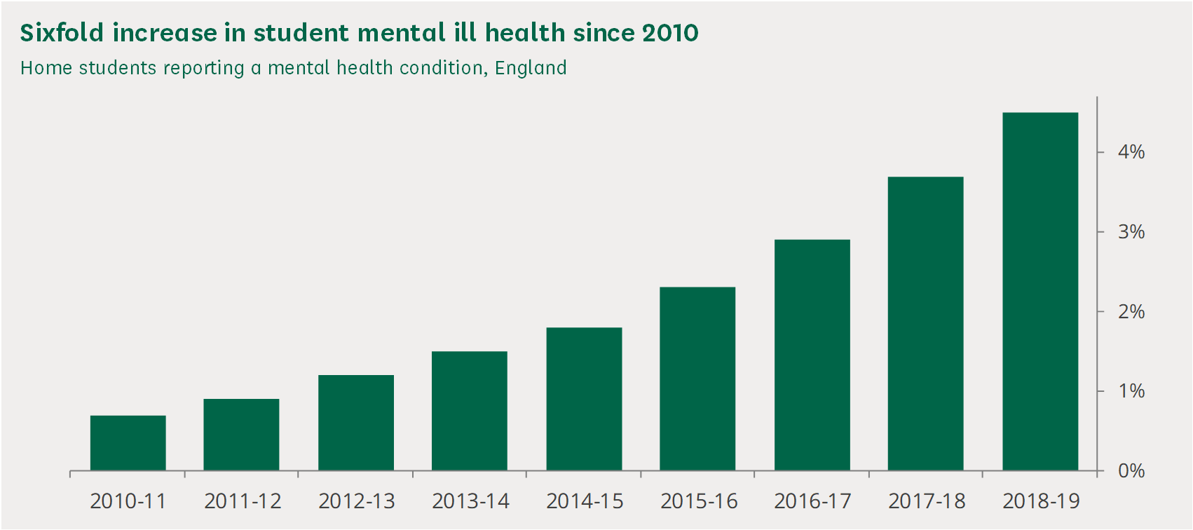

Figure 1. Students Reporting a Mental Health Condition, England. House of Commons

Figure 1 above demonstrates the rise in student mental health between the years 2010 and 2019. There is a clear need for more investment and support offered to students within education. There could be many factors as for the reasons why, however, this report does not factor in the results of Covid 19 from the year 2020 onwards. 33.9% of students surveys disclaimed that they had ‘experienced a serious psychological issue for which they felt they needed professional help’ (Bolton and Hubble, 2020), a considerably higher number than had been disclosed to University application databases. This is considerable evidence that there is a need for an accessible, affordable variety of therapy methods available for students throughout the UK including Art Therapy as a supplement therapy as discussed previously in this research. The above reference does not reflect the Covis-19 effects of anxiety in individuals, but in contrast, the ‘Office for National Statistics has posted considerably in-depth statistical research into this field of study.

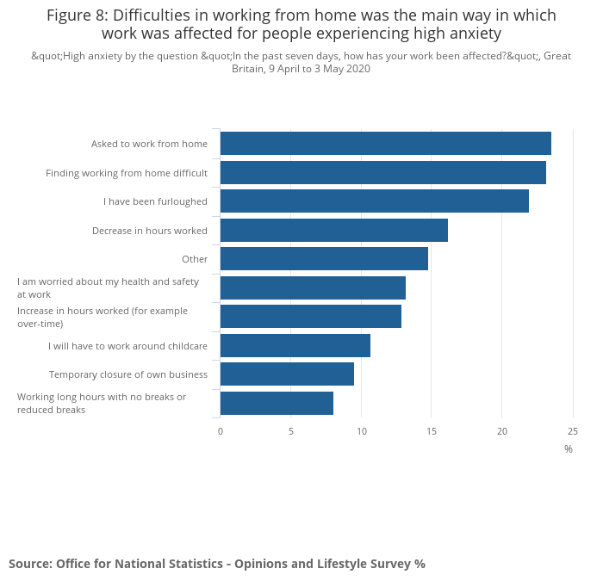

Figure 2. Difficulties in working from home were the main way in which work was affected for people experiencing high anxiety. Office for National Statistics.

Figure 2 is from the ‘Office for National Statistics’ and demonstrates the increases in anxiety for people working from home during the pandemic. This group showed the highest rise in anxiety and encompasses all UK students within further and higher education who were required to finish their studies at home in 2020 and 2021. It also states that ‘the odds of reporting high anxiety were 2.0 times as great for those aged 75 years and over than those aged 16 to 24 years’ (Hamilton and Coates, 2020) again highlighting that students aged over 16 fall into the high-risk category of developing anxiety disorders that need to be addressed within education systems.

‘Art Therapy Resources’ (a credible source previously used in this research) has released a case study on the specific effects art therapy had on an individual who experiences significant anxiety. The clinic art psychologist uses a pseudonym for a 15-year-old who has been attending Art Therapy for 5 weeks. Through collaborative discussion, a goal to develop new coping mechanisms through Creative Art Therapy is agreed upon. The technique used within this particular case is the use of collaging to collate ideas of what the individual finds most stressful throughout their days and activities that often bring them calm and regulated emotions. Through discussion with the art psychotherapist, the patient creates a pie chart that encompasses all activities that they could rely on to reduce stress, cope with overwhelming emotions and can be used within situations where anxiety levels increase (Case Study: Using Art Therapy for a Client with Anxiety, 2021). Below is a photograph of the pie chart created within the session.
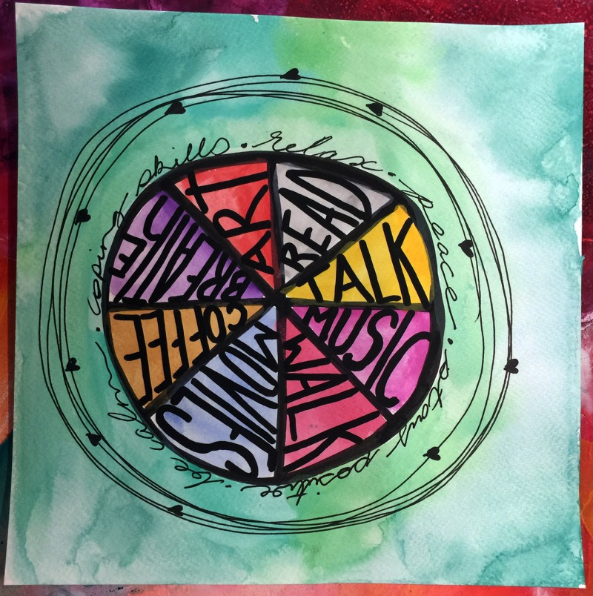
Figure 3. Pie Chart for Anxiety Coping Strategies. Art Therapy Resources.

Following on from these sessions, the art therapist reported a change within the individual to independently choose coping mechanisms that worked well for them. It encouraged the release of stress and enabled a calm distraction from overwhelming emotional outbursts. The author of this case studies and disclaims that ‘each therapist often approaches therapy with their foundation of psychological interventions, whether it be psychotherapy, CBT, DBT or other methods’ (Art Therapy for a Client with Anxiety, 2021). This links with the research led by Abbing et al (2018) and Carroll (2018) that Art Therapy is often best used with a combination of other successful CBT talking therapy methods. This is information presented time and time again within this research so it is important to consider when concluding the research question and whether Art Therapy is the best fit for Student Support Services. Students who are already creative may respond better to this particular type of therapy than students who are not. From the case study, it is clear that this is a collaborative approach, whether the patient takes an active role in creating and expressing their thoughts through action. Some individuals may struggle with this different approach than more traditional therapy methods, however, this is not a known fact.

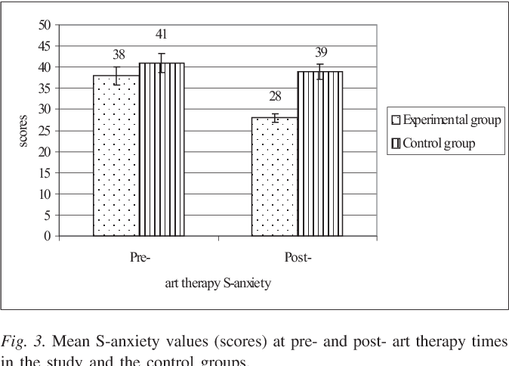

Figure 4. Mean S-anxiety values (scores) at pre-and post-art therapy times in the study and the control groups. Visnola, Sprūdža, Ārija Baķe and Piķe

A clinical trial was performed in 2010 to discover the ‘effects of art therapy on stress and anxiety of employees’. As seen from the figure above, the anxiety levels dropped significantly in a 24-hour time frame after only one Art Therapy session. This shows how direct, transferable and fast the positive effects of the therapy are for individuals. ‘No significant changes were found for trait anxiety in any of the groups’ (Visnola, Sprūdža, Ārija Baķe and Piķe, 2010). It was noted during the study that the effects were short-term psychologically but proved the participants with knowledge on how to cope with stressful emotions and pursue these strategies to improve their everyday life. This could mean that Art Therapy used in Higher and Further Education Settings could benefit funding difficulties, by providing students with a few sessions to equip them in their mental health journey rather than supplying many sessions of talking therapies. This would then also relieve the long wait times of ‘up to three months’ as previously discussed with this research (Campbell, 2019). The article referenced is from The Guardian; accredited by the United Nations and is listed as a credible and accurate news source. This information is supported by references to current figures posted by individual UK Universities within the ‘literature review’ section of this research.

Conclusion

This Action Research Project has discussed all 4 research questions and will conclude each by analysing data collected.

- Is there a clear need for a wider range of therapies for students

The evidence in this report proves that a combination of CBT and Art Therapies can benefit students by combining a creative and talking therapy approach by expression and methods proved by trial-led research. Having the widest possible scope of methods ensures that students will get the exact type of therapy that is right for them and their way of processing and coping with anxiety. One should not replace the other but should support and accompany each other.

- Is art therapy already being used within post-16 education settings?

Post-16 education settings are not required by law to provide art therapy as a student service. There was no evidence through research of Art Therapy being offered to students suffering from anxiety through colleges and universities throughout the UK. However, there is significant evidence of counselling being provided for students where art therapy could be suggested as a follow-up or supplement method.

- What are the benefits and downfalls of using creative art therapies as a therapy method?

Case studies have proven that art therapy has a direct, positive effect on an individual's current mental health, and can provide them with coping strategies that they can take forward as a preventative method for living with anxiety disorders every day. The research obtained demonstrates that Art Therapy may not be enough by itself to help an individual overcome an anxiety disorder completely, and there is not enough statistical evidence to prove otherwise yet.

- How and should it be introduced into UK Higher and Further education settings?

Whether Art Therapy is introduced is factored by funding and whether the budget often allows for trained therapists and the relevant facilities within an institution. There is a clear need and positive outcome evidence for this therapy method that should be taken into account when reviewing this research. The evidence proves that Art Therapy could be introduced alongside the traditional forms of talking therapies already in use to supplement the services provided to post-16 students. Due to the extra funding in 2020 to support student mental health in the UK, the resources to offer sessions with fully trained and accredited Art Psychotherapists is more accessible than pre-2020.

Introducing Art Therapy as a student support service within post-16 education settings would have positive effects on student anxiety, from short-term physical relief to creating personalised support strategies and self-regulation. It may also relieve the waiting times on the existing therapy methods already being offered to colleges and universities. Although there is no significant statistical data on the isolated effects on anxiety disorders, case studies have proven its direct effectiveness.

Recommendations

- Reconsider funding allocated to Mental Health within Education to allocate trained art psychotherapists

- Start offering art therapy alongside existing counselling methods

- Clinical-led trials on the effects Art Therapy has specifically on anxiety disorders to produce statistical data

- Introduce variable creativity within post-16 curriculums to encourage the expression of emotion and self-regulation within students

Reference List

2019. UKCP Standards of Education and Training (2019): Psychotherapeutic Counselling with Adults. [ebook] London: UKCP. Available at: <http://file:///Users/Alex/Downloads/ukcp-adult-psychotherapeutic-counselling-standards-of-education-and-training-2019.pdf> [Accessed 18 March 2022].

2020. Mental Health and Wellbeing in Higher and Further Education. [ebook] London: The British Psychological Society, pp.1-4. Available at: <https://www.bps.org.uk/sites/www.bps.org.uk/files/Policy/Policy%20-%20Files/Call%20to%20Action%20-%20Mental%20Health%20and%20Wellbeing%20in%20Higher%20and%20Further%20Education.pdf> [Accessed 18 March 2022].

Abbing, A., Ponstein, A., van Hooren, S., de Sonneville, L., Swaab, H., Baars, E. and Berger, V., 2018. The Effectiveness of Art Therapy for Anxiety in Adults. Plos One, [online] 13(12). Available at: <https://web-s-ebscohost-com.ezproxy.uwtsd.ac.uk/ehost/pdfviewer/pdfviewer?vid=0&sid=195186a1-1062-4da7-97fe-a27b7abb7555%40redis> [Accessed 18 March 2022].

Adelman, H and Taylor, L. Mental Health in School: Engaging Learners, Preventing Problems and Improving Schools. London: Sage Ltd.

Art Therapy Resources. 2020. Art Therapy Exercises To Help Reduce Feelings of Anxiety. [online] Available at: <https://arttherapyresources.com.au/art-therapy-exercises-anxiety/> [Accessed 18 March 2022].

Art Therapy Resources. 2020. Case Study: Using Art Therapy for a Client with Anxiety. [online] Available at: <https://arttherapyresources.com.au/case-study-anxiety/> [Accessed 19 March 2022].

Art Therapy Resources. 2021. Case Study: Using Art Therapy for a Client with Anxiety. [online] Available at: <https://arttherapyresources.com.au/case-study-anxiety/> [Accessed 17 March 2022].

Bolton, P. and Hubble, S., 2020. Support for students with mental health issues in higher education in England. [online] House of Commons Library. Available at: <https://commonslibrary.parliament.uk/research-briefings/cbp-8593/> [Accessed 19 March 2022].
Bristol.ac.uk. 2022. One-to-one counselling. [online] Available at: <https://www.bristol.ac.uk/students/support/wellbeing/request-support/services/counselling/one-to-one/> [Accessed 18 March 2022].

Campbell, D., 2019. UK students waiting up to three months for mental health care. [online] the Guardian. Available at: <https://www.theguardian.com/society/2019/sep/16/uk-students-waiting-up-to-three-months-for-mental-health-care> [Accessed 14 March 2022].

Carroll, D., 2018. Enhancing Cognitive Behavioral Therapy and Expressive Arts Therapy by Applying a Hybrid Approach. [ebook] Lesley University, pp.4-10. Available at: <https://digitalcommons.lesley.edu/cgi/viewcontent.cgi?article=1057&context=expressive_theses> [Accessed 19 March 2022].

Counselling.cam.ac.uk. 2022. Waiting Time for Student Counselling | University Counselling Service. [online] Available at: <https://www.counselling.cam.ac.uk/studentcouns/waitingt> [Accessed 18 March 2022].

Cromby, J, Harper, D and Reavey, P. Psychology, Mental Health and Distress. London: Palgrave.

GOV.UK. 2021. Schools and colleges to benefit from boost in expert mental health support. [online] Available at: <https://www.gov.uk/government/news/schools-and-colleges-to-benefit-from-boost-in-expert-mental-health-support> [Accessed 18 March 2022].

Hamilton, M. and Coates, S., 2020. Coronavirus and anxiety, Great Britain - Office for National Statistics. [online] Ons.gov.uk. Available at: <https://www.ons.gov.uk/peoplepopulationandcommunity/wellbeing/articles/coronavirusandanxietygreatbritain/3april2020to10may2020> [Accessed 18 March 2022].

Hillman, N., 2016. The invisible problem? Improving Students’ Mental Health. [online] HEPI. Available at: <https://www.hepi.ac.uk/2016/09/22/many-universities-need-triple-spending-mental-health-support-urgent-call-action-new-hepi-paper/> [Accessed 18 March 2022].

House of Commons, 2018. The Government's Green Paper on Mental Health: Failing a Generation. [online] London: Education and Health and Social Care Committees, pp.7-9. Available at: <https://publications.parliament.uk/pa/cm201719/cmselect/cmhealth/642/642.pdf> [Accessed 18 March 2022].

Isnola, D., Sprūdža, D., Ārija Baķe, M. and Piķe, A., 2010. Effects of art therapy on stress and anxiety of employees. Proceedings of the Latvian Academy of Sciences. Section B. Natural, Exact, and Applied Sciences., [online] 64(1-2), pp.85-91. Available at: <https://sciendo.com/article/10.2478/v10046-010-0020-y> [Accessed 13 March 2022].

Mind. 2021. How to Find a Therapist. [online] Available at: <https://www.mind.org.uk/information-support/drugs-and-treatments/talking-therapy-and-counselling/how-to-find-a-therapist/> [Accessed 18 March 2022].

Mitchell, D. 2008. What Really Works in Special and Inclusive Education: Using Evidence-Based Teaching Strategies. London and New York: Routledge Taylor and Francis Group.

Moula, Z., 2021. Art therapy in primary schools. [online] Baat.org. Available at: <https://www.baat.org/About-BAAT/Blog/270/Art-therapy-in-primary-schools> [Accessed 18 March 2022].

Neighbors, J., 2012. Art Therapy and Schools. 1st ed. [ebook] California: UCLA. Available at: <http://smhp.psych.ucla.edu/pdfdocs/arttherapy.pdf> [Accessed 18 March 2022].

nhs.uk. 2022. Counselling. [online] Available at: <https://www.nhs.uk/mental-health/talking-therapies-medicine-treatments/talking-therapies-and-counselling/counselling/#:~:text=The%20cost%20of%20private%20counselling,and%20those%20on%20low%20wages.> [Accessed 15 March 2022].

Royal College of Art. 2022. Student Counselling Service. [online] Available at: <https://www.rca.ac.uk/study/facilities-support/wellbeing/counselling-service/> [Accessed 18 March 2022].

Stein, M., 2020. COVID‐19 and Anxiety and Depression in 2020. Depression and Anxiety, [online] 37(4), pp.302-302. Available at: <https://web-p-ebscohost-com.ezproxy.uwtsd.ac.uk/ehost/pdfviewer/pdfviewer?vid=0&sid=e26a7714-5529-4fa7-8834-0c37ff91bc5c%40redis> [Accessed 7 March 2022].
Telehealth for Teens, Parents and Groups: Art Therapy Techniques to Reduce Anxiety and Depression. 2020. [video] Directed by P. Malkoff Hayes. Eau Claire, WI: Monograph.

UCAS. 2022. Sharing a mental health condition on the UCAS application. [online] Available at: <https://www.ucas.com/undergraduate/student-life/getting-student-support/mental-health-and-wellbeing> [Accessed 18 March 2022].

UWTSD, W., 2018. Counselling Service | UWTSD. [online] Uwtsd.ac.uk. Available at: <https://www.uwtsd.ac.uk/counselling/> [Accessed 19 March 2022].

UWTSD, W., 2022. Counselling Service | UWTSD. [online] Uwtsd.ac.uk. Available at: <https://www.uwtsd.ac.uk/counselling/> [Accessed 18 March 2022].

