UNIVERSITY OF WALES TRINITY SAINT DAVID

ACCC5001
Database Management Systems

DBMS Report

Author: Apostol George Adrian
Student Nr: 1807626
Teacher: Joy Botu

Table of Contents
Introduction 3
Proposed Design of DBMS 3
Table Samples 4
Benefits of using DBMS for Stakeholders 5
Queries Fetching Reports from Database 6
Queries Visualization by Pivot Tables and Pivot Charts 8
References: 11

Introduction
Our goal is to replace the current paper-based management system with DBMS so that the stakeholders can easily manage and use the DBMS for carrying out day to day operations and visualizing the reports in the form of pivot tables and pivot charts.

Proposed Design of DBMS
I have designed this model, keeping in view all the requirements for Property Management company. The proposed design covers all aspects ranging from storing data related to all the branches and keeping records of salespersons of each department.

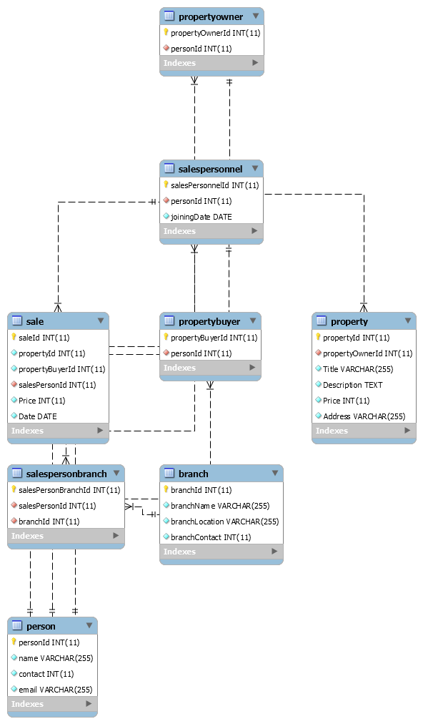

Table Samples

- Branch: To maintain and manage records of different offices, I have created this branch table. It will help us in analyzing the progress of each department, I.e. which of the chapters is making most of the sales and which of the branches is making the least sales per annum. Moreover, another significant advantage of making this entity is that the stakeholders can quickly get to know the profits made by each branch every quarter or other such related reports. Last but not least, keeping records for the salespersons of each office add up to the benefits of having a separate table for the department.
- Person: Keeping in view the advantages of keeping database model normalized, I created a separate table for storing the typical details of all the persons, including staff of all branches, property owners and property sellers. The person table will be the base table from which other relevant tables will inherit.
- Property: This table will be storing all the required attributes related to each property. This will prove to be helpful for the stakeholders since all the property details can easily be retrieved within seconds. Moreover, the searching process would be much faster as compared to a paper-based system. The issues of duplicate data entry for a single property in different branches would also be eliminated. There is an attribute for 'price' also. It will help in determining the actual demand of a property from the seller, and then later it will be easier to track the selling price of any property as well.
- PropertyOwner: By making a separate table for keeping all the property owners' data, the query performance for retrieving only the owner related attributes becomes very efficient. It can be used for various purposes. For example, if the stakeholders want to see some specific details regarding all the property owners, they can easily do so. This table inherits all the attributes from the base class named 'person'. It helps us in preventing redundancy issues and proves to be very beneficial for keeping the size of the database small when the dataset increases.
- PropertyBuyer: Buyers have a separate table as well, which helps in maintaining the buyer's data as well as querying out specific details of buyers. If the property management company even wants to have a website later, this table will promote the functionality of sending notifications or emails to all the buyers quickly without having to implement extensive queries for extracting buyers' records.
- Sale: This table helps to keep records of purchases ranging from the salesperson who made the deal to the sales price and the date on which the property was sold. It is essential for stakeholders since it helps a lot in producing reports for sales based on years and months.
- SalesPersonnel: All the salespersons making deals in each branch needs a separate identity for having records in the database. The stakeholders can evaluate the performance of each salesperson by querying out sales information of each. It is also very beneficial in appraisals and yearly bonus evaluation.
- SalesPersonBranch: As we know that each branch has multiple salespersons working in it. So, this table is designed to keep records of a salesperson with their corresponding department. It can also help in querying out the total number of salespersons working in each branch, the total sales to salesperson ratio, for example.
After the tables are created for entities, we need to have relationships between these tables represented in the database. Besides, to select some data outside of tables with connections, we will use the query “join”. (Guzel, 2010)

Benefits of using DBMS for Stakeholders

1. Improved data sharing: The stakeholders can access updated data simultaneously without having any consistency issues since it is very easier to manage in DBMS. Regardless of branch or city, the data can be obtained in real-time and updated from anywhere as well. Moreover, any of the changes made in data from anywhere will be instantly visible to all the stakeholders. It proves to be very beneficial in businesses like property management, where if a property is sold out once, it should not be sold out to another buyer from another location since it will cause issues for the management. Data sharing is essential for this business.
2. Improved data security: With a more significant number of users accessing the data, the risk of security breaches also increases. By using the database management system, security-related issues can be easily managed since it supports a framework for superior administration of data and security strategy. The proposed design covers all aspects of controlling access privileges. The stakeholders would not need to worry about data being stolen or leaked.
3. Better data integration: The risks of data privacy violation increase with the number of users accessing the data. Enterprises spend many resources to assure that such joint data are appropriately used. A DBMS supplies a structure to enforce data security and tactics. Also, “standardized stored data format is particularly desirable as old data to interchange or migration (change) between the system.” (Thakur, n.d.)
4. Minimized data inconsistency: Data inconsistency issues are reduced by using a DBMS system. All the data across different branches will be same and updated since it is one of the primary critical benefits of using DBMS. Any update or change in price or any other attribute of the property will remain consistent throughout the system. It is very advantageous for business-like property management since the sales being made are accurate and on updated data. The possibility of data inconsistency is considerably decreased in an accordingly designed database. (THIRU, n.d.). The proposed model is designed, keeping in view the fact that it does not have any inconsistency issues from a fundamental point of view.
5. Increased end-user productivity: The salespersons will easily be able to update the data, thus improving productivity. They will not have to wait for a long time to perform operations. Moreover, stakeholders need to have the availability of data to make real-time decisions. In this modern era, the ability to make real-time and quick decisions by using updated data in a critical factor behind success. The better the data management systems and strategies come, the higher quality information becomes. (Lehr, 2018)

6. Improved data access: By making use of DBMS, complex queries can be solved efficiently. When dealing with large datasets, getting query results becomes a bit difficult. The stakeholders can enjoy the benefits of efficient performance due to having data access to all the data. Questions such as the ones shown below can be answered in seconds if not milliseconds.

Queries Fetching Reports from Database
"Select" statements are exploited to bring back data from the database, so all the queries will begin with those statements.
In the query below we can see total sales with the properties names and the amount of each sale.

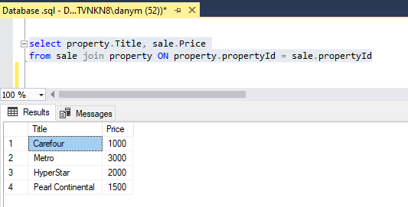

The second query shows all the sales with the personnel's names having made the sale, the amount of each transaction and the property sold.

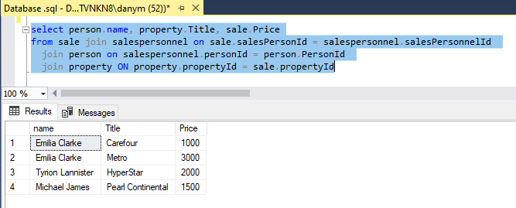

The third query shows all the sales for a year with the personnel’s names who made the sale, the amount of each sale and the property sold.

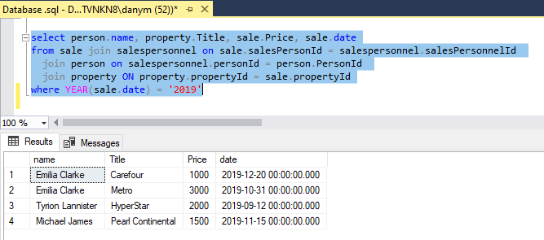

Queries Visualization by Pivot Tables and Pivot Charts
A pivot table helps in storing the analyses of a text file in a compressed method. This table allows the consumer to examine the changes in a considerable data pack. Pivot tables “helps in the easy analysis of a large amount of data.” (Associationofbusinesstraining.org, 2013)
- All the sales with the name of the properties and the amount of each transaction.

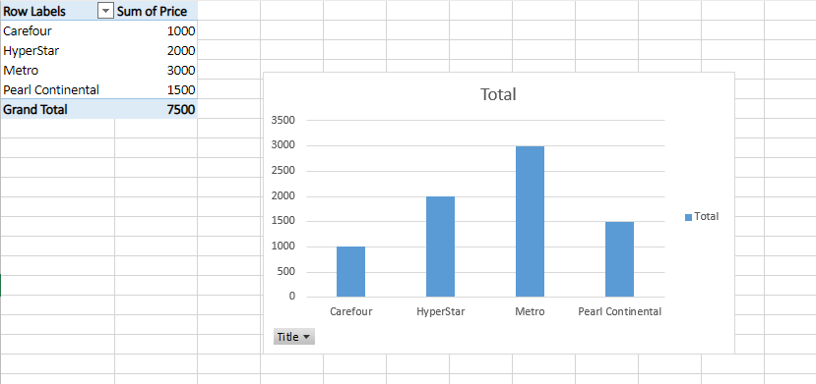

- List total sales with the name of the person who made the sale, the property sold, and the amount of each transaction.

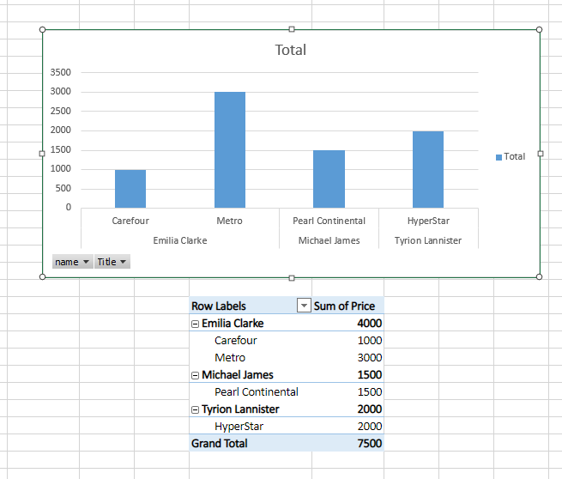

- List total sales for a year with the person's name who made the sale, the property sold, and the amount of each transaction.

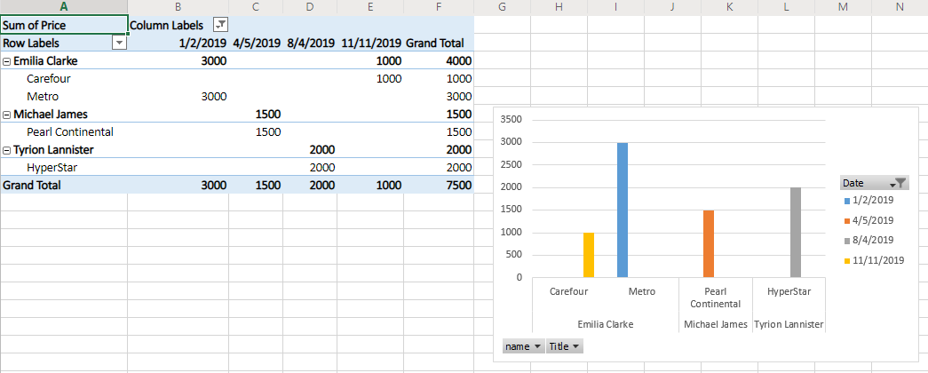

References:
- Thakur, D. (n.d.). Advantages of Database. [online] Ecomputernotes.com. Available at: http://ecomputernotes.com/fundamental/what-is-a-database/advantages-of-database [Accessed 20 Dec. 2019].
- Lehr, S. (2018). The Benefits Of Using Database Management Systems. [online] RingLead. Available at: https://www.ringlead.com/blog/the-benefits-of-using-database-management-systems [Accessed 29 Dec. 2019].
- THIRU (n.d.). What is DBMS? Advantages and Disadvantages of Database Management System(DBMS). [online] Myreadingroom.co.in. Available at: http://www.myreadingroom.co.in/notes-and-studymaterial/65-dbms/462-advantages-and-disadvantages-of-dbms.html [Accessed 1 Jan. 2020].
- Associationofbusinesstraining.org. (2013). What is a Pivot Table, and what are the Benefits of Utilizing Them in Excel? [online] Available at: https://www.associationofbusinesstraining.org/articles/view.php?article_id=11022 [Accessed 2 Jan. 2020].
- Guzel, B. (2010). SQL for Beginners: Part 3 - Database Relationships. [online] Code Envato Tuts+. Available at: https://code.tutsplus.com/articles/sql-for-beginners-part-3-database-relationships--net-8561 [Accessed 2 Jan. 2020].

