Name: Charis Copp
Student Number: 1902580
Theme: Deconstructing the Human: Self Identity and Other.
Module: Coexistent Perspectives
Word Count: 4147

List of Illustrations

Figure 1: Chadwick, Helen. (1991) Loop My Loop [Cibachrome transparency, glass, steel, electrical apparatus].
Available at: https://www.richardsaltoun.com/artists/101-helen-chadwick/works/17928-helen-chadwick-loop-my-loop-1991/
(Accessed: November 25th, 2023)

Figure 2: Hatoum, Mona. (1995) Hair Necklace [Human hair and wooden bust].
Available at: https://harvardartmuseums.org/collections/object/348038
(Accessed: December 5th, 2023)

Figure 2: Hatoum, Mona. (1993) Jardin Public [Painted wrought iron, hair and wax].
Available at: https://www.whitecube.com/artworks/jardin-public
(Accessed: November 30th, 2023)

Abstract:
I am unravelling how contemporary female artists respond to hair as a material because of the male gaze. Through this paper, I intend to challenge the limiting view that hair is primarily associated with sexuality. I argue that hair is a malleable and multifaceted material. My paper explores how contemporary artists Helen Chadwick and Mona Hatoum have responded to hair despite the male gaze rendering as a purely sexual material. These artists have been considered in conjunction with key philosophers Naomi Wolf, Dr Jen Gunter and Friderike Heuer. In my eyes hair is in the eye of the beholder.
Drawing on our contemporary culture, I seek to unravel the multifaceted material that is hair. Through its use in Victorian Mourning attire, its appearance (or lack thereof) in pornography, how hair has been used as a commodity and symbol of fascism. Through a series of sub questions Unravelling intends to determine whether hair is a site of shame or arousal for women and what other labels these locks could possibly hold.

Unravelling Locks and Labels: How do contemporary female artists respond to hair as a material despite the consequent conditioning of the male gaze?

“Humans seek to embed feelings onto tangible objects” (Scott, E, 2020:36).

This applies to how female hair is perceived and informed by emotions. As photographer and photomontage artist Friderike Heuer writes in her article titled Taking Stock of the Body “The long hair in the butter dish or the short hair in the sink and shower drain are irritants.” (Heuer, 2023)

To gain a balanced and gendered viewpoint for this discourse, the male perspective must be taken into consideration. English art critic John Berger considers hair to be “associated with sexual power” (Berger. 1972:55) As written in his 1972 book Ways of Seeing. This paper intends to unravel whether not hair can only be associated with sexuality as a material used both in everyday life and within an artist’s work.

Popular constructed culture and an individual’s personal perspective will heavily inform how they view the world around them. More specifically how they associate hair and the female body. The disquieting associations regarding hair in different settings will be of particular interest to this investigation. The issues surrounding this topic will be covered and answered through a series of case studies. All the while developing an argument as to whether hair is intrinsically associated with sexuality and answering a series of considered sub-questions with the intention of forming a well-rounded conclusion derived from this investigation. The aim of this paper is to explore and unravel the works of Helen Chadwick and Mona Hatoum in the hopes of exploring how contemporary female artists have responded to the subject of hair as a direct impact of the male gaze. These artists will be considered in conjunction with key thinkers, Niomi Wolf, Jen Gunter and John Berger. In relation to themes of memory, shame, gender and sexuality.

Within a contemporary context Helen Chadwick and Mona Hatoum will be discussed in synthesis with philosophers in correlation to my question of exploration

Case Study 1

The objective of this case study is to explore the deconstruction of hair as an icon to signify the female form and its evolution from the archetype of mourning attire to a symbol of erotic voyeurism.

Before initiating a deep analysis of said artists, it is first necessary to offer a brief historical background on Deconstruction. During the 1980s an increasing discomfort amongst feminists grew, concerning depictions of the female body. As English author Fiona Carson explains in her book, Feminist Visual Culture, “The physicality of the female body began to disappear under the weight of its own history”. (Carson, 2001: 62). As a result of this the language of the female body was forever altered. “As its physical representation became increasingly problematic, the female body dissolved into a flux of shifting signifiers and tangential references.” (Carson. 2001, 62). One of these ‘signifiers’ of course being hair. One must ask if this pervasive mistrust of the female form has permeated intellectual and popular culture, is the female form forever destined to be rendered as nothing more than a site of arousal and shame? It is interesting to note that both Helen Chadwick and Mona Hatoum responded to this dilemma through the depiction of grotesque female bodies in their work.
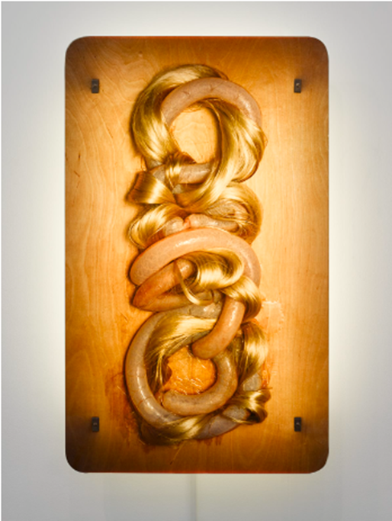
Figure 1: Loop My Loop

Loop My loop is a central component in Helen Chadwick’s larger than life repertoire of bodily-centric artwork. This piece operates in a liminal space, showing blonde hair (presumably belonging to a female), intertwined with intestines belonging to a pig. The conversational dominance interwoven within the two materials is of particular interest to this case study. This sculptural yet painterly piece of art will be exploring the fetishisation of hair in contemporary art. In her 2020 essay, The Decay of the Feminist Aesthetic in Helen Chadwick’s Loop My Loop, historian Ellen Scott explains:

Chadwick’s work is extremely paradoxical, these visceral aesthetic traverses the boundaries of permanency and ephemera, growth and decay, pleasure and repulsion, organic and synthetic. (E, Scott. 2020: 34)

Chadwick’s construction of decaying matter disturbs and subverts our assumptions surround the ideal female body. The most notable element of this is the term ‘ideal’ when describing female beauty because it is just that an idea, a notion. As “Ideal beauty is ideal because it does not exist: the action lies in the gap between desire and gratification” (Wolf. 1990: 143) Chadwick confirms this theory. She does so by deriving decaying and abject materials from the rejected female with the intention of utterly repulsing the male gaze. It is here in which we discover what follows this ‘gap’, as the hair that once stimulated us is now scorned by us.
Developing upon this, the contents of this piece have been described by Rosemary Betterton are subjective of gleaming pig intestines intertwined with golden Barbie doll hair in a braided embrace”. (Betterton 1996:142) One could theorise that Betterton’s use of ‘Barbie doll hair’ as a description could be a nod to our culture’s association with the Bimbo stereotype. The bimbo is a label that for a long time has been as a purely negative one. Intended to insult or dismiss women based on the colour of their hair. Women seen to have blonde hair are heavily viewed as being above other women in sex appeal but below them in terms of intellect. As the YouTube channel The Take explains in their video The Bimbo Trope, Explained; “Bimbo is actually a contraction of the Italian word bambino. Meaning male baby”. (The Take 2020) Over time this term became a primary descriptor for a certain type of woman. As the name’s roots imply this is a character who is often infantilised or treated like a simpleton. With this considered, can we view the contact shared between the flesh and hair as an embrace? Or is the flesh in fact cradling the hair?

Many have noted that, Helen Chadwick’s career masterfully reflected societies fears and fantasies. In doing this she became the driving force of the feminist art movement and highlighted the introduction and potential of new media and materials. This does beg the question, what are these ‘fears’ exactly? As Niomi Wolf posits “The current allocation of power is sustained by a flood of hostile and violent sexual images but threatened by imagery of mutual eroticism or female desire” (Wolf.1990: 44). Chadwick takes our “learnt assumptions” surrounding hair and corrupts the sentimentality of it. These once innocent golden locks have become subject to fetishisation. One needn’t look further than the title of this piece, ‘Loop My Loop’ humorously reads as a sexual request; a playful, private display of mutual eroticism. The once wholesome friendship knot now resembles a bondage knot.

Before initiating a deeper discourse surrounding the Chadwick’s deconstruction of the female form. A link must first be drawn between Chadwick’s work and the popular practice of eighteenth-century mourning jewellery. The purpose of this case study is to explore themes of hair as a medium which links to memory and mortality.

“Hair was processed as braided and bobbin-laced hair jewellery, into friendship-, mourning- and traditional costume jewellery, as well as into hair locks as keepsakes.” (Heuer 2023). Further disproving Burgers claim that hair is associated with female sexuality. One could contest that hair predominantly serves as a vessel for memory and mortality more so than a mere shorthand for female sexuality. Heur best exemplifies this by writing that:

Hair is, of course, a vivid reminder of the elapse of our allotted time: across the years it loses its color, it changes its density and weakens its structure, eventually thinning to the point of no return, with baldness for 7 many the result (Heuer, 2023)

This manifestation of literal human remains would not have been lost on Chadwick. Afterall hair is one of the few humans remains that seldom needs to be represented in any other form than its own. The disparity between male and female representations in art will be touched on when we dive into Mona Hatoum's case study.

This piece by Chadwick can be concluded to have successfully argued that hair can be representative of so much more than sexuality. This case study has clearly determined that there are no limitations or conformities that women and by extension hair; must abide by. This results in as Ellen Scott describes “A “macabre metaphor for the aesthetic trappings which the female body has struggled to break free from for centuries”. (E, Scott. 2020).

Case Study 2
John Berger writes “When an image is presented as a work of art the way we people look at it is affected by a whole series of learnt assumptions [...] Beauty, form and status” (Berger. 1972:11). Themes of ‘Form’ and ‘Status’ will be considered within this case study.
Helen Chadwick has been considered throughout this discussion for her utilising hair as a source of mortality, memory and fetishism, Mona Hatoum will now be discussed. Hatoum has similarly made works using hair as the primary material in her sculptural repertoire. However, this work deviates from Chadwick’s as Hatoum’s examines notions of hair as a source of wealth and status upon the contemporary psyche and the links between hair and perception towards one’s own body image. The themes of her works will now be formally discussed.

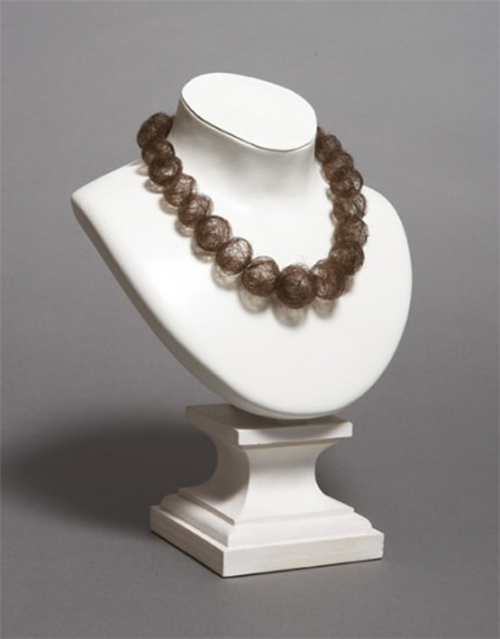
Figure 4: Hair Necklace

Mona Hatoum is a Palestinian born visual artist who has made a career of implementing bodily hair as a means of engaging her viewers and creating a dialogue surrounding the way in which women are forced to accommodate and appease male tastes. For this piece titled Hair Necklace Hatoum collected stray strands of hair, balled them up and painstakingly threaded them to be displayed on an elegant wooden display bust. The Harvard Museum notes that, “Hatoum grounds her work in the materiality of the body to convey a sense of the dislocation resulting from forced immigration.” (Harvard Museum, 2013).

When looking at this piece through a contemporary lens, viewers might be compelled to view hair as a signifier of racial identity and symbol of anti-fascism. One need only look to the horrors of concentration camps during World War II. In her digital article Taking Stock of the Body, Friderike Heuer recounts:

The hair was cleaned in an ammoniac solution, dried, and stored in paper bags. It was shipped to German factories for profit, paid by the pound, and used by industry to manufacture ropes, carpets, mattress stuffing, and socks for submarine crews as well as time-bombs. (Heuer, 2023)

When we consider Hatoum’s Palestinian identity and the current genocide taking place in Gaza. One cannot deny that this piece takes on a whole new meaning. Hair can most definitely be read as representing far more than ‘sexual power’. It can also be a commodity to be stripped from a person and implemented as a tool to wage war and destruction. In this sense hair is currency.
A trend that has sadly carried on into present day. China now takes the mantel of being the largest global exporter of human hair. Natural hair has been provided to the world market by “using both the hair of inmates in Uyghur internment camps and camp labour” (Hueuer, 2023). This is made even more worrying when we learn that $1.8 billion is exported to the U.S alone. With this considered, one cannot deny that hair is viewed as a commodity.

The exquisite and aestheticised space in which this piece is displayed an instrumental aspect of one reading Hair Necklace as signifier of wealth and status. The setting reads as elegant and high end. At the very start of this discussion, the term status was mentioned in relation to John Berger’s male perspective. It now serves as a reflection of the female psyche within this discussion. Status serves as the degree to which the female psyche will evaluate herself upon, in direct synthesis with the socially constructed culture she finds herself within. PBQ or ‘professional beauty qualification (as coined by Naomi Wolf) has been widely institutionalised as a condition for women to be hired and excel at their profession. In her own words, “Women learned to understand their own beauty as part of this economy.” (Wolf, 1990: 15)

It could be argued that the visual appeal is immediately offset by the viewers realisation the delicately strewn beads making up the necklace are in fact hair – real hair. However, this does call into question Bergers assertion as one starts to wonder when does the sexualising stop and the sickening begin? Here we see a binary has been formed as hair can be rendered as beautiful so long as it stays on the head. Is it only when the hair is detached from the body it serves to disgust.

These balls of hair compel the viewer to ponder the absent body, the rooted figure from which the unrooted hair was harvested from. This also begs the question of who was this necklace intended for? As previously discussed, aestheticised space the hair necklace is displayed in is reminiscent of high-end fashion, similar to the likes of Gucci or Vivian Westwood. We as viewers can deduce the implied economic disparity shared between maker and wearer. When we view the hair adorning the necklace in this context it reads as a representation of a society bent on categorising and stifling women. Whether it be, rich or poor, blonde, or brunette, beautiful or ugly. As Wolf asserts, “Male culture seems happiest to imagine two women together when they are defined as being one winner and one loser in the beauty myth.” (Wolf, 1990: 32)

It can be concluded that, Hatoum has identified hair as being a malleable yet radical signifier of wealth and class. Hair becomes a commodity when looked at through a contemporary and economic lens.

This leads perfectly into the following case study, yet again, involving the work of Mona Hatoum through her piece titled Jardin Public. In synthesis with philosophers which will formally discuss how the male psyche can condition one’s own body image in relation to hair maintenance and removal.

Case Study 3

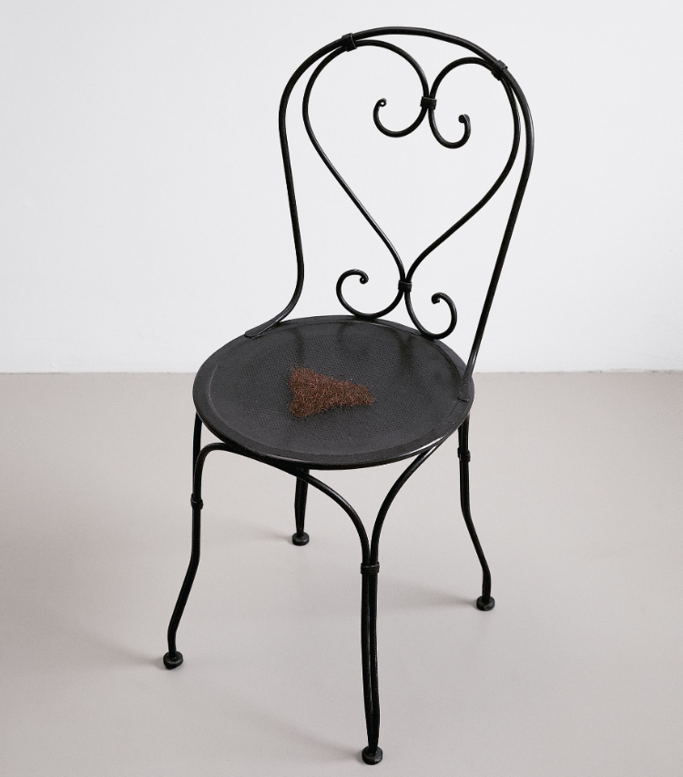
Figure 2: Jardin Public

Even though this photograph depicts a chair adorned with pubic hair, it is the prior mindset of the viewer that is of key interest in this discussion. Before we go on, I would like to establish that female sex organs are not inherently sexual, as I previously discussed in my essay surrounding the artistic portrayal of the vulva. This further extends to pubic hair. Stigma surrounding pubic hair is nothing more than a subject of socially constructed conformities.
American gynaecologist and New York Times columnist Jen Gunter has written in her 2019 book titled The Vagina Bible:
There is data that says the first naked genitals that you see prime you to consider them as your baseline for “normal” or typical. So given the almost complete absence of pubic hair in art since the beginning of time and now in pornography, it is easy to see how the absence of pubic hair has come to be accepted as the social norm. (Gunter, 2019:111)

Hatoum directly grapples with this subject matter within her photography. The triangular arrangement of the pubic hair suggests the presence of a biological female. Gunter goes on to explain that “visible pubic hair was often the definition of public nudity, so burlesque and erotic dancers removed their pubic hair as a way to show more skin.” (Gunter, 2019: 111).
Gunter notes that “Pubic hair is literally a sign of womanhood.” (Gunter, 2019:111) From this extract we can extrapolate that pubic hair serves as a direct symbol of maturity and womanhood itself. This begs the question, does the rejection and removal of pubic hair mean a rejection of womanhood itself? Heuer suggests that “Hair found in uncommon configurations on the body is associated with shame and disgust.” (Simmons, 2023) One can easily categorise this artwork as demonstrating a flight from femininity.
If this statement is to be believed, then one must beg the question; Is a woman physically rejecting the source of her sexual power (as Berges believes) the only way to appeal to the male gaze? Dr Gunter outright confirms this theory, as “pubic hair is attached to a nerve the hypothesis that removing hair reduces sexual sensation seems more valid.” (Gunter, 2019). The female psyche is therefore conditioned to diminish its own capacity for sexual pleasure in a bid to adhere to an ideological perception of female perfection.
However, this pursuit of perfection comes at a cost. As Gunter writes “Over 5 percent of women who have removed pubic hair report at least one complication such as lacerations, burns, rashes and infections.” (Gunter, 2019:110) As this quest for ideal perfection is conducted, one must risk their own health in the process. In addition, it is reported that “pubic hair removal is also associated with an increased risk of sexually transmitted infections.” (Gunter. 2019:110)

Within historical contexts, where the male has desired that ideological perfection of the female body, now within the contemporary, the female has punished herself for having hair. However, Jardin Public uses hair to materialise what the female is rejecting to appease to the male gaze. She is rejecting her very own womanhood.

As Wolf has stated, “The conventions of high-class pornographic photography, such as Playboy’s began to be used generally to sell products to women.” (Wolf 1990:42) This indicates that hair plays a significant role in the economy. Female financial advancement may have given women the false pretence of independence and spending power. But their minds and wallets are still being channelled into this futile pursuit of perfection. The association with hair as currency will be further explored in the case study of Hatom’s 1995-piece Hair Necklace.

If we survey the historical cannon of Western art, the erasure of female pubic hair is nothing new. Ellen Scott explains “The physical body has always been a touchstone for the aesthetic and virtuous.” (Scott, E, 2020) An honour reserved for the male form, with the female body acting as the antithesis of virtue. The female form is already viewed as unvirtuous. Dr Gunter notes that, “Women’s pubic hair is not typically depicted in ancient Western sculptures or works of art- artwork almost exclusively produced by men.” (Wolf. 2019:109) When we consider this ubiquitous lack of female pubic hair in mainstream porn as a continuation of this trend would it be fair to determine this is the result of a market caving into a strong male preference, or is the removal of pubic hair a means of optimising the visualisation of penetrative intercourse?
So, what are the parallels between Hatoum’s Jardin Public and the history of pubic hair removal? Much like Chadwick’s Loop My Loop, one could view Jardin Public as an exercise of subverting the male gaze. If pornography removes pubic hair as a means of optimising male vision, Jardin Publics inclusion of pubic hair seeks to not only obscure it but put it at the forefront for all to see.
As a result, the male gaze has influenced the female contemporary psyche into believing that her hair must be removed, going so far as to put themselves in harm’s way to fit into this subjective ideology. Hatoum challenges this by putting the very symbol of womanhood at the forefront of her work.

Continuing from this Gunter suggests “pubic hair may also play a role in sexual pleasure as tugging or traction on pubic hairs stimulates touch receptors.” (Gunter, 2019:108) With this in mind, pubic hair can be identified as a site of arousal for women. With this considered I must concede that there is some truth in John Berges assertion that hair does in fact have some association with sexual power. It is this very power that the female psyche has been conditioned to fear.
This begs the question of whether hair, more specifically pubic hair is a site of shame or arousal? Dr Gunter states the most predominant reasons for pubic hair removal amongst women is “Attractiveness, conforming to social norms, improving sexual function, hiding grey hair and enhancing femininity are also given as reasons for pubic hair removal.” (Gunter. 2019:111) With all this considered, hair has indeed become a phobia in women’s minds.
As far as arousal is concerned, Gunter suggests “pubic hair may also play a role in sexual pleasure as tugging or traction on pubic hairs stimulates touch receptors.” (Gunter, 2019:108) With this in mind, pubic hair has been confirmed to identify as a site of arousal for women as well as a phobia. With this considered I must somewhat concede that there is some truth in John Berges assertion that hair does in fact have some association with sexuality. However, Dr Gunter continues to say,” Your brain is your most powerful organ for orgasm” (Gunter. 2019: 111) This stands to question Berges assertion and confirms that although hair may play a role in sexual pleasure, it is the female brain has been established as the dominant organ in possessing sexual power.

I would like to close off this case study with a final assurance from Dr Gunter herself:

“The vulva has been exposed to blood, faeces, urine, and seminal fluid long before the ability to remove hair or wash with soap existed. If the absence of pubic hair was beneficial, bacteria-wise, then we simply wouldn’t have it.” (Gunter, 2019:109)

Jardin Public has been concluded to have successfully argued and identified that, within the contemporary, there are no conformities for hair to strictly abide by. Hair can read as a malleable and multifaceted material that reflects not only sexuality but womanhood. Her work has also opened a dialogue surrounding the subject of female sexuality and pubic hair removal. While there is some truth in Berges assertion, that pubic hair does in fact play a role in sexual pleasure. This is subsequently, undermined by the female psyche itself being determined as the most powerful organ for orgasms and the truest source of sexual power.

Conclusion
Contemporary artists such as the likes of Helen Chadwick and Mona Hatoum have strongly responded to the traditional image of hair as conditioned by the male psyche. Chadwick has brought empowerment to the female form by showcasing its vulnerabilities in Loop My Loop. By allowing deviancy to infect and corrupt the once wholesome aestheticization of memento mori. Through her use of hair she elicits themes of fetishization, infantilization, mortality and memory.
Mona Hatoum’s Jardin Public work granted an insight into the contemporary female psyche when conditioned by socially constructed conformities of the ideal body and the drastic harm she will endure to fulfil her perceived role in accommodating the male gaze. Through her Hair Necklace sculpture, Hatoum has called into question theories of status regarding hair and its subsequent commodification. She has highlighted her perspective of hair as a signifier for race, class and identity from the perspective of a Palestinian born immigrant.
When examining hair through our culture’s cynical and capitalist agenda, hair can be successfully determined as a fear and commodity, arguably more so than arousal. A fear for women elicited by themes of ageing, health and general cleanliness. These are due to the flood of stereotypical and unobtainable images of female perfection, seemingly achieved through conformity and frivolous consumption.
However, when hair is examined through the work of Helen Chadwick and Mona Hatoum, we are reminded that hair is a malleable material, rich in emotional and psychological bonds. It is no mere external covering or simple covering but instead a conduit of personal confidence and expression.
There is an undeniable shift in our society's attitude towards body hair. Following the COVID 19 Pandemic, the Pro Body Hair movement has started gaining traction with the rise of body hair positive razor brands such as Billie educating the public on gender inequalities and celebrities such as Miley Cirus openly opening a dialogue regarding this double standard. The LGBT + Community is arguably leading the charge. Citing bodily hair is an integral aspect of gender expression and gender euphoria, with many viewing shaving as a prior obligation rather than a choice. It is also important to recognise bodily hair standards have been heavily used to oppress marginalised groups such as ethnic minorities and those of an immigrant background.
Identifying as a female within the contemporary is a struggle, the pervasive male gaze is a psychological and physical strain we are forced to reckon with on a daily basis. The fact that women are burdened with this expectation to shave is an unfair double standard that highlights the Western cultures infantilization we are subjected to. The male gaze’s encouragement for women to appear as young prepubescent girls is far from empowering. As LGBT + women and non-binary people push the movement for body hair positivity, one can only hope it encourages women to embrace their raw and natural form and find empowerment in their right to choose.

Bibliography

Berger, J. (1972) Ways of Seeing. London British Broadcasting Corporation. London:
Penguin Books/ Penguin Group.

Betterton, R. (1996) An Intimate Distance Woman, Artist and The Body. Routledge Publishing.

Cuttle, J. 2016 Escaping the frame: the art of hairballs. Varsity.
Available at: https://www.varsity.co.uk/culture/9528
(Accessed December 5th, 2023)

F, Heuer. (2023) Taking Stock of the Body, Your Daily Picture.
Available at:
https://www.heuermontage.com/?p=51777
(Accessed December 6th, 2023)

F, Heuer. (2023) Addressing Affliction, Your Daily Picture.
Available at:
https://www.heuermontage.com/?p=49739
(Accessed: December 6th, 2023)

Gunter, J., 2019. The vagina bible: The vulva and the vagina: Separating the myth from the medicine. Citadel.

Harvard Museum (2013) 2013.16: Hair Necklace.
Available at: https://harvardartmuseums.org/collections/object/348038
(Accessed: December 12th, 2023)

Ince, K. (2000) Orlan Millennial Female Dress Body Culture. Oxford.

Scott, E, 2020. The Decay of the Feminist Aesthetic in Helen Chadwick's Loop My Loop. Footnotes, 13.
Available at: https://journal.lib.uoguelph.ca/index.php/footnotes/article/view/5921
(Accessed: December 1st, 2023)

The Take (2021) The Bimbo Trope, Explained - Reclaiming the Label [Video].
Available at: https://www.youtube.com/watch?v=r2eoegcgBdw&list=PLY8-JHLY9yDPIaO3VhNdSN9Axbsw4WzVD&index=48

Wolf, N., 2015. The Beauty Myth (Vintage Feminism Short Edition). Random House.

