

UNIVERSITY OF WALES
TRINITY SAINT DAVID
TITLE: MANAGING CUSTOMER SERVICE EXPERIENCE

NAME: Patrick Mokwe
NUMBER: 1604804
Word count:4953
May, 2018

Contents
Chapter One 3
1.0 Introduction 3
Chapter Two 4
2.0 Analysis of Value Maximization Through Customer Relationship Management 4
2.1 The Idic Model 4
2.2 The Payne Five-Process Model 6
2.3 The Quality Competitiveness Index Model (Qci) 7
2.4 The Crm Value Chain Model 10
2.5 Challenges Of Value Creation Through Crm 12
Chapter Three 13
3.0 Analysis 13
3.1 Organisation Quality Process And Its Impact On Customer Effectiveness 13
3.2 Different Systems For Managing Quality 16
3.3 The Concept Of Customer Experience 17
3.4 Managing The Total Customer Experience 19
Chapter Four 21
4.0 Conclusion 21
References 22

CHAPTER ONE

1.0 INTRODUCTION
Understanding customers better will aid an organization to satisfy them better and guarantee their loyalty forever. This, as argues by (Payne, 2006) is the major theme of customer relationship management (CRM). Meanwhile, the knowledge about the subject of CRM is still being developed. It is widely known as a business strategy, a business philosophy, a business process and/or a technological tool. As a strategy, (Bolton, 2014) posits that CRM is customer-centric which functions to improve customer loyalty and satisfaction by offering services which are better customized and more responsive to customer needs. As a philosophy, it is an orientation which on the relationship, retention of customers, and greater customer value created through the means of process management.
CRM can be defined as a highly aggregated business process which incorporates many sub-processes, e.g., customer knowledge, value creation and prospect identification. And as a technological process, CRM represents an aiding technology for companies to build closer and better relationships with their customers (Nguyen & Sherif, 2017)
Scholars have provided definitions for the CRM construct, e.g., (Payne, 2006) defined CRM as a policy, philosophy, and strategy which is facilitated through a range of information technologies, that focus on developing a two-way communication with customers to enable companies to possess a deep knowledge of customers’ needs, buying patterns, and preferences. Meanwhile, a very holistic definition was given by (Toor, 2009) who termed it as “a development of a customer-centric culture through which strategy is created to acquire, and enhance the profitability of, and retaining customers, which is aided through an IT application, to achieve shared benefits for both the customers and organisation”.
This report aims to analyze the various factors which impact the maximization of customer value at DEN SECURITIES and appraise the how the quality whatever impacts on customer service. For this report, primary data shall not be collected, information shall be gotten from journal articles and other academic publications. After the analysis, adequate conclusion and recommendations shall be made to management.

CHAPTER TWO

2.0 ANALYSIS of VALUE MAXIMIZATION THROUGH CUSTOMER RELATIONSHIP MANAGEMENT

2.1 THE IDIC MODEL
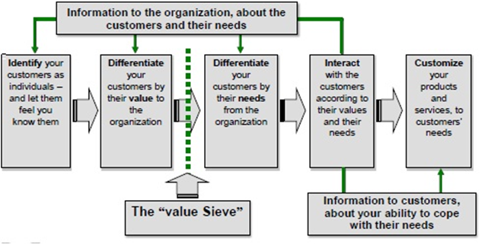
Figure 1. The IDIC model. Source: (Keaveney, 2014)
According to the IDIC model, firms must take steps to develop closer personalized relationships with the customers; which are identification, differentiating, interaction, and customization.
Identification: companies must identify who the customers are, and build a deep understanding of their wants, requirements, and preferences.
Differentiation: firms must differentiate their customers to know which customers have the greatest value presently and which ones will offer great value in the future. Also, the differentiation may allow the firms to create and implement specific strategies designed to meet the individual needs of customers. In addition, the clients serve as a different level of value to the firm, and their wants are different from that of the enterprise. According to (Keaveney, 2014), tasks involving the differentiation of customers will involve a firm to categorize its customers in terms of the value they create to the firm, and their needs.
Interaction: for firms to have a deep understanding of customer expectations, they must communicate with them. Firms must deepen the success of their interaction with customers, each sequential interaction with a customer must take place based on the previous interaction with the individual customer. A communication process with a customer must start from where its preceding one stopped as efficient interaction with customers give a better understanding of customer needs, which will in turn help the company to better serve them (Ranjan & Bhatnagar, 2014).
Customization: Opines that firms must customize their communications and offers to guarantee that customers’ expectations are met. Really, the firm must adapt certain aspect of its behavior towards each customer, which is based on their individual need and value. Involving a customer in a relationship will entail a firm to adapt its activities to satisfy the customers’ needs. Finally, it might involve mass-customization for products to cater for the numerous needs of customers (sanchez & sanchez, 2015).

2.2 THE PAYNE FIVE-PROCESS MODEL
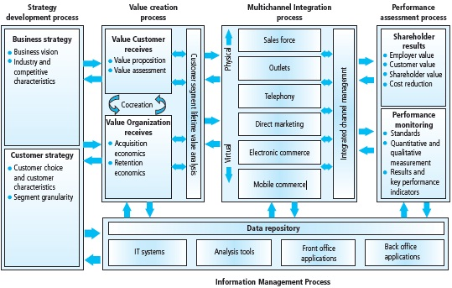
Fig 2. The Payne five-process model. Source: (sanchez & sanchez, 2015)
This model is focused on five major CRM processes which involve are:
Strategy development process:

- Value creation process
- Multichannel integration process
- Information management process
- Performance assessment process
The first stage of the model entails integrating and aligning customer strategy and business strategy and as opined by (Sureshchandar, et al., 2012), both strategies must be synergetic, working towards the same goal for achieving business success. Through this Payne indicates that assuming the firm decides to undertake customer-centric customer strategy, business goals and measurement tools must be focused more on customers as opposed to selling or products.
In the value creation process, the value is created for both the organization and the customer. (Ranjan & Bhatnagar, 2014) posits that a balanced value exchange will result in a relationship which is mutually beneficial. Also, satisfied customers have a high chance to be loyal. And it is these customers who are argued by (Evans, 2012) to be more valuable to the firm than first-time customers.
The third process involves the integration of every customer-facing channels and processes to achieve an expected superior quality. Based on (Evans, 2012)’s argument, it is not useful to have the remaining part of the channels delivering superior quality if one of those in the channel breaks organization’s promise by not delivering the expected quality.
The fourth process deals with the notion of the importance of customer information. With efficient systems and the appropriate use of analytical tools, firms can communicate with the right customers through the most suitable way (Kotler & Keller, 2006).
The final process deals with the measurement of CRM performance, and (Gronroos, 2014) opines that all firms must create their own success maps to know their business objectives and recognize the gap which exists between their present level and target level.

2.3 THE QUALITY COMPETITIVENESS INDEX MODEL (QCI)
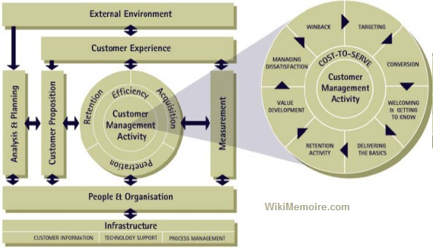
Figure 3. The QCI model. Source: (Cronin & Taylor, 2012)
This model puts customer management activity at the core of the model, and it uses people and organization as direct supportive processes. One other thing to note is that the QCI model does not use the “relationship” part of CRM. (Cronin & Taylor, 2012) argues that the strength of relationships differs in individual customer and service products, and the effect of the duration of the relationship and the regularity of purchase on relationship strength is contingent on the nature of service product.
Analysis and planning
Here, the behavior and value of different customers and customer group are understood, and they are segmented for planning activities to be effectively carried out. The planning process will be focused to allow the firm to acquire the value of its customer base, with focus on efficiency, retention, penetration, and acquisition.
Proposition
After the customers which are to be managed (or not) have been clear, propositions are created to match the needs of the customers, which must be attractive to the new customers. It is commonplace that there will be different propositions to be made for different customer groups (Kano, et al., 2004). In addition, the propositions must be detailed to drive the experience which the customer is expected to have when interacting with the organization’s touchpoints or products. Service standard development is crucial at this stage, and so it is important that the propositions are expressed to the customers.
Information and technology
Technology is utilized by the firm to help firms gain, manage, and use the huge volume of information with existing when managing customers. It is not a deliverable, rather it exists as an enabler, though it could act as a stopper when utilized ineffectively (Hernon, et al., 2015). The technology must deliver the existing information to the relevant person promptly to them to effectively manage customers. In addition, technology must be constantly reviewed to keep up with the new technological developments. Major processes here are a review of current systems, development of new ones, and quality management.
People and organization
To manage customers needs persons to be recruited, developed, motivated and managed in a supporting structure. The main variables in this aspect are; gap analysis and competencies definition, resources and training requirements, objective formulation and monitoring, and supplier selection and management.
Process management
This was opined by (Keaveney, 2014) is cumbersome to manage and implement formally in a context with many marketing and salespeople. However, clear and consistent processes are crucial to all aspects of customer management, and towards attaining continuous and step-change improvements. Also, processes must be revised constantly to be acceptable to both customers and the firm.
Customer management activity
This aspect is about the implementation of strategies to deliver the proposition across the customer lifecycle. Customer management includes: inquiry management, targeting, getting to know, welcoming, managing problems, winning back activities, and customer development.
Measuring the effect
Taking a measure of the elements of customer management activities leads to feedback into the planning process which ensures constant improvement thereby creating a sustainable competitive advantage.
Customer experience
The measuring activities must be complemented with the grasp of customer experience of interacting with the firm. Connecting customer’s actual and reported feeling, and their actions must be clearly understood to maximize loyalty. Experience of customers is measured using event-driven research, satisfaction monitoring, mystery shopping, benchmarking technique, and loyalty analysis.

2.4 THE CRM VALUE CHAIN MODEL

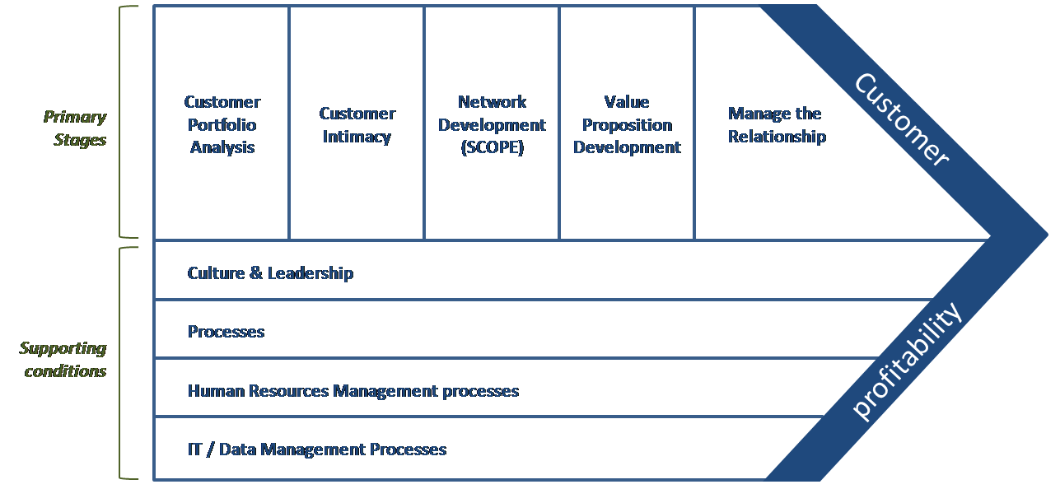
Figure 4. The CRM value chain model. source: (Payne & Frow, 2016)
This model was developed by Francis Buttle who postulated that businesses can rely on it to develop and implement their CRM strategies. The main purpose of the value chain process is to make sure that the firms develop sustainable mutually-beneficial relationships with the strategically-important customers (Payne & Frow, 2016).
In the model, there are five primary stages which include: customer portfolio analysis, customer intimacy, network development, development of value proposition, the management of customer lifecycle relationship. Then, their success is hinged on four supporting conditions which are: IT and data, culture and leadership, processes, and people. The five primary stages are involved in the creation and delivery of value proposition that acquire and retain profitable customers. In addition, the supporting conditions help the CRM strategy to function efficiently and excellently.
The five primary stages are explained as follows:
- The customer portfolio analysis step breaks down the customer base to reveal the right customers to target with different value propositions. The major question to be answered in this step by firms is “who the strategically valuable customers are?”. However, (Keaveney, 2014) suggests that companies without a customer history can adopt segmentation methods.
- The customer intimacy stage involves the processes of knowing the selected customers as segments and constructing a database which is available to people whose decisions affect customer behavior and attitude.
- The network development stage deals with the development of a strong network of relationship with suppliers, customers, investors and partners who have a knowledge of the needs of the customer.
- The value proposition development phase deals with creating propositions of symbiotic value for the firm and customer which must comply with the network from the preceding step.
- Managing the customer lifecycle stage entails the coordination of relationships with customers, and the focus in this phase is on process and structure.
Furthermore, (Grover, et al., 2012) posits that CRM solutions cannot be incorporated into any organization with the ultimate certainty that it will lead to business success. CRM requires a supportive culture as it will not be fruitful in companies that are not customer-centric. As a result, the supportive conditions of IT, HRM, and others, must be integrated with the CRM process. Businesses with a product-based orientation or reward systems focused on sales volume will find it difficult to implement the CRM agenda.

2.5 CHALLENGES OF VALUE CREATION THROUGH CRM
Privacy issues
The CRM tool operates on a database of customer data and the analysis of the data to aid better targeting of marketing communications and relationship-developing activities. There exists a trade-off in the capability of firms to deliver better-personalized services and products and the level of information needed to aid the delivery (Gronroos, 2014). Most especially with the prevalence adoption of the internet, many firms and advocacy groups are skeptical about the level of personal data which exists in databases and how it is utilized. As a result, this issue will continue to serve as a source of concern for businesses.
Direct marketers have engaged in mining of databases over the years by the means of analyses centered on census tract data, magazine subscription, motor vehicle records, credit card transaction, and other sources of information. Meanwhile, the provocative nature of unsolicited direct e-mails and the high volume of information secretly gotten when people surf the net through cookies, have gotten more notorious (Kotler & Keller, 2006). While many have argued that it is in the best interest of the customer to give their data to gain the rewards the internet has to offer, others disagree. The opponents of the notion have their arguments formalized in two options;
- Opt-in: this scenario needs web visitors to agree to the gathering and use of their private data, which allows the customer to better assert control over their data and build confidence in the industry. Meanwhile, in the view of the marketer, this will reduce substantially the level of data available in databases.
- Opt-out: this implies the Web version of direct marketing “negative reply” where a customer must plainly forbid the gathering and use of their data. This gives better information to marketers and hence improve the services and product available to customers. But customer will bear the loss of control of personal information.
These challenges will surely become even messier as the widespread use of wireless devices translates into more customer data becoming available.
The high failure rate of CRM implementation
The failure rate of the implementation of customer relationship management (CRM) is high, for instance; sometimes last decade, the failure rate of CRM projects was assessed to be from 55% to 75%. Also, up to 70% of CRM projects did not result in bottom-line improvement for the firms (Ranjan & Bhatnagar, 2014). Some scholars showed that for the many roles for the attributes of CRM process in the failure rate of CRM programs.
However, the crucial factors which contribute to the success rate of CRM projects are: (1) the successful integration between IT operations and business processes, (2) efficient management of business change process, (3) the grasp of CRM. Conversely, the factors which cause failure for CRM programs are: (1) failure to define business process before CRM implementation, (2) the ineffectiveness of measuring the deployment of CRM, (3) failure to re-engineer business process.

CHAPTER THREE

3.0 ANALYSIS

3.1 ORGANISATION QUALITY PROCESS AND ITS IMPACT ON CUSTOMER EFFECTIVENESS
A quality management system (QMS) refers to a formalized system which documents, procedures, processes, and responsibilities for attaining quality objectives and policies. A QMS aids management to direct and coordinate a firm’s activities, meet regulatory and consumer requirement, and enhance its efficiency and effectiveness on a continuous basis. ISO 9001:2015, the international standard which stipulates requirements for quality management systems serves as the most popular method in QMS.
A quality management system is used for numerous purposes, such as:
- Waste reduction
- Processes improvement
- Facilitation and identification of training opportunities
- Lowering of cost
- Staff engagement
- The setting of strategic direction
The implementation of a quality management system affects all areas of a firm’s performance. However, (Keaveney, 2014) opines that there exist two main advantages to the development and implementation of documented QMS which includes:
- Meeting the requirement of the firm, by guaranteeing compliance with various regulations and providing services and products in a resource and cost-efficient manner, making up room for growth, profit, and expansion.
- Meeting the needs of customers, by helping instill confidence in the firm, which then helps attract more customers, generate more sales, and repeat business.
Within these two main benefits are advantages such as, aiding to communicate an eagerness to create consistent results, prevent mistakes, reduce costs, ensure the definition and control of processes, and the continuous improvement of the firm’s offerings. (Nguyen & Sherif, 2017) posits that though any quality management system needs to be developed to address a firm’s specific needs, every system has these elements in common:
- quality manual
- the firm’s quality policy and objectives
- instructions, procedures, and records.
(Cronin & Taylor, 2012) opines that there are numerous things to consider when developing a quality management system in a firm, it is crucial to make it a strategic choice influenced by many needs, objectives, and services and product provided. The method is centered on the Plan-Do-Check-Act (PDCA) cycle, and it aids continuous improvement to the service and the QMS. The major steps towards executing a QMS are:
- Design
- Build
- Deploy
- Control
- Measure
- Review
- Improve
Design and build
The design and build part help to develop the structure of a quality management system, processes and plans for implementation. Top management will have to oversee this step to make sure the requirement of the customer and organization are the rationale behind the systems development.
Deploy
This phase is best deployed in a granularly through the breaking down of each process into smaller processes, and educating employees on aspects such as documentation, training tools, education, and metrics (Kano, et al., 2004). The intranets of firms are gaining prominence in their being used to deploy quality management systems.
Control and measure
Control and measurement are two aspects of creating a QMS which are hugely realized by routine, systematic auditing of QMS. The details vary from firm to firm based on size, environmental impact, and risk.
Review and improve
This involves how the outcomes of an audit are carried out. The objectives are to ascertain the efficiency and effectiveness of each process towards its goals, to communicate these outcomes to the workers, and create fresh best processes and practices according to the data gotten from the audit (Kano, et al., 2004).

3.2 DIFFERENT SYSTEMS FOR MANAGING QUALITY
Every firm possesses its own unique array of goals, products, beliefs and values. Quality management systems must embrace and reflect this uniqueness. To make this happen, there are many types of QMS, each with its own merits, and limitations. However, the following systems are popularly used:
Standardized systems
These are quality management systems which follow a set of code and regulations. These are ISO certifications, for example; ISO 14000/14001, ISO 9000/9001, ISO 13485, ISO 17025, HACCP, TS 16949, TL 9000, QSR Title 21 Part 820, A2LA, and OHSAS 18001. Firms which aim to follow these standards must satisfy the criteria and pass the audits. It is a prerequisite in some industries, while in others it is beneficial to firms’ strategic goals and objectives (Kano, et al., 2004).
Total Quality Management (TQM)
This is a managerial approach whereby the emphasis is on quality throughout all the aspects of a business. The goal here is to focus on the long-term creation of quality services and products through the breaking down of each individual process and activity to ascertain if it adds to or takes away from a firm’s quality goals and productivity (Keaveney, 2014). Divergent functions and processes are linked to the company’s values, goals, and beliefs by the development of flexible strategies.
Continuous Quality Improvement (CQI)
This is a quality system whose focus is on constant and continuous improvement and emphasizes on the role that individual and teams play towards quality. Functions and processes are not given much emphasis, rewards are considered an integral part of this quality management system. In addition, its “Plan, Do, Check, Act” approach has been modified to fit many firms and industries, even those who may not utilize CQI as their primary or quality management systems.
Six Sigma
Six Sigma represents a data-driven, disciplined, and methodology which aims for perfection in quality. It emphases on the reduction and improvement of deviation using specific outlined processes which are: define, measure, analyze, improve, and control. This is used by firms such as General Electric, and Motorola.

3.3 THE CONCEPT OF CUSTOMER EXPERIENCE
What it is and why it matters?
(Evans, 2012) defines customer experience as customers perceptions-both subconscious and conscious of their relationship with a firm’s brand because of their interactions with the customer lifecycle. Customer experience management is a practice of creating and reacting to the interaction of customers to meet and surpass customer expectations thereby increasing customer satisfaction, loyalty, and advocacy. Customer experience management transcends serving customers online. It involves having a complete knowledge about customers to give them a personalized and tailored experience which will spur them to be loyal and become advocates of the brand.
The concept of customer experience might be considered idealistic but (Grover, et al., 2012) argues that any firm who dismisses it does it at their own risk. Customer experience has also gained prominence as a crucial differentiator in the competitive business environment. These are a tangible value that businesses enjoy the effective management of customer experience. In addition, a good customer experience management can help companies to: increase revenue through sales from current customers, improve brand preference by the way of differentiated experiences, and increase customer loyalty and develop advocates by the means of memorable and valued customer interactions, and reduce cost through the reduction of customer churn.

Create and sustain complete
customer profiles

Successful customer
experience management
Personalize all customer
interactions

Get the right information to the
right place at the right time

Figure 5. Three steps to a successful customer experience management.
Source: (Sureshchandar, et al., 2012)

3.4 MANAGING THE TOTAL CUSTOMER EXPERIENCE
Recently, managers have come to be aware of the importance of value creation for their customers through experiences, but they have failed to properly understand the concept as they see it as just the provision of entertainment or being creative. (Bolton, 2014) argues that it is more complex than that. To execute such a strategy, firms must completely understand the journey of the customer, starting from their expectation before the occurrence of the experience to the assessments they might make at the end.
Because of this knowledge, firms can now develop an integrated series of “clues” whose combination serve to meet (and sometimes exceed) the expectation and emotional needs of customers. (Sureshchandar, et al., 2013) opines that the internalized internal meaning and the value the clues contain have the power to create a strong preference for a specific experience, and thereby for a firm’s service or product over another’s. A first step towards managing total customer experience is to know the clues it sends to its customers. Those firms find themselves in trouble (in the form of decreasing customer satisfaction scores) must carry out a focused, and comprehensive management of the numerous clues which gives off signal to customers.
“A company’s initial step towards managing the total experience is knowing the many clues it sends to customers”
Clues go beyond snippets of information or fragments of physical evidence which is only obvious to the keen mind. These clues were argued by (Lassar, et al., 2010) to constitute customer experience and are everywhere, also they are easily distinguished. Whatever which is sensed or perceived or recognized through its absence represents an experience clue. Hence, a service or product exudes an array of clues, the physical location does too, and the employees’ comments, dress, and tone all consists of clues which convey a message to the customer. The sum of all these clues makes up the customer’s total experience.
(Lassar, et al., 2010), (Kano, et al., 2004) posits that clues which constitute the customer experience can be divided into two aspects. The first borders on the actual operation or functioning of the service or good. The clues which relate to the functionality of the service or good are taken in mainly by the brain’s logical circuitry. While the second aspects border on the emotions which include sounds, smell, taste, good’s texture, ease of service, and the physical environment in which the service was offered. This second aspect of clues is subdivided into two parts: “humanics” which are clues emitted by people, and “mechanics” which are those clues emitted by things.
There is no gainsaying the fact that providing customers the right clue about functionality is crucial, if a good or service is deemed inferior, the customer will not buy it. What is iffy, perhaps, is that emotional clues, the “mechanics” and “humanists” are as important to customer experience, and work in synergy with functional values. (Gronroos, 2014) posits that the customer value must not be restricted to functionality vs price. Rather, it must consist of both the functional and emotional values minus the financial and non-financial cost they incur.
” Firms must engage the emotional component of experiences with the vigor they bring to the management of product and service functionality”
To completely capture the experience as an element of a customer-value proposition, firms must effectively manage the emotions of experiences with the same commitment they apply to the management of service and product functionality. (Grover, et al., 2012) posits this can be achieved through the observation of customer and interacting with them concerning their experiences to have a deeper knowledge of those clues they are processing throughout their encounters with the firm. Customers have experiences (good or bad) anytime a purchase is made from a company. The key is for companies to effectively manage the customer experience.
Finally, firms can stay ahead of the competition when they add up emotional and functional benefits in their various offerings. (Keaveney, 2014) argues that the emotional connection between companies and customers are tough for rivals to undo. Therefore, to successfully compete in this context, an increasing number firms are adeptly using tools and principles of customer experience management to increase and sustain customer loyalty. Unlike several enhancements of product and services, the all-inclusive nature of these designs makes them very tough for rivals to imitate.

CHAPTER FOUR

4.0 CONCLUSION
The purpose of this report was to appraise the factors which affect an organization’s ability to maximize customer value, and to analyze the quality process in the workplace and its effect in satisfying customer requirement. Using the IDIC model, Payne five-process model, quality competitiveness model, and the CRM value chain model, companies can increase customer value by the adoption of customer relationship management (CRM), whereby data about customer needs and preferences can be extracted through the various touch points of the organisation (using technology) to meet and exceed the needs of customers thereby guaranteeing customers satisfaction and loyalty, and increased profits for organisation (Payne & Frow, 2016).
The essence of quality standards in the workplace was also appraised. Quality processes have a strong impact on improving the customer experience through the production of superior and error-free products and through superior service delivery. In addition, management has a great chance of improving customer value, loyalty, and the firm’s competitive advantage if they properly manage the experiences of their customers through the clues left behind by the customers during their interactions with the firm.

REFERENCES
Bolton, 2014. customer centric business processing.. International journal of productivity and performance management, 53(1), pp. 44-51.
Cronin & Taylor, 2012. measuring service quality: a reexamination and extension. journal of marketing, 56(3), pp. 55-68.
Evans, 2012. measuring and managing customer value. work study, 51(3), pp. 134-139.
Gronroos, 2014. A service quality model and its marketing implications. European journal of marketing, 18(4), pp. 36-44.
Grover, Kettinger & Teng, 2012. business process change in the 21st century. business and economic review, 46(2), pp. 14-18.
Hernon, Danuta & Altman, 2015. service quality and customer satisfaction: an assessment and future directions. journal of academic librarianship, 25(1), pp. 9-17.
Kano, Seraku, T. & Tsuji, 2004. attractive quality and must-be quality. the journal of Japanese society for quality control, 14(4), pp. 266-277.
Keaveney, S., 2014. Customer switching behavior in service industries: An exploratory study. journal of marketing, 6(5), pp. 266-277.
Kotler & Keller, 2006. Marketing management. 12th ed. New Jersey: Prentice Hall.
Lassar, Manolis & Winsor, 2010. service quality perspectives and satisfaction in private banking. journal of services marketing, 14(3), pp. 244-271.
Nguyen & Sherif, N., 2017. strategies for successful CRM implementation. Information management and computer security. information management and computer security, 15(2), pp. 102-115.
Payne, 2006. Handbook of CRM: Achieving excellence in customer management. OXFORD: Elsevier.
Payne & Frow, 2016. customer relationship management: from strategy to implementation. journal of marketing management, 22(4), pp. 135-168.
Ranjan & Bhatnagar, 2014. principles for successful CRM in organizations.. international journal of marketing, 4(2), pp. 239-247.
Sanchez & Sanchez, 2015. analysis of customer portfolio and relationship management models: bridging managerial dimensions.. journal of business and industrial marketing, 20(6), pp. 307-316.
Sureshchandar, Rajendran & Anantharaman, 2012. customer perception of service qulaity. total qulaity management, 12(1), pp. 111-124.
Sureshchandar, Rajendran & Anantharaman, 2013. the relationship between service quality and customer satisfaction- a factor specific approach. journal of service marketing, 16(4), pp. 363-379.
Toor, 2009. creating a competitive edge through improved customer relationship management. business strategy series, 1(55-60), p. 10.

