Marketing plan written for

_______________________Travelodge Edinburgh Haymarket______________________

Student Name
Stancheva Yanka
__________________________________________________

Student ID number
2210661

Marketing Essentials BMIH4005

Lecturer
Christopher Wilkin

Introduction
The Travelodge hotel in Edinburgh will use advertising channels as part of its current marketing strategy to draw in new guests during the winter period. The SWOT and PESTLE analyses, as well as targeting, segmentation, and strategy for reaching the goal, will all be covered in the marketing plan.
Marketing plan
The Travelodge Edinburgh Haymarket hotel goal is to fulfil the travel demands of new guests by providing services that adhere to their standards for complexity, cost, quality, and the use of effective, ecologically friendly materials (Harvey, 1998). The two stars low-cost hotel has capacity of the 55 rooms. The hotel facilities include restaurant, dining room, bar, room service, laundry, and conference room. The hotel is pet friendly (Travelodge, 2022).
With many visitors a year, Edinburgh is one of the world's top tourist destinations. Ideal for domestic city break for local and international tourists. According to the ETAG (2015) the top attractions in Edinburg are Edinburgh Castle, National Museum of Scotland, Royal Botanic Garden and Scottish National Gallery.
SWOT analysis
Threats
- Increased competition with better facilities (Bowie et al., 2017)
- Foreign tourists may prefer to stay somewhere else because they would not be familiar with Travelodge.
- Changes of the Economic conditions
- Increased levels of Covid19 cases
Opportunities
- New customers during the winter period
- Improvement of the customer experience by creating more customer engaged content for the social media
- Building brand equity through customer experience (De Chertony et al., 1998)
Weaknesses
- Supply struggles – the high energy and gas bills have negative impact (Witts, 2022)
- The guests need to pay in addition if they would like to use the WIFI in the hotel rooms.
- Paid early/late check IN or OUT
- No available car park at the hotel. The closest car park is paid (Travelodge, 2022)
- Not ideal for large groups or families who need more space and rooms.
Strengths
- Very good location close to attractions and shopping centre
- Christmas market which it is only 25 minutes’ walk from the hotel and other Christmas activities
- Good transport links and train station “just around the corner” (Travelodge, 2022)
- Provide rooms to its visitors at a very attractive price (Benzaghta et al., 2021).
- Onsite restaurant and bar

Segmentation and targeting
Travelodge Edinburgh Haymarket hotel market segmentation is based on adventure travellers, history passionate, culturalists, shoppers, food lovers and train travellers (no parking). Middle aged and adults with cultural tastes, looking for new experiences, adventures, and hidden gems (ETAG 2015). Families looking for UK short or long breaks during the school holidays to visit the historic sites and attractions such as ice skating, light trails, and meet Santa Claus in Edinburg. According to Visit Scotland survey (2015), for 65% of Edinburgh tourists the main driver visiting the city is the history and culture of the city.

Competitors
Competitor analysis goes viral to help the hotel meet the goals set in the marketing plan. According to the Poster’s five framework, competitive strategies must be able to keep up with changes in the hospitality industry and remain profitable in the market by looking for opportunities and innovations (Bruijl, 2018). The hotels situated close to the Travelodge in Edinburg are following:
- No.32 Hotel – Victorian style rooms. Free WIFI. Twin rooms.
- The Haymarket Hotel – Deluxe rooms. Free WIFI. Late Check Out.
- The West end Hostel – 6 or more bunk beds in a shared room. Not suitable for families with children but may be desirable from the adventure seekers.
- Cumberland – limited paid parking for £10 per day. Free WIFI. Restaurant.
- Eliza House Edinburgh – 21 bedrooms. Free WIFI (Tripadvisor, 2022)

All hotels in the area offers free WIFI to their guests, but Travelodge charges a fee. Due to its central location, most hotels do not have a car parking and some of the hotels are more expensive than Travelodge.

Collaborators
The Travelodge Hotel has partnered with Tenpin – Bowling to bring you family vacations at promotional prices. Gourmet Society Diners Group offers up to 50% off dinning at popular restaurant chains such as La Tasca, Café Rouge, Bella Italia and Country Clubs. Sleepeezee is another Travelodge partner. Guests who love Travelodge beds and want to purchase their own mattress are offered £20 discount (Travelodge, 2022).

PESTLE analysis
Political – Limited migration and free movement, may have an impact on Travelodge, due to the lack of EU workers after Brexit (Portes, 2016). In 2022 the brand launched an offer for 500 job positions across UK, helping the candidates to develop their knowledge in hospitality industry. The Travelodge Parent Program supports parents to find a work during school hours, close to their children’s school (Travelodge 2022).
Economic - High inflation means lower growth that might cause economic crisis (Jongrim Ha et al., 2019). The high cost of petrol, as well as the high electricity bills, are affecting the hotel chain and their recovery plan still facing challenges due to the current economic environment. (Travelodge 2022).
Social factors – Travelodge chain opened the 597th hotel in Hexham in December. This is the first budget luxe hotel with stylish design but with the same affordable low-cost prices. The expansion program represents an investment of around £160m for third party investors and could create 400 new jobs (Hospitality, 2022).
Technological - Website improvement and fraud detection – the company enhanced their main website, to be able to stop or identify fraud or other website abuse, and allow third parties to perform technical, logistical, or other tasks on their behalf (Travelodge 2022).
Legal – Making a reservation through any company digital channel (such as website, mobile website, or app) or telephone reservation, the Terms and Conditions apply according to the GDPR.
Environmental – Travelodge supports sustainability for saving a planet and better life represented in their “Better Future plan” and an award-winning global management consultancy specializing in ESG and sustainable business (Travelodge 2022).

Objectives
The hotel’s main objective is to attract 500 new customers from UK and oversea targeted above. The campaign will be effectuated during the winter period September 2023 – February 2024. Low-cost choice for affordable travel close to the top attractions and shops in Edinburgh. Offering new opportunities to the new customers will increase the sales and brand awareness.

Strategy
According to Sharp (1980, p.5) differentiation strategy using low-cost prices it is highly demand from the customers next to the good customer services. SEO Optimisation, blog update, email newsletter, partnership with influencers, local business, and events, as well as the review companies such as Tripadvisor. Implementing the most appropriate strategy will improve the quality service provided by Travelodge Edinburgh (Gkatsikou, 2018).

Marketing Mix
- Product – double room, family room, restaurant
- Place/Distribution – Edinburgh central location, close to the Christmas Market, Ice skating, Christmas Lights on, Botanical Gardens Light Trail, Edinburgh castle and others (Everything Edinburgh, 2022)
- Price – affordable low-cost price suitable for short stay
- Promotion – Discount code of 15% for first stay. Hotel’s first guests during this period will be encouraged to add a tag to their social account and to share their experience.

Action
The successful campaign is being measured by the number of new customers, increase sales, website visits, tags, and engagement with the audience in social media (Flowers, 2003). The campaign will be promoted on TV, radio, social media, email marketing, influencers. Destination marketing – direct sales in the hotel, affiliate marketing, printed materials. The positive image, hotel relationship with the customer, and adding value to the hotel image will be another benefit gained after the campaign (De Chertony et al., 1998).

Gannt chart
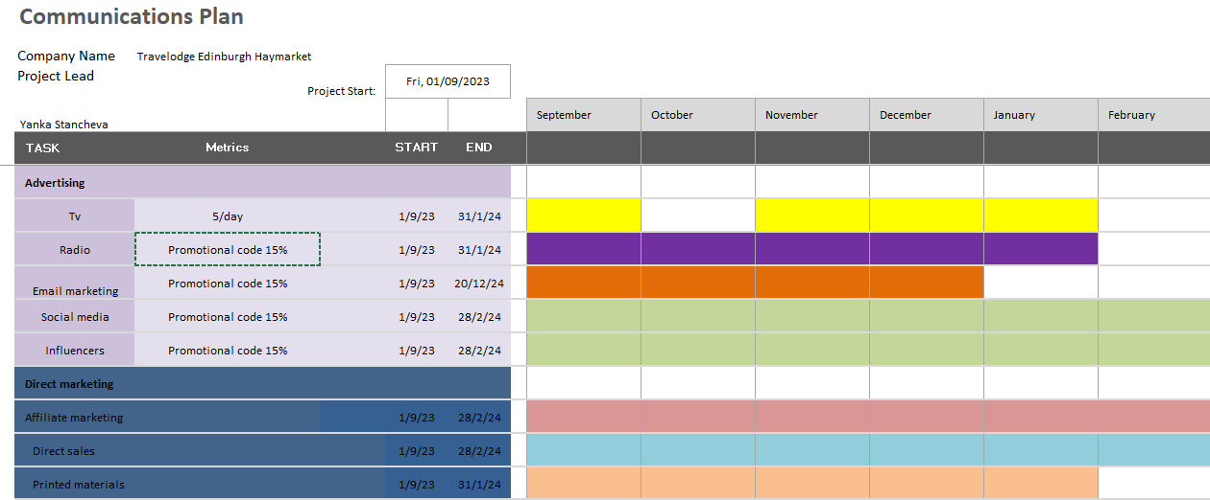

Conclusion
Price, product, and differentiation tactics were put into practise according to the marketing plan discussed above. A successful marketing message was developed for the Travelodge hotel's campaign to attract new customers throughout the winter months with the aid of segmentation and targeting techniques. Offering affordable lodging in a popular location will increase brand recognition and the hotel's reputation.

References
Benzaghta, M.A., Elwalda, A., Mousa, M.M., Erkan, I. and Rahman, M. (2021) SWOT analysis applications: An integrative literature review. Journal of Global Business Insights, 6(1), pp.55-73.
Bowie, D., Buttle, F., Brookes, M., Mariussen, A. (2017) Hospitality marketing. Routledge: New York. Third ed.
Bruijl, Gerard H. Th. (2018) The Relevance of Porter's Five Forces in Today's Innovative and Changing Business Environment. Available at: SSRN: https://ssrn.com/abstract=3192207
De Chertony,L., Dall’Olmo Riley, F. (1998) A positioning analysis of hotel brands experts' interpretations. Journal of marketing management, 14, 417-444
ETAG (2015) Tourism in Edinburgh. Scottish enterprise: Edinburg Tourism Action Group
Everything Edinburgh (2022) Thinks to do in Edinburg in winter. Available at: https://everythingedinburgh.com/things-to-do-in-edinburgh-winter-christmas/ (Accessed 27 November 2022)
Flowers, J.F., Haynes, A.A. and Crespin, M.H. (2003), The Media, the Campaign, and the Message. American Journal of Political Science, 47: 259-273. https://doi.org/10.1111/1540-5907.00018
George, R. (2021) Market Segmentation, Targeting, and Positioning in Marketing Tourism and Hospitality (pp. 221-246). Palgrave Macmillan: Cham

Gkatsikou, S. (2018) The Grande Bretagne Hotel, a strategy plan to address challenges up to 2021. International Hellenic University. Available at: https://repository.ihu.edu.gr/xmlui/handle/11544/29004 (Accessed 26 November 2022)

Jongrim Ha, Kose, M. A., Ohnsorge, F. (2019) Inflation in Emerging and Developing Economies: Evolution, Drivers, and Policies. The world bank: Washington

Harvey, J. (1998) Service quality: a tutorial. Journal of Operations Management. Volume 16, Issue 5, Pages 583-597

Hospitality Net (2022) Travelodge Hexham. Available at: https://www.hospitalitynet.org/announcement/41008374.html (Accessed 2 December 2022)

LJ Research (2016) Edinburgh Visitor Survey 2015. Available at: https://www.visitscotland.org/binaries/content/assets/dot-org/pdf/research-papers/scotland-visitor-survey-edinburgh-city-2016.pdf (Accessed 29 November 2022)

Kotler, P. and Armstrong, G. (2018) Principles of Marketing, 1tth Edt. Harlow: Pearson.

Porter, M.E. (1980) Competitive strategy: Techniques for analysing industries and competitors. Free Press: New York
Portes, J. (2016) Immigration, free movement and the EU referendum. National Institute Economic Review, 236, 14-22. doi:10.1177/002795011623600103
Travelodge (2022) Edinburg Haymarket Hotel. Available at: https://www.travelodge.co.uk/hotels/353/Edinburgh-Haymarket-hotel (Accessed 29 November 2022)
Tripadvisor (2022) Hotels. Available at: https://www.tripadvisor.co.uk/# (Accessed 01 December 2022)
Witts, S. (2022) Survey results: how are rising energy bills affecting hospitality businesses? The Caterer. Available at: https://www.thecaterer.com/business/hospitality-energy-bills-impact-the-caterer-survey-2022 (Accessed 02 December 2022)



