BMSW4004-Problem Solving and Decision Making

SEDA KOCA – 1921328

YAJESH KUMAR

Table of Contents

1. Introduction 3
2. Complex problems in workplace situation 3
3. Application of problem-solving tools 4
3.1 Mind mapping 4
3.2 Force Field Analysis 5
3.3 ADKAR change management model 6
4. Solutions to the problem 7
5. Evaluation of alternate solutions 8
6. Selection of the best solution 8
7. Implementation of the solution 9
8. Monitoring and control 9
9. Communication to stakeholders 9
10. Recommendations 9
11. Conclusion 10
References 11

1. Introduction
ObGyn Matters London is a group of five top Obstetrics and Gynaecology consultants. Its goal is to provide private, intimate, and tailored treatment.
From its facilities in Central London, it provides a wide range of Specialist, Private Obstetrics and Gynecology services (W1). Its two Senior Specialist Consultants have over 30 years of experience serving as Consultants at top London Teaching Hospitals. ObGyn Matters London is delighted to give patients 30-minute appointments 5 days a week.
Problem solving and decision making in ObGyn Matters London are important for leadership and management. There are specific techniques and processes to initiate improvement in decision-making leading to quality of decisions. For effective decision-making and problem-solving, a host of tools are available that facilitate the process. Those are primarily instrumental in identifying the causalities as well as charting the subsequent course of actions. However, before the application of any of the analytical tool, the main problems or issues in the workplace have to be accurately found out.

2. Complex problems in workplace situation
The complex problems in ObGyn Matters London arise due to the impending organisational change. Such ensuing change has ended up causing confusion, misunderstanding and lack of motivation among employees.
There is a greater degree of resistance to organisational change owing to the confusion among employees. When they are not well apprised about the consequences or impact of the planned changes, they usually harbour reservations about the same. Naturally, their efforts fall short of mutual co-operation that they may have otherwise extended. The reservation of employees is main due to poor management of change and bad execution. In such a situation, the upper echelons of the management must ensure direct supervision of the organisational change implementation.
Poor communication during the change process causes strife and misunderstanding among employees. It is most likely to take place in case of a perception of the creation of opposing interests. More often than not, employees may perceive that the organisational change may be in conflict with their own personal goals. Lack of effective communication may cause misunderstanding among employees to perpetuate.
Lack of motivation emanate from insecurity with respect to jobs, the continuous feeling of being under-valued as well as poor leadership. In the absence of self-efficacy among employees, the organisational change will be difficult to implement.

3. Application of problem-solving tools

3.1 Mind mapping
The mind mapping analysis tool is highly effective to facilitate the graphical representation of concepts and ideas for ObGyn Matters London. The structuring of information becomes easier with visual cue leading to better analysis, comprehension, synthesis, recalling and generation of new ideas. It not only highlights the important facts but also exhibits an overall structure of the issue in question and its relative importance to its constitutive components for ObGyn Matters London. There is greater scope to make the tenuous connections between various ideas. There are certain essential characteristics to mind-mapping. The characteristics include the main idea subject to be kept within the central image. All the branches comprise of separate keywords. Following that, the topics or issues that are of lesser importance will be represented as ‘twigs’. Subsequently, the branches go on to form a connected model structure. Finally, it should take the form of a highly organised diagram (Tamir and Thornton, 2018).
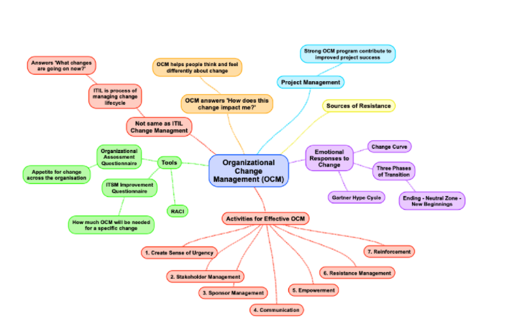
Figure 1: Mind mapping
(Source: Tamir and Thornton, 2018)
The mind mapping analysis in case of ObGyn Matters London organisational change management has to first ascertain the initial components of emotional responses, activities related to organisational change management, assessment questionnaires, definite scopes for project management along with the identification of the sources of resistance. Once these broad heads have been categories, the subsequent branches move out from these parameters.

3.2 Force Field Analysis
Lewin’s force field analysis model is utilised for making the distinction between factors that are within a specific situation or within a firm that moves away from a desired state, with that of the opposing driving forces. The core idea of force field analysis is that whichever situations are being maintained by equilibrium among the forces driving change, and at the same time the forces that exerts resistance on change. For the change to ultimately take place, the resisting forces have to be weakened and the driving forces are to be strengthened. This analytical tool is particularly useful for ObGyn Matters London to arrive at decisions through analysis of the forces for and against the ensuing change. It also incorporates effective communication of mentioning the reason behind the change decision of ObGyn Matters London. The usage of the analytical tool usually spans across five major steps. In step one, the proposal for change or plan is described. In the second step, the forces for change are identified. Thirdly, forces that are against change have to be identified. The fourth step includes assigning scores indicating weak and strong forces. The final step relates to the analysis and application (Schwarz, Buono and Adams, 2019).
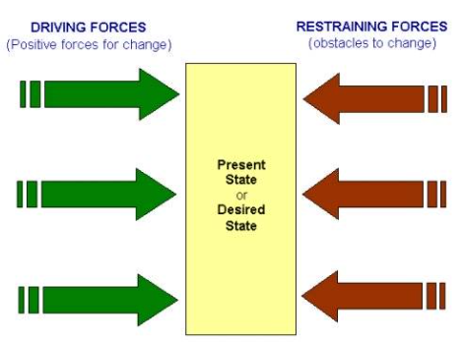
Figure 2: Force Field Analysis
(Source: Schwarz, Buono and Adams, 2019)
In implementing ObGyn Matters London organisational change, the positive forces for change relates to further growth opportunities, and enhancement of career prospects. The restraining forces relate to lack of communication that give rise to mistrust, confusion, and general disregard for the change to be implemented at ObGyn Matters London.

3.3 ADKAR change management model
The ADKAR model is an effective tool in enabling individuals to cope and plan for the process of change along with monitoring of their reactions, as it proceeds. Even though the model may occur in order, it is crucial to recognise that different individuals will be at different stages across the process at different points of time. The term ‘ADKAR’ is an acronym of five different outcomes that an entity needs to achieve in order to ensure that the change is successful. The terms are – Awareness, Desire, Knowledge, Ability and Reinforcement. The model is dependent on the core understanding that organisational change can only take place when the individuals change. The model is instrumental in guiding individuals through the change process by way of eliminating barriers or roadblocks along the way. The parameter of Awareness relates to the need for change, Desire involves the participation and support for change, Knowledge pertains to the manner on how to change, Ability is the implementation of desired skills and behaviour and Reinforcement is the sustaining of change (Karambelkar and Bhattacharya, 2017).
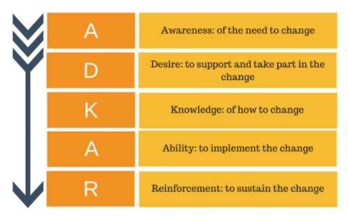
Figure 3: ADKAR Change Management Model
(Source: Karambelkar and Bhattacharya, 2017)
The model has to be made outcome oriented for the purpose of facilitation of change with the establishment of clear milestones to be reached at ObGyn Matters London. Milestones have to be reached all along the process. All the stakeholders of ObGyn Matters London and affected members of ObGyn Matters London have to be brought within the fold of change management deliberations. All persons involved in the change must reach their own goals in the determined time. To elucidate, while one person may already have developed the desire to change, another person may be in the process to merely become aware about the need to change. Thus, the implementation of this model would start with the creation of awareness about the need of change, followed by fostering a desire to initiate the change at ObGyn Matters London. Subsequently, appropriate knowledge had to be disseminated about how to change. Furthermore, it has to be ensured that all employees at ObGyn Matters London have the ability to make the change. There must be confidence about one’s own competencies. Finally, there has to be reinforcement of the change so that effective processes are built up at ObGyn Matters London.

4. Solutions to the problem
Other alternatives are available in lieu of organisational change. Some of those include –
Incremental adjustments: Incremental adjustments are known to have the impact of reducing some of the disruptions that otherwise occur owing to organisational change. Growth in ObGyn Matters London, more often than not, exhibit incremental adjustments.
Prototypes: Prototypes comprise of the yet-to-be announced projects which is likely to bear a substantial impact on ObGyn Matters London. It is often held to be an ideal way to introduce change which may have otherwise caused resistance among employees.
Cross-functional training: Cross functional training involves promotion or shifting of employees from one position to another making them better accomplished for job sharing at ObGyn Matters London. It can be particularly effective when plans are afoot to merge two or more departments.
Trial period: Trial period bears resemblance to prototype that includes trial run of a process across ObGyn Matters London. If such a trial does not prove to be worthwhile, ObGyn Matters London reverts to the original position (Rosenbaum, More and Steane, 2018).

5. Evaluation of alternate solutions
Incremental adjustments: Incremental adjustments enable employees to adjust to the organisational changes over a period of time. Naturally, it reduces the resistance which may have originated from employees. The changes are being slowly built up which ultimately goes on to ensure efficiency of the process.
Prototypes: Even though employees may have initial difficulty to accept the concerned change but a positive difference can be witnessed when the organisational change eventually comes into fruition. Prototypes primarily act as test-case that elicits much less friction.
Cross-functional training: Cross functional training enhances self-efficacy among employees and equips them with the necessary skills which allow them to hold down other hob roles within the particular organisation. It imparts a prior understanding among at ObGyn Matters London employees about the possible responsibilities in different other job roles.
Trial period: One of the major advantages of trial period is that reverting to the original position would not involve too much difficulty for the organisation. It can always return to its conventional business methods. The resistance among employees at ObGyn Matters London will also be minimal (Rosenbaum, More and Steane, 2018).

6. Selection of the best solution
The optimum solution for the for the requisite organisational change would be initiating incremental adjustments. Such incremental changes will be focusing on individual components with the objective of regaining or maintaining equilibrium.

7. Implementation of the solution
Incremental adjustments are to be implemented through the following stages –
1. Conducting assessments: A change characteristics assessment would enable to discern the nature of the planned change and also the extent to which it would be disruptive for ObGyn Matters London.
2. Segmentation of groups and addressing those: Not all business units or employee groups will be same at ObGyn Matters London. The approach has to be adjusted on the basis of how uniquely it impacts those groups.
3. Customisation of approach: The incremental adjustment strategy must take into consideration the potential for causing disruption and make the change management plans accordingly at ObGyn Matters London (Day, Crown and Ivany, 2017).

8. Monitoring and control
In the scope of monitoring incremental change, it must be first identified what it is being improved. It is due to the fact that a solid business case must be presented to the stakeholders at ObGyn Matters London. It is only after that the plan for change should be framed.

9. Communication to stakeholders
The communication to stakeholders should span across the entire change process. It should ideally initiate with what is the change that organisation is seeking make and also include the extent of its success.

10. Recommendations
Some of the recommendations about the implementation of organisational change are mentioned below –
- Notwithstanding the strategy or approach adopted for organisational change, one of the factors that should remain constant is effective communication. ObGyn Matters London’s employees must be kept well-informed at all times, and they should also have a role to play in the decision-making process. Employees must not be excluded from the plans of change in organisation
- Organisational change must be clearly defined and be in alignment with the business goals. There is always a need for articulation of the change and also undertake a critical review against the objectives and performance goals of ObGyn Matters London.
- The impacts must be determined along with the assessment of those who will be affected. Such effect should be reviewed across all business units
- Providing effective training is crucial to generate self-efficacy among employees
- Implementation of a support structure assists employees to practically adjust to organisational change and also build technical skills and proficiency of behaviours
- Measurement of the change process would show the progress of organisational change

11. Conclusion
It can be understood that proper strategy must be adopted for organisational change management. The significance of change management can be seen in the assessment and understanding the need and impact of change apart from aligning resources with the business to support the organisational change. The entire process also helps to undertake the management of the diverse costs of change.

References
Day, A., Crown, S. and Ivany, M., 2017. Organisational change and employee burnout: The moderating effects of support and job control. Safety Science, [online] 100, pp.4-12. Available at: <https://www.sciencedirect.com/science/article/abs/pii/S0925753517304277>
Karambelkar, M. and Bhattacharya, S., 2017. Onboarding is a change. Human Resource Management International Digest, [online] 25(7), pp.5-8. Available at: <https://www.emerald.com/insight/content/doi/10.1108/HRMID-04-2017-0073/full/html>
Rosenbaum, D., More, E. and Steane, P., 2018. Planned organisational change management. Journal of Organizational Change Management, [online] 31(2), pp.286-303. Available at: <https://www.emerald.com/insight/content/doi/10.1108/JOCM-06-2015-0089/full/html>
Schwarz, G., Buono, A. and Adams, S., 2019. Preparing for High Impact Organizational Change. [online] Available at: <https://www.elgaronline.com/view/edcoll/9781788116947/9781788116947.00021.xml>
Tamir, D. and Thornton, M., 2018. Modeling the Predictive Social Mind. Trends in Cognitive Sciences, [online] 22(3), pp.201-212. Available at: <https://www.sciencedirect.com/science/article/abs/pii/S136466131730267X>

