
Andrew Campbell

An Investigation into the impact of a Lead Musket Ball upon a Metal Breastplate

School of Applied Computing
Ordnance, Munitions and Explosives

Physics Level 4
Academic Year: 2024 - 2025

Supervisor: Kelvin Donne
March 2025

Academic integrity declaration
I declare that:
- the thesis submitted has been written by me alone.
- the thesis submitted has not been previously submitted to this university or any other.
- that all content, including primary and/or secondary data, is true to the best of my knowledge.
- that all quotations and references have been duly acknowledged according to the requirements of academic research.
I understand that to knowingly submit work in violation of the above statement will be considered by examiners as academic misconduct.

Contents
Academic integrity declaration 2
1. Abstract 3
2. Introduction 3
3. Material Model 5
4. Results 6
5. Conclusion 16
6. Bibliography 17

Figures, Tables and Equations
Figure 1: Initial Impact of Bullet on the cast iron breastplate. The left hand side shows the compression stress the right the shear stress 7
Figure 2: Impact of Bullet on the cast iron breastplate. The left hand side shows the compression stress the right the shear stress 8
Figure 3:Impact of Bullet on the cast iron breastplate. The left hand side shows the compression stress the right the shear stress 9
Figure 4: Ricochet of Bullet on the cast iron breastplate. The left hand side shows the compression stress the right the shear stress 10
Figure 5: Impact of Bullet on the Steel breastplate. The left hand side shows the compression stress the right the shear stress 11
Figure 6: Impact of Bullet on the Steel breastplate. The left hand side shows the compression stress the right the shear stress 12
Figure 7: Impact of Bullet on the Steel breastplate. The left hand side shows the compression stress the right the shear stress 13
Figure 8: Ricochet of Bullet on the Steel breastplate. The left hand side shows the compression stress the right the shear stress 14
Figure 9: Plot of the velocity of the bullet against time when impacting the breastplate. Left hand side is the cast iron plate, right hand side is the AISI 1018 steel plate. 15

Table 1: Parameters for the material models of the simulated components 6
Table 2: Input parameters for Johnson Cook dynamic failure model 7

Equation 1 6

Abstract
This paper deals with the impact of a lead bullet against a simulated breastplate equivalent to the arms and armour used around the late 16th century. This was a period of rapid changes in weapons and armour as the use of firearms propagated throughout the western world. Armour remained a relevant factor in western military units until the 19th century, and this paper investigates the effectiveness of breastplates at the time of the mass adoption of matchlock muskets. It investigates it through the use of Finite Element Modelling in Abaqus. This has been calculated using values to simulate the behaviour of materials used found in literary sources and the results compared between two different breastplates and compared to the historical record.

Introduction

The student was tasked with investigating a high velocity impact onto a target plate using Abaqus to simulate said problem. A Johnson-Cooke damage model was then used within the software to simulate how the bullet would interact with the plate. The particular focus chosen was to simulate a lead musket ball of a similar kind to those found in European Armies in the 16th century in a typical matchlock musket striking an armoured breastplate as was commonly worn by troops in that period. Two different metals would be chosen for the breastplate to simulate the difference in metallurgy of the armour worn by troops in that period.
The rise of firearms in European armies during the renaissance and early modern period was a gradual process with their use in a battle being documented as far back as the Battle of Crecy in 1346 [1]. These, however, were not handguns and were larger field pieces and it would take many years of development before the mass deployment of hand gunners would be encountered with the rise of the arquebus. This was a much superior weapon that spread throughout the second half of the 15th century in European and Middle Eastern armies, with a shoulder stock and serpentine handle to hold a cord of match it was more effective than the earlier handgonne’s that were wildly inaccurate and difficult to fire [2]. Their efficacy can be seen in the phasing out of crossbowmen and archers in armies during the late 15th and early 16th century. James IV of Scotland in issued an Act of parliament in 1491 banning golf and football so that archery would be instead be practiced [3] but, by 1535 the Scottish parliament, “required gentry to be armed with ‘hagbuts’ and ‘hagbuts of crochert’ at the wappinschaws” [4].
The sea change that this development in weapons technology provided is shown clearly with the Battle of Pavia in 1525. Where a smaller Imperial-Spanish force defeated the French in the Italian wars. The use of arquebusiers to defeat the heavy French cavalry which had been preeminent among western European armies throughout the Middle Ages [5]. This signalled the shape of things to come with the Knight in shining armour gradually fading away over the next century.
Nevertheless, armour would continue to be worn well into the 19th century on cavalry and until the second half of the 17th century on infantry in western European armies. It was still an effective means of protection even if the thickness of the plate increased throughout the period it was only with the improvements made in firearms in propellants and the bullet during the 19th century with the advent of the industrial revolution did body armour reach a state where the thickness required to provide effective protection was greater than an average soldier could realistically wear [6]. While some cavalry in the French army did wear armour during the opening months of the First World War it was by this point nothing more than excess weight and offered no protection to modern firearms.
The period focused on is when the state of play between armour and bullet was quite even. As can be seen from the armour developments and the changing thickness of the breastplate and how much armour an individual would wear throughout the 16th and 17th centuries. That armour was effective against shot is undoubtedly true. The comparatively low casualties sustained by the Knights Hospitaller of St. John during the Great Siege of Malta are a testament to that. It is not unfair to say that a large degree of their success in holding the Ottoman forces at bay until relief arrived can be given to the armourers of Europe [7]. While not impervious many a knight survived with a dent to their breastplate.
Therefore, for this investigation it was decided to simulate the same bullet and size of breastplate using a different metal in the construction of the plate. This is due to the wide variance in metallurgy of the period. Blacksmiths of the period did not have access to modern metallurgy or even production techniques like the Bessemer process and were forced to rely on bloomeries and the colour of the heated metal to tell whether it was ready [6]. Thus, the results of their efforts could vary and were prone to impurities and differences in how brittle or soft they could be. Unfortunately, it was not possible to obtain a metallurgical example of plates of the era that could have a damage model transcribed into Abaqus so instead models for modern metals were used that were expected to provide an idea of what a brittle and ductile metal of the era would behave like. The metals chose were Cast Iron and AISI 1018 steel (a low carbon highly ductile steel alloy). These were used on the Breastplate that was 4 mm thick similar to the maximal thickness of Breastplates used towards the end of the 16th century [8].
The bullet that would impact the breastplate was much more standard throughout the era. It would take until the invention of the Minie Ball in the middle of the 19th century that armies would begin to move away from the spherical lead bullet that had dominated handheld firearms for nearly all of their operation life until that point. What did change however, was muzzle velocity due to improvements in the construction of firearms and especially tolerances in the barrel would allow for a higher muzzle velocity. At the Battle of Pavia muzzle velocities of 235 ms⁻¹ were typical [9] but by the end of the century that had doubled in some examples [10]. Therefore, it was chosen that the bullet would strike the plate at 450ms⁻¹ as could be expected from a firearm of a similar period to the breastplate. The ball, in addition, would be of 20mm diameter again similar in size to those used at the time.

Material Model

This paper used Abaqus to simulate the impact between the bullet and the plate where a finite mesh model was created of the bullet and the plate. The accuracy of any simulation depends on the density of the mesh and the accuracy of the material model. In this case the model used a tetrahedral mesh on the bullet with and a linear based mesh for the plate that, nevertheless, had an increased density of the mesh at the point of impact.
Due to the high strain rate that would be found in the impact the Johnson Cook plasticity model was used. Johnson Cook is a plasticity model that considers the strain rate and the effect of temperature on the material and its compressibility. The equation for Johnson Cook is:
$$σ=\left[A+Bε^{n}\right]\left[1+Cln\left(\frac{\dot{ε}}{\dot{ε0}}\right)\right][1-\left(\frac{T-T_{0}}{Tmelt-T_{0}}\right)]$$
Equation 1
A series of tests for the materials used in the simulation would provide the best results to provide values for the parameters for the equation. However, obtaining the materials in question and testing them was unrealistic so values from reputable literary sources on comparable metals to those that would have been used historically were used in place.
Table 1: Parameters for the material models of the simulated components
Material | A (MPa) | B(MPa) | n | C | m | Θ_{melt} | Θ_{transistion}
Lead | 90 | 55.552 | 0.0987 | 0.2312 | 1 | 600 | 295
Cast Iron | 514 | 1900 | 0.26 | 0.079 | 1.03 | 1811 | 295
AISI 1018 Steel | 520 | 269 | 0.282 | 0.0476 | 0.053 | 1793 | 295

Table 2: Input parameters for Johnson Cook dynamic failure model
Material | D₁ | D₂ | D₃ | D₄ | D₅
Cast Iron | 0.2 | 0.6 | 3.0 | -0.04 | 0.6
AISI 1018 Steel | 0.1555 | 0.9900 | 1.8890 | 0.0420 | -1.8235

The sources used were [11], [12] for Lead, [13], [14] for Cast Iron and, [15], [16] for AISI 1018 Steel.

Results

  - Cast Iron
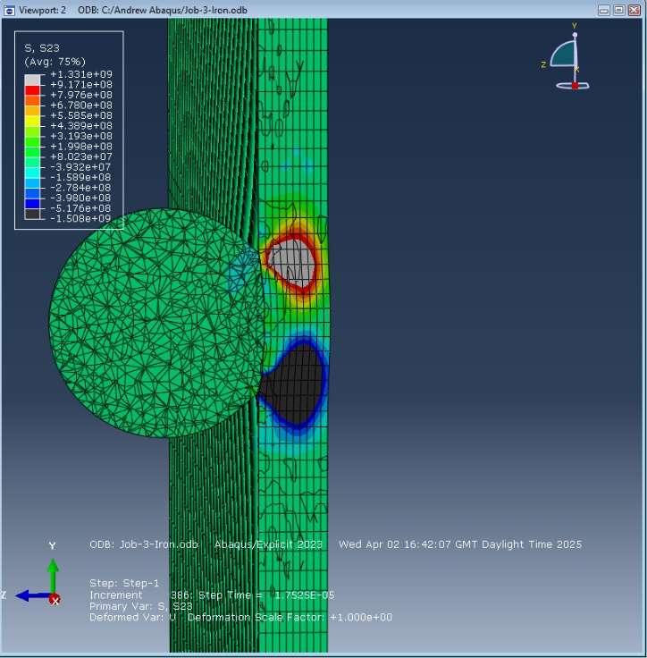
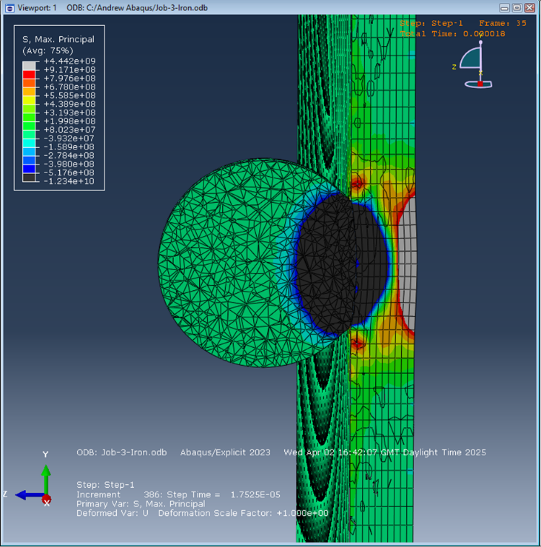

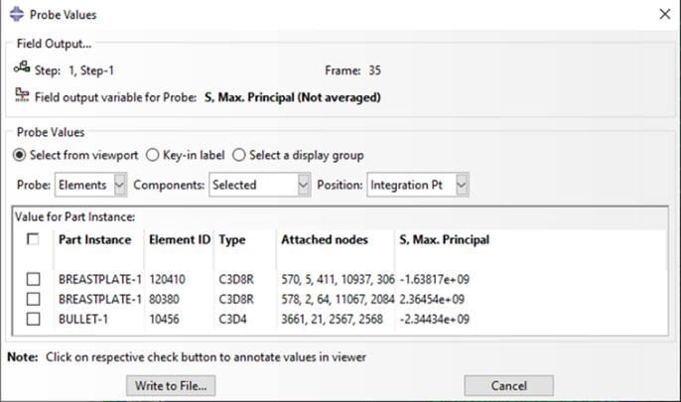
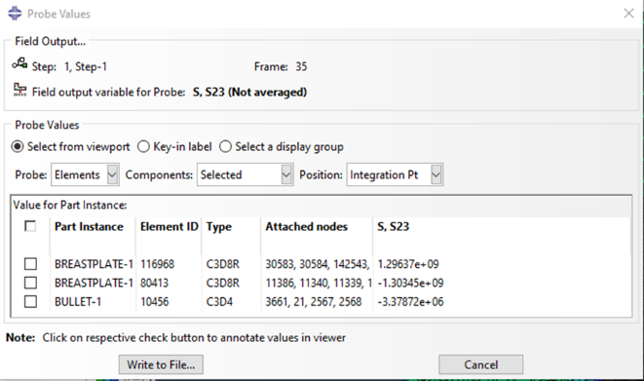

Figure 1: Initial Impact of Bullet on the cast iron breastplate. The left hand side shows the compression stress the right the shear stress

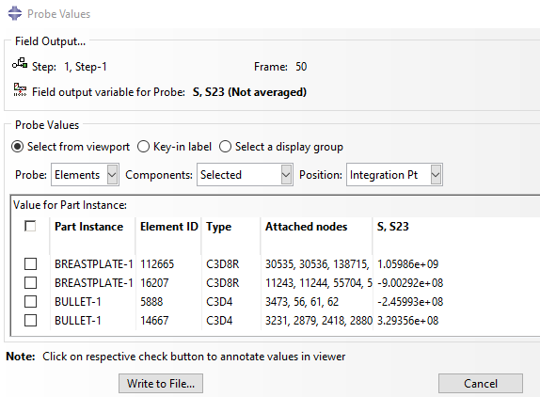
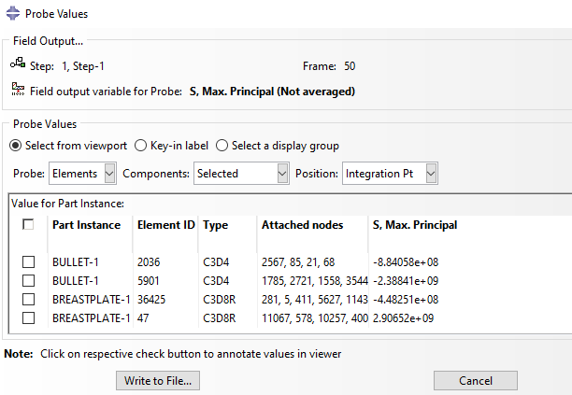
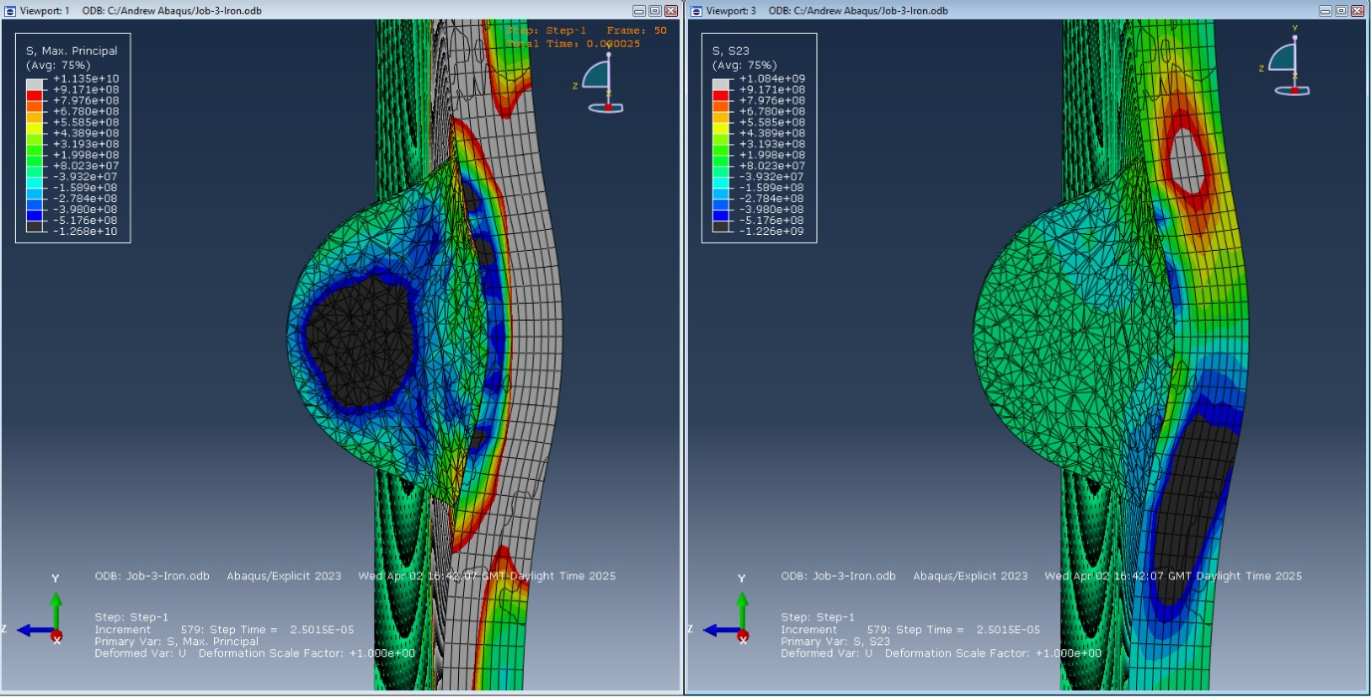
Figure 2: Impact of Bullet on the cast iron breastplate. The left hand side shows the compression stress the right the shear stress

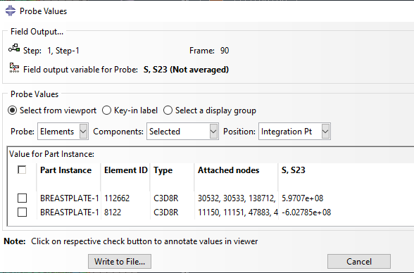
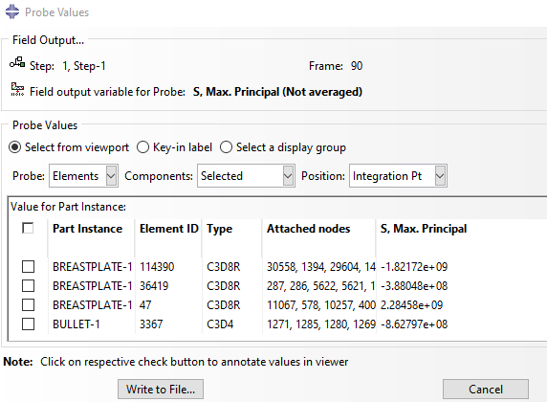
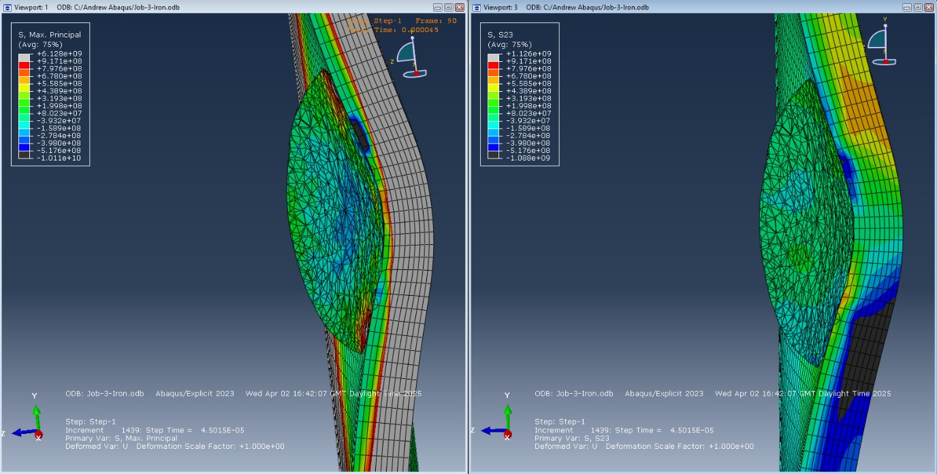
Figure 3:Impact of Bullet on the cast iron breastplate. The left hand side shows the compression stress the right the shear stress

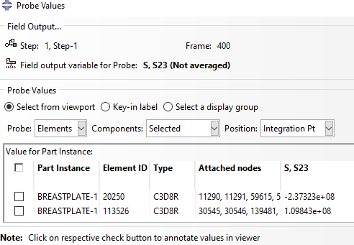
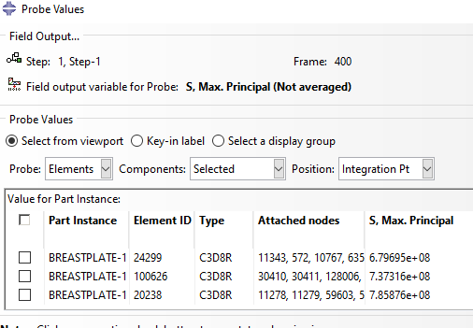
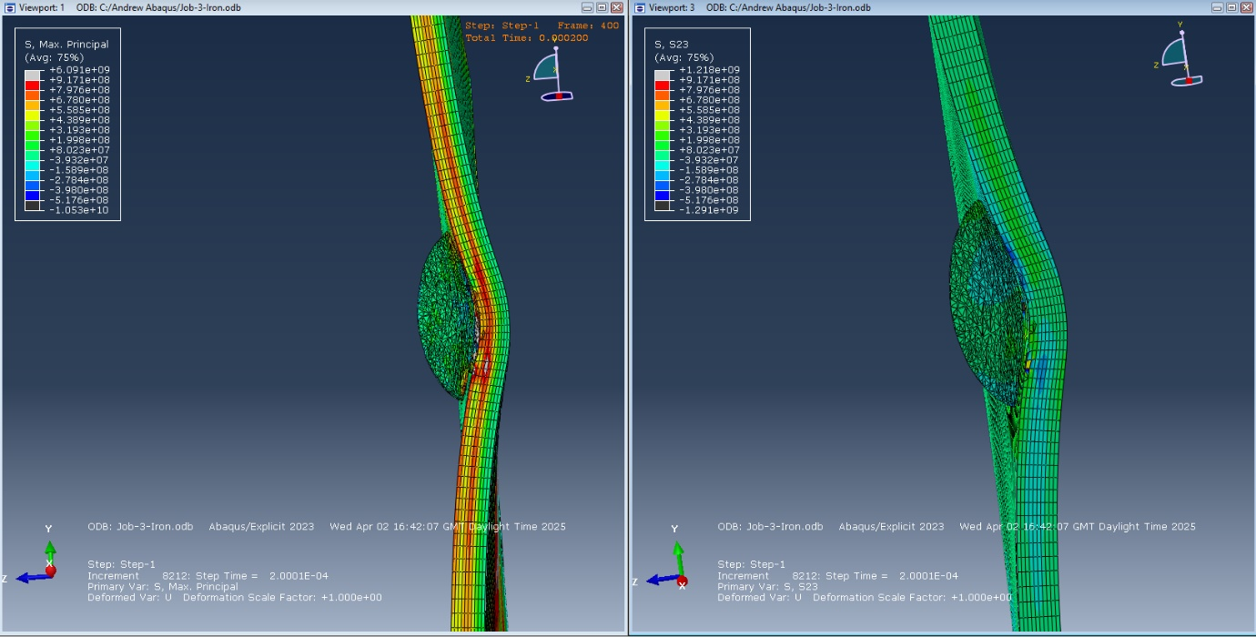
Figure 4: Ricochet of Bullet on the cast iron breastplate. The left hand side shows the compression stress the right the shear stress
It can be seen from the results that the compression stress is in the plate consistently much greater than the shear stress. The bullet, being made of lead is much softer than the breastplate causing a great deal of deformation causing it to ‘pancake’ as it tries to push its way through. While a Hertzian cone is visible in the shear stress it is much weaker than the compression stress.
The breast plate experiences deformation as the bullet causes it to buckle inwards from the point of impact caused by the impact of the bullet.

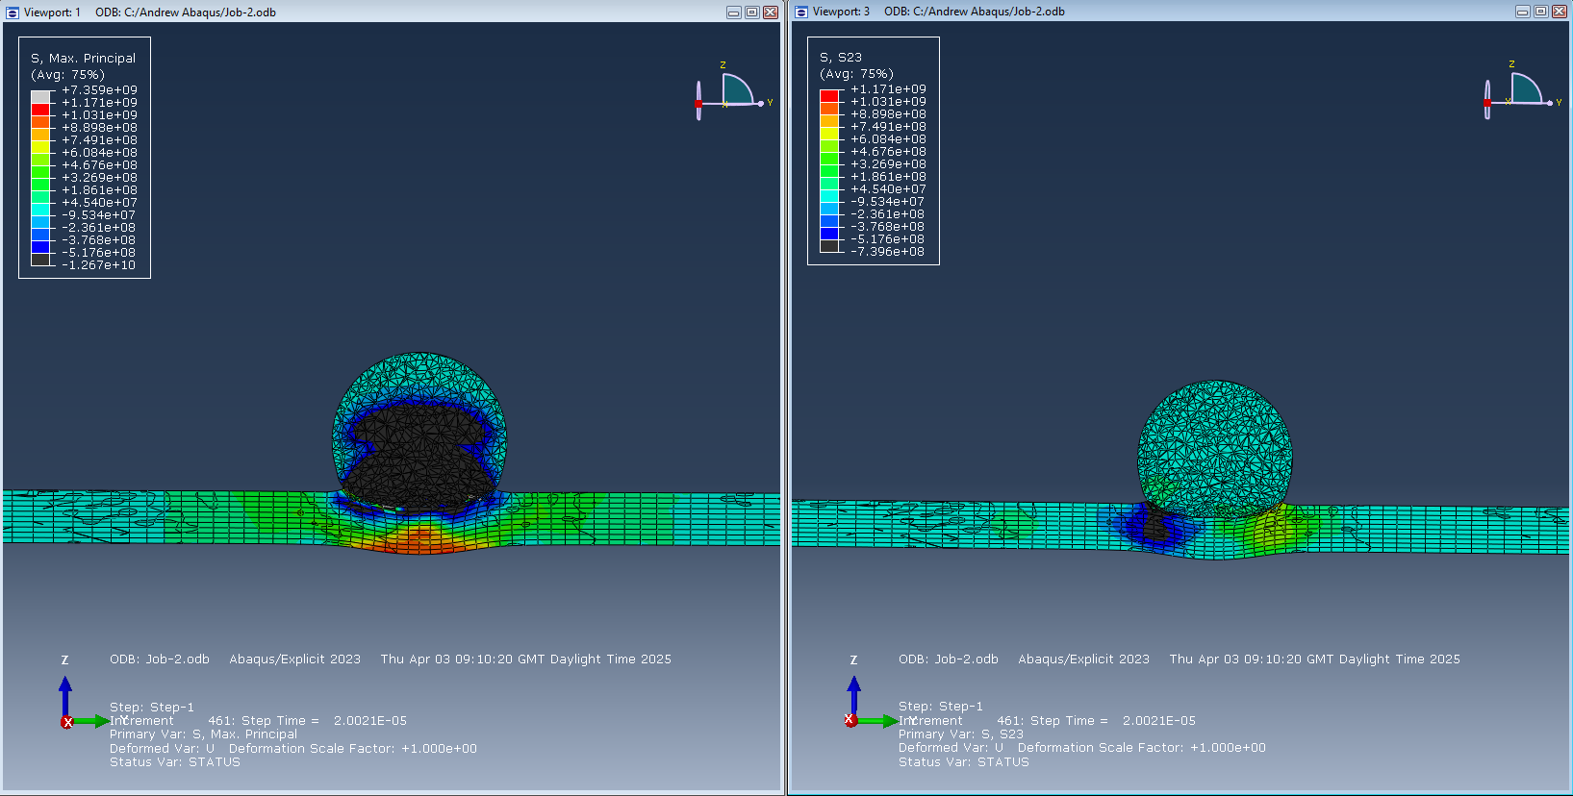
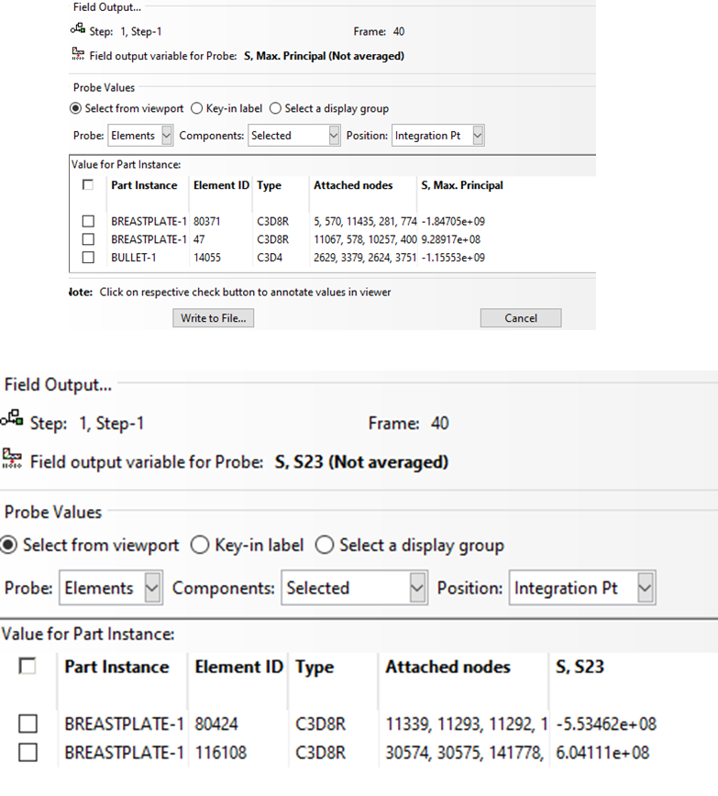
  - AISI 1018 Steel
Figure 5: Impact of Bullet on the Steel breastplate. The left hand side shows the compression stress the right the shear stress

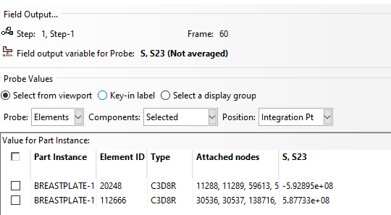
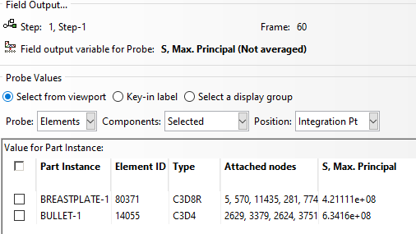
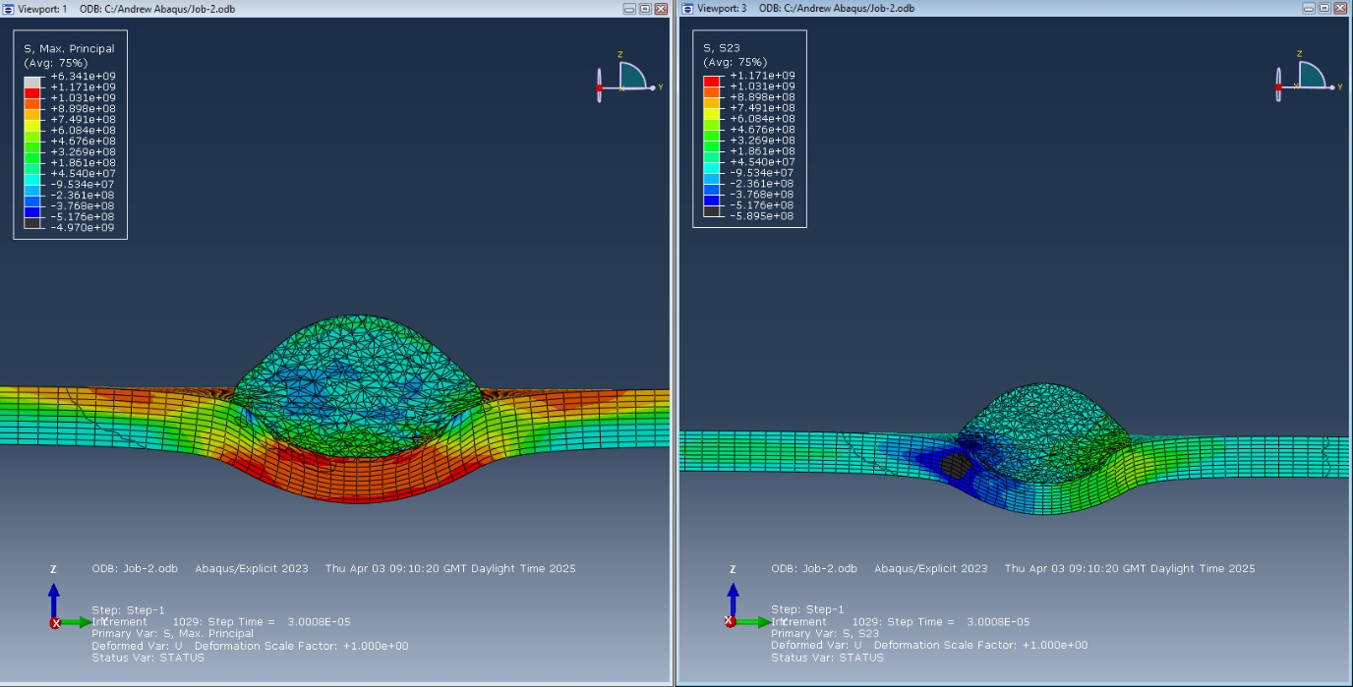
Figure 6: Impact of Bullet on the Steel breastplate. The left hand side shows the compression stress the right the shear stress

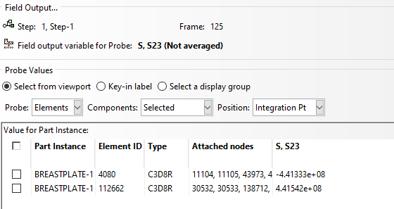
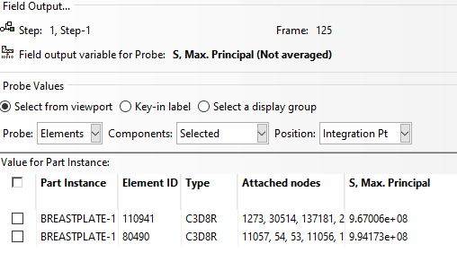
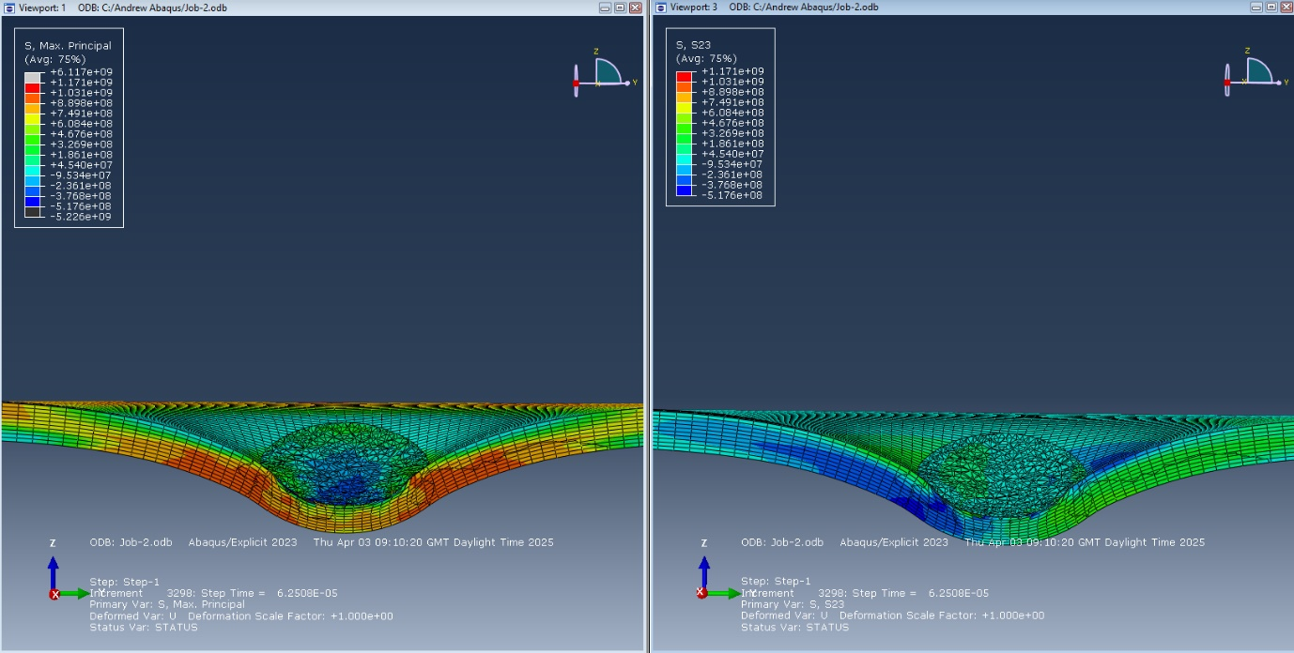
Figure 7: Impact of Bullet on the Steel breastplate. The left hand side shows the compression stress the right the shear stress

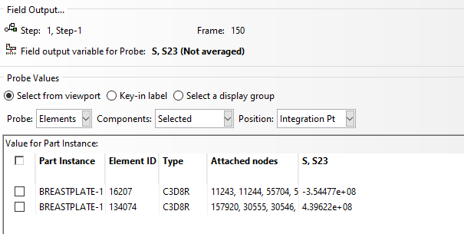
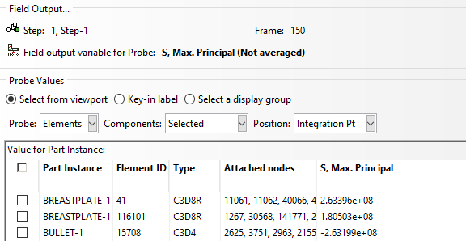
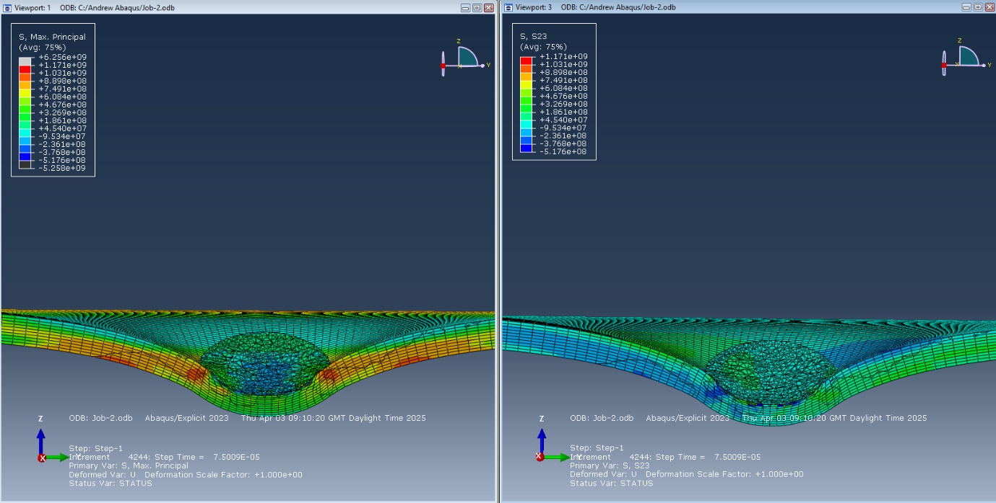
Figure 8: Ricochet of Bullet on the Steel breastplate. The left hand side shows the compression stress the right the shear stress
Again, the compression stress is significantly more than the shear stress as the bullet tries to force its way through the steel plate. The bullet is still softer than the plate but due to the plate being more ductile than the cast iron plate the bullet does not deform as much. It does squash considerably but does not pancake to the same degree.
The steel plate deforms considerable compared to the cast iron plate. A significant dent is placed within the plate due to it being more ductile than the cast iron plate.

  - Bullet Velocity
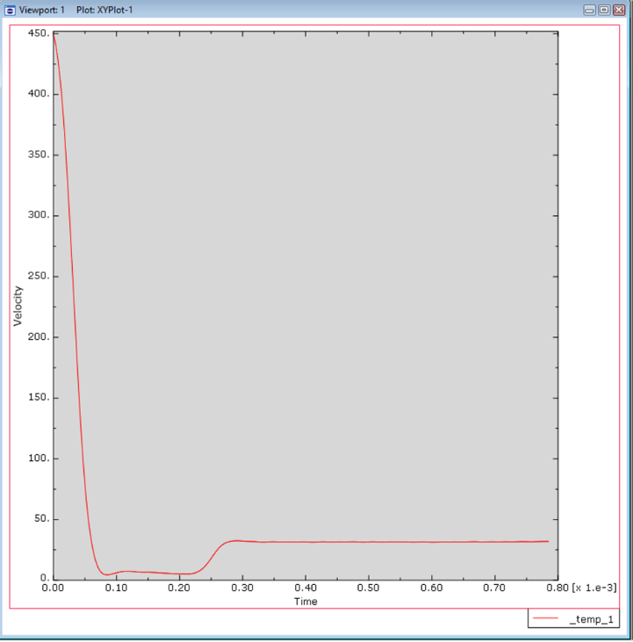
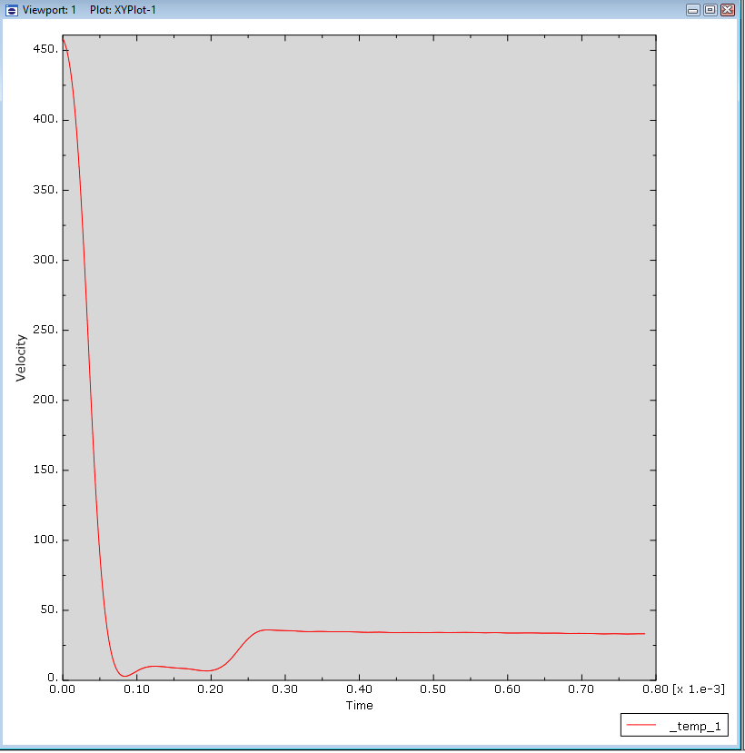
Figure 9: Plot of the velocity of the bullet against time when impacting the breastplate. Left hand side is the cast iron plate, right hand side is the AISI 1018 steel plate.

The bullet slows down precipitously upon impact with the breastplate in both cases although marginally faster with the cast iron plate. This would account for the smaller deformation taking place within the cast iron plate. The period of near zero velocity is longer in the steel plate before the bullet rebounds at a higher velocity than with the cast iron plate. This is likely due to the steel plate being more elastic.

Conclusion

In both occasions in the simulation the bullet failed to penetrate through the plate and rebounded. However, the deformation of both the bullet and the plate were significantly different when impacting the two plates. The AISI 1018 steel due to its ductile nature experienced much greater deformation and the bullet did not deform as much in comparison to the Cast Iron. The soft nature of the Lead bullet did not create enough shear stress to significantly impact the breast plate in either case and the compression and tensile stress did create deformation of the press but not enough to break through.
This is not an entirely unexpected outcome with the bullet failing to burst through the plate as many troops did survive being struck by a bullet while wearing armour, but it was not guaranteed. The plate in this case was using the maximal thickness of a breastplate and thus what would be the least likely part for penetration based on raw thickness. Another reason is that the material model is not truly accurate to the historical examples. Namely the Abaqus model is too perfect. The materials are modern simulacra as well as the plate being composed of a perfect block of the metal without the impurities that can be expected with the crude manufacturing techniques of the era. These would create points of weakness that could potentially cause the breastplate to fail allowing the bullet to penetrate. The same is true of the shape of the breastplate it is a uniform thickness which would not be the case for the historic examples.
To improve this for the future it would be ideal to be able to perform a material analysis to gain a more accurate damage model for the breast plate. Alternately, testing varying thicknesses of plate to simulate the variance in thickness across the plate would help provide a more holistic view of the protection on offer.
These results do back up the historical record on why breastplates continued to be worn well into the age of firearms. They continued to provide protection to the wearer from small arms, and it was the weight of armour required that saw the amount of armour worn decrease throughout the period. It was impossible to fully armour a person and them still be able to fight effectively therefore armour reduced to cover the most vital areas.

Bibliography

[1] | J. Fuller, Decisive Battles of the Western World Volume 1: From the earliest times to the Battle of Lepanto, London: Cassell & Co, 2001.
[2] | C. Stevenson, “Wheel-Lock Guns and Pistols,” Bulletin of the Pennsylvania Museum, vol. 7, no. 25, pp. 6-9, 1909.
[3] | K. B. e. a. eds, “The Records of the Parliaments of Scotland to 1707,” 17 4 1491. [Online]. Available: https://www.rps.ac.uk/trans/1491/4/24. [Accessed 16 5 2025].
[4] | J. Cooper, Scottish Renaissance Armies 1513-1550, Oxford: Osprey Publishing, 2008.
[5] | A. E. Kine, Pavia, Nieuwpoort and Breitenfeld: The Changing Role of Infantry during the European Military Revolution, Charlottetown: University of Prince Edward Island, 2020.
[6] | C. Blair, “Metalas in the service of Mars: Arms and Armour,” Journal of the Royal Society of Arts, vol. 129, no. 5304, pp. 764-781, 1981.
[7] | E. Bradford, The Great Siege: Malta 1565, London: Penguin Books, 1964.
[8] | J.Kraner, T. Lazar, “Thickness Mapping of Body Armour: a Comparative Study of Eight Breastplates from the National Museum of Slovenia,” Fasciculi Archaeologiae Historicae, vol. 32, pp. 129-145, 2019.
[9] | Tomasz Merda, Paweł Żochowski, “ANALYSIS OF BALLISTIC CHARACTERISTICS OF 16th CENTURY ARQUEBUSES USED IN BATTLE OF PAVIA,” Problemy Techniki Uzbrojenia i Radiolokacji, vol. 143, no. 3, pp. 71-84, 2017.
[10] | P. Krenn, P. Kalaus, and B. Hal, “Material Culture and Military History: Test-Firing Early Modern Small Arms,” Material History Review, vol. 42, no. 1, pp. 101-109, 1995.
[11] | “MatWeb - The Online Materials Information Resource,” 2025. [Online]. Available: https://matweb.com/search/DataSheet.aspx?MatGUID=ebd6d2cdfdca4fc285885cc4749c36b1&ckck=1. [Accessed 2 4 2025].
[12] | M. Giglio, A. Gilioli, A. Manes, L. Peroni, and M. Scapin, “Investigation about the influence of the mechanical properties of lead core and brass jacket of a NATO 7.62 mm ball bullet in numerical simulations of ballistic impacts,” EPJ Web of Conferences, vol. 26, p. 04010–04010, 2012.
[13] | “MatWeb - The Online Materials Information Resource,” 2025. [Online]. Available: https://matweb.com/search/DataSheet.aspx?MatGUID=654ca9c358264b5392d43315d8535b7d. [Accessed 2 4 2025].
[14] | G. Ljustina, R. Larsson, and M. Fagerström, “A FE based machining simulation methodology accounting for cast iron microstructure,” Finite Elements in Analysis and Design, vol. 80, pp. 1-10, 2014.
[15] | “MatWeb - The Online Materials Information Resource,” 2025. [Online]. Available: https://matweb.com/search/DataSheet.aspx?MatGUID=3a9cc570fbb24d119f08db22a53e2421. [Accessed 2 04 2025].
[16] | S. Sankarapandian, R. Pramod, S. M. Kumar, and N. S. Shanmugam, “Experimental and finite element analysis of Charpy impact, uniaxial tension and bending test of spin‐arc welded carbon steel 1018 plate,” Materialwissenschaft und Werkstofftechnik, vol. 54, no. 12, p. 1673–1683, 2023.

