MODULE: LCMB7035 – DISSERTATION
PROGRAMME: MASTER OF BUSINESS ADMINISTRATION
INSTITUTION: INSTITUTE OF INNER-CITY LEARNING, LONDON CAMPUS

GREEN GOVERNANCE AND ORGANISATIONAL PRODUCTIVITY: A SECONDARY QUALITATIVE STUDY OF TESCO’S SUSTAINABILITY PRACTICES


Master’s Degrees by Examination and Dissertation
Declaration Form.
I, Bhargav Detroja, declare that this dissertation has been composed by myself, that the work contained herein is entirely my own except where explicitly stated otherwise in the text, and that this work has not been submitted for any other degree or qualification, in whole or in part, except as specified.

Signature: …………bhargav detroja……………………............................

Date: …………02/02/2026……………………............................

Acknowledgement
I would like to acknowledge the assistance received from my supervisor, who supplied helpful feedback and support while I went through this research process, with a supervisory role to help guide me through the process of completing my dissertation. Additionally, I would like to thank the academic faculty members of the programme who provided theory and methodology to aid in providing the information to assist with my studies. I would like to thank all of my friends who were supportive of my work by motivating me to keep going, and offering reminder that would peak my spirits and keep me going as I was writing this dissertation. Finally, I want to thank my family members for their continual emotional support and understanding as they helped me complete this dissertation and be proud of my completed dissertation.

Abstract
This dissertation evaluates the effects of “green governance” on the productivity, resource efficiency, and sustainability performance of a major “UK grocery retailer”. The research was aimed at addressing gaps in the current understanding of how governance functions either as a direct performance impactor or as an enabler of organisational structure. Specific objectives of the study included analysing Tesco PLC’s governance framework for green products, evaluating how well it aligned with ESG goals, exploring its significance in terms of operational processes, and determining how it ultimately contributes to competitive positioning and “long-term resilience”.
The research took a “qualitative secondary case study approach”. The primary sources of data were publicly available corporate annual reports, governance publications, and sustainability-related documents. Data were processed and analysed through reflexive thematic analysis, with the aid of NVivo software, to discover patterns of governance, types of governance processes, and interpretive themes within the data set.
The study found that green governance does not create productivity gains directly, but, rather, creates indirect productivity increases through governance-related operational processes. The “Target Measure Act (TMA)” system and waste minimization initiatives produced the largest productivity impacts. ESG alignment was strongest at the levels of governance and reporting and the level of direct impact on performance and could be determined to a greater extent at the environmental, social, and governance levels.
Based on this research, the authors conclude that “green governance” is an organisational capability. Limitations in this study included use of a single case and reliance on secondary data. Therefore, the authors recommend future research on governance-related longitudinal studies of organisations that exhibit successful green governance practices.
Table of Contents
1. CHAPTER 1: Introduction 11
1.1. Research Rationale 12
1.1.1. Theoretical justification 12
1.1.2. Practical Justification 13
1.2 Research Contribution and Motivation 14
1.3. Research Aim, Objectives and Questions 15
1.4. Dissertation Structure 16
2. CHAPTER 2: Literature Review 17
2.1 Conceptual Foundations of Green Governance 17
2.1.1. Implementation of the “Corporate Sustainability Frameworks” (CSFs) in the Retail Market 18
2.1.2 Theoretical Perspectives 19
2.2 ESG Governance in Organisations 21
2.2.1 Sustainability Committees and Governance Structures 23
2.2.2. Governance and Long-Term Resilience 25
2.3 Tesco PLC: Green Governance and Sustainability Practices 25
2.3.1 Case Context 25
2.3.2 Tesco’s Productivity Challenges 26
2.4. Synthesis of Key Debates 28
2.5. Research Gap 29
2.6. Conceptual Framework 30
2.7. Summary 31
3. CHAPTER 3: Methodology 32
3.1 Research Philosophy 32
3.1.1 Interpretivist Epistemology 32
3.1.2. Ontology 32
3.2 Research Approach 33
3.2.1 Case Study Research Design 33
3.3 Research Strategy: Secondary Qualitative Analysis 34
3.3.1 Data Sources 34
3.3.2 Rationale for Secondary Data 35
3.4 Data Collection Procedures 36
3.5 Sampling Strategy 38
3.5.1 Purposive Sampling 38
3.5.2 Inclusion and Exclusion Criteria 38
3.6 Data Analysis Technique 38
3.6.1 Reflexive Thematic Analysis 38
3.6.2 Coding Framework 39
3.6.3 Tools 39
3.7 Trustworthiness and Quality Criteria 39
3.8 Ethical Considerations 40
3.9 Feasibility 41
3.10. Chapter Summary 41
CHAPTER 4: Findings / Results 42
4.1 Overview of Data Analysed 42
4.1.1 Overview of Data 42
4.1.2 NVivo Coding 43
4.1.3 Data Visualisation 55
4.1.4 Data Credibility and Limitations 67
4.2 Thematic Findings 67
4.2.1 Theme 1: Governance Structure and Oversight 67
4.2.2 Theme 2: Governance-Performance Alignment 67
4.2.3 Theme 3: Governance as Operational Driver 68
4.2.4 Theme 4: Governance as Productivity 69
4.2.5 Theme 5: Governance-ESG Alignment 69
4.2.6 Theme 6: Governance as Social ESG 70
4.2.7 Theme 7: Governance - Resilience 70
4.2.8 Theme 8: ESG - Competitive Advantage 71
4.3 Cross-Theme Summary 71
4.4 Summary of Key Findings 72
4.5 Chapter Summary 72
CHAPTER 5: DISCUSSION 74
5.1 Investigation of Tesco’s governance and “sustainability framework” (Objective 1) 74
5.2 Exploring “governance mechanisms” in Tesco’s retail operations (Objective 2) 75
5.3 Examination of correlation among “governance arrangements”, “ESG” and sustainability goals (Objective 3) 76
5.4 Evaluation of “green governance” (Objective 4) 77
5.5 Theoretical Implications 79
5.6 Chapter Summary 79
CHAPTER 6: Conclusion 81
6.1. Restatement of research aim, objective and questions 81
6.2. Link between the methodology and the key findings 81
6.3. Summary of the key findings 82
6.4. Contribution to practice 83
6.5. Limitations of the Study 83
6.6. Directions for Future Research 83
References 85
Appendices 96
Appendix A – Data Sources 96

List of Figures
Figure 2.1: External Governance Pressures vs. Internal Governance Conditions 19
Figure 2.2: The SDGs followed by Tesco Plc 20
Figure 2.3: Stakeholder Theory 20
Figure 2.4: Stakeholder Theory 21
Figure 2.5: Framework for SDGs 23
Figure 2.6: Due Diligence Framework 24
Figure 2.7: Human Rights Strategy 24
Figure 2.8: Food Waste Reduction Principles followed by Tesco Plc 29
Figure 4.1: Thematic Coding 1: Governance Structure and Oversight 45
Figure 4.2: Thematic Coding 2: Governance-Performance Alignment 46
Figure 4.3: Thematic Coding 3: Governance as Operational Driver 49
Figure 4.4: Thematic Coding 4: Governance as Productivity 51
Figure 4.5: Thematic Coding 5: Governance-ESG Alignment 52
Figure 4.6: Thematic Coding 6: Governance as Social ESG 54
Figure 4.7: Thematic Coding 7: Governance - Resilience 55
Figure 4.8: Thematic Coding 8: ESG - Competitive Advantage 56
Figure 4.9: Coding Density for Tesco Sustainability Report 57
Figure 4.10: Coding Density for Tesco Food Waste Report 58
Figure 4.11: Coding Density for Tesco Value, Quality, and Service 59
Figure 4.12: Coding Density for Sustainability Committee Terms of Reference 60
Figure 4.13: Coding Density for Tesco Report on Serving Committees 61
Figure 4.14: Coding Density for Tesco Report on Modern Slavery 62
Figure 4.15: Coding Density for Tesco Report on Human Rights 63
Figure 4.16: Coding Density for Tesco Report on Climate Change 64
Figure 4.17: Hierarchy Chart 65
Figure 4.18: Cluster Analysis 67

List of Tables
Table 3.1: Data Source Table (Source: Self-developed in MS-word) 37
Table 3.2: Data Collection Procedures (Source: Self-developed in MS-word) 39
Table 3.3: Inclusion and Exclusion Criteria (Source: Self-Created) 40
Table 4.1: Code Table 1: Governance Structure and Oversight (Source: Self-created) 46
Table 4.2: Code Table 2: Governance-Performance Alignment 47
Table 4.3: Code Table 3: Governance as Operational Driver (Source: Self-created) 49
Table 4.4: Code Table 4: Governance as Productivity 51
Table 4.5: Code Table 5: Governance-ESG Alignment 53
Table 4.6: Code Table 6: Governance as Social ESG 53
Table 4.7: Code Table 7: Governance - Resilience 55
Table 4.8: Code Table 8: ESG - Competitive Advantage 56

1. CHAPTER 1: Introduction
The retail industry, particularly “grocery retailers”, especially large, or total grocery retailers, functions in a complex and changing business environment, characterised by fierce competition, “rapid technological change”, pressures for regulation, and evolving expectations of consumers. In this context, “green governance” means the systems, oversight mechanisms, and decision-making processes by which organisations integrate environmental considerations into operations, strategy, and organisational controls (Ogunkan, 2022). In the UK for example, grocery retailers like Tesco PLC, operate in a market that is converging omnichannel retailing, “supply chain disruption”, and sustainability into a new series of strategic priorities. For example, 73% of the UK retailers indicate only that AI is helping them identify “operational inefficiencies”, reduce waste and emissions and carbon emissions (Retaileconomic.co.uk, 2025).
For instance, Johnson (2022), commented that 51% of retailers indicated that sustainability has become more important. In contrast, 79% indicated that their “supply chain ethics” and sustainability credentials need to improve. In this dissertation, “organisational productivity” in retail refers specifically to value derived from adherence to “waste implications”, resource optimisation, supply-chain functionality, “carbon efficient operations” and cost reductions achieved through enhancing process governance (Adeniran et al., 2024).
In this environment green governance can be seen as a facilitator of aligning social responsibility goals with operational control, risk management, and productivity performance (Juang et al. 2025). For Tesco, as with any enterprise, “sustainable governance” is more than a procedural or legislative process but is inherent in productivity and brand reputation and hence cost and risk mitigation, and ultimately “long-term resilience” (Zervoudi et al. 2025). In other words, the relationship between “green governance” in various forms as sustainable support for operational efficiencies, as “business risk management” and as formal regulatory standards is an additional positive reputational value to consumers.
There is evidence to this emerging priority, given that Tesco now states it redistributes 82% of its unsold food in its “UK operations”, as opposed to waste, and commits to being net-zero by 2035, 5 years ahead of its competitors, who raised the industry standard of facing net-zero by 2040 (Tescoimpactreport.com, 2025). Tesco has been chosen as a focal case primarily due to its size and market strength, but also as a “grocery retailer” with the UK’s leading and fastest-evolving sustainability governance framework. As compared to other retailers such as Sainsbury’s and Asda Tesco performs better in relation to “food-waste redistribution”, transparency in emissions disclosure, and “net-zero ambitions” and commitments. Yet, there remains a limited incidence of published evidence in the “grocery sector”, with only 65% of UK grocery retailers stating that their business models have yet evolved to offer meaningful “sustainability embedding” in their practice as a strategic driver (Brc.org.uk, 2024).

1.1. Research Rationale

1.1.1. Theoretical justification
Theoretical inquiry on the incorporation of sustainability into “corporate governance frameworks” has experienced significant momentum over the past several years. Researchers applying both “stakeholder theory” and “agency theory” illustrated how firms embed “environmental, social, and governance (ESG)” mechanisms within oversight by corporate boards, audit processes and team planning to align “stakeholder interests” and transform agency cost (Wang et al. 2023). Studies demonstrate that “green governance”, defined as the institutional systems, policies and oversight mechanisms by which organisations integrate sustainability into decision making, can enhance “sustainability performance” indirectly through enhanced disclosures and internal controls (Xu and Zhu, 2022). Empirical research has also attempted to explore connections between governance structures such as sustainability committees, board expertise and “firm-level outcomes” (Mojumder et al. 2022).
Even with these advancements, important uncertainties persist. For instance, while many studies look at the connection between “green governance” and “sustainability performance”, limited studies state how “green governance” affects an organisation’s productivity. In terms of operational output especially in large retail organisations. Additionally, the processes or mediators and moderators between governance and productivity are under-theorised. Some studies, such as Wang et al. (2023), predominantly focused on SMEs or manufacturing in “emerging economies”, providing less exploration to the large-scale retail context. Different studies utilise “cross-sectional survey data” and provide limited qualitative data, or look at a specific geography, which reduces the possibility of generalisation. In addition, the boundary conditions, such as industry type, maturity level of “digital transformation”, or supply-chain complexity, that may strengthen or weaken the “governance–productivity impact”, are still unknown (Sun and Guo, 2024).
Following on from the above, this research directly responds to the unexplored relationship between “green governance” and “organisational productivity” in the large-scale retail industry through “secondary qualitative analysis” of Tesco PLC's sustainability practices. Previous research, particularly that of Wang et al. (2023), quantitatively ratified that “governance mechanisms” influencing sustainability status. However, it offered a limited understanding of how these structures, when combined with other aspects of organisations, can be translated into some “scalar advantages” related to productivity within a “complex organisational form”. Furthermore, recent literature reviews have noted ongoing methodological and contextual gaps, with the focus of publications remaining concentrated to manufacturing. Besides, SMEs rely heavily on “quantitative survey designs” and still exclude governance mechanisms within the context of service drivers (Sun and Guo, 2024). In addition, past literature also lacks “theoretical sophistication” related to boundary conditions on the “governance-productivity link”, such as digitalisation driving complexity, supply-chain considerations, or stakeholder variability (Xu and Zhu, 2022).

1.1.2. Practical Justification
From a practical and managerial standpoint, “green governance” in large retail organisations could not be timelier. The pressure from regulators, consumers, and investors continues to grow on “retail chains” to manifest sustainability in their day-to-day operations and governance systems. Deloitte reported that 73% of the “consumer products industry” increased considerable investment in sustainability in the past year across three key drivers: “supply-chain efficiency”, brand reputation and “operational resilience” (Deloitte.com, 2023).
“Cost and strategic considerations” in the retail sector are significant. The sector is simply on the hook to meet “climate-related regulatory costs”, not to mention “greenhouse gas emissions” in the supply chain itself. Recent reports have been observed to assert that retailers must develop clear pathways to decarbonisation, as “ineffective planning leads” to unnecessary costs that affect “logistics and operational outcomes” (Bhargava et al. 2022). Consumer behaviour is also changing, as in April 2023, Deloitte reported that 46% of consumers surveyed in 23 countries purchased at least one sustainable good, with many prepared to pay a premium for “sustainable products” (Rogers et al. 2023). For managers, this implies that choices relating to “governance, supply-chain design” foster process efficiencies, or help in establishing “green policies
The opportunity cost is high. Firms that do not link governance and productivity miss out on both a dual opportunity to enhance sustainability performance while generating cost savings, waste reduction, and operational excellence. As evidenced by McKinsey’s “triple-play analytics”, organisations that value ESG, growth and profitability outperform their peers in terms of revenue gains and economic profit (Mckinsey.com, 2023). For example, this means that “retail firms”, if they only consider green governance efforts as a matter of compliance with no intention to realise a competitive advantage. Thus, by investigating whether “governance mechanisms” can shape productivity in large retailers, this research tackles a “time-sensitive managerial pain-point” to help frame all governance-led sustainability activity as productive and to offer actionable takeaways for “governance-led sustainability practices” to have operational impact rather than remain separate initiatives.

1.2 Research Contribution and Motivation
This study contributes to theory and practice by addressing the relatively neglected connection between “green governance” and “organisational productivity” in the context of large-scale retailing.
Theoretically, this study contributes to the “Green Governance Theory” further by framing governance as not only an “environmental compliance framework”, but also a productive mechanism for the strategy of efficiency, resource optimisation and resilience. Previous studies have examined the “Triple Bottom Line” and “Stakeholder Theory” primarily around ethics and sustainability (Nogueira et al. 2023; Ribeiro and Gavronski, 2021). This dissertation extends these theories by framing “governance-driven productivity” as a boundary condition that links ESG oversight with observable performance outcomes, and thus refines the theoretical assumptions that explain the operational aspects of “sustainability governance”. Moreover, the research contributes originality by addressing the scarcity of qualitative, mechanism-level research in large retail firms, and a “governance–productivity framework” specific to Tesco in the existing body of scholarship.
Empirically, the study conducts a “secondary qualitative case-study” using textual evidence from Tesco’s sustainability disclosures, “ESG reports” and corporate news sources, primarily between 2018-2025. Case studies allow for “context-sensitive exploration” of how organisations embed governance systems into real operational contexts, including analysis of “cause-and-effect” that are often lost in an over-reliance on generalisable, large-scale quantitative studies. This fits with Yin’s (2018), position that case studies provide rich in-depth analyses of complex organisational contexts, and help reveal patterns in contextual variables, giving a level of empirical richness that the quantitative ESG studies rarely provide.
In practical terms, the study provides managers and policymakers with a more fluid method for connecting “ESG governance approaches” to operational productivity metrics, assisting in better decisions and “performance evaluations”. The results will help to inform executives on how to construct “governance systems” to drive efficiency and sustainability outcomes. This study also contributes decision-support insights for retail leaders attempting to meet regulatory demands while enhancing cost efficiency, “stability of supply chains” and long-run “competitive advantage”.

1.3. Research Aim, Objectives and Questions
Aim
The purpose of this research is to explore the influence of green governance on organisational productivity, resource efficiency, and sustainability performance at Tesco PLC, using a secondary qualitative case-study analysis.
Objectives
- To identify and investigate Tesco’s governance and “sustainability framework” in terms of its structure, intention, and operational significance.
- To explore the influence of “governance mechanisms” in the optimisation of resources, productivity, and cost efficiencies in Tesco’s retail operations.
- To examine the interplay between, and alignment of, Tesco’s “governance arrangements” and its ESG and sustainability goals.
- To evaluate how “green governance” contributes to Tesco’s resilience, competitive positioning, and “sustainability performance” in the longer-term.
Questions
- In what manner does the “green governance framework” of Tesco affect productivity levels and efficiency of resources in their operations?
- What does it mean for Tesco’s governance systems, mechanism, and processes, in terms of an overall operational effective delivery of performance and performance outcomes?
- How does Tesco’s governance architecture map out with their ESG objectives that are connected to sustainability, and where does this influence their practice?
- How does a “green governance framework” for Tesco drive ongoing resilience capacity for future sustainability within their organisation, and where does it enhance competitive advantage in the retail community?

1.4. Dissertation Structure
The rest of the dissertation will be organised in the following manner:
- Chapter 2 provides the “literature and theoretical frameworks” that relate to green governance, sustainability and “organisational performance”, highlighting relations between concepts and areas for further research.
- Chapter 3 will explain the “secondary qualitative method” in detail, reporting data sources, how the thematic analysis was conducted and ethical considerations.
- Chapter 4 will report the data from the “thematic analysis” of the case study around Tesco and its views towards sustainability.
- Chapter 5 will discuss the findings and link them to existing theories, as well as present implications for “governance and performance”.
- Lastly, Chapter 6 will summarise key points from the study, offer implications for practice, and suggest next steps for future research.

2. CHAPTER 2: Literature Review
literature related to “Green Governance” in retail has been examined, specifically, how such acts are informed by ESG structures, and their impact. The chapter defines concepts being examined, provides a discussion on Tesco’s underlying framework for sustainability, and uses the “Stakeholder Theory” and “Resource-Based View” (RBV) to verify that the theoretical conceptual framework is centred on Green Governance.

2.1 Conceptual Foundations of Green Governance
Large retailers such as Tesco, adopt green governance from a hybrid model that includes both mandated Regulatory environmental compliance and additional environmental Commitments included in voluntary corporate social responsibility (CSR) initiatives (Bagali and Jose, 2022). Some authors define "green governance" primarily as a reactive 'Risk Management Process' (Ocran, 2023), while others highlight its progression into a proactive mechanism to increase an organisation's Resilience and sustain long-term Environmental Sustainability (Ocran, 2023). Green governance is also delivered through alignment with the Sustainable Development Goals (SDGs) in the European retail context, allowing organisations to align themselves with the Global Sustainability Agenda (Jones and Comfort, 2020). Criticism of Governance frameworks has an emphasis on the high priority given to the Environmental pillar at the expense of developing meaningful Social aspects (Gouldson and Sullivan, 2014). Figure 2.1 below has helped in illustrating the strength of “external governance pressures” vs. “internal governance conditions”.
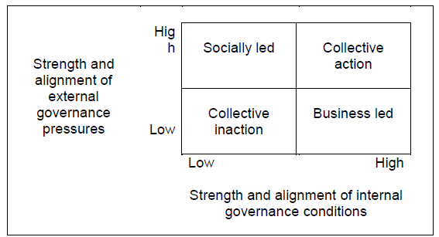

Figure 2.1: External Governance Pressures vs. Internal Governance Conditions
(Source: Gouldson and Sullivan, 2014)
There is a “strategic management” dilemma where the market signals or visibility establishes governance priority. The models are, therefore, much less established “green ethos” and more about balancing “stakeholder expectations” against competitive interests.

2.1.1. Implementation of the “Corporate Sustainability Frameworks” (CSFs) in the Retail Market
The retail market’s implementation of CSFs is associated with a strong focus on public disclosure and clear policy development. The evidence of Tesco’s framework is found in its reports convey a “company-wide vision” of addressing sustainability across its operations, “supply chain and sourcing” (Tesco Plc, 2025a; Tesco Plc, 2025b). The details of branded and corporate policies, including a “Protecting Forests Policy”, and subject-specific factsheets, notably “Climate Change and Energy”, further highlight evidence of sustainability implementation (Tesco Plc, 2025c; Tesco Plc, 2025g). Figure 2.2 below illustrates the SDGs that Tesco Plc adheres to.
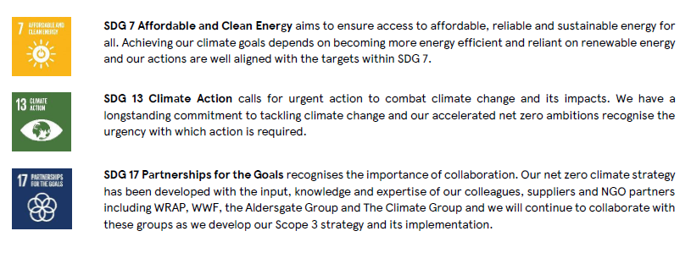

Figure 2.2: The SDGs followed by Tesco Plc
(Source: Tesco Plc, 2025c)

2.1.2 Theoretical Perspectives
The research utilised a dual theoretical framework involving “Stakeholder Theory” (ST) and the “Resource-Based View” (RBV) to assess the complex relationships between “green governance” and “corporate performance” in the case study of Tesco.
ST assumes that a firm can be successful only if it creates value for and manages relationships with all groups that can influence or are influenced by the firm’s objectives (Vola et al., 2025). Figure 2.7 illustrates the “Stakeholder Theory”.
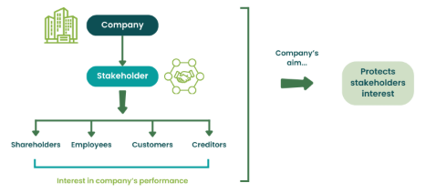

Figure 2.3: Stakeholder Theory
(Source: Wallstreetmojo.com, 2023)
These stakeholders include investors, employees, customers, the community, and the natural environment. In this case, “Green Governance” consists of the organisation of the firm and the process used to satisfy the claims of stakeholders. This theory is an appropriate lens for the research topic because it addresses why an organisation like Tesco engages in sustainability. Stakeholders have recently increased their calls for transparency, which pushes the firm to adopt policies around sustainability disclosure. Additionally, firms with high “ESG performance and governance” can create ways for stakeholders to trust the firm, which in turn has a “positive impact” on “corporate performance” (Wang, 2024).
On the other hand, the “Resource-Based View” (RBV) emphasises value derived from internal strategic advantages. The RBV asserts that sustained superior performance comes from controlling resources and capabilities that are Valuable, Rare, Inimitable, and Non-substitutable (VRIO) (Bamgbade et al., 2022). Figure 2.8 below has helped in illustrating the RBV Theory.
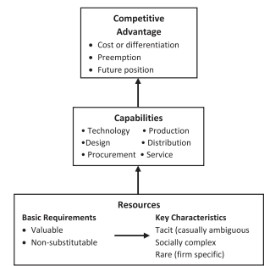

Figure 2.4: Stakeholder Theory
(Source: Bamgbade et al., 2022)
This is relevant when analysing how governance translates into productivity. For instance, the RBV helps in understanding how the firm engages successful “green innovation” from being a simple operating cost to a “strategic firm resource” that can create competitive advantage through unique process efficiencies or brand differentiation (Khanra et al., 2022). “Sustained competitive advantage” also requires that RBV principles are coupled with dynamic capabilities, highlighting the firm’s ability to sense, seize, and reconfigure its resource base (Kruasom and Saenchaiyathon, 2015).
In summary, ST provides the external mandate for “Green Governance”, whereas RBV explains the internal mechanism of how “Green Governance” successfully relates to its application into sustained “tangible organisational productivity” and competitive advantage.

2.2 ESG Governance in Organisations
The adoption of “ESG frameworks” represents a significant shift in corporate governance from a “stakeholder-centric approach”. This integration, referred to as “green governance,” has been demonstrated through research to enhance the “financial performance” of firms in the UK, as the board aligns strategy with “sustainability goals” (Moussa et al., 2024). Governance is generally referred to as the critical accountability mechanism that translates the nebulous concept of sustainability into enforceable “corporate policy” through board committees and subcommittees. It is important to note the extent of integration of ESG frameworks. For instance, some firms tend to adopt the “ESG framework” primarily to offer disclosure to legal obligation, as seen in research looking at comparable reporting across “multiple jurisdictions” (Kothari, 2025). Other firms use the ESG framework as an authentic lever for “operational change”. This requires the Governance to actively manage and allocate resources to the maintenance of the Environmental and Sustainable resources (Raman et al., 2025). Figure 2.4 below has illustrated the general “framework for sustainable and green finance”.
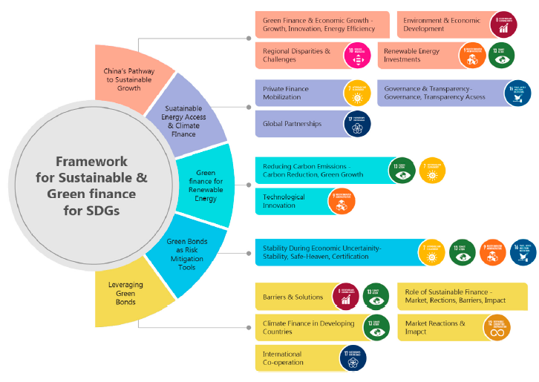

Figure 2.5: Framework for SDGs
(Source: Raman et al., 2025)
Moreover, it is essential that this integration appears authentic by firms acknowledging “sustainability accountability structures” through formalised statements such as the “Modern Slavery Statement”, and the “Human Rights factsheet” (Tesco Plc, 2025e; Tesco Plc, 2025h). The images below (Figure 2.5 and 2.6) explain in detail the diligence framework that is followed by Tesco plc as part of the governance.
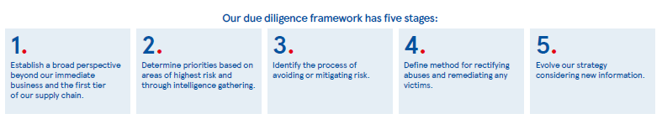

Figure 2.6: Due Diligence Framework
(Source: Tesco Plc, 2025e)
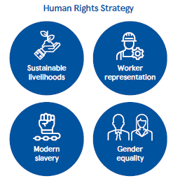

Figure 2.7: Human Rights Strategy
(Source: Tesco Plc, 2025e)
By using integrative formalised statements, firms will be able to distinguish “corporate commitments” from firm policies.

2.2.1 Sustainability Committees and Governance Structures
Tesco’s formal commitment to integrating ESG is structurally anchored by the “Sustainability Committee” an important mechanism for board-level oversight (Tesco Plc, 2025f). The existence of such a committee illustrates that sustainability has been elevated from a marginal issue to a formalised recognition of “corporate boards”. This formalisation is crucial to align the ‘G’ in ESG to an integrated practice with the ‘E’ and ‘S’ goals. Benghezal and Izadi (2022), argue that strong “internal structures” are important for the operationalisation of “CSR strategy”. However, the utility of any “governance structure” relies on the power relationships within. From a retail context, there is ever-present tension between a dedicated “Sustainability Committee” and established “Audit and Remuneration Committees” that typically exert more commercial influence. Unlike frameworks such as the OECD (2023), which focus on setting out general best issues, the vital debate for UK retail is that the “governance structure” needs to demonstrate integration, not simply delegation, where the responsibility for ESG is owned across all executive capacities.
For instance, the “governance structure” stipulates that the ethical implications of the “Social (S) component” comprise “fair labour practices” which must be an enforced criterion in the “supplier selection process” of the procurement function (Tesco Plc, 2025e). Moreover, as established in the “human resource function”, a body of evidence connecting “corporate ESG choices” directly to improved retention, affirms the impact of operationalising ESG on “human capital productivity” and retaining labour across business functions (Zhang et al., 2024). Smaller firms may certainly face challenges with respect to transparent reporting (Shalhoob and Hussainey, 2022). However, companies such as Tesco, as a large retailer, have established a standing mandate of governance, which enables “ESG standards” to be enforced and dispersed across comprehensive and “structured governance ramifications” throughout their expansive, complex footprint to facilitate the business process of sustainability as a fundamental trait. Good governance, including “transparent and ethical reporting”, builds a firm’s respectability and trust around consumption, which in turn leads to sales growth and better business market performance (Tran and Pham, 2022). Governance ultimately mandates and structures operational excellence, changing sustainability from altruism to value creation.
Effective governance requires the proactive incorporation of “ESG issues” within both “strategic planning and risk management”, so that it cannot become an operational externality by testing the governance structures. This alignment allows us to transform “non-financial risk”, such as “climate change” and human rights abuse, into areas that require oversight at the board level, and governance adheres to “human rights commitments”, especially when sourcing suppliers into the “strategic decisions” surrounding suppliers, which could considerably lessen the risk in the entire supply chain (Tesco Plc, 2025h). Governance allows the firm to safeguard its future viability through its governance of “climate disclosures” and “climate adaptation methodologies”. However, that alignment now faces a further critical promised challenge, especially regarding the financial aspect, which is to align with “clean governance” if the “sustainability investment” perspectives conflict with short-term financial returns (Raman et al., 2025). While at the same time, governance must be clean and believable, to resist the temptation to casually greenwash, which is the disclosure type that has little substance compared to a “true commitment” to “sustainable performance” (Feghali et al., 2025). As such, governance should also provide a check regarding the veracity of the firm’s strategic “ESG performance and commitment”.

2.2.2. Governance and Long-Term Resilience
Governance is the essential mechanism through which an organisation secures its continued “long-term viability” and its ability to be competitive in an increasingly turbulent global market. As articulated by Schoenmaker and Schramade (2023), governance does not only extend to compliance but it is the overarching mechanism for “long-term value creation”. This view suggests that good “governance structures” are essential for embedding sustainability to turn “short-term decisions” into decisions for “long-term corporate vitality” and market stability.
Resilience is, of course, realised through effective “risk management”. The governance structure must have oversight on strategic areas, such as “anti-corruption and sustainability practices” and correctly addresses ethical failures and environmental neglect, not as two separate “committee issues”, but rather as bundled threats to stability (Transparency.org.uk, 2025).
It is possible to measure the effect of this “governance-led approach” with regard to firm value persistence. Using survival analysis methods, Liu and Lee (2025), provide empirical evidence that firms that perform well on ESG and are subject to governance face lower “mortality risk” than firms that do not perform strongly on ESG. Firm value persistence is thus partly driven by “value creation” through disclosure mechanisms, whereby good ESG transparency and disclosure build trust with stakeholders and lower the cost of capital, ultimately yielding a better investment (Hamdouni, 2025). Governance in firms also enhances the competitive landscape with the “governance-driven strategy” of resilience and other initiatives specifically for resilience, especially by providing “ESG and sustainability ethics”, and even forcing the adoption of digital technologies, to engage the complexity created by “supply chain dynamics” and moderate their implications (Atieh et al., 2024).

2.3 Tesco PLC: Green Governance and Sustainability Practices

2.3.1 Case Context
Ocran (2023), reinforces the concept of organisational capability to address sustainability through the use of a framework to guide “sustainable operations management”. However, there is evidence of a critical gap to complete the translation of “high-level organisational policy” to an implementation of pervasive governance of “supply chain operations”. Although there are policies underlying the built environment and enacted at “scale asset management” for implementation, the “retail supply chain” is too complex and globally extensive to measure compliance with ethical and environmental standards beyond Tier 1 suppliers (Prabhakar and Gilmour, 2024).
Current research demonstrates considerable strengths through thorough case-specific analysis and detail on “retail sustainability practices”. The corporate reports provide primary-source transparency on targets and performance, which underpins external scrutiny (Tesco Plc, 2025a, 2025b). Ocran (2023), and Prabhakar and Gilmour (2024), provide a focused attention to the sector and well-documented “operational experiences” of sustainability relating to a large grocery retailer and its physical infrastructure. This provides a fine starting point for understanding what kinds of models are being developed.
Critically reflexive-argument research is also very limited in relation to the “internal workings” and enforcement power of governance mechanisms (Tesco Plc, 2025f). The retail sector is not homogeneous either; research tends to over-represent food retail, meaning that governance models in sectors such as UK clothing retail have received little critical attention (Jones, 2025). Therefore, the reliance on company reports risks reinforcing a sanitised narrative that needs to be acknowledged as a limitation in understanding the robustness of any governance model.

2.3.2 Tesco’s Productivity Challenges
Governance is increasingly being considered not just a compliance requirement, but rather a strategic enabler of “operational productivity” in retail. Proper governance structures that mandate transparency, accountability and embed “sustainable rules” into practice create forms of “cost-saving and efficiency”. The implementation of systematically governed “climate action”, using formal policies, improves financial performance for food retailers in the UK (Olarewaju et al., 2024). It does this through governance, enabling the oversight to sustain sustainability in the business, which in turn “reduces waste” and optimises resource use. Furthermore, good governance, including “transparent and ethical reporting”, builds a firm’s respectability and trust around consumption, which in turn leads to sales growth and better business market performance (Tran and Pham, 2022). Governance ultimately mandates and structures operational excellence, changing sustainability from altruism to value creation.
“Governance mechanisms” lead to productivity both directly through the mandates of “process improvement” and lean operations. For instance, Tesco’s commitment to tackling “food waste” through its “Target, measure, act” initiative is a structured “governance-led activity” that requires measured action along the “supply chain” that can result in proven efficiencies through reduced disposal costs and the loss of value of stock (Tesco Plc, 2025d). Figure 2.3 below illustrates the principles to prevent food wastage that are followed by Tesco plc.
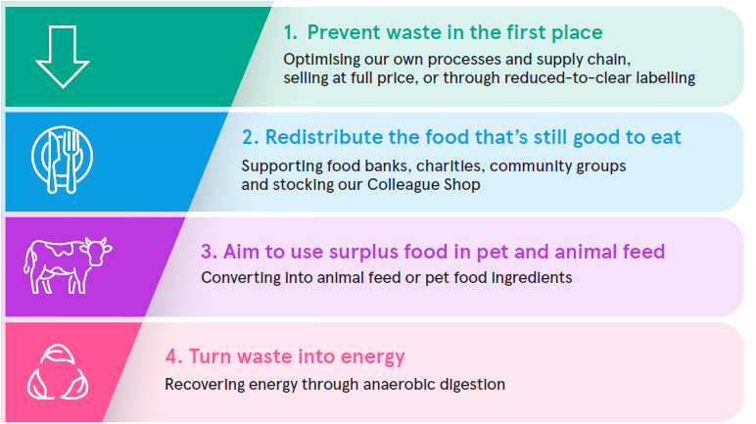

Figure 2.8: Food Waste Reduction Principles followed by Tesco Plc
(Source: Tesco Plc, 2025d)
Governance mechanisms in the supply chain involve the embedding of “sustainability and ethics” in management activities (Esan et al., 2024). Typical measures involve “rigorous monitoring” and auditing of suppliers to ensure compliance with “environmental and social guidelines”. This is an ethical obligation, but it can diminish “operational risk” and may positively mediate economic returns by creating more “resilient and efficient supply chains” (Sabat and Krishnamoorthy, 2020). In addition to this, green HRM initiatives, guided by adequate governance, will actively utilise new technologies to achieve sustainable organisational performance (Shayegan et al., 2023). These practices also include the competent use of “human capital” in sustainable operations in terms of reducing “long-term operational costs” for resources.
Leadership relies on “data-led decision-making” and strong performance monitoring systems to measure and manage sustainability initiatives. “Measuring performance” is a critical non-negotiable step in the “Target, measure, act” model (Tesco Plc, 2025d). Monitoring and measurement systems give “governance bodies” a feedback loop in which they can assess the efficacy of their policies. For instance, collecting a data point to quantify how much food waste was reduced or how much energy was consumed across stores allows management to plan for further optimisation and hold individual departments accountable.

2.4. Synthesis of Key Debates
The existing body of work justifies a clear “positive relationship”, albeit with some limitations, between climate action, ESG practices and financial performance, within a retail context (Olarewaju et al., 2024; Tran and Pham, 2022). Additionally, studies have detailed aspects of an operational nature, such as the mediating role of “sustainable supply chain practice” on economic profits and the potential of green HRM practices as a strategy for sustainability (Sabat and Krishnamoorthy, 2020; Shayegan et al., 2023).
Current research has considerable strength in repeatedly showing a positive relationship between effective “green governance” and organisational outcomes, including financial outcomes and social indicators like employee satisfaction (Moussa et al., 2024; Zhang et al., 2024). Theoretical and empirical work on disclosure standards likewise provides critical indicators of transparency. Still, the literature has three shortcomings (Kothari, 2025; Waked et al., 2025). Firstly, the literature is overly outcome-based, recognising achievements without sufficiently examining the inner workings of the “governance processes” that led to the alignment. Secondly, the distinction between symbolic and “substantive alignment” is often not critically explored. The reliance on public sustainability disclosures, compounded by the growing risk of greenwashing, makes it difficult to distinguish between substantive governing and reporting (Feghali et al., 2025). Finally, literature fails to explore tensions and trade-offs necessarily faced when the three pillars of ESG conflict, such as high costs of environmental compliance versus maintaining local jobs.
The existing body of literature illustrates significant strengths by articulating the strong conceptual link from governance to “long-term resilience” and value creation (Schoenmaker and Schramade, 2023). For instance, the survival analysis delivered empirical evidence that “governance-led ESG practices” resulted in business longevity (Liu and Lee, 2025). Additionally, the literature is future-focused and can also be applied in “contemporary strategic thinking”, such as the effect of ESG on “customer behaviour” through digital transformation and the need for “digital supply chain concepts” to support resilience (Hasan et al., 2024; Atieh et al., 2024). The literature also focuses on the coordination of “anti-corruption and sustainability” (Transparency.org.uk, 2025).
However, the literature suffers with respect to the communication of resilience. The biggest limitation lies in the tendency to treat disclosure as a sufficient proxy for “resiliency-based governance” (Hamdouni, 2025). Disclosures might be transparent reporting on governance output, but do not show that the organisation is taking effective action or has a superior “crisis response”. There is currently a critical gap in existing research because previous studies, to date, have not provided longitudinal studies comparing “governance effectiveness” before, during, and after a significant market or geopolitical event. Additionally, the prescriptive guidance created for coordinating “anti-corruption and sustainability” has often remained high-level and not the sort of granular detail that is required in low-margin retail settings (Transparency.org.uk, 2025).

2.5. Research Gap
The literature has a gap as it never clearly evaluated the speed and cost of implementing governance, or the “bureaucratic drag” and up-front investment cost of low-margin retail. Evidence exists that there are effects, but this research does not attempt to map the corresponding direct “causation link” between formal governance effects, such as the decision of a committee resolution and “operational performance metrics”.
Despite the extensive corporate disclosures and sectoral case studies, research has still not sufficiently addressed the “governance-accountability chain” in large retailers. Comparative governance analysis is needed so that a proper analysis can include the consideration and evaluation of “best-in-class practices” that go beyond the generalised evaluation of the “UK retail governance structures”, and to benchmark Tesco’s formal governance structure against international best practice. Most importantly, earlier research must shift beyond the “theoretical discussions” regarding elements of the “governance framework” to evidence, engage, and evaluate the validity and integrity of alignment, in other words, the degree to which “governance frameworks” and policies are in fact moving beyond the outer layer of the governance structure and are being driven by the governance framework and not external pressures.
Despite the extensive corporate disclosures and sectoral case studies, research has still not sufficiently addressed the “governance-accountability chain” in large retailers. Comparative governance analysis is needed so that a proper analysis can include the consideration and evaluation of “best-in-class practices” that go beyond the generalised evaluation of the “UK retail governance structures”, and to benchmark Tesco’s formal governance structure against international best practice. Most importantly, earlier research must shift beyond the “theoretical discussions” regarding elements of the “governance framework” to evidence, engage, and evaluate the validity and integrity of alignment, in other words, the degree to which “governance frameworks” and policies are in fact moving beyond the outer layer of the governance structure and are being driven by the governance framework and not external pressures.
An important gap in the literature is the failure to systematically look at the “dynamic capability of governance structures” to facilitate resilience. While a link has been established between ESG and “firm persistence”, there is no actual research regarding the “causal pathway” from specific governance inputs, such as board oversight or the structure of committees, to measure resilience outputs (Liu and Lee, 2025). The literature has also not adequately addressed the important trade-offs in “capital allocation” between resilience action focused on “long-term planning” and “short-term competitive pressure”. The detailed “cost-benefit analysis” involved in capitalising on “digital supply chain resilience” initiatives appear to be undervalued by traditional, lower-cost efficiency gains (Atieh Ali et al., 2024). Perhaps a central vulnerability is the lack of independent, “non-market-based auditing” of the practical coordination required of anti-corruption, ethics and sustainability functions mandated by the governance structure (Transparency.org.uk, 2025). The existing literature confirms that governance is necessary for resilience, but remains lacking in “critical reflection” on viable structuring principles, implementation and “enforcement capacity” required to gain true competitive advantage during periods of high market dynamism.

2.6. Conceptual Framework
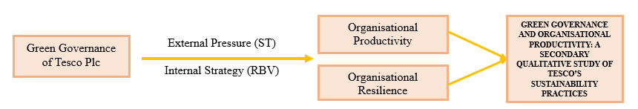
Figure 2.9: Conceptual framework
(Source: Self-developed by the Author)

2.7. Summary
Chapter 2 revealed an important gap in academic literature. The literature review supported the existence of “positive associations” between governance, productivity, and resilience, but a gap in the systematic assessment of the “governance structure” of Tesco has been identified relative to best practice or positioning in an international context.

3. CHAPTER 3: Methodology

3.1 Research Philosophy

3.1.1 Interpretivist Epistemology
The research focuses on the concept of “governance and sustainability” in Tesco using an interpretive epistemology. An “interpretive epistemology” aims to develop an understanding of the different meanings, interpretations and stories created by organisations rather than just trying to develop generalities or “universal laws” based on these interpretations (Ponelis, 2015). “Interpretive research” allows the researcher to examine how differing “social realities” influence the behaviours and decisions, while also taking into account the “cultural context” in which the research operates (Mohajan, 2018; Negou et al., 2023). As stated by Mohajan (2018), and Negou et al., (2023), interpretive approaches are also important because they allow for examination of how norms and perceptions influenced the practices of organisations, concerning “sustainability governance and productivity”, and thus allow for an understanding of how these practices were created.
An “interpretive epistemology” further offers an alternative view to the traditional positivist views when examining “sustainability and productivity”. This is because an interpretive view of these two concepts is that they are negotiable and change over time due to the different “cultural constructs” of the organisations (Junjie and Yingxin, 2022). The goals of this investigation are aligned with the goals of this epistemology in that it hopes to identify how Tesco creates a “governance story” through different documents and subsequently creates a textually-based narrative (Busetto et al., 2020). The broadening use of qualitative, “case-based insights” in today’s research, as highlighted by Thelwall and Nevill (2021), further confirms the appropriateness of an interpretivist philosophy for this study.

3.1.2. Ontology
A “relativist ontological perspective” has been adopted in this research, whereby any reality is dependent on the context it is embedded within. Governance, “sustainability and productivity” have all been created in the spatial and temporal context of the organisation’s own interpretation of the world around them. This organisation’s interpretation of governance, sustainability and productivity is shaped by its culture, structure and history (Mohajan, 2018). “Interpretivist ontology” states that there is no single objective truth, but rather the existence of many different realities that co-exists within each other (Junjie and Yingxin, 2022). This is similar to a “qualitative case study approach”, since organisations exist in a continuous state of dynamic and ongoing change (Haneda, 2025)

3.2 Research Approach
In this research, an “inductive approach” is being employed, which means the themes identified are allowed to generate from the source documents themselves, so there are no previously established hypotheses tested. Using an “inductive approach”, the researcher can create new theories through their repeated interaction with “data similarities and patterns” (Braun and Clarke, 2006). The “reflexive thematic analysis” will allow for the development of new insights generated by coding (Byrne, 2022). This supports a “unique interpretative style” consistent with developing “qualitative guidance” on flexible and progressively changing themes based on a source’s data set (Fuchs, 2023; Ayre and McCaffery, 2022). Additionally, this “exploratory analysis” has a unique potential for generating a more insightful understanding of the relationship between “governance and productivity” (Haan and Venema, 2025; Ahmed et al., 2025).

3.2.1 Case Study Research Design
A case study design focusing on Tesco exemplifies an examination of how governance affects “sustainability and productivity” through one business. A case study is a useful method of examining how complex organisations behave in practice, as it permits the researcher insight into the dynamics that take place within them (Yin, 2018). Tesco was chosen for this study because of the company's size, its extensive “sustainability documentation”, and the fact that it has a well-developed system of governance providing the researcher with the required documentation from which to conduct “qualitative research” (Chowdhury and Shil, 2021). Thus, a “case study design” assists in contextualising the interpretation of governance by allowing for a more comprehensive understanding of the evolution of practices associated with governance, as well as the relationship between governance and “current organisational practice” (Patnaik and Pandey, 2019).
This methodology adheres to the tenets of social science, within which there is great emphasis on understanding through “historical and contextual specificity” (Ylikoski and Zahle, 2019). Finally, this case study’s ability to provide longitudinal and “document-oriented data” regarding organisational processes over time is consistent with best practices in “qualitative case research” (McLeod et al., 2011). The contextual understanding derived through longitudinal and document-based data provides interpretive depth (Carstensen et al., 2023).

3.3 Research Strategy: Secondary Qualitative Analysis

3.3.1 Data Sources
Research data employed by the researcher is in the form of second-hand qualitative data, which is collected from documents available to the public. The data was collected from primary documents, including:
- Tesco’s Annual Report on Sustainability (2018 through 2025),
- Corporate Governance Statements,
- CSR and ESG Reporting,
- Annual Reports and Updates for Investors.
The following are additional forms of documentation that were utilized to compile this research:
- Press releases from Tesco
- Independent reports on the industry and market provided by other firms
- Analyzing documents created by third-party firms
- Publications that provide information related to Regulatory/Compliance issues
In Table 3.1 the various different data types used within this research are matched up with their stated objective, and all of them have been outlined on this table in an easily understandable format. For detailed view of the sources, Refer to Appendix A.
Data source | REFERENCES | Purpose in this study
Tesco Sustainability Reports (2018–2025) | [1]  [2]  [3]  [4] | To analyse green governance commitments, targets, and sustainability performance trends over time.
Corporate Governance Statements | [1] | To identify governance structures, board oversight mechanisms, and ESG accountability arrangements.
CSR and ESG Reports | [1] | To examine alignment between governance, sustainability strategy, and ESG objectives.
Annual Reports & Investor Updates | [1] | To assess disclosed productivity, efficiency, and risk-related outcomes linked to governance.
Press releases | [1]  [2]  [3]  [4]  [5]  [6]  [7]  [8]  [9] | To capture strategic initiatives and implementation evidence.
Industry, regulatory, and third-party reports | [1]  [2]  [3]  [4] | To provide external validation and contextual comparison.

Table 3.1: Data Source Table (Source: Self-developed in MS-word)

3.3.2 Rationale for Secondary Data
This research has increased the “strength and credibility” of the results by using “secondary qualitative data” in combination with a set of publicly available “organisational documents”, which provide consistent and verifiable information. Secondary products can enhance the quality of the research due to their ability to provide a high degree of “transparency and auditability”. By utilising secondary products, all research documentation can be tracked, confirmed and evaluated by independent parties (Kapiszewski and Karcher, 2021).
Furthermore, “secondary qualitative materials” support the use of rigorous methodologies by providing a structured and detailed description of the “organisational operations” and “governance systems” that can be methodologically analysed (Busetto et al., 2020). Also, because they do not require the researcher’s direct access to research participants and are based only on “secondary qualitative data” that is publicly available, “secondary qualitative sources” are cost-effective and have minimal ethical concerns, while at the same time, they allow an in-depth analysis (Chowdhury and Shil, 2021).
Additionally, these documents provide a macro-view of organisational practices, “industry pressures”, regulatory expectations and sustainability frameworks, highlighting a micro-view of organisational “internal governance actions”, reporting strategies and productivity plans of Tesco plc. This combination of perspectives aligns with the qualitative casework’s emphasis on contextualised interpretations of and the processes of translation within organisations (Carstensen et al., 2023).
While “secondary qualitative data” provides an increase in transparency, auditability and feasibility it does have its limitations. Examples of the limitations include reflecting the manager’s bias, having selective disclosures and not being applicable at all levels of operation in real time. Also, documents cannot capture the “informal practices” taking place within the company or the employee’s perspective on those practices.

3.4 Data Collection Procedures
In order to ensure consistency and clarity throughout the “data collection process”, a “structured and stepwise approach” is used. The data collection process consisted of three phases. The first phase involved identifying which documents were relevant for the research by examining Tesco’s sustainability, “governance and regulatory publications”, industry reports and third-party analyses. The documents were then selected based on their relevance to the area of governance nd productivity, their authenticity and a date range between 2018 to 2025. The availability of the information within that time frame, and the amount of content provided within each document. After identifying the appropriate documents, they were organised according to established “data management protocols”, including the use of coding sheets, folder labels and a digital filing system to maintain consistency when analysing data (Busetto et al., 2020).
A comprehensive document log was created in MS Excel, in which each document’s type, publication date and “analytical relevance” were recorded. This allowed for transparency and provided a concise and organised trail for the research conducted (Kapiszewski and Karcher, 2021). “Qualitative research principles” were adhered to throughout the data collection process, with emphasis placed on good recordkeeping and “reflexive engagement” in the research process to aid in a robust “data management system” and analytical accuracy (Negou et al., 2023). The use of these processes enabled a systematic collection and management for a thorough approach to thematic analysis of the materials.
A clear, staged approach was taken to extract the data:

Stages | Description | Comments
Document identification | Publicly available Tesco sustainability, governance, regulatory, industry and third-party documents from 2018–2025 were identified. | Establishes initial document pool
Relevance screening | Documents were screened for relevance to green governance, productivity, ESG alignment and operational performance. | Ensures focus on research aims
Eligibility verification | Authenticity, credibility, publication source and temporal fit were verified using inclusion and exclusion criteria. | Confirms methodological rigour
Structured Data Extraction | Key governance mechanisms, sustainability actions and productivity references were systematically coded using coding sheets. | Enables consistent analysis
Systematic organisation of all codes, logs | Documents, codes and reflexive notes were logged in Excel and digitally filed, ensuring transparency and auditability throughout the qualitative case study research lifecycle phase. | Supports audit trail and reliability

Table 3.2: Data Collection Procedures (Source: Self-developed in MS-word)
This staged approach provides both transparency and replicability and enhances the analytic rigor and validity of the study.

3.5 Sampling Strategy

3.5.1 Purposive Sampling
In this research, “purposive sampling” has been used as a means of selecting specific documents that directly relate to the “governance mechanism”, sustainability, reporting, “operational performance” and ESG Metrics. This approach of document selection contributes to a more meaningful interpretation that aligns with the goals of “case study-type qualitative research” (Ponelis, 2015). Also, by using “purposive sampling”, only those documents which contain relevant information and provide a detailed understanding and context will be included, thereby providing depth to the analysis (Mohajan, 2018). This method of research is well-suited to conducting “case-based research”, which focuses on the study of the materials that provide insight into (or show) a particular organisational process (Patnaik and Pandey, 2019).

3.5.2 Inclusion and Exclusion Criteria
Inclusion Criteria | Exclusion Criteria
Documents must be in English and directly relevant to this study’s focus on Tesco’s governance, sustainability practices, and productivity. | Documents not in English or unrelated to governance, sustainability, or productivity.
Must fall within 2018–2025 and include Tesco Sustainability Reports, Corporate Governance Statements, ESG Reports, CSR disclosures, and industry or regulatory documents used in this dissertation. | Documents outside 2018–2025 or lacking relevance to Tesco’s governance or sustainability activities.
Must originate from Tesco, reputable third-party analysts, regulators, or recognised industry sources. | No clear author, no publication, or no source authority and not connected to Tesco.

Table 3.3: Inclusion and Exclusion Criteria (Source: Self-Created)

3.6 Data Analysis Technique

3.6.1 Reflexive Thematic Analysis
The “reflexive thematic analysis” of this study follows Braun and Clarke’s (2006), six-step process. The first step (Familiarisation) required reading Tesco’s documents to fully understand the patterns regarding “Governance and Sustainability” within those documents. The second step (Initial coding) required producing both “descriptive and interpretive codes” that identified meaningful characteristics throughout the entire dataset (Ayre and McCaffery, 2022). Once codes were identified, provisional themes were developed utilising those codes to demonstrate the patterns represented in Tesco’s “governance-productivity stories” (Fuchs, 2023). The fourth step (“Refinement of themes”) comprised a check of each theme for coherence, uniqueness, and compliance with the purpose of the study, to ensure “consistent and coherent analysis” (Roberts et al., 2019). The fifth step (Defining themes) was to provide clarity regarding each theme’s boundaries and demonstrate how each contributed to the understanding of “sustainability governance” (Byrne, 2022). Each theme serves as a lens to interpret the way an organisation constructs its understanding of itself (Haan and Venema, 2025). Finally, in the sixth step (report writing), the findings of the “interpretive analysis” were compiled into one cohesive narrative, bringing together data examples and conceptual understandings to yield rigorous and transparent findings (Ahmed et al., 2025).

3.6.2 Coding Framework
Content has been recoded according to categories defined by “governance mechanism”, “sustainability practices”, productivity impact, risk mitigation, “operational efficiency” and “strategic alignment”. Coherence and analytical rigour were achieved periodically through the development of codes (Roberts et al., 2019) and identifying common themes that were conceptually aligned with research objectives and rational thought (Byrne, 2022).

3.6.3 Tools
The Document database was organised, coded and themed using NVIVO. Jiang et al., (2021) stated that by using digital tools, “qualitative transparency” and “analytical structure” are improved. By having a systematic approach to data handling, this increased the level of rigour in the interpretive process.

3.7 Trustworthiness and Quality Criteria
To ensure methodological integrity, the “research methodology” used is guided by the criteria of trustworthiness. The method for improving the “confidence and trustworthiness” of this research was based on two distinct criteria established by Lincoln (1985), such as credibility and dependability. Through a detailed description of the governance structure of Tesco and the triangulation of multiple organisational documents, it has given considerable support to the credibility of the findings. As described by Carstensen et al., (2023), who stress that corroborating evidence across a range of documents, it is essential to establish a “credible qualitative case study”. The development of the database document, demonstrating all “codebook development activities”, as well as maintaining the transparency of how data has been processed and refined over time, indicates the level of “elasticity and dependability”. This aligned with the principles outlined by Roberts et al., (2019), who state that transparency of “codebook development” provides consistency in data analysis. The use of “reflexive notes” and a “structured document log” has provided additional assurances that researchers behaved neutrally to reduce bias in interpretation (Kapiszewski and Karcher, 2021).
Establishing standards for “rigorous qualitative research” is through the three concepts such as “Trustworthiness and Quality”. Credibility indicates the degree to which the “research findings” are correct and believable, Dependability indicates the “degree of consistency” between the procedures used and the findings of the research. On the other hand, confirmability indicates the “degree of neutrality” of the researcher. Lastly, transferability indicates to the reader the degree in which the findings may be transferable to other “similar organisational contexts” (Lincoln, 1985).

3.8 Ethical Considerations
The data collected for this study consisted solely of “publicly accessible documentation”. Therefore, there were no requirements to collect or process personal, confidential or “sensitive information”. Ethical integrity was maintained by completely and accurately representing the information, and citation for every finding was provided in full. “Reflexive practice” was adopted during all phases of the study, as outlined in Reid et al., (2018), to ensure that the researchers stated their viewpoint in the interpretation of qualitative data. Furthermore, the authors of this study agree with Burgess et al., (2023), regarding the proper use of documentary data and the level of “ethical diligence” that researchers must apply, even when participating with individuals is not an option. The researcher’s neutrality was maintained through careful interpretations, as well as openly published reporting practices.

3.9 Feasibility
Based upon the availability of Tesco’s accounting documents that contain a good deal of reliable and relevant information that is within a manageable size, the feasibility of the research is strong. A detailed “time schedule” was used to systematically collect and analyse the data. There were multiple resources to assist with the effective organisation and interpretation of the results throughout the study, and therefore, the methodology was implemented within the total constraints of the project.

3.10. Chapter Summary
This chapter clarified the methodology that provided the basis for this research project and showed how both the interpretivist method of inquiry and case study “methodology and analytical techniques” were related to the research question. Specifics regarding the strategy for collecting data, sampling technique, data analysis methods, and data quality were addressed to present a “structured approach” for identifying the effects of governance on sustainability and productivity, thereby enabling the development of meaningful conclusions.

CHAPTER 4: Findings / Results

4.1 Overview of Data Analysed
The findings in this current study have been achieved through a qualitative analysis of the secondary data of Tesco Plc on the governance, sustainability, ESG and strategic disclosures. The objective of this discussion has been focused towards the systematic reporting of the empirical findings obtained. The gathered data has been analysed under the reflexive thematic coding which were analysed through NVivo software, with the interpretation of theoretical assessment. This chapter is a departure in descriptive coverage of the sustainability disclosures made by Tesco and rather offers an interpretive study of how governance structures are mechanisms to operate. The analysis therefore does not revolve at what governance structures are present, but should be converted into operational productivity, resilience and competitive positioning are measurable.

4.1.1 Overview of Data
The data used, in the analysis of green governance and organisational productivity and Tesco's sustainability practices, consisted of publicly available corporate documentation generated by Tesco Plc between 2023 and 2025. All these reports include formal instruments of governance, operational sustainability reports, and strategic performance reports. The data is focused on the Tesco Company Reports as the study focuses on the case study of Tesco only. The key documents that have been analysed include:
- Tesco PLC Sustainability Report 2024/25 (Tesco Plc, 2025a)
- Tesco PLC Annual and ESG Report 2024/25 (Tesco Plc, 2025b)
- Climate Change and Energy Factsheet (Tesco Plc, 2025c)
- Target, Measure, Act: Food Waste Report 2024 (Tesco Plc, 2025d)
- Modern Slavery Statement 2024/25 (Tesco Plc, 2025e)
- Sustainability Committee Terms of Reference (Tesco Plc, 2025f)
- Human Rights Factsheet (Tesco Plc, 2025h)
- Serving Communities a Little Better Every Day (Tescoimpactreport.com, 2025)
- Green Products Come of Age (Deloitte, 2023)
The primary reason behind the selection of these sources was that they make them relevant to the governance structures, sustainability implementation, ESG performance, and comparison on the sector level. In addition to that, the reason for choosing the reports is that these reports provide practical ideas which helps develop better engagement among different aspects.

4.1.2 NVivo Coding
NVivo software has been used to describe the obtained data and come up with the structured reflexive thematic analysis. The tables and pictures provided below indicate the source of the collected data references and their associated codes that make it possible to identify themes in the subsequent sections.
Code 1: Governance Structure and Oversight
Parent Node (Code) | Child Node (Final Code) | Source | Link to RQ
Governance Structure and Oversight | Committee Authority | Tesco Plc (2025f) Sustainability Committee TOR | RQ2
Governance Structure and Oversight | Committee Authority | Tesco Plc (2025b) Annual and ESG Report | RQ2
Governance Structure and Oversight | Electric delivery fleet strategy | Tesco Plc (2025c) Climate and Energy Factsheet | RQ3
Governance Structure and Oversight | Electric delivery fleet strategy | Tesco Plc (2025a) Sustainability Report | RQ3

Table 4.1: Code Table 1: Governance Structure and Oversight (Source: Self-created)
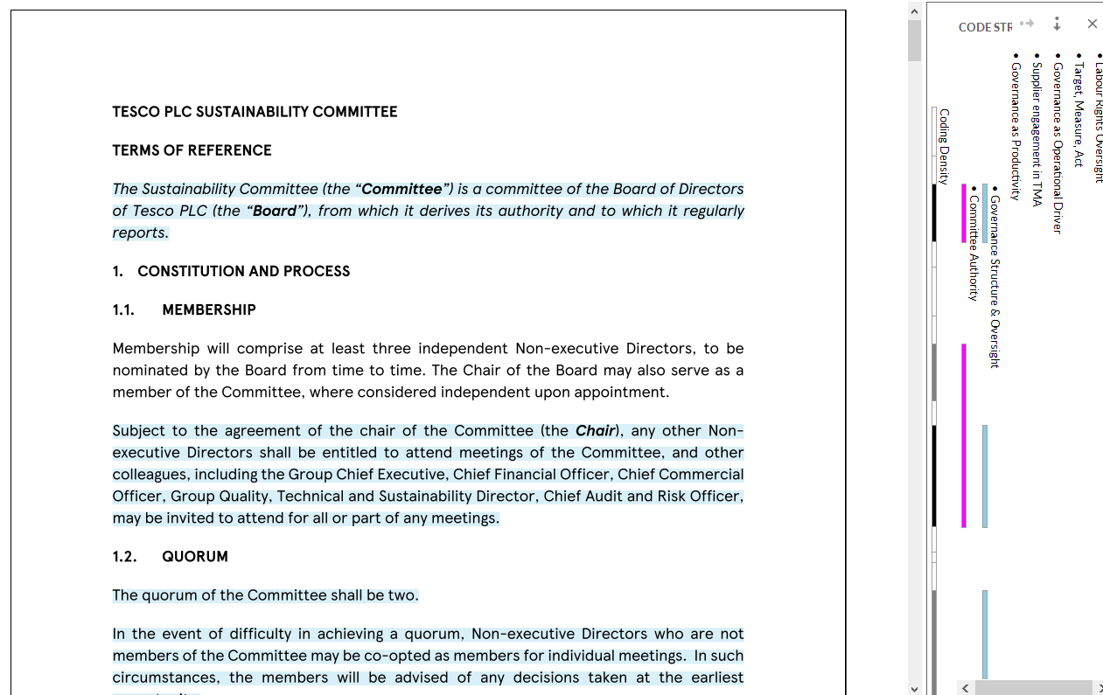
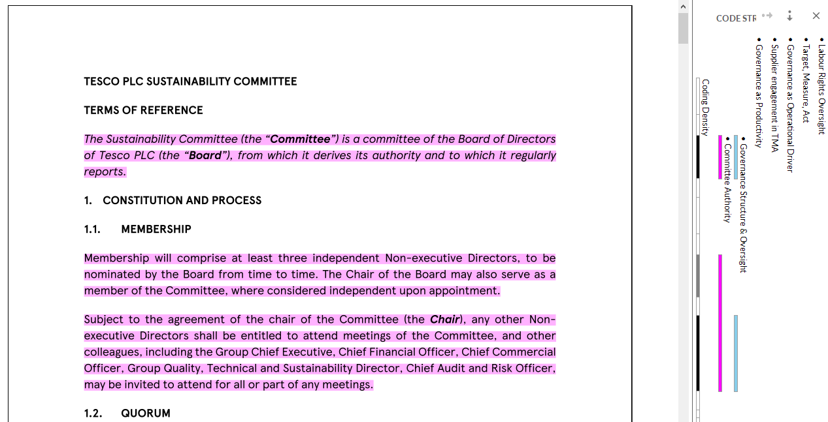

Figure 4.1: Thematic Coding 1: Governance Structure and Oversight
(Source: Self-created)
Code 2: Governance-Performance Alignment
Parent Node (Code) | Child Node (Final Code) | Source | Link to RQ
Governance-Performance Alignment | Reporting Cycles | Tesco Plc (2025b) Annual and ESG Report | RQ2
Governance-Performance Alignment | Sustainability governance integration | Tesco Plc (2025a) Sustainability Report | RQ1
Governance-Performance Alignment | Sustainability governance integration | Tesco Plc (2025b) Annual and ESG Report | RQ2

Table 4.2: Code Table 2: Governance-Performance Alignment
(Source: Self-created)
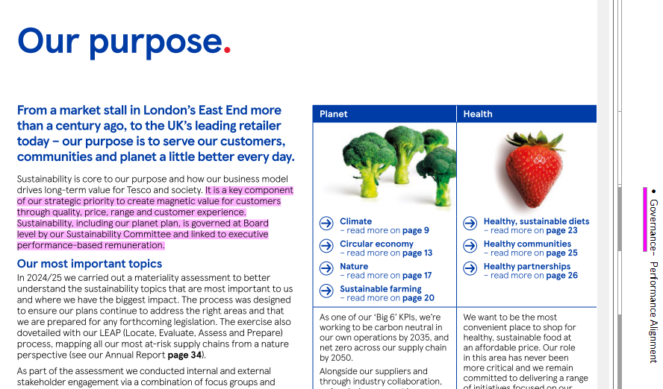

Figure 4.2: Thematic Coding 2: Governance-Performance Alignment
(Source: Self-created)
Code 3: Governance as Operational Driver
Parent Node (Code) | Child Node (Final Code) | Source | Link to RQ
Governance as Operational Driver | Waste Reduction Governance | Tesco Plc (2025a) Sustainability Report | RQ1
Governance as Operational Driver | Waste Reduction Governance | Tesco Plc (2025d) Food Waste Report | RQ1
Governance as Operational Driver | Governance accountability weighting | Tesco Plc (2025a) Sustainability Report | RQ1
Governance as Operational Driver | Governance accountability weighting | Tesco Plc (2025a) Sustainability Report | RQ1
Governance as Operational Driver | Waste Reduction Governance | Tesco Plc (2025d) Food Waste Report | RQ1

Table 4.3: Code Table 3: Governance as Operational Driver (Source: Self-created)
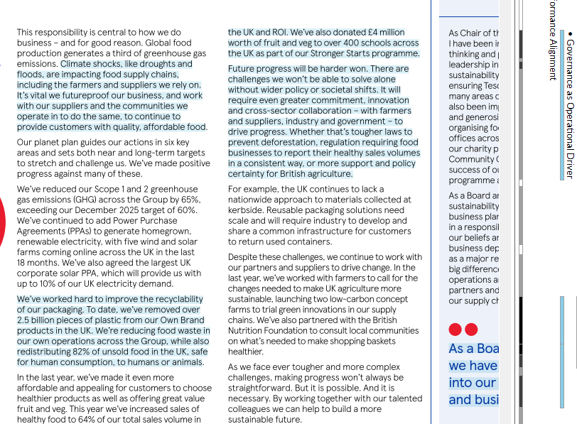
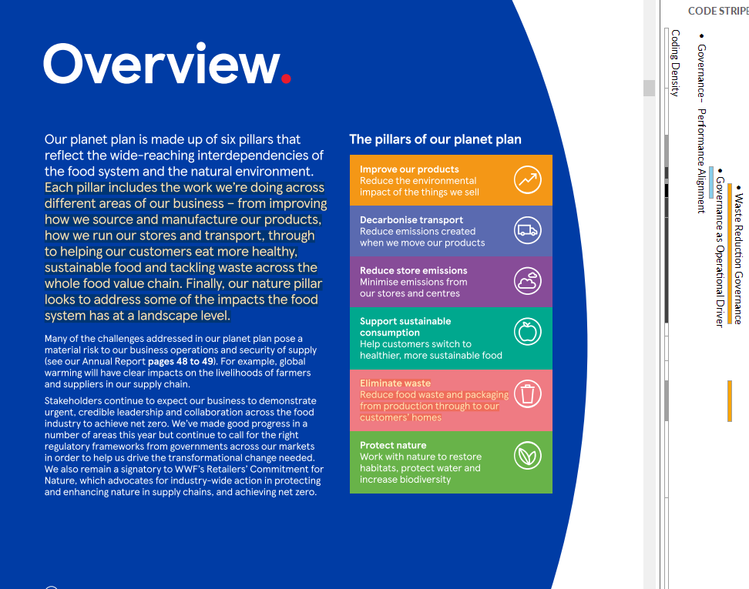

Figure 4.3: Thematic Coding 3: Governance as Operational Driver
(Source: Self-created)
Code 4: Governance as Productivity
Parent Node (Code) | Child Node (Final Code) | Source | Link to RQ
Governance as Productivity | Target, Measure, Act | Tesco Plc (2025d) Food Waste Report | RQ1
Governance as Productivity | Target, Measure, Act | Tesco Plc (2025d) Food Waste Report | RQ1
Governance as Productivity | Supplier engagement in TMA | Tesco Plc (2025d) Food Waste Report | RQ1
Governance as Productivity | Supplier engagement in TMA | Tesco Plc (2025d) Food Waste Report | RQ1
Governance as Productivity | Target, Measure, Act | Tesco Plc (2025d) Food Waste Report | RQ1

Table 4.4: Code Table 4: Governance as Productivity
(Source: Self-created)
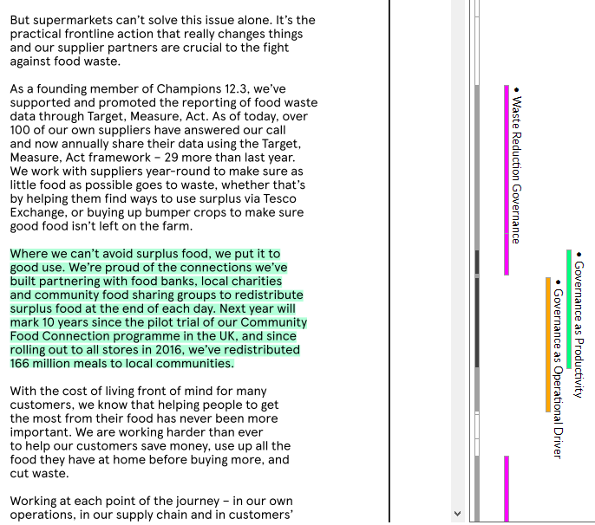
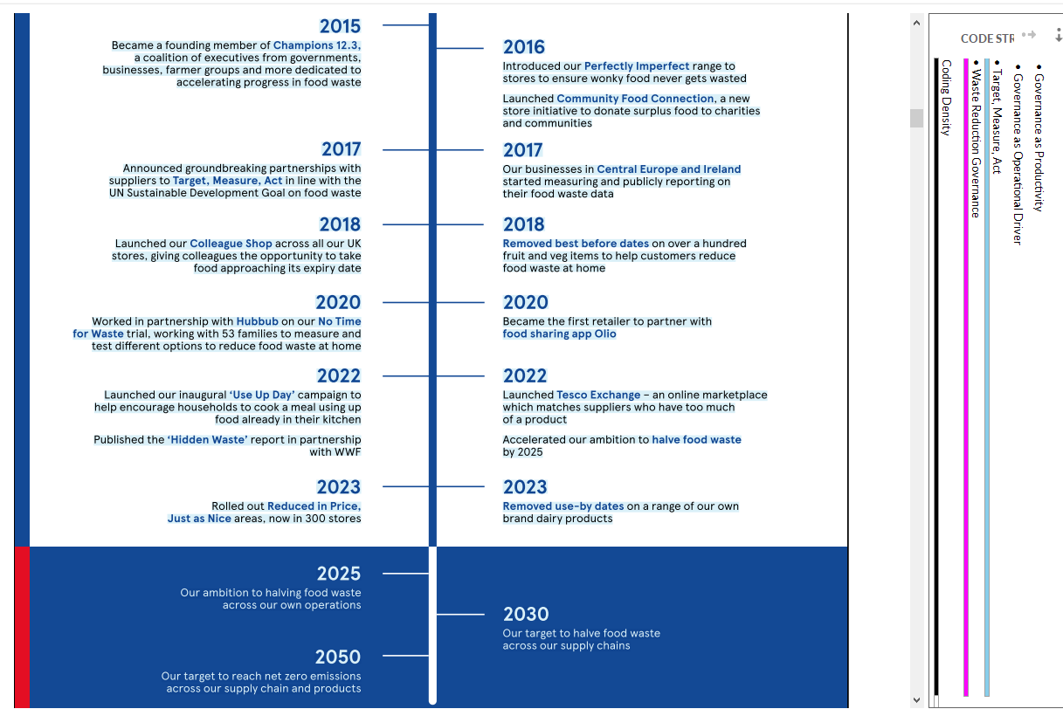

Figure 4.4: Thematic Coding 4: Governance as Productivity
(Source: Self-created)
Code 5: Governance-ESG Alignment
Parent Node (Code) | Child Node (Final Code) | Source | Link to RQ
Governance-ESG Alignment | Emissions Governance | Tesco Plc (2025c) Climate and Energy Factsheet | RQ3
Governance-ESG Alignment | Emissions Governance | Tesco Plc (2025a) Sustainability Report | RQ3
Governance-ESG Alignment | Emissions Governance | Tesco Plc (2025c) Climate and Energy Factsheet | RQ3

Table 4.5: Code Table 5: Governance-ESG Alignment
(Source: Self-created)
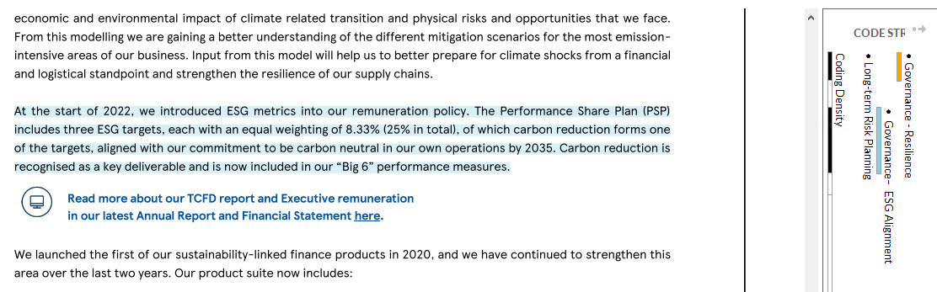

Figure 4.5: Thematic Coding 5: Governance-ESG Alignment
(Source: Self-created)
Code 6: Governance as Social ESG
Parent Node (Theme) | Child Node (Final Code) | Source | Link to RQ
Governance as Social ESG | Labour Rights Oversight | Tesco Plc (2025e) Modern Slavery Statement | RQ3
Governance as Social ESG | Modern slavery governance sign-off | Tesco Plc (2025e) Modern Slavery Statement | RQ3
Governance as Social ESG | Board oversight of sustainability | Tesco Plc (2025a) Sustainability Report | RQ3
Governance as Social ESG | Labour Rights Oversight | Tesco Plc (2025h) Human Rights Factsheet | RQ3
Governance as Social ESG | Board oversight of sustainability | Tesco Plc (2025f) Committee TOR | RQ3

Table 4.6: Code Table 6: Governance as Social ESG
(Source: Self-created)
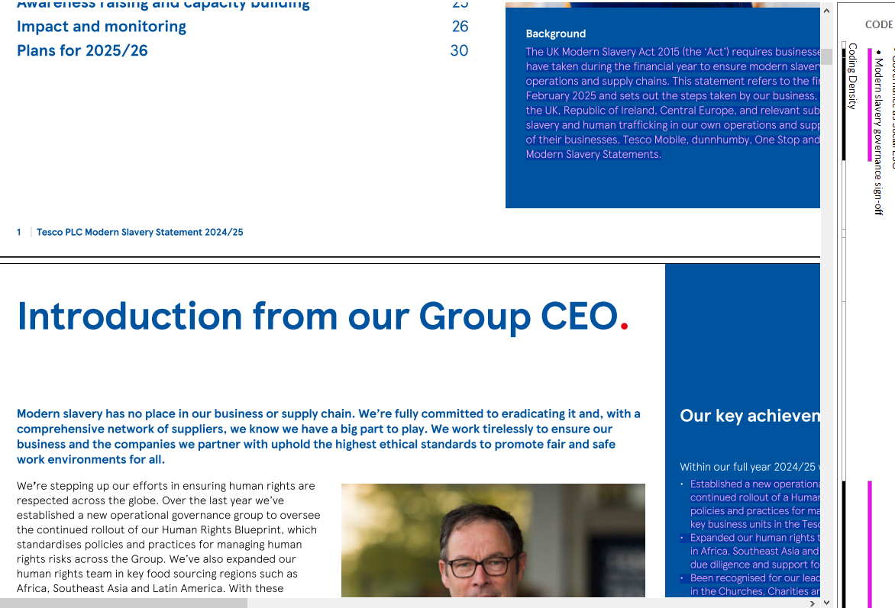
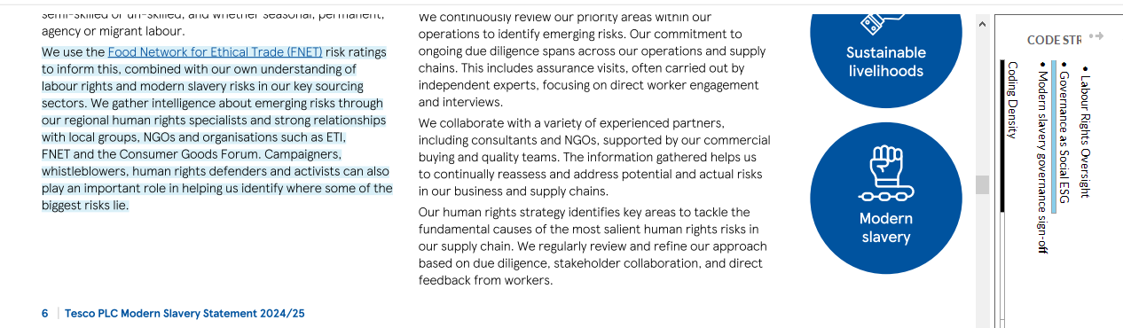
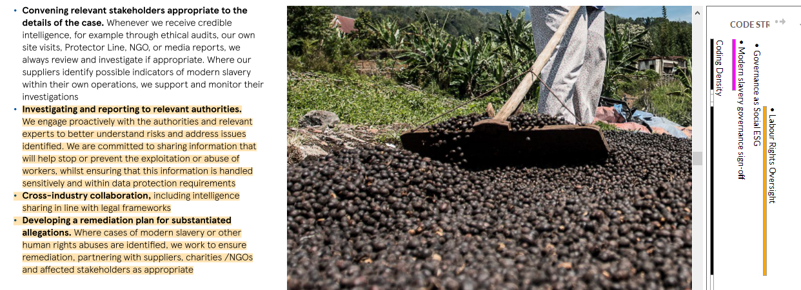

Figure 4.6: Thematic Coding 6: Governance as Social ESG
(Source: Self-created)
Code 7: Governance - Resilience
Parent Node (Code) | Child Node (Final Code) | Source | Link to RQ
Governance - Resilience | Long-term Risk Planning | Tesco Plc (2025a) Sustainability Report | RQ4
Governance - Resilience | Renewables commitment | Tesco Plc (2025c) Climate and Energy Factsheet | RQ4
Governance - Resilience | Long-term Risk Planning | Tescoimpactreport.com (2025) | RQ4

Table 4.7: Code Table 7: Governance - Resilience
(Source: Self-created)
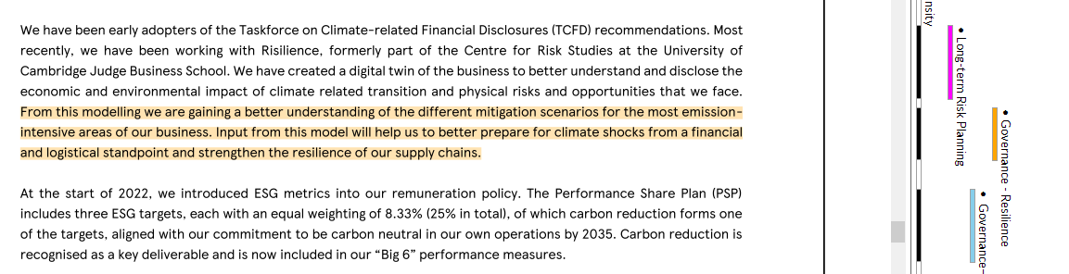
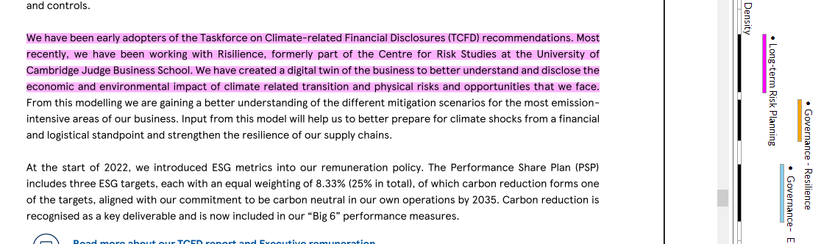

Figure 4.7: Thematic Coding 7: Governance - Resilience
(Source: Self-created)
Code 8: ESG - Competitive Advantage
Parent Node (Code) | Child Node (Final Code) | Source | Link to RQ
ESG - Competitive Advantage | Sector Benchmarks | Deloitte (2023) | RQ4
ESG - Competitive Advantage | Sector Benchmarks | Deloitte (2023) | RQ4

Table 4.8: Code Table 8: ESG - Competitive Advantage
(Source: Self-created)
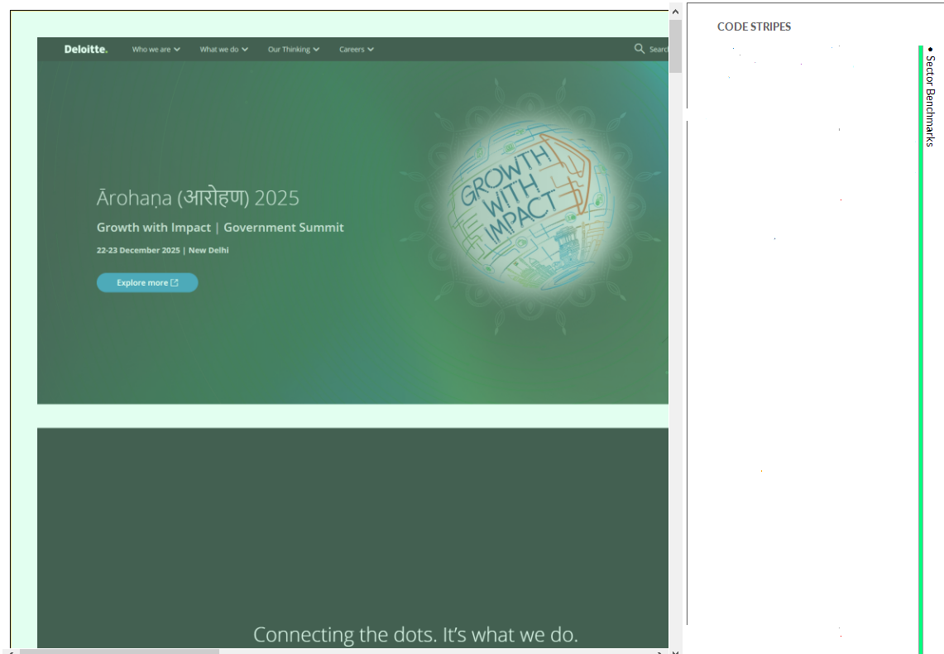

Figure 4.8: Thematic Coding 8: ESG - Competitive Advantage
(Source: Self-created)

4.1.3 Data Visualisation
The NVivo graphical displays in Figures 4.9 to 4.16 give interpretative ability on the dissemination of the governance mechanisms in the sustainability disclosures of Tesco. Instead of playing the role of mere descriptive drawings of coding density, these visualisations are helpful in determining what aspect of governance is highlighted in various corporate documents and its connexion with the aims of the research.
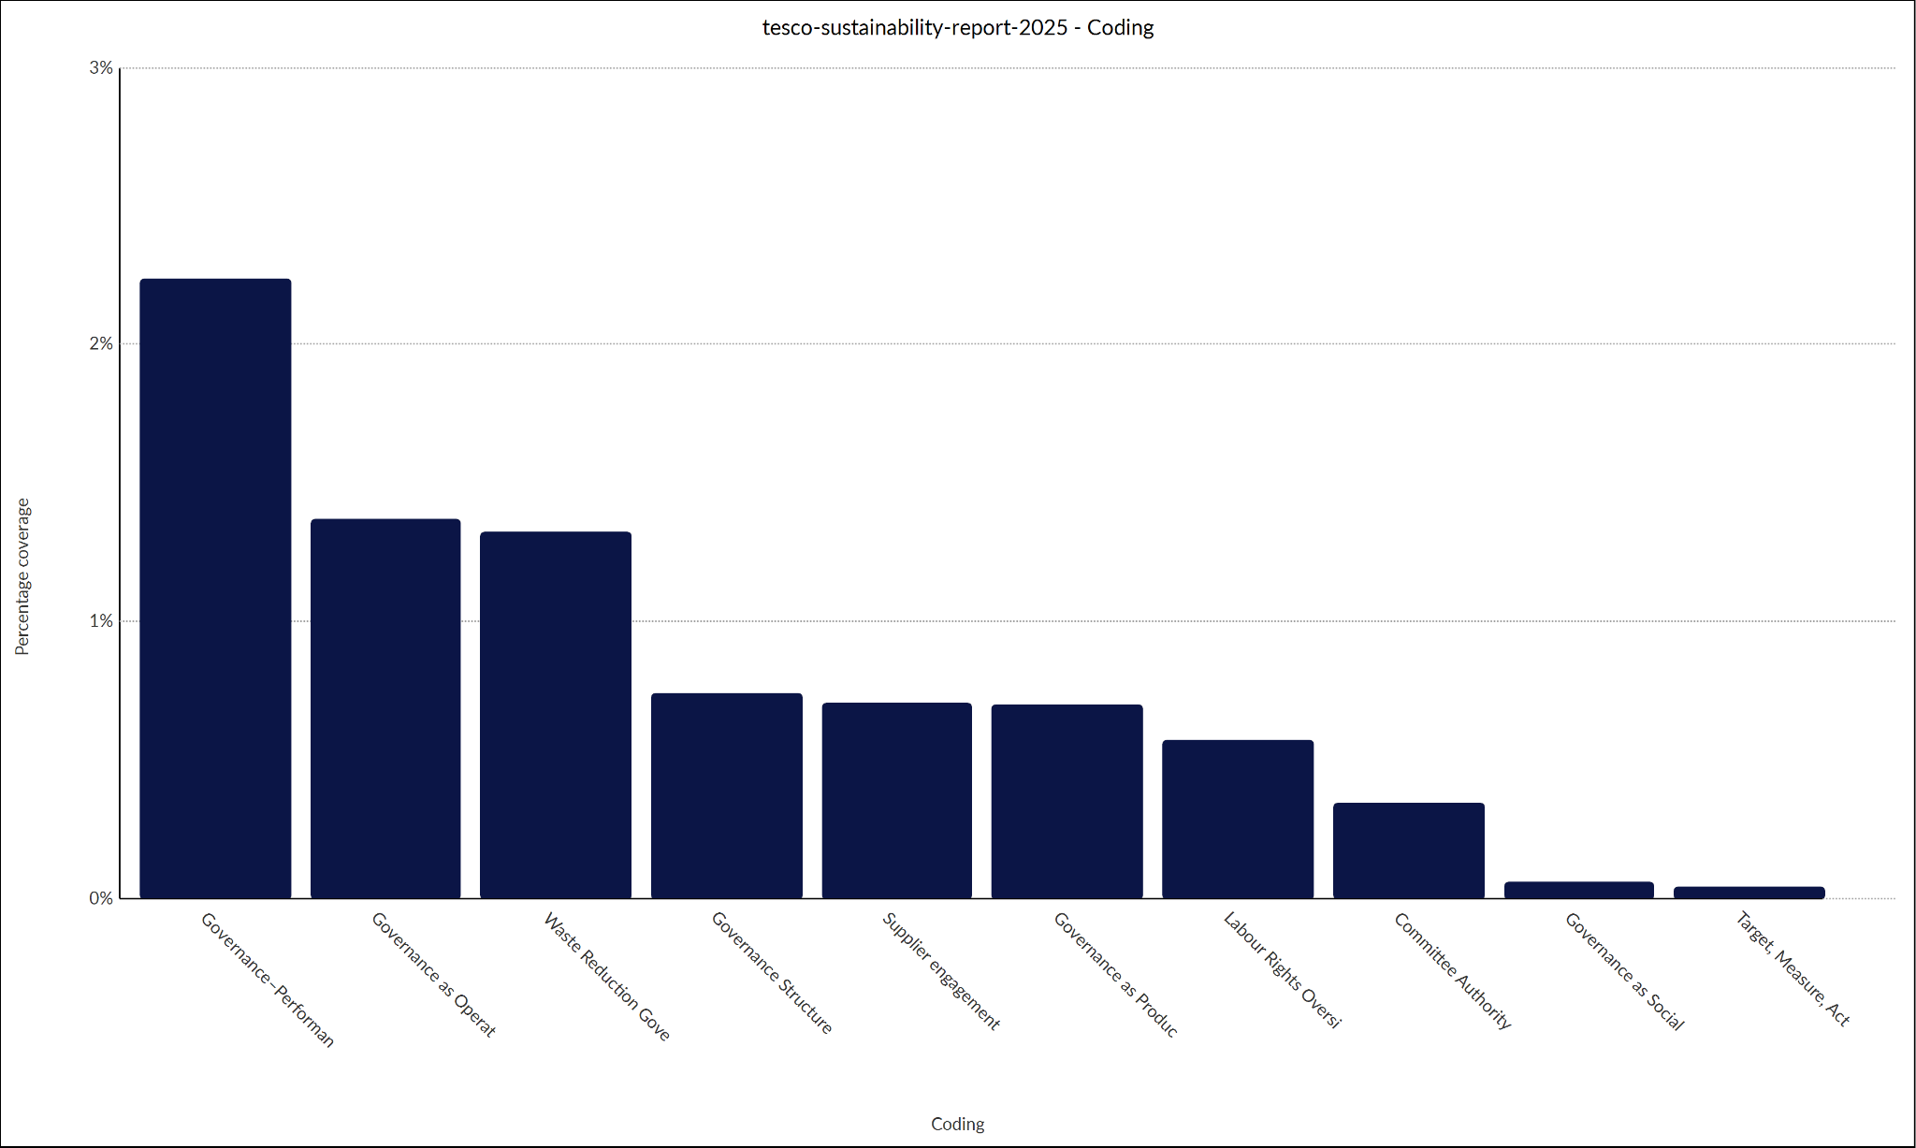

Figure 4.9: Coding Density for Tesco Sustainability Report (Source: Self-created)
The density of the Coding of the Sustainability Report demonstrates that the concentration around the defines of Governance as Operational Driver is high, especially, the child node, Waste Reduction Governance. The finding directly relates to Objective 2 where the mechanisms that govern the process of optimising resources and productivity are studied.
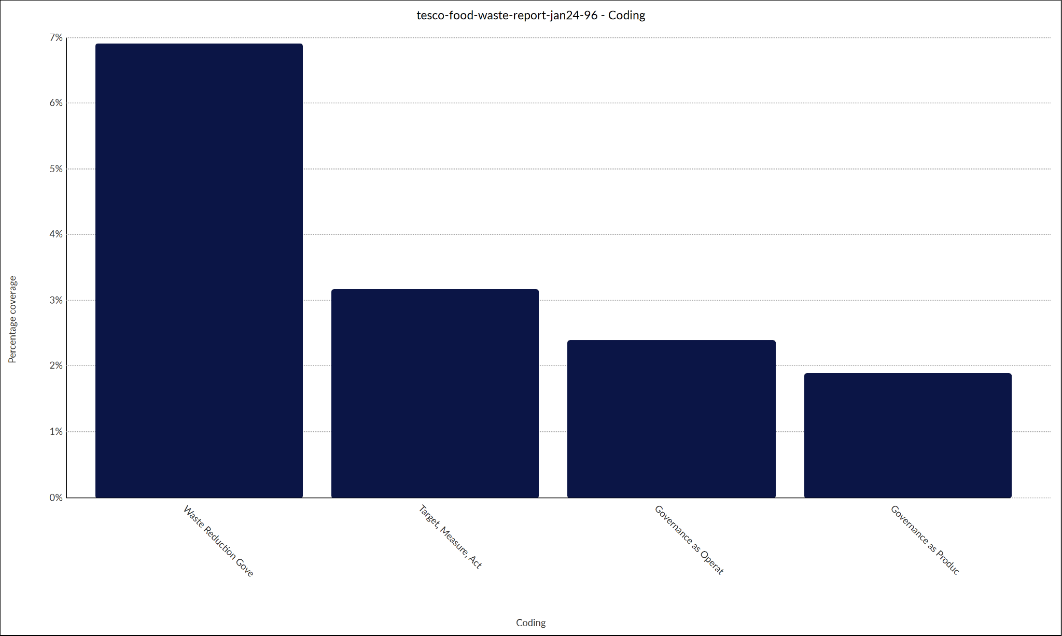

Figure 4.10: Coding Density for Tesco Food Waste Report
(Source: Self-created)
All of the additional Food Waste Report indicates a high degrees of density around the node of Governance as Productivity, particularly via the nodes of Target, Measure, Act (TMA) and Supplier Engagement. This result directly answers Objective 2 and Research Question 1, which dwell upon the dependence of governance and productivity performance. The TMA model formalises the observation, responsibility and coordination of suppliers, suggesting that government bears the cost efficiency and waste minimisation due to systemic data-driven controls.
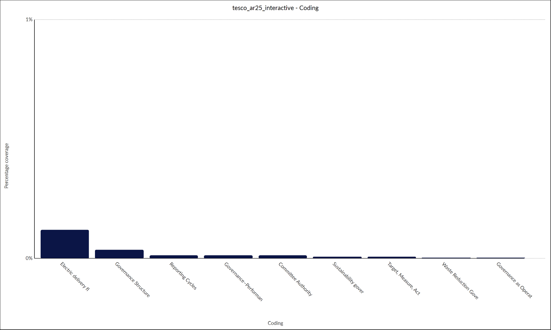

Figure 4.11: Coding Density for Tesco Value, Quality, and Service
(Source: Self-created)
The coding density within the “Value, Quality, and Service” documentation is concentrated around “Committee Authority,” “Sustainability Governance Integration,” and “Governance Structure and Oversight.”
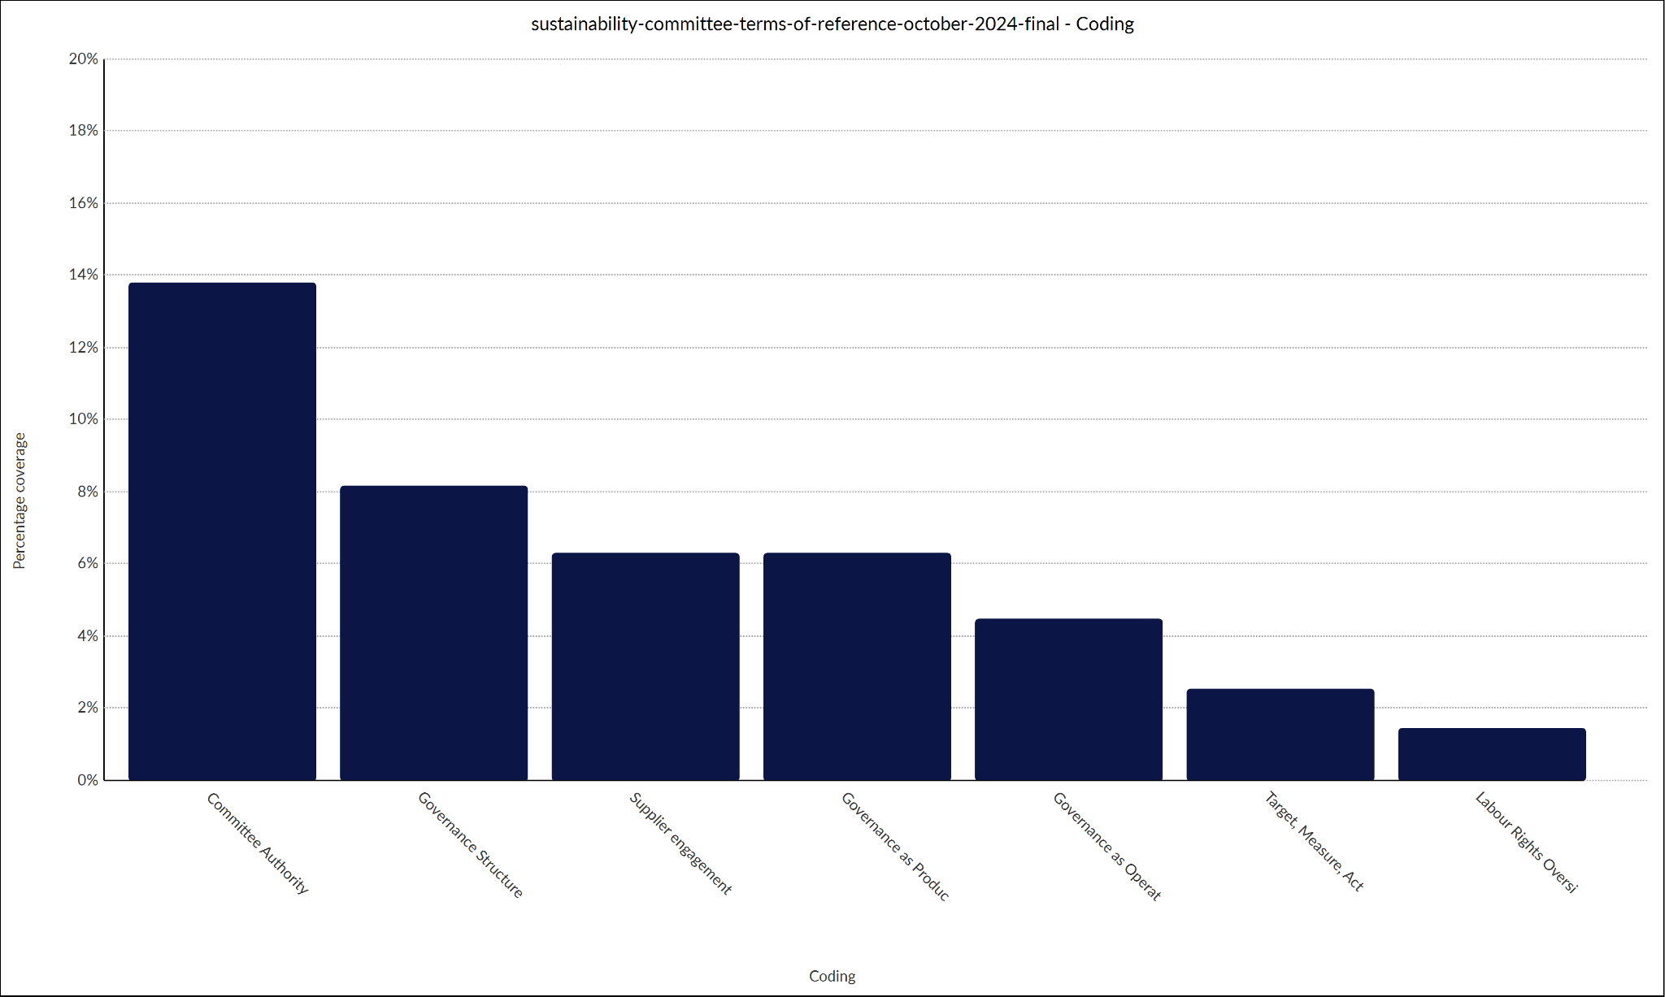

Figure 4.12: Coding Density for Sustainability Committee Terms of Reference (Source: Self-created)
Dense coding can be witnessed in the Terms of the Reference document under the “Governance as Authority,” and more precisely, within the Governance as Operations and also under the Labour Rights Oversight and also the Target, Measure, Act. This result can be connected to Objective 3.
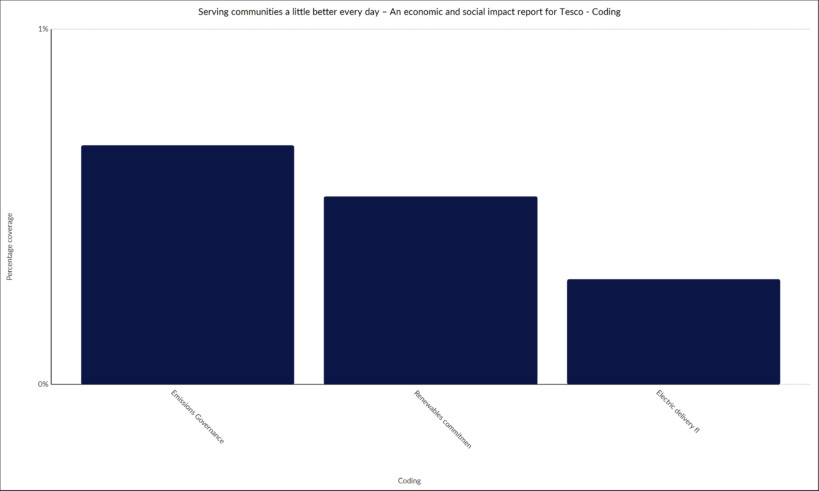

Figure 4.13: Coding Density for Tesco Report on Serving Committees (Source: Self-created)
The density of the code colours of the report on Serving Committees identifies themes like “Electric Delivery Fleet Strategy and Renewables commitment and these nodes are clustered with the governance oversight nodes. This will contribute to Objective 4 that assesses governance contribution to long-term resilience and competitive positioning.
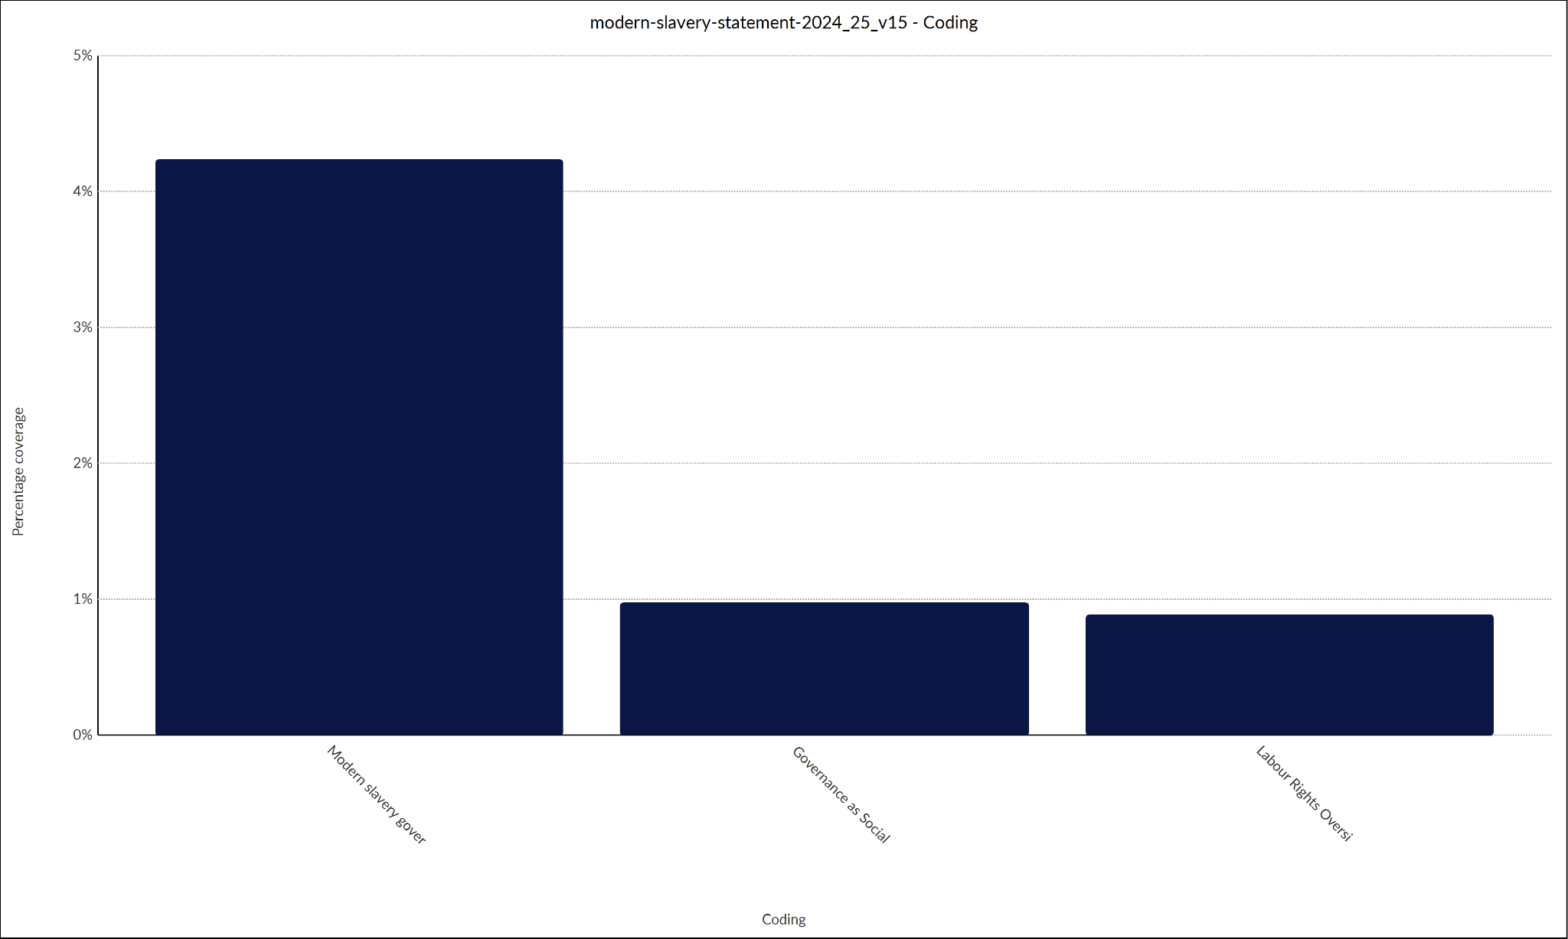

Figure 4.14: Coding Density for Tesco Report on Modern Slavery
(Source: Self-created)
This is indicated by the high density of modern slavery around the two categories, namely, Labour Rights Oversight, Governance Sign-off and the Governance as Social ESG in the Modern Slavery Report. These results are in line with Objective 3, which is ESG alignment. The operative significance of this difference is analytical, in that it shows difference in the operationalisation of governance mechanisms in the ESG pillars.
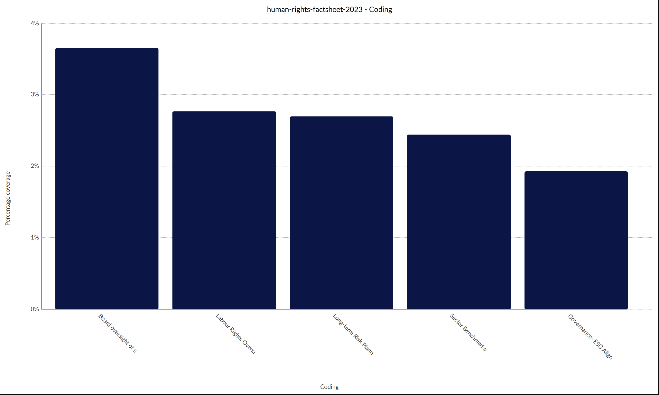

Figure 4.15: Coding Density for Tesco Report on Human Rights
(Source: Self-created)
Human Rights report demonstrates the moderate and consistent similarity between Governance-ESG Alignment, Board Oversight, and Long-term Risk Planning. This result also contributes to Objective 4, and specifically, the resilience dimension. The equalisation of distribution indicates that human rights governance is in place as an endeavour in risk reduction plan and not operational productivity improvement. This supports the wider empirical evidence that governance leads to resilience mechanisms by way of controls and risk management.
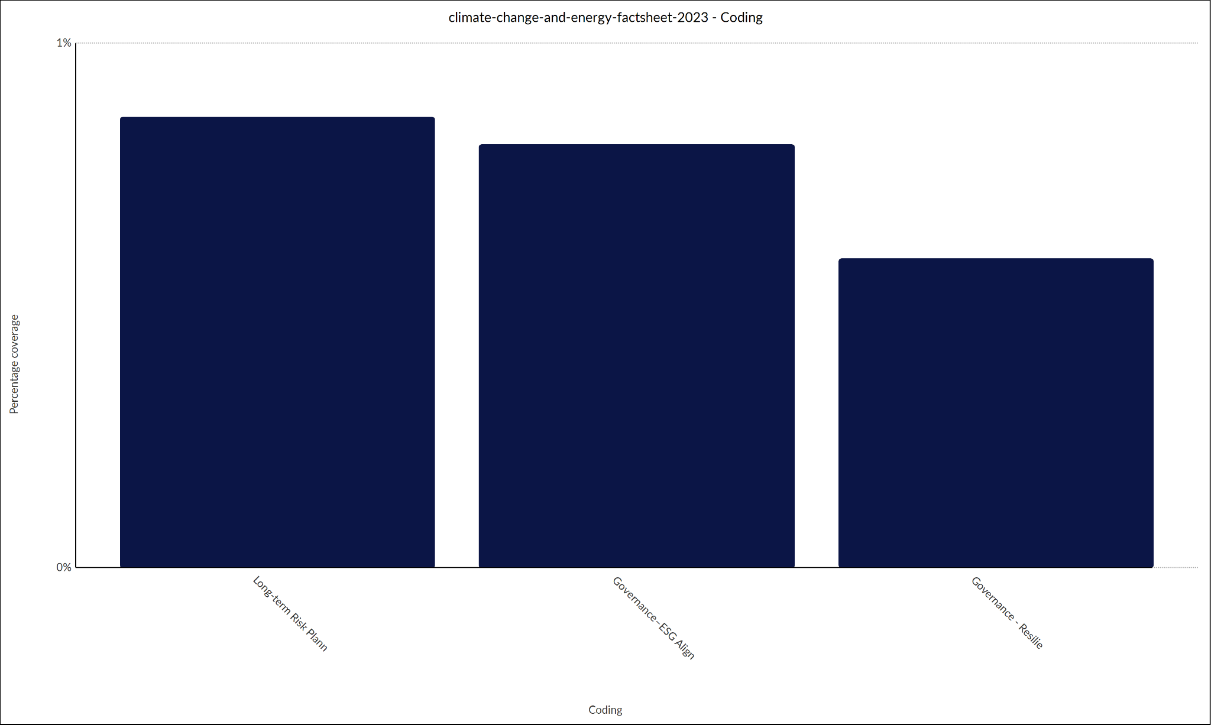

Figure 4.16: Coding Density for Tesco Report on Climate Change
(Source: Self-created)
The report of Climate Change, as opposed to the operationally dense report, exhibits a reasonably low operational density in the nodes of the Nodes of Governance-Performance Alignment. Rather, it seems to focus on reporting circles, emission goals, and disclosure measures. Such a pattern corresponds with Objective 2 and Objective 4 as it puts the focus on governance as a moderator between sustainability ambition and operational implementation.
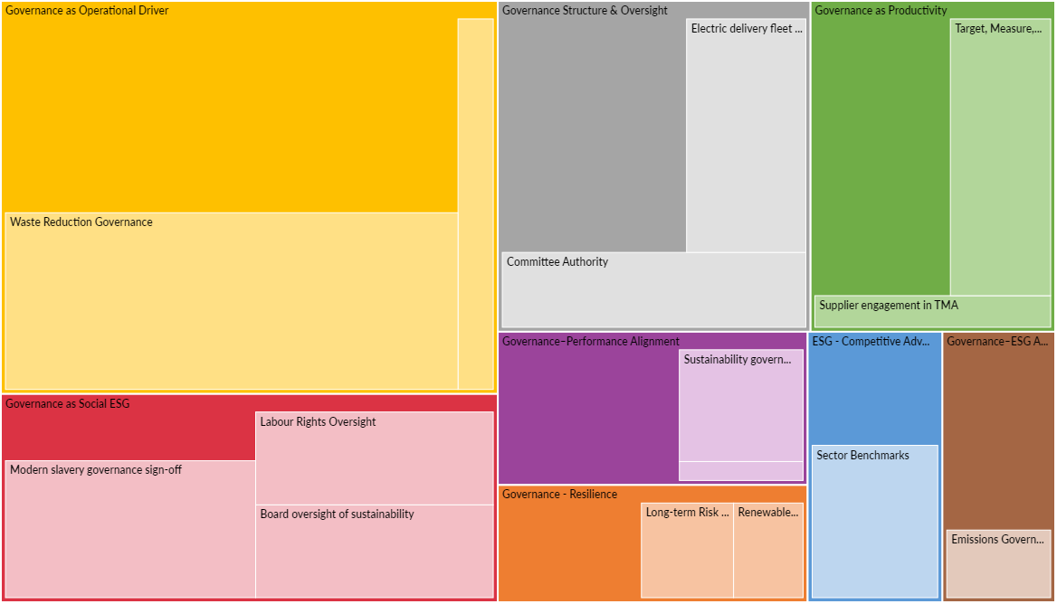

Figure 4.17: Hierarchy Chart
(Source: Self-created)
That hierarchical structure is the following figure 4.18 showing which coded themes are the most common ones in the dataset by the degree to which they are prominent. The graphical illustration reveals that the most dominant parent node is Governance as Operational Driver and Waste Reduction Governance displays the largest number of child nodes.
Since the governance is operating as an internal capability that increases the operational efficiency and not an administrative control mechanism, this depicts that the governance has assumed a Resource-Based View (RBV) perspective. The eminence of waste reduction governance also contributes to the fact that the governance systems are directly linked to the quantifiable productivity outcomes, specifically, cost savings and inventory optimisation.
It should be noted, however, that coding prominence represents emphasised disclosure and not operational impact that has been independently ascertained. Thus, although it might seem that operational governance comes into the picture as the key ingredient in narrative construction, the extent into which this can be higher productivity must be critically discussed in Chapter 5.
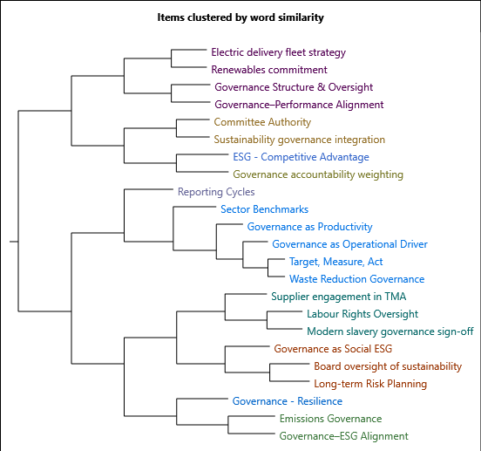

Figure 4.18: Cluster Analysis
(Source: Self-created)
The dendrogram in Figure 4.19 is the result of the cluster analysis, which shows a conceptual closeness of the governance-related themes in the dataset. As opposed to the hierarchy chart which indicates the coding volume, this visualisation can indicate the relational patterns among the governance constructs.
The clustering shows that there was a strong conceptual connexion between governance oversight, ESG alignment, operational accountability, and resilience planning. This implies that Tesco does not have a governance structure that is pursued as a number of isolated committees or sustainability projects in isolation. Rather, it is the interpretation of a cascading governance framework whereby strategic at the board-level governance is linked to operational mechanisms of implementation.
However, it does not mean that conceptual clustering proves functional integration. Although the disclosures made illustrate a relationship between governance that is interrelated and cascading, the length to which the coordination takes place across the operational levels are inferential and should be looked into critically in the next chapter.
The visualisation analysis in overall presents three fundamental patterns of empirical patterns:
- Coding density is dominated by operational governance mechanisms (waste reduction, TMA systems), which aid in the productivity linkage.
- Structural governance reports focus on control and power, support mechanisms of formal accountability.
- The social ESG governance is more governance-based than the environmental governance which is more operationally based.
These results corroborate the overall outcome of this chapter the overall Tesco green governance system has organised mediation systems that convert oversight board-level into operational operations, especially in fields relating to the environment. Strength of the direct productivity attribution is however different across the ESG dimensions, which implies that governance functionality is differentiated.

4.1.4 Data Credibility and Limitations
Although the data set includes a vast amount of sustainability and governance (2018 – 2025) publications, it is noteworthy that the majority of the sources stem on the Tesco company reports. Whereas these documents offer transparency and auditability, it can contain a tailored account in tandem with reputational goals. Hence, the results should be viewed as governance practise and its representation.

4.2 Thematic Findings

4.2.1 Theme 1: Governance Structure and Oversight
The theme of Governance Structure and Oversight reflects the way the governance structure of Tesco is officially structured and how the role of sustainability and ESG control are embedded by the board. The Terms of Referees of the Sustainability Committee clearly state the powers of the committee to manage the sustainability strategy, climate risk, human rights, and ESG disclosures (Tesco Plc, 2025f). The report notes that the performance of ESG, risk exposure and long term sustainability goals are periodically discussed at senior governance levels (Tesco Plc, 2025b). Other indications of leadership control are seen in the climate strategy at Tesco. The Climate Change and Energy Factsheet explains the governance provisions that support the initiatives like the conversion to electric delivery fleet and sourcing of renewable energy (Tesco Plc, 2025c). Instead of operating as compliance architecture on its own, it seems that governance is a strategic control mechanism that helps to minimise operational uncertainty and enhance accountability throughout the supply chain. This is an indication that governance plays an indirect role towards productivity by eliminating inefficiencies that are brought by piecemeal sustainability efforts.

4.2.2 Theme 2: Governance-Performance Alignment
The theme of Governance-Performance Alignment indicates the connection of mechanisms of governance with performance monitoring, reporting cycles and accountability systems. The Annual and ESG Report and the Sustainability Report are the main sources, which support this theme. The Annual and ESG Report include organised reporting cycles in accordance with which sustainability and ESG performance is evaluated (Tesco Plc, 2025b). The statement talks about the way the main indicators of sustainability, including the process of emissions reduction, food waste indicators, and compliance with society, are incorporated into performance scorecards and management reviews (Tesco Plc, 2025a). The executive remuneration is also connected with sustainability performance indicating that the governance mechanisms contribute to behavioural outcomes through incorporating the ESG provisions into performance management systems (Tesco Plc, 2025b). The findings depict the manner in which governance arrangements are operationalized using performance monitoring frameworks and provide an answer to Research Question 2 and aid in Objectives 1 and 2.

4.2.3 Theme 3: Governance as Operational Driver
The theme Governance as Operational Driver encompasses the realisation of the role of governance structures in the operational practise especially with regard to waste minimization and sustainability practise. In the Sustainability Report and the Food Waste Report, this theme is largely supported.
In the Sustainability Report, waste minimization is positioned as one of the main priorities of the operational processes, which are regulated with the help of organised lines of accountability (Tesco Plc, 2025a). The report on the target, measure, and act, and food waste is the source that offers a thorough understanding of the impact of the governance structure on the operation decision-making (Tesco Plc, 2025d). The report provides an outline of how governance sets transparency, publication of data and constant improvement, which instils waste reduction into the daily operation processes.
In addition, the weighting of governance accountability in the performance evaluation models is integrated into operational priorities, which supports the contribution of governance in performance evaluation. This proves that the process of governance has a direct impact on the management and optimisation of resources. These results answer Research Question 1 and Objective 2 results describing the impact of green governance models on productivity and resource efficiency.

4.2.4 Theme 4: Governance as Productivity
Governance as a Productivity theme is concerned with the governance tools and strategies that would contribute to efficiency, cost minimisation and resource optimization, specifically in the Target, Measure, Act (TMA) model.
This theme knows direct productivity linkages, unlike other themes which concentrate on structure and alignment. Coding density illustrates repetition of the reference to quantifiable cost reduction of the form of waste reduction, supply chain optimisation as well as energy efficiency programmes. Governance thus makes governance not just as a controller but as a driver of performance. A feedback loop mechanism is represented by the Target, Measure, Act framework through which the governance is institutionalised allowing a refinement process to continuously take place on operations. In an RBV perspective, these types of structured data-based governance contribute to enhancing the valuable and difficult to replicate resource optimisation capabilities at Tesco. This substantiates the claim that the administration is associated with productive dynamic capabilities produced through governance systems as opposed to the administrative overheads.
According to the Food Waste Report, TMA is a governance-based structure that is aimed at reducing food waste and improving operational efficiency in a systematic way (Tesco Plc, 2025d). The most important aspect of such a governance framework is that of supplier engagement. The report emphasises that expectations of governance are expanded along the supply chain and that the suppliers have to mimic the same practices to reduce wastes (Tesco Plc, 2025d). This shows the implication of governance mechanisms to impact productivity outside of the organisation.
Publication of food waste data is also presented as an accountability measure based on governance as it contributes to transparency and benchmarking. These results support the contribution of governance towards organising productivity deliverables which is Research Question 1.

4.2.5 Theme 5: Governance-ESG Alignment
The theme Governance-ESG Alignment shows the alignment of the governance arrangements following environmental ESG objectives, especially emissions governance. The sources of evidence include the Climate Change and Energy Factsheet and Sustainability Report.
The Climate Change and Energy Factsheet articulate the emissions cut and renewable energy goals of Tesco and places it in the framework of governance initiative (Tesco Plc, 2025c). The Sustainability Report makes climate change one of the key risks in the field of enterprise risk management which serves to strengthen the incorporation of environmental ESG goals in the processes of governance (Tesco Plc, 2025a). These results touch upon Research Question 3, and present the support of Objective 3. The results however also show some narrow specific quantification of productivity gains as direct result of decisions of governance committees. The causal relationship between the board-level governance activities and the operational performance enhancement is largely implied, as opposed to being directly presented, although sustainability metrics are widely reported. This implies the probability of disconnect between governance intention and quantifiable productivity effect.

4.2.6 Theme 6: Governance as Social ESG
Governance as Social ESG theme is the theme that represents governance mechanisms associated with labour rights, human rights, and ethical sourcing. To support it, the evidence is based on the Modern Slavery Statement, Human Rights Factsheet, and Sustainability Committee Terms of Reference.
The Modern Slavery Statement presents resources of governance on identification and reduction of labour risks, making the term board approval and oversight obvious (Tesco Plc, 2025e). This shows diversity of social responsibility at the hands of ESG. The Human Rights Factsheet also outlines governance frameworks that control the compliance of standards of suppliers and labour rights (Tesco Plc, 2025h). The issue of governance is brought out as one that influences the ethical behaviour in the entire chain of supply. These results touch upon Research Question 3, and present the support of Objective 3.

4.2.7 Theme 7: Governance - Resilience
The theme Governance - Resilience relates to the contribution of governance to long-term planning and organisational resilience. It is evidenced through Sustainability Report, Climate Change and Energy Factsheet, and Impact Report. In the Sustainability Report, long-term risk planning procedures are highlighted, whereby climate and supply chain risks are incorporated in the governance decision-making (Tesco Plc, 2025a). Governance would be placed as facilitating the readiness in the future. The Impact Report also strengthens the governance as the backbone of resiliency and sustainable value creation (Tescoimpactreport.com, 2025). These results pose an answer to Research Question 4 and Objective 4.

4.2.8 Theme 8: ESG - Competitive Advantage
The theme ESG - Competitive Advantage summarises the role of the sustainability practices that are in line with governance in competitive positioning. The analysis of the industry by Deloitte is used as evidence. Deloitte (2023) emphasises that organisations that incorporate sustainability in the governance structures are at a more advantageous position to react to the market demands and the regulatory requirements. Sector benchmarking offers third party confirmation of Tesco ESG approach that is governance-led. This is the theme where Research Question 4 is touched.

4.3 Cross-Theme Summary
The cross-theme analysis goes on to reveal that the Tesco green governance framework is a cohesive system of operation where operational efficiency, performance delivery, ESG alignment, and long-term resilience are collectively attained. According to Research Question 1, the results of Research Themes 3 and 4 indicate that governance is a direct productivity and resource efficiency driver in the operations of Tesco. It is a governance-based strategy that allows the optimisation of the resources and the elimination of waste to be formalised into the everyday system of the retail business and facilitated by accountability procedures that direct the observation and review of performance on multi-level organisational scales (Tesco Plc, 2025d). The frameworks of governance like Target, Measure, Act organise operation behaviour by setting clear targets, requiring the measurement to be consistent and entailing the processes correction acts.
The answer to Research Question 2, Themes 1 and 2, brings to the fore the importance of the governance systems in facilitating the delivery of operations effectively due to the lot of structure and alignment of performance. The alignment facilitates performance consistency and accountability throughout the organisation and thus illustrates the role of governance systems and processes in ensuring effective organisational operations (Tesco Plc, 2025b).
To answer the Research Question 3, Themes 5 and 6 analysis indicates that there was a high correlation between the governance arrangements and ESG and sustainability goals at Tesco. The results show that governance is at the heart of the process of converting ESG goals into organisational practice, both in the environmental and the social aspects (Tesco Plc, 2025c; Tesco Plc, 2025e). Sustainability capacity in governance processes boosts Tesco ability to predict and control risks in the long run and evidence of external benchmarking indicates that implementation of such governance practices increases competitive differentiation in the retail industry (Tescoimpactreport.com, 2025; Deloitte, 2023). As far as Research Question 4 is concerned, Themes 7 and 8 show that governance is a source of organisational resilience and competitive advantage.
The themes findings all indicate a governance-productivity mechanism which works in four phases:
- Structuring of governance (Board committees, policy mandates)
- Operational Embedding (Cross-functional ESG integration)
- Accountability (Target, Measure, Act systems) Data Monitoring and Accountability.
- Productivity (Reduced waste, minimised costs, enhanced resilience) Outcomes.

4.4 Summary of Key Findings
On the whole, the results of the current research suggest that the governance structure of Tesco is at the centre of productive and resource efficiency due to the introduction of accountability and performance evaluation into the functional processes. It seems the governance mechanisms can increase productivity in an indirect manner due to efficiency maximisation, risk reduction, and resilience. Nevertheless, there is a more significant lack of evidence on some themes, which the relationship with governance in terms of alignments and resilience is more evidently supported than that of direct productivity causation. These results ensure some empirical support of the theoretical framework which has been developed in Chapter 2 and forms the basis of the critical discussion held in Chapter 5.

4.5 Chapter Summary
In this chapter, the author has brought the results of a qualitative secondary analysis of the Tesco Plc governance and sustainability disclosures. The eight interrelated themes that were found through the reflexive thematic analysis show how the governance frameworks impact the operational practices, the alignment of performance, ESG integration, resiliency, and the competitive advantage.

CHAPTER 5: DISCUSSION

5.1 Investigation of Tesco’s governance and “sustainability framework” (Objective 1)
According to the findings, Tesco has a green governance framework, which is very formalised, board-led and entrenched in its corporate governance structure. This contributes to the argument put forward by Schoenmaker and Schramade (2023), who argue that sustainability can only be given strategic significance when it is managed at the board level instead of being pushed to the operational or CSR departments. The existence of sustainability committees, reporting cycles, or governance requirements in the case of Tesco are an indicator of a conscious effort to transform sustainability into a reputational issue into a strategic oversight role.
This interpretation however differs with the more sceptical views in the literature. According to Feghali et al. (2025), formal governance systems tend to emphasise the visibility rather than the effectiveness, especially in big companies where the quality of disclosure can conceal the little change in operations. Although the governance system at Tesco seems to be sound the results are based more on self-reported corporate documentation, which resonates with warning that the governance presence must not be confused with governance power (Kothari, 2025).
From the perspective of Stakeholder Theory view, the governance structure at Tesco demonstrates how the organization is responding to increasing pressure on the part of regulators, shareholders, and the general society. According to the stakeholder logic developed by Freeman, the governance is destined to maintain the level of legitimacy through balancing various requirements. This is evident where Tesco examines climate action, labour rights and impact on communities. Such balancing can however result in only the bare minimum of compliance, but not actual change, particularly in highly competitive, low-margin industries such as grocery retail (Gouldson and Sullivan, 2014).
The findings meet the objective by evidencing that Tesco’s sustainability framework is board-anchored, intentionally strategic and operationally significant through measurable mechanisms such as Target–Measure–Act, waste reduction governance, and supplier accountability. NVivo coding dominance around “Governance as Operational Driver” confirms governance is designed to translate oversight into productivity, resilience, and ESG execution rather than symbolic compliance.
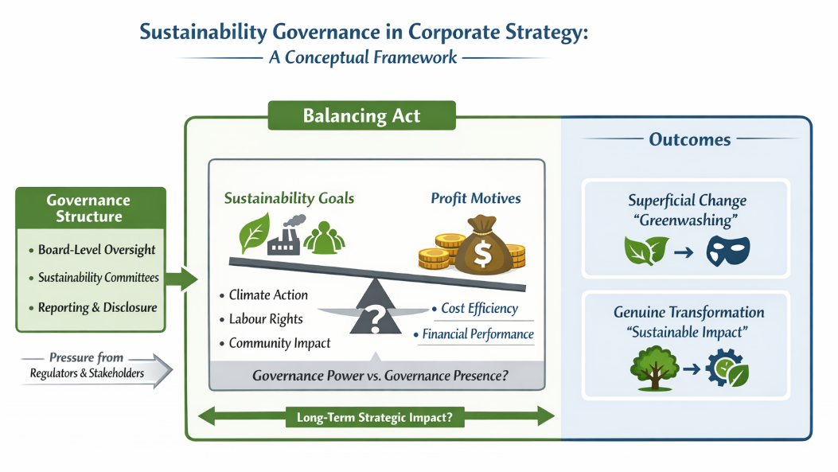

Fig 5.2: Sustainability governance framework for strategy
(Source: Self-developed)

5.2 Exploring “governance mechanisms” in Tesco’s retail operations (Objective 2)
One of the most significant findings of this study is that governance mechanisms at Tesco are explicitly framed as drivers of operational productivity, particularly through structured systems such as the “Target, Measure, Act” (TMA) framework and supplier engagement protocols (WRAP, 2022). This supports Olarewaju et al. (2024), who empirically demonstrate that sustainability-led waste reduction in food retail can generate measurable cost savings and efficiency gains.
However, the literature is divided on whether such productivity outcomes stem from sustainability initiatives themselves or from the governance systems that discipline organisational behaviour. While Sabat and Krishnamoorthy (2020) emphasise the role of sustainable supply chain practices in enhancing efficiency, Sun and Guo (2024) argue that productivity gains often depend more on digital maturity and process automation than on governance itself.
Under the Resource-Based View, governance is a dynamic ability that enables Tesco to continue remaking its resources to sustain its sustainability issues. According to Khanra and colleagues (2022), it is governance-based routines rather than individual green innovations that provide a sustainable competitive advantage. The Tesco waste-reduction programmes have shown the results of governance in the real life across the industries. As an example, Tesco announced that it recycled over 82% of spare food in the UK versus an industry average of approximately 60-65% of excess food in the groceries of larger European companies (Tesco, 2025). This reduced its disposal expenses and improved the overall reputation of the company. In comparison, Sainsbury reduced food waste by approximately 15% between 2018 and 2023, whereas Tesco reduced it by more than 40% within the same period (Sainsburys, 2025). It points to the fact that coordination of governance is significant in reducing food waste.
Importantly, the findings reveal that Tesco redefines productivity beyond short-term financial output, incorporating resource efficiency and waste minimisation. While this supports Adeniran et al. (2024), it also raises critical questions: does broadening productivity dilute accountability, or does it represent a necessary evolution in sustainability-intensive industries? The evidence suggests that governance legitimises this broader productivity narrative, but empirical causality remains inferential.
NVivo analysis indicates that Tesco’s governance mechanisms optimise resources and cost efficiency through operationally dominant nodes, particularly “Waste Reduction Governance” and “Target, Measure, Act.” High coding density in the Food Waste and Sustainability Reports shows governance cascading into daily decision-making via supplier accountability, performance-linked metrics, and feedback loops, directly enabling inventory optimisation, reduced disposal costs, and productivity gains.

5.3 Examination of correlation among “governance arrangements”, “ESG” and sustainability goals (Objective 3)
The third research objective was to investigate the alignment of the governance arrangements with environmental, social, and governance (ESG) goals of Tesco. The findings section shows that Tesco has put in place effective governance processes to help it fulfill its ESG promises. These arrangements comprise board level supervision, sustainability committees and official ratification of policies on climate change, modern slavery and human rights. It is consistent with Moussa et al. (2024), who express the opinion that ESG performance is higher when the sustainability is organized under formal governance instead of informal or voluntary measures. Tesco also does not consider ESG as an isolated or optional activity but a component of its operation as far as governance is concerned. Decision-making, reporting systems, and risk management practices incorporate the ESG responsibilities. Raman et al. (2025) agree with it, indicating that governance is the mechanism that transforms ESG goals into organisational action. As an example, Tesco management of environmental conservation and labour quality ties sustainability goals to definite supervision and responsibility frameworks (Tesco, 2025). But, not every researcher is sure that good governance is necessarily followed by effective ESG results. Prabhakar and Gilmour (2024) have stated that in a big retail organisation like Tesco, ESG governance functions effectively in the policy level but implementing it in supply chain level across the globe can be complex.
This limitation reflects a wider problem in ESG research. Feghali et al. (2025) warn that companies may appear well aligned with ESG goals through reporting, even when real-world outcomes are uneven. In Tesco’s case, governance alignment shows strong intention and direction, but it does not fully prove the depth of ESG impact across all operations (Michalski, 2024). Therefore, governance alignment should be seen as an enabling condition rather than a guarantee of success. Comparing Tesco with other global retailers further highlights this issue. For example, companies such as Walmart and Carrefour have strong ESG governance frameworks but have still faced criticism over labour practices in their supply chains (Rahdari et al. 2020). This shows that even well-governed organisations face challenges in fully controlling ESG performance in complex networks.
NVivo thematic analysis shows strong alignment between Tesco’s governance arrangements and ESG goals, with high coding density around “Governance-ESG Alignment,” “Board Oversight,” and “Social ESG Governance.” Formal committee authority, policy sign-off, and risk reporting integrate climate, labour, and human-rights objectives into governance systems; however, clustering patterns indicate governance alignment is stronger at policy and reporting levels than at operational ESG impact across global supply chains.

5.4 Evaluation of “green governance” (Objective 4)
The empirical findings show that green governance has been effective in improving organisational resilience through incorporating long-term risk planning, climate policy, and sustainability investment choices into the strategic decision-making practices of Tesco.
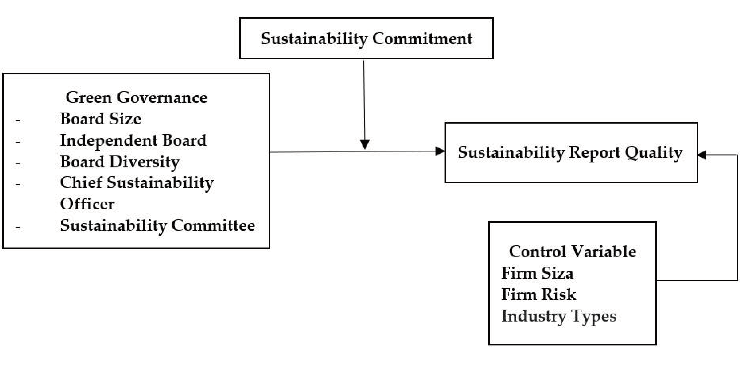

Fig 5.5: Concept of Green Governance
(Source: Liu and Lee, 2025)
These results are aligned with Liu and Lee (2025) who show that companies that have strong ESG governance are less likely to fail in the long run. Still, the notion of resilience is a highly controversial concept in the domain of sustainability studies. Although Schoenmaker and Schramade (2023) consider the governance structure to be the backbone of long-term value creation, Hamdouni (2025) argues that governance systems that focus on disclosure exaggerate the resilience when performance during crises is not measured. Though the outcomes of Tesco seem to be consistent, according to the former perspective, the absence of longitudinal crisis analysis does not allow the definitive empirical validation. Real-world evidence provides partial validation. In the COVID-19 pandemic, Tesco has shown a higher capability in supply-chain continuity in comparison to some of its competitors, reporting a lower number of stock-out events and a reduced time to recover (‌Harvard Business Review, 2021). These observations suggest that risk planning and governance-facilitated coordination led to operational resilience. However, it is also feasible that such considerations like the scale, access to capital, and digital infrastructure also contributed to these results.
In the Resource-Based View, governance mechanisms lead to organisational resilience by stabilising routine, improving foresight and coordinated responses. However, as Atieh et al. (2024) suggest, it is common to find that resiliency investments have high initial expenses, and this conflicts with short-term profitability. The results fail to exhaust the approach that Tesco takes to address these trade-offs and this is a significant shortcoming. Competitively speaking, it was revealed that governance-based sustainability is better in reputational capital and stakeholder trust, although not in long-term market leadership (Mandy, 2025). Governance-based competitive advantage is thus indirect, cumulative and fragile instead of immediate and self-reinforcing.
NVivo hierarchy and cluster analysis reveal that “Governance as Operational Driver” and “Governance–Resilience” are conceptually proximate, indicating that Tesco’s green governance converts environmental controls into long-term risk preparedness. High cross-coding between renewables, climate risk planning, and board oversight demonstrates governance-enabled resilience, while linkage with “ESG–Competitive Advantage” shows sustainability performance supporting adaptive competitiveness rather than short-term efficiency alone.

5.5 Theoretical Implications
Theory | Existing View in Literature | Contribution of This Study
Stakeholder Theory | Focuses on balancing stakeholder interests mainly through ethical responsibility and disclosure (Mandy, 2025). | Extends the theory by showing that stakeholder expectations are managed through formal governance mechanisms that influence operational decisions, not just reporting.
Resource-Based View (RBV) | Emphasises resources and capabilities as sources of competitive advantage (Lubis, 2022). | Reframes green governance as a dynamic organisational capability that supports productivity, efficiency, and long-term resilience in large retail firms.
Green Governance Theory | Often viewed as a compliance or risk-management framework (‌Sarjito, 2024). | Demonstrates that governance can act as a productivity-enabling mechanism when embedded into operational processes.

Overall, the study shows that green governance should not be seen only as a compliance tool. Instead, it plays a strategic role in shaping productivity and resilience. By linking governance structures to operational outcomes, this research strengthens existing theories and highlights governance as an active organisational capability rather than a symbolic or reporting-based practice.

5.6 Chapter Summary
This chapter critically interprets the findings presented in Chapter 4 by situating them within the broader academic debate on green governance, ESG integration, and organisational productivity. Unlike the findings chapter, which focused on presenting empirical patterns derived from Tesco’s sustainability disclosures, this discussion chapter evaluates what those patterns mean, how they align or conflict with existing literature, and what they imply for theory and practice. In doing so, the chapter explicitly compares and contrasts different scholarly viewpoints, integrates real-world industry evidence, and critically reflects on the limitations and boundary conditions of the findings.
The discussion is structured around the four research objectives. Each section synthesises empirical findings with theoretical perspectives, particularly Stakeholder Theory and the Resource-Based View (RBV), while also engaging with critical literature that questions the effectiveness, authenticity, and productivity implications of green governance.
This chapter also reviewed the results by amalgamating the green governance practices at Tesco with available theoretical frameworks and empirical studies. It showed the reinforcement of productivity, ESG alignment, and long-term resilience by effective governance mechanisms and outlined limitations, in particular, the dependence on disclosed information. The next chapter will present the conclusions of the study, summarizing the main findings, outlining the practical and theoretical implications, pre-empting methodological shortcomings, and suggesting future research directions.

CHAPTER 6: Conclusion

6.1. Restatement of research aim, objective and questions
The aim of this study was to evaluate how “green governance” has a positive impact on the productivity of companies, on being resource-efficient, and on environmentally sustainable performance of Tesco PLC. To do this a qualitative secondary case study was conducted. The findings of this study will confirm that governance is the mechanism that connects board level oversight to operational outcomes.
The “first objective” of this research was achieved when a formal, “board-led sustainability governance framework” was identified and had an obvious operational significance to it. The second and third objectives were fulfilled through demonstrating that “Target–Measure–Act systems” and governance mechanisms aligned productivity with ESG targets. Finally, the fourth objective of this research and all other research questions were accomplished when evidence of resilience and “competitive positioning” was demonstrated through the use of governance frameworks.

6.2. Link between the methodology and the key findings
The study utilized a “qualitative secondary case study” approach to examine Tesco’s publicly available “governance and sustainability (G&S) disclosures”. Using reflexive thematic analysis supported by NVivo enabled analysis of both explicit and implicit meanings and priorities associated with G&S, as well as normative assumptions about what is ‘right’ or ‘wrong’ within an organisation, is established and communicated through various types of documents.
In particular, “reflexive thematic analysis” enabled a deeper interpretative understanding of “corporate governance structures” than simply observing the formal descriptions of governance mechanisms, and illustrated that the operational implementation of board oversight occurs through “corporate governance reporting cycles”, accountability systems, and operational controls.
The study found that “corporate governance” has an indirect effect on organisational productivity through mediation mechanisms, particularly through the “Target–Measure–Act framework” that governs the use of organisational resources. Besides, “corporate governance systems” may be viewed as working in concert with organisation performance delivery systems through integrated monitoring and incentive measures. The relationship between “corporate governance systems” and ESG objectives, particularly with respect to environmental and social areas, was found to be formally aligned and structured. Furthermore, the study demonstrated how “corporate governance” promotes long-term risk planning and strategic investments in sustainable practices, thus providing an advantage in fostering organisational resilience and competitive positioning. Besides, the implications of “interpretative philosophy” were clear with the results not concerning causal measurement effects but interpreting “green governance” as an organisational capability.

6.3. Summary of the key findings
This research demonstrates that the function of “green governance” at Tesco operates predominantly as an intermediary mechanism to indirectly impact productivity levels and not as a direct productivity generator. “Research Question 1 (RQ1)” addresses how the “governance frameworks” affect the operationalisation of productivity and resource efficiency through formal governance structures, targets, and accountability frameworks, rather than providing resulting productivity performance. For RQ2, the study indicates that the operational governance mechanisms such as “waste reduction programs” and “Target-Measure-Act systems” have a strong direct relationship with productivity by converting strategic intent into quantifiable operational discipline.
For RQ3, ESG is primarily expressed from the dimensions of governance, policy, and reporting, where the “environmental and social objectives” are clearly articulated and measured for performance. Nevertheless, there are limited direct links identified between “ESG commitment” and quantifiable performance, indicating that there are differentiated results depending on the dimension of ESG. Additionally, there is greater “operational evidence” of environmental initiatives than there is of social and governance outcomes.
With respect to RQ4, “green governance” provides an indirect contribution to building “organisational resilience” and competitive positioning through embedding “long-term risk management capabilities”. When viewed through a RBV perspective, governance appears as one of Tesco's “organisational capabilities” that adds to its ability to coordinate, learn, and achieve strategic coherence. While not necessarily a performance lever on its own, “green governance” provides a continued capability for Tesco to maintain productivity and competitiveness well into the future. As such, “green governance” provides additional strategic value beyond “short-term efficiency” measures in retail environments.

6.4. Contribution to practice
This research provides useful insight into how retailers can implement “green governance” within their operations to help improve the efficiency and productivity of their business. The results indicate that incorporating “sustainability oversight” into an organisation’s performance systems adds value to corporate governance design. For example, the study demonstrates how the use of “Target-Measure-Act frameworks” helps organisations convert strategy into action as part of ESG implementation. As a result, managers may use governance as part of operational key performance indicators (KPIs), boards may use governance as part of their strategic capability, and policymakers may support “governance-led productivity” rather than merely “compliance-based sustainability” among modern retailers.

6.5. Limitations of the Study
The limitations of this research are that it relied on self-reported “secondary corporate disclosures” that may potentially reflect the company’s strategic intent rather than their operational effectiveness. Also, since the research was based on the case of Tesco Plc, it is limited in terms of generalisability to large retailers operating within the UK as it simply does not apply or extend to larger UK all retailers generally. The methodology does not permit direct observation of “operational behaviours” or establishing a direct causal relationship between governance structures and productivity outcomes. Furthermore, the use of NVivo for coding does reflect the emphasis or focus placed on the disclosures rather than an independent verification of actual performance impacts associated with those disclosures, thereby requiring researchers to interpret the findings with caution.

6.6. Directions for Future Research
Future research on the topic should build on the findings of the current study by conducting a multi-retailer “comparative analysis” to investigate how applicable these findings are across different retail environments. The use of mixed-methods such as interviews or surveys would enhance the understanding of how governance is enacted and the perceptions of managers. Future quantitative research is also recommended to empirically test the mediation models of governance and productivity. Eventually, conducting “sector-specific comparisons” outside of the grocery retail industry would further the understanding if “green governance” operates in the same way across multiple settings and in different organisational and regulatory settings throughout the world.

References
Adeniran, I.A., Efunniyi, C.P., Osundare, O.S. and Abhulimen, A.O., 2024. Optimizing logistics and supply chain management through advanced analytics: Insights from industries. Engineering Science & Technology Journal, 5(8). https://doi.org/10.56781/ijsret.2024.4.1.0020
Ahmed, S.K., Mohammed, R.A., Nashwan, A.J., Ibrahim, R.H., Abdalla, A.Q., Ameen, B.M.M. and Khdhir, R.M., 2025. Using thematic analysis in qualitative research. Journal of Medicine, Surgery, and Public Health, 6, p.100198. https://doi.org/10.1016/j.glmedi.2025.100198
Atieh Ali, A.A., Sharabati, A.A.A., Allahham, M. and Nasereddin, A.Y., 2024. The relationship between supply chain resilience and digital supply chain and the impact on sustainability: Supply chain dynamism as a moderator. Sustainability, 16(7), p.3082. https://doi.org/10.3390/su16073082
Ayre, J. and McCaffery, K.J., 2022. Research Note: Thematic analysis in qualitative research. Journal of Physiotherapy, 68(1), pp.76-79. https://doi.org/10.1016/j.jphys.2021.11.002
Bagali, M.M. and Jose, S., 2022. Going Green in Business: The Approaches in Retail Sustainability Practices and Green Policies. Journal of Pharmaceutical Negative Results, 13. doi: 10.1108/08858621311330245
Bamgbade, J.A., Nawi, M.N.M., Kamaruddeen, A.M., Adeleke, A.Q. and Salimon, M.G., 2022. Building sustainability in the construction industry through firm capabilities, technology and business innovativeness: empirical evidence from Malaysia. International journal of construction management, 22(3), pp.473-488. https://doi.org/10.1080/15623599.2019.1634666
Benghezal, D. and Izadi, J., 2022. Exploring the impact of CSR strategy in food retail sector firms. https://orcid.org/0000-0001-5607-5077
Bhargava, A., Hoffman, S. and Jakic, N. 2022. Climate sustainability in retail: Who will pay? Available at: https://www.mckinsey.com/industries/retail/our-insights/climate-sustainability-in-retail-who-will-pay [Accessed: 03.11.2025]
Braun, V. and Clarke, V., 2006. Using thematic analysis in psychology. Qualitative research in psychology, 3(2), pp.77-101. https://www.tandfonline.com/doi/abs/10.1191/1478088706QP063OA
Brc.org.uk, 2024. The Imperative to Act: Advancing Sustainability Maturity Within the UK Retail Industry. Available at: https://brc.org.uk/news-and-events/news/sustainability/2024/bearingpoint-uk-retail-sustainability-maturity-assessment-report [Accessed: 03.11.2025]
Burgess, T., Rennie, S. and Moodley, K., 2023. Key ethical issues encountered during COVID-19 research: a thematic analysis of perspectives from South African research ethics committees. BMC Medical Ethics, 24(1), p.11. https://doi.org/10.1186/s12910-023-00888-y
Busetto, L., Wick, W. and Gumbinger, C., 2020. How to use and assess qualitative research methods. Neurological Research and practice, 2(1), p.14. https://doi.org/10.1186/s42466-020-00059-z
Byrne, D., 2022. A worked example of Braun and Clarke’s approach to reflexive thematic analysis. Quality & quantity, 56(3), pp.1391-1412. https://doi.org/10.1007/s11135-021-01182-y
Carstensen, K., Kjeldsen, A.M., Lou, S. and Palmhøj Nielsen, C., 2023. Implementation through translation: a qualitative case study of translation processes in the implementation of quality improvement collaboratives. BMC Health Services Research, 23(1), p.241. https://doi.org/10.1186/s12913-023-09201-4
Chowdhury, A. and Shil, N.C., 2021. Thinking ‘qualitative’through a case study: Homework for a researcher. American Journal of Qualitative Research, 5(2), pp.190-210. https://doi.org/10.29333/ajqr/11280
Deloitte (2023). Green Products Come of Age. Available at: https://www.deloitte.com (Accessed: 3 November 2025).
Deloitte.com, 2023. Sustainability in retail. Available at: https://www.deloitte.com/global/en/Industries/consumer/analysis/sustainability-in-retail.html [Accessed: 03.11.2025]
Esan, O., Ajayi, F.A. and Olawale, O., 2024. Supply chain integrating sustainability and ethics: Strategies for modern supply chain management. World Journal of Advanced Research and Reviews, 22(1), pp.1930-1953. https://doi.org/10.30574/wjarr.2024.22.1.1259
Feghali, K., Najem, R. and Metcalfe, B.D., 2025. Greenwashing in the era of sustainability: A systematic literature review. Corporate Governance and Sustainability Review, 9(1), pp.18-31. https://doi.org/10.22495/cgsrv9i1p2
Fuchs, K., 2023. A systematic guide for conducting thematic analysis in qualitative tourism research. Journal of Environmental Management and Tourism (JEMT), 14(6 (70)), pp.2696-2703. https://doi.org/10.14505/jemt
Gouldson, A. and Sullivan, R., 2014. Understanding the Governance of Corporations: Linking theory and practice through an examination of the factors shaping UK supermarket strategies on climate change. Centre for Climate Change Economics and Policy Working Paper, (174).
Haan, M. and Venema, S.D., 2025. Using a Blended Approach to Thematic Analysis: A Case Study on Fatherhood and Imprisonment. Public Opinion Quarterly, 89(SI), pp.716-733. https://doi.org/10.1093/poq/nfaf033
Hamdouni, A., 2025. Value creation through environmental, social, and governance (ESG) disclosures. Journal of Risk and Financial Management, 18(8), p.415. https://doi.org/10.3390/jrfm18080415
Haneda, M., 2025. A Process-Oriented Approach to Qualitative Case Study Research. A Decolonial Perspective. In The Palgrave Handbook of Decolonising the Educational and Language Sciences (pp. 301-324). Cham: Springer Nature Switzerland. https://doi.org/10.1007/978-3-031-80322-2_11
‌Harvard Business Review (2021). How Disruption Accelerated Digital Supply Chain Transformation - SPONSOR CONTENT FROM GEP. [online] Harvard Business Review. Available at: https://hbr.org/sponsored/2021/08/how-disruption-accelerated-digital-supply-chain-transformation., [Accessed on: 29th Jan, 2025].
Hasan, M.B., Verma, R., Sharma, D., Moghalles, S.A. and Hasan, S.A.S., 2024. The impact of environmental, social, and governance (ESG) practices on customer behavior towards the brand in light of digital transformation: perceptions of university students. Cogent Business & Management, 11(1), p.2371063. https://doi.org/10.1080/23311975.2024.2371063
Jiang, J.A., Wade, K., Fiesler, C. and Brubaker, J.R., 2021. Supporting serendipity: Opportunities and challenges for Human-AI Collaboration in qualitative analysis. Proceedings of the ACM on Human-Computer Interaction, 5(CSCW1), pp.1-23. https://doi.org/10.48550/arXiv.2102.03702
Johnson, K., 2022. Reshaping Retail: How Ethics and Sustainability Are Changing Retail’s Ecosystem. Available at: https://brc.org.uk/news-and-events/news/associate-insight/2024/reshaping-retail-how-ethics-and-sustainability-are-changing-retail-s-ecosystem [Accessed: 03.11.2025]
Jones, P. and Comfort, D., 2020. Leading European Retailers and the Sustainable Development Goals. Journal of Sustainability Research, 3(1). https://doi.org/10.20900/jsr20210001
Jones, P., 2025. Sustainability and the UK’s Leading Clothing Retailers. Athens Journal of Business and Economics, 11(1), pp.9-24. https://doi.org/10.30958/ajbe.11-1-1
Juang, Y.S., Lin, S.S. and Lo, S.C., 2025. THE IMPACT OF ENVIRONMENTAL, SOCIAL, GOVERNANCE (ESG) ON THE ORGANIZATIONAL IMAGE AND BUILDING PUBLIC TRUST FOR POLICE. International Journal of Organizational Innovation (Online), 18(1), pp.255-283. https://www.ijoi-online.org/index.php
Junjie, M. and Yingxin, M., 2022. The Discussions of Positivism and Interpretivism. Online Submission, 4(1), pp.10-14. 10.36348/gajhss.2022.v04i01.002
Kapiszewski, D. and Karcher, S., 2021. Transparency in practice in qualitative research. PS: Political Science & Politics, 54(2), pp.285-291. https://doi.org/10.1017/S1049096520000955
Khanra, S., Kaur, P., Joseph, R.P., Malik, A. and Dhir, A., 2022. A resource‐based view of green innovation as a strategic firm resource: Present status and future directions. Business Strategy and the Environment, 31(4), pp.1395-1413. https://doi.org/10.1002/bse.2961
Kothari, R., 2025. A Comparative Study of ESG Reporting Practices: India, the UK, and Switzerland. Available at SSRN 5310596. https://dx.doi.org/10.2139/ssrn.5310596
Kruasom, T. and Saenchaiyathon, K., 2015. Achievement a sustainable competitive advantage on the integration of resource-based view and dynamic capacity. International Business Management, 9(1), pp.79-85. https://www.globalilluminators.org/wp-content/uploads/2014/09/TMBER-14-139.pdf
Lincoln, Y.S., 1985. Establishing Trustworthiness, Naturalistic Inquiry. https://ethnographyworkshop.wordpress.com/wp-content/uploads/2014/11/lincoln-guba-1985-establishing-trustworthiness-naturalistic-inquiry.pdf
Liu, Y.Y. and Lee, P.S., 2025. The Effect of Environmental, Social, and Governance (ESG) on the Persistence of Firm Value: Evidence from Survival Analysis. Accounting and Auditing, 1(1), p.4. https://doi.org/10.3390/accountaudit1010004
Lubis, N.W., (2022). Resource based view (RBV) in improving company strategic capacity. Research Horizon, 2(6), pp.587-596. https://journal.lifescifi.com/index.php/RH/index
Mandy, J., (2025). ESG Governance and Stakeholder Trust in Insurance: A Review of Emerging Practices. JBMI Insight, 2(5), pp.24-41. https://jbmipublisher.org/system/index.php/home/article/download/68/63
Mckinsey.com, 2023. The triple play: Growth, profit, and sustainability. Available at: https://www.mckinsey.com/capabilities/strategy-and-corporate-finance/our-insights/the-triple-play-growth-profit-and-sustainability [Accessed: 03.11.2025]
McLeod, L., MacDonell, S.G. and Doolin, B., 2011. Qualitative research on software development: a longitudinal case study methodology. Empirical software engineering, 16(4), pp.430-459. https://doi.org/10.48550/arXiv.2101.08444
Michalski, D., (2024). Operationalization of ESG-integrated strategy through the balanced scorecard in FMCG companies. Sustainability, 16(21), p.9174. https://doi.org/10.3390/su16219174
Mohajan, H.K., 2018. Qualitative research methodology in social sciences and related subjects. Journal of economic development, environment and people, 7(1), pp.23-48. https://mpra.ub.uni-muenchen.de/85654/
Mojumder, A., Singh, A. and Luthra, S., 2022. Enhancing Organizational Sustainability: The Green Construction Way. Corporate Governance and Sustainability Review, 6(3), pp.40-59. https://doi.org/10.22495/cgsrv6i3p4
Moussa, A.S., Elmarzouky, M. and Shohaieb, D., 2024. Green governance: How ESG initiatives drive financial performance in UK firms?. Sustainability, 16(24), p.10894. https://doi.org/10.3390/su162410894
Negou, E., Fonkem, M.N. and Abenwi, J.S., 2023. Qualitative Research Methodology in Social Sciences. International Journal of Scientific Research and Management, 11(09), pp.1431-1445. https://doi.org/10.18535/ijsrm/v11i09.sh01
Nogueira, E., Gomes, S. and Lopes, J.M., 2023. Triple bottom line, sustainability, and economic development: What binds them together? A bibliometric approach. Sustainability, 15(8), p.6706. https://doi.org/10.3390/su15086706
Ocran, J., 2023. The Tesco Group and Sustainable Operations Management. Journal of Earth and Environmental Sciences Research, 5(12) 1-6. https://www.onlinescientificresearch.com/articles/the-tesco-group-and-sustainable-operations-management.pdf
OECD, 2023. Sustainability Policies and Practices for Corporate Governance in Asia, Corporate Governance, OECD Publishing, Paris, https://doi.org/10.1787/c937a2d9-en.
Ogunkan, D.V., 2022. Achieving sustainable environmental governance in Nigeria: A review for policy consideration. Urban Governance, 2(1), pp.212-220. https://doi.org/10.1016/j.ugj.2022.04.004
Olarewaju, T., Dani, S., Obeng-Fosu, C., Olarewaju, T. and Jabbar, A., 2024. The Impact of Climate Action on the Financial Performance of Food, Grocery, and Supermarket Retailers in the UK. Sustainability, 16(5), p.1785. https://doi.org/10.3390/su16051785
Patnaik, S. and Pandey, S.C., 2019. Case study research. In Methodological issues in management research: Advances, challenges, and the way ahead (pp. 163-179). Emerald Publishing Limited. http://doi.org/10.1108/978-1-78973-973-220191011
Ponelis, S.R., 2015. Using interpretive qualitative case studies for exploratory research in doctoral studies: A case of information systems research in small and medium enterprises. International journal of doctoral studies, 10, p.535. http://ijds.org/Volume10/IJDSv10p535-550Ponelis0624.pdf
Prabhakar, K. and Gilmour, D., 2024. A Case Study on Tesco: Examining Sustainable Development through the Lens of the Built Environment. https://doi.org/10.13140/RG.2.2.30122.94401
‌Rahdari, A., Sheehy, B., Khan, H.Z., Braendle, U., Rexhepi, G. and Sepasi, S. (2020). Exploring global retailers’ corporate social responsibility performance. Heliyon, [online] 6(8), p.e04644. https://doi.org/10.1016/j.heliyon.2020.e04644.
Raman, R., Ray, S., Das, D. and Nedungadi, P., 2025. Innovations and barriers in sustainable and green finance for advancing sustainable development goals. Frontiers in Environmental Science, 12, p.1513204. https://doi.org/10.3389/fenvs.2024.1513204
Reid, A.M., Brown, J.M., Smith, J.M., Cope, A.C. and Jamieson, S., 2018. Ethical dilemmas and reflexivity in qualitative research. Perspectives on medical education, 7(2), pp.69-75. https://doi.org/10.1007/s40037-018-0412-2
Retaileconomic.co.uk, 2025. Transformative AI: Maximising efficiency while minimising carbon. Available at: Transformative AI: Maximising efficiency while minimising carbon. Available at” https://www.retaileconomics.co.uk/retail-insights/thought-leadership-reports/transformative-ai-retail-efficiency-sustainability-symphonyai [Accessed: 03.11.2025]
Ribeiro, R.P. and Gavronski, I., 2021. Sustainable management of human resources and stakeholder theory: A review. Revista de Gestão Social e Ambiental, 15, pp.1-21. https://doi.org/10.24857/rgsa.v15.2729
Roberts, K., Dowell, A. and Nie, J.B., 2019. Attempting rigour and replicability in thematic analysis of qualitative research data; a case study of codebook development. BMC medical research methodology, 19(1), pp.1-8. https://doi.org/10.1186/s12874-019-0707-y
Rogers, S., Cascone, J., Pankratz, D. and Waelter, A. 2023. Green products come of age. Available at: https://www.deloitte.com/us/en/insights/industry/retail-distribution/consumer-behavior-trends-state-of-the-consumer-tracker/sustainable-products-customer-expectations.html [Accessed: 03.11.2025]
Sabat, K.C. and Krishnamoorthy, B., 2020. Sustainable supply chain management practices and their mediation effect on economic returns. Corporate Governance and Sustainability Review, 4(1), pp.8-20. http://doi.org/10.22495/cgsrv4i1p1
Sainsburys, (2025). Reducing waste. [online] Available at: https://corporate.sainsburys.co.uk/sustainability/plan-for-better/circular-living/reducing-waste/., [Accessed on: 29th Jan, 2025].
‌Sarjito, A., (2024). GREEN GOVERNANCE: INTEGRATING ENVIRONMENTAL POLICY INTO PUBLIC DECISION-MAKING. Public Policy Journal, 5(1), pp.39-54. https://ejurnal.pps.ung.ac.id/index.php/PPJ/article/viewFile/2525/1730
Schoenmaker, D., Schramade, W. (2023). Corporate Governance. In: Corporate Finance for Long-Term Value. Springer Texts in Business and Economics. Springer, Cham. https://doi.org/10.1007/978-3-031-35009-2_3
Shalhoob, H. and Hussainey, K., 2022. Environmental, social and governance (ESG) disclosure and the small and medium enterprises (SMEs) sustainability performance. Sustainability, 15(1), p.200. https://doi.org/10.3390/su15010200
Shayegan, S., Bazrkar, A. and Yadegari, R., 2023. Realization of sustainable organizational performance using new technologies and green human resource management practices. Foresight and STI governance, 17. http://hdl.handle.net/11159/707989
Sun, Y. And Guo, J., 2024. How Does Digital Transformation Influence Green Governance? A Synthesis Of The Literature. Eco Cities Asia Pacific Academy of Science Pte. Ltd., 5(2), p.2826. https://doi.org/10.54517/ec.v5i2.2826
Tesco (2025). Making a positive impact. [online] Available at: https://www.tescoplc.com/media/wvkj1yic/tesco-sustainability-report-2025.pdf., [Accessed on: 29th Jan, 2025].
Tesco (2025). Making a positive impact. [online] Available at: https://www.tescoplc.com/media/wvkj1yic/tesco-sustainability-report-2025.pdf., [Accessed on: 29th Jan, 2025].
Tesco Plc (2025a). Tesco PLC Sustainability Report 2024/25 May 2025. Available at: https://www.tescoplc.com/media/wvkj1yic/tesco-sustainability-report-2025.pdf (Accessed: 19 November 2025).
Tesco Plc (2025b). Tesco PLC Annual and ESG Report 2024/25. Available at: https://www.tescoplc.com/media/ky0bfwpo/tesco_ar25_interactive.pdf (Accessed: 19 November 2025).
Tesco Plc (2025c). Climate Change and Energy Factsheet. Available at: https://www.tescoplc.com/media/vskdgjix/climate-change-and-energy-factsheet-2023.pdf (Accessed: 19 November 2025).
Tesco Plc (2025d). Target, Measure, Act: Food Waste Report 2024. Available at: https://www.tescoplc.com/media/sm2hn54l/tesco-food-waste-report-jan24-96.pdf (Accessed: 19 November 2025).
Tesco Plc (2025e). Modern Slavery Statement 2024/25. Available at: https://www.tescoplc.com/media/ahag4vn0/modern-slavery-statement-2024_25_v15.pdf (Accessed: 19 November 2025).
Tesco Plc (2025f). Sustainability Committee Terms of Reference. Available at: https://www.tescoplc.com/media/paahnlhd/sustainability-committee-terms-of-reference-october-2024-final.pdf (Accessed: 19 November 2025).
Tesco Plc (2025h). Human Rights Factsheet. Available at: https://www.tescoplc.com/media/fmjj5k5u/human-rights-factsheet-2023.pdf (Accessed: 19 November 2025).
Tesco Plc, 2025a. Tesco PLC Sustainability Report 2024/25 May 2025. Available at: https://www.tescoplc.com/media/wvkj1yic/tesco-sustainability-report-2025.pdf [Accessed: 19.11.2025]
Tesco Plc, 2025b. Tesco PLC Sustainability Report 2024/25 May 2025. Available at: https://www.tescoplc.com/media/ky0bfwpo/tesco_ar25_interactive.pdf [Accessed: 19.11.2025]
Tesco Plc, 2025c. Climate change and energy. Available at: https://www.tescoplc.com/media/vskdgjix/climate-change-and-energy-factsheet-2023.pdf [Accessed: 19.11.2025]
Tesco Plc, 2025d. Target, measure, act. Food Waste Report 2024. Available at: https://www.tescoplc.com/media/sm2hn54l/tesco-food-waste-report-jan24-96.pdf [Accessed: 19.11.2025]
Tesco Plc, 2025e. Modern Slavery Statement 2024/25. Available at: https://www.tescoplc.com/media/ahag4vn0/modern-slavery-statement-2024_25_v15.pdf [Accessed: 19.11.2025]
Tesco Plc, 2025f. Tesco Plc Sustainability Committee. Available at:
https://www.tescoplc.com/media/paahnlhd/sustainability-committee-terms-of-reference-october-2024-final.pdf [Accessed: 19.11.2025]
Tesco Plc, 2025g. Protecting Forests policy. January 2025. Available at: https://www.tescoplc.com/media/3a1gfxzo/protecting-forests-policy-2025.pdf [Accessed: 19.11.2025]
Tesco Plc, 2025h. Human rights. Available at: https://www.tescoplc.com/media/fmjj5k5u/human-rights-factsheet-2023.pdf [Accessed: 19.11.2025]
Tescoimpactreport.com (2025). Serving Communities a Little Better Every Day. Available at: https://tescoimpactreport.com/ (Accessed: 3 November 2025).
Thelwall, M. and Nevill, T., 2021. Is research with qualitative data more prevalent and impactful now? Interviews, case studies, focus groups and ethnographies. Library & Information Science Research, 43(2), p.101094. https://doi.org/10.48550/arXiv.2104.11943
Tran, T.H. and Pham, H., 2022. How do environmental, social and governance reporting promote sales? Empirical evidence from global firms. Journal of Strategic Marketing. 32(1). https://doi.org/10.1080/0965254X.2022.2118816
Transparency.org.uk, 2025. ESG Governance and Risk Management: Coordinating Anti-Corruption and Sustainability in Practice: A Guide for Boards, Ethics & Compliance, Legal and Sustainability Teams. Available at: https://www.transparency.org.uk/sites/default/files/2025-02/TIUK-Guidance-ESG-Governance-Risk-Management%20%281%29.pdf [Accessed: 19.11.2025]
Vola, P., Cantino, G. and Gransinigh, S., 2025. Stakeholder theory and sustainability disclosure: A comparative analysis of different approaches. CORPORATE OWNERSHIP & CONTROL, 22(2), pp.63-74. https://doi.org/10.22495/cocv22i2art6
Waked, S.S., Alturki, K.H. and Yamani, A., 2025. How Governance and CSR Reporting Shape Emission Outcomes: A Firm-Level Study from BRICS Countries. Sustainability, 17(17), p.8040. https://doi.org/10.3390/su17178040
Wallstreetmojo.com, 2023. Stakeholder Theory. Available at: https://www.wallstreetmojo.com/stakeholder-theory/ [Accessed: 19.11.2025]
Wang, C., 2024. The relationship between ESG performance and corporate performance-based on stakeholder theory. In SHS Web of Conferences (Vol. 190, p. 03022). EDP Sciences. https://doi.org/10.1051/shsconf/202419003022
Wang, L., Ur Rehman, A., Xu, Z., Amjad, F. and Ur Rehman, S., 2023. Green corporate governance, green finance, and sustainable performance nexus in Chinese SMES: A mediation moderation model. Sustainability, 15(13), p.9914. https://doi.org/10.3390/su15139914
WRAP (2022). UK Food and Drink Pact: Food Waste Reduction Roadmap. [online] WRAP. Available at: https://www.wrap.ngo/take-action/uk-food-drink-pact/food-waste-reduction-roadmap., [Accessed on: 29th Jan, 2025].
Xu, S. and Zhu, H., 2022. Does green governance efficiency and green finance polices matters in sustainable environment: Implications for public health. Frontiers in Public Health, 10, p.861349. https://doi.org/10.3389/fpubh.2022.861349
Yin, R.K., 2018. Case study research and applications (Vol. 6). Thousand Oaks, CA: Sage. https://www.academia.edu/download/106905310/Artikel_Yustinus_Calvin_Gai_Mali.pdf
Yin, R.K., 2018. Case study research and applications (Vol. 6). Thousand Oaks, CA: Sage. https://www.academia.edu/download/106905310/Artikel_Yustinus_Calvin_Gai_Mali.pdf
Ylikoski, P. and Zahle, J., 2019. Case study research in the social sciences. Studies in History and Philosophy of Science Part A, 78, pp.1-4. https://doi.org/10.1016/j.shpsa.2019.10.003
Zervoudi, E.K., Moschos, N. and Christopoulos, A.G., 2025. From the corporate social responsibility (CSR) and the environmental, social and governance (ESG) criteria to the greenwashing phenomenon: A comprehensive literature review about the causes, consequences and solutions of the phenomenon with specific case studies. Sustainability, 17(5), p.2222. https://doi.org/10.3390/su17052222
Zhang, T., Zhang, J. and Tu, S., 2024. An empirical study on corporate ESG behavior and employee satisfaction: A moderating mediation model. Behavioral Sciences, 14(4), p.274. https://doi.org/10.3390/bs14040274

Appendices

Appendix A – Data Sources
Data source | Example link (domain) | Purpose in this study
Tesco Sustainability Reports (2018–2025) | [1] https://www.tescoplc.com/media/wvkj1yic/tesco-sustainability-report-2025.pdf  [2] https://www.tescoplc.com/media/wvkj1yic/tesco-sustainability-report-2025.pdf  [3] https://www.tescoplc.com/media/ky0bfwpo/tesco_ar25_interactive.pdf  [4] https://tescoimpactreport.com/ | To analyse green governance commitments, targets, and sustainability performance trends over time.
Corporate Governance Statements | [1] https://www.tescoplc.com/media/paahnlhd/sustainability-committee-terms-of-reference-october-2024-final.pdf | To identify governance structures, board oversight mechanisms, and ESG accountability arrangements.
CSR and ESG Reports | [1]  https://www.tescoplc.com/media/ky0bfwpo/tesco_ar25_interactive.pdf | To examine alignment between governance, sustainability strategy, and ESG objectives.
Annual Reports & Investor Updates | [1] https://www.tescoplc.com/media/ky0bfwpo/tesco_ar25_interactive.pdf | To assess disclosed productivity, efficiency, and risk-related outcomes linked to governance.
Press releases | [1]  https://www.tescoplc.com/media/vskdgjix/climate-change-and-energy-factsheet-2023.pdf  [2]https://www.tescoplc.com/media/sm2hn54l/tesco-food-waste-report-jan24-96.pdf  [3]  https://www.tescoplc.com/media/ahag4vn0/modern-slavery-statement-2024_25_v15.pdf  [4]  https://www.tescoplc.com/media/fmjj5k5u/human-rights-factsheet-2023.pdf  [5]  https://www.tescoplc.com/media/vskdgjix/climate-change-and-energy-factsheet-2023.pdf  [6]  https://www.tescoplc.com/media/sm2hn54l/tesco-food-waste-report-jan24-96.pdf  [7]  https://www.tescoplc.com/media/ahag4vn0/modern-slavery-statement-2024_25_v15.pdf  [8]  https://www.tescoplc.com/media/3a1gfxzo/protecting-forests-policy-2025.pdf  [9]  https://www.tescoplc.com/media/fmjj5k5u/human-rights-factsheet-2023.pdf | To capture strategic initiatives and implementation evidence.
Industry, regulatory, and third-party reports | [1]  Ocran, J., 2023. The Tesco Group and Sustainable Operations Management. Journal of Earth and Environmental Sciences Research, 5(12) 1-6. https://www.onlinescientificresearch.com/articles/the-tesco-group-and-sustainable-operations-management.pdf  [2]  OECD, 2023. Sustainability Policies and Practices for Corporate Governance in Asia, Corporate Governance, OECD Publishing, Paris, https://doi.org/10.1787/c937a2d9-en  [3]  Prabhakar, K. and Gilmour, D., 2024. A Case Study on Tesco: Examining Sustainable Development through the Lens of the Built Environment. https://doi.org/10.13140/RG.2.2.30122.94401  https://www.transparency.org.uk/sites/default/files/2025-02/TIUK-Guidance-ESG-Governance-Risk-Management%20%281%29.pdf | To provide external validation and contextual comparison.

