Student Name: Diana Anim
Student ID Number: 2240207
module
Health, Wellbeing and Sustainable Development
Module Title: BMHP6030

Lecturer’s Name Zakiyyah Ahmed
Assignment Title: Component 2: Written Assignment (Report)

Introduction
Introduce the report's focus.
This report analyses the impact of global sustainability objectives on the citizens' health and well-being. It targets Sustainable Development Goal 3, which aims at promoting good health and well-being and Sustainable Development Goal 6, which aims at ensuring all people have access to clean water and sanitation. The two aims are directly connected as these three factors, safe water, hygiene, and sanitation, are the key to disease prevention and healthy living.
Importance of SDGs
Sustainable Development Goals matter as they give a common international agenda on how to make the world's livelihood better and how to conserve the environment. SDG 3 is in place to achieve a reduction in disease, an enhanced mental health, and an increase in life expectancy. This is supported by SDG 6 through the reduction of waterborne diseases, as well as the improvement of hygiene and sanitation.
Structure of the Report
This report is a critical analysis of the impact of SDG 3 and SDG 6 on global, national and local health and well-being levels. This is to determine the effectiveness of the associated health and sustainability efforts and where to improve. The report will look at SDG 3 and its impact on health systems and wellbeing outcomes. It will then examine SDG 6 and how it is used to prevent diseases and enhance environmental health. The report will consider some of the national and local initiatives and give evidence-based suggestions to enhance health, well-being, and sustainability outcomes.
Section 1: SDG 3 - Good Health and Well-Being
Overview of the SDG
Sustainable Development Goal 3, or Good Health and Well-Being, aims to provide healthy living and well-being to every human society regardless of age. This aim is comprehensive in nature as it aims at reducing maternal and child mortality, eliminating epidemics of major infectious diseases and also minimising early mortality of non-communicable diseases such as heart disease and cancer (Zhong et al., 2022). SDG 3 is also focused on the necessity of universal health coverage that can enable the access of all people to the necessary health services without becoming impoverished and increasing the capacity of the health system to manage the risks related to such events as pandemics or environmental disasters.
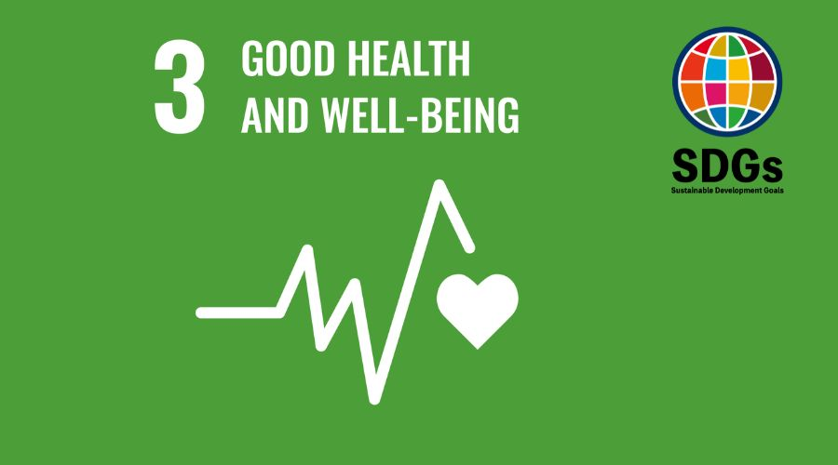
Figure: Sustainable Development Goal 3: Good Health and Well-Being
(Source: Katrin Taepke, 2023)
Global/National/Local Policies and initiatives
At the global level, the United Nations and the World Health Organisation (WHO) are major organisations that spearhead policies that promote SDG 3 targets (WHO, 2022). One attempt to coordinate 13 multilateral agencies in accelerating the achievement of the health SDGs was the Global Action Plan Healthy Lives and Well-being for all, but recent assessments indicate it has had some challenges and will cease by 2025, with lessons learned informing future partnerships (Garcia, 2025).
National policies may differ, but they may consist of national health missions, national health insurance schemes, and disease control programmes. Indicatively, most nations have boosted the services of primary healthcare to ensure that more people have access to immunisation and maternal care, and they have intensified training of health workers to enhance the quality of services (Yang et al., 2022).
Local policies usually go hand in hand with national plans as health programmes are made to suit the needs of the community (england.nhs.uk, 2020). The community health workers, local clinics, and health education campaigns also have crucial roles in promoting preventive care, early diagnosis and local understanding of healthy behaviours (Dwyer, 2022). All these local initiatives will assist in accessing underserved communities and limiting access to care.
Theoretical Underpinning
There are a number of theoretical approaches that can be used to explain why SDG 3 is significant and how the health results can be improved. A major framework is the Social Determinants of Health theory that assumes that health can be determined not by medical services alone, but by broader social, economic, and environmental factors (Adel and HS Alani, 2024). The other theory applicable in this case is the Health Belief Model, which describes the effects of the perception of risk and benefits on the health behaviours of individuals, such as seeking medical attention or health screening (Hariram et al., 2023). The importance of health education and community engagement is that it can be strengthened to change beliefs and enhance preventive health behaviours, which will help in the realisation of SDG 3.
Critical Evaluation
The world has contributed to the reduction of the child mortality rate in the last ten years, and there have been strides made in fighting diseases like HIV/AIDS and malaria. Millions of lives have been saved, and health outcomes have been enhanced in most low and middle-income countries through expanded immunisation programmes and increased primary healthcare systems (Sorooshian, 2024).
The course of COVID-19 reversed life expectancy gains and the progress in most health indicators. Tuberculosis and other infectious diseases remain the primary causes of mortality, and non-communicable diseases have a significant and increasing proportion of premature mortality in the world (Singh et al., 2022). Moreover, the problem of universal health coverage still escapes a substantial part of the world community, creating a group of billions of people who are not entirely covered by the basic services and financial insurance. All these negative sides point out that the existing policies and investments are not yet good enough to achieve the 2030 targets (england.nhs.uk, 2020).
Recommendations
In order to hasten the process towards SDG 3, there is a need to increase investments in the health systems, especially in the areas of primary health care and prevention. To be able to have a strong infrastructure, a good supply chain of necessary medicines, and make the health insurance coverage more expansive should be the role of governments, so that people will not strain their budgets on medical expenses (Goel and Vishnoi, 2022). The review of surveillance systems and emergency preparedness can assist the nations to better detect and respond to health threats.
Health outcomes should be made more equitable and more focus should be directed to handling social determinants of health, which include education, nutrition and living environment. Health literacy and promotion of preventive behaviours can be achieved through the implementation of health education into curriculum programs at schools and within community programmes (Raman et al., 2024). Mental health and non-communicable disease prevention should also be given priority in policies since they are leading causes of death in the world (england.nhs.uk, 2020). Last but not least, international collaboration must be maintained, best practices and resources exchanged to help low-income nations scale up successful interventions (Barragan-Jason et al., 2023).
Section 2: SDG 6 - Clean Water and Sanitation
Overview of the SDG
The Sustainable Development Goal 6, Clean Water and Sanitation, is to make water and sanitation available and sustainably managed for everyone by 2030. This target acknowledges the fact that safe drinking water and proper sanitation are a fundamental human right and health determinant, and are obligatory in education, economic development and wellbeing (Troell et al., 2023). Goal 6 contains objectives such as the need to achieve universal access to safe and affordable drinking water and end open defecation by enhancing sanitation and hygiene services.
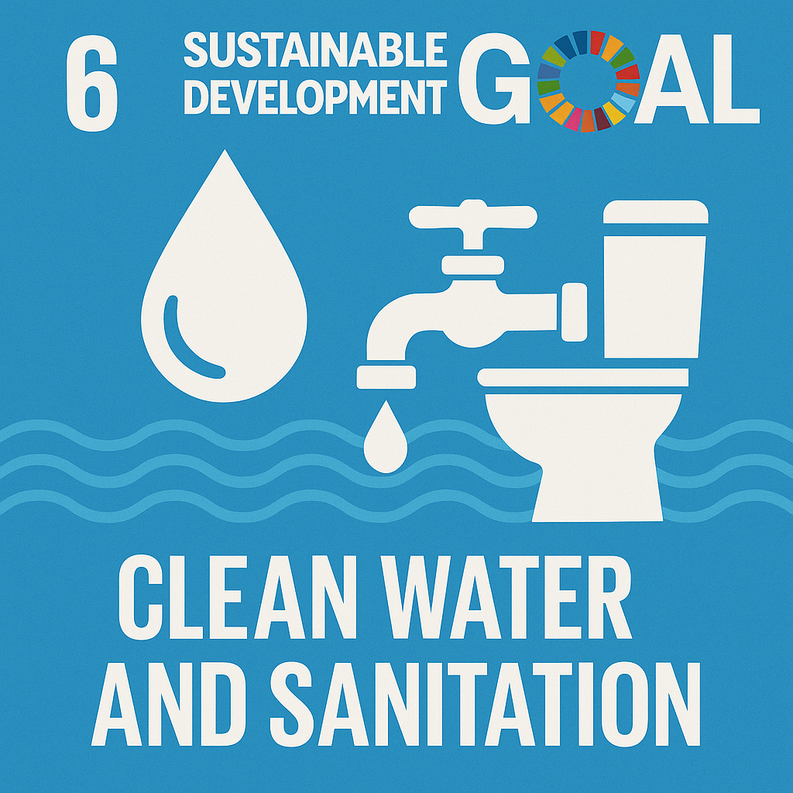
Figure: Sustainable Development Goal 6: Clean Water and Sanitation
(Source: Go Sharpener, 2025)
Global/National/Local Policies and initiatives
The United Nations and the partners at the international level are at the forefront in coordination and monitoring of SDG 6 with frameworks such as the UN Water SDG 6 Data Portal and the United Nations System-wide Strategy on Water and Sanitation (Ugwu et al., 2025). The countries are urged to come up with national water policies which are consistent with SDG 6, include water management in other development policies, and invest in enhancing WASH (Water, Sanitation, and Hygiene) infrastructure.
Water resource management plans, water pollution reduction regulations and hygiene improvement education programmes are often national policies. Indicatively, numerous nations have established national sanitation campaigns or, as part of climate change resilience plans, have realised the nexus between water security and environmental change, and have established water policies (Singh et al., 2024). Awareness of hygiene practices and assist behaviour change, which can lower the prevalence of waterborne diseases, can be enhanced with the assistance of local clinics, schools, and public campaigns (england.nhs.uk, 2020).
Theoretical Underpinning
Several theories and frameworks can be used to explain why SDG 6 is necessary and how this can be granted. According to the Human Rights to Water and Sanitation framework, water and sanitation are inherent human rights, which should be afforded to the dignity, health, and non-discrimination (Olabi et al., 2023). The next theory that is applicable is the Integrated Water Resources Management (IWRM) theory, which says that water management should be synchronised across sectors, regions and stakeholders in order to address competing needs by agriculture, industries and households. IWRM advocates the view that water systems are entangled with social and ecological systems and that sustainable solutions need governance structures which consider economic, environmental, and social aspects (Berniak-Woźny and Rataj, 2023). The Social Determinants of Health theory is also used to describe how water and sanitation interplay with other determinants such as education, income, and living conditions.
Critical Evaluation
SDG 6 has contributed to significant achievements in most areas. The number of households with basic hygiene facilities has increased in recent years, and the world has increased access to safely run drinking water sources, hence slowing down the spread of water-borne diseases such as diarrhoea and cholera (Mathew and M, 2022). The sanitation facilities have led to enhanced sanitation and general health of the population, particularly among children, because clean sanitation will eliminate intestinal infections and encourage school attendance through facilities that are dignified and private.
Although these gains were achieved, challenges are still tough. By 2024, approximately 2.2 billion individuals were still without access to safely managed drinking water and 3.4 billion without access to safely managed sanitation services, indicating that the disparities in progress are uneven and inadequate to achieve the 2030 targets at existing rates (Garcia, 2025). The weak presence of transboundary water cooperation is another phenomenon that is experienced, even though most major water basins are shared. These adverse realities indicate the intricacy of Goal 6 SDG and the necessity to invest and reform governance over the long term (england.nhs.uk, 2020).
Recommendations
The governments and development partners should invest more in sustainable WASH infrastructure to hasten the goal of SDG 6 achievement, which should be directed towards rural and underserved populations (england.nhs.uk, 2020). It is important to strengthen the governance and institutional capacity; having water rights, a clear pricing system, and strict enforcement of pollution rules would enhance the water quality and fair access to water.
The growth can be facilitated by innovation and technology, which can encompass low-cost purification, remote water quality monitoring, and planning tools which are based on data and highlight areas that need services (Yang et al., 2022). All these actions will contribute to eliminating disparities in access and achieve sustainable water and sanitation services to the entire population by 2030.
Conclusion
Summarise key findings
The report notes that Sustainable Development Goals 3, Good Health and Well-being, as well as 6, Clean Water and Sanitation, play a critical role in improving the quality of life of people across the globe. SDG 3 is aimed at the reduction of disease mortality, enhancement of healthcare systems, and universal access to health services. Goal 6 relates to reliable and sanitary access to drinking water, sanitation, and hygiene in order to stop disease and safeguard human health. The two objectives have achieved some strides with world strategies, national strategies and local initiatives, yet numerous nations continue to have deficits in the infrastructure, finances, and equal access.
Reflect on the interlinking of SDGs
The clean water and proper sanitation directly affect the health outcomes, especially in the prevention of waterborne diseases and the provision of a safe environment to families and communities. The lack of clean water and sanitation means that healthcare alone cannot reduce the disease or improve well-being. On the same note, healthy populations can sustain safe water systems and embrace healthy hygiene behaviours. The connection between these aims will bring a better platform of sustainable development, decreasing inequalities, and improving wellbeing.
Discussion of Border Implications
The bigger ramifications of this analysis underline that sustainable health and water systems demand investments in the long term and inter-sectoral collaboration. Such partnerships and national strategies need to be in line with the needs of the community, particularly in vulnerable and rural settings. Tightened governance, climate-resilient planning and non-discriminatory policies are key in bridging the access and quality gaps. Health and water services are not only the technical solutions to make, but the cornerstone of human rights and fair development.

Reference List
Adel, A. and HS Alani, N. (2024). Human-centric collaboration and Industry 5.0 framework in smart cities and communities: Fostering sustainable development goals 3, 4, 9, and 11 in Society 5.0. Smart Cities, 7(4), pp.1723-1775. Available at: https://www.mdpi.com/2624-6511/7/4/68 [Accessed on: 10th Feb. 2026]
Barragan-Jason, G., Loreau, M., de Mazancourt, C., Singer, M.C. and Parmesan, C. (2023). Psychological and physical connections with nature improve both human well-being and nature conservation: A systematic review of meta-analyses. Biological Conservation, 277, pp.109-842. Available at: https://www.sciencedirect.com/science/article/pii/S0006320722003950 [Accessed on: 10th Feb. 2026]
Berniak-Woźny, J. and Rataj, M. (2023). Towards green and sustainable healthcare: a literature review and research agenda for green leadership in the healthcare sector. International Journal of Environmental Research and Public Health, 20(2), pp.908. Available at: https://www.mdpi.com/1660-4601/20/2/908 [Accessed on: 10th Feb. 2026]
Dwyer, L. (2022). Tourism contribution to the SDGs: Applying a well-being lens. European Journal of Tourism Research, 32, pp.3212-3212. Available at: https://www.ejtr.vumk.eu/index.php/about/article/view/2500 [Accessed on: 10th Feb. 2026]
england.nhs.uk, (2020). Available at: https://www.england.nhs.uk/south/wp-content/uploads/sites/6/2022/06/Devon-UHP-Green-Plan-2020-2025.pdf. [Accessed on: 10th Feb. 2026]
Garcia, A.G. (2025). The impact of sustainable practices on employee well-being and organisational success. Brazilian Journal of Development, 11(3), pp.78599-78599. Available at: https://ojs.brazilianjournals.com.br/ojs/index.php/BRJD/article/view/78599 [Accessed on: 10th Feb. 2026]
Go Sharpener. (2025). 💧Sustainable Development Goal 6 💧. [online] Available at: https://gosharpener.com/blogs/784596/Sustainable-Development-Goal-6. [Accessed on: 10th Feb. 2026]
Goel, R.K. and Vishnoi, S. (2022). Urbanisation and sustainable development for inclusiveness using ICTs. Telecommunications Policy, 46(6), pp.102-311. Available at: https://www.sciencedirect.com/science/article/pii/S0308596122000155 [Accessed on: 10th Feb. 2026]
Hariram, N.P., Mekha, K.B., Suganthan, V. and Sudhakar, K. (2023). Sustainalism: An integrated socio-economic-environmental model to address sustainable development and sustainability. Sustainability, 15(13), pp.10-682. Available at: https://www.mdpi.com/2071-1050/15/13/10682 [Accessed on: 10th Feb. 2026]
Katrin Taepke (2023). SDG 3 - Good health and well-being. [online] Sustainable Event Solutions. Available at: https://sustainable-event-solutions.de/en/sdg-3-gesundheit-wohlergehen/. [Accessed on: 10th Feb. 2026]
Mathew, P.V. and M, N.P. (2022). Sustainable tourism development: discerning the impact of responsible tourism on community well-being. Journal of Hospitality and Tourism Insights, 5(5), pp.987-1001. Available at: https://www.emerald.com/insight/content/doi/10.1108/jhti-02-2021-0052/full/html [Accessed on: 10th Feb. 2026]
Olabi, A.G., Abdelkareem, M.A., Al-Murisi, M., Shehata, N., Alami, A.H., Radwan, A., Wilberforce, T., Chae, K.J. and Sayed, E.T. (2023). Recent progress in Green Ammonia: Production, applications, assessment, barriers, and its role in achieving the sustainable development goals. Energy Conversion and Management, 277, pp.116-594. Available at: https://www.sciencedirect.com/science/article/pii/S0196890422013723 [Accessed on: 10th Feb. 2026]
Raman, R., Lathabhai, H., Pattnaik, D., Kumar, C. and Nedungadi, P. (2024). Research contribution of bibliometric studies related to sustainable development goals and sustainability. Discover Sustainability, 5(1), pp.7. Available at: https://link.springer.com/article/10.1007/s43621-024-00182-w [Accessed on: 10th Feb. 2026]
Singh, A., Kanaujia, A., Singh, V.K. and Vinuesa, R. (2024). Artificial intelligence for Sustainable Development Goals: Bibliometric patterns and concept evolution trajectories. Sustainable Development, 32(1), pp.724-754. Available at: https://onlinelibrary.wiley.com/doi/abs/10.1002/sd.2706 [Accessed on: 10th Feb. 2026]
Singh, H.P., Singh, A., Alam, F. and Agrawal, V. (2022). Impact of sustainable development goals on economic growth in Saudi Arabia: Role of education and training. Sustainability, 14(21), pp.14119. Available at: https://www.mdpi.com/2071-1050/14/21/14119 [Accessed on: 10th Feb. 2026]
Sorooshian, S. (2024). The sustainable development goals of the United Nations: A comparative midterm research review. Journal of Cleaner Production, 453, pp.142-272. Available at: https://www.sciencedirect.com/science/article/pii/S0959652624017207 [Accessed on: 10th Feb. 2026]
Troell, M., Costa‐Pierce, B., Stead, S., Cottrell, R.S., Brugere, C., Farmery, A.K., Little, D.C., Strand, Å., Pullin, R., Soto, D. and Beveridge, M. (2023). Perspectives on aquaculture's contribution to the Sustainable Development Goals for improved human and planetary health. Journal of the World Aquaculture Society, 54(2), pp.251-342. Available at: https://onlinelibrary.wiley.com/doi/abs/10.1111/jwas.12946 [Accessed on: 10th Feb. 2026]
Ugwu, C.N., Ugwu, O.P.C., Alum, E.U., Eze, V.H.U., Basajja, M., Ugwu, J.N., Ogenyi, F.C., Ejemot-Nwadiaro, R.I., Okon, M.B., Egba, S.I. and Uti, D.E. (2025). Sustainable development goals (SDGs) and resilient healthcare systems: Addressing medicine and public health challenges in conflict zones. Medicine, 104(7), pp.41535. Available at: https://journals.lww.com/md-journal/fulltext/2025/02140/sustainable_development_goals__sdgs__and_resilient.8.aspx?context=latestarticles [Accessed on: 10th Feb. 2026]
WHO (2022). Sustainable Development Goals. [online] www.who.int. Available at: https://www.who.int/data/gho/data/themes/sustainable-development-goals. [Accessed on: 10th Feb. 2026]
Yang, H., Chen, T., Zeng, Z. and Mi, F. (2022). Does urban green space justly improve public health and well-being? A case study of Tianjin, a megacity in China. Journal of Cleaner Production, 380, pp.134-920. Available at: https://www.sciencedirect.com/science/article/pii/S0959652622044936 [Accessed on: 10th Feb. 2026]
Zhong, W., Schröder, T. and Bekkering, J. (2022). Biophilic design in architecture and its contributions to health, well-being, and sustainability: A critical review. Frontiers of Architectural Research, 11(1), pp.114-141. Available at: https://www.sciencedirect.com/science/article/pii/S2095263521000479/pdf [Accessed on: 10th Feb. 2026]

